StrollStats Documentation

**Members:**

Darian Elbert (2540127856)

Dave Sebastian Wijono (2540103080)

Juan Arnold (2540110760)

Nathan Setiawan (2540127774)

Nathanael Deciano Sugiharto (2501959485)

**Log-in Page (welcoming page on first-time visit)**

**Register Pager (To create new account)**

**Continue with google (google account select)**

This will act as an alternative register method. If a google account is already made, user could just log in with Gmail.

**Home Page**

On first time visit, the phone and gender tab would be empty and would need to be edited using edit profile feature. This page also shows the 10 players with the highest steps taken in the season.

**Edit Profile Page**  
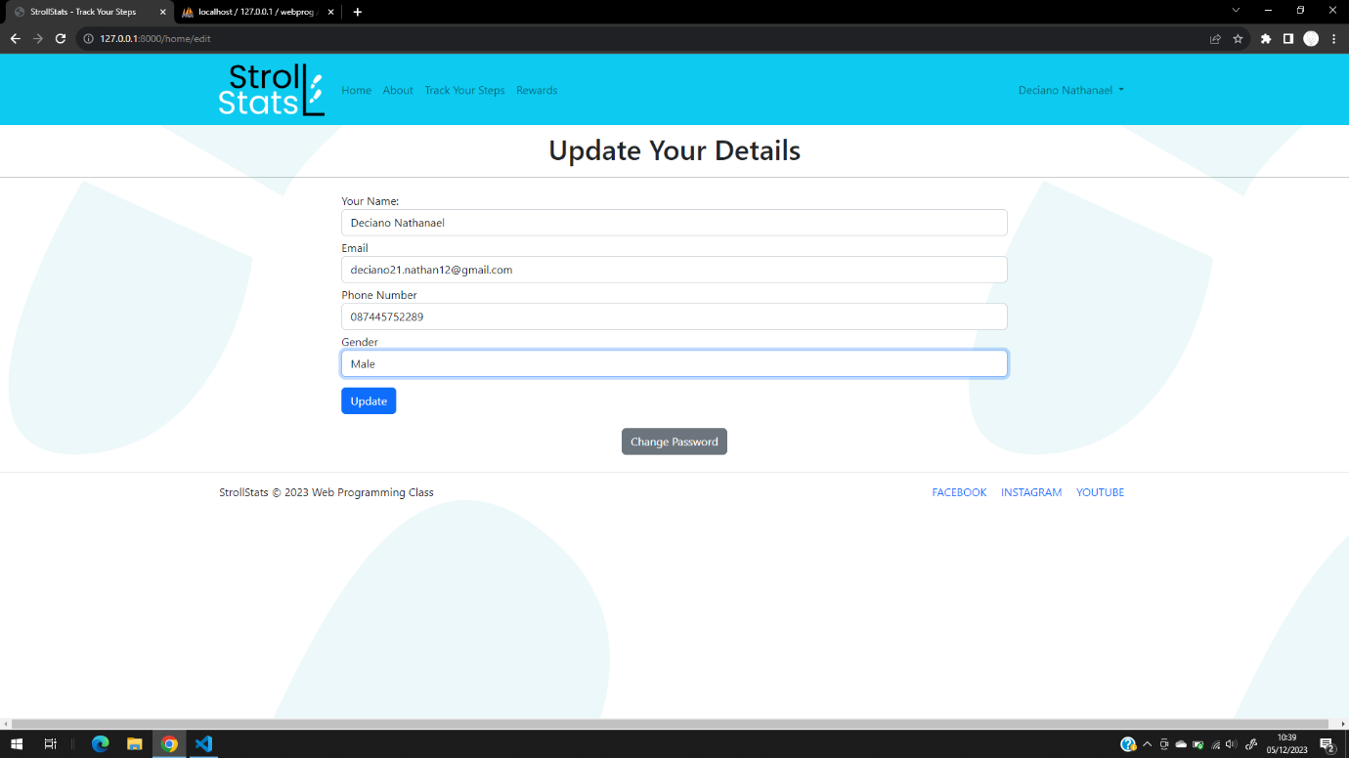

**Change Password Page**

**About Page**  
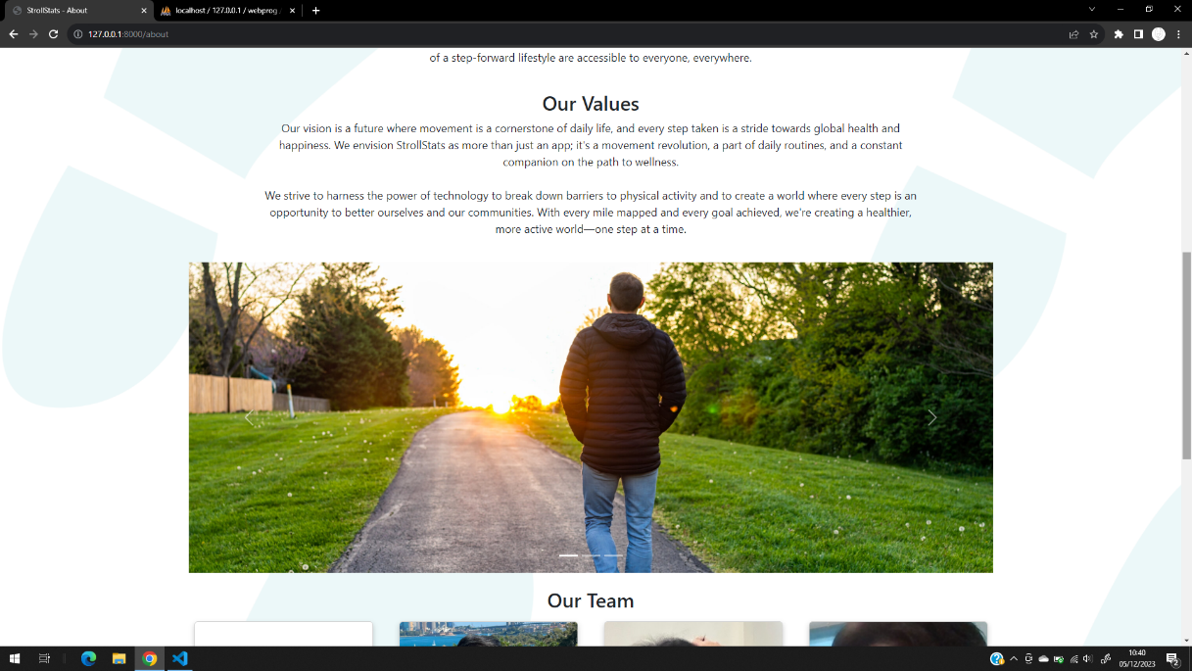

**Track Your Steps Page (To input steps and view steps history)**

Users can add their steps manually. There would also be one record that is actually the steps taken that are recorded by google fit.

**Vouchers Page**

The vouchers would unlock when the user reach a certain number of total steps. The value is based on the steps taken, which are in rupiah (100k, 500k, 1mil, and 5 mil). It will reset every season.

**Snake and Easter Egg Barcode Page**

This page will open when we enter “Snake” when inputting step. Just a fun easter egg with a fun barcode in it…