**Class:** Final Year (Computer Science and Engineering)

**Year:** 2022-23 **Semester:** 1

**Course:** High Performance Computing Lab

**Practical No. 5**

**Exam Seat No:**

2019BTECS00033 – Teknath Jha

**Title of practical:**

Installation of MPI & Implementation of basic functions of MPI

**Problem Statement 1:**

Implement a simple hello world program by setting number of processes equal to 10

**Screenshot 1:**

*// Q1 Hello world in MPI*

#include <mpi.h>

#include <stdio.h>

int main(int argc, char **argv)

{

    MPI_Init(NULL, NULL);

    int world_size;

    MPI_Comm_size(MPI_COMM_WORLD, &world_size);

    int world_rank;

    MPI_Comm_rank(MPI_COMM_WORLD, &world_rank);

    printf("Hello world, rank %d out of %d processors\n", world_rank, world_size);

    MPI_Finalize();

}

**Screenshot 2:**

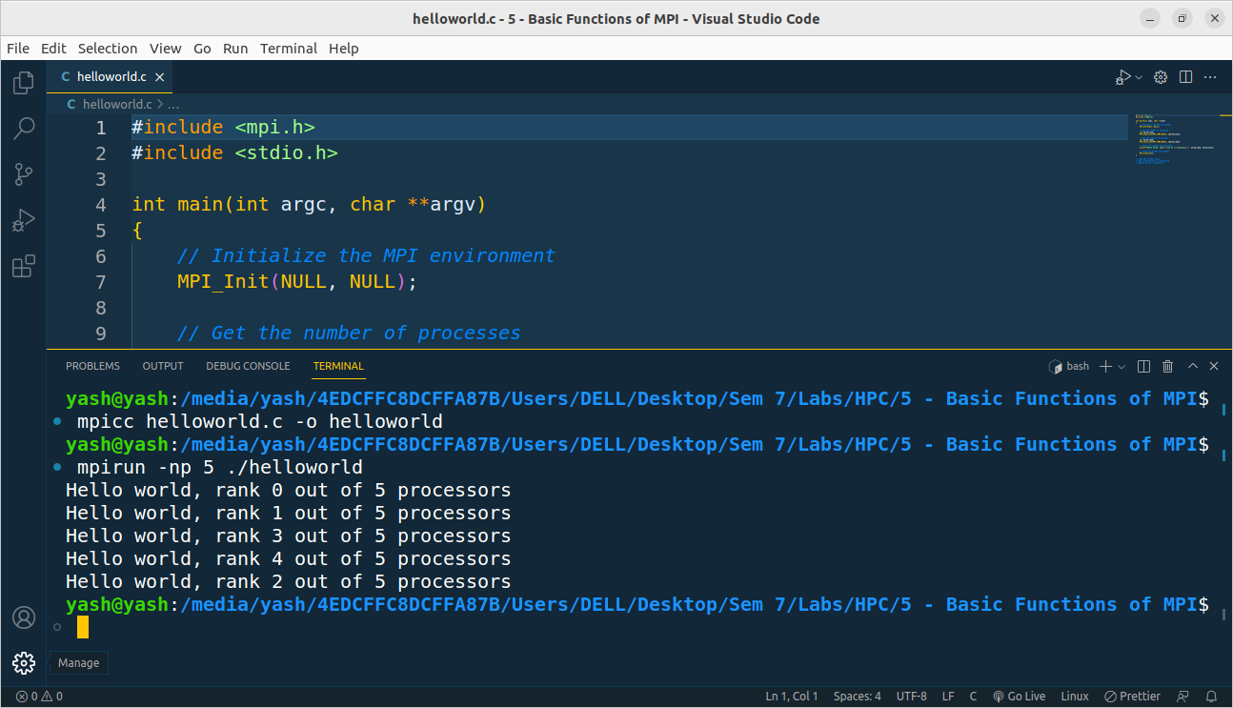

**Information 1:**

First step to building an MPI program is including the MPI header files with #include <mpi.h>. After this, the MPI environment must be initialized with MPI_Init.

During MPI_Init, all of MPI’s global and internal variables are constructed. For example, a communicator is formed around all of the processes that were spawned, and unique ranks are assigned to each process. Currently, MPI_Init takes two arguments that are not necessary, and the extra parameters are simply left as extra space in case future implementations might need them.

After MPI_Init, there are two main functions that are called. These two functions are used in almost every single MPI program:

1. MPI_Comm_size returns the size of a communicator. In our example, MPI_COMM_WORLD (which is constructed for us by MPI) encloses all of the processes in the job, so this call should return the amount of processes that were requested for the job.
2. MPI_Comm_rank returns the rank of a process in a communicator. Each process inside of a communicator is assigned an incremental rank starting from zero. The ranks of the processes are primarily used for identification purposes when sending and receiving messages.

MPI_Finalize is used to clean up the MPI environment. No more MPI calls can be made after this one.

**Problem Statement 2:**

Implement a program to display rank and communicator group of five processes

**Screenshot 3:**

*// Implement a program to display rank and communicator group of five processes*

#include <mpi.h>

#include <stdio.h>

int main(int argc, char **argv)

{

    MPI_Init(NULL, NULL);

    int world_size;

    MPI_Comm_size(MPI_COMM_WORLD, &world_size);

    int world_rank;

    MPI_Comm_rank(MPI_COMM_WORLD, &world_rank);

    int color = world_rank / 2;

    MPI_Comm row_comm;

    MPI_Comm_split(MPI_COMM_WORLD, color, world_rank, &row_comm);

    int row_rank, row_size;

    MPI_Comm_rank(row_comm, &row_rank);

    MPI_Comm_size(row_comm, &row_size);

    printf("World Rank/Size : %d/%d \t Row Rank/Size: %d/%d\n", world_rank, world_size, row_rank, row_size);

    MPI_Finalize();

}

**Screenshot 4:**

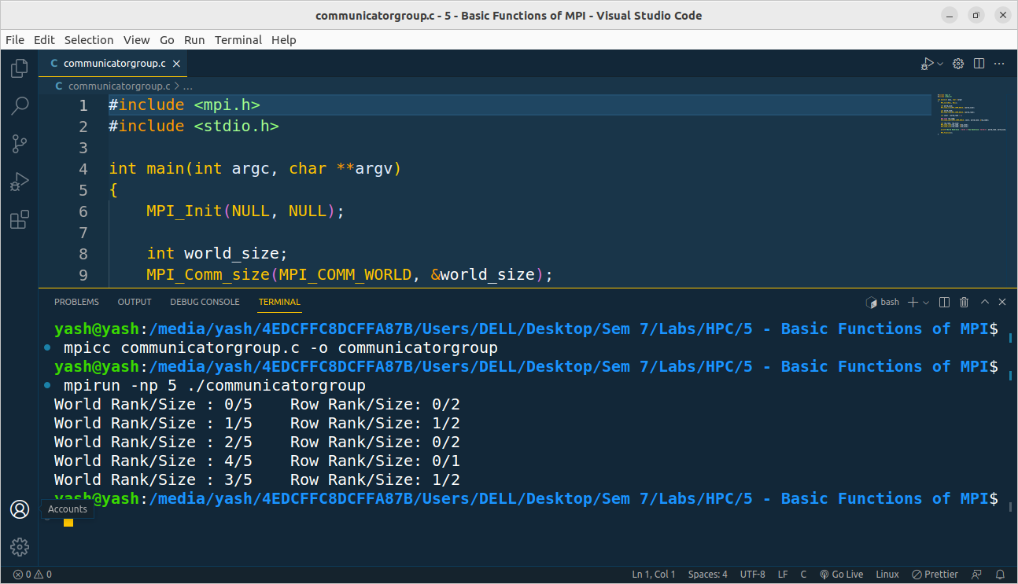

**Information 2:**

MPI_Comm_split creates new communicators by “splitting” a communicator into a group of sub-communicators based on the input values color and key. It’s important to note here that the original communicator doesn’t go away, but a new communicator is created on each process. The first argument, comm, is the communicator that will be used as the basis for the new communicators. This could be MPI_COMM_WORLD, but it could be any other communicator as well. The second argument, color, determines to which new communicator each processes will belong. All processes which pass in the same value for color are assigned to the same communicator. The third argument, key, determines the ordering (rank) within each new communicator. The process which passes in the smallest value for key will be rank 0, the next smallest will be rank 1, and so on. If there is a tie, the process that had the lower rank in the original communicator will be first. The final argument, newcomm is how MPI returns the new communicator back to the user.

**Github Link:**

<https://github.com/Teknath-jha/HPC-LAB-2019BTECS00033/tree/main/Assignment-5>