**Class:** Final Year (Computer Science and Engineering)

**Year:** 2022-23 **Semester:** 1

**Course:** High Performance Computing Lab

**Practical No. 7**

**Exam Seat No:**

2019BTECS00033 – Teknath Krishna Jha

**Title of practical:**

MPI programming

GITHUB LNK : <https://github.com/Teknath-jha/HPC-LAB-2019BTECS00033/tree/main/Assignment-7>

**Problem Statement 1:**

Implement Matrix-Vector Multiplication using MPI. Use different number of processes and analyze the performance.

**Output 1:**

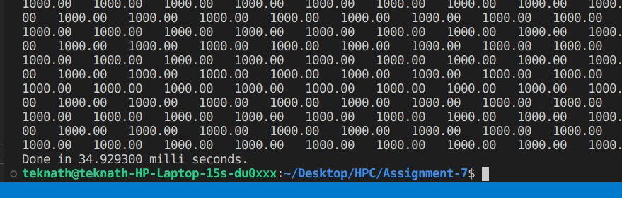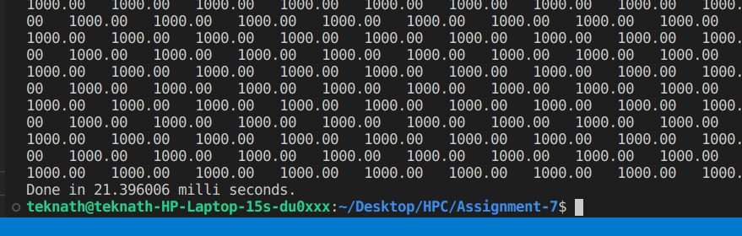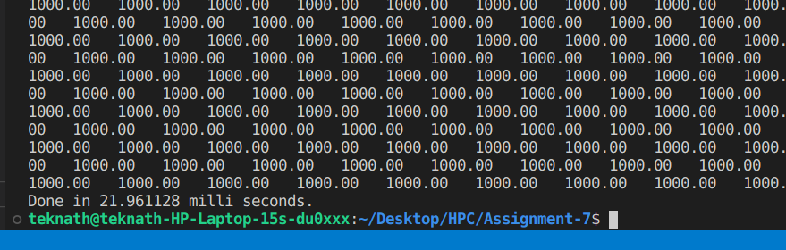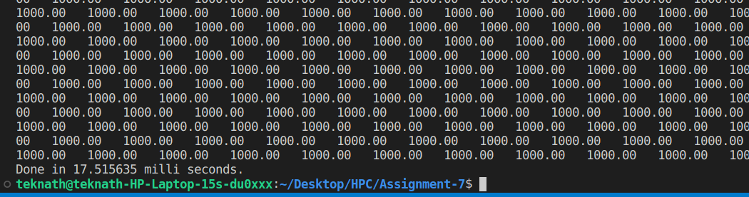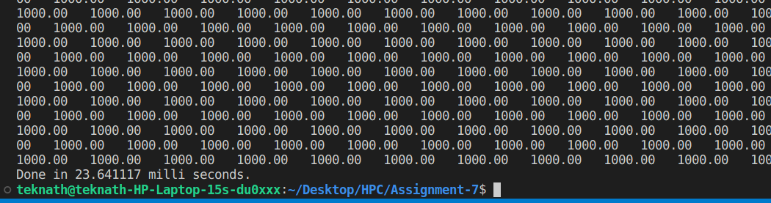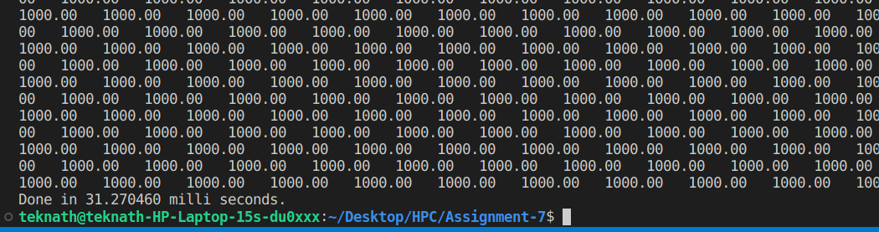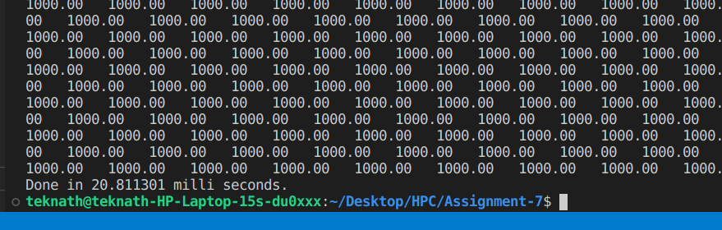

**Analysis :**

|  |  |  |
| --- | --- | --- |
| Matrix Vector Multiplication | | |
| processes | Time in milli seconds |  |
| 2 | 22.29 |  |
| 3 | 15.65 |  |
| 4 | 16.6 |  |
| 5 | 22.39 |  |
| 6 | 24.4 |  |
| 7 | 25.27 |  |
| 8 | 30.77 |  |
| 9 | 36.44 |  |
| 10 | 40.39 |  |

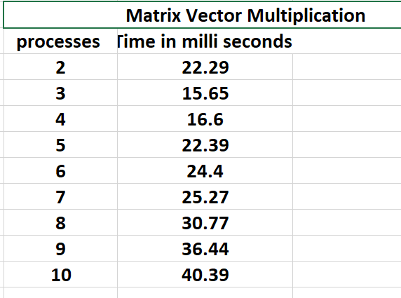

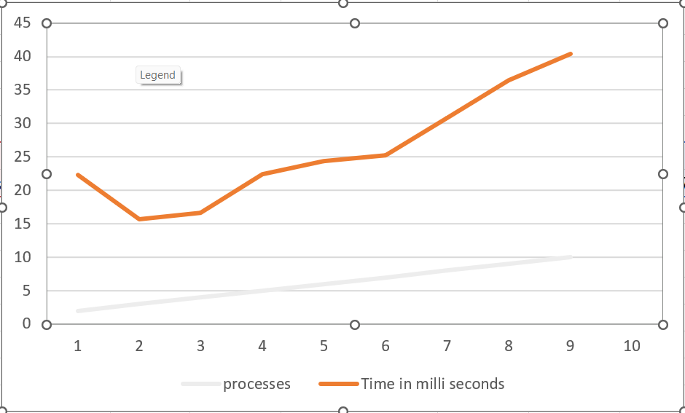

**COMMENT :**

**Initiall number of process were not sufficient as per problem size as we increase processes time required is less and after few number of process it again adds to overheads to it .**

**Problem Statement 2:**

Implement Matrix-Matrix Multiplication using MPI. Use different number of processes and analyze the performance.

**Screenshot 2:**

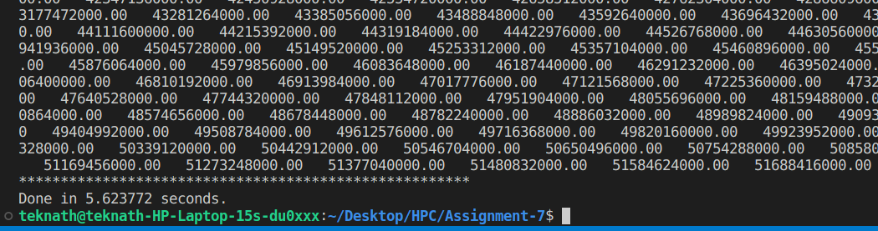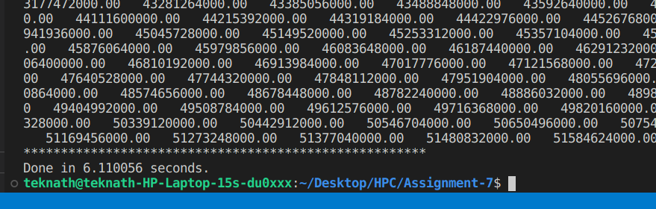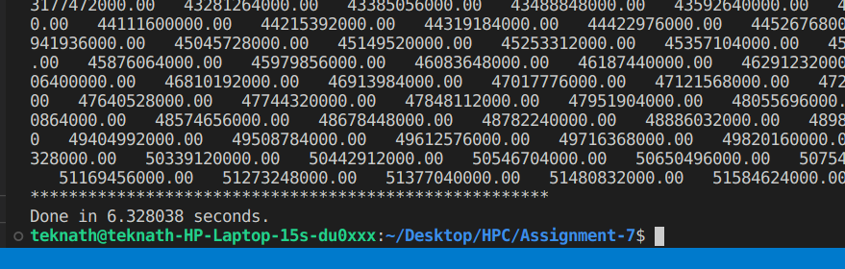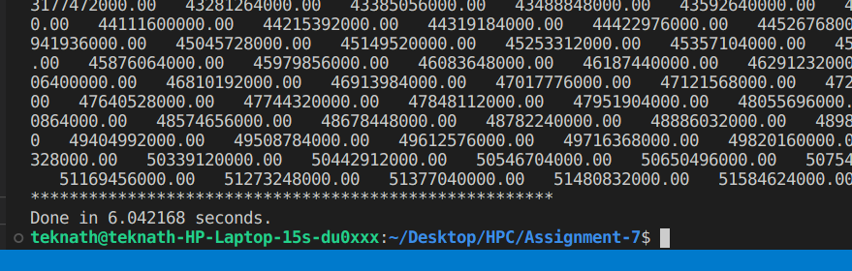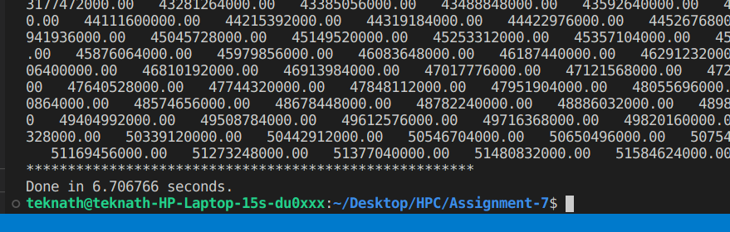

**Analysis :**

|  |  |  |
| --- | --- | --- |
| **Matrix Matrix Multiplication** | | |
| **processes** | **Time in seconds** |  |
| **2** | **6.25** |  |
| **3** | **5.71** |  |
| **4** | **5.95** |  |
| **5** | **5.86** |  |
| **6** | **5.29** |  |
| **7** | **6.26** |  |
| **8** | **6.38** |  |
| **9** | **6.42** |  |
| **10** | **6.64** |  |

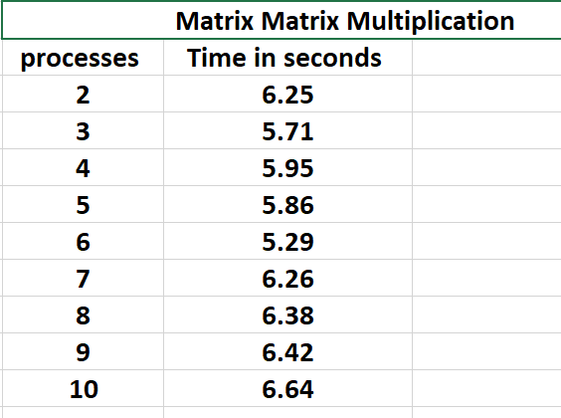

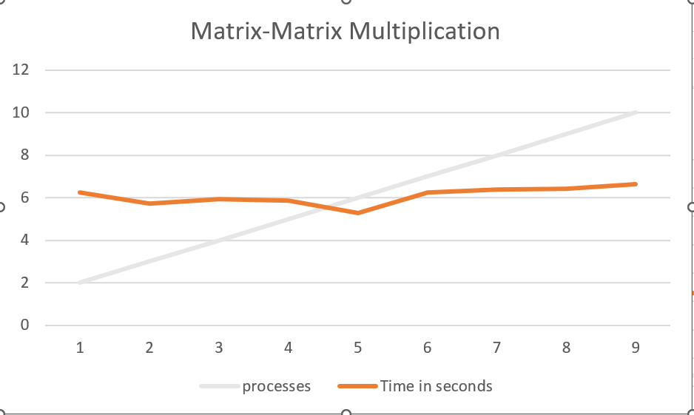

**Started from p=4 onwards**

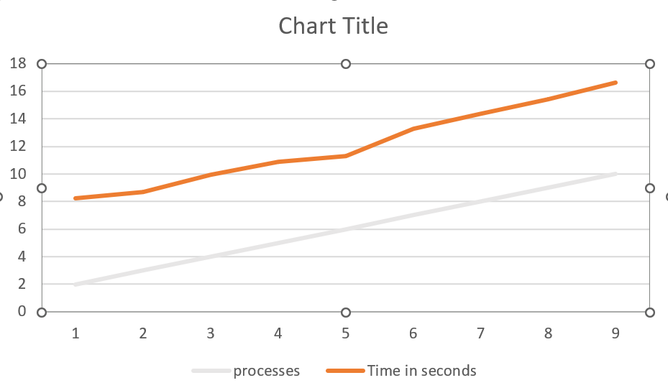

**Comment :**

**Initiall number of process were not sufficient as per problem size as we increase processes time required is less and after few number of process it again adds to overheads to it .**