**Class:** Final Year (Computer Science and Engineering)

**Year:** 2022-23 **Semester:** 7

**Course:** High Performance Computing Lab

**Practical No. 01**

**Exam Seat No:**

1. 2019BTECS00033 --- Teknath K Jha

**Title of practical:**

**openMp program for :**

1. **Hello World**
2. **Squares from 1 to 100**

**MY SYSTEM CONFIGURATION :**

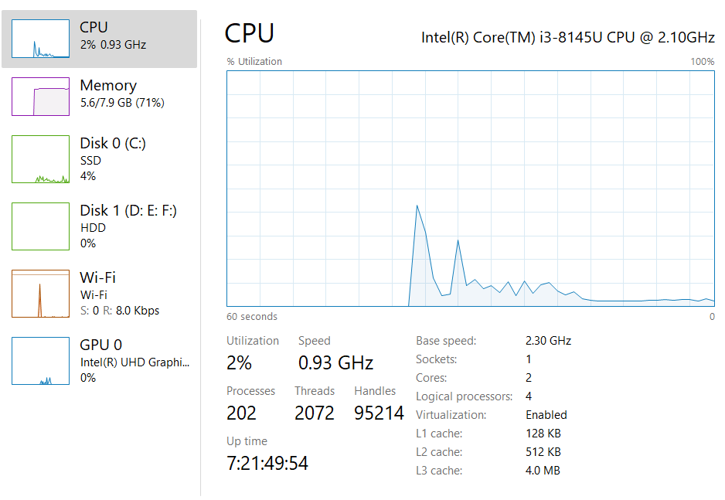

**Physical Vs Software threads :**

* + Software threads are threads of execution managed by the operating system.
  + A "hardware thread" is a physical CPU or core. So, a 4 core CPU can genuinely support 4 hardware threads at once - the CPU really is doing 4 things at the same time.
  + One hardware thread can run many software threads.
  + In modern operating systems, this is often done by time-slicing - each thread gets a few milliseconds to execute before the OS schedules another thread to run on that CPU

1. **Problem Statement 1: Hello World :**

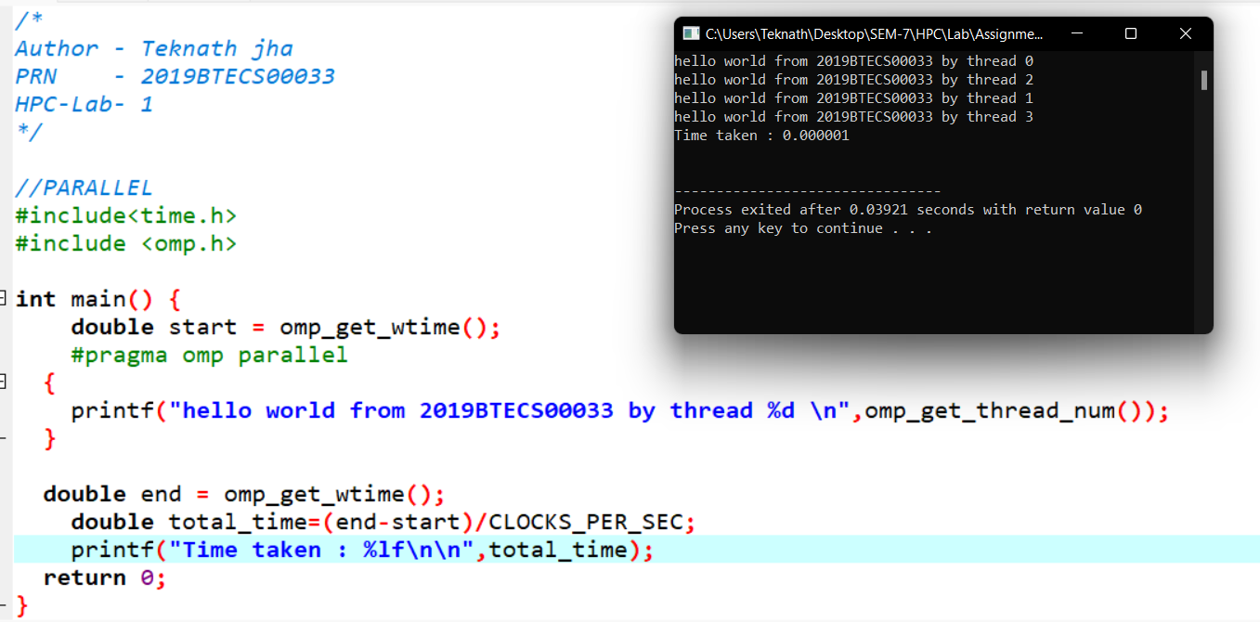

**Comparison with sequential :**

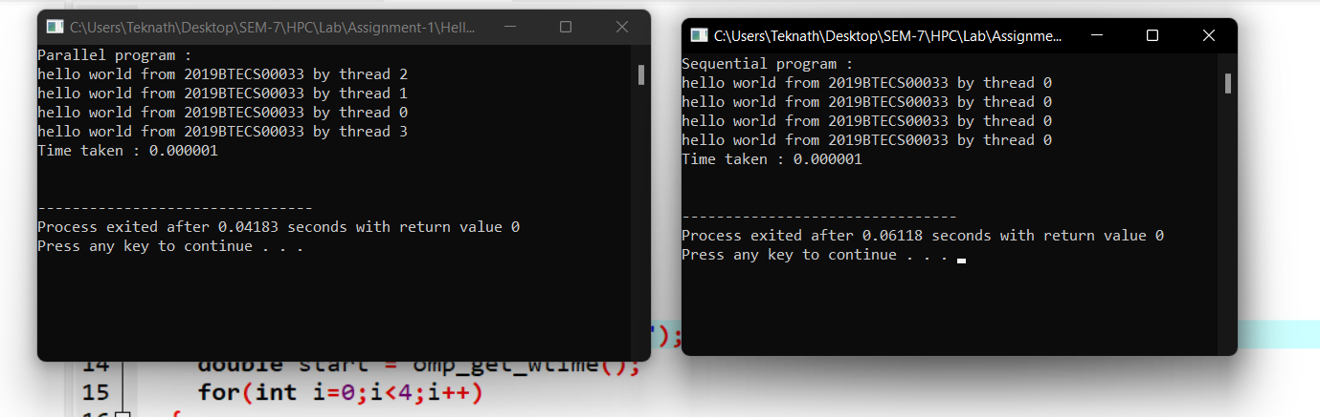

**In below images 1st peak is of sequential and later is of parallel program :**

**Images from CPU Utilization Task Manager :**

1. 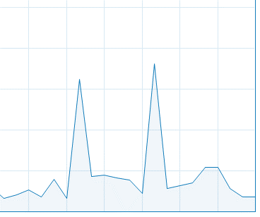
2. 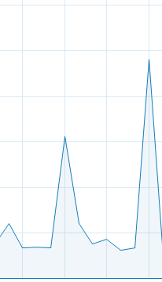
3. 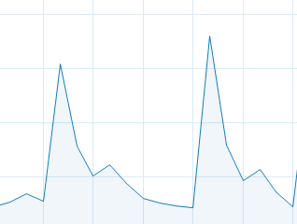

**Conclusion : my sequential program uses less CPU and parallel program uses more UPU for same program and same number of instruction Sets.**

**Although time calculation is negligible as it is small program .**

**Problem Statement 2: Squares from 1 to 100**

**Screenshot #:**

**Information #:**

**Squares from 1 to 100**

**Output Screenshots :**

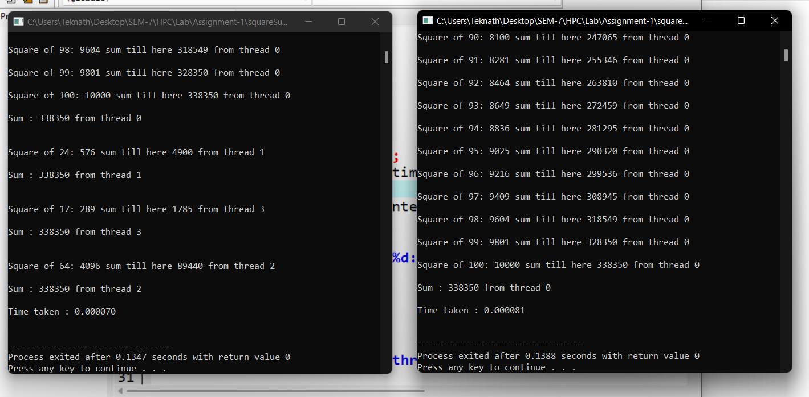

**Parallel :70 Sequential: 81**

**So here parallel is faster than sequential.**

**In below images 1st peak is of sequential and later is of parallel program :**

**CPU Graphs :**

1. 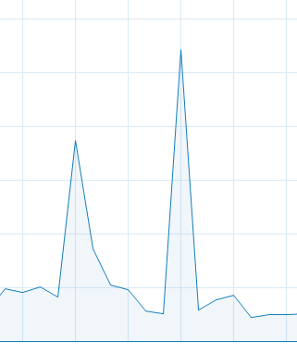
2. 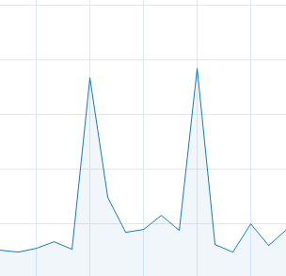
3. 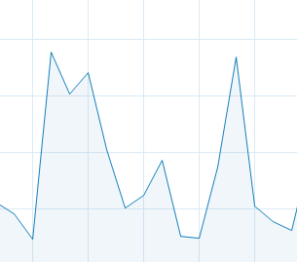

**Here most of time width of sequential is more than parallel which shows time difference.**

**Conclusion :**

**In execution : sequential taken 0.000081 while parallel taken 0.000070 which is considerable difference , further observation of CPU cycles also proves this that parallel is faster than sequential .**

**Github Link:** [**https://github.com/Teknath-jha/HPC-LAB-2019BTECS00033/tree/main/Assignment-1**](https://github.com/Teknath-jha/HPC-LAB-2019BTECS00033/tree/main/Assignment-1)