**Class:** Final Year (Computer Science and Engineering)

**Year:** 2022-23 **Semester:** 7

**Course:** High Performance Computing Lab

**Practical No. 02**

**Exam Seat No:**

1. 2019BTECS00033 – Teknath K jha

**Title of practical:**

**openMp program for :**

1. **Vector Vector Addition**
2. **Vector Scalar Addition**

**MY SYSTEM CONFIGURATION :**

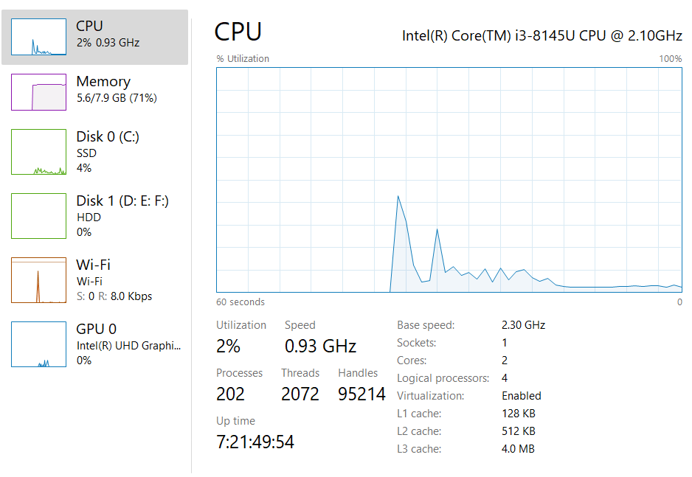

1. **Problem Statement 1: Vector Vector Addition :**

**Comparison with sequential :**

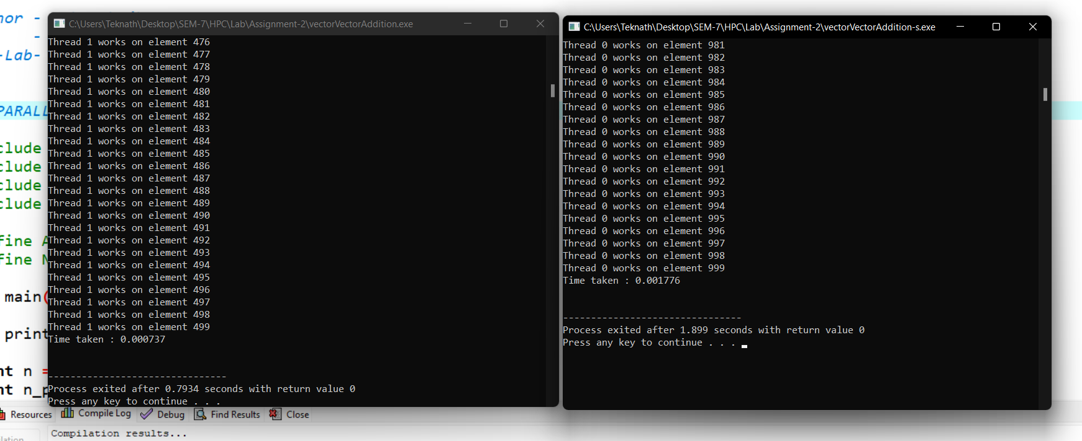

**In below images 1st peak is of sequential and later is of parallel program :**

**Images from CPU Utilization Task Manager :**

1. 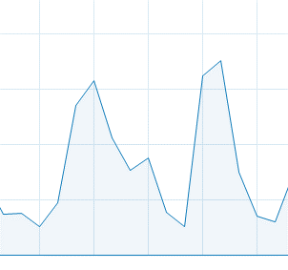**for n=1000**
2. 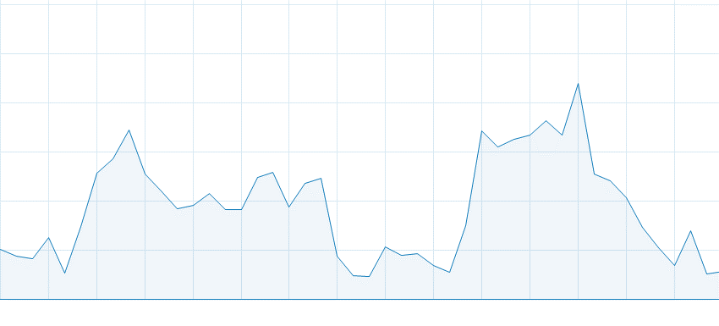**for n=10000**
3. 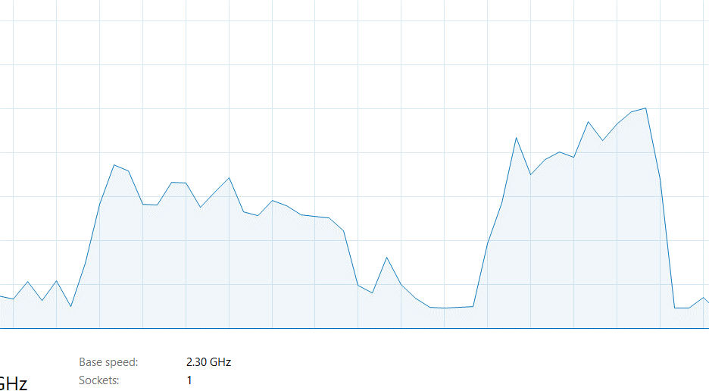**for n= 100000**

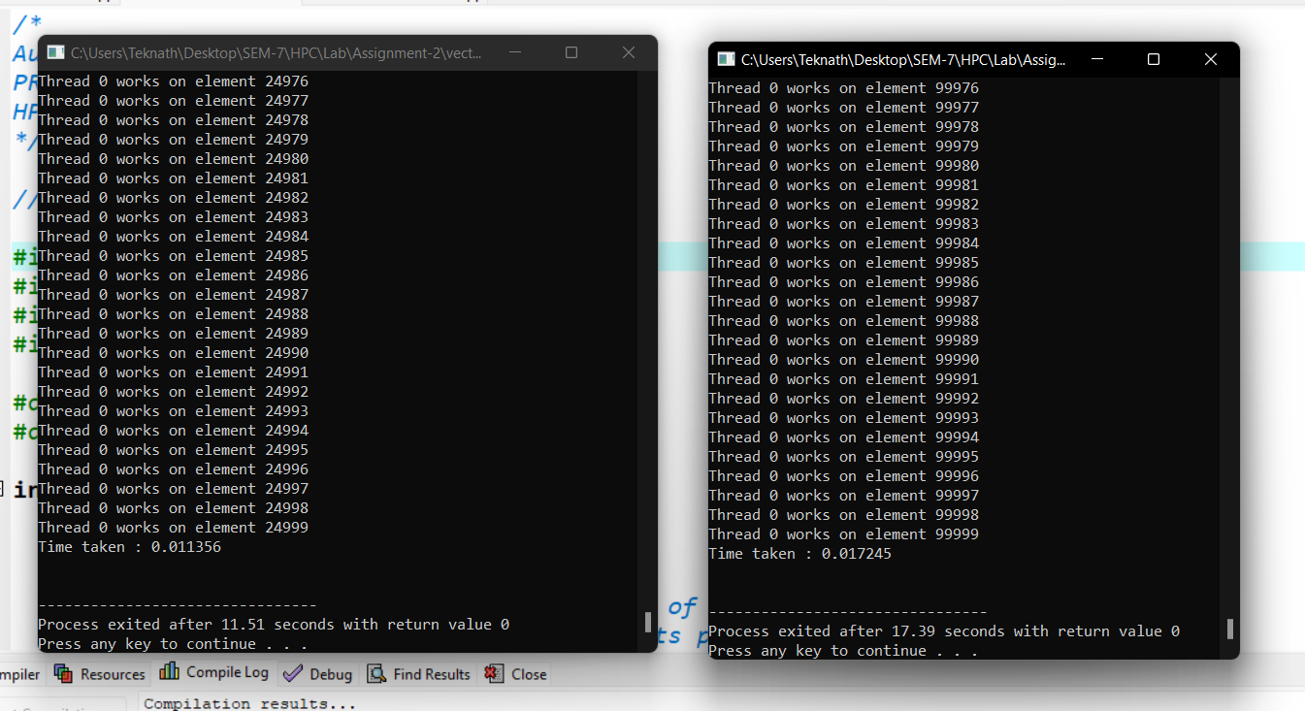

**Here sequential takes 0.01725 and parallel takes 0.011356 clock ticks**

**Conclusion : my sequential program uses less CPU and parallel program uses more UPU for same program and same number of instruction Sets.**

**Although time calculation is negligible as it is small program .**

**Problem Statement 2: Vector Scalar Addition**

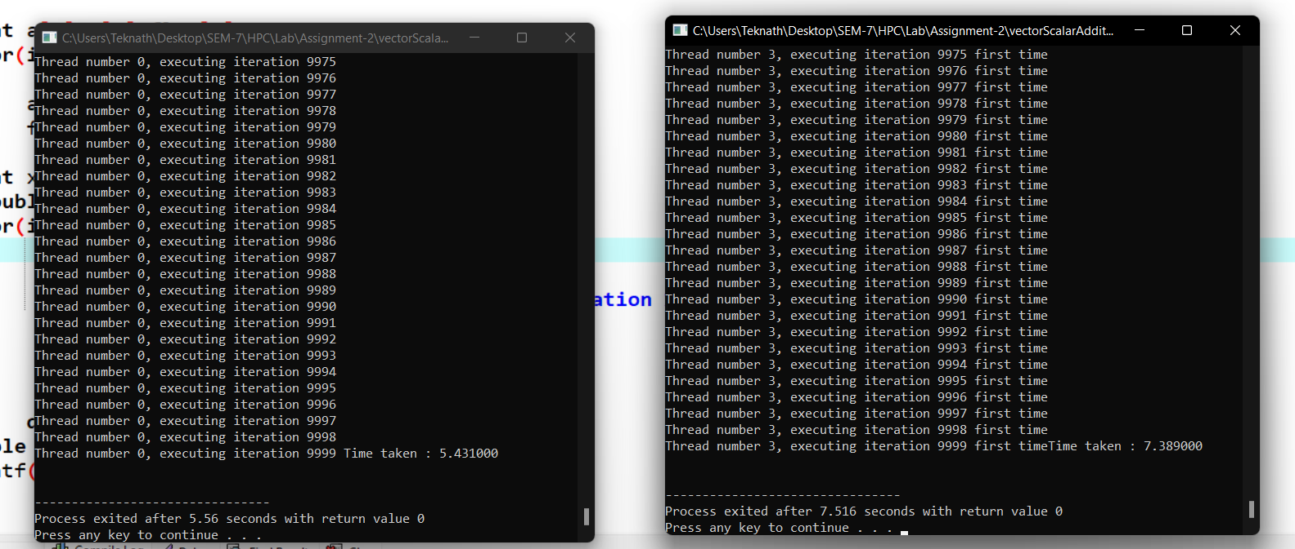

**Parallel :7.3 sec Sequential: 5.4sec**

**So here sequential is faster than parallel.**

**In below images 1st peak is of sequential and later is of parallel program :**

**CPU Graphs :**

1. 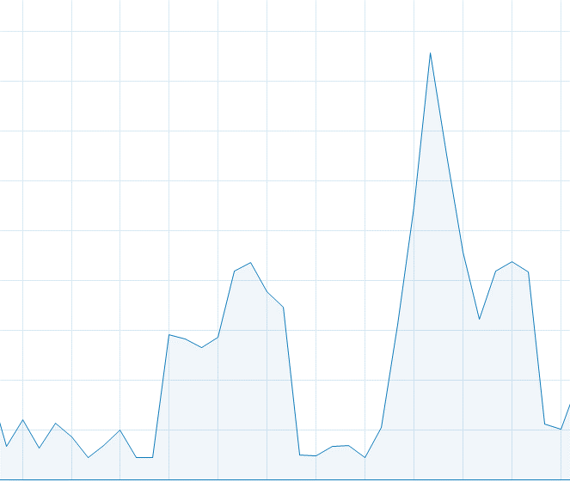
2. 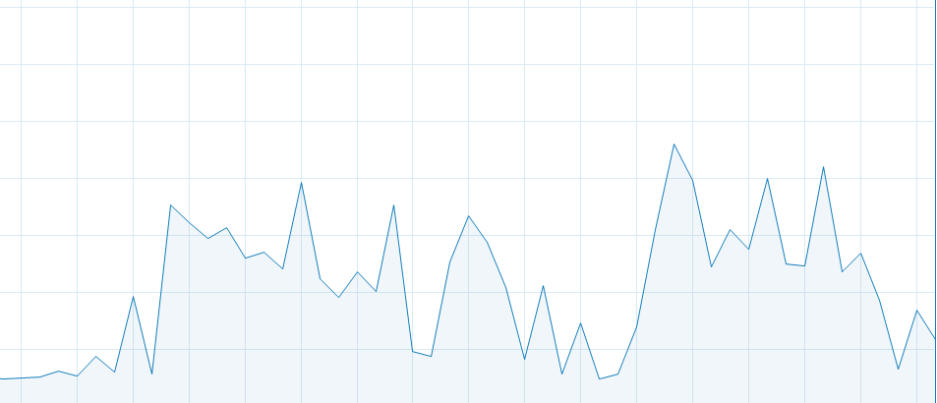

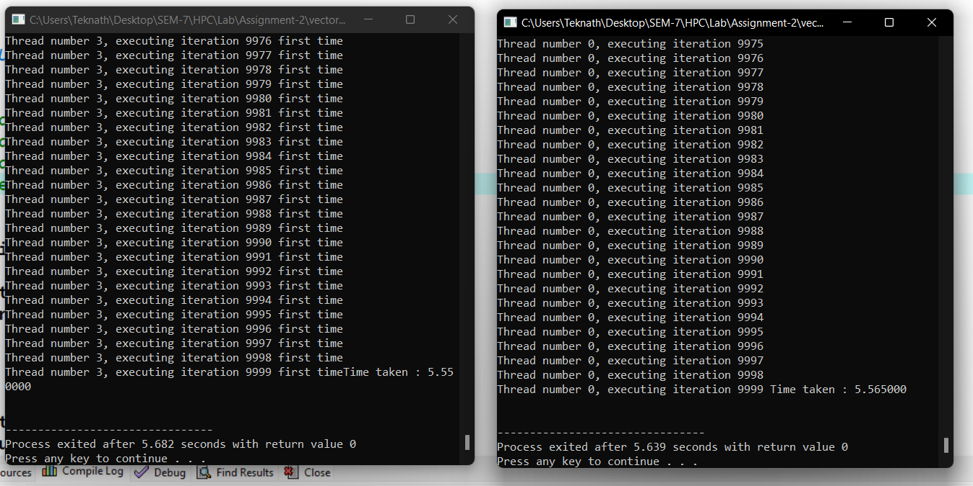

**Here most of time width of sequential is more than parallel which shows time difference.**

**Conclusion :**

**In execution : sequential taken 5.56 while parallel taken 5.55 which is considerable difference , further observation of CPU cycles also proves this that parallel is faster than sequential .**

**Github Link:**

[**https://github.com/Teknath-jha/HPC-LAB-2019BTECS00033/tree/main/Assignment-2**](https://github.com/Teknath-jha/HPC-LAB-2019BTECS00033/tree/main/Assignment-2)