**Class:** Final Year (Computer Science and Engineering)

**Year:** 2022-23 **Semester:** 7

**Course:** High Performance Computing Lab

**Practical No. 03**

**Exam Seat No:**

1. 2019BTECS00033 --- Teknath K jha

**Title of practical:**

**Solve give questions**

1. **Problem Statement 1:** Analyse and implement a Parallel code for below program using openMP

**Screenshot 1:**

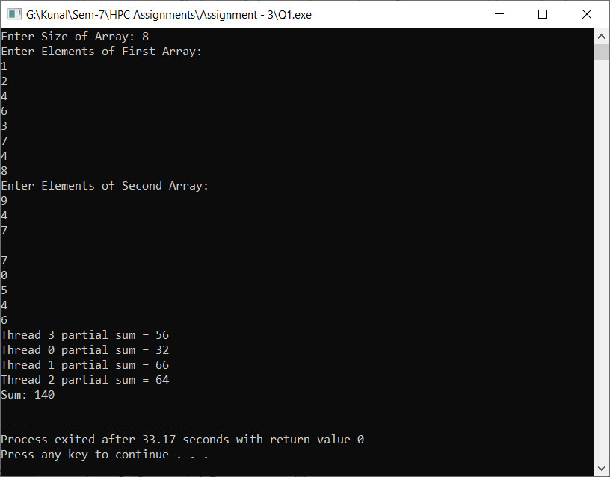

**Information 1:**

**Here I have to modify the give code for finding minimum from array in which I have used openmp clauses like schedule , static , private , for , reduction**

**I have printed intermediate steps on console .**

**Code : On github**

**Problem Statement 3:**

**Problem Statement 2:**

1. Write OpenMP code for two 2D Matrix addition, vary the size of your matrices from 250, 500, 750, 1000, and 2000 and measure the runtime with one thread (Use functions in C in calculate the execution time or use GPROF)
2. For each matrix size, change the number of threads from 2,4,8., and plot the speedup versus the number of threads.
3. Explain whether or not the scaling behaviour is as expected.

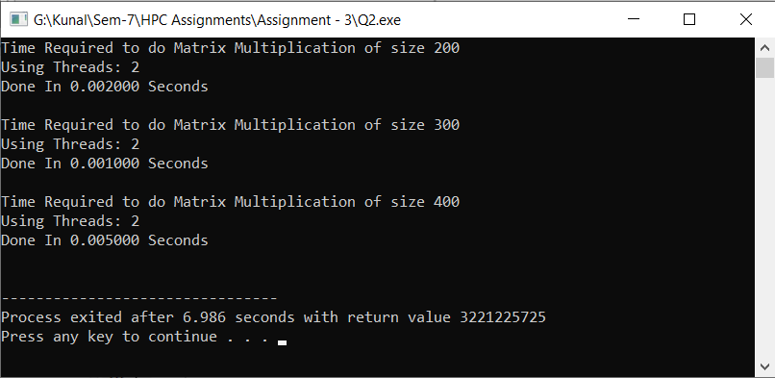

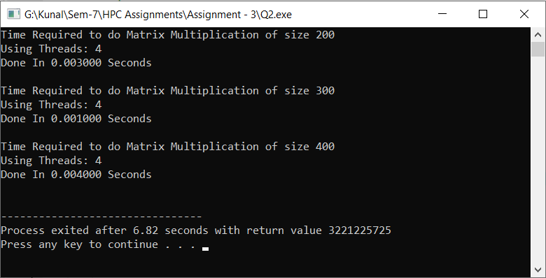

**Problem Statement 3: For 1D Vector (size=200) and scalar addition, Write a OpenMP code with the following:**

1. **Use STATIC schedule and set the loop iteration chunk size to various sizes when changing the size of your matrix. Analyze the speedup.**

**For array size 100000 with 4 threads :**

1. **Use DYNAMIC schedule and set the loop iteration chunk size to various sizes when changing the size of your matrix. Analyze the speedup.**

**For n=10000 with 4 threads**

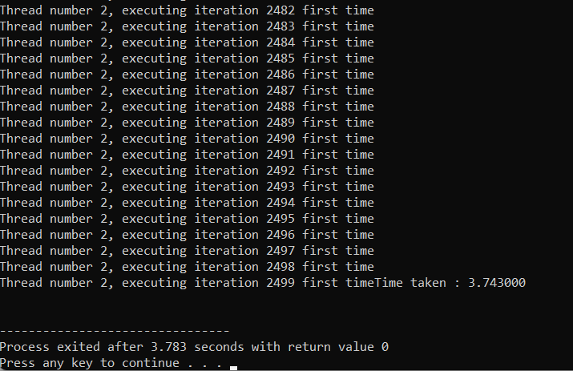

**For N= 100000 with 4 threads**

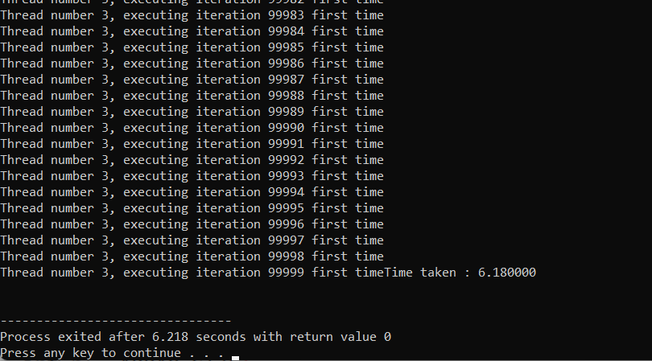

1. **Demonstrate the use of nowait clause**

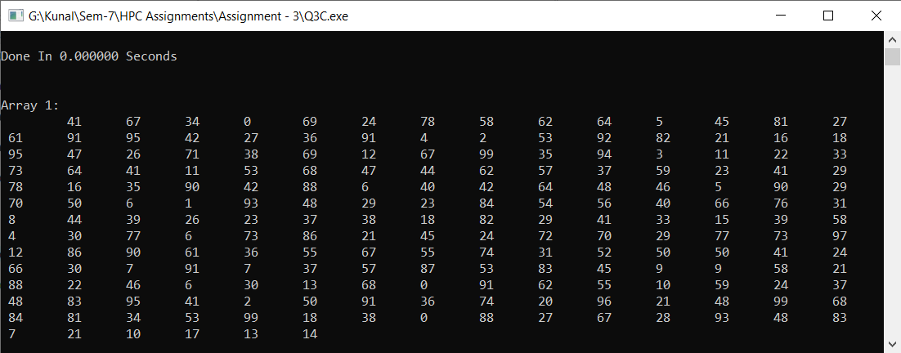

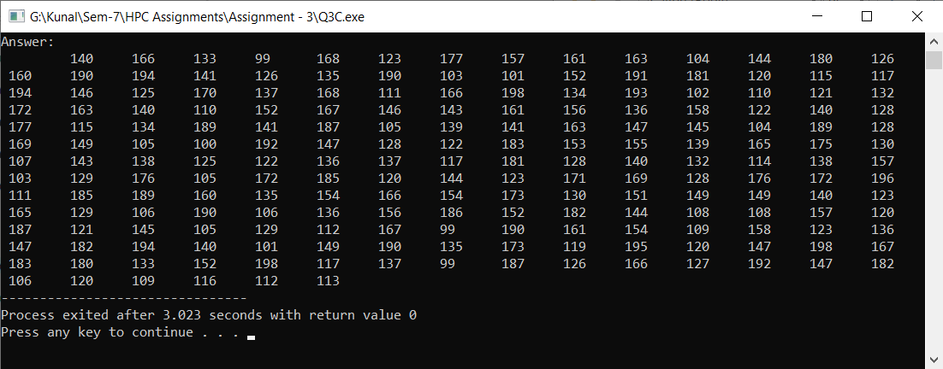

**Here I have used two threads which will execute with synchroniznation with nowait but as this is vector addition with scalar so independent execution have communication requirement thus nowait will execute .**

**Code : On github**

**Github Link:**

<https://github.com/Teknath-jha/HPC-LAB-2019BTECS00033/tree/main/Assignment-3>