Cross-Compiling Example Programs for BeagleBone

Introduction:
This document demonstrates how to open and run the ClearPath SDK Example programs on the Beagle Bone Black

Prerequisites:
- A BeagleBone Black, configured with ssh access (e.g. a username and password), connected to the internet and configured with the Exar USB driver (If using USB to communicate). see Preparing_the_BeagleBone.doc, and Setting_Up_EXAR_USB_Driver.doc
- A desktop Ubuntu computer, or a Ubuntu VM
- This document was tested with 64-bit Ubuntu 16.04 LTS
- ClearPath motors, cables, and SC hub

- Preparing your Ubuntu environment
  - From the terminal, update software with
sudo apt-get update && sudo apt-get upgrade
  - ((((Y/n dialog here... This can take a little while and occasionally hang)))))
  - Install software dependencies:
sudo apt-get install default-jre gdb-multiarch g++-arm-linux-gnueabihf
  - ((((had Y/n dialog here)))))
Here's why:
    - default-jre is needed to run Eclipse, as Eclipse is built on Java
    - gdb-multiarch is needed to debug programs from Eclipse while they execute on the BeagleBone
    - g++-arm-linux-gnueabihf is the compiler for the BeagleBone architecture
- Installing Eclipse
  - Note: These instructions download Eclipse directly, rather than using the installer, as the installer is less reliable.
  - Navigate to https://www.eclipse.org/downloads/eclipse-packages/
  - Next to "Eclipse IDE for C/C++ Developers" select the appropriate link (32 or 64 bit) for your machine
  - Click "Download"
  - Save the .tar.gz file (e.g. to ~/Downloads)
  - Extract the file
    - Double-click to open with Archive Manager
    - Select Extract
    - Choose a location and select Extract
    - Select "Show the Files"
- Running Eclipse
  - Double-click the eclipse directory
  - Double-click the eclipse executable:
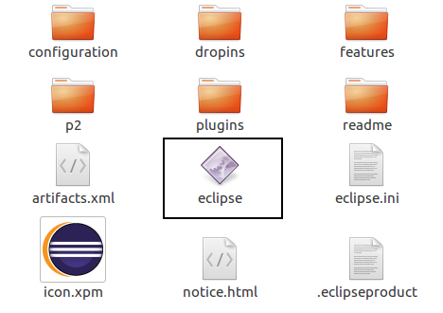
  - Select a workspace directory
    - The default location is fine
    - (Optional) Check "Use this as the default and do not ask again"
    - Click "Ok"
- Configuring Eclipse
  - From the menu bar at the top of your screen (even above the Eclipse window), choose "Help" -> "Install New Software"
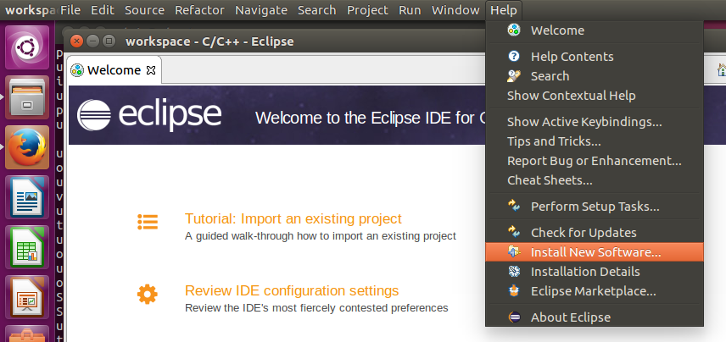
  - Next to "Work with:" type
http://gnuarmeclipse.sourceforge.net/updates
and press Enter
  - (Optional) Add this URL to Eclipse for later use
    - Choose Add
    - Enter "GNU ARM Eclipse" for Name, and http://gnuarmeclipse.sourceforge.net/updates for Location
    - Press OK
  - Check the "GNU ARM C/C++ Cross Development Tools" checkbox and hit Next
  - Click Next again, accept the license agreement, and click Finish
  - Click OK on the Security Warning dialogue
  - Click Yes on the Software Updates dialogue to allow Eclipse to restart
  - (Optional) Make it easier to start Eclipse by right-clicking on its icon in the launcher and selecting "Lock to Launcher"
  - (Recommended) From the menu bar, choose Window->Preferences->expand C/C++->expand Build->Global Tools Paths and set the Default toolchain to "Linaro ARMv7 Linux GNU EABI HF"; Apply; OK
- Downloading/Installing the sFoundation Library and Example programs
  - Download and extract the Linux_Software.tar file from Teknic's website: www.teknic.com/downloads under >>ClearPath>> Software >> Clearpath-SC
  - Extract the sFoundationPkg.tar file into the workspace directory for Ecplise
  - Optional: To run the Beaglebone TekTip examples, download the example projects from https://github.com/Teknic-ClearPath/Tektips-BeagleBone-Examples Save these examples into the SDK_Examples folder in the workspace and run these projects like any other example program.
- Opening the sFoundation/SDK_Examples
  - To open the projects in Eclipse, select File>>OpenProjects from File System...
  - For the Import source, click directory and navigate to the workspace
  - Ensure "Search for nested projects", and "Detect and configure project natures" checkboxes are selected, and click finish
- Building the libsFoundation20.so
  - Select the appropriate configuration by right-clicking the sFoundation project in the project explorer and select Build configurations >> set active, and select DebugBeagle (Debug version built for beaglebone)
  - Build the sFoundation project by right-clicking the sFoundation project in the project explorer and selecting Build Project
  - The libsFoundation20.so will be built into the sFoundation/DebugBeagle directory in your workspace
- Configuring the BeagleBone Black
  - You will need a copy of libsFoundation20.so on the BeagleBone in a library search path. Use any file upload tool you are comfortable with, or follow the steps below to do so from Eclipse:
    - From the menu bar, choose Window -> Perspective -> Open Perspective -> Other...
    - Select Remote System Explorer and click OK
    - Click the "Define a connection to a remote system" button
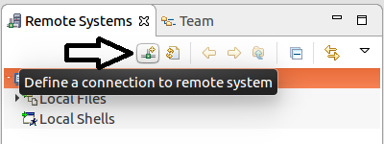
    - Select "SSH Only" and click Next
    - Enter the Host name or IP Address of your BeagleBone
    - Enter a Connection name (e.g. "BeagleBone Black")
    - (Optional) Enter a Description
    - Click Finish
    - You should now see a new connection with the name you gave it. Underneath, expand "Sftp Files", then Root. You will be prompted for authentication. Type the username and password (machinekit's default is machinekit/machinekit)
    - (Optional) Check "Save password". If you do this, you will be prompted to set up a master password after you click OK.
    - Click OK
    - When prompted that The authenticity of host can't be established, verify the fingerprint if you wish (steps below), then click Yes.
      - Fingerprint verification prevents MITM attacks. It is likely overkill if you are on a trusted local network.
      - On the BeagleBone, execute
ssh-keygen -lf /etc/ssh/ssh_host_rsa_key.pub
      - Verify the displayed fingerprint matches the one in Eclipse
    - Expand /
    - Drag-and-drop libsFoundation20.so onto tmp
    - Copy it to /usr/lib by executing the following command on the BeagleBone:
sudo cp /tmp/libsFoundation20.so /usr/lib/
  - For error messages to be interpreted you will need a copy of MNuserDriver20.xml in the same directory as libsFoundation20.so
    - Use the steps above starting from xiii to copy it to /usr/lib/
  - Create a directory on the BeagleBone to hold the compiled project files.
    - This can be done from the Remote Systems view as above, by right-clicking on a directory and choosing New -> Folder
    - Or, from the terminal on the BeagleBone, use mkdir, e.g.
mkdir ~/ClearPathTest (clarify where this would be Home/ Ubuntu)
  - You will need to synchronize the versions of the C++ standard library between your development machine and the BeagleBone.
    - On a terminal on the development machine (Ubuntu), execute
cd /usr/arm-linux-gnueabi/libhf
    - Execute the following command to locate your version:
ls -l libstdc++.so.6
    - You should see output like the following:
lrwxrwxrwx 1 root root 19 Dec 1 17:36 libstdc++.so.6 -> libstdc++.so.6.0.21
    - The filename in red (after the arrow) is the one you need to copy to the BeagleBone. Follow the steps above starting from xiii to copy it to the BeagleBone's /tmp/ directory, or use scp:
cdscp libstdc++.so.6.0.21 <username>@<ip>:/tmp/
    - (((((there is a password promt)))))
    - On the BeagleBone, move the file to /usr/lib/arm-linux-gnueabihf/:
sudo mv /tmp/libstdc++.so.6.0.21 /usr/lib/arm-linux-gnueabihf/
    - Update the link to point to this copied version on the BeagleBone:
cd /usr/lib/arm-linux-gnueabihf
sudo ln -fs libstdc++.so.6.0.21 libstdc++.so.6
  - Install gdbserver on the BeagleBone:
sudo apt-get update
sudo apt-get install gdbserver
  - Add your user to the dialout group so it can use the serial port:
sudo usermod -G dialout -a <username>
  - If you are using a serial cape or RS232 to TTL converter, enable the serial port of interest (for example, UART4):
edit /boot/uEnv.txt and add the following line to the end:
cape_enable=capemgr.enable_partno=BB-UART4
Then reboot the BeagleBone.
  - If you are using a USB cable, make sure the Teknic-modified Exar USB Driver is installed (see Exar Driver BeagleBone.doc)
- Configuring Remote Debugging
  - Remote Debugging lets you use the Eclipse debugger on your Linux computer to run and debug programs executing on the BeagleBone.
  - If you were in the Remote Systems perspective, switch back to the C/C++ perspective by clicking the icon with a C on it in the upper right
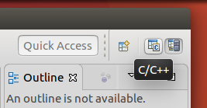
  - Right click on the project and choose Debug As -> Debug Configurations
  - Select C/C++ Remote Application and click the New button
  - Give it a name (if ProjectName Debug is prepopulated, it will work fine)
  - Fill in the fields in the Main tab:
    - Project should be the project you are trying to run. If not, hit Browse and select it.
    - C/C++ Application should be the compiled .elf file. If not, hit Browse and browse to it.
      - (Optional) Under "Build (if required) before launching", check Enable auto build
    - Next to "Connection:" choose "New..."
      - Select SSH as the connection type and hit OK
      - Give the connection a name e.g. "Remote BeagleBone"
      - For "Host:" enter the hostname or IP address of the BeagleBone
      - For User enter the username
      - Add an authentication method
        - If using passwords, select "Password based authentication" and enter your password
        - Otherwise, click "Network Connections, SSH2" and configure ssh.
        - Click Finish
    - Under "Remote Absolute File Path for C/C++ Application:", enter
<directoryname>/<projectname>.elf
Where <directoryname> is the absolute path to the directory you created earlier (on the BeagleBone), and <projectname> is the project name in eclipse e.g. /home/ubuntu/ClearPathTest/ClearPathTest.elf (if the username is "ubuntu")
  - Fill in the fields of the Arguments tab:
    - Under "Program arguments:" enter any arguments your program needs. Example, with a letter O not a number 0, /dev/ttyO4 (for serial users) or /dev/ttyXRUSB0
  - Fill in the fields of the Debugger tab:
    - Note the location of the Stop on startup checkbox so you can disable it later if it becomes unnecessary
    - Under the Debugger Options->Main tab, change GDB debugger to
gdb-multiarch
The Browse button will not work as this executable is only on the BeagleBone, not your development machine.
  - Click Apply
- Running the program
  - In the Debug Configurations window which should still be open, click Debug
  - If there is an "Error during file upload":
    - Close and re-open Eclipse and try again
    - Make sure program is not currently executing on Beaglebone
    - Make sure the "Remote absolute filepath" is in the folder you just created
    - Try creating the file on the BeagleBone manually and setting permissions:
touch /<directory>/<filename.elf>
chmod 777 /<directory>/<filename.elf>
  - If you get an Authentication Message, click OK
  - If you get a Confirm Perspective Switch option, choose "Yes"
  - If you did not uncheck "Stop on startup", the program will pause at Main. Hit the Resume button at the top of the Eclipse window.
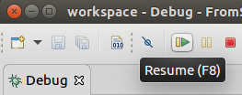
  - The program should begin to execute.
  - (Optional) The program can also be executed directly on the BeagleBone. From a terminal, navigate to the directory created earlier. Execute the program with any necessary arguments, e.g.
./ClearPathTest.elf /dev/ttyO4

