Interior Ballistics of the 5.56 × 45 mm NATO Cartridge
Pressure, bullet motion and muzzle conditions as a function of barrel length

A lumped-parameter model, its derivation, calibration and validation, together with a companion browser-based simulator.
Prepared for Åke Larsson, Getinge Critical Care.
Model, source code and this document: github.com/Teknosofen/BallisticAnalysis
Companion simulator: web/ballistics.html — a single self-contained HTML file with the same model implemented in JavaScript.
Revision 1.0 — August 2026

Contents
If the list below appears empty, click in it and press F9 (Word updates table-of-contents fields on demand).

1 Purpose and scope
This document derives, from first principles, a lumped-parameter interior ballistics model for the 5.56 × 45 mm NATO cartridge loaded with the M855 / SS109 62-grain projectile, and applies it to the question that motivated the work: how does barrel length change the pressure history in the bore, the position and velocity of the bullet, and — in particular — the pressure still acting behind the bullet at the instant it leaves the muzzle?
The deliverables are:
§2–§6 the governing equations, their derivation, the assumptions behind each one, and the numerical scheme used to integrate them.
§7–§9 a complete, sourced parameter set for the cartridge, the calibration procedure, and validation against published chronograph and pressure measurements.
§10 results: pressure–time and pressure–travel histories, muzzle velocity and muzzle pressure as functions of barrel length from 5 in to 26 in.
§11 an honest account of what this class of model gets wrong, and the specific upgrade paths — Lagrange gradient, one-dimensional gas dynamics, two-phase flow — that remove each limitation.
§12 how to drive the companion HTML simulator.
The model is of the classical "lumped-parameter" or "zero-dimensional" class: the same family as the US Army’s IBHVG2 and the interior-ballistics module of PRODAS. It treats the propellant gas as a single well-mixed control volume with one space-mean pressure and one temperature, then reconstructs the pressure at the breech, at the bullet base and at any station in between using the Lagrange gradient. That is enough to answer the barrel-length question quantitatively, and it runs in a few milliseconds in a browser, which a distributed model would not.

2 Nomenclature
SI units are used throughout the derivation. Results are reported in both SI and the customary US units of the source literature.
Symbol | Quantity | Unit | Value used
A | bore cross-sectional area | m² | 2.507 × 10⁻⁵
a | Vieille burning-rate coefficient | m s⁻¹ Pa⁻ⁿ | 3.908 × 10⁻⁸
d | effective bore diameter | m | 5.65 × 10⁻³
e, e₁ | burnt web depth; half-web (total burn distance) | m | e₁ = 1.30 × 10⁻⁴
f | propellant impetus (force constant), f = R T_v | J kg⁻¹ | 1.00 × 10⁶
h | wall heat-transfer coefficient | W m⁻² K⁻¹ | 3.333 × 10⁵
K | friction / engraving part of the secondary-work factor | — | 1.02
L_b | barrel length measured from the bolt face | m | variable
L₀ | reduced chamber length, L₀ = V₀ / A | m | 0.0658
m_b | projectile mass | kg | 4.018 × 10⁻³ (62 gr)
m_c | propellant charge mass | kg | 1.620 × 10⁻³ (25.0 gr)
n | Vieille burning-rate exponent | — | 0.80
p̄ | space-mean gas pressure | Pa | computed
p_br, p_base | pressure at the breech face / at the bullet base | Pa | computed
p_ign | pressure produced by the primer / igniter | Pa | 15 × 10⁶
p_start | shot-start (engraving) pressure | Pa | 30 × 10⁶
p_r | residual bore resistance | Pa | 10 × 10⁶
Q | cumulative heat lost to the bore and chamber walls | J | computed
S(x) | gas-swept wall area | m² | computed
T, T_v | mean gas temperature; adiabatic flame temperature | K | T_v = 2850
t | time from ignition | s | —
V₀ | free chamber volume behind the seated bullet base | m³ | 1.65 × 10⁻⁶
V_ψ | volume actually available to the gas | m³ | computed
v | bullet velocity | m s⁻¹ | computed
x | bullet travel from its seated position | m | computed
x_b0 | bullet-base position at rest, from the bolt face | m | 34.3 × 10⁻³
z | fraction of the web burnt, z = e / e₁ | — | state variable
α | propellant-gas covolume | m³ kg⁻¹ | 1.00 × 10⁻³
γ | ratio of specific heats of the gas | — | 1.24
θ | θ = γ − 1 | — | 0.24
ζ | charge-to-projectile mass ratio, m_c / m_b | — | 0.403
λ, χ, μ | form-function coefficients | — | λ = 0.380, χ = 0.725, μ = 0
ρ_p | density of the solid propellant | kg m⁻³ | 1600
φ | secondary-work factor, φ = K + ζ/3 | — | 1.154
ψ | burnt mass fraction of the charge | — | computed

3 Physical picture and modelling assumptions
The shot cycle divides into five overlapping phases:
1. Ignition. The primer sprays hot particles and gas into the charge, raising the pressure in the interstitial space between the propellant grains to a few tens of MPa and igniting the grain surfaces.
2. Pre-motion burning. The bullet is still held by the case-neck grip and by the rifling it has not yet engraved. Pressure rises at essentially constant volume, so it rises very quickly.
3. Engraving and early travel. At the shot-start pressure the bullet begins to move and its jacket is engraved by the lands. Gas generation still outruns the volume increase, so the pressure keeps climbing to its peak — for this cartridge about 0.4 ms after ignition, roughly 25–30 mm of travel.
4. Expansion. Past the peak, the volume behind the bullet grows faster than the gas is generated and the pressure falls. The charge is fully consumed at about 280–290 mm of travel — i.e. inside roughly the first 11.5 in of barrel.
5. Pure adiabatic expansion. From then until the muzzle the gas simply expands and cools while continuing to push. The pressure at the moment of exit — the "uncorking" pressure — is set entirely by how far the bullet has travelled, and this is why barrel length controls it so strongly.

3.1 Assumptions
The lumped-parameter formulation rests on the following assumptions. Each one is revisited in §11, where the cost of relaxing it is discussed.
A1. The propellant gas is spatially uniform in composition and temperature: one gas phase, one temperature, one density, one space-mean pressure.
A2. The gas obeys the Nobel–Abel equation of state with constant covolume α and constant ratio of specific heats γ.
A3. The impetus f and flame temperature T_v are constant, i.e. the combustion products do not shift with pressure or temperature.
A4. All grains are geometrically identical, ignite simultaneously at t = 0, and burn in parallel layers at a rate that depends only on the instantaneous pressure (the "geometric burning law").
A5. Solid and gas move together; there is no relative velocity between unburnt grains and gas, and no pressure wave travels through the charge bed.
A6. The gas velocity varies linearly from zero at the breech face to the bullet velocity at the bullet base (the Lagrange assumption), and the gas density is uniform along the column.
A7. Bore resistance is a prescribed function: a shot-start threshold p_start followed by a constant residual resistance p_r. It does not depend on velocity or on barrel temperature.
A8. Heat loss to the walls is convective, with a single constant coefficient h acting over the gas-swept area. The wall stays at its initial temperature.
A9. There is no gas leakage past the bullet, no bullet deformation, and the air ahead of the bullet offers negligible resistance.
A10. Rotational kinetic energy of the bullet is neglected. For a 1:7 in twist at 930 m/s it amounts to about 9 J, i.e. 0.5 % of the muzzle energy and 0.13 % of the charge’s chemical energy.

4 Governing equations

4.1 Equation of state
At the densities reached inside a small-arms chamber — the gas can exceed 500 kg m⁻³ near peak pressure — the ideal-gas law is badly in error because the molecules occupy a non-negligible fraction of the volume. The standard remedy in interior ballistics is the Nobel–Abel (covolume) equation of state:
$p\left(\frac{V}{m_{g}}−α\right)=R T$ (1)
where V is the volume occupied by the gas, m_{g} the mass of gas present, and α the covolume — physically the volume per unit mass that the molecules themselves exclude. For nitrocellulose propellant gases α ≈ 1.0 × 10⁻³ m³ kg⁻¹, which is close to the reciprocal of the density of the condensed phase, as it should be.
It is conventional in this field to work not with R but with the impetus or force constant
$f=R T_{v}$ (2)
which has units of J kg⁻¹ and is the quantity that propellant manufacturers characterise in a closed-bomb test. The specific internal energy of the gas, measured from the products at absolute zero, follows from c_{v} = R/θ:
$u=\frac{R T}{θ}=\frac{f T}{T_{v} θ}, θ=γ−1$ (3)
so that gas produced at the adiabatic flame temperature carries f/θ joules per kilogram. For f = 1.00 MJ kg⁻¹ and θ = 0.24 this is 4.17 MJ kg⁻¹, and the 1.620 g charge of a 5.56 round therefore holds 6 750 J of available chemical energy.

4.2 The form function
Let e be the depth of propellant burnt away normal to the grain surface and e₁ the half-web, i.e. the burn distance that consumes the grain completely. The dimensionless burn progress is
$z=\frac{e}{e_{1}}, 0≤z≤1$ (4)
The form function ψ(z) converts geometric burn progress into the burnt mass fraction. For grains that burn in parallel layers it is a cubic in z:
$ψ\left(z\right)=χ z\left(1+λz+μz^{2}\right), χ=\frac{1}{1+λ+μ}$ (5)
Normalisation requires ψ(1) = 1, so χ = 1/(1 + λ + μ). The single parameter λ then controls the character of the burn:
Grain geometry | χ | λ | μ | Character
Sphere, bare (ψ = 1 − (1−z)³) | 3 | −1 | 1/3 | strongly degressive
Solid cylinder (ψ = 1 − (1−z)²) | 2 | −0.5 | 0 | degressive
Thin flake / disc | 1.06 | −0.06 | 0 | nearly neutral
Single-perforated tube | 1 | 0 | 0 | neutral
Deterred flattened ball (fitted, §8) | 0.725 | 0.380 | 0 | progressive
Seven-perforation grain | 0.70 | 0.43 | 0 | progressive
A degressive grain has a burning surface that shrinks as it burns (a sphere is the extreme case); a progressive grain has a surface that grows, either because it is perforated or — as in the ball propellants used in 5.56 — because the outer layers are coated with a burn-rate deterrent that is consumed first. Progressivity is what allows a high muzzle velocity without an excessive pressure peak, and §8 shows that the fit to the measured data recovers exactly this.
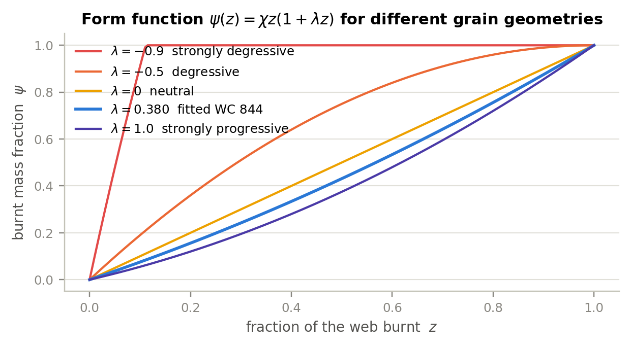
Figure 1 — The form function ψ(z) = χ z(1 + λz) for a range of progressivities. The fitted value λ = 0.380 for the 5.56 charge sits between neutral and strongly progressive, consistent with a surface-deterred ball propellant.

4.3 The burning-rate law
Solid propellant regresses normal to its surface at a rate that, over the pressure range of interest, is well represented by Vieille’s law (also called Saint-Robert’s law):
$\frac{de}{dt}=a p^{ n}$ (6)
Dividing by the half-web gives the first state equation of the model:
$\frac{dz}{dt}=\frac{a}{e_{1}} p^{ n}$ (7)
Note that a and e₁ are not separately identifiable from a pressure trace — only the ratio a/e₁ appears. They are kept separate in the model so that the effect of changing grain size at fixed chemistry can be explored: halving the web at constant a doubles the burn rate.

4.4 Volume available to the gas
The gas does not have the whole space behind the bullet. Part of it is still occupied by unburnt solid, and part is excluded by the covolume of the gas already produced:
$V_{ψ}=V_{0}+A x−\frac{m_{c}\left(1−ψ\right)}{ρ_{p}}−α m_{c} ψ$ (8)
At ignition, with ψ ≈ 0, this reduces to the ullage — the free space between the grains, V₀ − m_{c}/ρ_{p} = 0.638 cm³ for the reference load, or 39 % of the chamber volume. The corresponding solid packing fraction of 0.61 is physically sensible for spherical grains (random close packing is 0.64) and provides a useful consistency check on the charge mass and case capacity — the simulator warns if the combination becomes physically impossible.

4.5 Energy balance — the Résal equation
This is the heart of the model. Take a control volume enclosing everything behind the bullet base. Over the shot, the chemical energy liberated by the propellant that has burnt so far must equal the internal energy still stored in the gas, plus the kinetic energy given to the bullet and to the gas itself, plus the work done against bore friction, plus the heat conducted into the walls:
$m_{c} ψ \frac{f}{θ}=\frac{p V_{ψ}}{θ}+\frac{1}{2} φ m_{b} v^{2}+Q+W_{r}$ (9)
Reading term by term: the left-hand side is the energy released, f/θ per kilogram of propellant burnt. The first term on the right is the internal energy of the gas, which follows directly from §4.1 because u = RT/θ and p V_{ψ} = m_{g} R T. The second term is the total kinetic energy, written using the secondary-work factor φ derived in §4.6. The third is the heat lost to the walls (§4.8) and the fourth the work done against bore resistance, W_{r} = p_{r} A x.
Multiplying through by θ and solving for the pressure gives the algebraic closure that the time integration uses at every step:
$\overset{‾}{p}=\frac{f m_{c} ψ−θ\left[\frac{1}{2}φ m_{b} v^{2}+Q+p_{r} A x\right]}{V_{ψ}}$ (10)
The pressure is therefore never integrated: it is reconstructed from the state variables at every instant, which is numerically far better behaved than carrying p as a state. Equation (10) is the classical Résal equation with the loss terms made explicit; setting Q = W_{r} = 0 recovers the textbook form.

4.6 The Lagrange pressure gradient
The gas column between the breech face and the bullet base is itself accelerating, so the pressure cannot be uniform: it must fall from the breech towards the bullet in order to accelerate the gas. This gradient matters here — for the 5.56 the charge is 40 % of the bullet mass, and the breech pressure exceeds the base pressure by about 20 %.
The Lagrange approximation assumes the gas velocity varies linearly with distance y from the breech, u(y) = v y/L, and the gas density is uniform. Consider a force balance on everything downstream of station y: the gas from y to L has mass m_{c}(1 − y/L) and, on the linear profile, mean acceleration a(y + L)/2L, so
$p\left(y\right) A=\left[m_{b}+\frac{m_{c}}{2}\left(1−\frac{y^{2}}{L^{2}}\right)\right]\frac{dv}{dt}$ (11)
Evaluating at the two ends and averaging over the column gives the three pressures that the model reports, in terms of the charge-to-bullet ratio ζ = m_{c} / m_{b}:
$\frac{p_{br}}{p_{base}}=1+\frac{ζ}{2}, \frac{\overset{‾}{p}}{p_{base}}=1+\frac{ζ}{3}, ζ=\frac{m_{c}}{m_{b}}$ (12)
For the reference load ζ = 0.403, so p_{br} : p̄ : p_{base} = 1.202 : 1.134 : 1. This is not a cosmetic correction. It is the reason a transducer at the case mouth and a transducer near the muzzle read different things, and it is why the model reports all three stations separately. The pressure at any intermediate station — for example a gas port — follows from Eq. (11) directly.

4.7 Equation of motion
Newton’s second law for the bullet uses the pressure at its base, less the bore resistance:
$m_{b} \frac{dv}{dt}=A\left(p_{base}−p_{r}\right)$ (13)
Substituting p_{base} = p̄/(1 + ζ/3) from Eq. (12) converts this into an equation in the space-mean pressure with an effective mass:
$φ m_{b} \frac{dv}{dt}=A\left(\overset{‾}{p}−p_{r}\right), φ=K+\frac{ζ}{3}$ (14)
The term ζ/3 is exactly the Lagrange gas inertia — a third of the charge mass must be accelerated along with the bullet. The extra factor K ≥ 1 absorbs the rotational inertia imparted by the rifling and the part of the engraving work not captured by p_{r}; K = 1.02 is used here. The bullet does not move at all until the pressure first exceeds the shot-start pressure:
$\frac{dv}{dt}=0 \text{while} v=0 \text{and} \overset{‾}{p}<p_{start}$ (15)

4.8 Heat loss to the barrel
A 5.56 bore has an extreme surface-to-volume ratio, and heat loss is correspondingly large — the calibration in §8 puts it at about a quarter of the charge’s chemical energy. A single lumped convective law is used:
$\frac{dQ}{dt}=h S\left(x\right)\left(T−T_{w}\right)$ (16)
with the gas-swept area taken as an equivalent cylinder of the reduced length L₀ + x:
$S\left(x\right)=π d\left(L_{0}+x\right)+2A, L_{0}=\frac{V_{0}}{A}$ (17)
and the mean gas temperature obtained from the equation of state:
$T=\frac{p V_{ψ} T_{v}}{f m_{c} ψ}$ (18)
Modelling heat loss as a rate rather than as a flat reduction of the impetus matters. A constant efficiency factor removes energy in proportion to the energy released, i.e. mostly early; the real loss keeps accumulating during the expansion phase, when the swept area is largest. That difference shows up almost entirely in the muzzle pressure and hardly at all in the muzzle velocity, because by then most of the impulse has already been delivered. It was only after replacing the flat factor with Eq. (16) that the model could match measured velocity and measured uncorking pressure at the same time.

4.9 Ignition
The burning-rate law is degenerate at ψ = 0: no gas means no pressure means no burning. The primer breaks this deadlock. It is represented by specifying the pressure p_{ign} it establishes in the ullage, and inverting Eq. (10) at x = v = Q = 0 for the corresponding initial burnt fraction:
$ψ_{0}=\frac{p_{ign}\left(V_{0}−\frac{m_{c}}{ρ_{p}}\right)}{f m_{c}−p_{ign} m_{c}\left(\frac{1}{ρ_{p}}−α\right)}$ (19)
The initial value of the state variable is then z₀ = ψ⁻¹(ψ₀), obtained by bisection on the cubic Eq. (5). For the reference load p_{ign} = 15 MPa gives ψ₀ = 0.0064 — less than 1 % of the charge, so the result is insensitive to the exact value.

4.10 The closed system
Collecting the results, the model is a system of four coupled first-order ordinary differential equations in the state vector y = [z, x, v, Q]:
$\frac{dz}{dt}=\frac{a}{e_{1}} {\overset{‾}{p}}^{ n}, \frac{dx}{dt}=v$ (20)
$\frac{dv}{dt}=\frac{A\left(\overset{‾}{p}−p_{r}\right)}{φ m_{b}}, \frac{dQ}{dt}=h S\left(x\right)\left(T−T_{w}\right)$ (21)
closed at every step by the algebraic relations Eq. (5), Eq. (8), Eq. (10), Eq. (12) and Eq. (18). Integration stops when x reaches the bullet travel
$x_{max}=L_{b}−x_{b0}$ (22)
and the state at that instant gives the two answers of primary interest: the muzzle velocity v_{m} = v(t_{exit}) and the muzzle pressure — reported as the base, mean and breech values via Eq. (12).

5 What sets the muzzle conditions
Before turning to numbers it is worth stating the physics of the barrel-length question in one paragraph, because the model then simply confirms it.
Once the charge is fully consumed — for this cartridge at about 290 mm of travel — no further energy enters the system. From that point the gas is a fixed parcel doing work on a piston, and to a good approximation the pressure follows a polytropic expansion, p V_{ψ}^{k} ≈ constant, with k somewhat above γ because heat continues to leave through the walls. Two consequences follow immediately:
Velocity saturates. The work extracted over an extra increment of travel is p A dx, and p is already falling steeply, so each additional inch buys less than the last. The model gives 205 ft/s per inch at 5 in of barrel, 60 ft/s per inch at 14.5 in, and 21 ft/s per inch at 22 in.
Muzzle pressure collapses. Because p ~ V^{−k} and V grows linearly with travel, the pressure at exit falls roughly as the inverse 1.2–1.4 power of the expansion ratio. It is an inherently much steeper function of barrel length than the velocity is.
That asymmetry is the practical headline of this study: shortening a 20 in barrel to 10.5 in costs 15 % of the muzzle velocity but triples the pressure still behind the bullet when it uncorks. Blast, flash and suppressor loading scale with that pressure, not with velocity — which is why short barrels are disproportionately loud and violent at the muzzle for the velocity they give up.

6 Numerical solution
The system Eq. (20)–Eq. (21) is integrated with a fixed-step classical fourth-order Runge–Kutta scheme. Each step evaluates the derivative four times; the pressure closure Eq. (10) is re-evaluated inside every derivative call, so the algebraic constraint is satisfied at all four stages rather than only at the step boundaries.
A fixed step is adequate here because the problem is smooth and its total duration is known in advance to within a factor of two. The step-size study below was run at the reference 20 in configuration:
Δt (µs) | Steps to exit | v_m (m/s) | p_peak (MPa) | p_muzzle,base (MPa) | t_exit (µs)
2.00 | 530 | 920.489 | 380.048 | 47.774 | 1060.0
1.00 | 1059 | 920.183 | 379.968 | 47.956 | 1059.0
0.50 | 2117 | 920.030 | 379.927 | 48.047 | 1058.5
0.20 | 5291 | 919.991 | 379.969 | 48.093 | 1058.2
0.10 | 10581 | 919.947 | 379.944 | 48.114 | 1058.1
0.05 | 21162 | 919.957 | 379.956 | 48.112 | 1058.1
The scheme is converged to better than 0.01 % in velocity and 0.1 % in muzzle pressure by Δt = 0.5 µs, which is the default in the browser simulator — roughly 2 100 steps, or a few milliseconds of computation. (These figures come from an earlier parameter iteration and so differ slightly from the final calibrated results in §10; the convergence behaviour is unchanged.) The reference Python implementation uses 0.1 µs. A second, independent check is available at no cost: the energy balance Eq. (9) can be evaluated at muzzle exit and compared with the chemical energy of the charge. The residual is −0.51 % at the default step and is dominated by the discrete accounting of friction work, not by the integrator; both the Python model and the browser model report it continuously.
The two implementations were cross-checked directly. python/verify_js.js loads the HTML page in a headless browser, sweeps the barrel length, and python/compare_js_py.py compares the result against the Python reference at the same time step. Over 16 barrel lengths from 5 in to 26 in the worst relative disagreement in muzzle velocity, muzzle pressure or peak pressure is 0.021 %.

7 Parameter set for 5.56 × 45 mm NATO / M855
The table distinguishes three classes of parameter: measured and published, derived by calculation from published dimensions, and fitted (§8). This distinction matters when judging how much confidence to place in a prediction.

7.1 Cartridge and weapon geometry
Parameter | Value | Class | Source / note
Case length | 44.70 mm | published | Wikipedia, 5.56×45 mm NATO
Cartridge overall length | 57.40 mm | published | Wikipedia; inetres 5.56 mm ammunition
M855 bullet mass | 62 gr = 4.018 g | published | inetres 5.56 mm ammunition
M855 bullet length | ≈ 23.0 mm (0.906 in) | published | measured values reported by users; JBM 0.907 in
Land / groove diameter | 5.56 / 5.69 mm | published | Wikipedia, 5.56×45 mm NATO
Effective bore diameter d | 5.65 mm | assumed | between land and groove; A = 25.07 mm²
Case water capacity | 1.85 cm³ (28.5 gr H₂O) | published | Wikipedia, 5.56×45 mm NATO
Free volume behind bullet V₀ | 1.65 cm³ | derived | case capacity less the seated bullet volume; see note
Bullet base from bolt face x_b0 | 34.3 mm | derived | COAL − bullet length
Bullet travel | L_b − 34.3 mm | derived | 473.7 mm in a 20 in barrel
Note on V₀. The seating depth is 44.70 + 23.0 − 57.40 = 10.3 mm; the boat-tailed spitzer occupies roughly 0.26 cm³ of the case over that length, leaving about 1.59 cm³. A value of 1.65 cm³ is adopted, allowing for the boat-tail relief and for chamber-throat volume ahead of the case mouth. This is a derived number, not a published one, and it is the single geometric quantity with the largest residual uncertainty. It is exposed as a slider in the simulator for exactly that reason.

7.2 Propellant
M855 is loaded with WC 844, a single-base, surface-deterred, flattened spherical ("ball") propellant produced by St. Marks Powder. Its thermochemical constants are not published in the open literature, so generic single-base nitrocellulose values are used and the burning-rate parameters are fitted. This is the principal source of parametric uncertainty in the model and is stated plainly rather than buried.
Parameter | Value | Class | Source / note
Charge mass m_c | 25.0 gr = 1.620 g | assumed | open sources quote 25–26.1 gr for M855; 25.0 gr is the largest value consistent with the case volume and a physical packing fraction
Solid density ρ_p | 1600 kg m⁻³ | generic | standard for nitrocellulose ball propellant
Impetus f | 1.00 MJ kg⁻¹ | generic | single-base NC propellants: 0.95–1.05 MJ kg⁻¹
Flame temperature T_v | 2850 K | generic | single-base NC: 2800–3000 K
Covolume α | 1.00 × 10⁻³ m³ kg⁻¹ | generic | standard value for NC combustion products
Ratio of specific heats γ | 1.24 | generic | θ = γ − 1 = 0.24
Half-web e₁ | 0.130 mm | assumed | only the ratio a/e₁ is identifiable (§4.3)
Vieille exponent n | 0.80 | fitted / generic | literature values 0.69–0.9; a free fit returns 0.797
Vieille coefficient a | 3.908 × 10⁻⁸ m s⁻¹ Pa⁻ⁿ | fitted | §8
Form-function λ | 0.380 (χ = 0.725) | fitted | §8; progressive, consistent with a deterred grain

7.3 Losses
Parameter | Value | Class | Source / note
Igniter pressure p_ign | 15 MPa | assumed | result is insensitive (§4.9)
Shot-start pressure p_start | 30 MPa | assumed | typical small-arms engraving pressure, 20–50 MPa
Residual bore resistance p_r | 10 MPa | assumed | gives 119 J of friction work over a 20 in barrel, ≈ 1.8 % of the charge energy
Secondary-work factor K | 1.02 | assumed | rotational inertia and un-modelled engraving work
Heat-transfer coefficient h | 3.33 × 10⁵ W m⁻² K⁻¹ | fitted | §8; yields 25 % heat loss over a 20 in barrel
Wall temperature T_w | 300 K | assumed | cold barrel, first round

7.4 Reference pressure and velocity data
Quantity | Value | Source
NATO EPVAT maximum mean chamber pressure | 430 MPa (62 366 psi) | Wikipedia, 5.56×45 mm NATO
SCATP 5.56 maximum average pressure (case-mouth port) | 380 MPa (55 114 psi) | Wikipedia, 5.56×45 mm NATO
SAAMI .223 Rem maximum average pressure | 379 MPa (55 000 psi) | Wikipedia, .223 Remington
SS109 measured peak, EPVAT case-mouth port (n = 30) | 343.7 ± 7.3 MPa | Int. J. Metrology & Quality Engineering (2026)
SS109 measured velocity, same test series | 926.4 ± 3.6 m/s | Int. J. Metrology & Quality Engineering (2026)
M855 measured peak, port 3 in from bolt face (n = 9) | 384 MPa (55 744 psi) | Small Arms Defense Journal, barrel-length study
M855 nominal muzzle velocity, 20 in | 3025 ft/s (922 m/s) | inetres 5.56 mm ammunition
On the EPVAT / SAAMI discrepancy. The 430 MPa NATO figure and the 380 MPa SCATP figure are not two different pressures; they are the same event measured with transducers at different locations and with different conformal-piston conventions. The model’s peak breech pressure is therefore calibrated to 380 MPa, consistent with the case-mouth and 3 in port measurements, and not to the 430 MPa EPVAT ceiling.

8 Calibration
Three parameters are fitted; everything else is fixed at the values in §7. The three are chosen because they are the ones genuinely unknown for this propellant, and because each has a distinct signature in the data:
a — the Vieille coefficient. Controls how fast the charge is consumed and therefore, almost alone, the height and timing of the pressure peak.
λ — the form-function progressivity. Controls the shape of the pressure curve after the peak, and therefore how much velocity is obtained for a given peak pressure.
h — the wall heat-transfer coefficient. Controls how much energy leaves late in the cycle, and therefore the curvature of the velocity-versus-barrel-length curve and the muzzle pressure.
They are fitted by weighted least squares against eleven measurements: the peak breech pressure (380 MPa, weighted × 3) and ten muzzle-velocity points spanning 7 in to 22 in from three independent test series. The four published muzzle-pressure figures are deliberately withheld from the fit so that they can serve as an independent check (§9.2).
Fitted parameter | Value | Comment
a | 3.9077 × 10⁻⁸ m s⁻¹ Pa⁻ⁿ | with n = 0.80 and e₁ = 0.130 mm; a/e₁ = 3.006 × 10⁻⁴ s⁻¹ Pa⁻ⁿ
λ | 0.3799 (χ = 0.7247) | progressive — physically consistent with a surface-deterred ball propellant
h | 3.333 × 10⁵ W m⁻² K⁻¹ | gives 1742 J, i.e. 25.4 % of the charge energy, lost to the walls over 20 in
Two robustness checks were run. First, freeing the Vieille exponent n as a fourth parameter returns n = 0.797 and changes the predictions by less than 0.5 % — so fixing it at 0.80 costs nothing. Second, adding the four withheld muzzle-pressure points to the objective with a moderate weight moves the fitted parameters by under 4 % and does not materially improve the muzzle-pressure agreement at short barrels; that discrepancy is discussed in §9.2 and is not a fitting artefact.
On the size of the heat loss. A quarter of the propellant energy going into the barrel is at the upper end of what the literature reports for small arms (typically 10–25 %). It is, however, what the shape of the velocity-versus-length data demands, and it is physically plausible for a 5.65 mm bore, whose surface-to-volume ratio is far higher than that of the artillery pieces from which the usual figures derive. Some of this fitted "heat loss" is undoubtedly standing in for other unmodelled sinks — incomplete combustion, dissociation of the products at peak temperature, and gas leakage past the bullet.

9 Validation

9.1 Muzzle velocity
Three independent published test series are available for M855-class ammunition. They disagree with each other by up to 8 % at the same barrel length, which sets a realistic floor on what any model can be expected to achieve.
Barrel (in) | Source | Measured (ft/s) | Model (ft/s) | Error
7.0 | Lucky Gunner | 2257 | 2183 | −3.3 %
10.5 | Lucky Gunner | 2653 | 2589 | −2.4 %
14.5 | Lucky Gunner | 2920 | 2859 | −2.1 %
14.5 | SADJ / Watters | 2700 | 2859 | +5.9 %
16.0 | Lucky Gunner | 2990 | 2925 | −2.2 %
16.1 | TFB (PMC M855) | 2932 | 2930 | −0.1 %
18.0 | Lucky Gunner | 3058 | 2993 | −2.1 %
20.0 | SADJ / Watters | 2979 | 3046 | +2.2 %
20.0 | TFB (FN 20 in CHF) | 3059 | 3046 | −0.4 %
22.0 | Lucky Gunner | 3110 | 3088 | −0.7 %
RMS error 2.7 %, maximum 5.9 % — and the largest single residual is against the SADJ 14.5 in point, which itself sits 8 % below the Lucky Gunner value at the same length. Within the scatter of the source data the model is doing as well as the data allow.
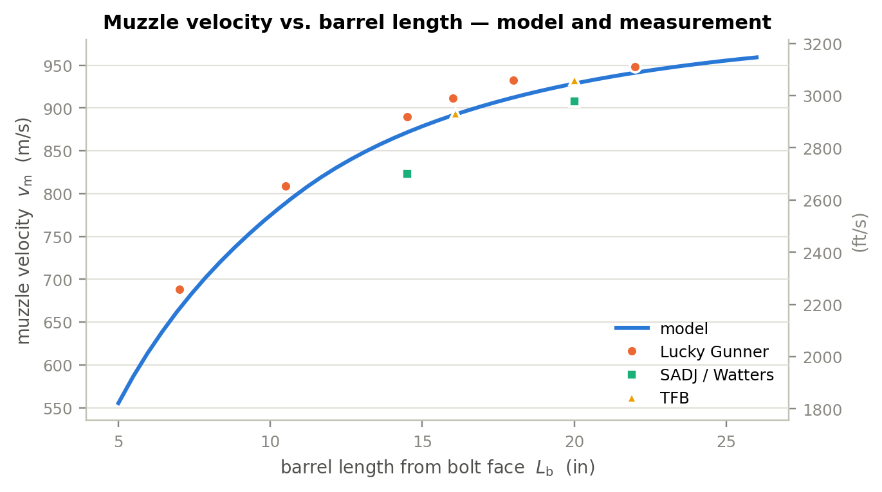
Figure 2 — Muzzle velocity versus barrel length. The continuous curve is the model; symbols are three independent published test series for M855-class ammunition. Note the spread between series at 14.5 in and at 20 in.

9.2 Muzzle (uncorking) pressure
The only published measurements of the pressure remaining in the bore at the instant of bullet exit come from the Small Arms Defense Journal cut-barrel study, which drilled ports at 1 in intervals and instrumented a barrel progressively shortened from 24 in to 5 in. These four points were withheld from the calibration.
Barrel (in) | Measured (psi) | Model, p_base (psi) | Difference
24.0 | 4 800 | 5 209 | +8.5 %
14.5 | 8 150 | 13 220 | +62 %
10.5 | 11 500 | 21 810 | +90 %
7.0 | 17 140 | 29 290 | +71 %
This is the model’s weakest result and it should not be glossed over. The long-barrel point is matched well; the short-barrel points are over-predicted by a factor approaching two. Three observations bear on the discrepancy.
First, the model is energetically self-consistent. An independent energy balance — measured velocity in, gas volume at exit computed from geometry — gives about 30 000 psi of mean pressure at the muzzle of a 7 in barrel, essentially the model value. To produce the measured 17 140 psi instead, roughly 1 500 J of additional energy would have to disappear in 0.64 ms in a 7 in barrel, which is more than the entire wall loss the model computes for a 20 in barrel over 1.03 ms. No consistent thermal model does that.
Second, the measured set is internally steep-but-not-steep-enough. Between 24 in and 7 in the gas volume behind the bullet falls by a factor 3.06. A pure adiabatic expansion at γ = 1.24 would therefore give a pressure ratio of 4.25, and the real ratio should be larger still, because at 7 in some 20 % of the charge is still unburnt and generating gas. The measured ratio is 3.57 — flatter than adiabatic. That is difficult to reconcile with any model in which the propellant is still burning at 7 in.
Third, the measurement is genuinely hard. The published intermediate values at 14.5 in and 10.5 in are stated to have been obtained by averaging adjacent port measurements, and the end points are read from a chart. A drilled port with finite volume, sampling a pressure that is changing at order 10⁵ MPa s⁻¹ at the instant the bullet passes, will read low.
The honest conclusion is that the trend — muzzle pressure rising steeply and non-linearly as the barrel shortens — is robust and is reproduced, but the absolute level at barrels below about 12 in should be treated as an upper bound with an uncertainty of roughly a factor of two. Section 11 identifies which modelling upgrade would most likely resolve it.
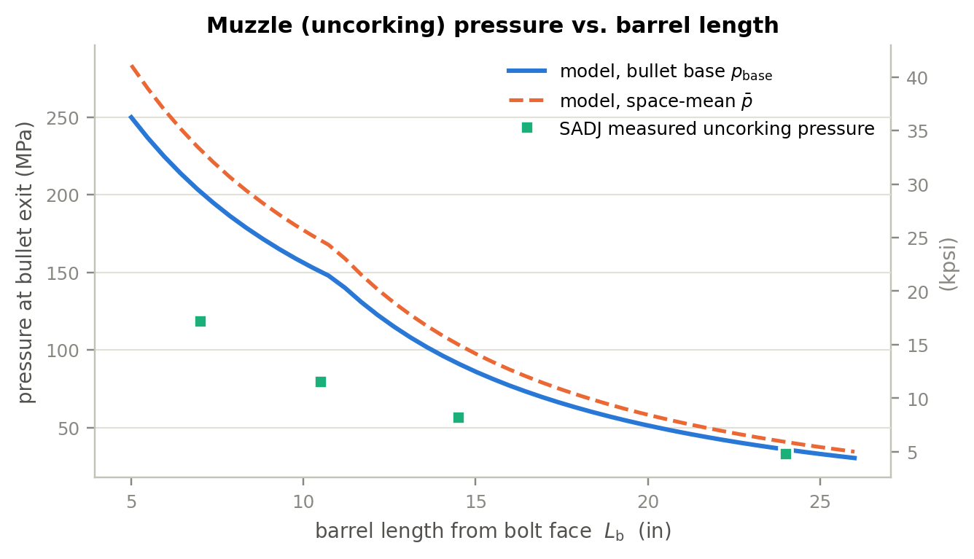
Figure 3 — Muzzle pressure at bullet exit versus barrel length. The kink near 11.5 in is the point at which the charge becomes fully consumed before the bullet exits; below it, propellant is still burning as the bullet uncorks. Measured points were not used in the calibration.

9.3 Energy balance
A model that reproduces velocities but violates conservation of energy is not to be trusted. The budget below is evaluated at muzzle exit for the reference 20 in barrel and closes to within 0.5 %, the residual being discretisation of the friction work.
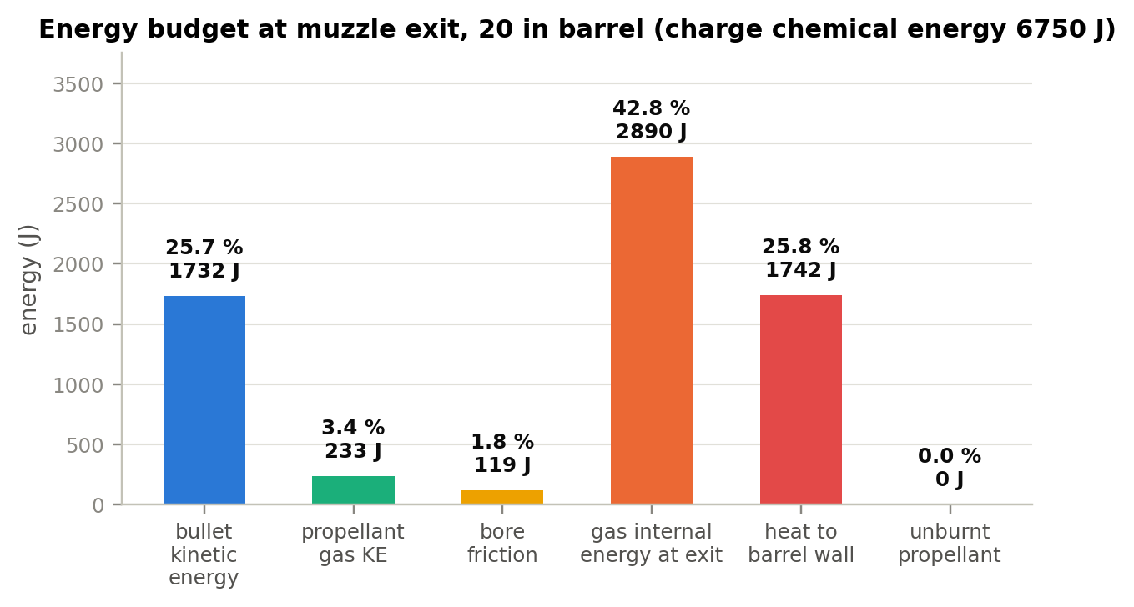
Figure 4 — Energy budget at muzzle exit, 20 in barrel. Only about a quarter of the charge’s chemical energy ends up as bullet kinetic energy; more than 40 % is still stored in the gas at the muzzle and is dumped into the atmosphere as blast.
Destination | Energy (J) | Share of charge energy
Chemical energy of the charge (m_c f / θ) | 6750 | 100.0 %
Bullet translational kinetic energy | 1732 | 25.7 %
Propellant-gas kinetic energy (Lagrange) | 233 | 3.5 %
Work against bore resistance | 119 | 1.8 %
Internal energy still in the gas at exit | 2890 | 42.8 %
Heat conducted into the barrel | 1742 | 25.8 %
Unburnt propellant ejected | 0 | 0.0 %
Total accounted for | 6715 | 99.5 %
The 25.7 % thermal efficiency is typical for small arms, and the fact that 43 % of the energy is still in the gas at the muzzle is the quantitative statement of why a rifle muzzle blast is so energetic.

10 Results

10.1 Reference shot, 20 in barrel
Quantity | Value | Alternative units
Peak breech pressure | 385.0 MPa | 55 840 psi, at t = 0.408 ms
Peak space-mean pressure | 363.3 MPa | 52 690 psi
Muzzle velocity | 928.5 m/s | 3046 ft/s
Muzzle pressure, bullet base | 51.3 MPa | 7 447 psi
Muzzle pressure, space-mean | 58.2 MPa | 8 448 psi
Muzzle pressure, breech | 61.7 MPa | 8 951 psi
Muzzle-exit time | 1.034 ms | bullet travel 474.0 mm
Muzzle energy | 1732 J | 1277 ft·lbf
Charge burnt at exit | 100 % | complete at ≈ 290 mm of travel
Peak bullet acceleration | 1.91 × 10⁶ m/s² | 195 000 g
Gas temperature at exit | 1220 K | from 2850 K flame temperature
Gas-port pressure at exit (port at 12 in) | 58.1 MPa | 8 431 psi
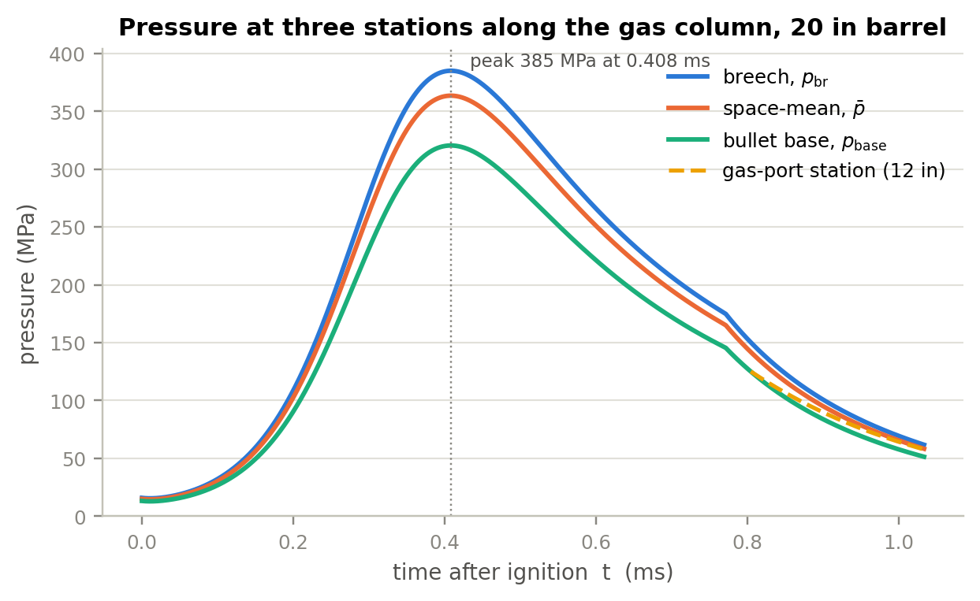
Figure 5 — Pressure at the breech face, space-mean, and bullet base for the reference 20 in barrel, together with the pressure at a 12 in gas port from the moment the bullet base uncovers it. The three stations differ by about 20 % near the peak — a direct consequence of the Lagrange gradient, Eq. (12).

10.2 Effect of barrel length
The table below is the central result. It is the same data the simulator produces interactively, tabulated at the barrel lengths of practical interest — 10.3 in (Mk18 CQBR), 11.5 in, 14.5 in (M4), 16 in (civilian minimum), 18 in, 20 in (M16A2/A4).
L_b (in) | L_b (mm) | v_m (m/s) | v_m (ft/s) | p_base at exit (MPa) | (psi) | p_breech at exit (MPa) | t_exit (ms) | ψ at exit (%) | E_m (J)
5.0 | 127 | 555.3 | 1822 | 249.8 | 36 230 | 300.2 | 0.553 | 63.4 | 620
7.0 | 178 | 665.4 | 2183 | 202.0 | 29 290 | 242.7 | 0.636 | 78.6 | 889
7.5 | 191 | 687.1 | 2254 | 192.6 | 27 930 | 231.4 | 0.654 | 81.8 | 948
10.3 | 262 | 783.3 | 2570 | 152.6 | 22 130 | 183.4 | 0.751 | 97.0 | 1233
10.5 | 267 | 789.0 | 2589 | 150.3 | 21 810 | 180.7 | 0.757 | 98.0 | 1251
11.5 | 292 | 815.2 | 2674 | 134.1 | 19 460 | 161.2 | 0.789 | 100 | 1335
14.5 | 368 | 871.5 | 2859 | 91.2 | 13 220 | 109.5 | 0.879 | 100 | 1526
16.0 | 406 | 891.4 | 2925 | 76.9 | 11 160 | 92.4 | 0.922 | 100 | 1596
18.0 | 457 | 912.3 | 2993 | 62.4 | 9 048 | 75.0 | 0.979 | 100 | 1672
20.0 | 508 | 928.5 | 3046 | 51.3 | 7 447 | 61.7 | 1.034 | 100 | 1732
22.0 | 559 | 941.2 | 3088 | 42.8 | 6 200 | 51.4 | 1.088 | 100 | 1779
24.0 | 610 | 951.2 | 3121 | 35.9 | 5 209 | 43.2 | 1.142 | 100 | 1817
26.0 | 660 | 959.1 | 3147 | 30.4 | 4 408 | 36.5 | 1.195 | 100 | 1848
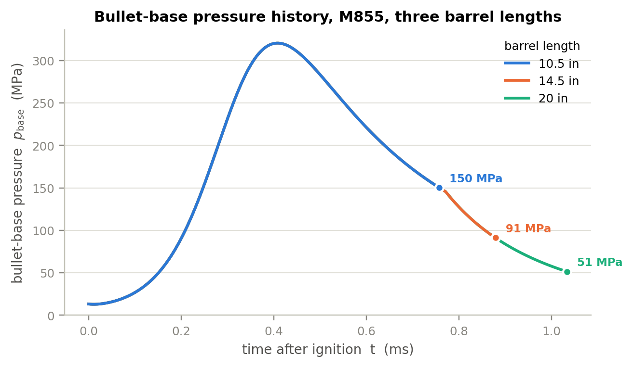
Figure 6 — Bullet-base pressure history for three barrel lengths. The three curves are identical until the shortest barrel uncorks: barrel length does not change the pressure history, it only decides where on that history the bullet leaves. The end point of each curve is its muzzle pressure.
This is the single most useful way to see the answer. Everything that happens inside the bore up to the moment of exit is independent of what comes after, so a 10.5 in barrel and a 20 in barrel produce exactly the same pressure–time curve; the shorter one simply stops sooner, at a point where the pressure is still 150 MPa rather than 51 MPa. Peak pressure is therefore completely independent of barrel length (385.0 MPa in every row of the table above), which is why a short-barrelled rifle is no harder on the case head than a long one.
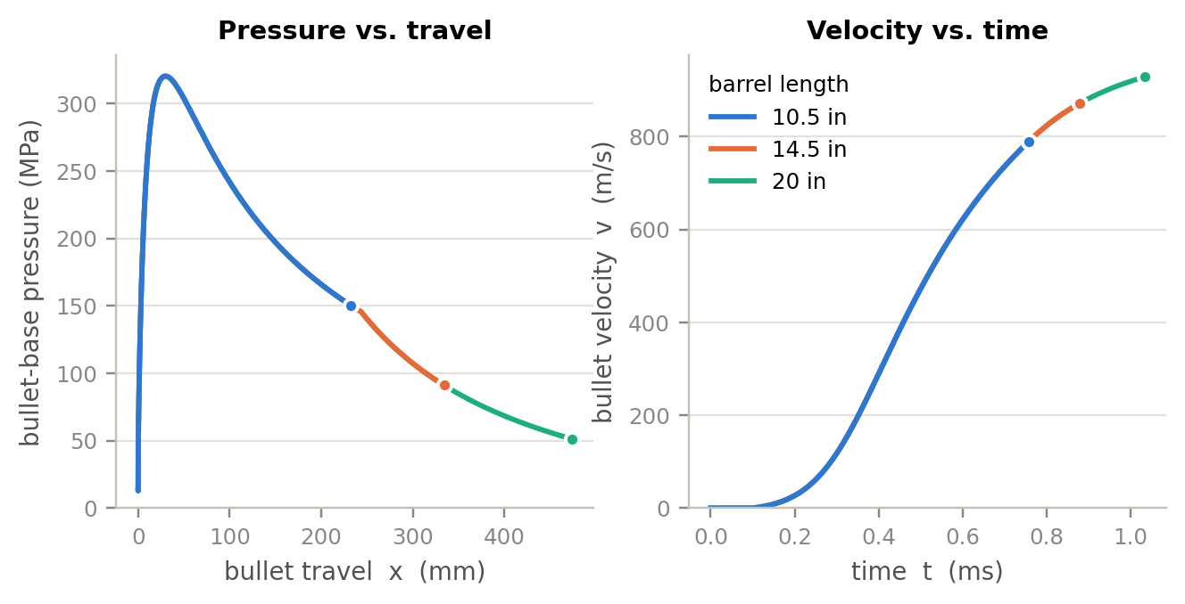
Figure 7 — Left: bullet-base pressure against bullet travel — the area under each curve, multiplied by the bore area, is the work delivered to the bullet. Right: velocity against time, showing how the acceleration has already fallen to a small value long before the muzzle of a long barrel.
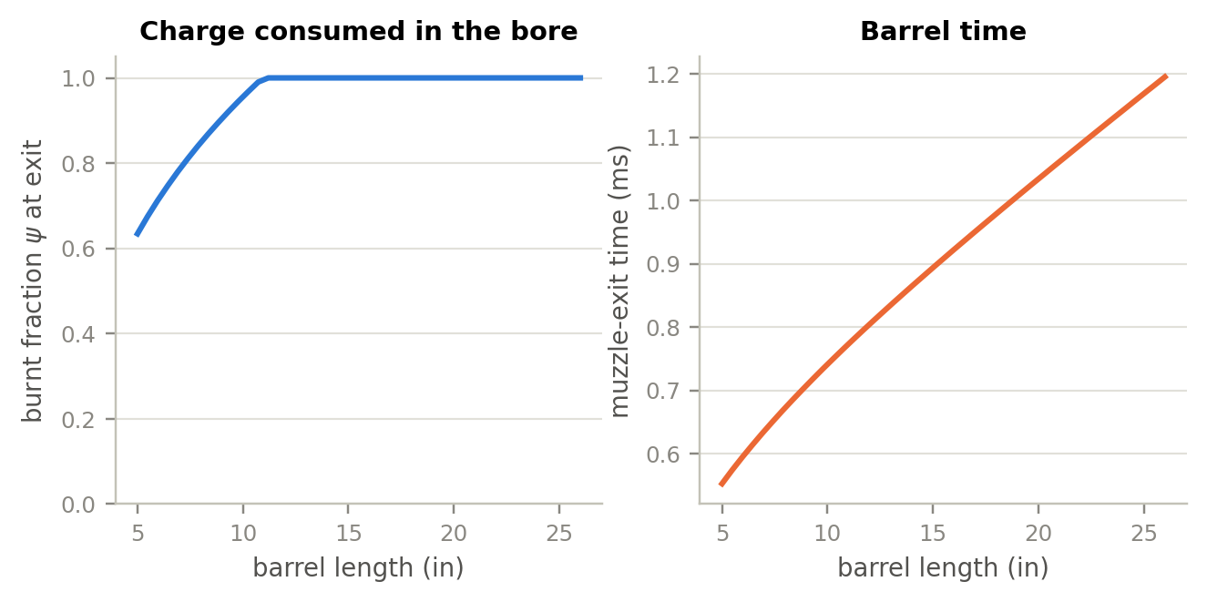
Figure 8 — Left: the fraction of the charge consumed before the bullet exits. Below about 11.5 in the round leaves the barrel with propellant still burning. Right: barrel time, which grows almost linearly with barrel length.

10.3 Reading the numbers
Velocity. From 10.5 in to 20 in the muzzle velocity rises from 789 m/s to 928 m/s, a gain of 139 m/s or 17.7 %. The marginal gain falls monotonically: 205 ft/s per inch at 5 in, 60 ft/s per inch at 14.5 in, 21 ft/s per inch at 22 in. Past about 24 in the curve is nearly flat, and in reality friction eventually wins — the SADJ cut-barrel data show velocity peaking near 20 in and then falling, which this model does not reproduce because bore resistance is taken as constant (§11.5).
Muzzle pressure. Over that same change, the pressure behind the bullet at exit falls from 150 MPa to 51 MPa — a reduction of 66 % against a velocity gain of 18 %. Halving the barrel roughly triples the uncorking pressure. Since muzzle blast energy scales with the product of that pressure and the gas volume, and the volume is itself smaller in a short barrel, the practical scaling of blast is close to linear in uncorking pressure.
Combustion completeness. The charge is fully consumed at about 290 mm of travel, i.e. inside an 11.5 in barrel. Below that length the round leaves with unburnt propellant: 2 % at 10.5 in, 21 % at 7 in, 37 % at 5 in. That ejected propellant burns in the muzzle blast — this is the mechanism behind the pronounced flash of very short 5.56 barrels, and it is why flash suppressors matter far more on a 10.3 in weapon than on a 20 in one.
Gas port. For a direct-impingement AR the model reports the pressure at the port station as the bullet passes and thereafter. With a 12 in rifle-length port on a 20 in barrel it gives 58 MPa (8 400 psi) at bullet exit and a peak of 125 MPa (18 100 psi). Moving the same port to the 7.5 in carbine position on a 14.5 in barrel raises the exit value substantially — the well-known reason carbine gas systems run the bolt harder and are more sensitive to ammunition and suppressor back-pressure. The port position is a slider in the simulator.

11 Model compromises and upgrade paths
This section states what the lumped-parameter formulation gives up, and what the next model up the ladder would buy. They are ordered by cost.

11.1 What the lumped model assumes away
No wave dynamics. Assumption A1 replaces a compressible gas column with a single control volume. Real ignition is not simultaneous: the primer jet ignites the rear of the charge first and a combustion front sweeps forward, generating pressure waves that traverse the chamber several times during the shot. In small arms these are of order a few per cent of the peak pressure and decay quickly, so the lumped model is defensible; in large guns they are a design driver and can be destructive.
No two-phase flow. Assumption A5 makes the solid grains ride with the gas. In reality the grain bed is compacted by the initial pressure gradient, gas percolates through it, and the grains near the bullet base move at a different velocity from those at the breech. This is what a two-phase model resolves.
Fixed thermochemistry. Assumption A3 holds f, T_v, α and γ constant. At 2850 K and 400 MPa the combustion products are partly dissociated, and both γ and the effective impetus vary through the cycle. An equilibrium-chemistry code such as BLAKE or CHEETAH would supply p- and T-dependent properties.
Crude bore resistance. Assumption A7 is the weakest of the physical submodels. Measured bore resistance has a sharp engraving spike over the first few millimetres, then falls, then rises again with velocity as viscous and thermal effects in the bullet–bore interface grow. A constant p_r cannot capture the late rise, which is precisely why the model does not reproduce the observed velocity roll-over beyond about 20 in.
No leakage, no bullet dynamics. Assumption A9 ignores blow-by past an imperfectly obturating bullet and any change in the bullet’s length or diameter under 400 MPa of base pressure and 195 000 g of acceleration. Both would reduce the delivered impulse slightly and, importantly, both would tend to lower the computed muzzle pressure — a candidate explanation for the short-barrel discrepancy in §9.2.

11.2 Level 1.5 — the Lagrange gradient (already included)
The cheapest possible improvement over a strictly uniform-pressure model is the Lagrange gradient of §4.6, and it is included here because it costs three lines of algebra and no computation at all. It converts a single pressure into a physically meaningful spatial distribution, which is what makes it possible to report breech, mean and base pressures separately — and to compute a gas-port pressure. For a cartridge with ζ = 0.40 the effect is a 20 % spread between breech and base, so it is not optional at this charge-to-mass ratio.
What it still cannot do: the Lagrange profile is a quasi-steady approximation. It has no wave content, and it assumes uniform gas density along the column, which is poor while the charge is still burning and gas is being created preferentially where the grains are.

11.3 Level 2 — one-dimensional gas dynamics
The next step replaces the control volume with the one-dimensional Euler equations for the gas column, solved on a moving mesh between the breech face and the bullet base with a shock-capturing scheme. Mass, momentum and energy are conserved locally, with the propellant burn appearing as a distributed source term.
What it buys: genuine pressure waves and their reflections; a correct density distribution; a proper treatment of progressive ignition if the igniter is modelled as a distributed source; and — most relevant here — a physically-based rather than assumed pressure at any station, including the gas port and the muzzle.
What it costs: roughly three orders of magnitude more computation than the present model, and it introduces mesh and scheme dependence that must itself be verified. It would not run interactively in a browser.

11.4 Level 3 — two-phase reactive flow
The reference formulation used in modern gun design (NGEN, XKTC, and their descendants) treats gas and solid propellant as two interpenetrating continua, each with its own velocity, with mass, momentum and energy exchange between them, intergranular stress in the packed bed, and a resolved ignition front.
What it buys: the ability to predict ignition-related phenomena that the lumped model cannot represent at all — hangfires, pressure-wave-driven overpressure, the effect of charge-bed settling and of primer output on round-to-round variation. For small arms it is the tool of choice when the question is about ignition robustness rather than about mean performance.
What it costs: a substantially larger parameter set — interphase drag, intergranular stress law, grain-bed permeability — most of which is not published for commercial propellants and must be measured. For the barrel-length question posed here it would add cost without adding accuracy.

11.5 Targeted improvements worth more than a level change
1. A measured bore-resistance curve. Replacing the constant p_r with a travel-dependent function p_r(x) — engraving spike, plateau, velocity-dependent rise — is a small code change and would let the model reproduce the velocity roll-over at long barrels. This is the highest-value single improvement.
2. A closed-bomb characterisation of the actual propellant. A single closed-bomb test of WC 844 would replace the three fitted parameters and the four generic thermochemical constants with measured values, and would convert the model from calibrated to predictive.
3. A physically-scaled heat-transfer correlation. Replacing the constant h with a Nusselt-type correlation, h ∝ Re⁰·⁸, would make the heat loss scale correctly with charge, calibre and pressure instead of being tied to this one cartridge.
4. Gas leakage past the bullet. A simple orifice model for blow-by, driven by the pressure difference across the bullet, is cheap and would test the hypothesis that leakage explains part of the short-barrel muzzle-pressure discrepancy.
5. Muzzle and after-effect modelling. The present model stops at bullet exit. The blast field, the additional 1–3 % of velocity imparted by the gas jet in the first few calibres of free flight, and suppressor back-pressure all follow from the uncorking conditions the model already computes, and would be a natural extension.

12 The companion simulator
The file web/ballistics.html is a single self-contained HTML document — no server, no build step, no external libraries. Opening it in any modern browser gives an interactive implementation of exactly the model derived above; the JavaScript is a line-by-line port of the Python reference and agrees with it to 0.021 % (§6).
The interface has four tabs:
Single shot. Summary tiles for the reference quantities, then pressure versus time at all four stations, and pressure, velocity and travel versus time for up to five barrel lengths overlaid at once. This overlay is the clearest way to see the barrel-length effect: the curves coincide and each simply terminates at its own muzzle.
Barrel-length sweep. Muzzle velocity, uncorking pressure, muzzle energy, burnt fraction, barrel time and marginal velocity gain, each against barrel length from 5 in to 26 in, with the published measurements overlaid.
Energy & diagnostics. The energy budget, gas-port pressure history, derived quantities such as loading density and expansion ratio, and a live time-step convergence check.
Data table. The full numerical output, plus a CSV export of both the time history and the sweep.
Every parameter in §7 is exposed as a slider, grouped by category, with the derived quantity shown alongside. Cartridge presets are provided for M855, M193 and Mk262, and weapon presets for the M4, Mk18 and mid-length configurations. The page warns when a parameter combination becomes physically impossible — for instance when the charge mass and case volume imply a packing fraction above what spheres can achieve — or when peak pressure exceeds the NATO limit.
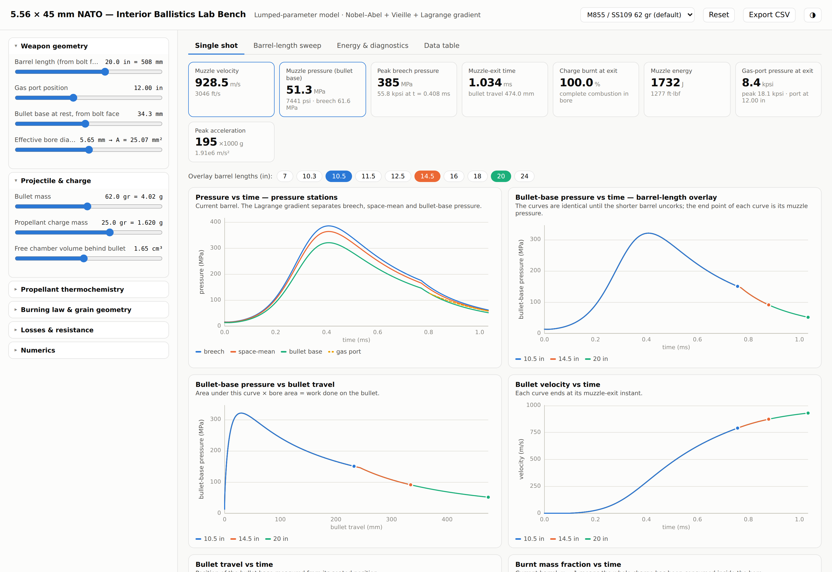
Figure 9 — The single-shot tab of the simulator. The overlaid pressure curves for 10.5 in, 14.5 in and 20 in barrels coincide exactly, each terminating at its own muzzle-exit point.
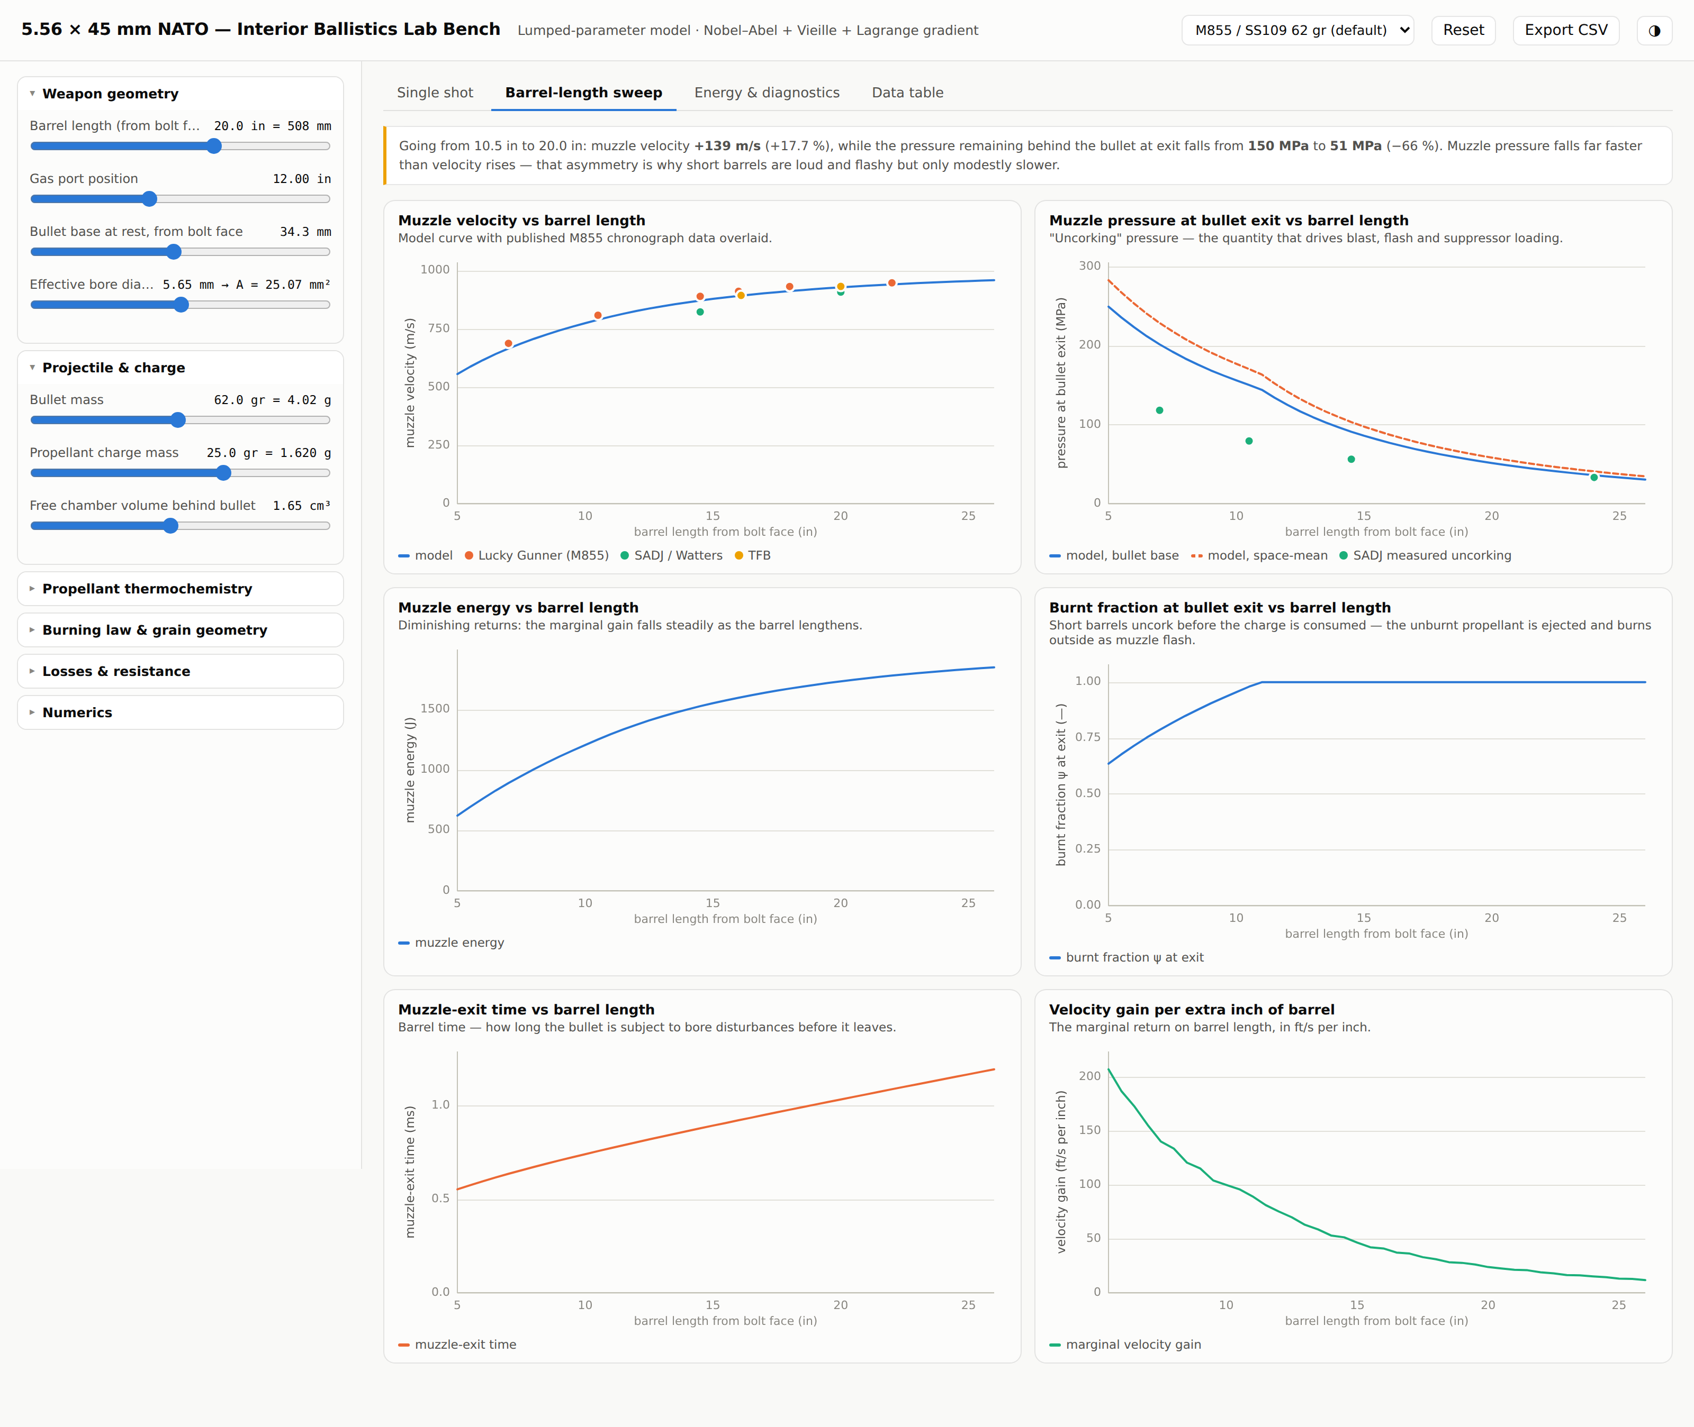
Figure 10 — The barrel-length sweep tab, with published chronograph and uncorking-pressure measurements overlaid on the model curves.

12.1 Repository layout
Path | Contents
web/ballistics.html | the self-contained interactive simulator
python/interior_ballistics.py | reference implementation of the model
python/calibrate.py | least-squares calibration against the published data
python/make_figures.py | generates every figure in this document
python/verify_js.js | drives the HTML page headlessly and dumps its results
python/compare_js_py.py | cross-checks the JavaScript against Python
python/calibration.json | fitted parameters, reference results and the sweep
doc/ | this document, its source script and its figures

13 References
Sources are grouped by what they were used for. Web sources were accessed in August 2026.

Measured performance data
Lucky Gunner Labs, "223 / 5.56 Ballistics: Barrel Length vs. Velocity" — cut-barrel test of Winchester M855 62 gr and other loads at 7, 10.5, 14.5, 16, 18 and 22 in. https://www.luckygunner.com/lounge/223-ballistics/
D. E. Watters, "Barrel Length Studies in 5.56 mm NATO Weapons", Small Arms Defense Journal — cut-barrel study from 24 in to 5 in with instrumented ports; source of the uncorking-pressure data and of the 55 744 psi chamber-pressure measurement. https://sadefensejournal.com/barrel-length-studies-in-5-56mm-nato-weapons/2/
The Firearm Blog, "Cartridge Test 008: PMC M855 5.56×45 mm 62 gr, 16 and 20 in barrels". https://www.thefirearmblog.com/blog/2018/01/09/cartridge-test-008-pmc-m855/
P. Dater, "Suppressor Design and Muzzle Pressure", NDIA Armament Systems Forum — method and instrumentation for muzzle-port pressure measurement. https://ndia.dtic.mil/wp-content/uploads/2010/armament/WednesdayCumberlandPhilipDater.pdf
International Journal of Metrology and Quality Engineering (2026) — EPVAT proof-barrel measurements of SS109: 343.70 ± 7.29 MPa case-mouth peak pressure, 926.39 ± 3.57 m/s velocity, 116.61 MPa port pressure, n = 30. https://www.metrology-journal.org/articles/ijmqe/full_html/2026/01/ijmqe250019/ijmqe250019.html

Cartridge specification and geometry
"5.56×45 mm NATO" — case and cartridge dimensions, case capacity, EPVAT and SCATP pressure limits. https://en.wikipedia.org/wiki/5.56%C3%9745mm_NATO
".223 Remington" — SAAMI maximum average pressure, case capacity, groove diameter. https://en.wikipedia.org/wiki/.223_Remington
inetres.com, "5.56 mm ammunition" — M855 projectile mass, cartridge mass, nominal muzzle velocity. https://www.inetres.com/gp/military/infantry/rifle/556mm_ammo.html
General Dynamics / St. Marks Powder, military ball powder brochure — confirms WC 844 as the qualified propellant for M855. https://www.gdots.com/wp-content/uploads/2024/01/400001942-SMP-Military-BallPowder-Brochure-2023-1.pdf

Propellant thermochemistry and interior-ballistics theory
Middle East Technical University, thesis on interior ballistics modelling — generic single-base propellant constants (f = 0.98 MJ kg⁻¹, α = 1.0 cm³ g⁻¹, T_v = 2825 K, γ = 1.24, Vieille n = 0.69) and the lumped-parameter formulation. https://open.metu.edu.tr/bitstream/handle/11511/23426/index.pdf
US Army Research Laboratory / BLAKE thermochemical data for M1 single-base propellant — force 911.7–919.2 J g⁻¹, T_v 2343–2447 K, covolume 1.1044 cm³ g⁻¹, γ 1.2675. https://www.govinfo.gov/content/pkg/GOVPUB-D101-PURL-gpo1849/pdf/GOVPUB-D101-PURL-gpo1849.pdf
US Army Research Laboratory, "Measuring Barrel Friction in the 5.56 mm NATO", ADA555779 — method for extracting bore friction from muzzle-energy versus charge-mass data. https://apps.dtic.mil/sti/html/tr/ADA555779/index.html

Standard texts (not accessed online; cited for the classical formulation)
P. G. Baer & J. M. Frankle, "The Simulation of Interior Ballistic Performance of Guns by Digital Computer Program", BRL Report 1183 (1962) — the ancestor of IBHVG2.
R. D. Anderson & K. D. Fickie, "IBHVG2 — A User’s Guide", BRL-TR-2829 (1987).
M. E. Serebryakov, "Internal Ballistics of Guns and Solid-Propellant Rockets" — the origin of the form-function notation ψ = χz(1 + λz + μz²) used here.
J. Corner, "Theory of the Interior Ballistics of Guns", Wiley (1950) — the Résal equation and the Lagrange gradient in their classical form.

Disclaimer
This document is an engineering modelling study prepared for analysis and teaching. It is not load data and must not be used as such. The parameter set was fitted to published aggregate performance figures, not measured from any specific lot of ammunition, and the propellant constants are generic. Do not use these numbers to develop handloads.

