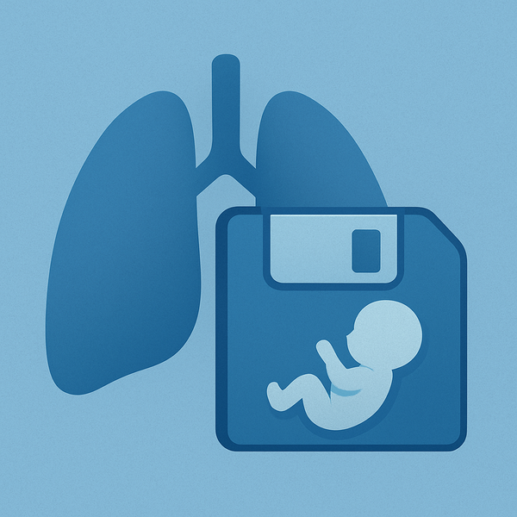
LundaLoggern
User Manual
Uncomplicated data logging for intensive care ventilators
For SERVO-u, SERVO-n, SERVO-air and SERVO-c
Draft · October 2026 · Software version 1.3.0

Contents
1. Welcome
2. Getting to know the device
3. Connection
4. Collecting data
5. Getting your data
6. Configuration
7. Practicalities
8. Quick reference and glossary

1. Welcome
LundaLoggern is a small box that plugs into a SERVO ventilator and quietly saves its measurements to an SD card, so you can read them later on a phone or computer. This manual explains how to connect it, how it collects data, how to get the data out, and how to change what it records.
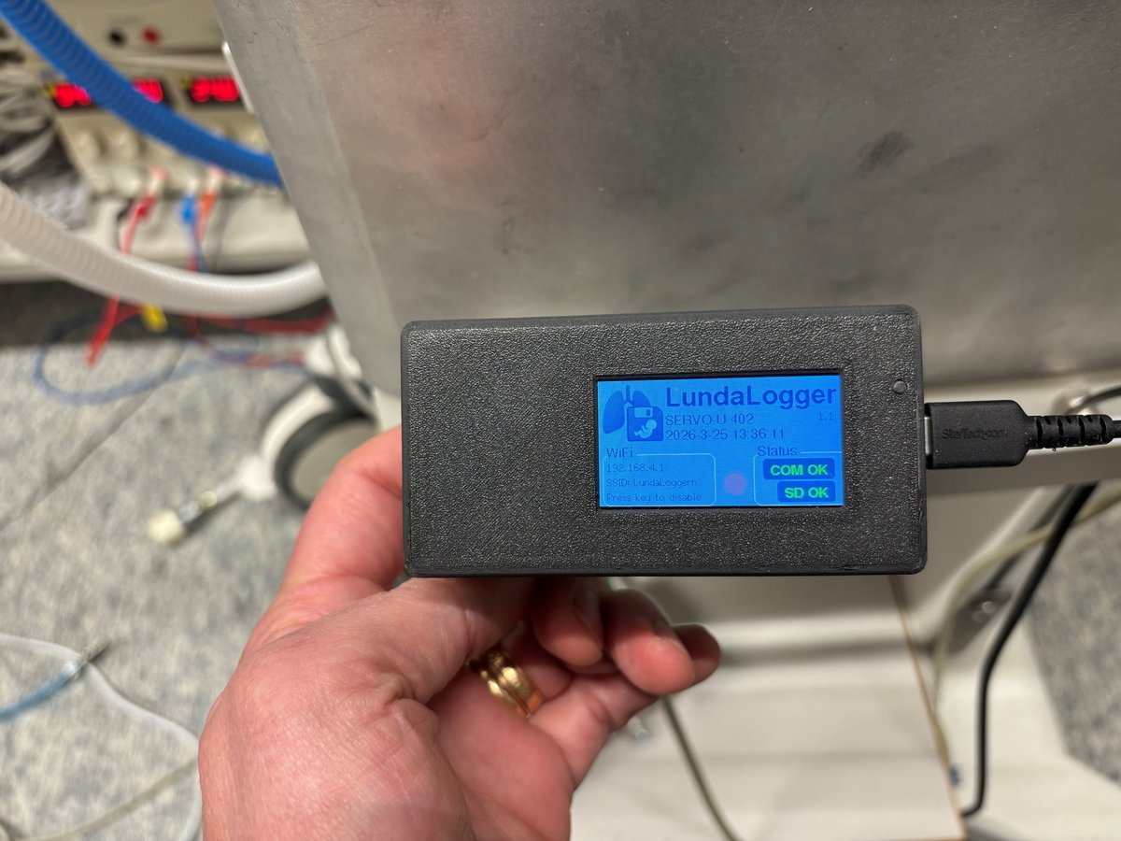
Figure 1. LundaLoggern connected to a ventilator, powered by a USB cable.

What it does
Once connected, LundaLoggern finds the ventilator on its own and starts recording. It saves breath-by-breath measurements, ventilator settings and alarm events as simple text files. Every entry is stamped with the ventilator’s own clock.

What you do not need
No computer, software installation, hospital network or internet connection is needed. The data stays on the SD card until you choose to copy it.

Who this manual is for
Anyone who uses the device at the bedside, in a lab or in a workshop. No technical background is needed. Words in bold are things you will see on the screen or press.
Works with: SERVO-u, SERVO-n, SERVO-air and SERVO-c ventilators (through the CIE connection on the ventilator).
Important. LundaLoggern is a working prototype for data logging and research. It is not a certified medical device, and it must not be used to make treatment decisions. Always follow your hospital’s rules for connecting extra equipment to a ventilator. Never rely on it instead of the ventilator’s own display and alarms.

2. Getting to know the device
The device is a small unit with a colour screen, one button, a USB-C socket, a serial (RS232) connection to the ventilator and a slot for a microSD card. It fits in a pocket and can be moved between ventilators.
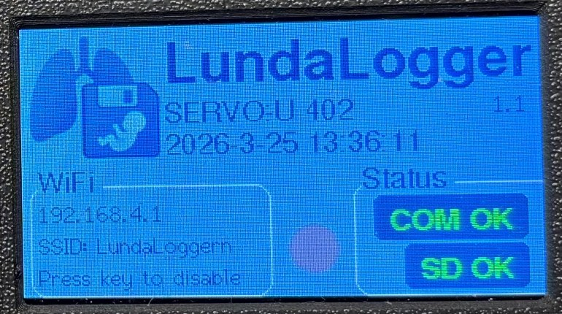
Figure 2. The screen of a connected unit, showing the ventilator type, date and time, WiFi information and the status indicators.

The screen
The screen shows the state of the device at a glance:
Where on the screen | What it shows
Top left | The LundaLoggern logo
Top, next to the logo | The name LundaLogger, with the software version in small print on the right
Middle | Type and serial number of the connected ventilator (for example SERVO-U 402), and below it the date and time, taken from the ventilator
Bottom left, WiFi box | The WiFi address and network name, and a short prompt telling you which button press to use (for example “Press key to disable”)
Bottom right, Status box | Two status indicators: COM (link to the ventilator) and SD (memory card). They show OK when all is well.
Bottom middle | A round breath state indicator
When both COM OK and SD OK are shown, the ventilator is connected, the card is in place and logging is running.

The button
There is a single button. What it does depends on how long you press it:
Press | Result
Long press (hold the button down) | Turns WiFi on. A QR code appears on the screen.
Short press (a quick tap) | Turns WiFi off.

WiFi is off whenever the device starts. This is deliberate: it keeps radio signals low around sensitive patients, such as in a neonatal intensive care unit, and saves power. Logging works fine with WiFi off.

3. Connection
Setting up takes about a minute and needs no tools or software.

What you need
- The LundaLoggern unit
- A microSD card, formatted as FAT32 (the usual format for new cards; if unsure, format it on a computer and choose FAT32)
- The cable that connects the unit to the ventilator’s CIE port
- A power-only USB-A to USB-C cable (see step 3 below)

Step by step
- Insert the SD card. Put the microSD card into the slot on the unit before you power it on. If the card is new or empty, that is fine: the device prepares it by itself.
- Connect to the ventilator. Plug the unit into the ventilator’s CIE port.
- Power it. Plug the unit into the USB port on the SERVO’s panel, using a power-only USB-A to USB-C cable (USB-A end in the ventilator, USB-C end in the unit). This is the preferred way to power the unit. The cable carries power only, so the unit does not exchange any data with the ventilator through it.
- Wait a few seconds. The screen lights up. The device asks the ventilator who it is, and the ventilator type and serial number appear on the screen. The COM indicator shows that the link is working.
- Check the clock. The date and time on the screen come from the ventilator. LundaLoggern has no clock of its own, so the time appears once the connection is made.
- Done. Logging starts automatically. You do not need to press anything.

If the connection drops
If the ventilator is switched off, or the cable is pulled out, COM shows that the link is lost. The device does not give up. It tries to reconnect every few seconds, and logging resumes when the ventilator is back.

Taking it away
You can unplug the unit at any time. Everything recorded up to that moment is already saved on the SD card. Before you take the SD card out, unplug the unit first, so that nothing is being written to the card at that moment.
Open question for the author: the cable and any adapter between the CIE port and the unit are not described in the source documents. Add a photo and part name here.

4. Collecting data
Logging starts by itself as soon as the ventilator is recognised, and it starts again by itself after any interruption. You never need to press a start or stop button.

What is recorded
- Breath measurements: one line for every breath, for example tidal volume, respiratory rate, minute ventilation, FiO₂, PEEP and peak pressure.
- Ventilator settings: for example mode, patient category and compliance compensation.
- Alarms: a line is written only when an alarm changes, meaning it starts, is silenced or clears. A quiet ventilator therefore produces no alarm lines.
Every line carries the date and time from the ventilator’s clock. Which measurements are included can be changed (see section 6).
Waveforms. Waveform curves (flow, pressure, volume, CO₂, Edi) are not saved to the SD card in the current software version. They can only be watched live from a computer connected by USB cable. Plan for breath, settings and alarm data on the card.

Where the data goes
Everything is saved on the SD card as plain text files. A new file is started every 12 hours, at midnight (00:00) and at noon (12:00), so no single file grows too large. The file name tells you what is inside and when it began:
File name | Contains | Example
metrics_YYYYMMDD_HHMM.txt | Breath-by-breath measurements | metrics_20260518_1200.txt
settings_YYYYMMDD_HHMM.txt | Ventilator settings | settings_20260518_1200.txt
alarms_YYYYMMDD_HHMM.txt | Alarm changes | alarms_20260518_0000.txt
log.txt | Technical notes used when building the device. Ignore it.

Read the date as year, month, day and the time as hours and minutes. The file metrics_20260518_1200.txt therefore started at 12:00 on 18 May 2026.

Reading a data file
The files can be opened with Excel, Notepad or any text editor. Each file looks like this:
- The first line says which ventilator the data comes from.
- The second line holds the column names.
- Every following line is one moment in time. The values are separated by tab stops, so Excel will place them in columns automatically.
If a column says No Valid Data, the ventilator did not provide that value for that breath, for instance because it does not apply in the current mode.

Reading the alarm file
Alarm values look like 3:1. The first number is how serious the alarm is, the second says what is happening:
First number (priority) | Meaning | Second number (status) | Meaning
0 | Not defined | 0 | No alarm
1 | Low | 1 | Alarm is active
2 | Medium | 2 | Active, but silenced
3 | High

Examples: 3:1 is a high-priority alarm that is sounding. 2:2 is a medium alarm that has been silenced. 0:0 means all clear. N/A means that alarm does not apply in the current ventilation mode.

5. Getting your data
There are two ways to get the files. Use WiFi when you want something quickly from a phone or laptop, and use the SD card when you want everything.

Option A: WiFi and the web page
The device creates its own small WiFi network. It does not connect to the internet or to the hospital network, so your phone may say “no internet”. That is normal.
- Switch WiFi on. Hold the button down (long press). The WiFi strip at the bottom of the screen shows the network name and address, and a QR code appears.
- Connect your phone or laptop. Scan the QR code with your phone camera, or choose the network yourself. The network is called LundaLoggern and has no password.
- Open the web page. In your browser, go to 192.168.4.1 (or scan the second QR code if the screen shows one).
- Use the page. See below.
- Switch WiFi off. Give the button a short tap. WiFi does not switch itself off, so always do this when you have finished.
Open network. The WiFi network has no password. While WiFi is on, anyone within range can connect and download or delete files. Keep WiFi on only as long as you need it.

The web page
The start page shows the state of the SD card (size, used and free space), the software version, the network name and the connected ventilator. It has two buttons.
Button | What you can do
Open File Manager | See every file on the card with its size. Tick the box next to a file to select it, then download or delete it.
View Config Files | See the settings the device is currently using (read only). Use Back to Main Page to return.

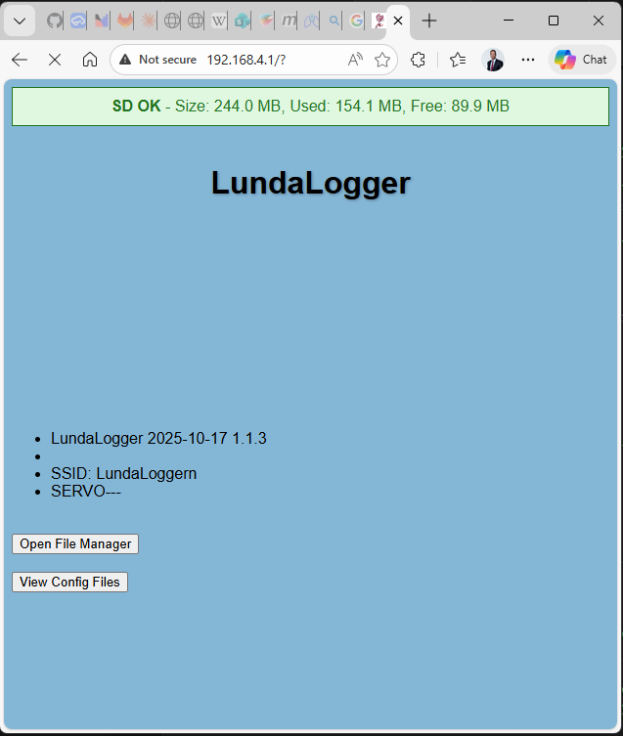  Figure 3. The start page at 192.168.4.1. The green bar shows the SD card status. | 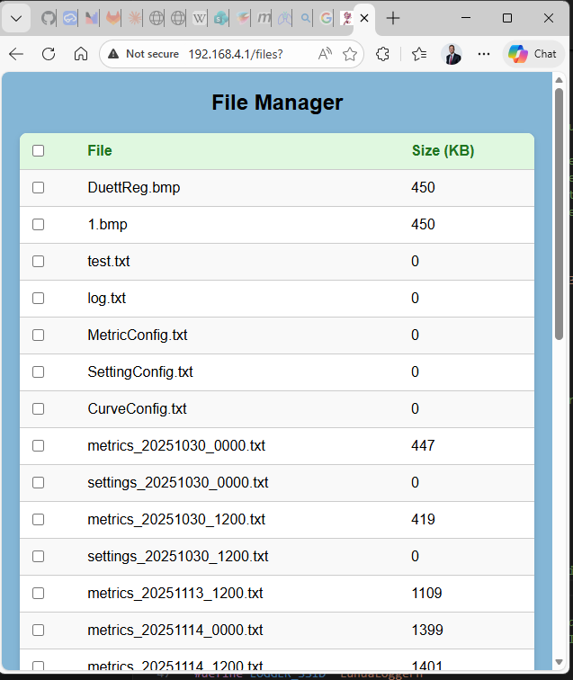  Figure 4. The file manager lists the files on the card. Sizes are in KB.

Careful with Delete. A deleted file is removed from the SD card and cannot be brought back. Download it first if you may need it.

Option B: Take out the SD card
This is the simplest way to collect a large amount of data.
- Unplug the unit (see section 3).
- Take out the microSD card.
- Put it in your computer’s card reader and copy the files you need.
- Put the card back in the unit.
The unit keeps logging into the same card, so it is fine to copy files and leave them on the card too.

Looking at the data
Open the files in Excel and the values will land in columns, one column per measurement. For graphs, mark a column and insert a chart. The data can also be shown as graphs in a viewer program, as in the example below.
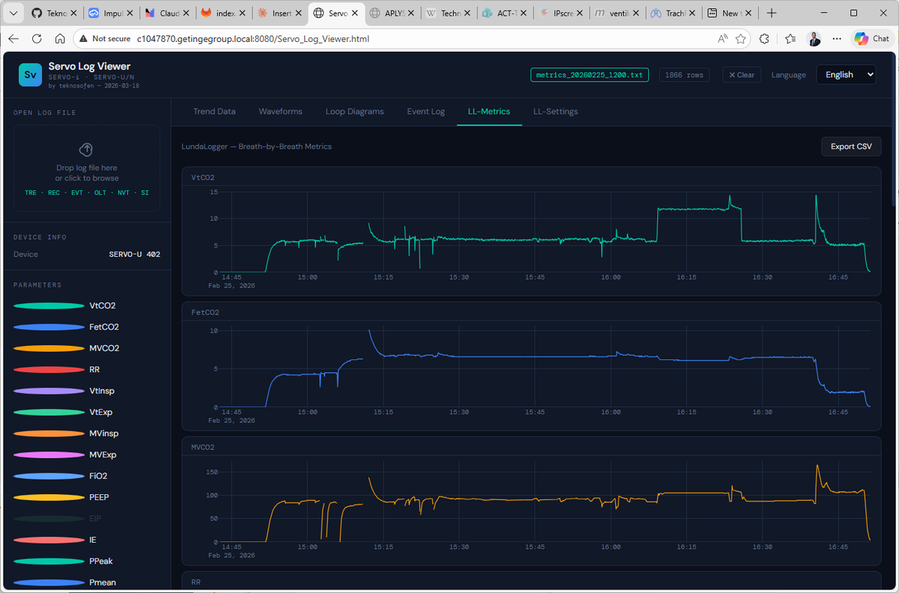
Figure 5. Example: logged data shown as graphs in the SERVO Log Viewer.

6. Configuration
You can change what LundaLoggern records by editing a few text files on the SD card. No software or special tool is needed, only a computer with a card reader and a text editor such as Notepad. Most users never need to change anything: the defaults work as they are.

The configuration files
File | What it controls
MetricConfig.txt | Which breath measurements are recorded
SettingConfig.txt | Which ventilator settings are recorded
AlarmConfig.txt | Which alarms are watched and recorded
CurveConfig.txt | Which waveform channels are available for live viewing
DeviceConfig.txt | Reserved for a future software version (WiFi settings). Has no effect yet

On first start, the device places a copy of the metric, setting, alarm and curve files on the SD card root (the top level of the card, not inside any folder). If you insert a new, empty card later, the device puts them there again.

How to change a setting
- Unplug the unit and take out the SD card.
- Put the card in your computer and make a copy of the file you will edit, so you can go back.
- Open the file with Notepad (or another plain text editor) and make your change.
- Save the file on the card with the same name.
- Put the card back in the unit and connect it. The device reads the files when it starts.
Changes take effect only after the unit has been restarted. Check them with View Config Files on the web page if you wish.
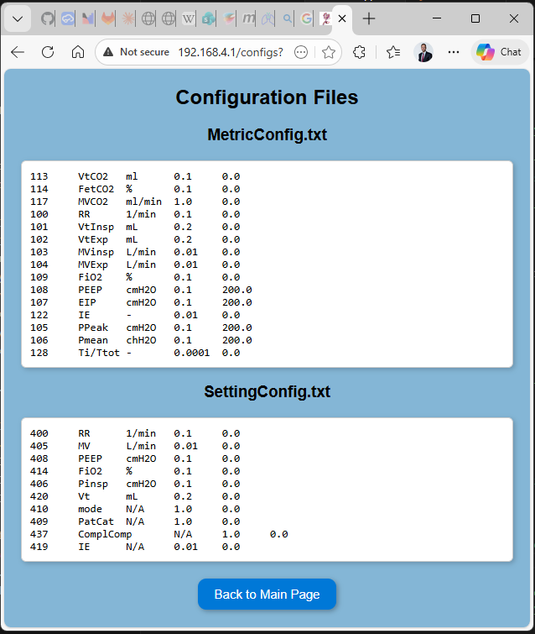
Figure 6. The configuration viewer shows the channel lists the device is using.

WiFi name, password and switch-off time
These cannot be changed yet. In this version the WiFi network is called LundaLoggern, has no password, and does not switch itself off. The file DeviceConfig.txt is reserved for a coming software version that will let you set a WiFi name, a password and an automatic switch-off time. Until then, editing it has no effect.

Choosing what is recorded
The channel files (MetricConfig.txt, SettingConfig.txt, AlarmConfig.txt, CurveConfig.txt) have one line per value. The columns are separated by tab stops:
Column | Meaning | Example
Channel | The ventilator’s number for this value | 113
Label | The name shown in the data file | VtCO2
Unit | The unit of measurement | ml
Scale factor | Number the raw value is multiplied by | 0.1
Offset | Number applied afterwards | 0.0

Where do the numbers come from? The channel numbers, labels, units, scale factors and offsets are defined in the SERVO communication manual (the SERVO Connectivity Reference Manual, SCI). At the time of writing, the latest version is 87498-servo-connectivity-reference-manual-sci-v0010.pdf. Use that manual to look up a value before you add or change a line.
The alarm and waveform files also have an active column that can be set to true or false to switch a channel on or off.
The simplest safe changes are:
- Record less: set a channel to false where there is an active column.
- Rename a column: change only the Label.
- Leave the channel number, scale factor and offset alone unless you have looked up the right values in the SERVO communication manual (SCI) or an engineer has told you which to use. A wrong number gives wrong measurements.

Protection against mistakes
If a configuration file on the card is empty or cannot be read at all, the device ignores it and uses its own stored copy instead, then writes that copy back to the card. So a damaged file does not stop logging. Mistakes inside a line, such as spaces in place of tab stops, can still make that line unusable, so always keep a copy of the original.

7. Practicalities

Good habits
- Use a good microSD card, formatted as FAT32. Keep a spare, labelled card.
- Copy your data regularly. Treat the card as temporary storage, and copy important files to a computer or secure location.
- Label the card with the ventilator or study it belongs to, so files are not mixed up.
- Leave WiFi off unless you need it. It saves power and avoids extra radio signals around sensitive patients.
- Remember the WiFi has no password. Anyone nearby can join while it is on, so switch it off when you are done.
- Handle the unit like electronics. Keep it dry, and wipe it only with a lightly damp cloth according to your hospital’s cleaning rules. Do not spray liquid on it.

Patient privacy
LundaLoggern keeps the data on its own SD card and sends nothing to the internet or a cloud service. The data only leaves the device when you download or copy it. The files contain the ventilator’s serial number and time-stamped patient measurements, so store and share them according to your hospital’s rules for patient data. Treat the SD card as you would any other patient record.

What the device does not do
- It does not save waveform curves to the SD card in the current software version.
- It does not control the ventilator in any way. It only listens.
- It has no clock of its own. The time comes from the ventilator.
- It is not a replacement for the ventilator’s alarms or monitoring.

Troubleshooting
What you see | What to try
Screen is dark | Check the USB-C cable and that the ventilator is switched on. Try another USB port or power source.
SD indicator shows a problem | Switch off, take the card out, push it in again firmly. Check that it is a microSD card in FAT32 format. Try another card.
COM indicator shows no link, or no ventilator name appears | Check that the cable is pushed fully into the ventilator’s CIE port, and that the ventilator is on. The device retries every few seconds, so wait a moment.
Date and time are missing | The time arrives from the ventilator when the link works. Fix the link first.
Cannot find the WiFi network | Hold the button until the WiFi strip shows the network name. If you switched it off with a tap, hold the button again.
Phone says “no internet” | Normal. The device has its own network without internet. Stay connected and open the address.
Web page does not open | Check that you are on the LundaLoggern network, then type the address again. Make sure you type it in the address bar, not a search field.
No alarm file | Normal if no alarm happened. Alarms are only written when something changes.
A column says No Valid Data | The ventilator did not provide that value. It may not apply in the current mode.
My configuration change had no effect | Restart the unit after saving. Check that the file name is correct and that the file is in the root of the card, not in a folder.
Nothing helps | Unplug the unit and plug it in again. Keep the card in place, as recorded data is safe on it.

Getting help
For questions about the device, contact the person responsible for your LundaLoggern unit (add name or email here).

8. Quick reference and glossary

At a glance
Item | Value
Works with | SERVO-u, SERVO-n, SERVO-air and SERVO-c ventilators, via the CIE port
Power | Power-only USB-A to USB-C cable to the USB port on the SERVO’s panel
Start logging | Automatic when the ventilator is recognised
Switch WiFi on | Long press on the button
Switch WiFi off | Short press on the button
WiFi name | LundaLoggern, no password
Web page address | 192.168.4.1
Memory card | microSD, FAT32
New file started | Every 12 hours, at 00:00 and 12:00
Time source | The ventilator’s clock
Data files | metrics_, settings_ and alarms_ followed by date and time, as .txt
Change settings | Edit the configuration files on the SD card, then restart the unit

Words used in this manual
Word | Meaning
SCI | The SERVO communication interface. Its manual lists the channel numbers, scale factors and offsets that LundaLoggern uses
CIE | The computer connection on SERVO ventilators that LundaLoggern plugs into
SD card / microSD | A small memory card. The data is saved here.
FAT32 | The standard format that the memory card must have
WiFi network (SSID) | The name of the wireless network the device creates
QR code | A square pattern on the screen that a phone camera can scan to connect quickly
Breath-by-breath data (metrics) | Measurements the ventilator reports for every breath
Settings | The values that have been set on the ventilator
Waveform / curve | A continuous line of values, for example airway pressure or flow, shown over time
Tab-separated text file | A plain text file where values are separated by tab stops, so spreadsheet programs place them in columns
Prototype | A working early version, not yet a finished and certified product

