LundaLoggern
Design Summary
Portable CIE data logger for SERVO-u ventilators
Version | 1.3.0 (2026-05-18)
Author | Åke L
Platform | LilyGo T-Display S3 (ESP32-S3)
Framework | Arduino (PlatformIO)

Contents
1. Purpose 3
2. Hardware Overview 3
Pin Assignments 3
Hardware Design — Schematic and PCB 5
3. Software Architecture 8
3.1 Architectural Style 8
3.2 Class Diagram 8
3.3 Class Interfaces 8
3.4 Runtime and Processing Logic 9
3.5 Data Flow 10
4. Configuration System 11
MetricConfig.txt — Breath-by-breath measured values 11
SettingConfig.txt — Ventilator settings 11
CurveConfig.txt — High-frequency waveform channels 11
AlarmConfig.txt — Ventilator alarm channels 11
DeviceConfig.txt — Device-level settings 12
Configuration loading priority 12
4a. Log File Formats 12
metrics_YYYYMMDD_HHMM.txt 12
settings_YYYYMMDD_HHMM.txt 12
alarms_YYYYMMDD_HHMM.txt 13
curves_YYYYMMDD_HHMM.txt 13
log.txt 13
5. Communication Protocol 13
5a. USB-CDC Command Interface (HostCli) 14
5a.1 Wire format 14
5a.2 Default state at boot 14
5a.3 Commands 15
5a.4 Curve streaming 15
5a.5 Example session 16
5a.6 Integration points 16
6. WiFi & Web Interface 16
7. Display Layout 17
8. Build & Dependencies 17
8.1 Preparing a New Board (First-Time Setup) 17
8.2 TFT_eSPI Library Configuration 18
8.3 Rebuilding After Configuration Changes 18
9. File Structure 19
10. Key Design Decisions 19
11. Planned Improvements 20
11.1 WiFi Auto-Shutoff — Implementation Analysis 20

1. Purpose
LundaLoggern is a portable, standalone data logger designed for SERVO-u intensive care ventilators. It continuously captures real-time ventilator metrics, settings, waveform curve data, and alarm events via the ventilator's CIE (Computer Interface Equipment) serial interface and stores them as timestamped log files on an SD card. A built-in WiFi access point and web server allow clinical/engineering staff to download, review, and manage logged data wirelessly from any device with a browser.

2. Hardware Overview
Component | Details
Microcontroller | ESP32-S3 (LilyGo T-Display S3)
Display | 170 × 320 px ST7789 TFT (integrated)
Storage | MicroSD card via HSPI bus + on-chip SPIFFS
Serial Interface | RS232 transceiver on UART2 (38 400 baud, 8E1)
User Input | Physical button on GPIO 14 (short/long press)
Memory | PSRAM enabled for image buffering
WiFi | ESP32 SoftAP mode (802.11 b/g/n)

Pin Assignments
T-Display S3 GPIO | Firmware signal | Connected device / signal | Direction at logger
GPIO 12 | HSPI MISO | SD reader DO / MISO | SD reader → logger
GPIO 11 | HSPI MOSI | SD reader DI / MOSI | Logger → SD reader
GPIO 13 | HSPI SCLK | SD reader CLK / SCK | Logger → SD reader
GPIO 10 | HSPI CS | SD reader CS | Logger → SD reader
GPIO 16 | UART2 RX (RXD2) | RS232 transceiver receiver output (RO) | Transceiver → logger
GPIO 17 | UART2 TX (TXD2) | RS232 transceiver driver input (DI / TXD) | Logger → transceiver
GPIO 14 | Interaction button | Physical button input | Button → logger

UART2 runs at 38 400 baud, 8E1. Connect the UART pins to the logic-side pins of an RS232 transceiver; connect the transceiver's RS232 line side to the ventilator. Do not connect ESP32-S3 GPIO directly to RS232 voltage levels. The SD reader uses the dedicated HSPI bus and GPIO10 as chip select. Use a 3.3 V logic-compatible SD interface and a shared ground.
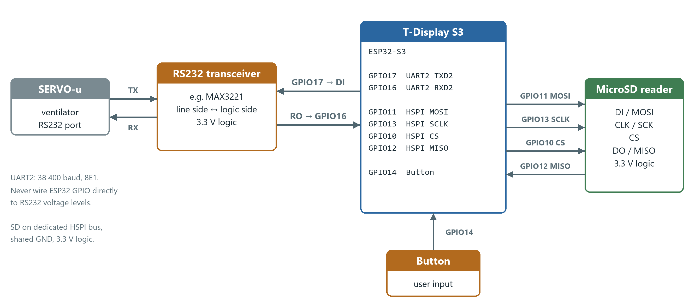
Figure 1. Wiring between the T-Display S3, RS232 transceiver, SERVO-u ventilator and MicroSD reader.
To find the physical pins on the board, the LilyGo pinout drawing below has the pins used by LundaLoggern highlighted. Note that the project remaps HSPI with build flags (HSPI_CS=10, HSPI_MOSI=11, HSPI_MISO=12, HSPI_SCLK=13 in platformio.ini), so the SD signals differ from LilyGo's default SPI labels, and that UART2 runs on GPIO16/17 rather than the UART1 pins LilyGo marks on GPIO18/17. The user button is the on-board IO14 key, not a header pin.
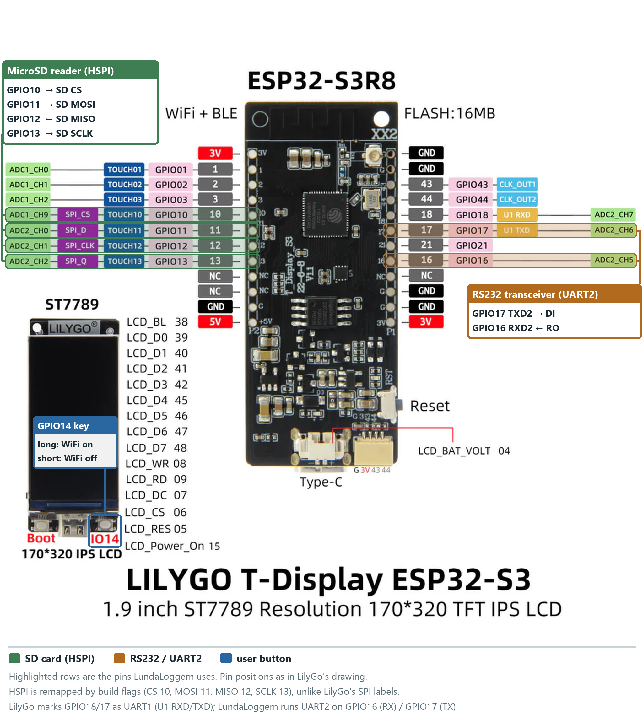
Figure 2. T-Display S3 pinout with the pins used by LundaLoggern highlighted: SD card (green), RS232/UART2 (amber) and the IO14 user button (blue).

Hardware Design — Schematic and PCB
The logger is built as a carrier board (EasyEDA design "LundaLoggern" V1.0, Teknosofen HB, 2025) that the T-Display S3 plugs into. It holds:
- U13 — MAX3221 RS232 transceiver with charge-pump capacitors C1–C4 and decoupling capacitor C5 (all 100 nF). DIN is driven by GPIO17 (TXD2) and ROUT feeds GPIO16 (RXD2). EN# is tied to GND and FORCEON / FORCEOFF# to VCC, so the transceiver is always on. INVALID# is not connected.
- Vent-CIE — 3-pin header (RSRX, RSTX, GND) for the cable to the ventilator's DB9 CIE port (DB9 pin 2 CIE RxD, pin 3 CIE TxD, pin 5 GND).
- U12 — microSD socket wired in SPI mode: CD/DAT3 = CS (GPIO10), CMD = MOSI (GPIO11), DAT0 = MISO (GPIO12), CLK = SCLK (GPIO13). The socket's card-detect switch is wired to GPIO21, but the current firmware does not read it (card presence is polled through the SD library instead).
- I2C_1 … I2C_3 — three 4-pin expansion headers (GND, 3V3, SDA, SCL) on GPIO43/GPIO44, for future sensors. They are not used by the current firmware.

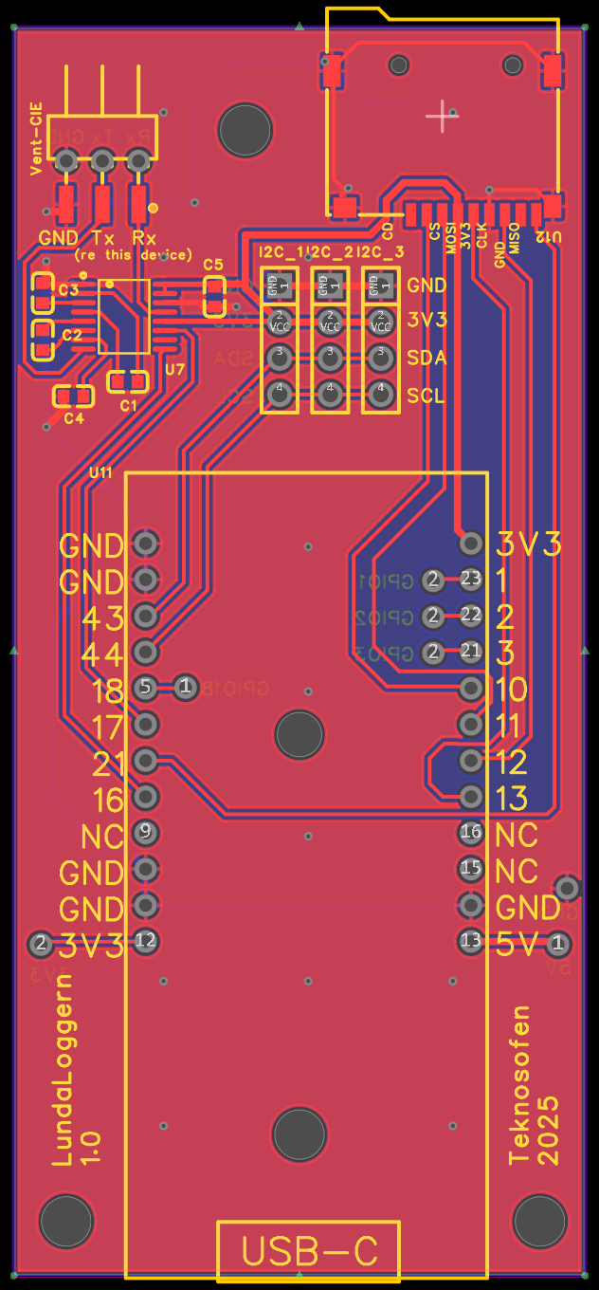
Figure 3. PCB layout of the LundaLoggern carrier board: Vent-CIE header and MAX3221 top left, microSD socket top right, I2C headers in the middle, T-Display S3 footprint with USB-C at the bottom edge.

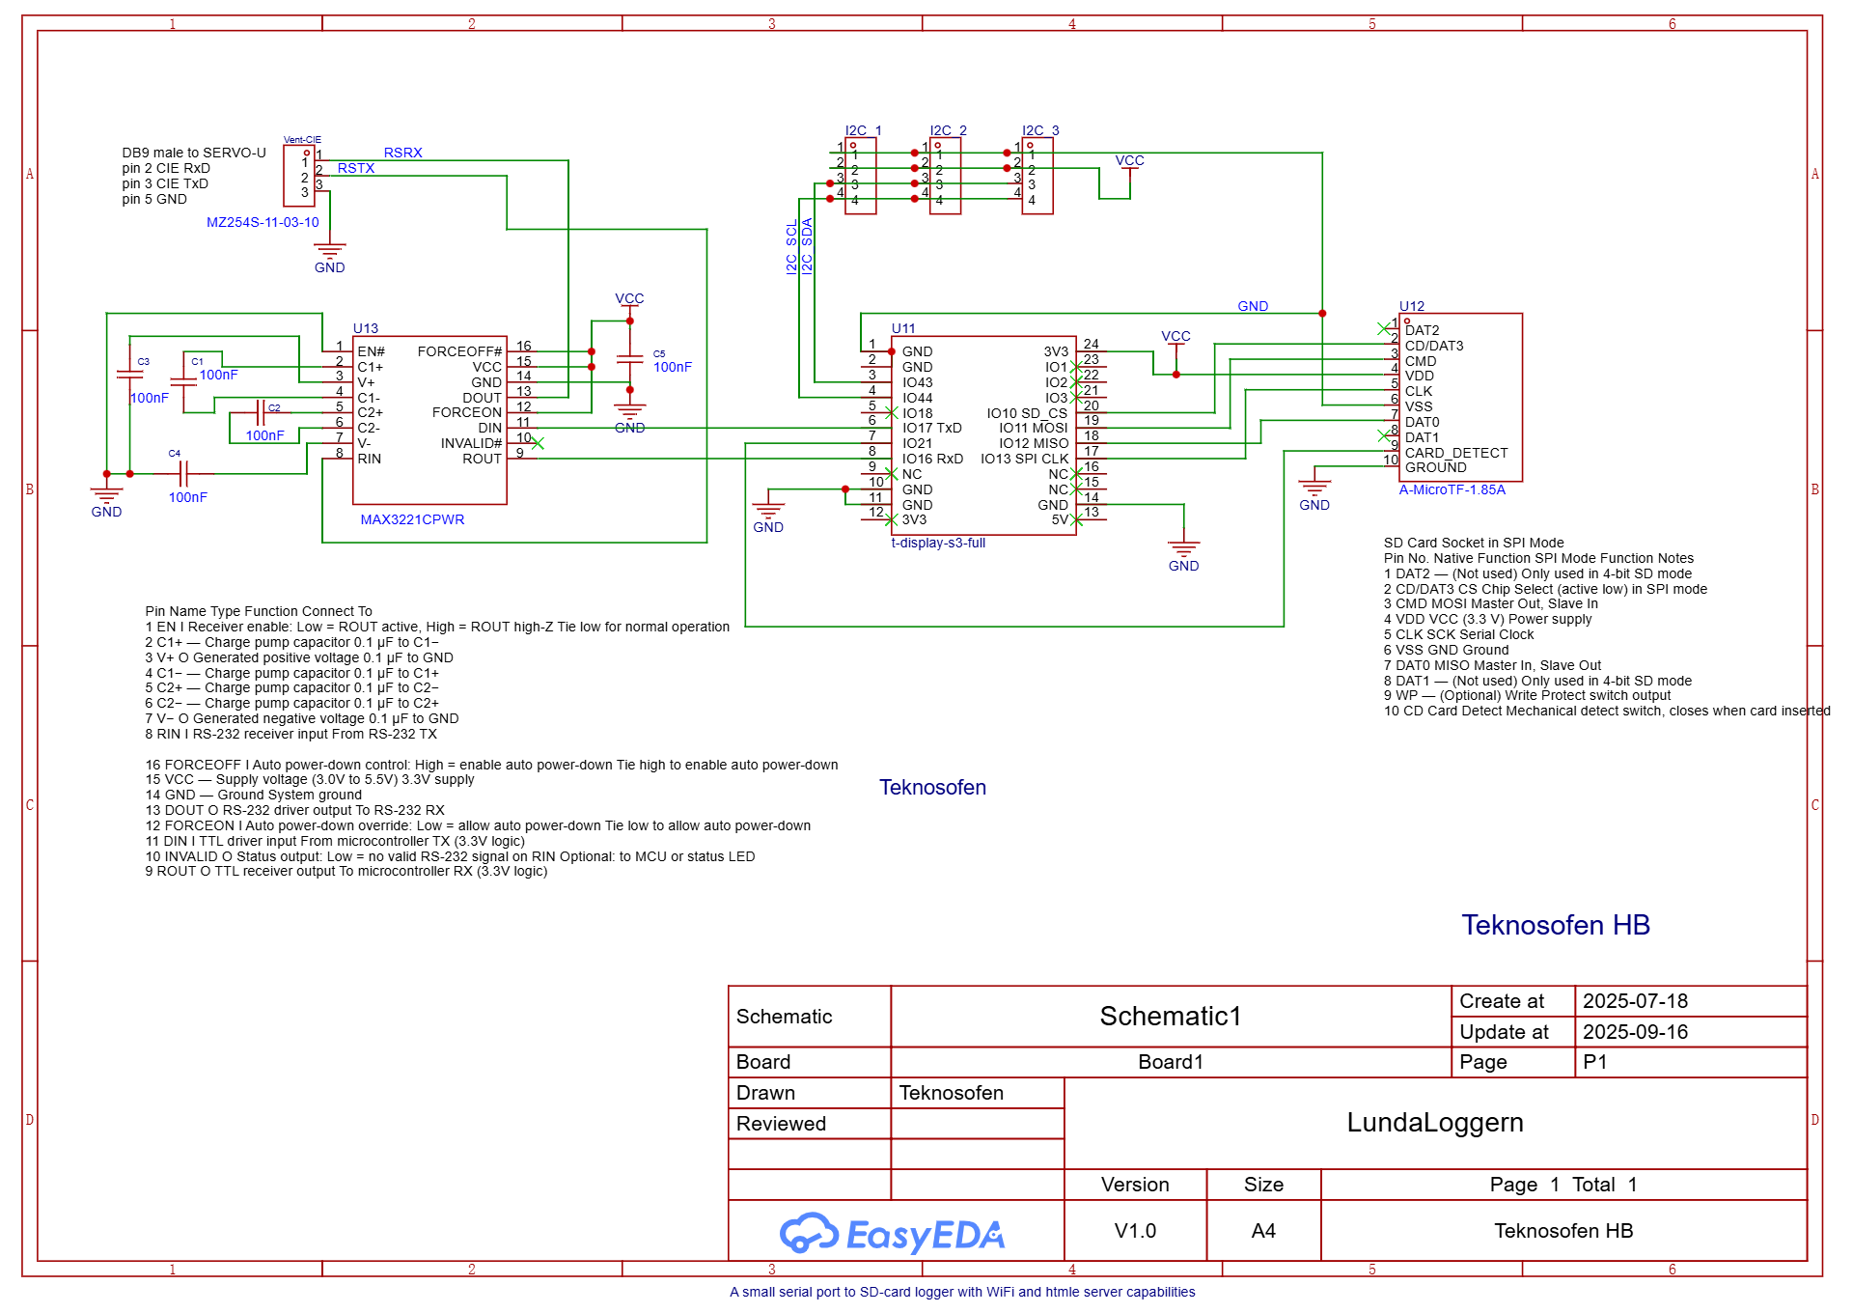
Figure 4. Schematic of the LundaLoggern carrier board: MAX3221 RS232 transceiver, Vent-CIE header, microSD socket, I2C expansion headers and the T-Display S3 connection.

3. Software Architecture

3.1 Architectural Style
The firmware uses a small, loop-driven embedded architecture. main.cpp owns the global device objects and coordinates their lifecycle; it is the application controller rather than a separate controller class. Hardware-facing modules expose narrow C++ interfaces, while ServoCIEData owns the CIE parsing and channel-processing logic. Dependencies are passed by reference or pointer where practical (SDManager receives the SPI bus and DateTime; ServoCIEData receives SDManager; HostCli is attached to the storage and CIE objects during setup).

3.2 Class Diagram
The diagram shows active runtime dependencies. QRHandler is also implemented, but is currently not instantiated or called by main.cpp.
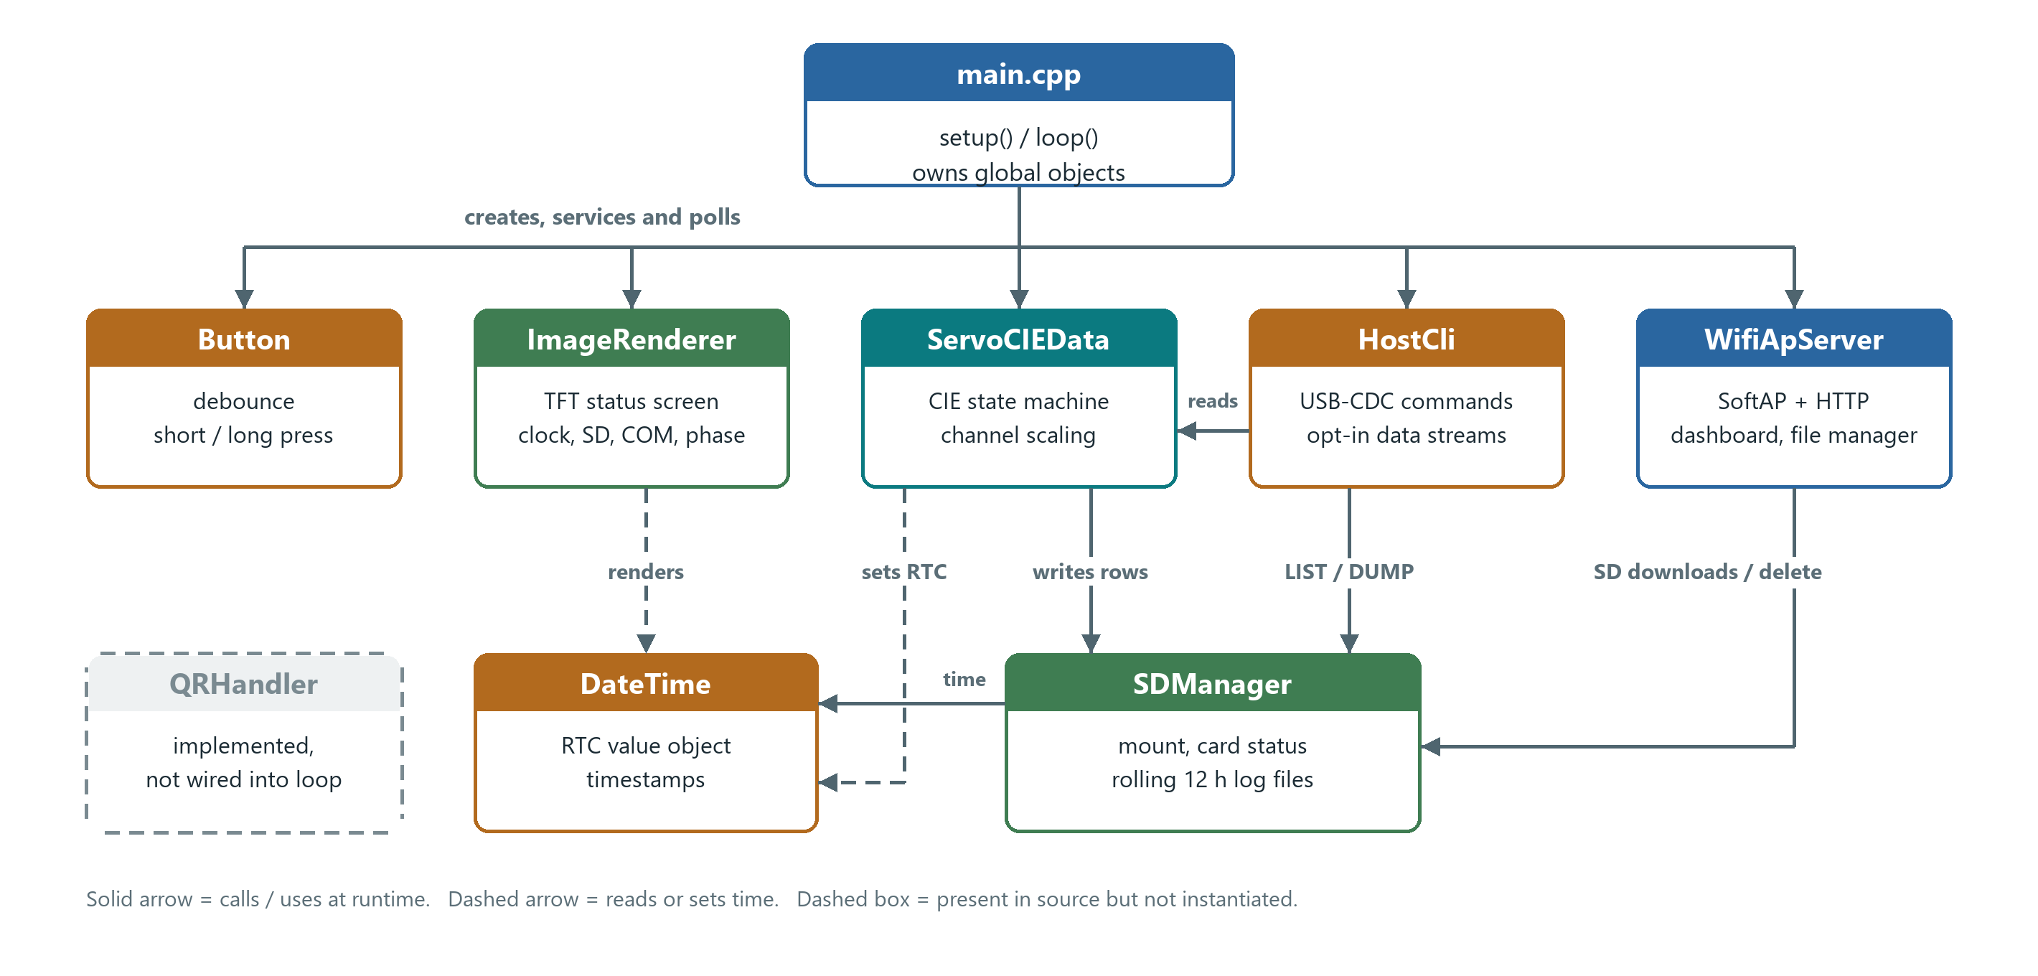
Figure 5. Runtime class relationships. main.cpp owns and services every module; arrows show direct calls between modules.

3.3 Class Interfaces
Class | Public interface and contract | Collaborators / notes
ServoCIEData | begin(), parseCIEData(byte), CIE_comCheck(), and CIE_setup() manage CIE startup and byte-wise parsing. initializeConfigs(...) loads channel definitions. Getters expose device ID, breath phase, communication state, and alarm summaries. | Constructed with an SDManager*; writes metric, setting, and alarm rows through it. Uses DateTime/RTC for ventilator time. Channel configuration arrays are currently public.
SDManager | begin() mounts the card; updateCardStatus() reports presence transitions; appendData(data, type) routes a data row to its rolling log; text-file methods provide basic file operations. Busy/card state is queryable. | Constructed with an SPI bus, chip-select pin, and DateTime*. Owns the SD logging and file-name window logic.
HostCli | attach(sd, cie), begin(), then non-blocking update() form the lifecycle. emitSetting/Metric/Alarm/CurveSample() mirror data only when the corresponding stream is enabled; info() and dbg() provide tagged output. | Receives SDManager and ServoCIEData pointers through attach(). Its command parser controls streams and provides status, headers, file listing/dump, and marker commands.
WifiApServer | begin() starts the AP/server (routes are registered once, so repeated calls are safe); end() stops the server and switches the radio off; handleClient() services HTTP requests. Setters update dashboard text/values/labels; feature toggles control SD download and delete actions; getApIpAddress() reports the AP address. | Constructed with SSID and password. Its HTTP server provides dashboard, file-manager, and configuration-viewer routes.
ImageRenderer | begin() initializes the display; drawing methods update screen regions, device/time labels, SD/COM indicators, breath phase, and WiFi status. | Constructed with a TFT_eSPI&; main.cpp decides when status changes warrant a redraw.
DateTime | Value object with field accessors/mutators, validity, toString()/rawString(), and RTC read/write helpers. | Shared timestamp source for log naming and display. The CIE time response is parsed by ServoCIEData.
Button | begin() configures input; handleInterrupt() records edge events; update() advances press/debounce state; wasPressed(), wasReleased(), and wasLongPress() expose events to the caller. | main.cpp maps a long press to WiFi startup and a short press to WiFi shutdown.
QRHandler | begin(), showWiFiQR(), showHomepageQR(), and showWiFiOff() draw QR screens; isShowingHomepageQR() reports its view state. | Uses its own TFT_eSPI and QRCode members. It is not currently connected to the main setup/loop path.

Configs is the channel record shared by the CIE parser: it carries channel/label/unit metadata, scale and offset, raw and scaled values, and an active flag. It is a data structure rather than a service class.

3.4 Runtime and Processing Logic
1. Startup (setup()): Initialize USB-CDC and attach/start HostCli; initialize the display, ventilator UART, SPI bus, and SD card; mount SPIFFS; load metric, setting, curve, and alarm configurations; then start CIE initialization. Configure the web dashboard, enable its SD actions, and initialize the physical button. WiFi itself remains off until the operator requests it.
2. Main loop (loop()): Each iteration reads available ventilator bytes and passes them to ServoCIEData::parseCIEData(), services HTTP requests and USB-CDC commands, and updates button state. A roughly 200 ms supervision interval refreshes the clock display, breath phase, and SD status; it also detects CIE timeouts and retries initialization when communication is down.
3. CIE frame processing: The parser uses a run-mode state machine to identify frame type, validate/interpret payloads, and update configured channel values. Metric, setting, and alarm rows are appended to SD and offered to the matching optional HostCli stream. Alarm snapshots are emitted on alarm changes. Curve samples are offered to USB only after a complete configured sample set; curve decimation is applied by HostCli, and curve data is not written to SD in this firmware revision.
4. Time and files: Ventilator time received during CIE initialization seeds the RTC. SDManager uses the timestamp to choose the active 12-hour file window and writes a header when a target log is new or empty. Configuration loading uses SD as the primary source and SPIFFS as fallback/sync, as detailed in § 4.
5. Operator controls: A button long press starts the WiFi AP and web server; a short press disconnects the AP and turns WiFi off. The web server is serviced continuously from the main loop, while file access and downloads are handled through the SD/web interfaces.

3.5 Data Flow
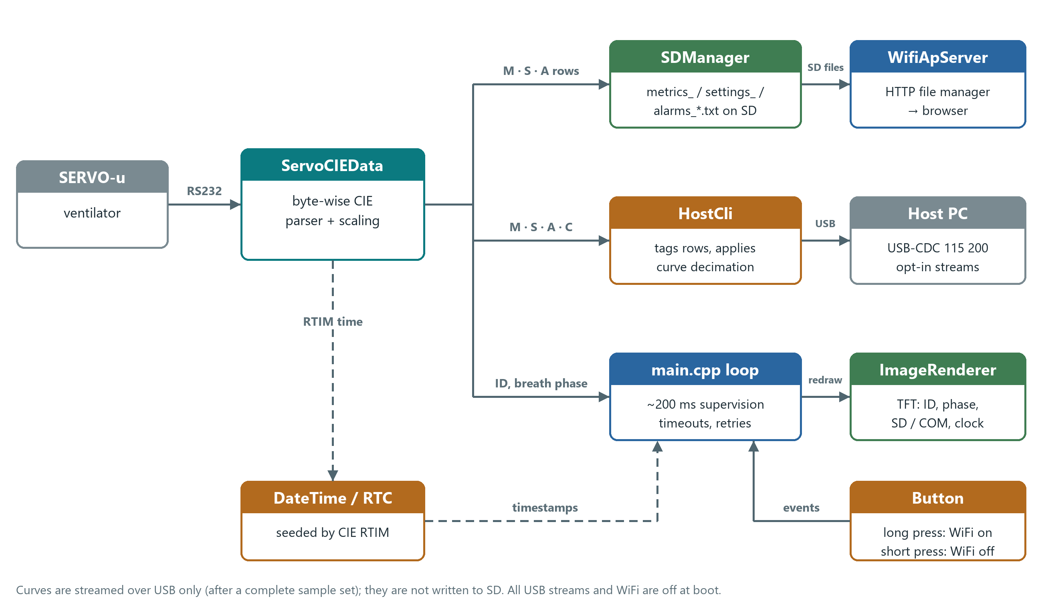
Figure 6. Runtime data flow from the ventilator to SD card, USB host, web browser and TFT display.
1. Ventilator → ServoCIEData: Raw bytes arrive on UART2 and are parsed character-by-character through the CIE state machine. Its run modes distinguish breath measurements, settings, curves, phase, trends, alarms, errors, and initialization responses.
2. ServoCIEData → SDManager: Parsed and scaled metric and setting values, plus alarm priority/status snapshots, are formatted as tab-separated rows and appended to date-stamped files (metrics_*.txt, settings_*.txt, and alarms_*.txt). Alarm rows are written when subscribed alarm state changes. Curve samples are kept in memory and are not written to SD in this firmware revision.
3. ServoCIEData → HostCli → USB-CDC: Metric, setting, and alarm rows are offered to HostCli, which emits them only when the corresponding streams are enabled. Complete curve sample sets can also be emitted, subject to curve decimation. USB streaming is independent of SD logging.
4. CIE state → main.cpp → ImageRenderer: main.cpp reads device identity and breath phase from ServoCIEData and updates the TFT when needed. The parser does not call the renderer directly.
5. SDManager → WifiApServer → browser: With WiFi enabled, the HTTP interface exposes SD files for listing, download, and deletion, as well as the configuration viewer. main.cpp services HTTP requests each loop iteration.
6. Ventilator time → DateTime → logs and display: The CIE RTIM response seeds the RTC. DateTime supplies timestamps for log naming and display updates.

4. Configuration System
Configuration is stored as tab-separated text files, loaded from the SD card (with SPIFFS as fallback/sync). Four configuration types exist:

MetricConfig.txt — Breath-by-breath measured values
Column | Meaning | Example
Channel | CIE channel number | 113
Label | Human-readable name | VtCO2
Unit | Engineering unit | ml
Scale Factor | Multiply raw value | 0.1
Offset | Add after scaling | 0.0

SettingConfig.txt — Ventilator settings
Same column format as metrics, using channel numbers in the 400-range (e.g., RR, MV, PEEP, FiO2, mode).

CurveConfig.txt — High-frequency waveform channels
Adds an active flag (true/false) to enable/disable individual curve channels (Flow, Pressure, Volume, Edi, FCO2). The active channels, in file order, are what the logger subscribes to with SDADC (up to 5). At least one channel must be active: the ventilator refuses to start streaming (RADC) without a curve channel.

AlarmConfig.txt — Ventilator alarm channels
Defines which SCI alarm channels (800–999) to subscribe to and log. Same tab-separated format as metrics/settings.
Column | Meaning | Example
Channel | CIE alarm channel number (800–999) | 805
Label | Human-readable alarm name | Apnea
Unit | Type identifier (always AD) | AD
Scale Factor | Not used for alarms (set to 1.0) | 1.0
Offset | Not used for alarms (set to 0.0) | 0.0
Active | Enable/disable this alarm channel | true

Alarm data from SCI is transmitted as priority/value byte pairs (not gain/offset-scaled values). Each alarm has:
- Priority: 0 = undefined, 1 = low, 2 = medium, 3 = high
- Status: 0 = no alarm, 1 = alarm active, 2 = alarm active but silenced
- Not applicable: The special value 0x7EFF indicates the alarm channel does not apply in the current ventilation mode.

Logged format is prio:status per channel (e.g., 3:1 = high priority, active; 0:0 = no alarm; N/A = not applicable).
Default channels include O2 concentration, EtCO2, airway pressure, apnea, gas supply, battery, disconnect, leakage, respiratory rate, minute volume, tidal volume alarms, and summary alarm channels (995–999).

DeviceConfig.txt — Device-level settings
A key-value configuration file for parameters that govern the device itself (as opposed to ventilator data channels). Lines starting with # are comments.
Key | Default | Description
SSID | LundaLoggern | WiFi access-point name
Password | neonatal | WiFi access-point password
WiFiAutoOff_min | 5 | Minutes of no connected clients before WiFi is automatically disabled. Set to 0 to disable auto-shutoff.

Configuration loading priority
SD card → SPIFFS. Bi-directional sync between SD and SPIFFS ensures resilience. If a configuration file is not found on the SD card (e.g., a fresh/empty card is inserted), the last known valid copy stored in SPIFFS is written to the SD card as a template. The operator can then edit it on the SD card and the changes will be picked up on next boot.
A load attempt is treated as successful only if at least one valid entry is parsed. An SD file that exists but is empty or contains no parseable lines is rejected, and the SPIFFS copy is used instead (and re-synced to SD). This prevents an accidentally truncated SD file from overwriting the SPIFFS factory defaults.

4a. Log File Formats
All log files are written to the SD card root as plain UTF-8 text with tab-separated fields and Unix-style newlines (\n). File names use the pattern <type>_<YYYYMMDD>_<HHMM>.txt, where the HHMM part is the start of the 12-hour rolling window (0000 or 1200 local time). When the window changes, a new file is created and the next write begins it with the header.
Header detection: a file is considered "new" (header is written) when it does not yet exist on the SD card or has size 0. Detection is per-file, so interleaved metric, setting and alarm writes never trigger spurious re-headers.

metrics_YYYYMMDD_HHMM.txt
Breath-by-breath measurements (from SCI B frames).
Data from: <ServoID>
Timestamp <label1> <label2> ... <labelN>
2026-04-28 13:05:19 12.0 No Valid Data 7.6 ...
2026-04-28 13:05:24 12.0 No Valid Data 7.6 ...

- One row per received breath frame.
- Values are scaled floating-point (scale*raw - offset) per MetricConfig.txt.
- Channels marked invalid by the ventilator (raw 0x7EFF) appear as No Valid Data.

settings_YYYYMMDD_HHMM.txt
Ventilator setting values (from SCI S frames, sent when a setting changes). Same header and row format as metrics (one row per frame: <timestamp>\t<v1>\t<v2>…), using the channels and scaling defined in SettingConfig.txt.

alarms_YYYYMMDD_HHMM.txt
Alarm-state snapshots, written only when at least one subscribed alarm transitions (becomes active, silenced, or clears). The SCI alarm stream is change-driven, so a quiet ventilator produces no rows.
Data from: <ServoID>
Timestamp <label1> <label2> ... <labelN>
2026-04-28 13:42:11 0:0 0:0 3:1 0:0 N/A 2:2 0:0 ...

Per-channel field is either prio:status or the literal N/A:
Field | Code | Meaning
prio (priority) | 0 | undefined
 | 1 | low
 | 2 | medium
 | 3 | high
status | 0 | no alarm
 | 1 | alarm active
 | 2 | alarm active but silenced
N/A | — | channel does not apply in current ventilation mode (raw 0x7EFF)

Example: 3:1 = high-priority active; 2:2 = medium-priority silenced; 0:0 = clear; N/A = not applicable.
The label order in the header matches the channel order in AlarmConfig.txt. To translate a row into named events, line up each tab-separated value with the corresponding header label.

curves_YYYYMMDD_HHMM.txt
Reserved for waveform data (Flow / Press / Volume / Edi / FCO2). Curve data is currently parsed and stored in memory but not written to SD in the present firmware revision; the file name pattern is provided for forward-compatibility. Curve samples can, however, be streamed live over the USB-CDC port — see § 5a. USB-CDC Command Interface (HostCli).

log.txt
Free-form diagnostic log used during board bring-up. Not part of the regular data stream and may be removed at any time.

5. Communication Protocol
The device communicates with SERVO ventilators using the CIE (Computer Interface Equipment) binary/ASCII protocol:
- Physical layer: RS232, 38 400 baud, 8 data bits, even parity, 1 stop bit (8E1)
- Initialization: Sends RTIM (request time), RCTY (request device type), RSEN (request serial number) commands to identify the ventilator.
- Data subscription: Sends SDADB / SDADS / SDADA / SDADC commands to subscribe to breath data, settings, alarm, and curve channels respectively. Each payload is the list of active channels from the matching config file, in file order.
- Framing: ASCII commands end with a 2-digit hex XOR checksum and EOT (0x04); ESC (0x1B) stops any ongoing transmission. Binary stream frames end with 0x7F plus a checksum byte.
- Curve samples: Sent either as absolute 16-bit values (0x80 <hi> <lo>) or as one-byte signed differences (0x82–0x7E, −126…+126) from the previous sample of the same channel. The parser decodes both.
- Timeout handling: If no data is received for 8 seconds, the connection is marked lost and re-initialization is attempted every 5 seconds.

5a. USB-CDC Command Interface (HostCli)
In addition to the ventilator-facing RS232 link, the device exposes a line-oriented command and streaming interface on the USB-CDC port (hostCom, 115 200 baud). This lets a connected PC selectively mirror logged data live, replay SD log files, and query device status — without touching the SD card or the WiFi web UI.
The interface is implemented by the HostCli class (include/HostCli.hpp, src/HostCli.cpp). It is non-blocking and runs from the main loop via hostCli.update().

5a.1 Wire format
All output lines are tab-separated and begin with an uppercase TAG that identifies their category. Lines are terminated by \n. The boot banner is:
READY <version> <SSID>
INFO Type HELP for commands. All data streams are OFF at boot.

Tag | Meaning
READY | Boot banner, emitted once after reset
OK | Command accepted; payload echoes effective state
ERR | Command rejected; payload describes the reason
INFO | Free-form informational text (also used inside HELP output)
DBG | Debug chatter; only emitted when DEBUG ON
SETTING | One settings row (or header/Data from: line)
METRIC | One metric row (or header/Data from: line)
ALARM | One alarm-state row (or header/Data from: line)
CURVE | One curve sample row, or the curve header line
HEADER | Explicit label header emitted by the HEADER command
STATUS | Key-value status line (STATUS\t<key>=<value>)
FILE | One entry in the LIST response (FILE\t<name>\t<size>)
LIST_END | End-of-list marker for LIST
DUMP_BEGIN / DUMP_END | Bracket raw file content emitted by DUMP
MARK | User-injected marker (MARK\t<timestamp>\t<text>)

Data rows reuse the same format as the SD log files: the first * line of a stream is Data from: <ServoID>, the second is Timestamp\t<label1>\t<label2>…, and subsequent rows are <RTC time>\t<v1>\t<v2>…. Each such line is simply prefixed with its stream tag on the USB side, e.g.
METRIC Data from: SERVO-u 12345
METRIC Timestamp VtCO2 MVe RR …
METRIC 2026-05-18 14:03:11 12.0 6.4 18 …

5a.2 Default state at boot
- All four data streams (Setting, Metric, Alarm, Curve) are OFF.
- DEBUG is OFF.
- Curve decimation is 1 (every sample emitted when the stream is on).
- Free-form hostCom.println(...) startup/WiFi messages that predate HostCli still appear (untagged) — they are informational and do not interfere with tagged lines.

5a.3 Commands
Commands are case-insensitive and terminated by \n (CR is ignored). Maximum input line length is 200 characters; an oversize line is rejected with ERR\tinput line too long.
Command | Effect
HELP, ? | List all commands
VERSION, VER | OK\tVERSION <fw>
STATUS | Emit a block of STATUS\tkey=value lines (fw, servoID, comOpen, sdPresent, rtc, psramFree, heapFree, wifiClients, stream, curveRate) terminated by OK\tSTATUS
STREAM ON S|M|A|C|* | Enable one or more data streams
STREAM OFF S|M|A|C|* | Disable one or more data streams
STREAM ? | Report current mask as SMACD (each char is the letter if enabled, - if not). The 5th char is the DEBUG flag.
DEBUG ON|OFF|? | Gate DBG lines
HEADER S|M|A|C | Re-emit the current label header for that stream (useful when a PC tool attaches mid-session)
RATE C <n> | Emit every Nth curve sample, n ∈ [1, 10000]. Decimation is currently only supported on the curve stream.
FORMAT [TSV|?] | Reports/sets output format. Only TSV is supported in this build; the command exists so a PC tool can probe and future formats can be added without protocol changes.
LIST | List files on the SD card root as FILE\t<name>\t<size> lines, followed by LIST_END and OK\tLIST
DUMP <filename> | Stream the contents of an SD file verbatim, bracketed by DUMP_BEGIN\t<path>\t<size> and DUMP_END\t<path>. File content is emitted unmodified (no per-line tagging) so the same parser used on the SD card can consume it directly.
MARK <text> | Inject MARK\t<RTC time>\t<text> — useful for annotating tests
TIME | Report RTC time. Setting the RTC from the host is intentionally rejected (ERR) because the firmware syncs the RTC from the ventilator on every CIE init.

5a.4 Curve streaming
Curves are not logged to SD (see § 4a curves_*.txt). They are only available over USB-CDC, and only when explicitly enabled. The first sample emitted after STREAM ON C is preceded by a header line:
CURVE Timestamp <label0> <label1> …
CURVE 2026-05-18 14:03:11.42 12.7 -3.1 0.05 …

Labels and channel count come from CurveConfig.txt. Values are the scaled floats from curves[i].scaled, formatted with 2 decimal places. One CURVE row is emitted per complete sample set (i.e. once all curveCount channels have been refreshed), subject to the RATE C <n> decimation factor. Both absolute samples and the ventilator's one-byte delta samples are decoded, so the rows follow the ventilator's curve sampling rate.
Bandwidth caution. At native rate the SERVO curve channel produces tens of samples per second across multiple channels. The USB-CDC link can carry this, but: (1) it can saturate slow terminal programs, and (2) printing curves while also running STREAM ON M S A and DEBUG ON will interleave a lot of text. Use RATE C n to thin the stream, or only enable curves for short captures.

5a.5 Example session
> VERSION
OK VERSION 1.3.0
> STREAM ON M,A
OK STREAM -M A--
> HEADER M
METRIC Timestamp VtCO2 MVe RR …
OK HEADER M
> STATUS
STATUS fw=1.3.0
STATUS servoID=SERVO-u 12345
STATUS comOpen=1
STATUS sdPresent=1
STATUS rtc=2026-05-18 14:03:11
STATUS psramFree=2087612
STATUS heapFree=204880
STATUS wifiClients=0
STATUS stream=-M A--
STATUS curveRate=1/1
OK STATUS
> DUMP metrics_20260518_1200.txt
DUMP_BEGIN /metrics_20260518_1200.txt 4821
Data from: SERVO-u 12345
Timestamp VtCO2 MVe RR …
2026-05-18 12:00:04 12.0 6.4 18 …
…
DUMP_END /metrics_20260518_1200.txt
OK DUMP /metrics_20260518_1200.txt

5a.6 Integration points
- setup() in src/main.cpp calls hostCli.attach(&sd, &servoCIEData); hostCli.begin();.
- loop() calls hostCli.update(); once per iteration.
- The Setting/Metric/Alarm emit sites in src/ServoCIEData.cpp now call hostCli.emitSetting/Metric/Alarm(dataStr) instead of writing directly to hostCom. SD logging is unaffected.
- handleValueData() calls hostCli.emitCurveSample() whenever CurveCounter wraps back to 0, i.e. once per complete sample set.
- Bulky [DBG] appendData … lines in src/SDManager.cpp are routed through hostCli.dbg(...) and are silent unless DEBUG ON is in effect.

6. WiFi & Web Interface
- SSID: LundaLoggern (password: neonatal)
- IP: Default SoftAP IP (192.168.4.1)
- Default state: WiFi and the web server are off by default. The operator must manually start them with a long-press of the physical button. A short-press shuts them down again. This minimises power consumption and RF interference in sensitive clinical environments.
- Web pages:
- Home / Dashboard: Displays version, device ID, status labels, and logo.
- File Manager: Lists all SD card log files with download and delete actions.
- Config Viewer: Shows the currently loaded configuration files from SPIFFS: DeviceConfig.txt, MetricConfig.txt, SettingConfig.txt, CurveConfig.txt, and AlarmConfig.txt.
- QR Code: Display can show a QR code for quick WiFi connection from a phone.

7. Display Layout
The 320 × 170 TFT is divided into functional zones:
Zone | Content
Top-left | LundaLoggern logo (100 × 100 px)
Top-right | Version label
Center-right | Connected ventilator type + serial number
Bottom-right | Date & time (from ventilator RTC)
Right status bar | SD card indicator, COM link indicator, breath-phase indicator
Bottom band | WiFi status (AP IP, SSID, prompt to enable/disable)

8. Build & Dependencies
PlatformIO environment: lilygo-t-display-s3
Library | Version | Purpose
bodmer/TFT_eSPI | 2.5.43 | TFT display driver
ricmoo/QRCode | ^0.0.1 | QR code generation
Arduino core | — | WiFi, SPI, SD, SPIFFS

Build flags: USB CDC on boot, HSPI pin definitions, display variant selection.

8.1 Preparing a New Board (First-Time Setup)
When programming a brand-new LilyGo T-Display S3, three separate upload steps are needed:

Step 1 — Upload the SPIFFS filesystem image
The data/ folder contains factory-default configuration files and image assets that must be flashed to the on-chip SPIFFS partition. This only needs to be done once per new board (or after a full flash erase), and again whenever files in data/ are changed.
From the PlatformIO CLI (VS Code terminal):
pio run --target uploadfs

From the VS Code GUI: Open the PlatformIO sidebar → Project Tasks → lilygo-t-display-s3 → Platform → Upload Filesystem Image.
This uploads the following files to SPIFFS:
File | Purpose
MetricConfig.txt | Breath-by-breath metric channel definitions
SettingConfig.txt | Ventilator setting channel definitions
CurveConfig.txt | Waveform curve channel definitions
AlarmConfig.txt | Alarm channel subscriptions (800–999)
DeviceConfig.txt | WiFi SSID, password, and auto-off timeout
LogoWeb.png | Logo served by the web interface
logo150.bmp | Logo displayed on TFT (loaded to PSRAM)

Note: SPIFFS does not support subdirectories. All files are placed in the root / of the SPIFFS partition.

If SPIFFS needs to be erased/reformatted (e.g. corruption or partition layout change):
pio run --target cleanfs

Then re-upload the filesystem image with uploadfs.

Step 2 — Upload the firmware
pio run --target upload

Or use PlatformIO sidebar → Upload.

Step 3 — Prepare the SD card
Insert a FAT32-formatted MicroSD card. On first boot the device will attempt to read configuration files from the SD card. If they are not found, it falls back to SPIFFS and automatically copies its factory defaults to the SD card (syncConfigSPIFFSToSD). From that point on, the SD card copy is the primary configuration source.
To use customised configurations, place edited copies of MetricConfig.txt, SettingConfig.txt, CurveConfig.txt, AlarmConfig.txt, and/or DeviceConfig.txt on the SD card root before first boot. The device will load those and sync them back to SPIFFS.

8.2 TFT_eSPI Library Configuration
The TFT_eSPI library requires a one-time manual setup in its installed library folder. After the first build (which downloads the library), locate the TFT_eSPI folder inside .pio/libdeps/lilygo-t-display-s3/TFT_eSPI/ and verify:
1. User_Setup_Select.h — Ensure the LilyGo T-Display S3 setup is enabled:
#include <User_Setups/Setup206_LilyGo_T_Display_S3.h>

All other #include lines for other boards should be commented out.
2. Alternatively, the project includes include/My_Display_Setup.h which defines:
- ST7789_DRIVER
- TFT_WIDTH 170 / TFT_HEIGHT 320
- The correct SPI pin assignments for the T-Display S3

8.3 Rebuilding After Configuration Changes
What changed | Action needed
Source code (.cpp / .hpp) | pio run --target upload
Files in data/ folder | pio run --target uploadfs (re-flash SPIFFS)
Config files on SD card only | No rebuild — just reboot the device
platformio.ini build flags | Clean build: pio run --target clean then pio run --target upload
TFT_eSPI library settings | Delete .pio/libdeps/ and rebuild, then re-apply display setup

9. File Structure
LundaLoggern/
├── platformio.ini # Build configuration
├── README.md # Project overview
├── data/ # SPIFFS data (uploaded via pio uploadfs)
│ ├── MetricConfig.txt
│ ├── SettingConfig.txt
│ ├── CurveConfig.txt
│ ├── AlarmConfig.txt # Alarm channel subscriptions (800-999)
│ └── DeviceConfig.txt # SSID, password, WiFi auto-off
├── Documentation/ # Non-code documentation
├── include/ # Header files
│ ├── main.hpp # Global includes, pin defs, constants
│ ├── ServoCIEData.hpp # CIE protocol & data management
│ ├── SDManager.hpp # SD card abstraction
│ ├── WifiApServer.hpp # WiFi AP & HTTP server
│ ├── HostCli.hpp # USB-CDC command / stream interface
│ ├── ImageRenderer.hpp # TFT display rendering
│ ├── DateTime.hpp # Date/time object & RTC
│ ├── Button.hpp # Button input handler
│ ├── QRHandler.hpp # QR code display
│ ├── constants.h # Display position constants
│ └── ... # Fonts, logo bitmap
├── src/ # Implementation files
│ ├── main.cpp
│ ├── ServoCIEData.cpp
│ ├── SDManager.cpp
│ ├── WifiApServer.cpp
│ ├── HostCli.cpp
│ ├── ImageRenderer.cpp
│ ├── DateTime.cpp
│ ├── Button.cpp
│ └── QRHandler.cpp
└── LundaLoggern_logo/ # Logo source assets

10. Key Design Decisions
1. SD + SPIFFS dual storage: Configurations live in both locations for resilience. SPIFFS holds factory defaults; SD card holds user overrides.
2. Character-by-character CIE parsing: A state machine processes each incoming byte, allowing the main loop to remain non-blocking.
3. Button-controlled WiFi: WiFi and the web server are off by default to minimise power consumption and RF interference in clinical environments. The operator must explicitly activate them via a long-press of the interaction button, and can shut them down again with a short-press.
4. Ventilator-derived time: No RTC module is needed; the device obtains accurate timestamps from the connected ventilator. Until a ventilator has set the clock, timestamps read as invalid (the clock read never blocks).
5. Configurable channels: Which metrics, settings, curves, and alarms to log are fully configurable via text files, enabling adaptation to different clinical needs without recompilation.
6. Alarm logging: Alarm data is parsed from the SCI RADC continuous data stream (flag byte 0x41 / 'A'), which transmits priority/status byte pairs whenever any subscribed alarm state changes. Up to 100 alarm channels can be subscribed via the SDADA command. Alarms are logged to separate alarms_YYYYMMDD_HHMM.txt files with the same 12-hour rolling window as metrics and settings.

11. Planned Improvements

11.1 WiFi Auto-Shutoff — Implementation Analysis
Goal: Automatically disable the WiFi access point and web server when no client has been connected for a configurable idle period (default 5 minutes, configurable via WiFiAutoOff_min in DeviceConfig.txt). This reduces unnecessary RF exposure and power draw in the NICU.

Existing behaviour (reference)
The WiFi AP and web server are off by default. The operator starts them with a long-press on the interaction button. The shutdown path already exists as WifiApServer::end(), called from the short-press handler in main.cpp:
myWiFiServer.end(); // stops the HTTP server and the AP, radio off
renderer.drawWiFiAPIP("WiFi OFF ", "No SSID ");
renderer.drawWiFiPromt("Press key to enable");

The ESP32 API WiFi.softAPgetStationNum() returns the number of currently connected SoftAP clients — this is already referenced in a comment in main.cpp.

Implementation plan
The feature requires changes in three areas:

A. Load DeviceConfig.txt at startup
A new key-value parser (simpler than the channel-config parser) reads DeviceConfig.txt from SD (SPIFFS fallback) during setup(). Parsed values replace the compile-time #define LOGGER_SSID / #define LOGGER_PW constants and populate a new wifiAutoOffMinutes variable.
Where: Add a loadDeviceConfig() function. This can live in a small new class (e.g., DeviceSettings) or be added to ServoCIEData / a free function. The same SD → SPIFFS fallback/sync pattern used by initializeConfigs() applies.
Pseudocode:
struct DeviceSettings {
String ssid = "LundaLoggern";
String password = "neonatal";
uint16_t wifiAutoOff_min = 5; // 0 = disabled
};
bool loadDeviceConfig(const char* path, DeviceSettings& cfg);

B. Track idle time in WifiApServer
Add three members to the WifiApServer class:
// WifiApServer.hpp — new private members
bool _wifiActive = false; // true after begin() is called
uint16_t _autoOffMinutes = 5; // 0 = disabled
unsigned long _lastClientSeen = 0; // millis() timestamp

Add a public method to configure and a method to check the idle timer:
// WifiApServer.hpp — new public methods
void setAutoOffMinutes(uint16_t minutes);
bool checkAutoOff(); // returns true if WiFi was shut down

checkAutoOff() logic (called from the slow-loop in main.cpp):
if WiFi is not active, or auto-off is disabled (== 0):
return false
clientCount = WiFi.softAPgetStationNum()
if clientCount > 0:
_lastClientSeen = millis() // reset timer
return false
if (millis() - _lastClientSeen) > (_autoOffMinutes * 60000):
shut down WiFi (same code as the short-press handler)
_wifiActive = false
return true // caller updates display
return false

C. Integrate into the main loop
In the existing slow-loop block in main.cpp (the if (micros() - loopStartTime > SET_LOOP_TIME) section), add:
if (myWiFiServer.checkAutoOff()) {
hostCom.println("WiFi auto-off: no clients for timeout period");
renderer.drawWiFiAPIP("WiFi OFF ", "No SSID ");
renderer.drawWiFiPromt("Press key to enable");
}

Also update the long-press handler to pass the loaded SSID/password and reset the idle timer:
myWiFiServer.begin(); // already exists
myWiFiServer.resetIdleTimer(); // new — sets _lastClientSeen = millis()

Summary of changes
File | Change
data/DeviceConfig.txt | New file — SSID, Password, WiFiAutoOff_min
main.hpp | Remove hard-coded LOGGER_SSID / LOGGER_PW defines; add DeviceSettings struct or include
main.cpp setup() | Call loadDeviceConfig(); pass loaded SSID/password to WifiApServer constructor or a setter
main.cpp loop | Call myWiFiServer.checkAutoOff() in the slow-loop; update display if it returns true
WifiApServer.hpp | Add _wifiActive, _autoOffMinutes, _lastClientSeen members; add setAutoOffMinutes(), checkAutoOff(), resetIdleTimer() methods
WifiApServer.cpp | Implement checkAutoOff() using WiFi.softAPgetStationNum() and the shutdown sequence
ServoCIEData.cpp or new file | loadDeviceConfig() with SD → SPIFFS fallback/sync

Edge cases to consider
- WiFiAutoOff_min = 0: Feature disabled — WiFi stays on until manual short-press.
- Client connects then disconnects: Timer resets on every poll where clientCount > 0; countdown only begins after the last client disconnects.
- WiFi never started: checkAutoOff() returns false immediately if _wifiActive == false.
- Operator re-enables WiFi after auto-off: Long-press works normally, resets the idle timer.
- Missing DeviceConfig.txt: Hard-coded defaults (LundaLoggern / neonatal / 5 min) are used, matching current behaviour.

