TjofiaWX Weather Station
Hardware & Firmware Reference Guide

Firmware v1.1 · Adafruit HUZZAH32 (ESP32) · GC9A01 240×240 Circular Displays

28BYJ-48 Dual Stepper Motor Control
ULN2003A Driver · Adafruit HUZZAH32 (ESP32-WROOM) · GC9A01 SPI Display

Quick Start
This section gets a freshly flashed TjofiaWX station running in about five minutes.
The detailed reference sections that follow cover wiring, pin assignments, and
firmware internals.

What you need
Item | Notes
Assembled TjofiaWX hardware | HUZZAH32 + both GC9A01 displays + stepper gauges + PWM meter wired per §2–§5
USB cable or 5V supply | HUZZAH32 USB for power; stepper motors need a separate 5V rail
Home WiFi network | 2.4 GHz band; WPA/WPA2 personal
OpenWeatherMap API key | Free account at openweathermap.org → My Profile → API keys
Phone, tablet, or laptop | Any device with a browser; must support WiFi

Step 1 — Power on
Apply power. Both circular displays show the Teknosofen splash (project name, firmware version, build date). After ≈ 2 seconds the startup self-test moves all instrument needles briefly and the clock display transitions to the WiFi setup screen.
If WiFi credentials are already saved the device connects directly and you can skip to Step 5.

Step 2 — Connect to the setup hotspot
The clock display shows four lines:
WiFi Setup
Connect to:
TjofiaWX-Setup
192.168.4.1

On your phone or laptop, open the WiFi settings list and connect to TjofiaWX-Setup (open network — no password required). Then open a browser and go to http://192.168.4.1 — a setup page loads.

Step 3 — Enter WiFi credentials and OWM key
The setup page lists nearby WiFi networks. Select your home network, enter its password, and paste your OpenWeatherMap API key into the field at the bottom. Tap Save. The device connects to your home network; the setup hotspot closes.
Can't see a network? Tap Scan or scroll down — the list auto-refreshes. The HUZZAH32 only supports 2.4 GHz; 5 GHz networks will not appear.

Step 4 — Read the IP address from the clock display
Once connected to your home network the clock display shows two lines:
YourNetworkName
192.168.x.x
Line 1 is the name (SSID) of your home WiFi.
Line 2 is the IP address the router assigned to TjofiaWX.
Make a note of the IP address — it lets you reach the web portal from any browser on the same network even if mDNS is not available.
The display then steps through NTP syncing…, Locating…, and Fetching weather… before the analogue clock face appears and the weather panel shows live data.

Step 5 — Open the web portal
From any browser on your home network, open one of:
Address | When to use
http://TjofiaWX.local | Works on macOS, iOS, Windows 10 1903+; may not work on Android
http://192.168.x.x | Always works — use the IP shown on the clock display in Step 4

The portal home page shows four large buttons:
Button | Page | What you do there
☁ Weather | /wx | View live data; update or change the OWM API key
📍 Set Location | /location | Pin exact lat/lon on a map for precise local weather
⚙ Calibration | /calib | Calibrate the stepper gauges and speed meter
🖼 Images | /images | Upload photos that cycle on the weather display

Step 6 — (Optional) Pin your location
IP geolocation resolves to the ISP's exchange, which can be tens of kilometres from the device. For accurate local weather data, open the portal and tap
📍 Set Location:
- The map opens centred on the auto-detected position.
- Click the map or drag the pin to your exact location.
- Tap Use my GPS on a phone to jump the map to your GPS position.
- Tap Save & pin — a new weather fetch starts within 30 seconds.

Step 7 — Done
Display | What you see | Update rate
Clock (left) | Analogue clock face + today's date below centre | Every second
Weather (right) | Temperature, feels-like, wind direction & speed, pressure, humidity | Every 10 minutes

The weather display also cycles through any uploaded photos: weather panel → photo 1 → weather panel → photo 2 → … (default interval 10 s, adjustable on the Images page).
If the clock display ever shows No weather data / Check setup, open http://TjofiaWX.local/wx, verify the OWM key, and check that the device has internet access.

1. Overview
This guide covers control of two 28BYJ-48 stepper motors from an Adafruit HUZZAH32 (ESP32-WROOM32 Feather) using two separate ULN2003A driver chips. A circular SPI display (GC9A01, 240×240) shows weather and clock data. All control signals run at 3.3V logic; the motor coils are powered from a separate 5V supply.
Parameter | Value
Motor | 28BYJ-48, 5V unipolar stepper
Driver (×2) | ULN2003A, DIP-16
Controller | Adafruit HUZZAH32 (ESP32-WROOM32)
Display | GC9A01 240×240 circular, hardware SPI (VSPI)
Display library | DIYables_TFT_Round (Adafruit GFX compatible)
Wind speed meter | Analog panel meter, 0–30 kn, driven by 12-bit LEDC PWM (GPIO22)
Steps / rev (half-step) | 4096 — output shaft, internal 1:64 gear included
Gear ratio | 1:64 internal (motor only — no external reduction)
Motor supply | 5V external — NOT the 3.3V board rail

2. HUZZAH32 Pin Allocation
The HUZZAH32 uses an ESP32-WROOM32 module. Some board pins carry alternate labels (A0–A5) that do not match the underlying GPIO number — the table below shows both.
Board label | GPIO # | Assigned to | Notes
SCK | 5 | Display CLK | SPI SCK — shared by both displays
MOSI | 18 | Display MOSI | SPI MOSI — shared by both displays
D15 | 15 | Display 1 CS | Clock face display — chip select
D13 | 13 | Display DC | Data/command — shared by both displays
A5 | 4 | Display RST | Reset — shared by both displays (wired together)
23 | 23 | Display 2 CS | Weather display — chip select (TFT2_CS)
22 | 22 | PWM speed out | Electrical speed indicator output (PWM_SPEED_PIN)
14 | 14 | Motor 1 — IN1 | Wind gauge
27 | 27 | Motor 1 — IN2 | Wind gauge
32 | 32 | Motor 1 — IN3 | Wind gauge
33 | 33 | Motor 1 — IN4 | Wind gauge
A1 | 25 | Motor 2 — IN1 | Pressure gauge — board label A1, actual GPIO 25
A0 | 26 | Motor 2 — IN2 | Pressure gauge — board label A0, actual GPIO 26
RX | 16 | Motor 2 — IN3 | Pressure gauge — safe if Serial1 unused
TX | 17 | Motor 2 — IN4 | Pressure gauge — safe if Serial1 unused
19 | 19 | (free) | SPI MISO — not needed (write-only displays); reserve for future use
34, 35, 36, 39 | — | Do not use for output | Input-only pins — no output driver
6–11 | — | Do not use | Internal SPI flash — never expose

Note: The A0/A1 labels on the HUZZAH32 silk refer to GPIO 26 and 25 respectively — not GPIO 0 and 1. Always use the GPIO number in code, not the A-prefix label.
Note: RX (GPIO 16) and TX (GPIO 17) are usable as general outputs as long as you do not need the hardware Serial1 port.

2.1 Second display wiring
Both GC9A01 displays share the same SPI bus (SCK, MOSI) and the same DC and RST lines. Only the CS pin differs:
Signal | Both displays | Display 1 only | Display 2 only
CLK | GPIO 5 | — | —
MOSI | GPIO 18 | — | —
DC | GPIO 13 | — | —
RST | GPIO 4 | — | —
CS | — | GPIO 15 | GPIO 23

Wire the second display's CLK, MOSI, DC, and RST to the same board pins as the first display. Connect only CS to GPIO 23. Initialisation order matters: clockDisp.begin() is called first — this drives the shared RST line and resets both displays simultaneously. weatherDisp.begin() is called second with rst=-1 so it sends init commands to the second display without toggling RST again (which would reset the already-running first display).

3. Motor Connector — Wire Colours
The 28BYJ-48 uses a 5-pin JST PH (2 mm pitch) connector. Pin numbering is with the latch/tab facing you, left to right. Both motors use identical connectors and wire colours.
Pin | Colour | Coil | ULN OUT pin | Connect to
1 | Blue | B2 (IN4) | Pin 13 | Motor 1: GPIO 33 / Motor 2: GPIO 17 (TX)
2 | Pink | B1 (IN3) | Pin 14 | Motor 1: GPIO 32 / Motor 2: GPIO 16 (RX)
3 | Yellow | A2 (IN2) | Pin 15 | Motor 1: GPIO 27 / Motor 2: GPIO 26 (A0)
4 | Orange | A1 (IN1) | Pin 16 | Motor 1: GPIO 14 / Motor 2: GPIO 25 (A1)
5 | Red | +5V common | — | +5V supply + ULN2003A pin 9 (COM)

Note: The red wire must connect to both +5V and the ULN2003A COM pin (pin 9). This activates the internal flyback diodes which suppress voltage spikes when coils switch off.

4. ULN2003A Chip Pinout (DIP-16)
Wire both ULN2003A chips identically — only the GPIO source pins differ between
Motor 1 and Motor 2.
Pin | Signal | Pin | Signal | Notes
1 | IN1 ← GPIO (see §2) | 16 | OUT1 → Orange wire | Coil A1
2 | IN2 ← GPIO (see §2) | 15 | OUT2 → Yellow wire | Coil A2
3 | IN3 ← GPIO (see §2) | 14 | OUT3 → Pink wire | Coil B1
4 | IN4 ← GPIO (see §2) | 13 | OUT4 → Blue wire | Coil B2
5 | IN5 (unused) | 12 | OUT5 (unused)
6 | IN6 (unused) | 11 | OUT6 (unused)
7 | IN7 (unused) | 10 | OUT7 (unused)
8 | GND | 9 | COM → +5V | Must connect to motor supply

5. Full Wiring Summary
Motor 1 (Wind gauge)
HUZZAH32 label | GPIO # | ULN2003A #1 | Motor 1 wire
14 | 14 | Pin 1 (IN1) → Pin 16 (OUT1) | Orange
27 | 27 | Pin 2 (IN2) → Pin 15 (OUT2) | Yellow
32 | 32 | Pin 3 (IN3) → Pin 14 (OUT3) | Pink
33 | 33 | Pin 4 (IN4) → Pin 13 (OUT4) | Blue
+5V | — | Pin 9 (COM) | Red (common)
GND | — | Pin 8 (GND) | —

Motor 2 (Pressure gauge)
HUZZAH32 label | GPIO # | ULN2003A #2 | Motor 2 wire
A1 | 25 | Pin 1 (IN1) → Pin 16 (OUT1) | Orange
A0 | 26 | Pin 2 (IN2) → Pin 15 (OUT2) | Yellow
RX | 16 | Pin 3 (IN3) → Pin 14 (OUT3) | Pink
TX | 17 | Pin 4 (IN4) → Pin 13 (OUT4) | Blue
+5V | — | Pin 9 (COM) | Red (common)
GND | — | Pin 8 (GND) | —

GC9A01 SPI Displays — shared signals (wire to both displays)
HUZZAH32 label | GPIO # | Display pin label | Notes
SCK | 5 | SCK | SPI clock — board label matches display label
MOSI | 18 | SDA | SPI data — display PCB labels this SDA, not I2C
D13 | 13 | DC | Data / command select
A5 | 4 | RST | Reset — wire both display RST pins together to this pin
3V | — | VCC | 3.3V supply — both displays
GND | — | GND | Common ground — both displays

⚠ SPI, not I2C: The GC9A01 module labels its data pin SDA and its clock pin SCK, which makes it look like an I2C device. It is not — it is 4-wire SPI. Connect SDA → MOSI (GPIO 18) and SCK → SCK (GPIO 5). There is no I2C address, no pull-up resistor, and no SDA/SCL bidirectional bus involved.
GC9A01 SPI Displays — per-display CS (one wire each)
HUZZAH32 label | GPIO # | Connect to | Display
D15 | 15 | CS | Display 1 — clock face
23 | 23 | CS | Display 2 — weather panel

6. Display Controller — GC9A01
round display information: https://diyables.io/products/1.28-inch-round-circular-tft-lcd-display-module The GC9A01 is a single-chip LCD/TFT controller designed for circular or square displays up to 240×240 pixels. It communicates over 4-wire SPI and operates entirely at 3.3V — no level shifting is needed when driven from the HUZZAH32.
Parameter | Value
Resolution | 240 × 240 px
Colour depth | 16-bit RGB565
Interface | 4-wire SPI (CLK, MOSI, CS, DC) + RST
Supply voltage | 3.3V (logic and panel)
SPI clock used | 80 MHz (ESP32 VSPI maximum; GC9A01 supports up to 100 MHz)
Driver IC | Sitronix GC9A01

6.1 SPI Signal Roles
Display pin label | SPI signal | Direction | Function
SCK | CLK | ESP32 → display | SPI clock
SDA | MOSI | ESP32 → display | Serial data in — not I2C; display has no MISO
CS | CS | ESP32 → display | Chip select — active LOW
DC | DC | ESP32 → display | HIGH = data, LOW = command
RST | RST | ESP32 → display | Hardware reset — active LOW pulse on startup
VCC | — | — | 3.3V supply
GND | — | — | Common ground

Pin labelling quirk: The physical module silkscreen reads SDA for the data line and SCK for the clock, matching I2C conventions. The GC9A01 is purely SPI; the labels are a common misnomer on round display breakouts. There is no I2C mode.

6.2 Initialisation Sequence
The DIYables_TFT_Round library handles the full GC9A01 init sequence (sleep-out, colour format, display-on, etc.) inside begin(). No manual register writes are needed.
#include <DIYables_TFT_Round.h>

// Pins: RST=4, DC=13, CS=15 (CLK=18 and MOSI=23 are hardware-fixed VSPI)
DIYables_TFT_GC9A01_Round tft(4, 13, 15);

void setup() {
tft.begin();
tft.fillScreen(BLACK);
}

6.3 Colour Format
All colours are 16-bit RGB565 — 5 bits red, 6 bits green, 5 bits blue. Common values used in this project:
Name | Hex | Use
COL_BG | 0x0000 | Background — black
COL_FACE | 0xFFFF | Clock face and text — white
COL_ACCENT | 0xFD20 | Temperature, centre dot — amber
COL_SEC | 0xF800 | Second hand — red
COL_ERROR | 0xF800 | Error screen border — red

7. WiFi Setup and Weather Service

7.1 Weather data source
Weather data comes from OpenWeatherMap (OWM), free tier. The free plan allows 1 000 API calls per day; the firmware fetches every 10 minutes (~144 calls/day), well within the limit.
Getting an API key:
- Create a free account at openweathermap.org
- Confirm your e-mail address
- Go to My Profile → API keys
- Copy the default key (or create a named key, e.g. TjofiaWX)
- The key becomes active within a few minutes of account creation

7.2 Web portal — access methods
The firmware runs a permanent web portal. Two ways to reach it:
Situation | How to connect | URL
Device AP only (first boot, no WiFi yet) | Connect phone/laptop to TjofiaWX-Setup | http://192.168.4.1
Device on home WiFi (normal operation) | Stay on home WiFi | http://TjofiaWX.local
Device AP always runs in parallel | Connect to TjofiaWX-Setup | http://192.168.4.1
Note: TjofiaWX.local uses mDNS (Bonjour). It works natively on macOS, iOS, and Windows 10 1903+. Android support varies; use the IP address 192.168.4.1 via the AP if .local does not resolve.
Portal pages:
Path | Purpose
/ | Settings — OWM API key form, current WiFi/IP info, WiFi reset
/wx | Status — live weather, time, location, gauge steps, speed meter, calibration toggle
/location | Map-based location pin — set lat/lon manually
/calib | Calibration — set speed meter full-scale voltage (more options coming)
/images | Image gallery — upload photos for the weather display boot screen; browser converts any format to RGB565 automatically
/reset | Clears saved WiFi credentials and restarts (confirmation prompt)

First boot (no saved WiFi credentials):
- Power on the ESP32
- Hotspot TjofiaWX-Setup appears — connect from any phone or laptop
- Open http://192.168.4.1 — a WiFiManager credential page loads
- Select your home WiFi network, enter the password, and paste the OWM API key
- Save — the device connects to your router
After first boot:
The AP TjofiaWX-Setup stays visible at all times alongside the home WiFi connection. The OWM key can be updated at any time via http://TjofiaWX.local/ or http://192.168.4.1/ without reflashing.

7.3 Geolocation
Automatic (IP-based)
On every boot the firmware calls ip-api.com (no key required) to determine latitude, longitude, timezone, and UTC offset from the device's public IP address. The request uses an explicit fields parameter so the UTC offset is included (it is not in the default response):
http://ip-api.com/json?fields=status,city,country,lat,lon,timezone,offset

IP geolocation resolves to the ISP's gateway or exchange, which can be tens of kilometres from the actual device. For weather data this is usually acceptable, but if the nearest OWM station is wrong, use the manual pin below. All values are cached in NVS (lat, lon, timezone, utc_off) so they survive reboots and temporary network outages.
Manual location pin
A map-based location picker is available at /location (http://TjofiaWX.local/location or a button on the main config page).
Requires internet access on the browser — the ESP32 serves only a small HTML skeleton; the Leaflet.js library and OpenStreetMap tiles are fetched by the browser from public CDNs. Use the TjofiaWX.local address on the home WiFi network, not the device AP.
Step | Action
1 | Open http://TjofiaWX.local/location
2 | The map opens centred on the current (IP-geolocated) position with a draggable pin
3 | Click anywhere on the map to move the pin, or drag the marker to fine-tune
4 | Tap Use my GPS to jump the map and pin to the browser's GPS position (works best on a phone)
5 | Press Save & pin — lat/lon are written to NVS and a loc_pinned flag is set

Once pinned:
- The loc_pinned flag is shown with a green banner on the location page.
- ip-api.com is still called on each boot for the UTC offset only — its lat/lon is silently ignored. Local time therefore remains correct.
- The serial monitor prints [pinned] next to the coordinates to confirm.
Location: [pinned] (60.1234, 16.5678) tz offset +7200 s (UTC offset from ip-api)

To revert to automatic IP geolocation, press Clear pin on the location page. NVS keys lat and lon are not deleted — they are simply unprotected again and will be overwritten by the next successful ip-api fetch.

7.4 NTP time sync
Local time is obtained from pool.ntp.org / time.nist.gov after WiFi connects. The UTC offset comes from the ip-api geolocation response — no manual timezone configuration is needed.
The ESP32 Arduino configTime() function builds an invalid POSIX timezone string when the DST offset is zero (e.g. "UTC-1UTC-11"), which the C runtime rejects and silently treats as UTC. The firmware avoids this by calling configTzTime() directly with a manually built POSIX string:
ip-api offset | POSIX string | Meaning
+3600 (UTC+1) | "UTC-1" | 1 hour east of UTC
+7200 (UTC+2) | "UTC-2" | 2 hours east of UTC
-18000 (UTC−5) | "UTC+5" | 5 hours west of UTC

Note the inverted sign — this is the POSIX timezone convention. Half-hour and quarter-hour offsets (e.g. +19800 for UTC+5:30) are handled correctly. The serial monitor prints the offset and the resulting POSIX string on every boot for easy verification:
Location: Råby, Sweden (60.1000, 16.3667) tz offset +7200 s
NTP sync: offset +7200 s → POSIX "UTC-2"

7.5 Boot image (weather display)
The /images page lets you upload a photo that appears on the weather display at startup instead of the Teknosofen splash. The conversion from any photo format to 240×240 RGB565 happens entirely in the browser — no Python, no PC tool, no pre-processing step needed.
Uploading a photo:
Step | Action
1 | Open http://TjofiaWX.local/images
2 | Tap Choose photo and pick any JPEG, PNG, HEIC, BMP, etc.
3 | A circular 240×240 preview appears instantly (centre-crop + resize done in the browser)
4 | Tap Convert & Upload — the browser encodes RGB565 big-endian and POSTs 115,200 bytes directly to the device
5 | The gallery updates; tap Set as boot to use the image at next power-on

Gallery management:
- Each stored image is shown as a circular 80×80 thumbnail (decoded from raw RGB565 by the same browser canvas)
- Set as boot — marks the image as the startup image; path stored in NVS (boot_img key)
- Delete — removes the file from LittleFS; clears boot-image NVS key if it pointed to that file
- Clear (use splash) — reverts to the Teknosofen splash without deleting any image
Auto-selection:
If no boot image is pinned in NVS, the firmware scans LittleFS on every boot and uses the first .raw file it finds. Pin an explicit boot image with Set as boot to make the choice deterministic when multiple images are stored.
Storage limits:
Images are stored as raw 240×240 RGB565 big-endian files (115,200 bytes each). The LittleFS partition is 1 MB — this allows up to ~8 images with headroom for the filesystem metadata.
Alternative (PC-based conversion):
tools/convert_image.py (Pillow required) still works for cases where the browser cannot decode a particular format (some HEIC files on Android). It produces an identical .raw file that can be uploaded via the same /images page:
python tools/convert_image.py photo.jpg # saves photo.raw
python tools/convert_image.py photo.jpg --preview # preview before saving
Run without arguments on Windows/macOS to open a file picker dialog.

8. Half-Step Sequence
The same 8-phase sequence applies to both motors. Each row shows the coil states driven by IN1–IN4.
Step | IN1 (Orange) | IN2 (Yellow) | IN3 (Pink) | IN4 (Blue)
0 | 1 | 0 | 0 | 0
1 | 1 | 1 | 0 | 0
2 | 0 | 1 | 0 | 0
3 | 0 | 1 | 1 | 0
4 | 0 | 0 | 1 | 0
5 | 0 | 0 | 1 | 1
6 | 0 | 0 | 0 | 1
7 | 1 | 0 | 0 | 1

9. Project Code Structure
The firmware is a PlatformIO project targeting the featheresp32 board. Key source files:
File | Purpose
src/Stepper28BYJ.h | Low-level half-step driver — one instance per motor
src/Instruments.h/cpp | StepperGauge and Instruments — position-aware gauge abstraction
src/config.h | All pin assignments, gauge limits, timing constants
src/BaseDisplay.h/cpp | Abstract base — owns _tft, bezel, boot screens (splash/status/error/AP)
src/ClockDisplay.h/cpp | Extends BaseDisplay — analogue clock face, hands, centre temperature
src/WeatherDisplay.h/cpp | Extends BaseDisplay — weather data panel (temp, wind, pressure, humidity)
src/DisplayManager.h | Thin alias: typedef ClockDisplay DisplayManager (kept for compatibility)
src/SpeedMeter.h/cpp | 12-bit LEDC PWM driver for the analog wind-speed meter panel
src/WeatherClient.h/cpp | IP geolocation + OpenWeatherMap fetch + Nominatim reverse geocoding
src/main.cpp | State-machine entry point
src/demo/main.cpp | Motor test sketch (see §11)

Stepper28BYJ is self-contained — no external stepper library needed.
StepperGauge wraps it with a value-to-steps mapping and tracks the current needle position so only the delta is driven on each update.

9.1 Display driver and dual-display architecture
The upstream DIYables_TFT_Round library is vendored into lib/DIYables_TFT_Round/ with two patches applied:
Patch | Reason
SPI clock raised from 40 MHz → 80 MHz | Upstream hardcoded 40 MHz; GC9A01 and ESP32 VSPI both support 80 MHz
fillScreen() rewritten to send 512-byte chunks | Upstream sent one byte at a time — 115 200 individual transfers to clear the screen; patched version uses 225 bulk writes (~10× faster)
spiTx() switched to SPI.writeBytes() | SPI.transfer() overwrites the data buffer (full-duplex); writeBytes() is write-only and correct for a display
begin() skips reset when _res == 0xFF | The library stores the reset pin as uint8_t; passing rst=-1 (the "no reset" sentinel) silently becomes 255. Without this guard, begin() called pinMode(255) and digitalWrite(255), generating HAL errors. Secondary displays sharing a RST line now pass rst=-1 cleanly.

Class hierarchy
BaseDisplay owns _tft, drawBezel(), showSplash/Status/Error/APMode
├── ClockDisplay analogue clock face, hour/minute/second hands, centre temp
└── WeatherDisplay weather data panel updated after each 10-min fetch

Two instances live in main.cpp:
static ClockDisplay clockDisp(TFT_CS); // CS=15, RST=4 (drives shared RST)
static WeatherDisplay weatherDisp(TFT2_CS); // CS=23, rst=-1 (no RST toggle)

Shared RST initialisation order:
clockDisp.begin() is called first — it drives GPIO 4 (RST) low→high, which resets both displays simultaneously (RST lines are wired together). weatherDisp.begin() is called second with rst=-1; it sends init commands to the second display without toggling RST again, which would otherwise reset the already-initialised first display.
WeatherDisplay layout (240×240 circle)
y (baseline) | Content | Font | Colour
72 | Temperature 22.5°C | FreeSansBold18pt | amber
92 | feels 20.1°C | FreeSans9pt | dim white
101 | separator line | — | dark grey
135 | Compass rose (cx=58, cy=135, r=30) + wind speed m/s + bearing | FreeSans9pt | white / amber
178 | Pressure 1013 mBar | FreeSans9pt | white
193 | Humidity 65% RH | FreeSans9pt | white
202 | separator line | — | dark grey
215 | Weather description | FreeSans9pt | amber

The compass needle points FROM the wind source (meteorological convention: deg=0 = from North, needle tip at top of circle). Cardinal points N/S/E/W are labelled inside the ring using the built-in 6×8 font; N is red, S/E/W are white. WeatherDisplay::update() does a full fillScreen + redraw on each call; at 10-minute intervals the brief black flash is imperceptible. platformio.ini references Adafruit GFX directly (was previously a transitive dependency of the DIYables library):
lib_deps =
adafruit/Adafruit GFX Library @ ^1.11.0

Note: The HUZZAH32 routes its SPI bus to SCK=GPIO5 and MOSI=GPIO18 — these differ from the raw ESP32 VSPI defaults (CLK=18, MOSI=23). The library picks up the correct pins automatically via the board's SPI.begin(). Only RST, DC, and CS are free to assign.

9.2 Gauge physical limits (`config.h`)
Stepper gauges
// Motor 1 – wind speed: 0–60 knots → 0 to 3/4 revolution
#define WIND_MIN_KT 0.0f
#define WIND_MAX_KT 60.0f
#define WIND_MAX_STEPS (STEPS_PER_REV * 3 / 4) // 3072 steps

// Motor 2 – pressure: 960–1040 hPa → 0 to 3/4 revolution
#define PRES_MIN_HPA 960.0f
#define PRES_MAX_HPA 1040.0f
#define PRES_MAX_STEPS (STEPS_PER_REV * 3 / 4) // 3072 steps

PWM wind speed meter (`SpeedMeter` class, GPIO22)
The third instrument is an analog panel meter with a 0–300 mV (nominal) full-scale range, wired directly to GPIO22. The SpeedMeter class drives the pin with a 12-bit, 1 kHz LEDC PWM signal; the meter's own inertia filters the switching to a steady deflection.
Parameter | Value
GPIO | 22 (PWM_SPEED_PIN)
LEDC resolution | 12-bit (4096 steps)
LEDC frequency | 1 kHz
Scale | 0–30 kn → 0–fullScaleMv
Default full-scale | 300 mV
Supply voltage used for duty calc | 3300 mV (3.3V rail)

The full-scale voltage is user-adjustable via the /calib web page and persisted in NVS under the key pwm_fs_mv. Changing it does not require reflashing — save and the new calibration is applied immediately.

9.3 Main firmware features
Boot sequence
On every power-on both displays show the project name ("Teknosofen"), firmware version (FW_VERSION in config.h), and the build date (stamped automatically by the compiler via __DATE__). After 2 seconds the startup motor self-test runs (see below), then another 2 seconds of splash before WiFi setup begins.
Bumping the version requires only changing FW_VERSION. Once running, the two displays diverge: display 1 (clock face) shows the analogue clock updated every second; display 2 (weather panel) shows the weather data layout and refreshes after each 10-minute weather fetch.
Startup self-test — motors and speed meter simultaneously
Immediately after the splash screen appears, all three instruments perform a coordinated self-test driven directly from the setup() loop:
- Both stepper needles sweep +30° (341 half-steps forward) then −30° back, returning to their exact pre-test positions. NVS-restored step counts remain valid.
- The PWM speed meter sweeps 150 → 200 → 100 → 150 mV in sync with the motor movement (150→200 mV on the forward sweep, 200→100 mV on the backward sweep, then back to 150 mV at rest).
The interleaving is done step-by-step in setup() using Instruments::stepBoth() and SpeedMeter::setMillivolts() in the same loop — no RTOS tasks are needed. Total self-test duration is approximately 2 seconds (341 steps × 3 ms × 2 directions).
Gauge position persistence (NVS)
After every weather update and every calibration mode change, the current step counts for both gauges are written to flash (ESP32 NVS, namespace tjofia, keys wind_steps / pres_steps). On the next boot, these counts are read back and passed to Instruments::begin(), which sets the internal position tracker without moving the motors. The needles stay physically where they were when power was cut; the firmware resumes with correct delta tracking from the first new weather fetch.
Wind speed tracking
After each successful weather fetch SpeedMeter::setKnots() is called with the current wind speed converted from m/s to knots. The duty cycle is computed as:
duty = (knots / 30.0) × (fullScaleMv / 3300.0) × 4095

The /wx status page shows the current output in mV, the equivalent knots, and the calibrated full-scale value.
Calibration mode (stepper gauges)
Accessible from the /wx status page. When enabled, both stepper gauges move to fixed reference positions (≈19.4 kn / 1000 hPa) and the speed meter is also driven to the same reference wind speed. Step counts are persisted to NVS; the speed meter position is not persisted (it is always derived from weather data or the reference value on enable/disable). Live weather updates are suppressed while active.
Speed meter calibration page (`/calib`)
Accessible from the main config page. Allows setting the full-scale voltage (mV) — the output that drives the meter to full-scale (30 kn) deflection. The value is stored in NVS (pwm_fs_mv) and applied immediately without restart. More calibration options will be added to this page in future firmware revisions.

9.4 Display rendering
Erase-by-overwrite
All moving elements (clock hands, temperature text) are erased by redrawing them in the background colour (COL_BG = 0x0000) rather than by clearing a rectangle with fillRect(). This avoids erasing neighbouring pixels and eliminates the brief blank flash that fillRect() causes on the black display.
- Clock hands — each hand's previous pixel path is redrawn in COL_BG before the new position is drawn in its hand colour.
- Second-hand tail — the 20-pixel counter-balance stub is explicitly erased (it was previously leaked between frames because it lies outside the main-hand sweep).
- Temperature text — the previous formatted string is reprinted in COL_BG at its stored cursor position, then the new string is drawn in COL_ACCENT. If the formatted value is unchanged the function returns immediately with zero SPI traffic (~59 of every 60 ticks).
Skipping unchanged hands
The minute hand moves < 0.14 px/s at its 80-pixel length; the hour hand even less. Both are compared pixel-endpoint before and after each tick — the erase-and-redraw is skipped entirely when the integer endpoint has not moved. This eliminates the sub-second hand flicker visible in earlier firmware.
Bevelled bezel ring
The clock face bezel is an 8-pixel wide ring drawn as 8 concentric circles from R+5 (almost black 0x0841) to R−2 (white COL_FACE), giving a dark-to-bright gradient. The same drawBezel() helper is called by every full-screen function (showSplash, showStatus, showError, showAPMode, drawFace) so the look is consistent across all screens.
Ring radius | RGB565 | Appearance
R+5 | 0x0841 | almost black (outermost)
R+4 | 0x1082 | very dark grey
R+3 | 0x2104 | dark grey
R+2 | 0x4208 | medium-dark grey
R+1 | 0x630C | medium grey
R | 0x8410 | medium-light grey
R−1 | 0xC618 | light grey
R−2 | 0xFFFF | white (innermost)

R = 112. R+5 = 117 — safely within the GC9A01's 120 px circular clip.
Tick marks and hand thicknesses
Element | Previous | Current
Minute tick | 1 px, grey (0x7BEF) | 2 px, white
Hour tick | 1 px, white | 3 px, white
Minute hand | 3 px wide | 5 px wide
Hour hand | 5 px wide | 7 px wide
Second hand | 1 px | 1 px (unchanged)
Tick width is achieved by drawing an extra parallel line offset by one pixel perpendicular to the radial direction. Hour ticks get an extra line on each side (3 total); minute ticks get one additional line (2 total).

10. Practical Tips
- Always call `off()` when a motor is stopped. Coils stay energised otherwise, causing the motor to run warm and draw current needlessly.
- Power motor coils from an external 5V supply. The HUZZAH32 3.3V rail cannot supply the ~200 mA per coil the motors require.
- Share GND between the ESP32, both ULN2003A chips, the motors, and the 5V supply.
- 4096 half-steps = 360° of the output shaft (internal 1:64 gear already included). 2048 = 180°. 341 ≈ 30°. Full gauge scale (270°) = 3072 steps ≈ 15 s at 5 ms/step.
- Reliable step delay is 3–5 ms. Default in Stepper28BYJ.h is 5 ms. 3 ms works on confirmed hardware; do not go below 2 ms.
- GPIO 16 and 17 (board labels RX/TX) are used for Motor 2. If you later need the hardware Serial1 port, reassign those motor pins to other free GPIOs.

11. Demo / Motor-Test Mode
The project includes a dedicated PlatformIO environment (demo) that exercises both stepper motors through a three-phase test sequence without requiring WiFi, a working display, or an OpenWeatherMap key. Use it to verify wiring and motor function before final assembly.

11.1 PlatformIO Environment
The demo is compiled from src/demo/main.cpp. build_src_filter keeps the demo and main firmware completely separate — they share only config.h and Stepper28BYJ.h.
; platformio.ini (relevant excerpt)

[env:featheresp32] ; main weather station firmware
extends = common
build_src_filter = +<*> -<demo/>
lib_deps = ...

[env:demo] ; motor test — no WiFi or display needed
extends = common
build_src_filter = -<*> +<demo/>

To upload the demo from the command line:
pio run -e demo -t upload

Or select the demo environment in the PlatformIO IDE toolbar before clicking
Upload.

11.2 Pre-flight Requirement
Important: Both motor needles must be at their physical minimum stop (zero position) before uploading the demo. The sequence tracks relative steps only and has no homing routine.

11.3 Test Sequence
The demo runs once in setup() then idles in loop(). Three phases:
Phase | Description
1 — Full-range sweep | Each motor sweeps CW from zero to its maximum gauge position (3072 steps, ¾ rev) then returns CCW to zero. Confirms motor runs, wiring is correct, and full needle travel is unobstructed.
2 — Quarter landmarks | Both motors step to 25 %, 50 %, 75 %, and 100 % of full scale with a brief pause at each point, then return to zero. Useful for marking gauge face positions.
3 — Fast oscillation ×5 | Both motors shuttle between zero and mid-scale at a 2 ms step delay (near-maximum speed). Stresses driver chips and coils; check for missed st eps or overheating.

11.4 Serial Output
Connect at 115200 baud. Progress is printed for each phase:
=== Motor demo ===
Both needles should be at physical zero before flashing.

-- Phase 1: full range --
[wind] sweep CW 3072 steps
[wind] sweep CCW 3072 steps
[pres] sweep CW 3072 steps
[pres] sweep CCW 3072 steps

-- Phase 2: 25 / 50 / 75 / 100 % landmarks --
25%
50%
75%
100%

-- Phase 3: fast oscillation (5x) --

Demo complete. Needles should be at zero.

If a needle does not return to zero the motor likely missed steps — increase the step delay (default 3 ms) or check for power supply sag on the 5V rail.

11.5 Switching Between Demo and Main Firmware
Environment | CLI command | Purpose
featheresp32 | pio run -e featheresp32 -t upload | Full weather station firmware
demo | pio run -e demo -t upload | Motor test only

After testing, upload featheresp32 to restore the full firmware. The two environments are independent — neither overwrites the other's source files.

Appendix A — Web Interface
The TjofiaWX web portal is accessible at http://TjofiaWX.local (mDNS) or via the IP address shown on the clock display after WiFi connects. The following pages are served directly from the ESP32.

Home Page ( / ) 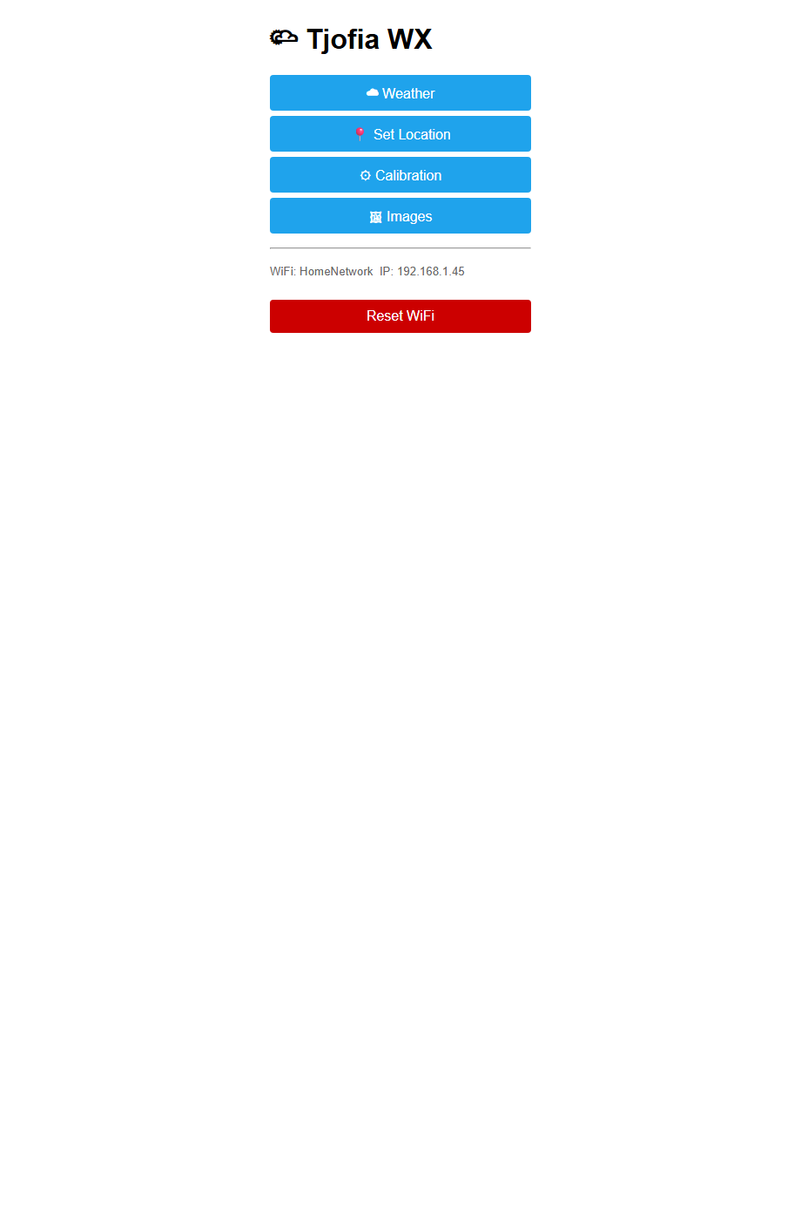

Weather Status Page ( /wx )
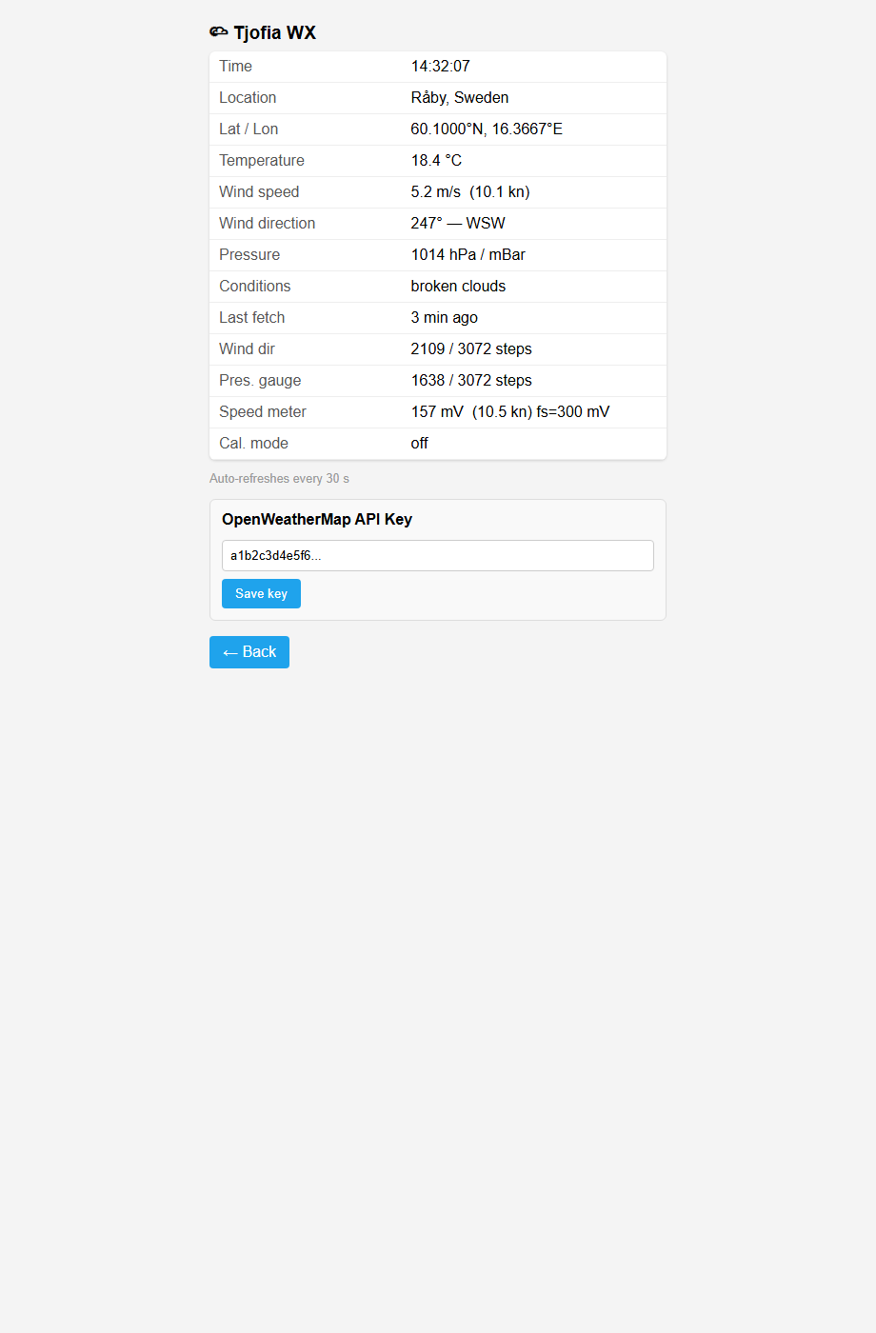

Location Page ( /location )
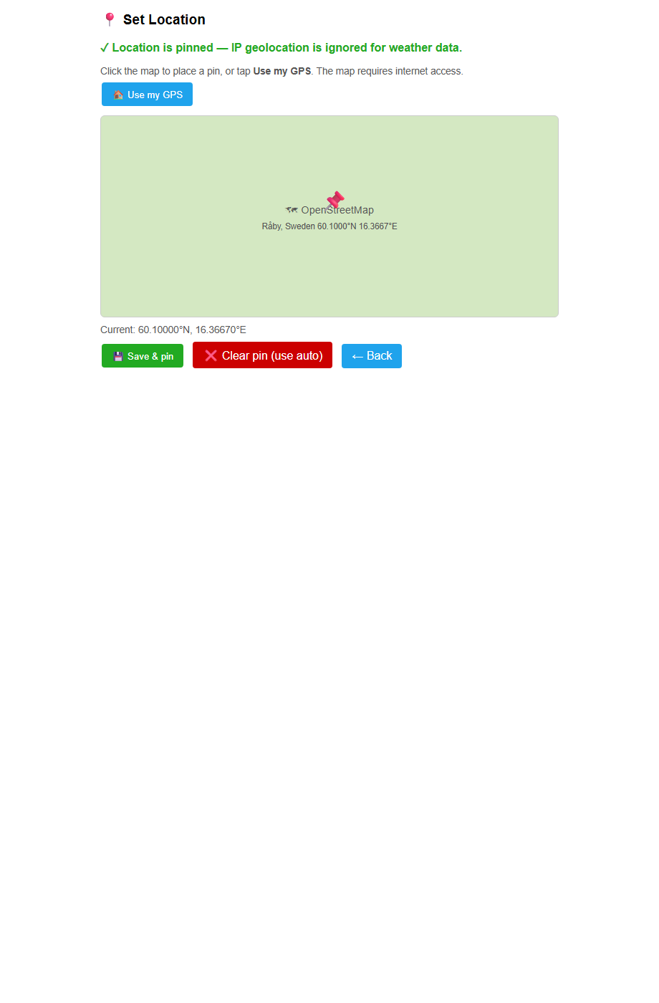

Calibration Page ( /calib )
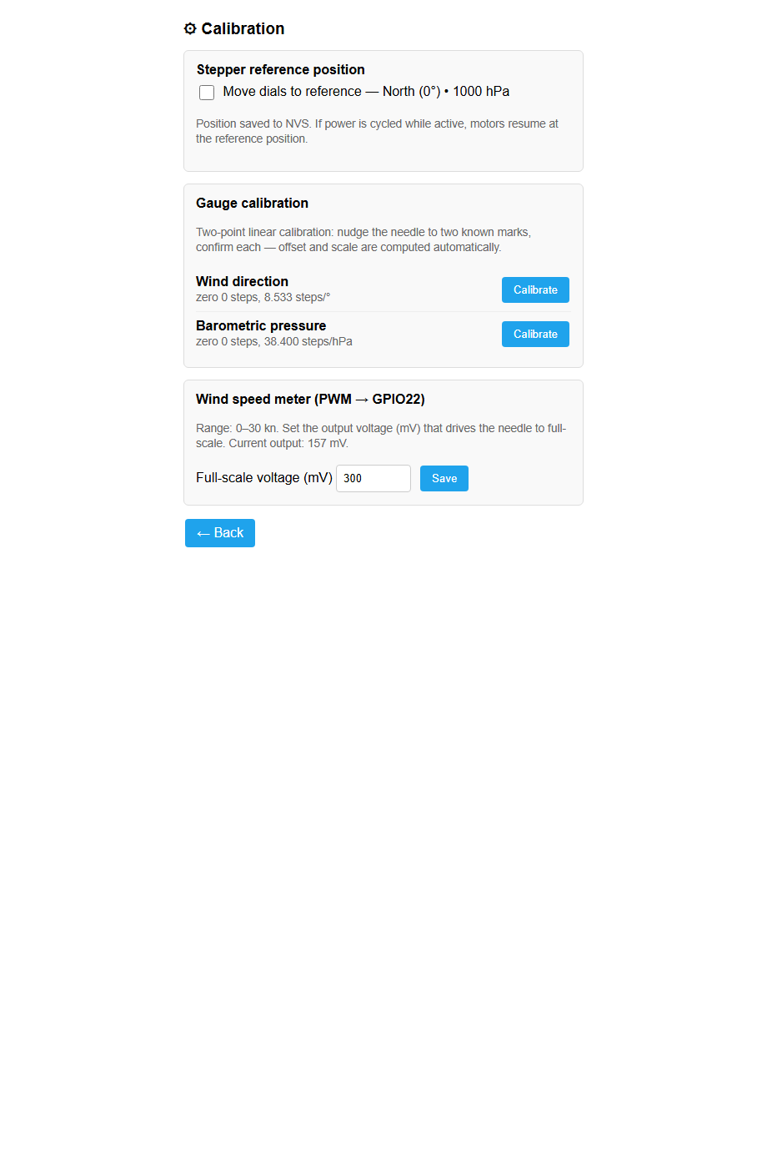

Calibration Wizard ( /calib — active )
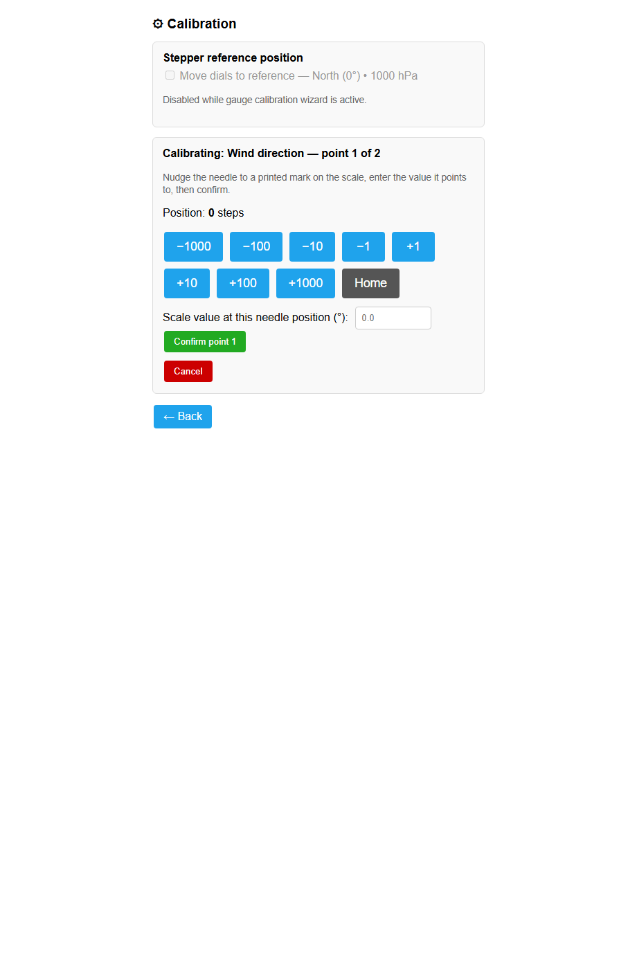

Images Page ( /images )
