Kyle Gilpin

June 1st 2021

IT FDN 110 A

Assignment 08

<https://github.com/Tekpro007/IntroToProg-Python-Mod08.git>

Creating a Product Price List

# Introduction

In this assignment, I will be creating a script that allows for data input. This script will use classes and objects for its manipulation.

# Creating the PyCharm Project file

Before starting my script, I created a new project in PyCharm and named it assignment 08. To create the project, I opened PyCharm and selected New Project under the File Menu. I chose the location to be C:\_PythonClass\Assignment8 and unselected the creation of the main.py welcome script as seen in figure 1.

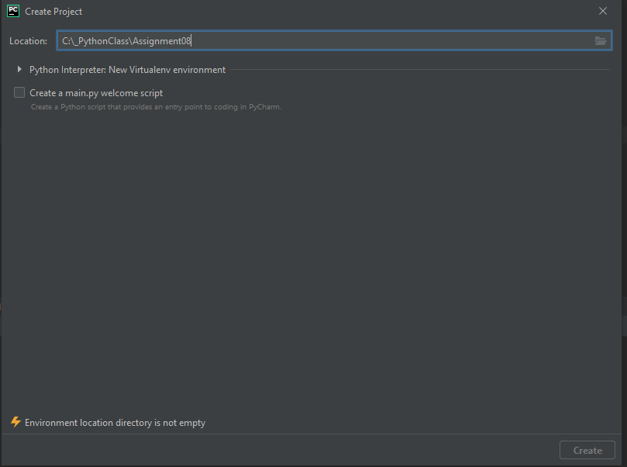

Figure (Creating Project in PyCharm)

I moved the starter script from the zip file into PyCharm as seen in figure 2.

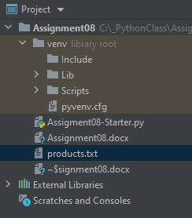

Figure Creating Python file

# Finishing assignment08-starter.py

To begin with, I reviewed how much data had been created. I began by building my class Product with objects. Using the knowledge from the lecture, I was able to build the objects class functions. I first started by creating the constructor as seen in figure 3.

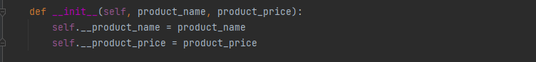

Figure Creating Constructor

I then proceeded to create the objects that would be used for the products and prices. I used the knowledge from the lecture to create the functions for the setter. This is seen figure 4.

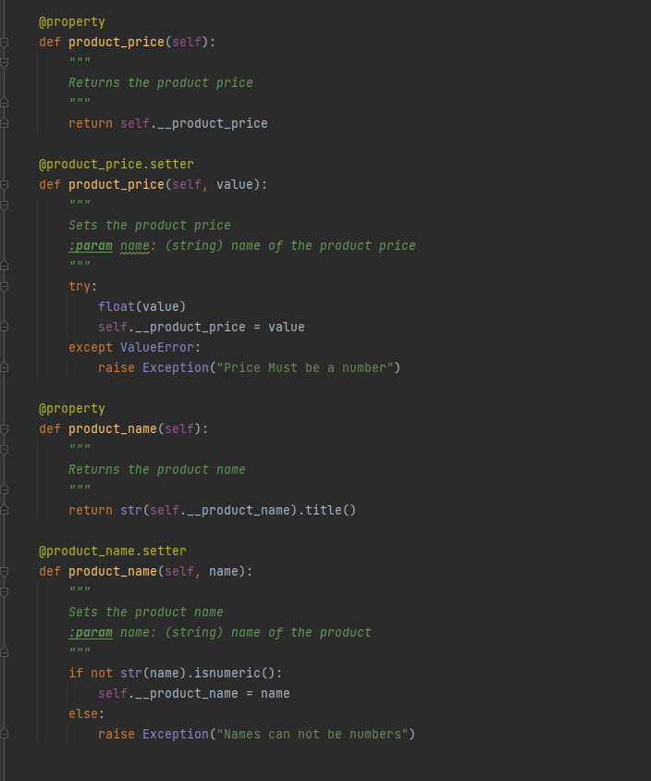

Figure Creating the function for the setter

I then proceed to create the functions for saving data and reading data from a file. I used knowledge form our previous lessons to build it. I had to change the write and open function to work with the classes that I built. This is seen in figure 5.

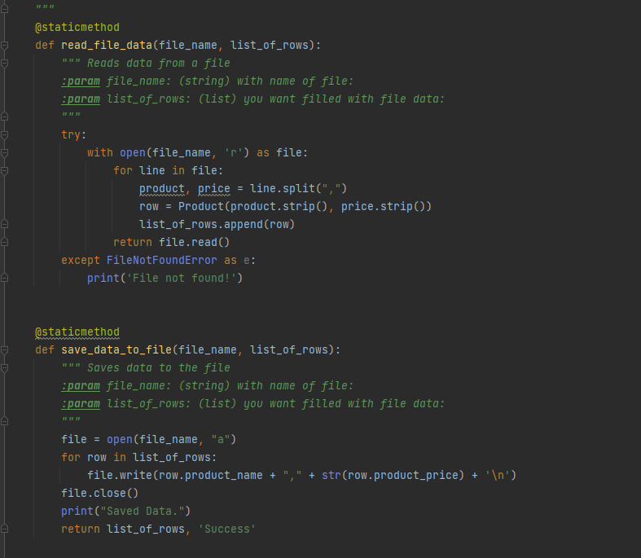

Figure 5 Functions for saving data and reading data.

For the IO portion of my script, I was able to use my knowledge from the previous lesson to create the input functions and printing the menu. This is seen in figure 6.

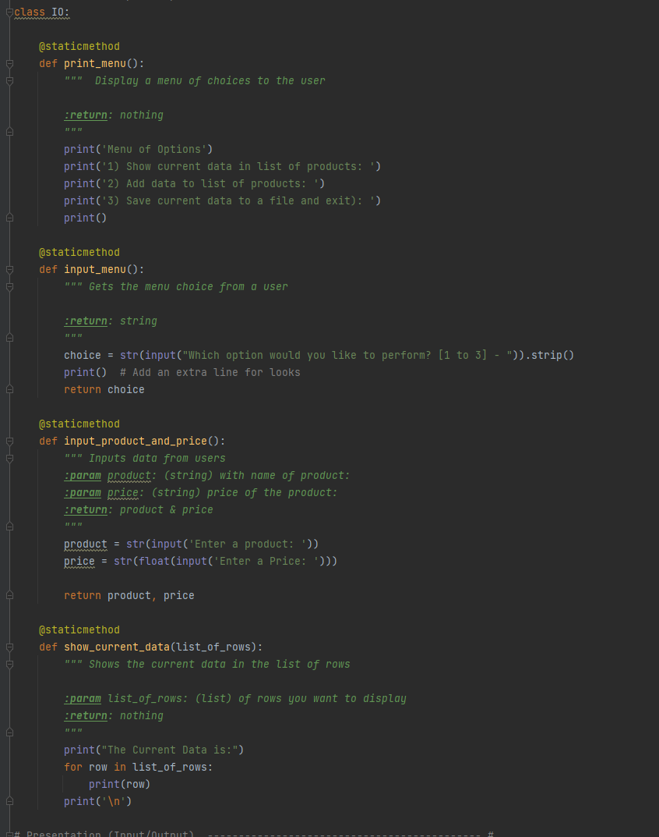

Figure 6 Creating IO function

The final piece was to create the main execution of my script. I called the first function to read the data from a file. I put in error handling in case the file didn’t exist. I then created the while loop to handle the menu choices until the user exited the program. Option 1 was very simple and calls the function for showing the user data. Option 2, uses the objects and classes that I had built. Option 3, saves the current data and exists the program. My code is seen in figure 7.

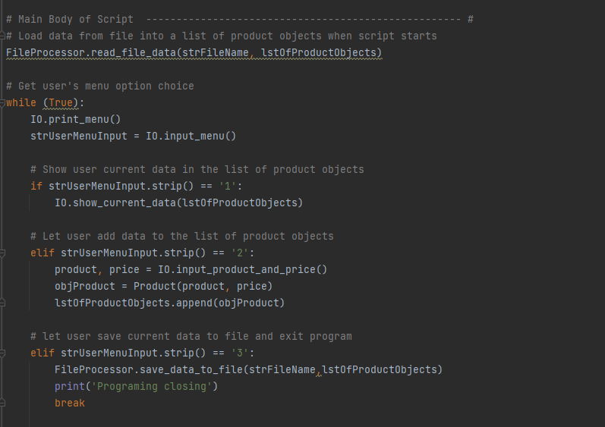

Figure 7 Execution main body of the script.

This is my script fully running in PyCharm as seen in figure 8.

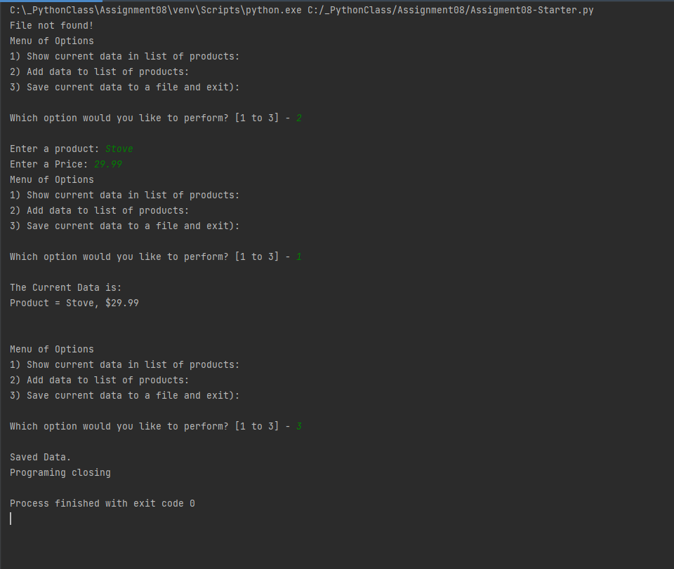

Figure 8 Running in PyCharm

This is a screenshot from an OS command shell as seen in figure 8.

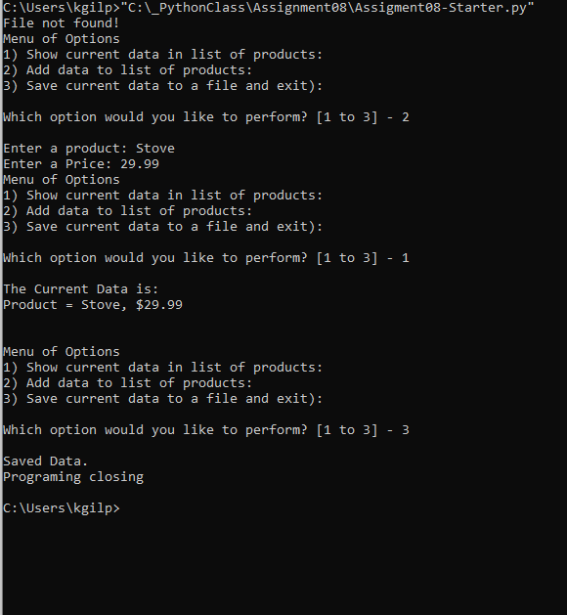

Figure 9 Running from OS Shell

# Summary

As part of this assignment, I learned how to build objects and classes. I also learned about GitHub Desktop and uploading files from it directly GitHub.