Problem

The [Calendar class](https://docs.oracle.com/javase/7/docs/api/java/util/Calendar.html) is an abstract class that provides methods for converting between a specific instant in time and a set of calendar fields such as YEAR, MONTH, DAY_OF_MONTH, HOUR, and so on, and for manipulating the calendar fields, such as getting the date of the next week.

You are given a date. You just need to write the method, , which returns the *day* on that date. To simplify your task, we have provided a portion of the code in the editor.

For example, if you are given the date , the method should return  as the day on that date.

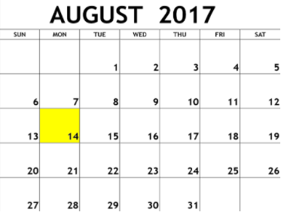

**Input Format**

A single line of input containing the space separated month, day and year, respectively, in    format.

**Constraints**

**Output Format**

Output the correct day in capital letters.

**Sample Input**

08 05 2015

**Sample Output**

WEDNESDAY

**Explanation**

The day on August th  was WEDNESDAY.

import java.io.*;

import java.math.*;

import java.security.*;

import java.text.*;

import java.util.*;

import java.util.concurrent.*;

import java.util.function.*;

import java.util.regex.*;

import java.util.stream.*;

import static java.util.stream.Collectors.joining;

import static java.util.stream.Collectors.toList;

import java.time.LocalDate;

class Result {

/*

* Complete the 'findDay' function below.

*

* The function is expected to return a STRING.

* The function accepts following parameters:

* 1. INTEGER month

* 2. INTEGER day

* 3. INTEGER year

*/

public static String findDay(int month, int day, int year) {

return LocalDate.of(year, month, day).getDayOfWeek().name();

}

}

public class Solution {

public static void main(String[] args) throws IOException {

BufferedReader bufferedReader = new BufferedReader(new InputStreamReader(System.in));

BufferedWriter bufferedWriter = new BufferedWriter(new FileWriter(System.getenv("OUTPUT_PATH")));

String[] firstMultipleInput = bufferedReader.readLine().replaceAll("\\s+$", "").split(" ");

int month = Integer.parseInt(firstMultipleInput[0]);

int day = Integer.parseInt(firstMultipleInput[1]);

int year = Integer.parseInt(firstMultipleInput[2]);

String res = Result.findDay(month, day, year);

bufferedWriter.write(res);

bufferedWriter.newLine();

bufferedReader.close();

bufferedWriter.close();

}

}