The **active laser medium** (also called gain medium or lasing medium) is the source of optical gain within a laser. The gain results from the stimulated emission of photons through electronic or molecular transitions to a lower energy state from a higher energy state previously populated by a pump source.

Examples of active laser media include:

* **Certain crystals, typically doped with rare-earth ions:** neodymium, ytterbium, or erbium) or transition metal ions (titanium or chromium); most often yttrium aluminium garnet (Y3Al5O12), yttrium orthovanadate (YVO4), or sapphire (Al2O3);[1] and not often Caesium cadmium bromide (CsCdBr3)
* **Glasses**: silicate or phosphate glasses, doped with laser-active ions
* **Gases**: mixtures of helium and neon (HeNe), nitrogen, argon, carbon monoxide, carbon dioxide, or metal vapors
* **Semiconductors**: gallium arsenide (GaAs), indium gallium arsenide (InGaAs), or gallium nitride (GaN)
* **Liquids**: dye solutions as used in dye lasers.

To fire a laser, the active gain medium must be in a nonthermal energy distribution known as a **population inversion**.

Population inversion is the situation where there are a greater number of atoms in their excited state than in their ground state. This principle is necessary to produce a laser because excess photon generation is desired, and this only occurs if photons are absorbed by atoms within their excited state. Conversely, if more atoms are in their ground state, photons are absorbed without emission.

When atoms are excited into a highly excited energy state level, their lifetime within that state is on the order of nanoseconds, which is not long enough for stimulated absorption occurring in the order of microseconds or even milliseconds. Consequently, spontaneous emission or decay occurs. To work around this, metastable states within the energy band of an atom must be available to allow for longer lifetimes.

Examples of common pump sources are electrical discharges, flashlamps, arc lamps, light from another laser, chemical reactions, and even explosive devices. The type of pump source used principally depends on the *gain medium*, and this also determines how the energy is transmitted to the medium.

|  |
| --- |
|  |
|  |
|  |
| (a) Spontaneous emission occurs when an atom decays into a lower-level state. (c) An atom in its ground state absorbs the nearby photon but no emission is produced. (b) An atom in an excited state absorbs the nearby photon and there is emission that produces two photons. |

Lasers require intense (white light) pumping to maintain the population inversion, because the lasing transition re-populates the ground state.

The number of levels (energy states) determines the pump efficiency. Three levels require more intense pumping while four level energy states can be more efficiently pumped since the lower level of the lasing transition is not the ground state. Only four-level lasers provide continuous output. HeNe and Nd:YAG are common four-level lasers.

The ruby (Cr3+:Al2O3) crystal gain medium is an example of a three-level laser used by Maiman for the first laser.

|  |  |
| --- | --- |
|  |  |
| **3 levels of lasing transitions** | **4 levels of lasing transitions** |

Light amplification by stimulated emission of radiation (LASER)

**Stimulated Emissions:**

* CASE 1: An atom does not absorb a photon in proximity and so the photon passes through the medium
* CASE 2: An atom in its ground state absorbs the nearby photon but no emission is produced.
* CASE 3: An atom in an excited state absorbs the nearby photon and there is emission that produces two photons

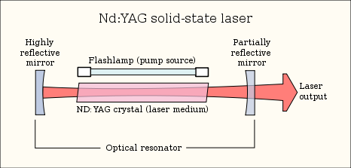

Gain Medium

The gain medium is the major determining factor for the wavelength of operation.

Optical gain is the cascade rate of photon emission due to spontaneous and stimulated emission.

|  |  |
| --- | --- |
|  |  |
| **Laguerre-gaussian** – cylindrical transverse mode patterns TEM(pl)  *p* and *l* are integers labeling the radial and angular mode orders | **Hermite-gaussian** – Rectangular transverse mode patterns TEM(mn)  *m* and *n* being the horizontal and vertical orders of the pattern |

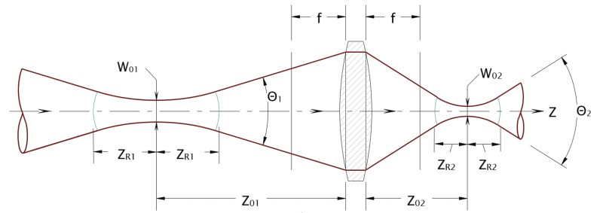

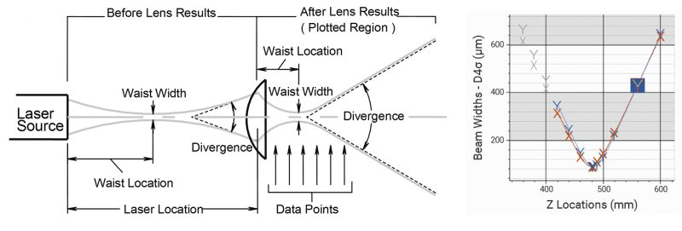

<https://www.gentec-eo.com/blog/spot-size-of-laser-beam>

<https://www.rp-photonics.com/mode_locked_lasers.html>

<https://www.rp-photonics.com/optical_resonators.html>

Mode Locking


   
    Figure 20: A pulse propagating in the optical cavity of a mode-locked laser.
   
  


   
    Figure 21: Comparison of the beat signal (on leaving the cavity) when all the modes are in phase (in blue) and with random phases between the modes (in red).
   
  
   
    Figure 22: "Snapshot" at a given moment. The different sinusoidal curves represent the amplitude of the electrical field for different modes of the cavity.
   
  

When the longitudinal modes are in phase, there is only one place in the cavity where the electric fields add together constructively. Everything occurs as if a pulse was travelling inside the cavity, just as described at the beginning of this section

Round trip time in linear cavity:

$$T_{R}=\frac{2λ}{c_{0}}=\frac{1}{Δf}$$

Where λ (wavelength) is the optical length

Roundtrip loss is approximately the transmission T (for small T) of a semi-transparent mirror:

$$2l=-\ln\left(1-T\right)≈T$$

All the radiation missing from output of the laser is considered as the roundtrip loss and the gain of the active medium must overcome these losses.

Phase shift occurs after one round trip of propagation (2d) and wave reproduces itself.

<https://ocw.mit.edu/courses/electrical-engineering-and-computer-science/6-977-ultrafast-optics-spring-2005/lecture-notes/chapter4.pdf>

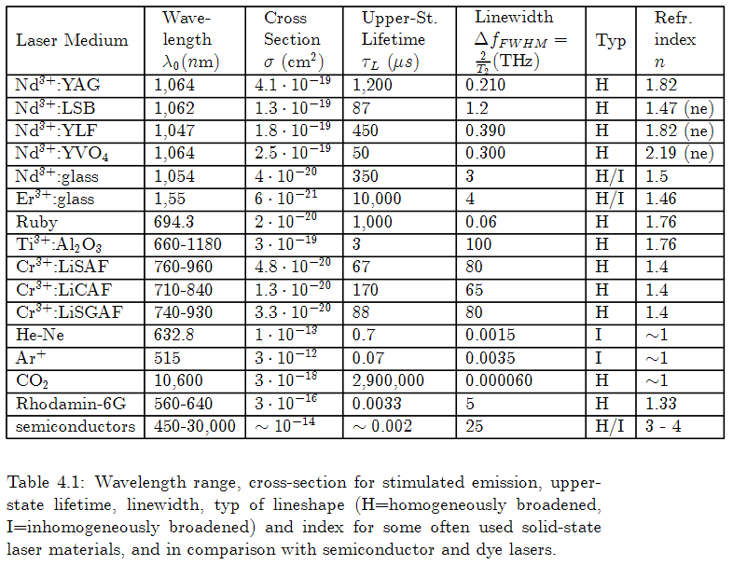

<http://www.uobabylon.edu.iq/eprints/publication_2_14877_1775.pdf>

An appropriate optical cavity has a length between its mirrors equal to an integer multiple of the wavelength. This ensures standing waves of equal frequency separation are created within the cavity. The maximum number of modes able to exist within a cavity is directly proportional to the length of the cavity. For instance, to produce a multi-modal laser of 7 spectral components, the cavity must have a length 7 times larger than a single half wavelength.

$$L=mode×\frac{λ}{2}$$

The first longitudinal mode is referred to as the **basic** longitudinal mode. This described as:

$$f_{0}=\frac{c}{2nL}$$

$$where n is the index of refraciton of the medium$$

For modes greater than 1,

$$f_{0}=mode\frac{c}{2nL}=mode×f_{0}$$

**Example:**

Optical Cavity = 30cm

Optical Gain Medium: He-Ne

Index of Refraction: 1.0

Emitted Wavelength: 0.6328mm

**Frequency separation:**

$$Δf=\frac{c}{2nL}=\frac{{3×10}^{8} m/s}{2×1.0×0.30m}=0.5GHz$$

The **number of longitudinal modes** created by the cavity:

$$modes=\frac{2L}{λ_{m}}=\frac{2×0.30m}{0.6328×{10}^{-3}}≈948,000$$

**The laser frequency**

$$f_{out}=modes×Δf=948,000×0.5 GHz=474 THz$$

$$f_{out}=\frac{c}{λ}=\frac{3×{10}^{8} [m/s]}{0.6328×{10}^{-6} [m]}$$

Not all longitudinal modes inside a cavity will be emitted out of the laser, which is determined by the laser gain medium’s lasing threshold, or the emission bandwidth, or fluorescence line width, or the laser linewidth of the material. The line width is determined by the width of the amplification curve at half the maximum height (FWHM) Amplification through a medium occurs only above a certain minimum frequency.

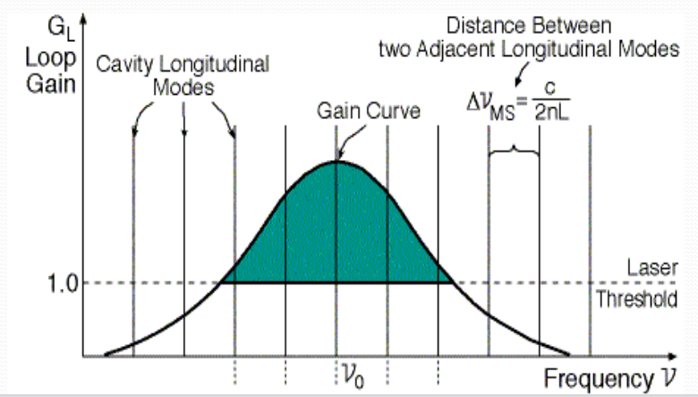

Transverse Electro-Magnetic (TEM) Modes

Transverse electro-magnetic modes describe the shape of energy distribution in the beam cross section.

|  |  |
| --- | --- |
|  |  |
| **Laguerre-gaussian** – cylindrical transverse mode patterns TEM(pl)  *p* and *l* are integers labeling the radial and angular mode orders | **Hermite-gaussian** – Rectangular transverse mode patterns TEM(mn)  *m* and *n* being the horizontal and vertical orders of the pattern |

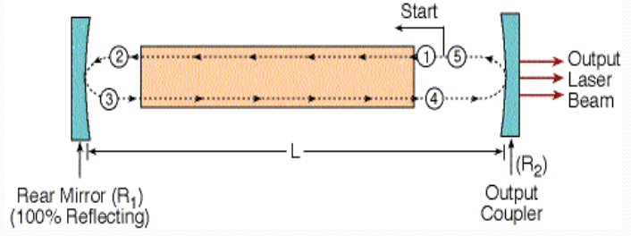

Gaussian Distribution

General density of a normal distribution:

Used for our active gain medium:

**Fabry–Pérot Laser Resonator**

The resonator is comprised of two parallel plates separated by a distance L with an active region located in the center. The mirrors are necessary to provide positive feedback to the system ensuring stimulated photons are returned through the active region to stimulate more photons.

Stimulated photons from the active medium are reflected off each mirror resulting in a 180 phase shift each time. Note only standing waves are supported within the cavity since 180 phase shift off the mirror should not produce a discontinuity.

|  |  |
| --- | --- |
|  |  |
| A wave with resulting discontinuity | A standing wave (a single longitudinal mode) |

An infinite number of wavelengths are supported by a resonator if they form a standing wave within the cavity. In the following expression, a mode as a subset of infinity produces a wavelength directly proportional to the length of the cavity:

The longitudinal modes are the eigenmodes of the cavity. An eigenmode is a natural vibration of a system such that various parts all move together at the same frequency.

The active gain medium emitting stimulated photons within the cavity has a gain bandwidth that limits the number of longitudinal modes emitted by the laser. Longitudinal modes outside this bandwidth are highly attenuated.

|  |  |
| --- | --- |
|  |  |
| A wave with resulting discontinuity | A standing wave (a single longitudinal mode) |

While longitudinal modes below the laser threshold of the gain medium emit luminescence (or fluorescence for optically pumped lasers) it is small compared to the regular luminescence bandwidth of the medium. Since the threshold is the line where emission power equals the resonator losses, only modes which experience enough gain to overcome the cavity losses will ultimately surpass threshold.

<https://courses.engr.illinois.edu/ece455/sp2020/Files/Galvinlectures/02_CavityModes.pdf>

<https://physics.stackexchange.com/questions/278759/why-do-most-laser-beams-have-a-gaussian-intensity-profile/278761>

**Gaussian Beams**

For resonators based on spherical mirrors, the TEM00 mode features a Gaussian intensity distribution.


   
    Figure 2 : longitudinal and transverse modes in a resonant cavity.
   
  

<http://www.optique-ingenieur.org/en/courses/OPI_ang_M01_C03/co/Contenu_02.html>

**Transverse Modes**

The transverse electromagnetic mode (TEM) structure of a laser beam describes the power distribution (power) across the beam.

Intensity profile is determined by the combination of modes.

long narrow bores ensure single beam TEM00 while wide bore ensure multiple sub-beams emerge from the same cavity in two dimensions.

Laser modes are the eigen-modes of a laser resonator: only specific distributions of electro-magnetic field can "resonate" in each resonator.

Laser modes are described by 3 indices m, n, q where q is the longitudinal mode of the laser.

A laser beam is typically the superposition of several modes. The fundamental mode is nearly always generated because it requires high gain and low losses close to the axis of the resonator (furthest from the cavity walls).

The number of longitudinal modes generated by a laser depends on how many longitudinal modes of the laser's resonator can fit within the gain bandwidth of the active medium.

Transverse modes manifest themselves as the spatial intensity distribution in the cross-section of the beam, the longitudinal modes define the frequency composition of the beam.

Transverse modes are created by the width of the cavity, which enables diagonal modes to develop.

The transverse structure of either rectangular, cylindrical, or a mix of these symmetries is defined by the shape of the mirror (rectangular or circular).

<https://physics.stackexchange.com/questions/72082/laser-transverse-longitudnal-modes>

<https://www.repairfaq.org/sam/laserhen.htm#hentoo3>

<https://www.repairfaq.org/sam/laserhen.htm#hentoo1>

**Simulations**

<http://physics.bu.edu/~duffy/semester2/semester2.html>

**Single Mode laser:**

Single mode lasers are created by reducing the length of the cavity such that only one longitudinal mode exists under the fluorescence curve of the active gain medium. However, shorter cavities limit the power output of the laser.

**Laser Gain Curve**

The laser active gain medium undergoes population inversion when an external pump source is applied. This allows energized atoms to dominate the number of ground state atoms within the gain medium.

Some gain curves can be modeled with a Gaussian distribution since details of the band structure and pumping conditions distribute the range of energies probabilistically. The solid-state medium GaAs is an example of a Gaussian distributed gain bandwidth. Many gas lasers and other typical 3- or 4- level energy band system models, on the other hand, have very narrow excitation bands.

<https://physics.stackexchange.com/questions/355223/laser-gain-curve>

<https://physics.stackexchange.com/questions/278759/why-do-most-laser-beams-have-a-gaussian-intensity-profile/278761>

<http://www.optique-ingenieur.org/en/courses/OPI_ang_M01_C01/co/Contenu_11.html>

**Fundamental Gaussian Mode:**

**Physicist’s (not Probabilist’s) Hermite Polynomials:**

The first eleven **physicist’s Hermite polynomials** (not to be confused with the first eleven probabilist’s Hermite polynomials)

**High Order Transverse Modes:**

The sequence of Hermite polynomials satisfies recursion where:

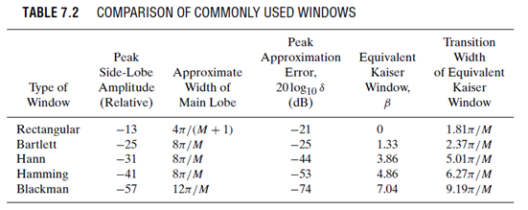

**Source:**

**Discrete-Time Signal Processing**

Alan V. Oppenheim and Ronald W. Schafer

Chapter 10

**Transverse Modes:**

<https://www.youtube.com/watch?v=o1YjIyzshh8>

<https://ocw.mit.edu/resources/res-6-006-video-demonstrations-in-lasers-and-optics-spring-2008/demonstrations-in-laser-fundamentals/laser-transverse-modes/>