Stepper Motors

Overview
There are two types of stepper motors:

UNIPOLAR | Two windings per phase, allowing the magnetic field to be reversed without having to reverse the direction of current in a coil. Drawback is that only half of the phase is carrying current at any given time, which decreases the torque you can get out of the stepper motor.
BIPOLAR | One coil per phase, requiring the direction of current to be reversed to reverse the magnetic field. Drawback is that they require more complicated control circuitry (typically an H-bridge for each phase).

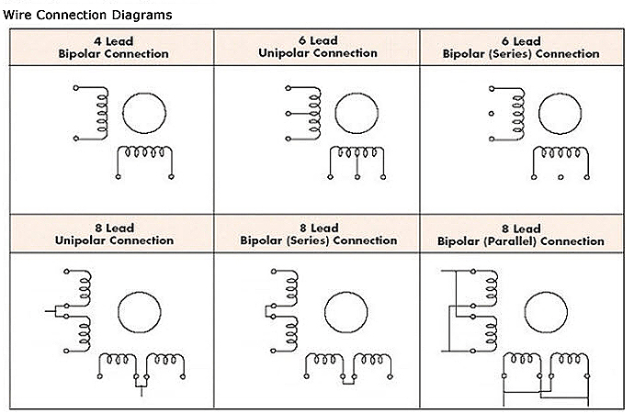

Standardization
The US National Electrical Manufactures Association (NEMA) standardized the dimensions, markings, and specifications for stepper motors. This ensures installing motors from different manufactures all conform to the same hole placement and wiring. For instance, NEMA 17 is a hybrid stepping motor with a 1.8° step angle (200 steps/revolution).
Unfortunately, the standard does not specify the current and voltage ratings. One model could indicate each phase draws 1.2 A at 4 V while another manufacture specifies 1.7 A. Finding an adequately rated motor driver is crucial for ensuring the motor is meeting the desired performance.
You have to also take the voltage rating of a steppers with a grain of salt. They are not voltage controlled devices. They are current controlled devices. What you want is a stepper driver that has current feedback so that it drives the coils with a constant current.
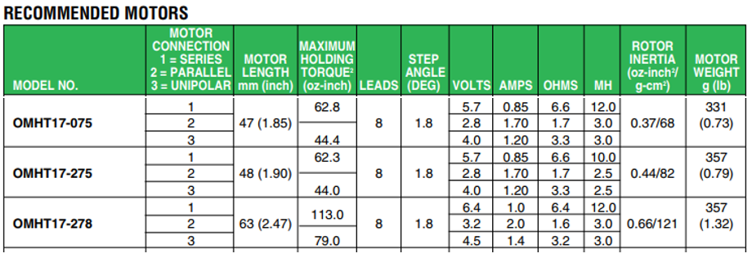

Microstepping
Microstepping-enabled motor driver will adjust the current in the stator coils to position the permanent magnet rotor in an intermediate position between two subsequent full-steps. A full-step is then divided into a number of microsteps, and each microstep is achieved by the two coil currents.
One thing usually not mentioned is that a stepper motor driver can only hold a micro step when powered. Since the microstepping works by current limiting the stators to something like sin(θ) and cos(θ), if you cut power and disable the driver, the shaft will snap to the nearest full step. So if you want a stepper due to low power draw when not in motion, make sure you can park it on a full step. Keep in mind that even after the motor snaps to the nearest step on power-down, the motor retains just a tiny amount of the full torque capable to hold the shaft. So, once power is removed, they are just a generator and will freely spin. This is important to note for two reasons, you lose position of the shaft and you run the risk of generate reverse current. Be sure your driver has reverse current protection.

Driving Bipolar Stepper Motors
Although there are two types of stepper motor constructions and over 6 different wiring configurations, this document only focuses on the most common configuration as demonstrated by the DRV8825 datasheet.
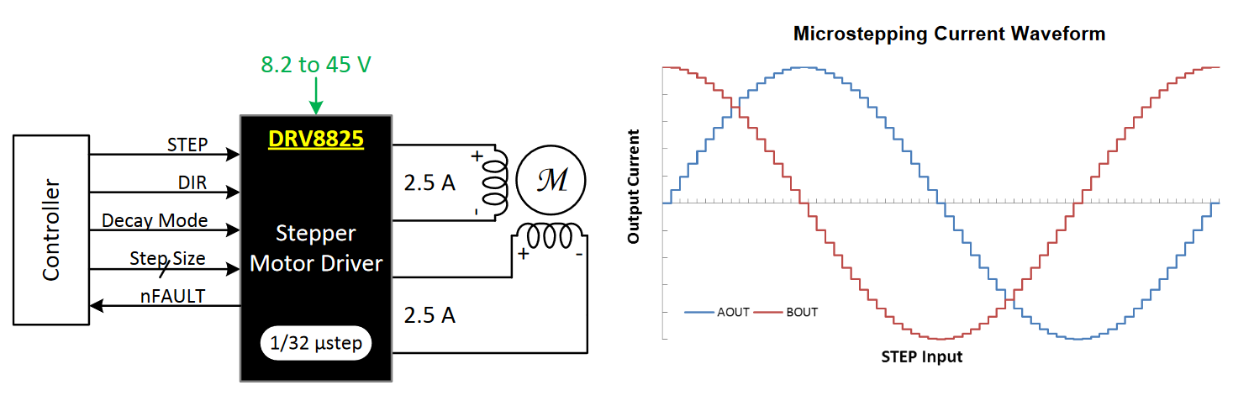
However, there are more than a few references in articles where the SN754410 Quadruple Half-H driver is used. The device is designed to drive inductive loads such as bipolar stepper motors. Note that these dedicated drivers do not contain integrated control circuitry. So microstepping, current sensing, and other useful features typical to a modern motor controller must now be implemented separately.

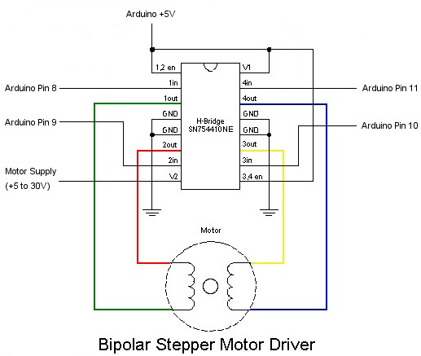

Controllers
Many controllers on the market include an integrated H-bridge driver. Consequently, configuring a stepper motor loop is quite trivial. Most of them use just three wires, step, direction, and ground, between the Arduino and the driver.

 | 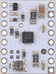 | 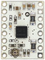 | 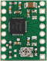 | 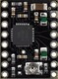 | 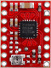 | 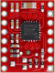
Driver chip: | STSPIN220 | DRV8834 | A4988 |  | MP6500
Min operating voltage: | 1.8 V | 2.5 V | 8 V |  | 4.5 V
Max operating voltage: | 10 V | 10.8 V | 35 V |  | 35 V
Max continuous current per phase: | 1.1 A | 1.5 A | 1 A | 1.2A | 1.5 A
Peak current per phase: | 1.3 A | 2 A | 2 A |  | 2.5 A | 2 A
Microstepping down to: | 1/256 | 1/32 | 1/16 |  | 1/8
Board layer count: | 4 | 4 | 2 | 4 | 4
Special features: |  |  |  |  |  | digital current  control
1-piece price: | $7.95 | $9.95 | $14.45 | $14.45 | $12.95 | $12.95

 | 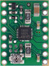 | 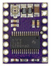 | 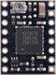 | 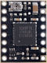 | 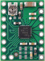
Driver chip: | STSPIN820 | DRV8825 | TB67S279FTG | TB67S249FTG | DRV8434A
Min operating voltage: | 7 V | 8.2 V | 10 V | 10 V | 4.5 V
Max operating voltage: | 45 V | 45 V | 47 V | 47 V | 48 V
Max continuous current per phase: | 0.9 A | 1.5 A | 1.1 A | 1.6 A | 1.2 A
Peak current per phase: | 1.5 A | 2.2 A | 2 A | 4.5 A | 2 A
Microstepping down to: | 1/256 | 1/32 | 1/32 | 1/32 | 1/256
Board layer count: | 4 | 4 | 4 | 4 | 4
Special features: |  |  | Auto Gain Control,  ADMD | Auto Gain Control,  ADMD | Stall detect,  smart tune ripple  control decay
1-piece price: | $14.95 | $18.95 | $10.75 | $21.95 | $12.95

Firmware
Arduino hosts several stepper motor libraries through its Library Manager, such as <Stepper.h> and <AccelStepper.h>. These libraries function fundamentally the same except that the AccelStepper library also supports integrated controllers like the DRV8825, among other great features.

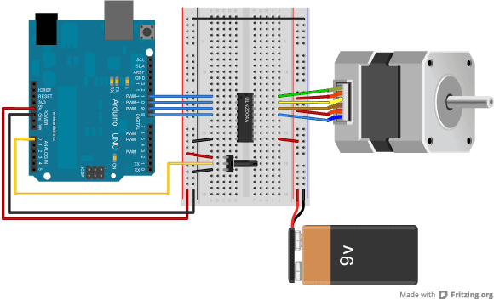 | 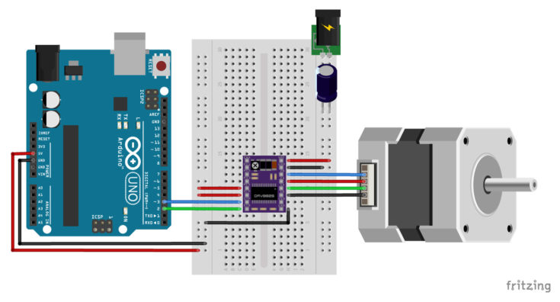
SN754410 | DRV8825

DRV8825
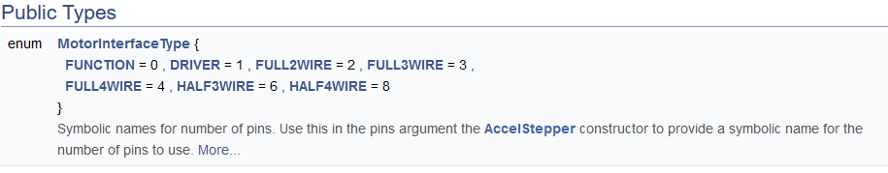
0  1  2  3  4  5  6  7  8  9 | // Include the AccelStepper library:  #include <AccelStepper.h>  // Define stepper motor connections and motor interface type  #define dirPin 2 // pin used to set direction  #define stepPin 3 // pin used to set step size  // Define stepper  AccelStepper stepper(AccelStepper::DRIVER, stepPin, dirPin);

SN754410
0  1  2  3  4  5  6  7 | // Include the Stepper library:  #include <Stepper.h>  // steps per revolution for the specific motor  const int stepsPerRevolution = 200;  // initialize the stepper library on pins 8 through 11  Stepper myStepper(stepsPerRevolution, 8, 9, 10, 11);

