Deploy Edurell app on server

Index

Connect to the server: 2

Update Edurell App Files from the repository: 2

Download updated files from the repository: 2

Update and setup Video Annotation App: 2

Update and setup Video Augmentation App: 2

Useful commands: 3

Commands for systemctl: 3

Launch gunicorn: 3

View gunicorn instances: 4

Run manually Video Augmentation App: 4

Important Files: 4

Bugs or Common Issues: 5

Provided github credentials are not valid: 5

Punctuator or “Demo-Europarl-EN” file is not inside EdurellVideoAnnotation folder: 5

Found error: cannot find module punctuator or similar: 6

# Connect to the server:

* ssh pret_wiki@130.251.47.105

*passw:* < ask to project administrator >

# Update Edurell App Files from the repository:

*Follow all the next steps to update the Edurell app…*

--------------------------------------------------------------------------------------------------------------------

## Download updated files from the repository:

Go inside app folder (/var/www/edurell)

* cd /var/www/edurell

Pull new versions of files from repository

* sudo git pull
* username for github: Mirwe
* password: < ask to project administrator >

(if github credentials are not valid or you want to use your own credentials …)

--------------------------------------------------------------------------------------------------------------------

## Update and setup Video Annotation App:

Go inside EdurellVideoAnnotation app folder

* cd /var/www/edurell/EVA_apps/EdurellVideoAnnotation/

Update dependencies from requirements.txt (if different from last version)

* sudo /home/anaconda3/envs/myenv/bin/pip install -r ./requirements.txt

Check that there is a punctuator folder containing the file “Demo-Europarl-EN.pcl”

([if punctuator or file is not inside EdurellVideoAnnotation folder…](Demo-Europarl-EN#_Punctuator_or_))

Go in static folder, then create folder videos and give permissions

* cd /var/www/edurell/EVA_apps/EdurellVideoAnnotation/static
* (create the folder if you don’t have it already -> sudo mkdir videos)
* sudo chmod 777 ./videos

Restart VideoAnnotation App

* sudo systemctl restart edurell

--------------------------------------------------------------------------------------------------------------------

## Update and setup Video Augmentation App:

Go inside EdurellVideoAugmentation app folder

* cd /var/www/edurell/EVA_apps/EdurellVideoAugmentation/

Go inside flask-server folder and update dependencies from requirements.txt (if different from last version)

* cd ./src/flask-server/
* sudo /home/anaconda3/envs/env-wp3/bin/pip install -r ./requirements.txt

Go inside react-app folder

* cd /var/www/edurell/EVA_apps/EdurellVideoAugmentation/src/react-app

IF you have a build folder delete it

* sudo rm -r ./build

Update npm packages

* sudo npm install

Create new version of the react app build

* sudo -s
* npm run build

Restart VideoAugmentation App

* sudo systemctl restart edurell-wp3

--------------------------------------------------------------------------------------------------------------------

# Useful commands:

*Those commands should be used for debugging or for big changes in the server structure.*

## Commands for systemctl:

(*Additional commands for edurell systemctl modules*)

There are 3 important modules of systemctl (that you can use as <name> in the commands:

* edurell (Video Annotation App)
* edurell-wp3 (Video Augmentation App)
* nginx (Global connection for the server)
* sudo systemctl enable <name> (enable systemctl)
* sudo systemctl status <name> (view info about the status)
* sudo systemctl start <name> (start the app)
* sudo systemctl stop <name> (stop the app)
* sudo journalctl -u <name> (checks your app’s logs)

(For the Edurell app to work and be accessible all 3 of these modules must be active and running.)

## Launch gunicorn:

(*used to run the first app on 127.0.0.1:5050*)

(**note**: this is done automatically by “systemctl edurell”, no need to do this commands unless it is for debugging this steps)

* cd /var/www/edurell/EVA_apps/EdurellVideoAnnotation/
* /home/anaconda3/envs/myenv/bin/gunicorn --bind 127.0.0.1:5050 connector:app --timeout 180 --limit-request-line 0

(if found error: cannot find module punctuator or similar…)

## View gunicorn instances:

* ps -ef|grep gunicorn

## Run manually Video Augmentation App:

(**note**: this is done automatically by “systemctl edurell”, no need to do this commands unless it is for debugging this steps)

* cd /var/www/edurell/EVA_apps/EdurellVideoAugmentation/src/flask-server
* sudo /home/anaconda3/envs/env-wp3/bin/python ./main.py

# Important Files:

Github Repository folder: **/var/www/edurell**

Video Annotation folder: **/var/www/edurell/EVA_apps/EdurellVideoAnnotation/**

Video Augmentation folder: **/var/www/edurell/EVA_apps/EdurellVideoAugmentation/**

Server run service Video Annotation: **/etc/systemd/system/edurell.service**

Server run service Video Augmentation: **/etc/systemd/system/edurell-wp3.service**

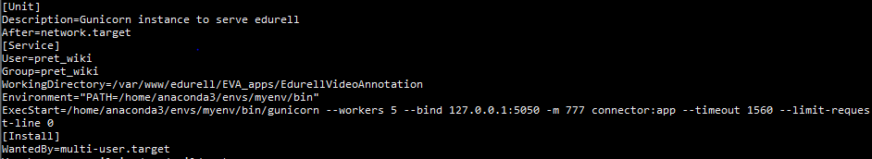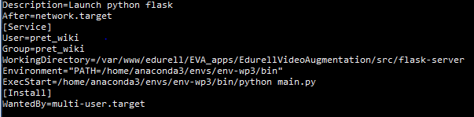

NGINX:

**/etc/nginx/sites-enabled/edurell-wp3**

(to setup server)

location / and /api are for react project of video augmentation.

Location /annotator is for annotation tool (was added prefix annotator for each route of app using reverseProxy class in config.py)

(Might be necessary to do “sudo systemctl daemon-reload” if editing those files)

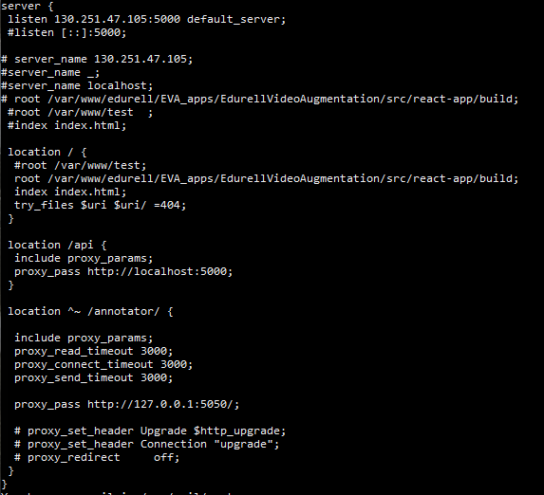

# Bugs or Common Issues:

## Provided github credentials are not valid:

You can use your own github credentials:

$ git clone https://github.com/...

Username: your_username

Password: your_token -> ([how to create a personal github access token](https://docs.github.com/en/authentication/keeping-your-account-and-data-secure/creating-a-personal-access-token))

## Punctuator or “Demo-Europarl-EN” file is not inside EdurellVideoAnnotation folder:

You can create the folder:

* cd /var/www/edurell/EVA_apps/EdurellVideoAnnotation/
* sudo mkdir ./punctuator

And you can copy the Demo-Europarl-EN file inside from a backup directory:

* sudo cp /var/www/important_files/Demo-Europarl-EN.pcl /var/www/edurell/EVA_apps/EdurellVideoAnnotation/punctuator/

(might be necessary to give “chmod 777” permissions to this file)

## Found error: cannot find module punctuator or similar:

This is caused by Incompatibility between (gunicorn <–> punctuator python module)

(gunicorn create a punctuator file inside home/anaconda3/envs/myenv/bin environment folder)

(to remove this issue we removed this folder from the python sys paths before the import of punctuator module:

import sys

incompatible_path = '/home/anaconda3/envs/myenv/bin'

if incompatible_path in sys.path:

    sys.path.remove(incompatible_path)

from punctuator import Punctuator

)

Have a look on this issue: (<https://github.com/chrisspen/punctuator2/issues/3>)