Search

[Write](https://medium.com/new-story?source=---top_nav_layout_nav-----------------------------------------)

IMG_256

# **Deploying to On-Prem Server with using Azure DevOps — Pipelines**

[](https://medium.com/@arslanaybars?source=post_page---byline--842f4aa226a7---------------------------------------)

[IMG_258](https://medium.com/software-development-turkey?source=post_page---byline--842f4aa226a7---------------------------------------)

[Aybars Arslan](https://medium.com/@arslanaybars?source=post_page---byline--842f4aa226a7---------------------------------------)

·

Follow

Published in

[SDTR](https://medium.com/software-development-turkey?source=post_page---byline--842f4aa226a7---------------------------------------)

·

4 min read

·

Apr 9, 2020

189

4

For a long time, I am thinking to share my development experiences 📋. After all this desire and the pandemic time (COVID-19 #StayHome), I decided to share my [Azure DevOps](https://azure.microsoft.com/en-us/services/devops/" \t "https://medium.com/software-development-turkey/_blank) on-prem deployment experience. 💪

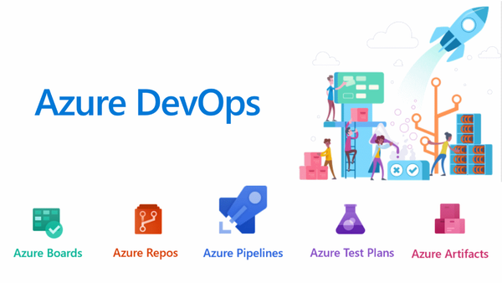

[Azure DevOps](https://azure.microsoft.com/en-us/services/devops/" \t "https://medium.com/software-development-turkey/_blank) is a platform that helping to improve [SDLC (Software Development Life Cycle)](https://en.wikipedia.org/wiki/Systems_development_life_cycle" \t "https://medium.com/software-development-turkey/_blank)

In this article, we will use Azure Pipelines while creating our automated deployment.

Basically, Azure DevOps teams define Azure Pipelines as ‘*Build, test, and deploy with CI/CD that works with****any language****,****platform****,****and cloud****.*’

Here, I will explain how to create ****build****and ****release****pipeline at Azure DevOps and deploy your code to the on-premises server

# **Table of Content**

* Prerequisites
* Creating .NET Core Build Pipeline
* Set Up Deployment Group
* Creating the Release Pipeline
* Run and Deploy [🚀](https://emojipedia.org/rocket/" \t "https://medium.com/software-development-turkey/_blank)

****Prerequisites****

Basic .NET and IIS deployment knowledge.

PS. I am going to deploy the app which is based on .NET Core 3.1 SDK

****Creating .NET Core Build Pipeline****

Here is our [blank.netcore](https://github.com/arslanaybars/blank.netcore" \t "https://medium.com/software-development-turkey/_blank). It’s the project that we are going to build then deploy! It’s totally empty app. I just clicked create a project then select mvc so then next next next ⏭️… The repository hosted on GitHub.

Let’s dive into the build action 🏁

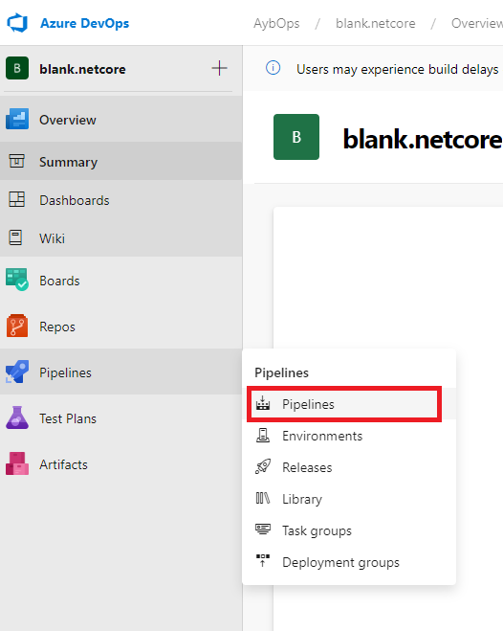

Azure Pipelines

Currently, we do not have any pipeline so let’s create one!

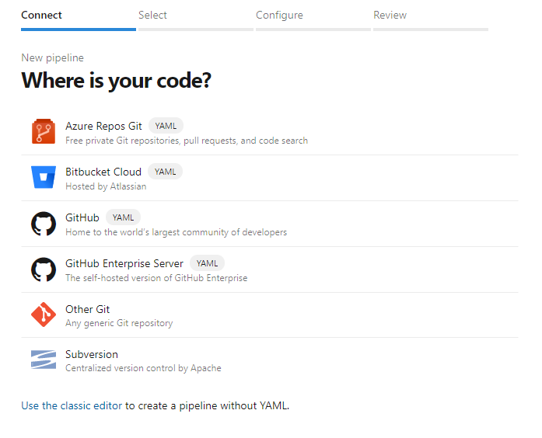

after we clicked the create pipelines. Need to select the source repository. In our example, [blank.netcore](https://github.com/arslanaybars/blank.netcore" \t "https://medium.com/software-development-turkey/_blank) is on GitHub so select the GitHub then select the [blank.netcore](https://github.com/arslanaybars/blank.netcore" \t "https://medium.com/software-development-turkey/_blank) repository.

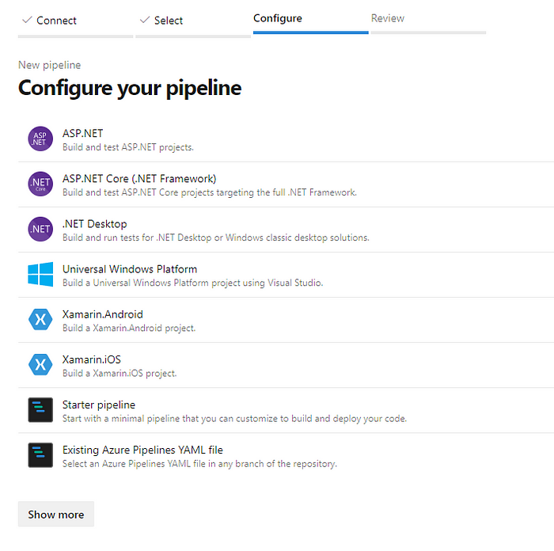

Let’s write our YAML on the Configure part. I select ASP.NET Core template.

After some modification, you can see the entire yml above.

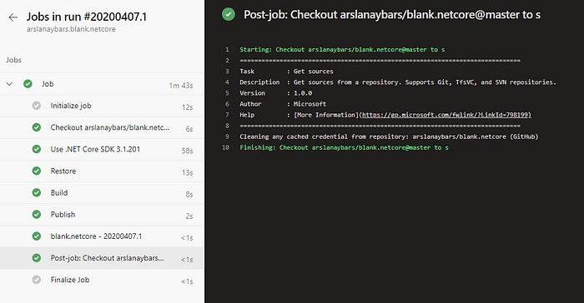

We zipped the published project and move it to the drop. (*will download zipped project while releasing*)

Our build progress is completed ✔️

****Set Up Deployment Group****

We need to set up our deployment group for connecting our on-prem server. It runs behind the firewall. So after you set up the deployment group, don’t need to touch any firewall or configuration settings at all.

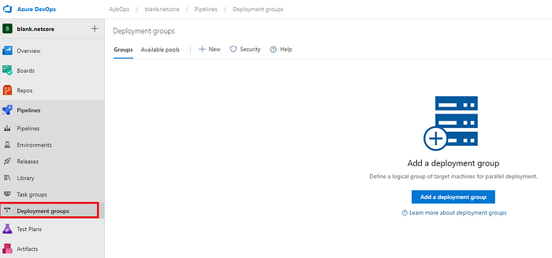

Let’s click to add a deployment group button!😎👍

We specify the name and description then create and magic is happening. Azure DevOps gives us the code that we need to run our server. You can do it for Windows or Linux Server as well

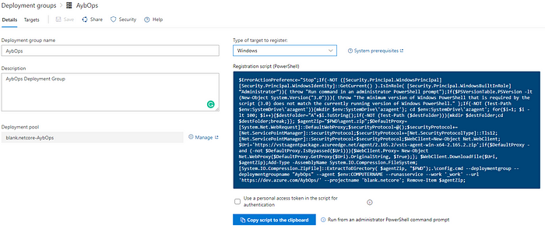

If you select to authentication checkbox, it adds the authentication for us. We don’t have to do anything.

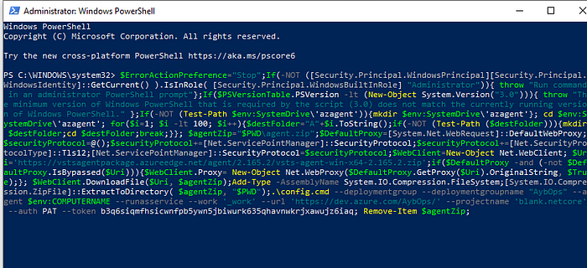

Just pasted the copied script to PowerShell. You can specify agent name, tags vs then our set up is ready!

****Creating the Release Pipeline****

Time for creating a release.

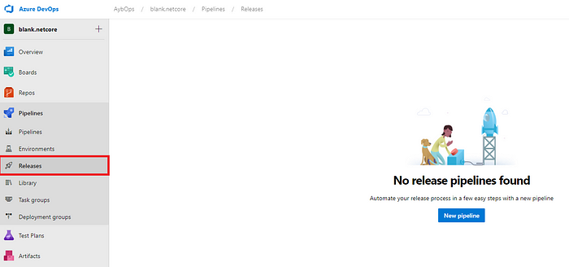

Click the new pipeline button

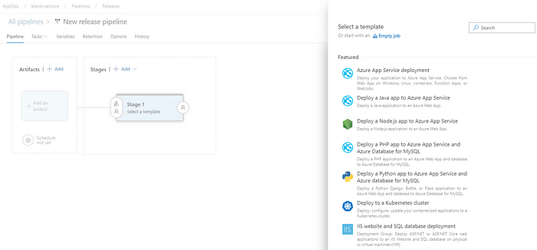

Azure DevOps ask us a template. I am going to continue with the IIS website deployment template. Before the deployment stage, we need to add our build artifact.

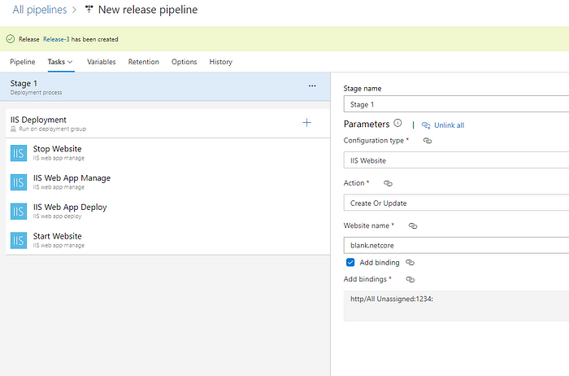

I configured my task as above. I added the website to IIS 1234 port so that I added these bindings to the deployment process.

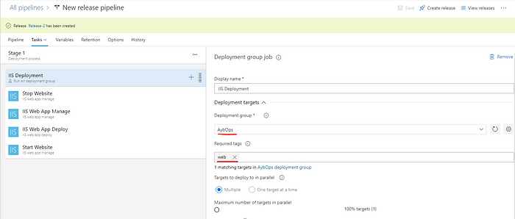

In the IIS Deployment part, we set the deployment group which we created in.

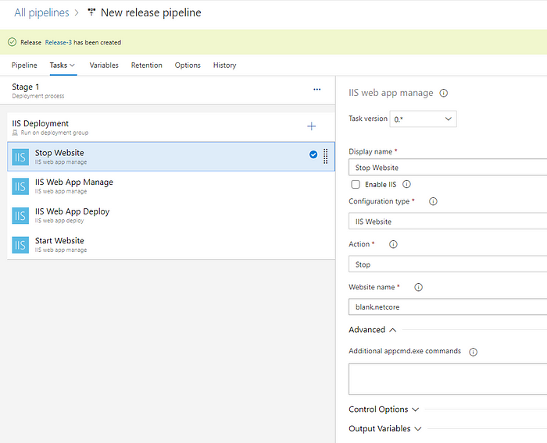

Stop Website

Don’t forget to configure the website name. That website name must be the same as your IIS website name.

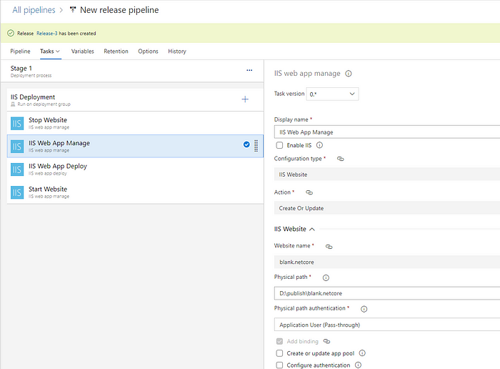

IIS Web App Manage

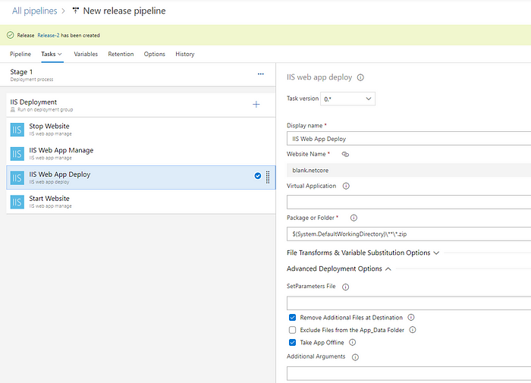

IIS Web App Deploy

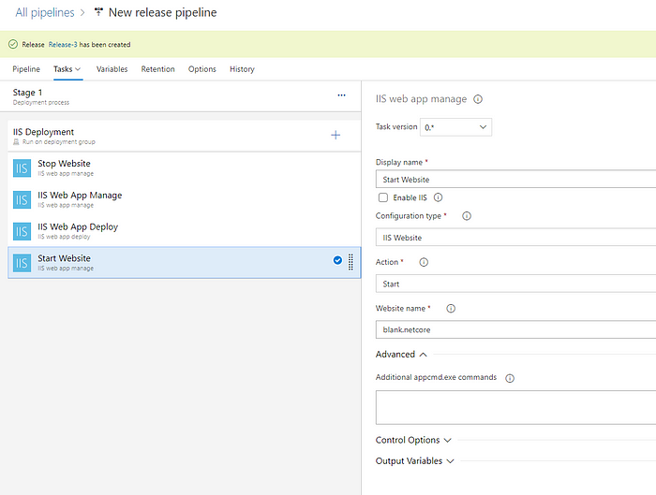

Start Website

So show you all our release tasks.

****Run and Deploy****🚀

Navigation -> Release -> Create Release

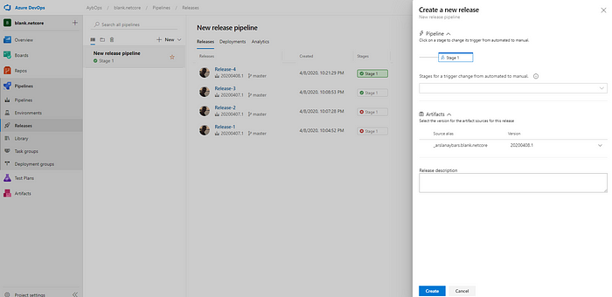

Create a new release

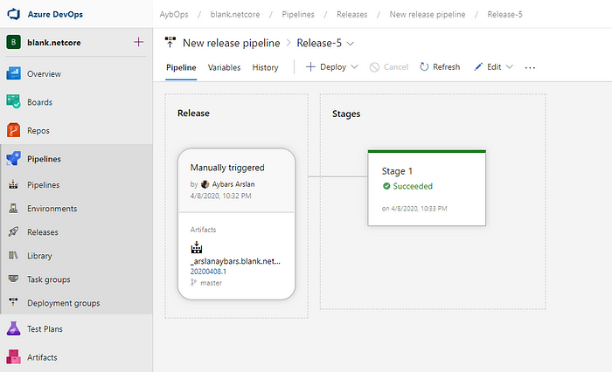

Our deployment is stages are succeeded. It means that deployed! ⚡⚡

