|  |  |  |
| --- | --- | --- |
| TC_001: App Login Error | | |
| **Short Description:** Incorrect entry of phone number and password fields | | |
| **Pre-Condition:** Open Android app | | |
| Triggering the Test Case:   * Write Tel No. * Write Password. * Click Login | | |
| **Expected Outputs (Success conditions)** | Passed | Finding Id |
| * “Invalid Tel.No or Password.” |  |  |

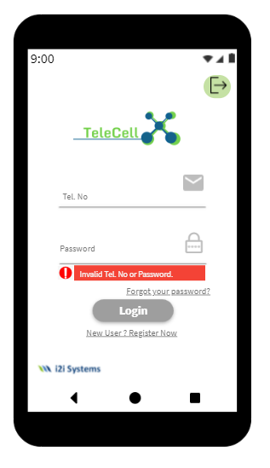

|  |  |  |
| --- | --- | --- |
| TC_002: App Sign Up Password Digit Error | | |
| **Short Description:** The password specified during registration must be longer than 6 characters. | | |
| **Pre-Condition:** Open Android app | | |
| Triggering the Test Case:   * Write Tel No. * Write Password. * Write Password again. * Click Sign-Up | | |
| **Expected Outputs (Success conditions)** | Passed | Finding Id |
| * “Password Mus be >=6 Characters” |  |  |

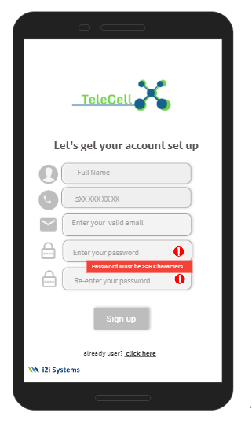

|  |  |  |
| --- | --- | --- |
| TC_003: App Sign Up Password Empty Error | | |
| **Short Description:** The password set during registration cannot be left blank. | | |
| **Pre-Condition:** Open Android App | | |
| Triggering the Test Case:   * Write Tel. No * Click Sign Up | | |
| **Expected Outputs (Success conditions)** | Passed | Finding Id |
| * “Password is Required” |  |  |

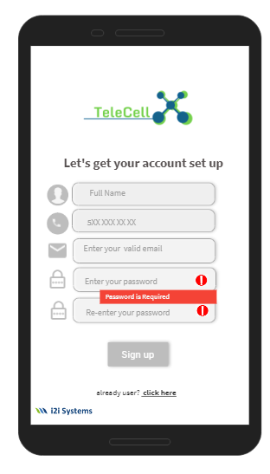

|  |  |  |
| --- | --- | --- |
| TC_004: App Sign Up Passwords not Matching | | |
| **Short Description:** The 2 passwords entered during registration must match each other. | | |
| **Pre-Condition:** Open Android App | | |
| Triggering the Test Case:   * Write Tel No. * Write Password. * Write Password again. * Click Sign-Up | | |
| **Expected Outputs (Success conditions)** | Passed | Finding Id |
| * “Passwords are not same.” |  |  |

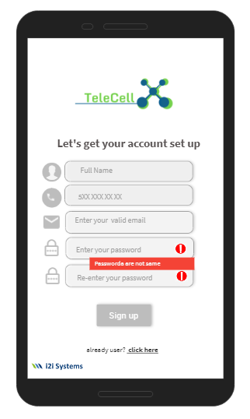

|  |  |  |
| --- | --- | --- |
| TC_005: App Password Change Not Succesfull | | |
| **Short Description:** If the passwords written while changing the password do not match, the operation will fail. | | |
| **Pre-Condition:** Open Android App | | |
| Triggering the Test Case:   * Write Password. * Write Password again. * Click Done | | |
| **Expected Outputs (Success conditions)** | Passed | Finding Id |
| * “Passwords are not same.” |  |  |

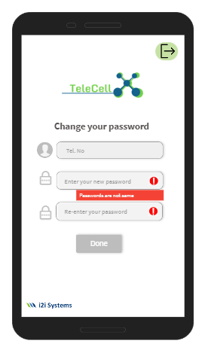

|  |  |  |
| --- | --- | --- |
| TC_006: Web Login Error | | |
| **Short Description:** Incorrect entry of phone number and password fields | | |
| **Pre-Condition:** Open Web Page | | |
| Triggering the Test Case:   * Write Tel No. * Write Password. * Click Login | | |
| **Expected Outputs (Success conditions)** | Passed | Finding Id |
| * “Invalid Tel.No or Password.” |  |  |

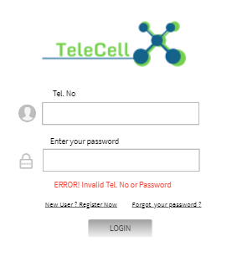

|  |  |  |
| --- | --- | --- |
| TC_007: Web Sign Up Password Digit Error | | |
| **Short Description:** The password specified during registration must be longer than 6 characters. | | |
| **Pre-Condition:** Open Web Page | | |
| Triggering the Test Case:   * Write Tel No. * Write Password. * Write Password again. * Click Sign-Up | | |
| **Expected Outputs (Success conditions)** | Passed | Finding Id |
| * “Password Mus be >=6 Characters” |  |  |

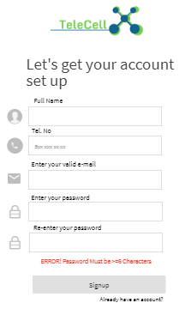

|  |  |  |
| --- | --- | --- |
| TC_008: Web Sign Up Password Empty Error | | |
| **Short Description:** The password set during registration cannot be left blank. | | |
| **Pre-Condition:** Open Web Page | | |
| Triggering the Test Case:   * Write Tel.No * Click Sign Up | | |
| **Expected Outputs (Success conditions)** | Passed | Finding Id |
| * “ERROR! Password is Required” |  |  |

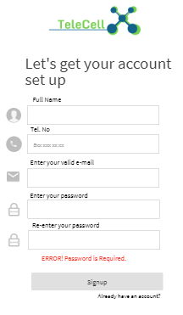

|  |  |  |
| --- | --- | --- |
| TC_009: Web Sign Up Passwords not Matching | | |
| **Short Description:** The password set during registration is written twice and the 2 passwords must match. | | |
| **Pre-Condition:** Open Web Page | | |
| Triggering the Test Case:   * Write Tel No. * Write Password. * Write Password again. * Click Sign-Up | | |
| **Expected Outputs (Success conditions)** | Passed | Finding Id |
| * “ERROR! Passwords are not same” |  |  |

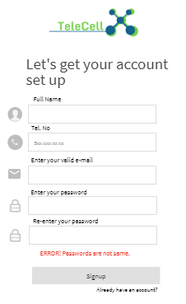

|  |  |  |
| --- | --- | --- |
| TC_010: Web Password Change Not Succesfull | | |
| **Short Description:** If the passwords written while changing the password do not match, the operation will fail. | | |
| **Pre-Condition:** Open Web Page | | |
| Triggering the Test Case:   * Write Password. * Write Password again. * Click Done | | |
| **Expected Outputs (Success conditions)** | Passed | Finding Id |
| * “ERROR! Passwords are not same” |  |  |

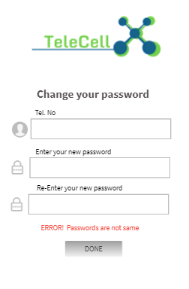

|  |  |  |
| --- | --- | --- |
| TC_011: After Login Display Index | | |
| **Short Description:** After logging in, display the index page. | | |
| **Pre-Condition:** Open Android App | | |
| Triggering the Test Case:   * Write Tel No. * Write Password. * Click Sign-Up | | |
| **Expected Outputs (Success conditions)** | Passed | Finding Id |
| * Display the Index |  |  |



|  |  |  |
| --- | --- | --- |
| TC_012: After Login Display Index | | |
| **Short Description:** After logging in, display the index page. | | |
| **Pre-Condition:** Open Web Page | | |
| Triggering the Test Case:   * Write Tel No. * Write Password. * Click Sign-Up | | |
| **Expected Outputs (Success conditions)** | Passed | Finding Id |
| * Display the Index |  |  |

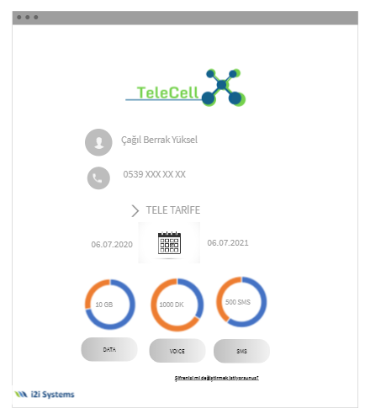

|  |  |  |
| --- | --- | --- |
| TC_013: App Log Out | | |
| **Short Description:** Exit the application after clicking the exit button. | | |
| **Pre-Condition:**   * Click Exit Button | | |
| **Expected Outputs (Success conditions)** | Passed | Finding Id |
| * Display First Page |  |  |

|  |  |  |
| --- | --- | --- |
| TC_013: Web Log Out | | |
| **Short Description:** Exit the page after clicking the exit button. | | |
| **Pre-Condition:**   * Click Exit Button | | |
| **Expected Outputs (Success conditions)** | Passed | Finding Id |
| * Display First Page |  |  |