Test Result Analysis

# Report on Performance Metrics

This report contains the analysis of the performance metrics for the events:

1. WEBSOCKET AccountDashboardModuleAgent.1.getAccountModules_success

2. WEBSOCKET Settings.3.getUserSettingsConfig

## Graph 1: Number of Events Per Second

The first graph shows the number of events per second, grouped by 5 second intervals.

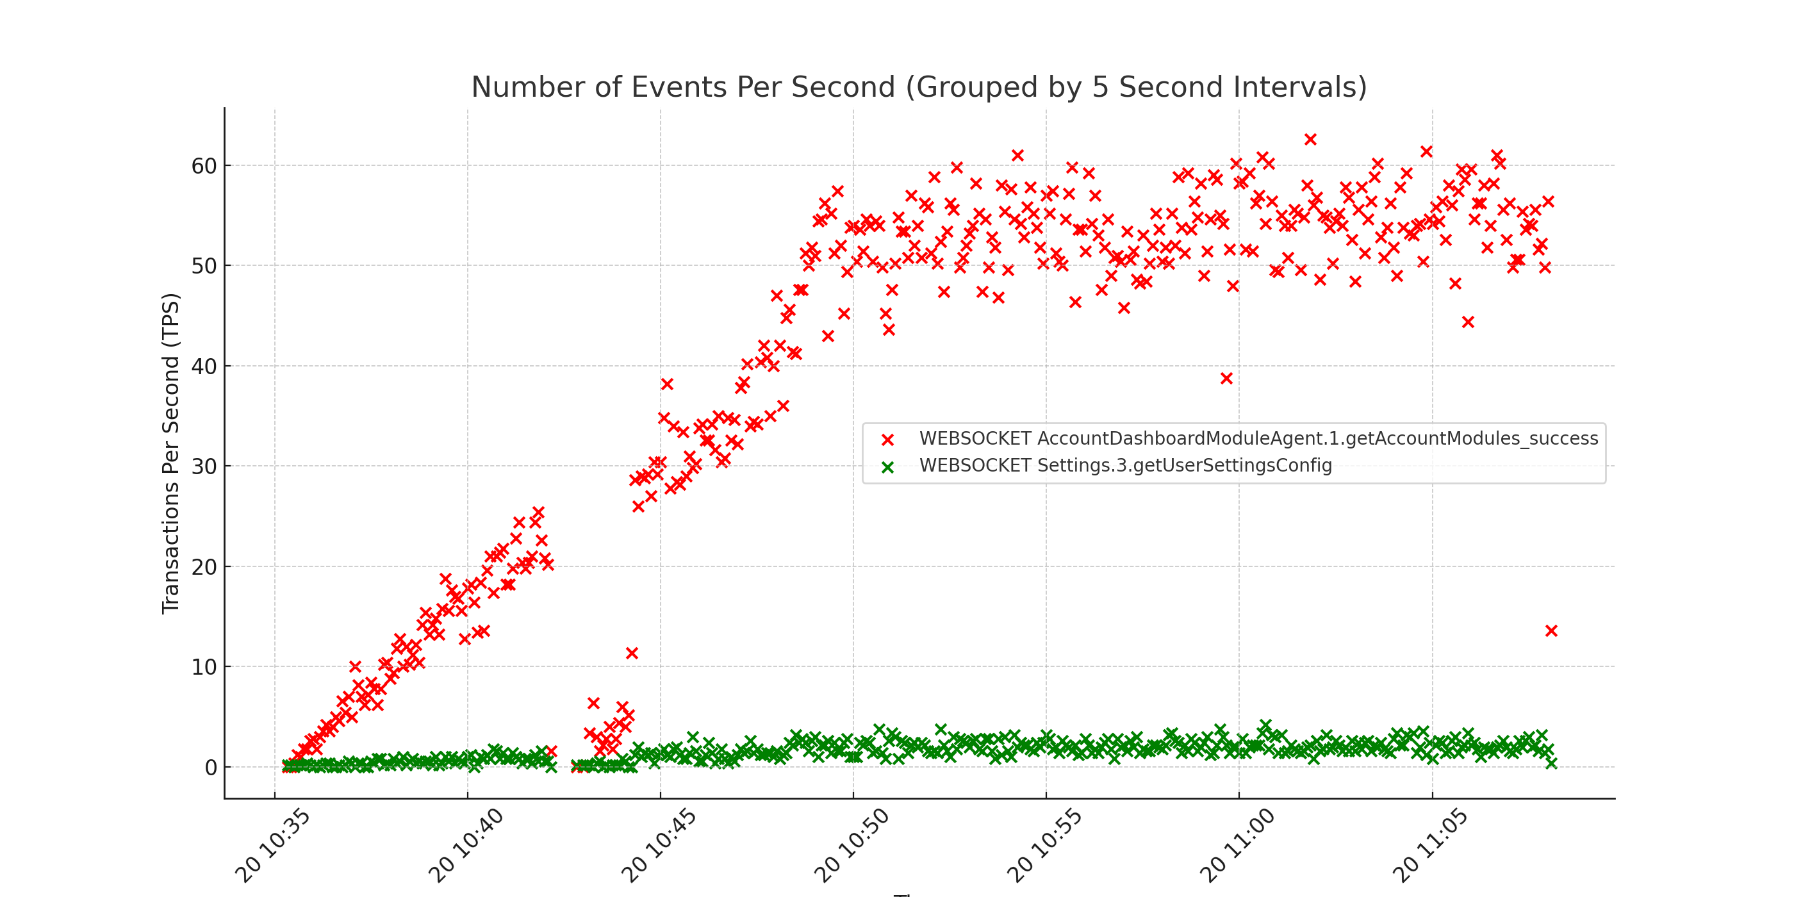

## Graph 2: 95th Percentile of Elapsed Time

The second graph shows the 95th percentile of elapsed time, grouped by 5 second intervals. A threshold maximum of 1000 ms is indicated by a horizontal red dashed line.

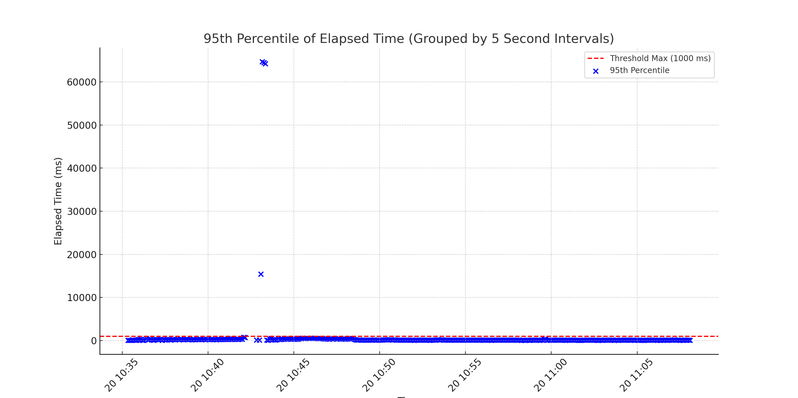

# Conclusions

Based on the performance metrics and the generated graphs, the following issues have been identified:

The 95th percentile of elapsed times is somewhat unstable, with between 0.1% and 5% of values exceeding the threshold of 1000 ms. Consider investigating potential causes of latency.