Supervisor: Ina Andersen

Report on GC

*Group 5: Ana Maria Guzunov, Marta Auguleviciute, Neringa Novikaite*

Content

Aim 1

Principles 1

Procedure 2

Results 4

Evaluation

Conclusion

Safety

Waste

Traceability

References

Aim

*To identify the 9 unknown substances by using GS MS which is followed by checking the performance quality of GC FID, finding and setting the optimal temperature program and performing Qualitative/Quantitative analysis on control sample.*

Principles

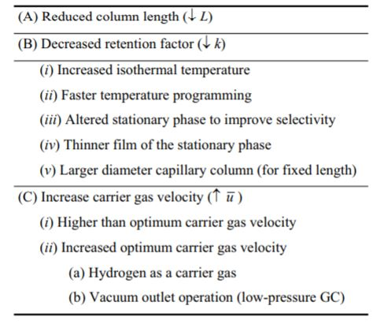

Factors which influence the separation

*Gas chromatography (GC)* is an analytic technique which usually used for the identification and quantitation of compounds in the liquid or gas mixture. To identify the compounds properly the certain settings for the GC is needed. To get the best separation with optimal settings of a proper column temperature, carrier gas flow rate, column length, amount of material injected, and a vapor pressure is needed. The technician has to adjust the parameters by himself depending on how peaks of the substances appears in the chromatogram window.

Table 1 Approaches to faster GC separation

**The temperature** affects retention and relative retention in gas chromatography. Changing the temperature and setting temperature rate improves or decreases the selectivity of the separation. That is because the higher the temperature the faster peaks appears in the chromatogram and the peaks getting very close to each other because all substances mainly stay in the gas phase. When the temperature is lower, the interaction with the stationary phase is stronger and the substance moves slower through the column which gives us the better separation but also the longer retention time.

**The carrier gas flow rate** mainly affects the retention time – the higher the flow rate the shorter the retention time. If the pressure is too high the components going very fast through the column and that gives the poor separation too. If the laboratory experiment takes more than one day, the gas flow rate must be measured each of the days in the beginning of a work.

To calculate *split ratio* this formula is used:

$$Ratio=Split flow rate ÷column flow rate$$

**The column length** is proportional of the increasing retention time. The longer column is always better because it makes the compounds separate better.

**Amount of material injected** is also an important factor – if amount is too big it can make a poor separation on the compounds. To reach an optimal amount of the sample the technician needs to test how injecting different amounts of the same substance affects the result showed in the chromatogram.

**Vapor pressure** if it is too high the substance spends more time in the gas phase and the retention time will be really short. It is related to a boiling point (which is related to polarity) – the higher boiling point, the lower the vapor pressure.

Identification of components

Gas chromatography makes simple to find the unknown compounds. What is complicated is that the different compounds can have the same polarity and appear in different sequence than they should in the chromatogram window. To identify the unknown substances which are mixed together it is necessary to dissolve them in the methanol. After run and results appear each unknown compound will have its retention time and by that using Library program the compound can be find by looking at the probability(%) and comparing the peak area with the one that is in the Library. For the further analysis and detection mass spectrometric detectors is used which helps to identify compounds based on their fragmentation pattern.

Because of the polarity differences the peaks are not appearing in order of increasing boiling point. To identify the right compounds mixtures with known substances must be prepared and tested. The substances are identified by the retention times and compared with the chromatogram result from the unknown mixture. If the polarity caused a switch, the right compound peak would probably stay in one place back or after the one that is false peak of that compound.

Procedure

1st day

Identification of components on GC MS

* First the mixture of 9 unknown substances (Ratio 1:1) was ran on the GC MS no 213 12. The Chromatogram was then transferred to the computer and by using the library, the substances were identified.

Set up of GC

* 100µl 2% methane was injected at these conditions:

|  |  |  |  |
| --- | --- | --- | --- |
| Injector | Detector | Oven | Pressure |
| 200° | 250° | 40° | 15 psi |

* The flow was measured with the flowmeter and the split ratio calculated.
* Then the test mix was injected at:

|  |  |  |  |
| --- | --- | --- | --- |
| Injector | Detector | Oven | Pressure |
| 200° | 250° | 120° | 15 psi |

Parameters were collected and evaluated.

2nd day

Temperature program – standard mix

* Boiling points of all substances were found and once again standard mixture was diluted with methanol by ratio 1:1 by taking 500µl of standard and 500µl of methanol and that was injected to the GC. There were 3 sets of temperature set until the optimal (4th) one was reached. (Table no )
* The chromatogram made with the optimal temperatures was evaluated.

*The temperature program was being used for further analysis of the protocol.

|  |  |  |  |  |  |
| --- | --- | --- | --- | --- | --- |
| Bp1 | Cyclohexane | Bp2 | Isopropylalcohol | Bp3 | Heptane |
| Bp4 | Octane | Bp5 | 1-Pentanol | Bp6 | p-Xylene |
| Bp7 | o-Xylene | Bp8 | Nonane | Bp9 | Dodecane |

Identification of peaks

* Three sets of the substances were made

this way:

* These three sets of standards were each injected using the optimal temperature program. The retention times were compared to those from the previous injection of all mixed substances.

Quantitative determination of control sample

* Control sample is injected, two unknown substances are identified. One of the peaks (substances) between the two now known peaks (substances) was chosen as an Internal Standard.
* 4 different solutions were made :
* Each standard was injected once and control injected 3 times. The standard curves were made by calibration on Peak Simple using Internal Standard method.

Results

Traceability

Nonane 99% lot 1318587 CAS 111-84-2

p-Xylene 28 984 292 RECTAPUR

Methanol Art. 1481.2500

GC kontrolprøve 20/9-2018 GHS 02,08,06

Octane lot #STBH2520 SIGMA-ALDRICH

2-propanol Art. 1136.1000 Batch: 1344/11/15