Simulated Data in Managed IoT Cloud

This document describes how to easily set up a Thing (sensor) in Telenor’s cloud solution called Managed IoT Cloud (MIC), and how to send simulated data to your dashboard. By simulating data streams you can start designing your visual dashboard and explore all the possibilities MIC offers before you have made any physical IoT devices:

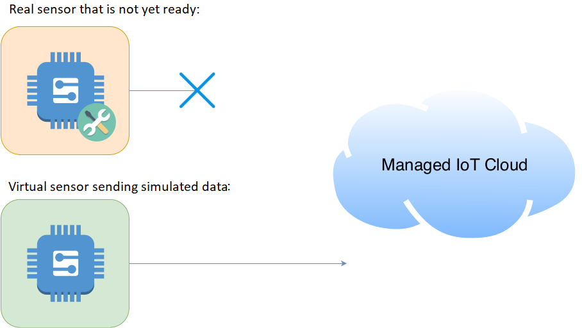

What you’ll need:

* An account in MIC
* Node.js needs to be installed on your computer. This can be done by following the steps as described here (Windows): <https://www.guru99.com/download-install-node-js.html>
* Script to represent the simulated Thing (attached)

So, how can the included script take the role as a Thing and send data from something that doesn’t yet exist? It’s quite simple; we create a Thing in MIC and download the unique keys (certificates). We then configure the script to use these keys and run the script. It’s that simple ☺

**Create a new Thing and Download the Keys**

Login to your account in MIC. Click on the desired Thing Type (1) that you’ll find in the left-side menu and then click the “+ THINGS” button (2):

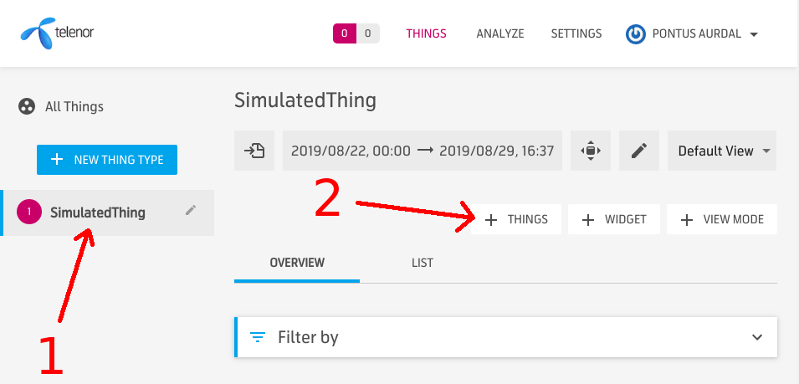

A popup-menu will appear. Choose 1 as the number of things to add (1) and pick a domain that has been assigned to your organization (2). Then, click “CREATE” to create the new Thing (3):

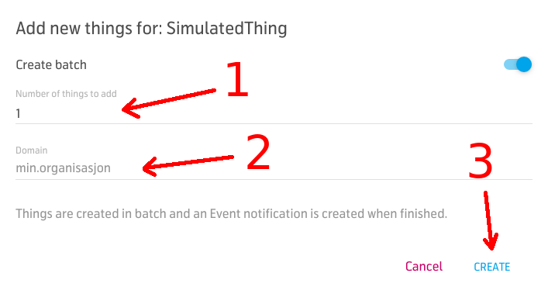

We are now ready to download the keys! If you click the “LIST” tab you’ll get a list of all the created Things for this Thing Type (1). If you hover your newly created Thing you’ll see a download button that you can use to download the keys (2):

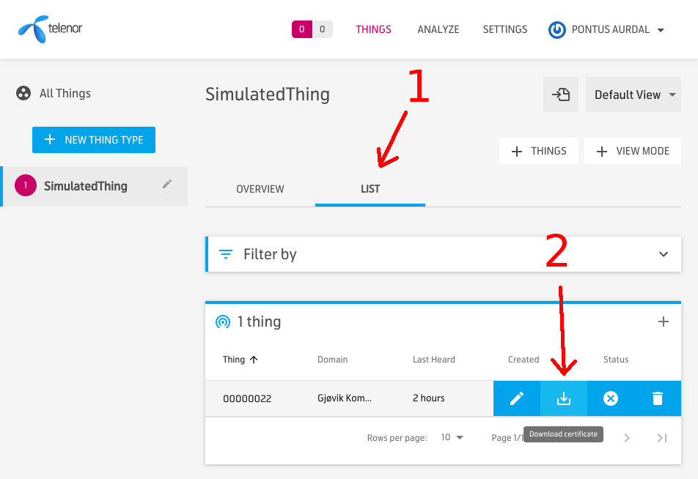

**Configure the Script to Use the New Keys**

When we download the keys from MIC we get a ZIP-archive that needs to be uncompressed. Use a ZIP-compatible program to uncompress the archive (e.g. 7zip). If you open the archive you’ll find another folder with a name similar to this: **000000XX**. This folder has the same name as the virtual Thing in MIC, and contains the keys that you’ll use. Copy this folder into the “certs” folder that is located in the attached script folder (1):

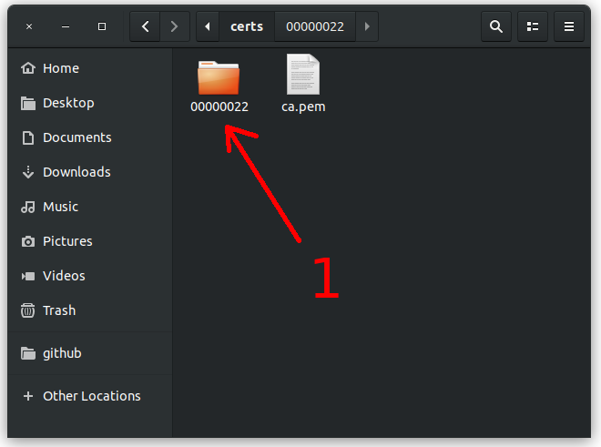

We now need to tell the attached script to use these keys. Open “index.js” and modify the variable called “THING_NAME”. Change it to the same value as the name of the folder that we copied in the previous step. The script will now know where to look for the correct keys to be used:

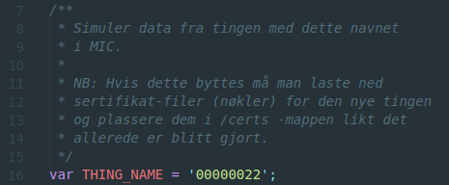

**Run the Script**

The script is written in Node.js and requires that Node.js is installed on the computer. There are many websites that describes how to install it on your computer. E.g. this (Windows): <https://www.guru99.com/download-install-node-js.html>

When Node.js is installed, open a terminal (also called a “command prompt” on Windows), navigate to the script location and run «npm install» (to install required dependencies) and then «node index.js» (to start the simulation):

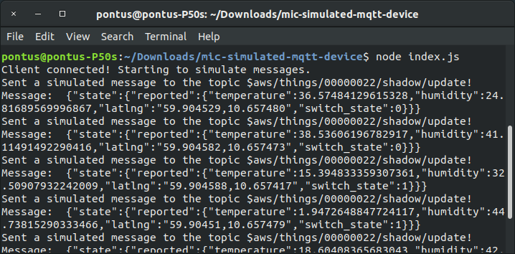

Good job! Data is now simulated and sent to MIC and you can start designing your dashboard to visualize the data:

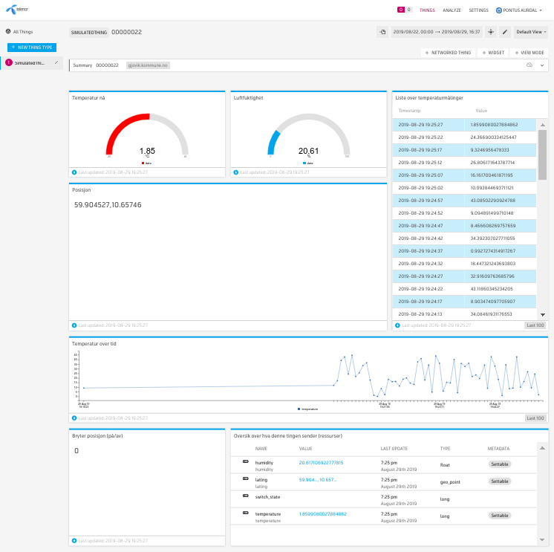

**Pontus Edvard Aurdal**

Technical Expert IoT

Telenor Norway

+47 40 60 62 81

[pontus.aurdal@telenor.com](mailto:pontus.aurdal@telenor.com)