GAME: Conquiztador

# Team: Fig

|  |  |
| --- | --- |
| Avatar image | Nikolay_Radkov ( Николай Радков ) |
| Avatar image | tddhome ( Виктор Даков ) |
| Avatar image | Yasen ( Ясен Михайлов ) |
| Avatar image | triplexsa ( Ясен Башов ) |
| Avatar image | elfoles ( Стефан Миревски ) |
| Avatar image | stoianpp ( Стоян Пенчев ) |

# Project Purpose

The game “Conquiztador” including live chat

# Class-Diagrams

WebAPI:

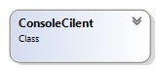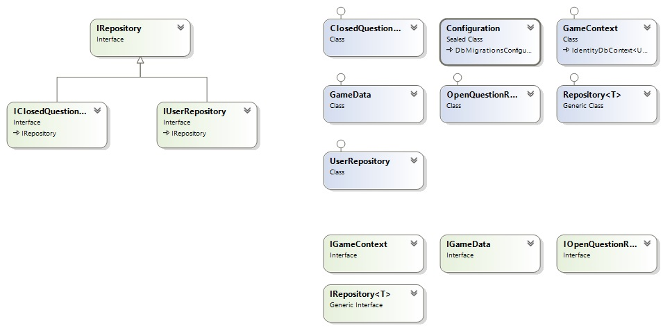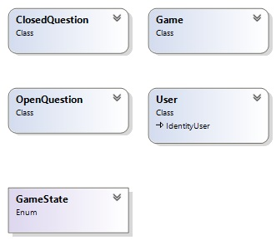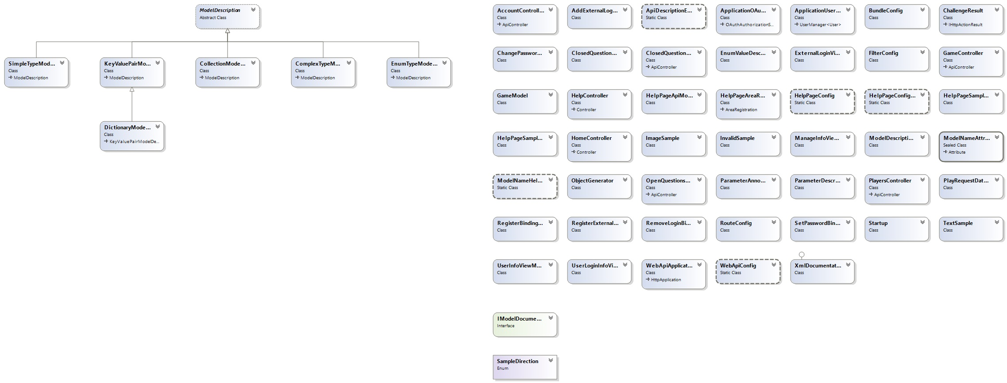

# Repositories

Conquiztador Client:

<https://github.com/TelerikConquiztador/ConquiztadorClient>

Conquiztador WebAPI:

<https://github.com/TelerikConquiztador/ConquiztadorWebApi>

Appharbor:

<https://appharbor.com/applications/gameconquiztador>