InstaPulse
AI-Powered Social Media Engagement Analytics

IBM SkillBuild — Final Project Submission
Data Analytics with Artificial Intelligence
Author: Teli Mushera

Abstract
InstaPulse is an AI-powered social media engagement analytics project built as part of the IBM SkillBuild programme. The project uses a real dataset of 5,000 social media posts across six platforms — Instagram, TikTok, YouTube, Facebook, Twitter, and LinkedIn — to analyse post performance and predict engagement levels using machine learning. A Random Forest Classifier was trained to classify posts as Low, Medium, or High engagement, achieving 71.4% accuracy. The full project is delivered as a Python analytics script, a FastAPI backend, and a React web dashboard — making it simple, understandable, and ready to demonstrate.
Introduction
Social media has become one of the most powerful communication channels in the world. Every day, millions of posts are published across platforms — but only a fraction of them achieve high engagement. Understanding what makes a post perform well is a challenge for content creators, marketers, and businesses alike.
InstaPulse addresses this challenge by combining data analytics with machine learning. Instead of guessing which posts will succeed, the system analyses historical data to identify patterns and trains an AI model to predict future performance. The result is a simple, transparent, and fully working system that any student or professional can understand and extend.
Problem Statement
Content creators and social media managers often make publishing decisions based on intuition rather than data. They lack easy-to-use tools that can tell them: which platform delivers the highest engagement, which content type works best, what time is best to post, and whether a planned post will likely get high or low engagement.
InstaPulse solves this with four capabilities:
- Descriptive analytics — what happened across 5,000 real posts.
- Comparative analysis — which platforms, content types, and categories performed best.
- Time analysis — which days and hours drive the most engagement.
- Predictive AI — a trained model that predicts whether a new post will be Low, Medium, or High engagement.
Objectives
- Load and inspect a real social media dataset (5,000 posts, 20 columns).
- Perform exploratory data analysis across platforms, content types, categories, sentiment, and posting time.
- Build and evaluate a Random Forest Classifier to predict engagement performance.
- Identify the most important features that drive high engagement.
- Deploy an interactive web dashboard with AI prediction capability.

Dataset
The dataset used is social_media_engagement.csv — a single CSV file with 5,000 rows and 20 columns. There are no missing values. No fake data was created and no external datasets were used.
Link: Social Media Engagement Dataset

Property | Value
Rows | 5,000 posts
Columns | 20 features
Missing values | None
Platforms covered | Instagram, TikTok, YouTube, Facebook, Twitter, LinkedIn
Date range | 2024 (Timestamp column available)

The 20 columns include:
- Post_ID, Timestamp — post identifier and posting date/time.
- Platform, Content_Type, Category — categorical descriptors of the post.
- Likes, Comments, Shares, Views, Saves — direct engagement metrics.
- Engagement_Rate — the main performance indicator (float %, used as the prediction target).
- Follower_Count, Hashtag_Count, Content_Length, Hour_of_Day — numeric features.
- Day_of_Week, Sentiment, Influencer_Tier — posting day, tone, and account tier.
- Has_Media, Is_Verified — boolean flags.
Methodology
The project follows a clear, step-by-step data science pipeline. Each stage feeds into the next, ensuring the work is transparent and reproducible.
- Step 1 — Load the CSV with pandas and inspect shape, data types, and missing values.
- Step 2 — Preprocess: encode categorical columns, convert booleans, and create the 3-class target label.
- Step 3 — Exploratory Data Analysis: calculate averages, group statistics, and top performers.
- Step 4 — Create visualisations: 6-panel chart and confusion matrix.
- Step 5 — Train a Random Forest Classifier on an 80/20 stratified train/test split.
- Step 6 — Evaluate with accuracy, precision, recall, F1-score, and feature importances.
- Step 7 — Save the trained model (model_data.pkl) with joblib.
- Step 8 — Serve the model via FastAPI and display results on the React dashboard.

Data Preprocessing
Because the dataset contains no missing values, preprocessing was intentionally minimal and easy to understand:
- Boolean columns (Has_Media, Is_Verified) were converted to integers (0 = No, 1 = Yes).
- Post_ID and Timestamp were removed as they carry no predictive information.
- Six categorical columns were Label Encoded: Platform, Content_Type, Category, Day_of_Week, Sentiment, Influencer_Tier.
- The target variable — Engagement_Rate — was binned into three performance classes using the 33rd and 66th percentile thresholds:

Class | Condition
Low (0) | Engagement Rate <= 1.36% | 1,661 posts
Medium (1) | 1.36% < Engagement Rate <= 4.14% | 1,646 posts
High (2) | Engagement Rate > 4.14% | 1,693 posts

Data Analysis & Visualisations
Key Statistics
Metric | Value
Total posts | 5,000
Average Engagement Rate | 11.96%
Average Likes | 7,537
Average Comments | 340
Average Shares | 835
Average Views | 110,968
Average Saves | 753

Engagement by Platform
- TikTok — 41.83% average engagement rate (highest by far)
- YouTube — 10.46%
- Instagram — 8.12%
- Facebook — 7.17%
- Twitter — 4.76%
- LinkedIn — 1.75% (lowest)

Engagement by Content Type (Top 5)
- Stitch — 45.38% (TikTok-specific format)
- Duet — 41.63% (TikTok-specific format)
- Video — 20.41%
- Reel — 11.67%
- Short — 10.74%

Engagement by Day & Sentiment
- Best posting day: Friday (19.12% avg), worst: Wednesday (8.74%).
- Positive sentiment posts achieve the highest average engagement.
- Top categories: Lifestyle (19.13%), Travel (15.21%), Technology (13.96%).

Analytics Charts
The chart below shows six key analytics visualisations generated from the dataset: average engagement by platform, average engagement by content type, post distribution by platform (pie chart), engagement by day of week, engagement by sentiment, and a correlation heatmap of all numeric variables.
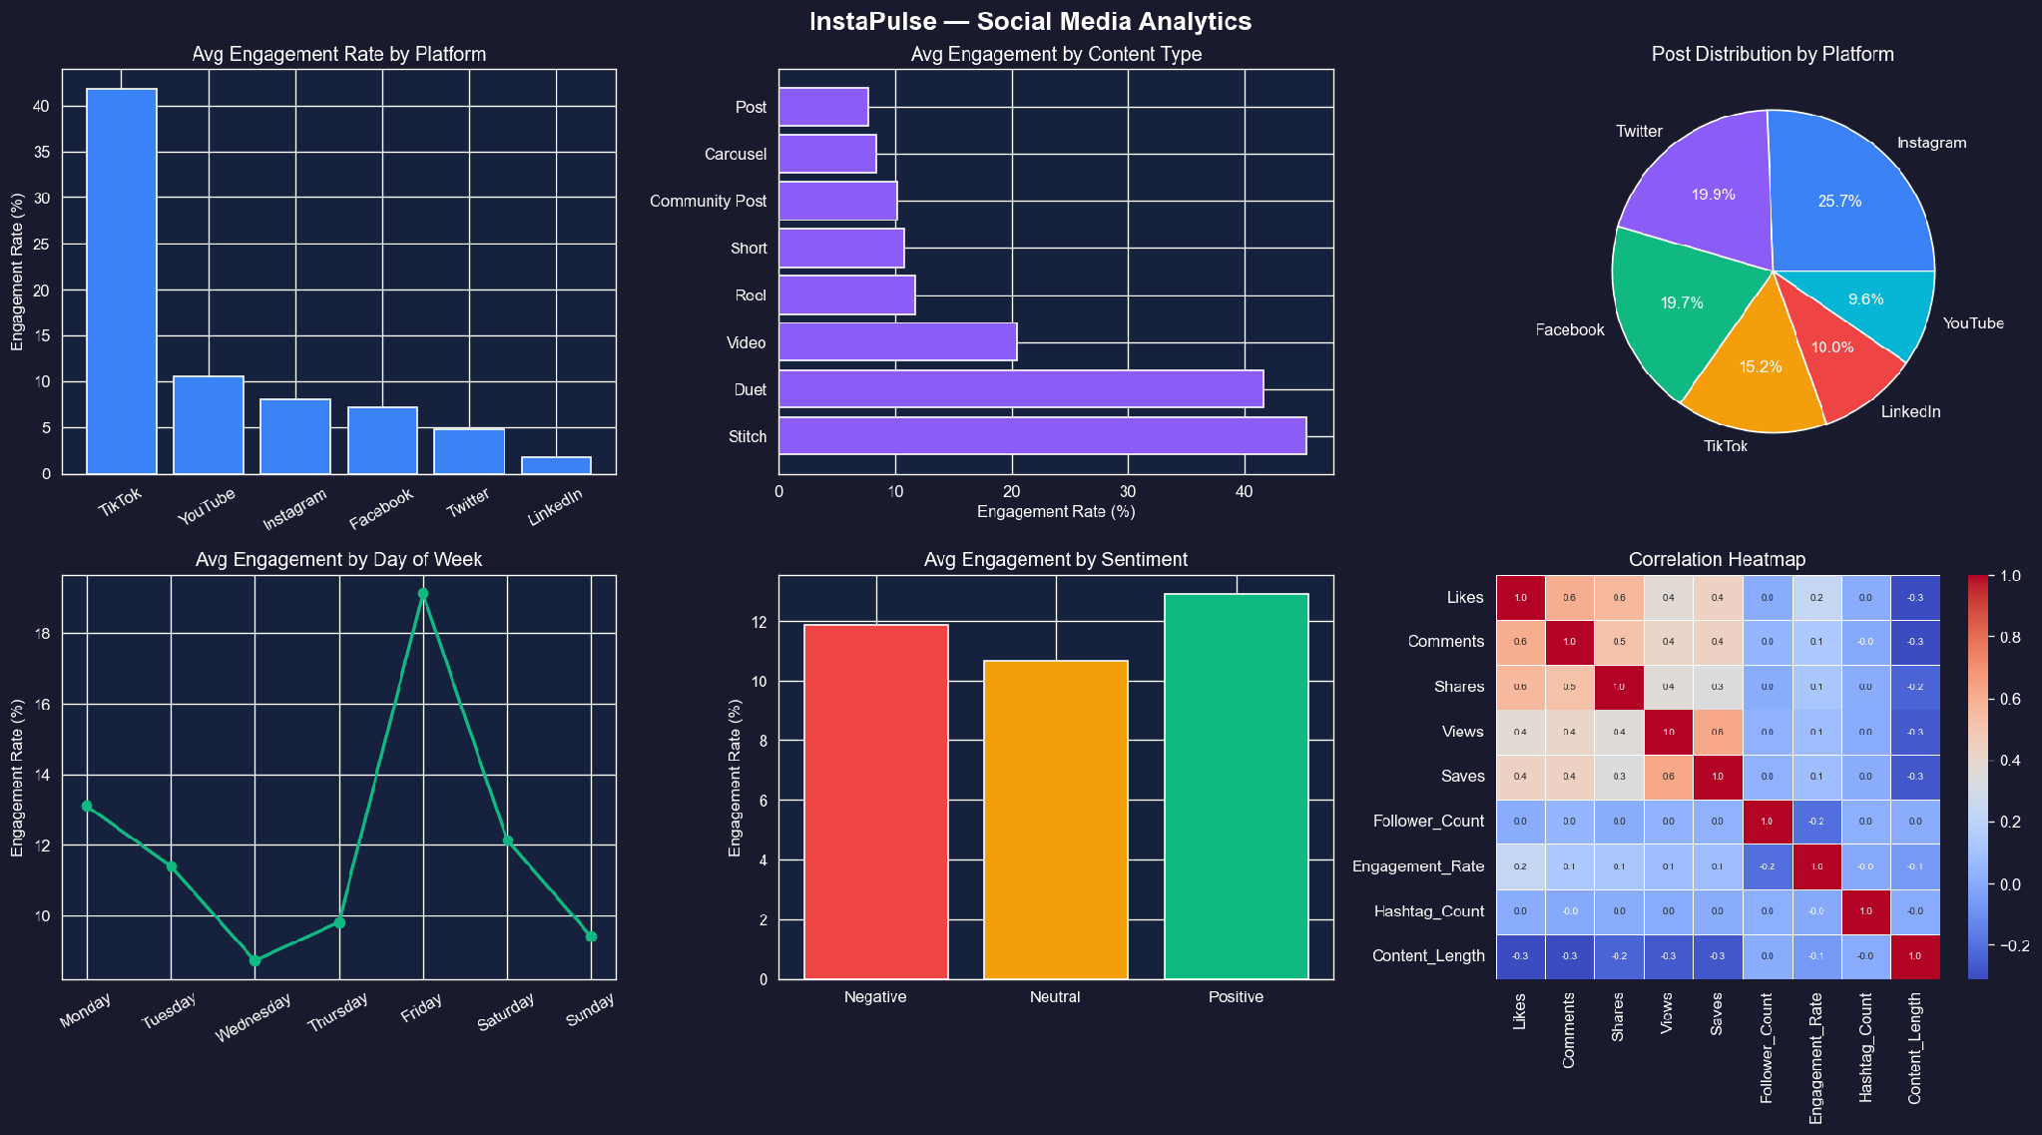
Figure 1 — InstaPulse Analytics Dashboard: 6-panel chart generated from the 5,000-post dataset

Machine Learning Model
Algorithm Choice
A Random Forest Classifier was selected for the following reasons:
- It handles mixed data types (numerical + categorical) without feature scaling.
- It provides feature importances, making results explainable.
- It is resistant to overfitting and works well on datasets of this size.
- It is simple to train, tune, and understand — ideal for a teaching demonstration.

Configuration
- Number of trees: 100
- Random state: 42 (for reproducibility)
- Train / Test split: 80% training (4,000 posts) / 20% testing (1,000 posts)
- Split strategy: Stratified — equal class balance in both sets
- Target variable: Performance_Label (Low = 0, Medium = 1, High = 2)

Input Features (12 total)
- Platform, Content_Type, Category — what and where the post was published.
- Follower_Count — size of the posting account's audience.
- Hashtag_Count — number of hashtags used.
- Content_Length — length of the post text in characters.
- Hour_of_Day — what hour (0–23) the post was published.
- Day_of_Week — which day of the week.
- Sentiment — tone of the post (Positive / Neutral / Negative).
- Influencer_Tier — account tier (Nano / Micro / Mid-tier / Macro).
- Has_Media — whether the post includes an image or video.
- Is_Verified — whether the account is verified.

Results & Model Evaluation

Classification Report
Class | Precision | Recall | F1-Score | Support
Low | 0.77 | 0.66 | 0.71 | 332
Medium | 0.58 | 0.60 | 0.59 | 329
High | 0.80 | 0.88 | 0.84 | 339
Overall Accuracy |  |  | 71.4% | 1,000

The model correctly classifies 71.4% of posts. High-engagement posts are predicted most reliably (F1 = 0.84), while Medium posts are the hardest to distinguish (F1 = 0.59) — which is expected, as medium-performing content sits between two extremes.

Confusion Matrix
The confusion matrix below shows how predicted labels compare to actual labels across the 1,000 test posts.
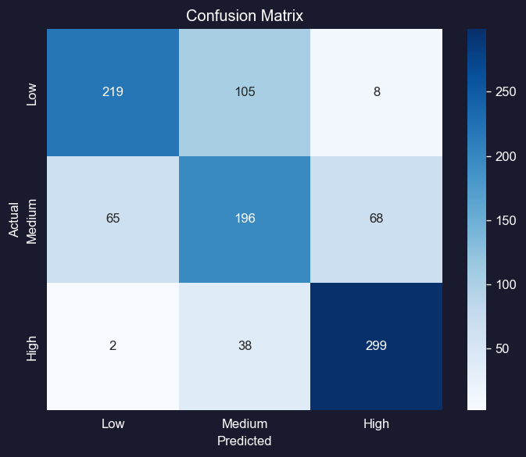
Figure 2 — Confusion Matrix on the 1,000-post test set

Feature Importance
The model's most influential features in ranking order:
- Follower_Count — 23.6% (single strongest predictor)
- Platform — 15.6%
- Content_Length — 12.7%
- Hashtag_Count — 8.1%
- Content_Type — 7.9%
- Influencer_Tier — 7.7%
- Hour_of_Day — 7.6%
- Category — 6.4%
- Day_of_Week — 5.1%
- Sentiment — 2.6%
Follower Count being the top predictor makes intuitive sense — larger accounts reach more people, which naturally drives higher raw engagement. Platform is the second most important factor, confirming that TikTok's algorithm significantly amplifies content compared to other platforms.

System Architecture
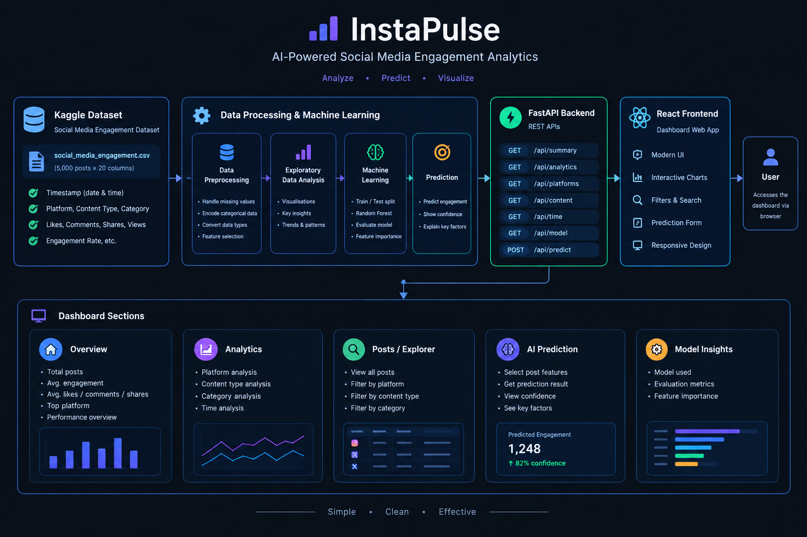
Figure 3 — InstaPulse System Architecture: Data layer → Python script → Backend → Frontend
Web Dashboard
The dashboard is a full-stack web application accessible at http://localhost:5173 when both the backend and frontend are running. It has five pages:
Page | What it shows
Dashboard | Summary KPIs (total posts, average engagement, likes, comments), platform comparison bar chart, post distribution pie chart, content type chart.
Analytics | In-depth charts: engagement by platform, by category, by day of week, by hour of day, by sentiment. Top 10 posts table.
Posts Explorer | Full paginated table of all 5,000 posts with dropdown filters for Platform, Content Type, and Category. Each row shows engagement metrics and a performance badge.
AI Prediction | A form with 12 input fields (Platform, Content Type, Category, Follower Count, Hashtag Count, etc.). After clicking Predict, the model returns a Low / Medium / High label with confidence percentages.
Model Insights | Classification report table, feature importance bar chart, and a plain-English explanation of how the model works and what it learned.

Conclusion
InstaPulse successfully demonstrates a complete data analytics and AI workflow applied to a real social media dataset. The project confirmed the following key findings:
- TikTok delivers the highest engagement (41.83%) by a large margin — more than four times higher than the next platform.
- Follower Count is the single most important feature for predicting engagement performance.
- Posting on a Friday with positive sentiment gives the best chance of high engagement.
- A simple Random Forest Classifier can predict engagement performance with 71.4% accuracy across three balanced classes.
The project is simple enough to understand and explain in a student presentation, but complete enough to demonstrate a real-world data analytics and AI pipeline from raw CSV data to an interactive web dashboard.

