High-Side Multi-Classification SIEM:
Document 1: System Architecture and Module Design

Will Lawson
Master of Science in Information Technology
University of the People
MSIT Capstone
April 2026
Instructor: Dr. Shabia Shabir

Table of Contents
System Architecture 1
Module Breakdown 5
Functional and Non-Functional Requirements 6
4.1 Functional Requirements 6
4.2 Non-Functional Requirements 7
System Architecture and Module Design 9
Version Control Strategy and Git Branching Model 14
Repository Setup and Hosting 14
Branching Strategy 14
Commit History and Version Tracking 15
Collaboration Features and Practices 16
Version Control, Academic Integrity, and Reproducibility 17
References 19

System Architecture
The following diagram presents the layered architecture of the High-Side Multi-Classification SIEM system. The architecture enforces unidirectional data flow from three isolated low-side classification domains, through a Cross-Domain Solution (CDS) sanitization guard, to a high-side correlation engine and unified analytics platform. Each layer is described in detail below the diagram.
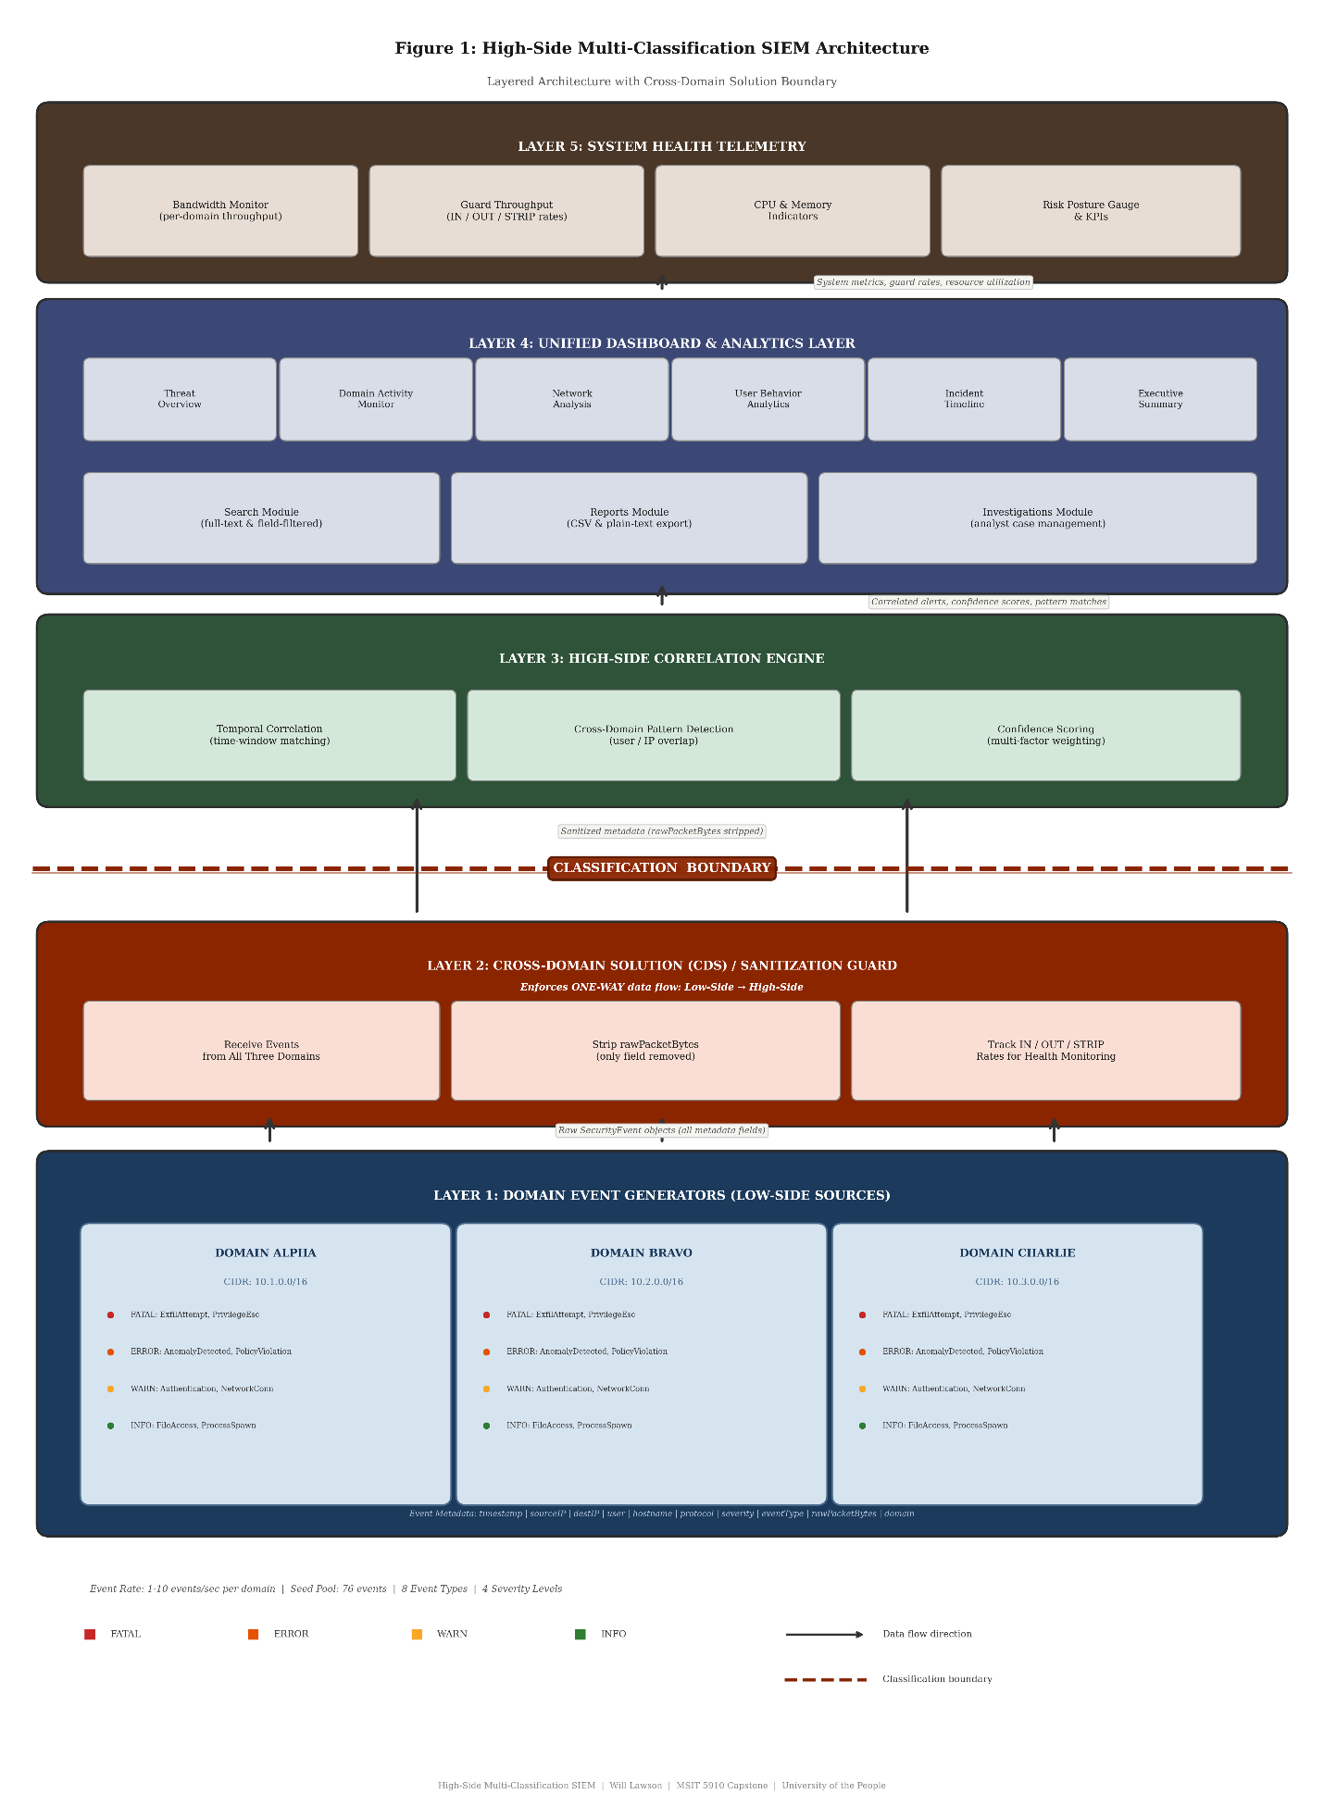

LAYER 5: SYSTEM HEALTH TELEMETRY
Bandwidth Monitor (per domain throughput) | Guard Throughput (IN / OUT / STRIP rates) | CPU & Memory Indicators | Risk Posture Gauge & KPIs

LAYER 4: UNIFIED DASHBOARD & ANALYTICS LAYER
Threat Overview | Domain Activity Monitor | Network Connection Analysis | User Behavior Analytics | Incident Timeline | Executive Summary
Search Module (full-text & field-filtered) | Reports Module (CSV & plain-text export) | Investigations Module (analyst case management)

▲ Correlated alerts, confidence scores, pattern matches ▲

LAYER 3: HIGH-SIDE CORRELATION ENGINE
Temporal Correlation (time-window matching) | Cross-Domain Pattern Detection (user/IP overlap) | Confidence Scoring (multi-factor weighting)

▲ Sanitized metadata (rawPacketBytes stripped) ▲

LAYER 2: CROSS-DOMAIN SOLUTION (CDS) / SANITIZATION GUARD
Receive events from all three domains | Strip rawPacketBytes (only field removed) | Track IN / OUT / STRIP rates for health monitoring
Enforces ONE-WAY data flow: Low-Side → High-Side

▲ Raw SecurityEvent objects (all metadata fields) ▲

LAYER 1: DOMAIN EVENT GENERATORS (LOW-SIDE SOURCES)
Domain Alpha CIDR: 10.1.0.0/16 | Domain Bravo CIDR: 10.2.0.0/16 | Domain Charlie CIDR: 10.3.0.0/16
Event Types (per domain): ExfilAttempt [FATAL] | PrivilegeEsc [FATAL] | AnomalyDetected [ERROR] | PolicyViolation [ERROR] | Authentication [WARN] | NetworkConn [WARN] | FileAccess [INFO] | ProcessSpawn [INFO]
Event Metadata: timestamp, sourceIP, destIP, user, hostname, protocol, severity, rawPacketBytes

Figure 1: High-Side Multi-Classification SIEM Architecture

Module Breakdown
Table 1 presents a comprehensive breakdown of the nine core modules that compose the High-Side Multi-Classification SIEM system. Each module is described in terms of its purpose, inputs, outputs, and key methods or functions. Together, these modules form the complete data pipeline from synthetic event generation through sanitization, correlation, analysis, and reporting.
Table 1: Module Breakdown with Inputs, Outputs, and Methods

Module Name | Purpose | Inputs | Outputs | Key Methods / Functions
DomainEventGenerator | Generates synthetic SIEM events for each classification domain | Domain config (name, CIDR, event rate 1-10/sec); seed event pool (76 events) | Raw SecurityEvent objects with all metadata fields | generateEvent(), selectEventType(), assignSeverity(), buildMetadata()
CrossDomainGuard (CDS Sanitizer) | Enforces sanitization policy at the classification boundary | Raw SecurityEvent from any domain | SanitizedEvent (rawPacketBytes stripped); guard metrics | sanitize(), stripRestrictedFields(), validateSchema(), updateThroughputMetrics()
CorrelationEngine | Detects multi-domain threat patterns | Stream of SanitizedEvents from all domains | CorrelationAlert objects with confidence scores; cross-domain pattern matches | correlate(), detectSynchronizedThreats(), computeConfidenceScore(), matchTemporalWindow()
DashboardRenderer | Renders six analytical dashboards | Correlated event stream; alert objects; system metrics | Rendered visualization components (charts, tables, gauges, timelines) | renderThreatOverview(), renderDomainActivity(), renderNetworkAnalysis(), renderUserBehavior(), renderIncidentTimeline(), renderExecutiveSummary()
SearchModule | Provides full-text and field-filtered event search | User query string; field filters | Filtered event result set; match highlights | search(), applyFieldFilters(), highlightMatches(), paginateResults()
ReportGenerator | Produces downloadable event reports | Event dataset; filter configuration | CSV file; plain-text report | generateCSV(), generateTextReport(), applyFilters(), formatOutput()
InvestigationManager | Manages analyst investigations and case tracking | Notable events; analyst annotations | Investigation records; status updates | createInvestigation(), linkEvents(), updateStatus(), exportCase()
HealthMonitor | Tracks system health and bandwidth telemetry | Guard throughput data; system resource metrics | Health status indicators; bandwidth charts; risk posture gauge | measureBandwidth(), trackGuardRates(), computeRiskPosture(), generateKPIs()
SimulationController | Controls simulation lifecycle | User commands (start, pause, resume, reset); rate configuration | Simulation state changes; event stream control signals | start(), pause(), resume(), reset(), setEventRate()

Functional and Non-Functional Requirements

Functional Requirements
The following functional requirements define the observable behaviors and capabilities that the High-Side Multi-Classification SIEM system must exhibit. Each requirement is traceable to one or more modules described in Table 1.
- FR-01: The system shall generate synthetic security events across three isolated classification domains at configurable rates (1 to 10 events per second).
- FR-02: Each domain shall produce eight distinct event types with appropriate severity levels (FATAL, ERROR, WARN, INFO).
- FR-03: The Cross-Domain Solution shall strip rawPacketBytes from all events while preserving all structured SIEM metadata.
- FR-04: The CDS shall enforce unidirectional data flow from low-side domains to the high-side analysis platform.
- FR-05: The correlation engine shall detect synchronized threat patterns across multiple domains using temporal correlation.
- FR-06: The system shall compute confidence scores for all cross-domain correlation alerts.
- FR-07: The system shall provide six distinct analytical dashboards covering threat overview, domain activity, network analysis, user behavior, incident timeline, and executive summary.
- FR-08: The search module shall support both full-text keyword search and field-filtered queries across all events.
- FR-09: The report generator shall export event data in CSV and plain-text formats with configurable filters.
- FR-10: The investigation manager shall allow analysts to create, manage, and export investigation cases from notable events.
- FR-11: The health monitor shall display real-time bandwidth, guard throughput (IN/OUT/STRIP rates), and system resource indicators.
- FR-12: The simulation controller shall support pause, resume, and reset operations without data loss.
- FR-13: The system shall preload 76 seed events distributed across all three classification domains to provide a realistic historical baseline upon initialization.
- FR-14: The system shall display a risk posture gauge that aggregates severity-weighted event counts and active correlation alerts into a single composite indicator.

Non-Functional Requirements
The following non-functional requirements define the quality attributes, performance constraints, and design principles that govern the system's implementation and operation.
- NFR-01: The system shall render dashboard updates within 200 milliseconds of event ingestion.
- NFR-02: The simulator shall operate entirely client-side with no backend dependencies, external API calls, or database requirements.
- NFR-03: The system shall maintain consistent performance with event rates up to 10 events per second across all three domains simultaneously.
- NFR-04: All synthetic data shall be clearly labeled to prevent confusion with real network traffic, credentials, or classified material.
- NFR-05: The user interface shall be responsive and functional across modern browsers (Chrome, Firefox, Edge, Safari).
- NFR-06: The codebase shall use TypeScript with strict type checking to ensure type safety and maintainability.
- NFR-07: The system shall preload 76 seed events to provide a realistic historical dataset before simulation begins.
- NFR-08: The architecture shall support modular design, allowing individual components to be updated or replaced independently.
- NFR-09: The system shall provide accessible color contrast ratios and semantic HTML structure to support usability across diverse user populations.
- NFR-10: The source code repository shall be publicly accessible to support academic review, reproducibility, and transparency.

System Architecture and Module Design
Organizations operating across multiple classification domains face a persistent and consequential challenge: how to correlate security events generated on isolated networks without violating the data spillage boundaries that separate those networks. In environments governed by national security policy, each classification domain maintains strict information assurance controls that prohibit the unauthorized movement of data from one security level to another. Yet the analytical value of cross-domain visibility is substantial; adversaries who probe multiple networks simultaneously leave coordinated signatures that are invisible to any single domain's security monitoring tools. The High-Side Multi-Classification SIEM addresses this challenge by providing a unified security analytics platform that ingests sanitized event metadata from multiple low-side classification domains, correlates threat patterns across domain boundaries, and presents analyst-ready situational awareness through a consolidated dashboard layer.
The system architecture is organized into five distinct layers, each responsible for a clearly bounded function within the data pipeline. At the foundation, Layer 1 consists of three Domain Event Generators, each representing an isolated classification domain: Alpha (CIDR 10.1.0.0/16), Bravo (CIDR 10.2.0.0/16), and Charlie (CIDR 10.3.0.0/16). Each generator produces eight distinct event types spanning four severity tiers. FATAL-severity events include ExfilAttempt and PrivilegeEsc, representing the most critical threat indicators. ERROR-severity events include AnomalyDetected and PolicyViolation. WARN-severity events cover Authentication and NetworkConn activities, while INFO-severity events capture routine FileAccess and ProcessSpawn telemetry. Every generated event carries a structured metadata payload consisting of timestamp, sourceIP, destIP, user, hostname, protocol, severity, and rawPacketBytes. The event generation rate is configurable between 1 and 10 events per second per domain, and the system initializes with a pool of 76 preloaded seed events that establish a realistic historical baseline before live simulation begins.
Layer 2, the Cross-Domain Solution (CDS) Sanitization Guard, serves as the critical information assurance enforcement point. Modeled after the principles articulated in the National Security Agency's Raise the Bar (RTB) standards and the guidance published by the National Cross Domain Strategy and Management Office (NCDSMO), the CDS receives raw SecurityEvent objects from all three domains and applies a deterministic sanitization policy. Specifically, the guard strips the rawPacketBytes field from every event. This field is the only field removed, and it represents the type of raw binary payload data that would pose a spillage risk if transferred across classification boundaries. All other structured SIEM metadata (timestamp, sourceIP, destIP, user, hostname, protocol, and severity) passes through intact, because these fields carry the analytical value needed for high-side correlation without containing classification-sensitive content. The CDS enforces strictly unidirectional data flow: information moves only from the low-side domains to the high-side platform, and no feedback channel exists in the reverse direction. The guard also maintains internal throughput metrics, tracking IN rates (events received), OUT rates (events forwarded), and STRIP rates (fields removed), which feed into the system health telemetry layer for operational monitoring.
Layer 3, the High-Side Correlation Engine, receives the stream of sanitized events from the CDS and performs the analytical core function of the system: detecting synchronized threat patterns across multiple classification domains. The engine uses temporal correlation with configurable time windows to identify events that occur in close proximity across two or more domains. For example, if ExfilAttempt events appear in Domain Alpha and Domain Bravo within a narrow temporal window, and the events share overlapping user identifiers or destination IP addresses, the correlation engine flags this pattern as a potential coordinated attack. Each correlation alert is assigned a confidence score computed through multi-factor weighting that considers the number of domains involved, the severity of the constituent events, the tightness of the temporal window, and the degree of metadata overlap (such as matching usernames or IP address ranges). This approach enables analysts to prioritize alerts by likelihood of genuine coordinated activity rather than treating all cross-domain coincidences as equal.
Layer 4, the Unified Dashboard and Analytics Layer, translates the output of the correlation engine into actionable intelligence through six specialized analytical views. The Threat Overview dashboard provides a high-level summary of active alerts, severity distributions, and trending threat categories. The Domain Activity Monitor visualizes event volumes and patterns within each individual classification domain, enabling comparative analysis. The Network Connection Analysis dashboard maps source and destination IP relationships across domains, highlighting anomalous connection patterns. The User Behavior Analytics view tracks user activity across domains, surfacing accounts that appear in correlation alerts or exhibit unusual behavioral patterns. The Incident Timeline provides a chronological visualization of events and alerts, supporting forensic reconstruction of attack sequences. The Executive Summary dashboard distills operational metrics into leadership-ready indicators, including overall risk posture, alert resolution rates, and domain health status. Supporting these dashboards, the Search Module provides both full-text keyword search and field-filtered queries across the entire event corpus. The Reports Module enables export of filtered event datasets in CSV and plain-text formats. The Investigations Module allows analysts to create and manage investigation cases, linking notable events, adding annotations, and tracking investigation status through defined workflows.
Layer 5, the System Health Telemetry subsystem, plays an essential role in operational assurance. It continuously monitors bandwidth consumption per domain, CDS guard throughput (IN/OUT/STRIP rates), CPU and memory utilization indicators, and a composite risk posture gauge. These metrics ensure that operators can verify the system is functioning correctly, that the CDS guard is processing events at expected rates, and that no performance degradation is affecting the quality of correlation or dashboard responsiveness. The health monitoring subsystem also generates key performance indicators (KPIs) that support capacity planning and operational reporting.
The conceptual simulator, implemented as a React and TypeScript single-page application and hosted at the public GitHub repository (https://github.com/Telieou-source/Unified-Security-View), serves as the proof-of-concept implementation that demonstrates this architecture's data flow, sanitization logic, correlation algorithms, and dashboard presentation. The technology stack consists of React 18 for component-based user interface rendering, TypeScript with strict type checking for code reliability and maintainability, Vite 7 for fast development builds and optimized production bundling, and Tailwind CSS v4 for utility-based styling. The simulator operates entirely client-side with no backend dependencies, external API calls, or database requirements, making it self-contained and easily reproducible for academic evaluation. All synthetic data is clearly labeled to prevent any confusion with real network telemetry or classified material.
The module design maps directly to the functional and non-functional requirements defined in Section 4. The DomainEventGenerator module satisfies FR-01 and FR-02 by producing configurable, multi-type event streams. The CrossDomainGuard module satisfies FR-03 and FR-04 by enforcing sanitization and unidirectional flow. The CorrelationEngine module addresses FR-05 and FR-06 through temporal pattern detection and confidence scoring. The DashboardRenderer, SearchModule, ReportGenerator, and InvestigationManager modules collectively satisfy FR-07 through FR-10. The HealthMonitor and SimulationController modules fulfill FR-11 and FR-12 respectively. Non-functional requirements, including client-side operation (NFR-02), performance targets (NFR-01, NFR-03), and modular architecture (NFR-08), are enforced through the technology stack choices and the layered separation of concerns that governs the overall system design.

Version Control Strategy and Git Branching Model

GitHub Repository Setup and Hosting
The source code for the High-Side Multi-Classification SIEM conceptual simulator is maintained in a public GitHub repository at https://github.com/Telieou-source/Unified-Security-View. GitHub was selected as the hosting platform for its industry-standard support for Git-based version control, integrated issue tracking, pull request workflows, and public accessibility. The repository is configured as a public repository, ensuring that the complete codebase, commit history, and project documentation are openly available for academic review, capstone evaluation, and independent verification of the implementation. The repository structure includes clearly organized directories: the artifacts/ directory contains project deliverables, the lib/ directory holds the core application source code, and the scripts/ directory contains build and utility scripts. Root-level configuration files, including package.json, tsconfig.json, tsconfig.base.json, pnpm-workspace.yaml, and .npmrc, define the project's dependency management, TypeScript compiler settings, and workspace configuration. These version-controlled configuration files ensure that any reviewer can reproduce the exact build environment by cloning the repository and running a single install command. The live simulator is also deployed and accessible via Replit (https://unified-security-view.replit.app), providing a browser-based runtime environment for reviewers who prefer not to build the project locally.
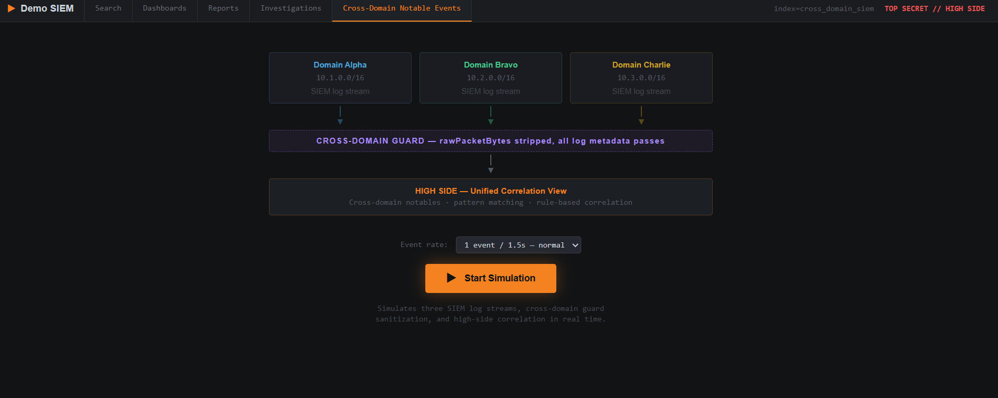

Branching Strategy
The project follows a trunk-based development workflow, a strategy well-suited to single-developer capstone projects where rapid iteration and a clean linear history are priorities. The main branch serves as the sole long-lived branch and represents the stable, production-ready state of the application at all times. Feature development proceeds through direct commits to the main branch rather than through short-lived feature branches or pull requests. This approach was chosen for several reasons: it minimizes branching complexity and merge conflicts in a single-developer context; it produces a clear, linear commit history that transparently documents the incremental construction of each system module; and it ensures that the main branch always reflects the latest verified state of the project. While a multi-branch strategy (such as GitFlow or GitHub Flow) would be appropriate for team-based development, the trunk-based model provides the simplicity and traceability best suited to this capstone's scope and authorship structure.

Commit History and Version Tracking
The repository contains 17 commits that comprehensively track the project from its initial scaffold through the complete implementation of all system modules. Each commit message describes the functional change introduced, creating a chronological narrative of the development process. The following key milestones document the major phases of development:
- Initial commit (project scaffold): Established the repository structure, initialized the React 18 and TypeScript project with Vite 7 build tooling, configured the pnpm workspace and dependency management through package.json and pnpm-workspace.yaml, and set up TypeScript compiler options via tsconfig.json and tsconfig.base.json.
- Create interactive demo for cross-domain security metadata aggregation (core simulation logic): Implemented the DomainEventGenerator, CrossDomainGuard, and CorrelationEngine modules; established the complete event data pipeline from domain sources through CDS sanitization to high-side correlation; constructed the seed event pool of 76 events; and built the initial dashboard rendering components for all six analytical views.
- Add bandwidth and system health monitoring (health monitor feature): Integrated the HealthMonitor module with per-domain bandwidth tracking, guard throughput metrics (IN/OUT/STRIP rates), CPU and memory utilization indicators, and the composite risk posture gauge with KPI generation.
- Add descriptive readme file (documentation): Created the repository README with a comprehensive project overview, architecture summary, technology stack description, build and installation instructions, usage guidance, and descriptions of the classification domains and event types.
Intermediate commits between these milestones addressed incremental feature additions including the SearchModule implementation with full-text and field-filtered query support, ReportGenerator CSV and plain-text export functionality, InvestigationManager case tracking logic, SimulationController lifecycle management (start, pause, resume, reset operations), dashboard refinements and responsive layout adjustments, seed event pool construction and distribution across domains, Tailwind CSS v4 styling integration, and Replit deployment configuration (.replit and .replitignore files). The 17-commit history demonstrates a disciplined, incremental development process in which each commit represents a meaningful, self-contained functional addition to the system.

Collaboration Features and Practices
Although this capstone project was developed by a single author, the repository is configured to support collaborative development practices that would be essential in a team or production environment. GitHub's built-in issue tracking system is available for reporting bugs, requesting features, and documenting design decisions; while not extensively used during solo development, the capability is in place for future contributors. The public repository visibility enables code review by capstone evaluators, peer reviewers, and any interested party, as the entire codebase and commit history are accessible without authentication. The comprehensive README file serves as onboarding documentation for potential collaborators, providing clear instructions for cloning the repository, installing dependencies (via pnpm install), running the development server (via pnpm run dev), and understanding the project's architecture and module structure.
Reproducibility is further supported through the version-controlled build configuration files. The package.json file locks the project's dependency tree with exact version specifications, the tsconfig.json file defines consistent TypeScript compiler settings, and the pnpm-workspace.yaml file establishes the monorepo workspace structure. Together, these files ensure that any collaborator or reviewer can reproduce the exact development and build environment. The .gitignore file excludes build artifacts, node_modules, and environment-specific files from version control, maintaining a clean repository state. The .npmrc file configures package manager behavior to ensure consistent dependency resolution across different development environments.

Version Control, Academic Integrity, and Reproducibility
The Git commit history serves multiple critical purposes in the context of this capstone project. First, it provides a verifiable record of original authorship, demonstrating through 17 incremental commits that the implementation was developed progressively rather than submitted as a single bulk upload. Second, it supports full reproducibility by enabling any reviewer to check out any prior commit and observe the system's state at that specific point in the development lifecycle, verifying that each module was built upon the foundation of prior work. Third, the public nature of the repository reinforces academic integrity by making the complete development history, including all source code changes, configuration modifications, and documentation additions, available for open scrutiny. Fourth, the version-controlled configuration files (package.json, tsconfig.json, pnpm-workspace.yaml) ensure that the build environment itself is reproducible, eliminating "works on my machine" discrepancies. Each commit message follows a descriptive convention that identifies the functional change introduced, creating a development narrative that complements and corroborates the architectural documentation presented throughout this capstone submission.

References
Cinque, M., Cotroneo, D., & Pecchia, A. (2018). Challenges and directions in security information and event management (SIEM). In 2018 IEEE International Symposium on Software Reliability Engineering Workshops (ISSREW) (pp. 95-99). IEEE. https://doi.org/10.1109/ISSREW.2018.00-24
Elastic. (2024). Elastic Security: SIEM solution documentation. Elastic. https://www.elastic.co/security/siem
González-Granadillo, G., González-Zarzosa, S., & Diaz, R. (2021). Security information and event management (SIEM): Analysis, trends, and usage in critical infrastructures. Sensors, 21(14), Article 4759. https://doi.org/10.3390/s21144759
Joint Task Force. (2020). Security and privacy controls for information systems and organizations (NIST Special Publication 800-53, Rev. 5). National Institute of Standards and Technology. https://doi.org/10.6028/NIST.SP.800-53r5
López Velásquez, J. M., Martínez Monterrubio, S. M., Sánchez Crespo, L. E., & Garcia Rosado, D. (2023). Systematic review of SIEM technology: SIEM-SC birth. International Journal of Information Security, 22(3), 691-711. https://doi.org/10.1007/s10207-022-00657-9
Meta Platforms. (2024). React: A JavaScript library for building user interfaces (Version 18). https://react.dev/
Microsoft. (2024). TypeScript: JavaScript with syntax for types. https://www.typescriptlang.org/docs/
National Cross Domain Strategy and Management Office. (2024). Raise the Bar: Cross domain solution security standards and guidance. National Security Agency. https://www.nsa.gov/Cybersecurity/Partnership/National-Cross-Domain-Strategy-Management-Office/
Splunk. (2024). Splunk Enterprise Security: SIEM platform documentation. Splunk. https://docs.splunk.com/Documentation/ES
Torvalds, L., & Hamano, J. C. (2024). Git: Fast version control system (Version 2.x). https://git-scm.com/doc
Vite Contributors. (2025). Vite: Next generation frontend tooling. https://vite.dev/guide/

