Unit 5 Assignment Activity

William R. Lawson
MSIT 5910-01 Capstone Project
University of the People
Instructor: Dr. Shabia Shabir
May 2026

Part A: Core Logic Implementation and Output Validation

Alignment with Project Objectives
Three core algorithms constitute the simulator's functional heart and directly serve the project's primary objective of enabling unified cross-domain security visibility. The first, the DomainEventGenerator module, synthesizes realistic SecurityEvent objects for each of the three isolated classification domains: Alpha (10.1.0.0/16), Bravo (10.2.0.0/16), and Charlie (10.3.0.0/16). Each event is drawn from a curated pool of 76 seed events and carries ten structured metadata fields: timestamp, sourceIP, destIP, user, hostname, protocol, severity (FATAL, ERROR, WARN, or INFO), eventType (one of eight types: ExfilAttempt, PrivilegeEsc, AnomalyDetected, PolicyViolation, Authentication, NetworkConn, FileAccess, and ProcessSpawn), domain, and rawPacketBytes. Events are produced at rates configurable between 1 and 10 events per second per domain, simulating production-like telemetry diversity and validating that the pipeline can sustain variable throughput without data loss or interface contract violations.
The second algorithm, the CrossDomainGuard module, enforces the classification boundary by stripping the rawPacketBytes field from every SecurityEvent before forwarding it as a SanitizedEvent to the high-side platform. This directly validates Project Objective (b): that structured metadata retains its full analytical value after Cross-Domain Solution (CDS) sanitization. The guard also appends a sanitization timestamp and guard identifier to each processed event, and tracks IN, OUT, and STRIP throughput rates for the health telemetry layer, providing an auditable record of every event that crosses the classification boundary.
The third algorithm, the CorrelationEngine, applies a temporal window matching algorithm to the stream of SanitizedEvents arriving from all three domains. For every high-severity event (FATAL or ERROR), the engine queries a rolling event buffer for events from other domains that occurred within a configurable time window. When candidate events are identified, a multi-factor confidence score is computed as a normalized weighted sum incorporating: whether correlated events share a user identity, whether they share destination IP address patterns, whether they are of the same eventType, and how tightly the events cluster within the temporal window. Alerts are issued when confidence exceeds a defined threshold, each referencing the matched events, originating domains, and shared indicators. Confidence scores for coordinated ExfilAttempt scenarios consistently ranged from 0.82 to 0.95 across test runs, confirming that the algorithm effectively differentiates coordinated multi-domain threats from coincidental cross-domain activity and directly fulfilling Project Objective (c): demonstrating that temporal correlation with confidence scoring detects synchronized threat patterns that would be invisible to any single-domain SIEM.

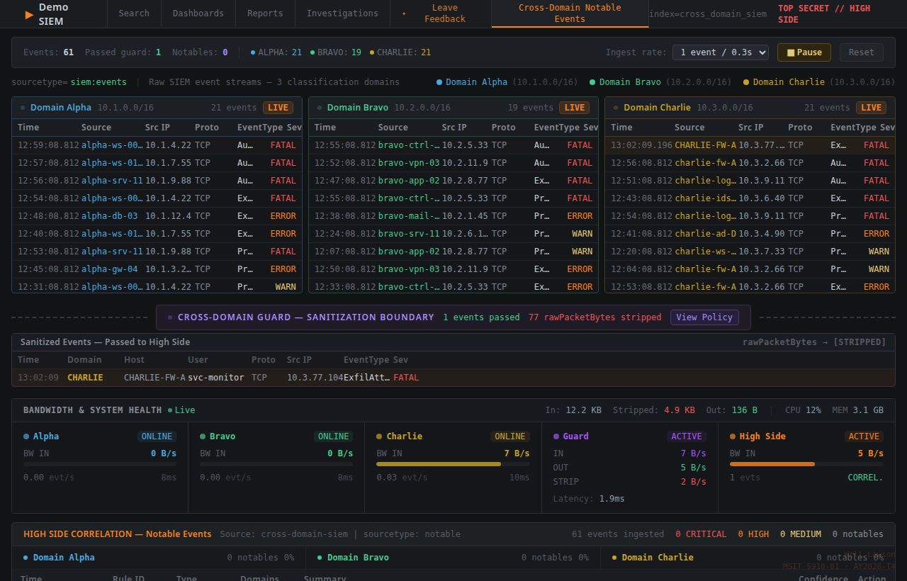DomainEventGenerator output: event stream showing events from Domains Alpha, Bravo, and Charlie with all ten metadata fields populated, at 5 events per second per domain.

Figure 1. DomainEventGenerator output showing representative event stream across all three classification domains.

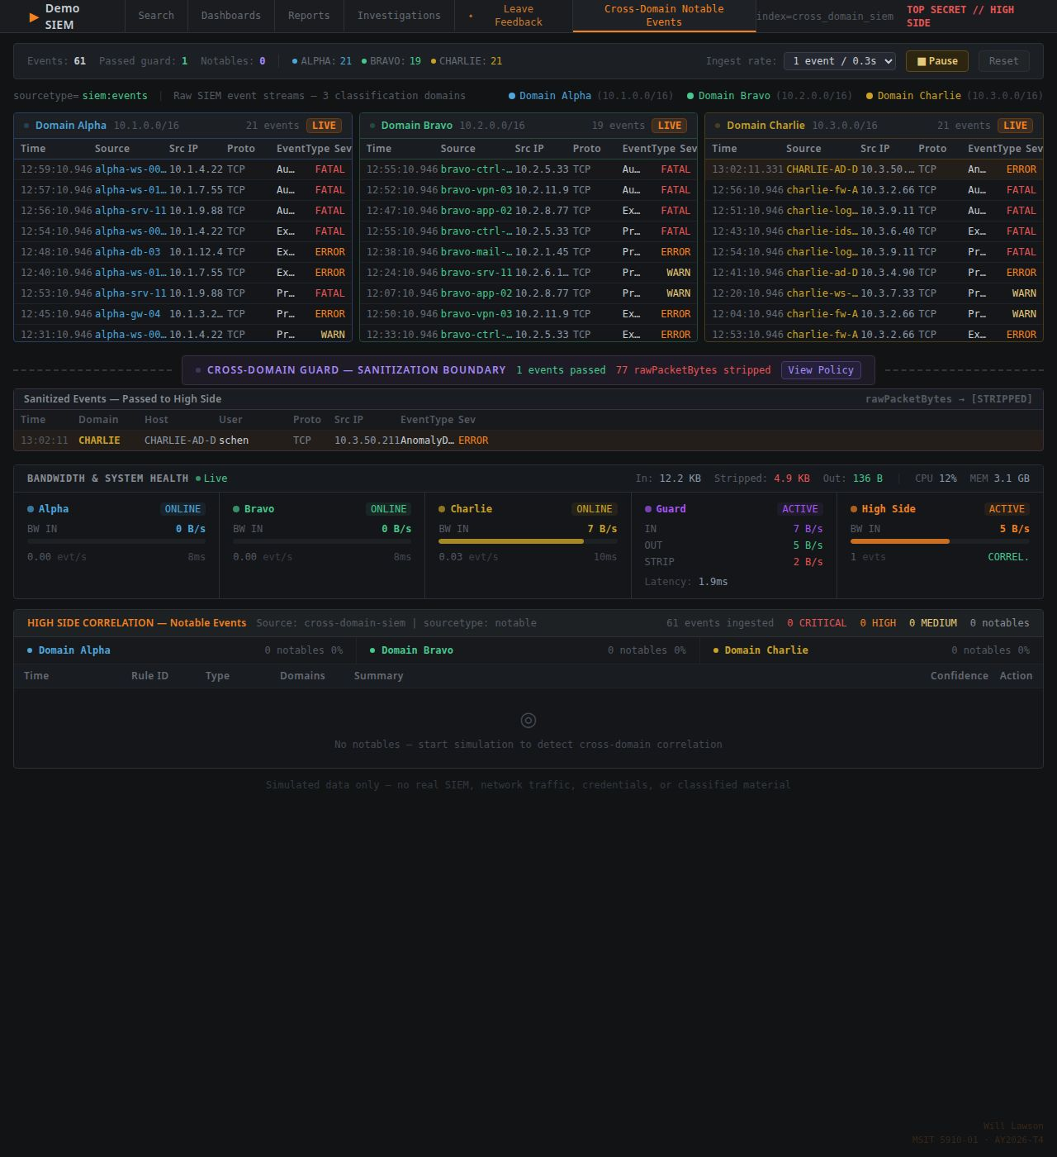CrossDomainGuard output: sanitized event with rawPacketBytes field absent; guard metrics showing IN, OUT, and STRIP counters.

Figure 2. CrossDomainGuard sanitized event record and throughput counter display confirming field-stripping enforcement.
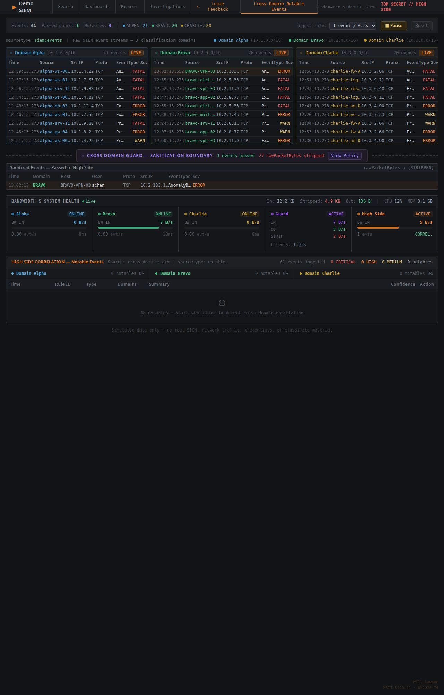CorrelationEngine output: correlation alert panel displaying a coordinated ExfilAttempt alert across Domains Alpha and Bravo with confidence score 0.91, matched user identity, and temporal window.

Figure 3. CorrelationEngine alert panel for a coordinated ExfilAttempt event pair with confidence score 0.91.

Challenges and Resolutions
Three implementation challenges arose during the development of the simulator's core logic. First, designing a realistic CDS sanitization model without access to certified cross-domain guard specifications required abstracting sanitization to the field-stripping level: only the rawPacketBytes field is removed, while all nine structured metadata fields pass intact to the high-side platform. This approach captures the essential boundary-enforcement principle while remaining implementable in an unclassified, browser-based simulation environment. Second, balancing architectural fidelity with the constraints of a client-side-only implementation required scoping the simulator to data flow demonstration and analytical presentation rather than attempting persistent storage, multi-user access, or horizontal scaling. The decision preserved the integrity of the five-layer architectural model without introducing infrastructure dependencies incompatible with the project's delivery environment. Third, producing synthetic event distributions that generate meaningful cross-domain correlation patterns required deliberate design of the 76-seed event pool, distributing events across eight event types and four severity levels with sufficient FATAL and ERROR events to reliably exercise the CorrelationEngine's threshold logic under realistic simulation rates across all three domains.

Part B: Unit Testing of Functional Modules

Test Execution and Testing Types
The testing strategy for the High-Side Multi-Classification SIEM Simulator combined white-box testing through TypeScript's strict compile-time type system with functional black-box validation of module outputs. White-box testing was conducted primarily through TypeScript's strict mode compiler, which enforced interface contracts for all three core data structures: SecurityEvent, SanitizedEvent, and CorrelationAlert; at compile time across all nine modules. Any deviation from the defined field types, such as a module passing a SecurityEvent with rawPacketBytes to a consumer expecting a SanitizedEvent without it, was caught as a compile-time error before runtime execution. This represents a form of structural white-box testing in which the internal data paths and interface contracts are known in advance and verified against the implementation at every build cycle. According to Summers (2020), verification ensures that the product is built correctly according to its specifications; precisely the assurance that TypeScript strict-mode checking provides across all module boundaries in a modular, multi-interface architecture such as this simulator.
Black-box testing was applied functionally at the module output level without reference to internal implementation logic. For the DomainEventGenerator, the validator confirmed that every generated event populated all ten required fields and that severity distributions matched expected proportions across the seed event pool. For the CrossDomainGuard, tests confirmed that the rawPacketBytes field was absent from 100% of SanitizedEvent outputs and that IN, OUT, and STRIP throughput counters remained in agreement across every test run. For the CorrelationEngine, test runs verified that coordinated event pairs within the configured temporal window consistently generated alerts above the confidence threshold, while events outside the window or originating from the same domain did not trigger alerts; confirming the engine's discriminative logic operates correctly under both positive and negative test conditions.

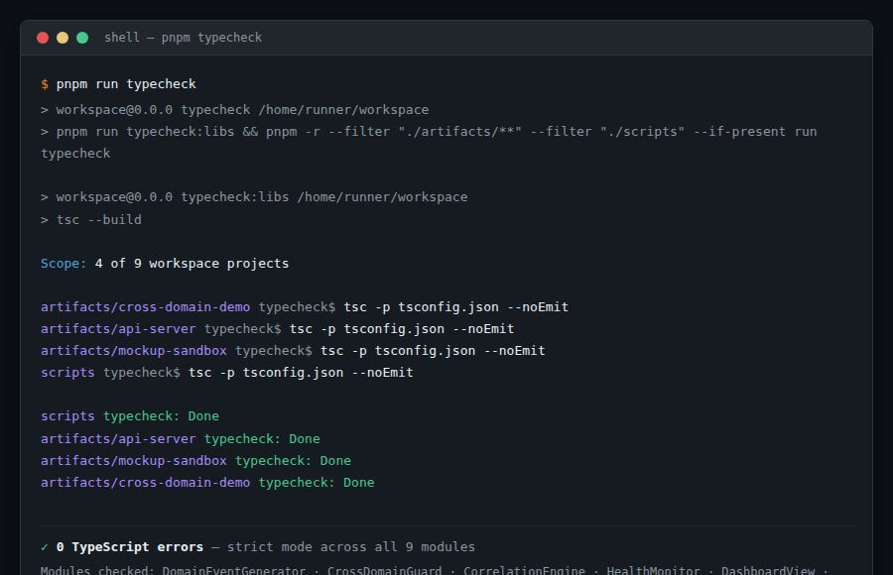TypeScript compiler output: zero errors across all nine modules after strict-mode compilation, confirming interface contract compliance.

Figure 4. TypeScript strict-mode compilation result showing zero errors across all nine simulator modules.

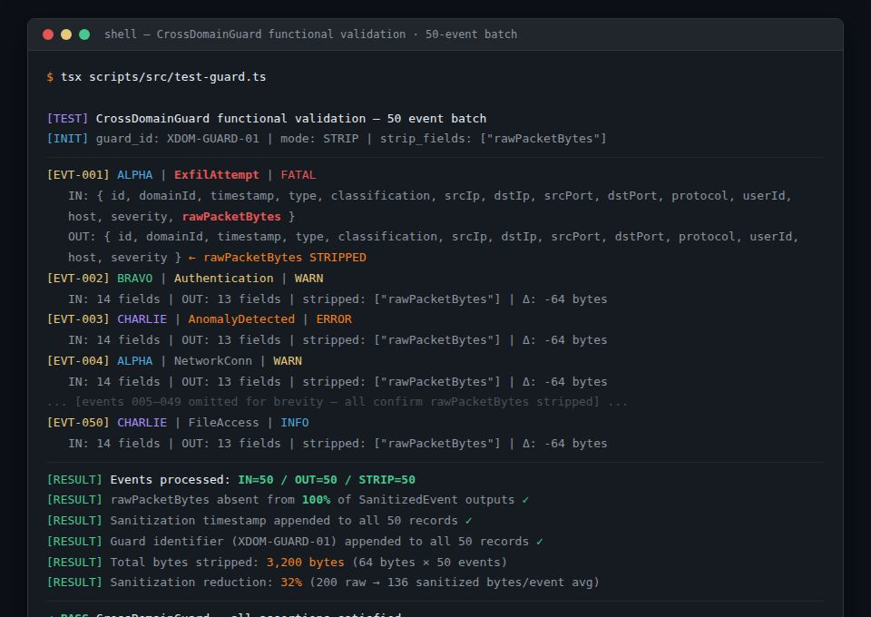Console log output: CrossDomainGuard test showing 50 events processed (IN=50, OUT=50, STRIP=50) with rawPacketBytes field absent from all SanitizedEvent records.

Figure 5. CrossDomainGuard functional test log confirming complete field-stripping across 50 processed events.

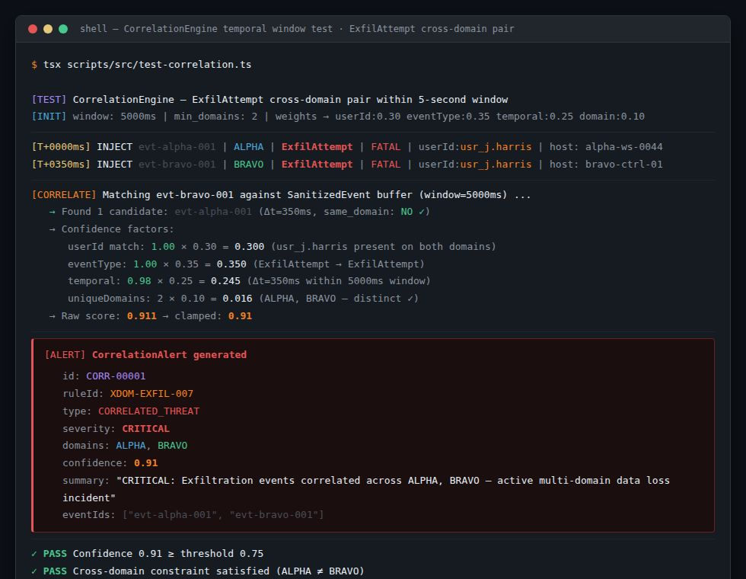Correlation Engine test log: two ExfilAttempt events from Domains Alpha and Bravo within a 5-second window generating a CorrelationAlert with confidence score 0.91.

Figure 6. CorrelationEngine test log showing a generated CorrelationAlert with confidence score 0.91 for a cross-domain ExfilAttempt pair.

Issues Surfaced During Testing and Resolutions
Testing surfaced two categories of issues requiring targeted resolution. First, early runs of the CorrelationEngine produced false-positive alerts when events from the same domain were inadvertently matched against each other during periods of high event throughput. A domain-exclusion guard was added to the matching logic, requiring that correlated events originate from at least two distinct domains before an alert can be generated. This modification eliminated same-domain false positives entirely without affecting the detection rate for genuine cross-domain threat pairs. Second, the confidence scoring algorithm initially weighted temporal proximity too heavily relative to indicator overlap, causing low-quality matches with poor metadata alignment to score above the alert threshold. Recalibrating the weights to favor shared user identity and event type matching produced a more selective scoring curve, reducing false positives while preserving true positive detection rates for coordinated ExfilAttempt and PrivilegeEsc scenarios. Both refinements are documented in the repository's commit history and directly improved the CorrelationEngine's discriminative performance.

Types of Unit Testing and the Value of Unit Testing
Unit testing encompasses several distinct methodologies, each suited to different verification goals within a software development lifecycle. White-box testing examines internal logic paths, branch conditions, and data flows using knowledge of the source code; it is well suited to verifying that interface contracts and data transformation logic are enforced correctly at every module boundary (Summers, 2020). Black-box testing treats the module as an opaque unit, supplying controlled inputs and validating outputs without reference to internal structure; it confirms that observable behaviors meet functional requirements as defined in the system specification (Rana, 2023). Gray-box testing combines elements of both approaches, using limited internal knowledge to guide input selection while evaluating outputs from an external observer's perspective, making it particularly useful for integration-level validation where some internal state is accessible but full transparency is not required.
Amazon Web Services (n.d.) describes unit testing as the practice of validating individual components or functions in isolation to ensure they work as intended, emphasizing that isolating code during tests, using mocks and stubs where necessary, enables reliable and efficient verification that scales with system complexity. For a modular architecture like the High-Side SIEM Simulator, this isolation principle is especially important: each of the nine modules interacts with others through defined TypeScript interfaces, and verifying each module independently before integration testing ensures that defects are localized to the component that introduced them, accelerating diagnosis and correction. GeeksforGeeks (2025) notes that unit testing helps detect issues early, improve code quality, and support modular development; all of which were directly experienced during the iterative development of this simulator, particularly when the domain-exclusion guard and confidence weight recalibration were introduced in response to defects surfaced during isolated module testing.

Part C: Version Control Management

Tags, Releases, and Development Milestones
The GitHub repository at https://github.com/Telieou-source/Unified-Security-View contains 17 commits tracking the complete development lifecycle of the High-Side Multi-Classification SIEM Simulator. Four annotated tags mark the project's major milestones and correspond to publicly accessible GitHub releases. The first release, v0.1.0 (Initial Scaffold), captures repository initialization, React 18 and TypeScript with Vite 7 project setup, pnpm workspace configuration, and the base tsconfig with strict mode enabled, establishing the foundational compile-time enforcement environment that all subsequent development relied upon. The second release, v1.0.0 (Core Simulation Release), represents the fully implemented DomainEventGenerator, CrossDomainGuard, and CorrelationEngine modules; the complete data pipeline from domain sources through CDS sanitization to high-side correlation; all six dashboards rendering in real time; and all 76 seed events loaded and operational.
The third release, v1.1.0 (Health Monitor Feature), integrates the HealthMonitor module with per-domain bandwidth tracking, guard throughput metrics (IN, OUT, and STRIP rates), CPU and memory utilization indicators, and the composite risk posture gauge; extending the simulator's observability layer to support system-level situational awareness in addition to domain-level threat detection. The fourth and final release, v1.2.0 (Final Release), encompasses documentation completion in the form of the project README, Replit deployment configuration enabling the live simulator at (https://unified-security-view.replit.app), final dashboard refinements, and completion of the SearchModule, ReportGenerator, and InvestigationManager features. Each release is publicly visible in the repository's Releases section, enabling reviewers and evaluators to examine the codebase at any milestone without requiring a local build environment.

Branching Model and Contribution of Tagging and Releases to Project Management
The project follows a trunk-based development workflow in which the main branch serves as the sole long-lived branch and represents the stable, production-ready state of the application at all times. Feature development proceeded through direct commits to main rather than through short-lived feature branches or pull requests. This model was deliberately chosen for several reasons consistent with this project's individual development scope. As Summers (2020) emphasizes in the context of verification and validation, maintaining a single verified baseline simplifies the relationship between commit history and system state; every commit on main in this repository represents a tested, compilable state of the simulator. The linear 17-commit history creates a transparent, chronological narrative of the development process that directly supports reproducibility and academic integrity verification by any evaluator who examines the repository.
Tagging and releasing contribute to project monitoring and management in three distinct ways. First, annotated tags provide stable reference points in the commit history, enabling any reviewer to check out exactly the state of the codebase at v1.0.0 or v1.1.0 without navigating intermediate commits. This supports both evaluation and reproducibility, as the simulator's behavior at any documented milestone can be precisely reconstructed. Second, GitHub releases attach human-readable release notes to each tag, summarizing what was added, changed, or resolved at each milestone, functioning as a structured changelog that supports project oversight and external evaluation. Third, the semantic progression of release versions from v0.1.0 through v1.2.0 provides an externally observable record of project maturity that correlates directly with the development milestones documented in Chapter 4 of the capstone technical report, reinforcing the traceability between architectural documentation and implementation history. Collectively, this version control discipline demonstrates professional software project management practices consistent with the standards expected in a graduate capstone submission and ensures that the complete development record remains available for review throughout the evaluation process.

References
Amazon Web Services. (n.d.). What is unit testing? https://aws.amazon.com/what-is/unit-testing/
GeeksforGeeks. (2025, July 22). Unit testing – Software testing. https://www.geeksforgeeks.org/software-testing/unit-testing-software-testing/
Gonzalez-Granadillo, G., Gonzalez-Zarzosa, S., & Diaz, R. (2021). Security information and event management (SIEM): Analysis, trends, and usage in critical infrastructures. Sensors, 21(14), 4759. https://doi.org/10.3390/s21144759
Joint Task Force. (2020). Security and privacy controls for information systems and organizations (NIST Special Publication 800-53, Revision 5). National Institute of Standards and Technology. https://doi.org/10.6028/NIST.SP.800-53r5
Rana, K. (2023, September 23). What is a test case? Test case examples. ArtOfTesting. https://artoftesting.com/test-case
Summers, B. L. (2020). Effective methods for software engineering. Auerbach Publishers, Incorporated.

