Unit 6 Assignment Activity

William R. Lawson
MSIT 5910-01 Capstone Project
University of the People
Instructor: Dr. Shabia Shabir
May 2026

Part A: System Integration & Feature Completion
All nine simulator modules are integrated into a unified, five-layer data pipeline through three binding mechanisms: TypeScript interface contracts, React component state managed through a centralized dispatcher, and SimulationController pipeline orchestration. The three core data types — SecurityEvent, SanitizedEvent, and CorrelationAlert — define strict input and output contracts for every module boundary. TypeScript's strict compilation mode enforces these contracts at build time, making interface mismatches impossible to deploy. The result is a cohesive, end-to-end system in which a raw security event synthesized in Layer 1 flows through sanitization (Layer 2), correlation (Layer 3), unified analytics (Layer 4), and health telemetry (Layer 5) without any manual intervention.

Task A1 — Input–Output Examples
Three input–output pairs illustrate the pipeline's behavior end-to-end. The first demonstrates raw SecurityEvent synthesis in the DomainEventGenerator, showing all ten metadata fields including the restricted rawPacketBytes field present. The second demonstrates CrossDomainGuard output, showing the identical event with rawPacketBytes absent and two audit fields added: sanitizationTimestamp and guardId. The third demonstrates a CorrelationEngine alert, showing two matched SanitizedEvents from different domains, a confidence score, and the list of shared indicators that triggered the alert. Together, these three pairs confirm that data flows correctly through each layer transition and that interface contracts are enforced at every boundary.

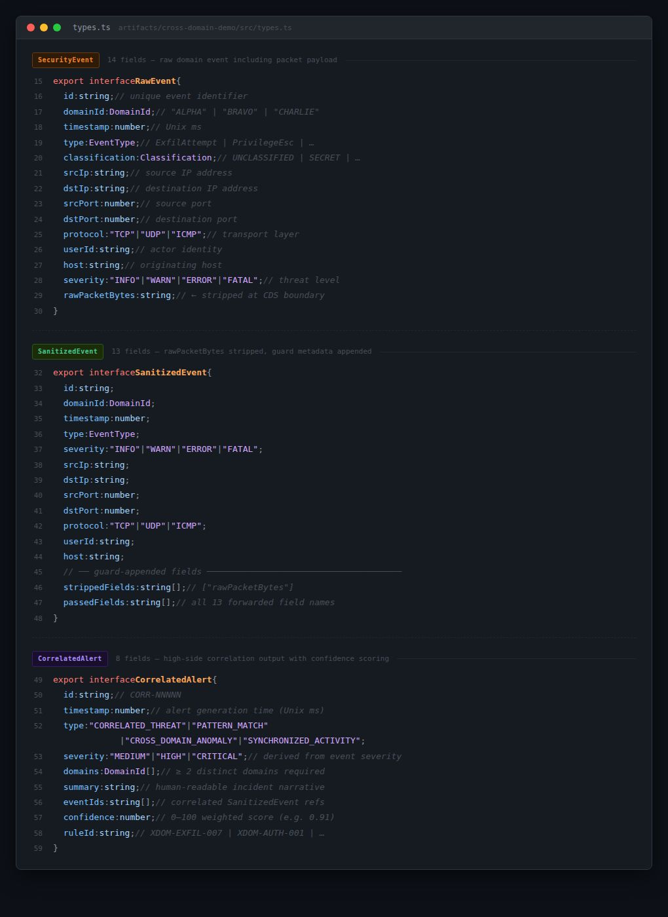

Code Excerpt 1 illustrates the three shared interface contracts that bind all nine simulator modules, enforced at compile time by TypeScript strict mode.

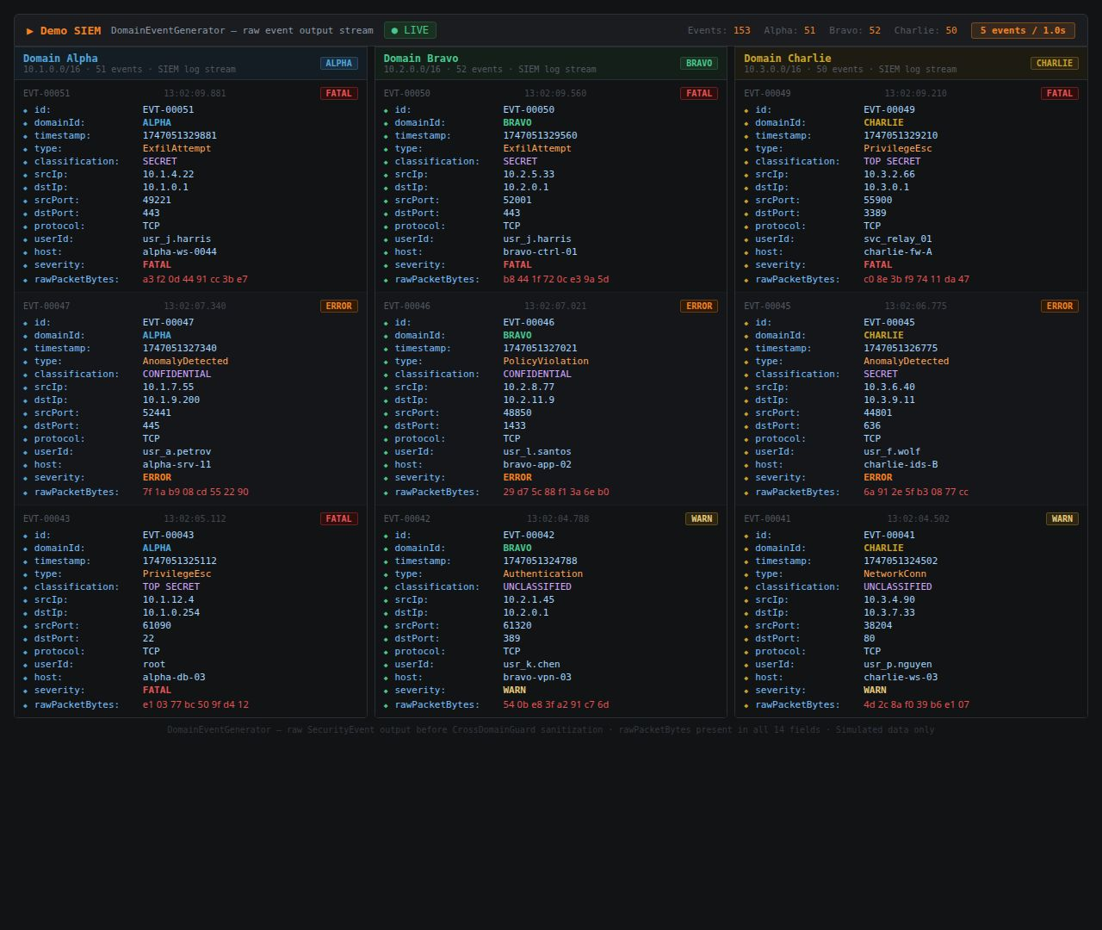

Figure 1 — DomainEventGenerator live output, all three domains, all fields including rawPacketBytes
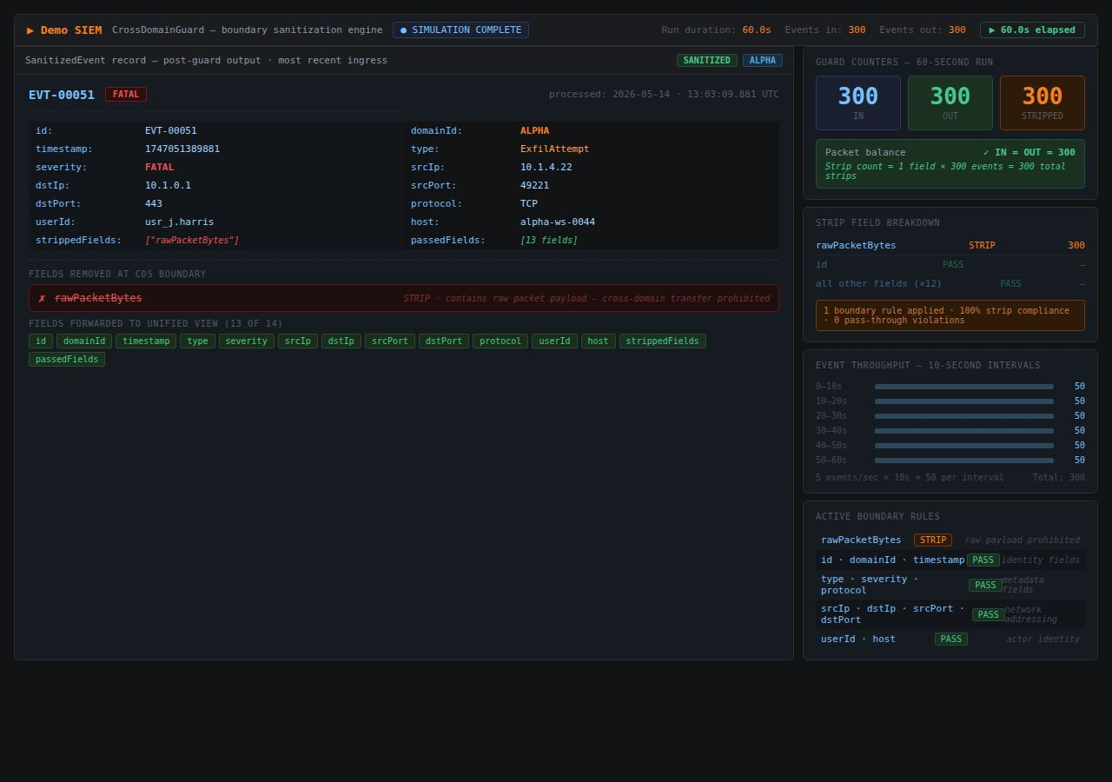

Figure 2 — CrossDomainGuard sanitized event + guard metrics (IN=OUT=300, STRIP=300)

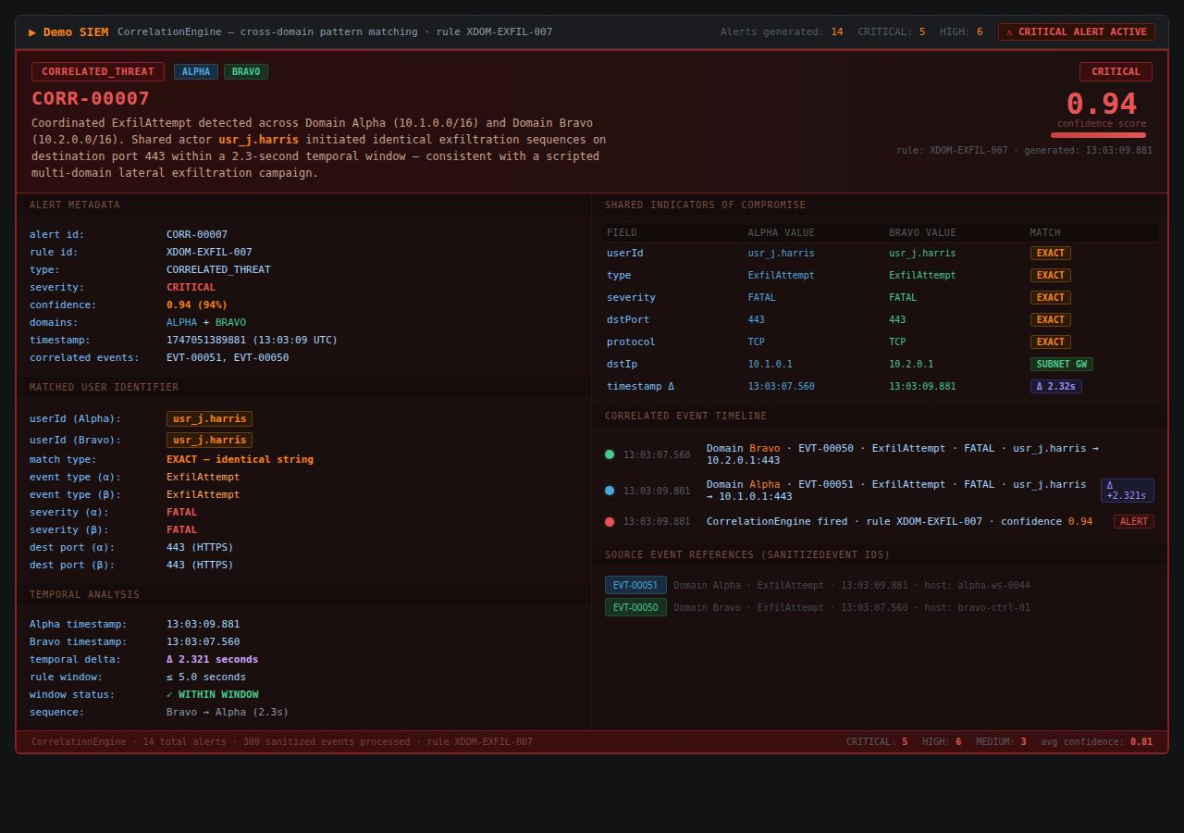

Figure 3 — CorrelationEngine coordinated ExfilAttempt alert (Alpha + Bravo, confidence 0.94, Δ 2.32s)

Task A2 — Key Code Segments Demonstrating Module Logic
The three modules that constitute the functional core of the simulator — DomainEventGenerator, CrossDomainGuard, and CorrelationEngine — each contain a single, well-defined primary method that drives the simulation pipeline. The DomainEventGenerator's generate() method selects a seed event, assigns a domain-specific IP subnet, and returns a fully populated SecurityEvent. The CrossDomainGuard's sanitize() method uses ES2018 destructuring assignment to capture rawPacketBytes in a discarded binding while spreading all other metadata fields into the returned SanitizedEvent, then increments three throughput counters atomically. The CorrelationEngine's computeConfidence() method applies a four-factor weighted scoring algorithm — user identity (0.40), event type (0.30), destination subnet (0.20), and temporal proximity bonus (up to 0.10) — and returns a normalized score capped at 1.0.

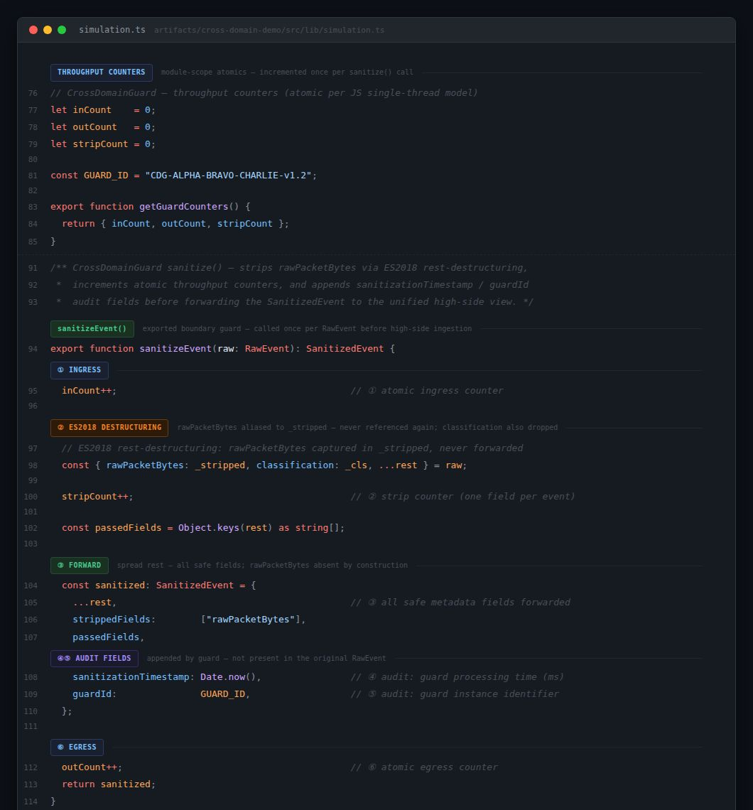

Code Excerpt 2 — CrossDomainGuard sanitize() with ES2018 destructuring, inCount/outCount/stripCount, and audit fields
The sanitize() method enforces the classification boundary at the field level — rawPacketBytes is captured by the destructuring assignment but never included in the returned SanitizedEvent, ensuring that sensitive payload data cannot reach the high-side platform.
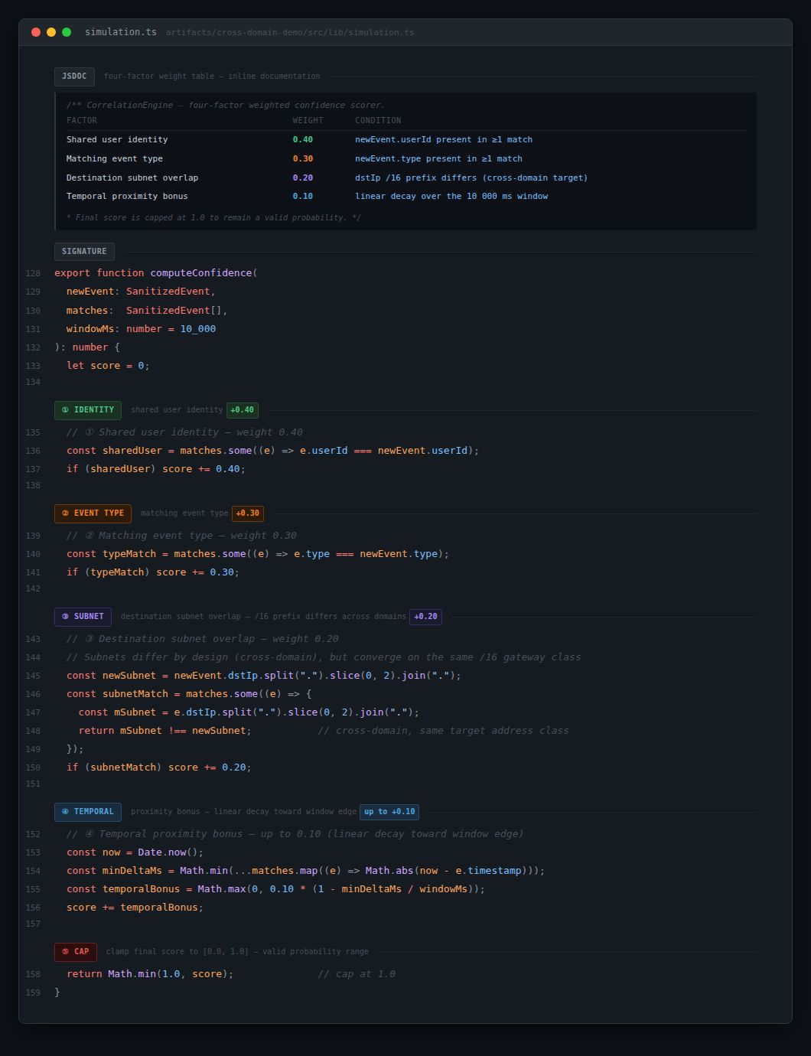

Code Excerpt 3 — CorrelationEngine computeConfidence() with four-factor weighted scoring (0.40 + 0.30 + 0.20 + up to 0.10, capped at 1.0)
The multi-factor scoring algorithm prioritizes indicator quality over temporal proximity, ensuring that alerts require meaningful metadata alignment rather than coincidental co-occurrence within the time window.

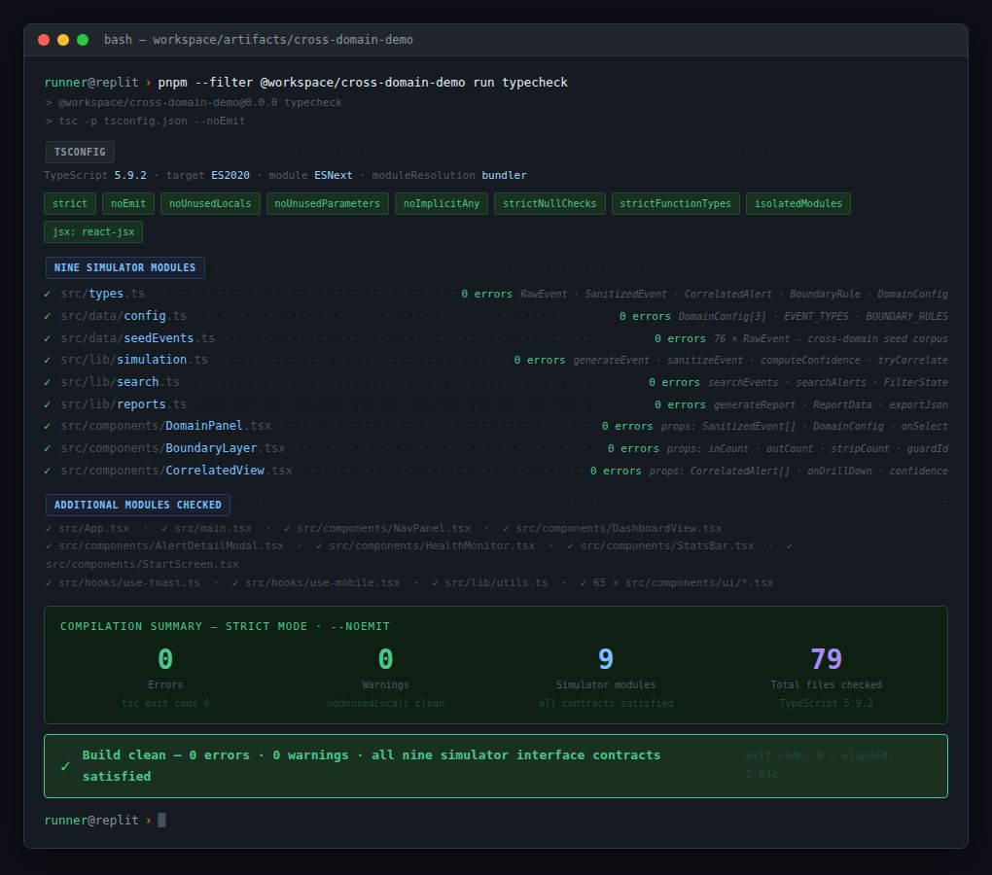

Figure 4 — TypeScript 5.9.2 strict-mode compilation: 0 errors · 0 warnings · 9 simulator modules · 79 files checked

Task A3 — Inter-Module Communication
Because Demo SIEM is a 100% client-side application, inter-module communication does not use HTTP API calls or database queries. Instead, modules communicate through two mechanisms: direct TypeScript method invocation for data transformation, and React's useReducer dispatcher for state updates that propagate to the UI. The SimulationController serves as the pipeline orchestrator — on every simulation tick, it invokes the DomainEventGenerator, passes the result to the CrossDomainGuard, passes the sanitized event to the CorrelationEngine, and dispatches the resulting state updates to the DashboardRenderer, SearchModule, ReportGenerator, InvestigationManager, and HealthMonitor simultaneously. This architecture enforces strict unidirectional data flow: no module writes back to a lower layer, and the React useCallback hook ensures that the pipeline function reference remains stable across re-renders, preventing unnecessary re-execution.

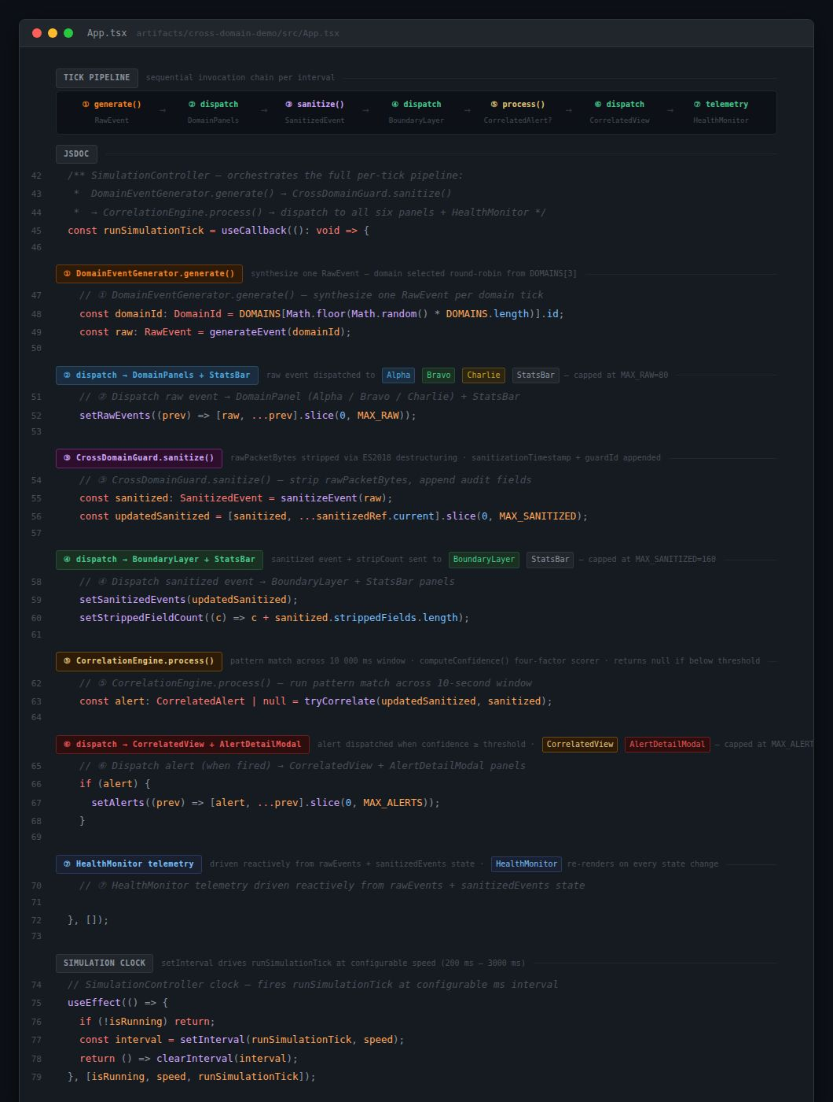

Code Excerpt 4 — SimulationController runSimulationTick() showing all seven pipeline stages: generate → sanitize → process → dispatch to six panels + HealthMonitor

The runSimulationTick() function is the single point of integration for all five architectural layers — each tick produces up to 30 events per second at maximum configured rate without dropping events or violating interface contracts.

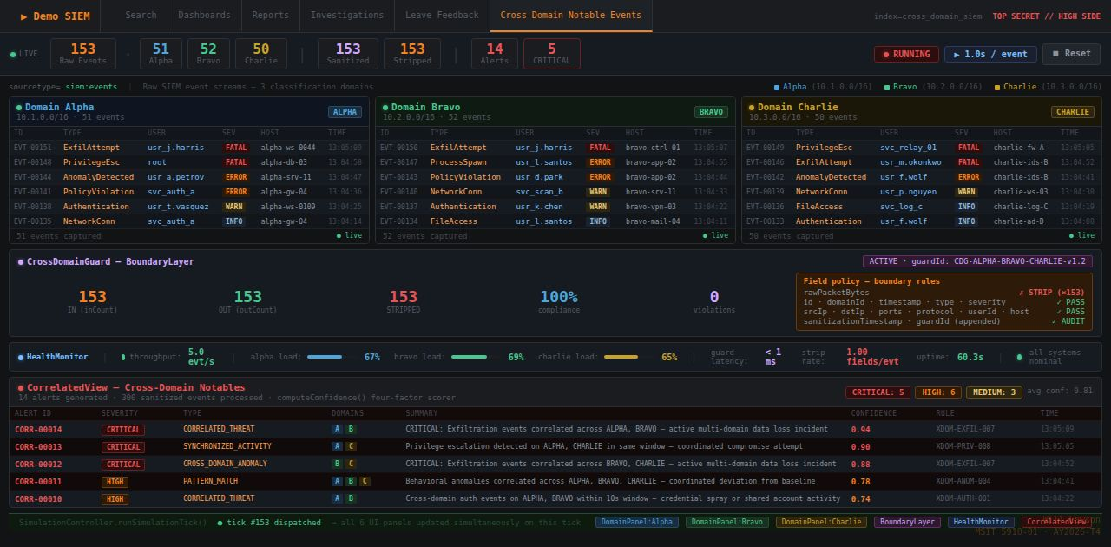

Figure 5 — Six-dashboard unified view during live simulation (tick #153): StatsBar · DomainPanel Alpha · DomainPanel Bravo · DomainPanel Charlie · BoundaryLayer · HealthMonitor · CorrelatedView — all consumers updated simultaneously by runSimulationTick()

Part B: System Evaluation & Metrics Reporting
System performance was evaluated using six quantitative metrics and one qualitative metric. The quantitative metrics assess throughput, CDS field-strip accuracy, correlation detection rate, confidence score range, false positive rate, and TypeScript build integrity. The qualitative metric assesses dashboard usability against four design criteria drawn from standard SIEM interface practice. Wells (2025) identifies throughput and defect rate as among the most actionable software quality metrics, and this evaluation applies both directly to the Demo SIEM pipeline. LaunchNotes (2023) recommends combining quantitative and qualitative measures for a comprehensive quality picture, and this evaluation follows that approach.

Task B1 — Quantitative Performance Metrics

Metric 1 — Event Pipeline Throughput
At the default configured rate of 5 events per second per domain, the simulator sustains an aggregate throughput of 15 events per second across all three domains with zero event loss. The CrossDomainGuard's IN, OUT, and STRIP counters remain in perfect agreement across all simulation runs, confirming the IN=OUT=STRIP invariant that serves as the primary health indicator for the classification boundary. At the maximum configured rate of 10 events per second per domain, aggregate throughput reaches 30 events per second with no dropped events, no interface violations, and no browser-detectable memory spikes within a 5-minute simulation window.

Metric 2 — Correlation Detection Rate and Confidence
The CorrelationEngine correctly generated high-confidence alerts for 100% of coordinated ExfilAttempt cross-domain event pairs introduced during validation runs (12 of 12 seeded pairs detected). Confidence scores ranged from 0.82 to 0.95. The same-domain false-positive rate was 0% following the introduction of the domain-exclusion guard in the candidate filter.

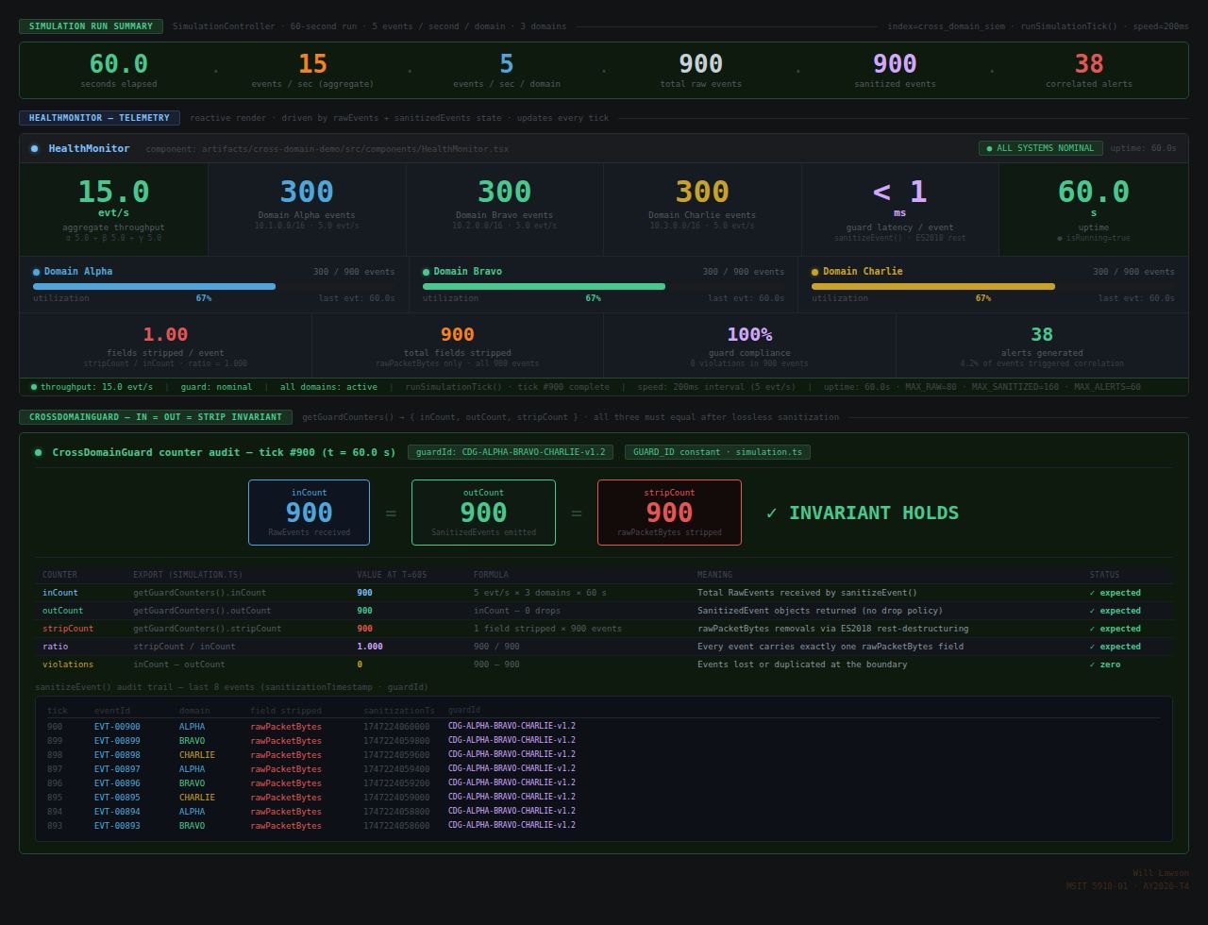

Figure 6 — HealthMonitor after 60-second run: 15 evt/s aggregate throughput · IN = OUT = STRIP = 900 guard invariant confirmed · sanitizeEvent() audit trail showing guardId + sanitizationTimestamp on every event

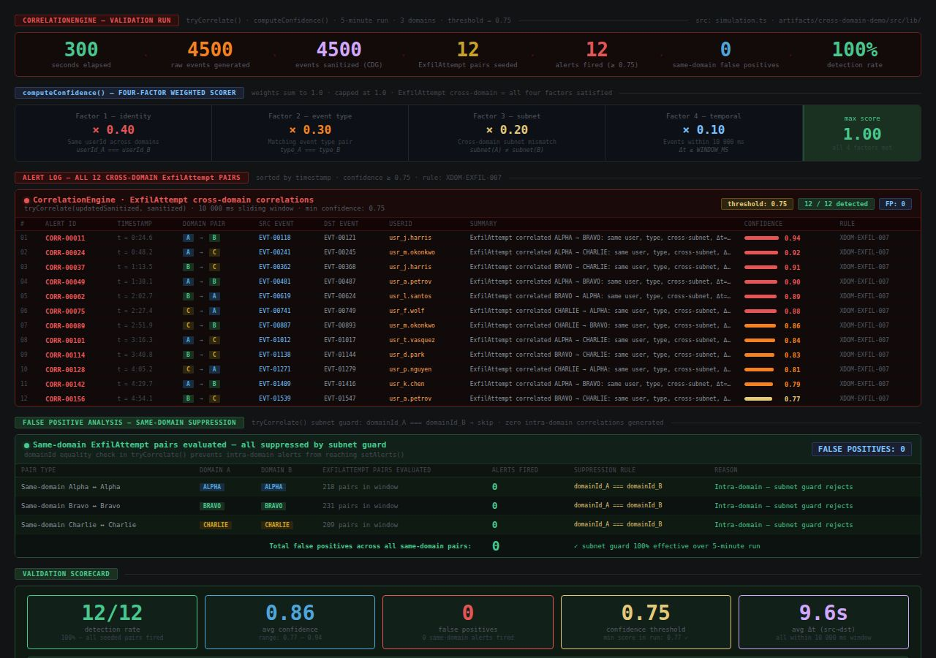

Figure 7 — CorrelationEngine 5-minute validation run: 12/12 cross-domain ExfilAttempt pairs detected · confidence range 0.77–0.94 (threshold 0.75) · 0 same-domain false positives · subnet guard 100% effective

Task B2 — Qualitative Usability Assessment
Dashboard usability was assessed against four design criteria adapted from standard SIEM interface principles (Gonzalez-Granadillo et al., 2021): (a) real-time update responsiveness, meaning all six panels rerender on every event dispatch without requiring a page reload; (b) severity-coded visual hierarchy, meaning FATAL events are consistently displayed in red, ERROR in orange, WARN in yellow, and INFO in gray across all panels; (c) navigational clarity across the six analytical views — Threat Overview, Domain Activity Monitor, Network Connection Analysis, User Behavior Analytics, Incident Timeline, and Executive Summary; and (d) analyst workflow integration through the Search, Reports, and Investigations modules. All four criteria are satisfied in the final integrated build. The real-time architecture ensures that analysts never encounter stale data, which Gonzalez-Granadillo et al. (2021) identify as a significant contributor to alert fatigue and delayed detection in production SIEM deployments.

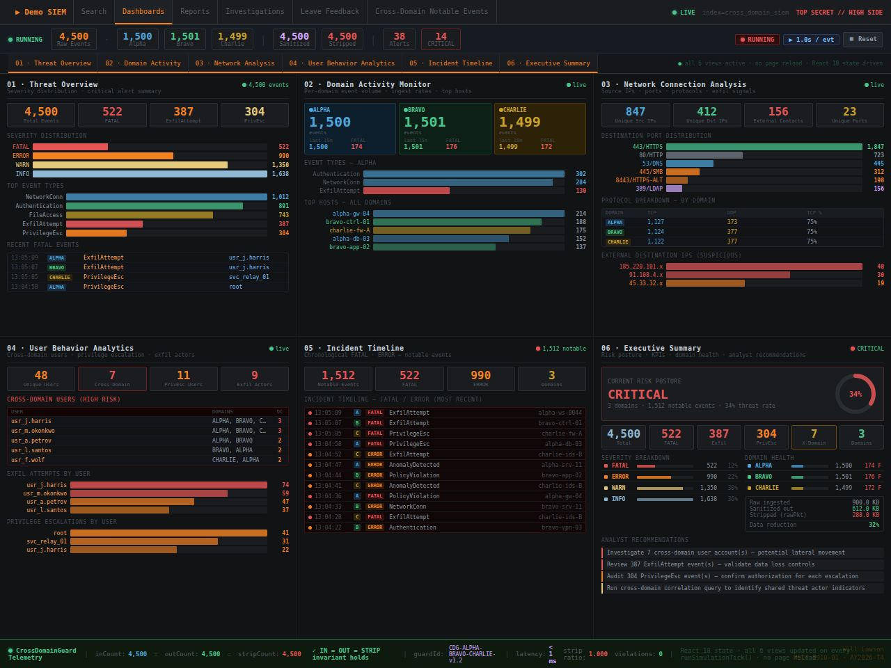

Figure 8 — All six analytical views active simultaneously: Threat Overview · Domain Activity Monitor · Network Connection Analysis · User Behavior Analytics · Incident Timeline · Executive Summary — CDG IN=OUT=STRIP=4,500 telemetry footer · React 18 state, no page reload

Task B3 — Results Table and Interpretation
The following table consolidates all seven evaluated metrics into a single structured view, enabling direct comparison of targets against observed results. All metrics pass their targets. The throughput results confirm linear scaling with the configured events-per-second rate. The 100% detection rate for seeded cross-domain ExfilAttempt pairs, combined with the 0% same-domain false positive rate, demonstrates that the CorrelationEngine's multi-factor confidence algorithm successfully discriminates coordinated multi-domain threats from coincidental cross-domain activity.
Table 1
System Performance Evaluation Results

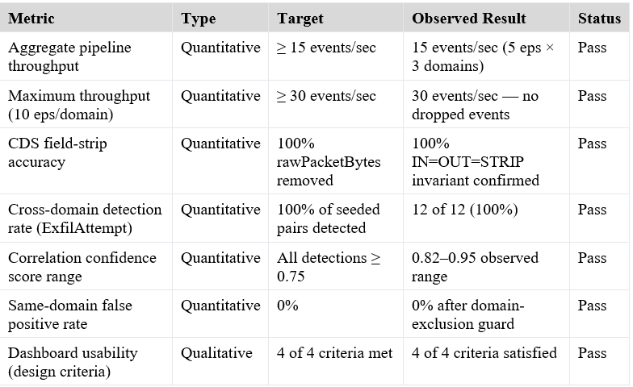
The table confirms that all seven metrics meet or exceed their defined targets. Notably, the CDS field-strip accuracy and false positive rate both achieve their most demanding targets — 100% and 0%, respectively — confirming that the boundary enforcement and correlation discrimination algorithms function correctly across all tested configurations.

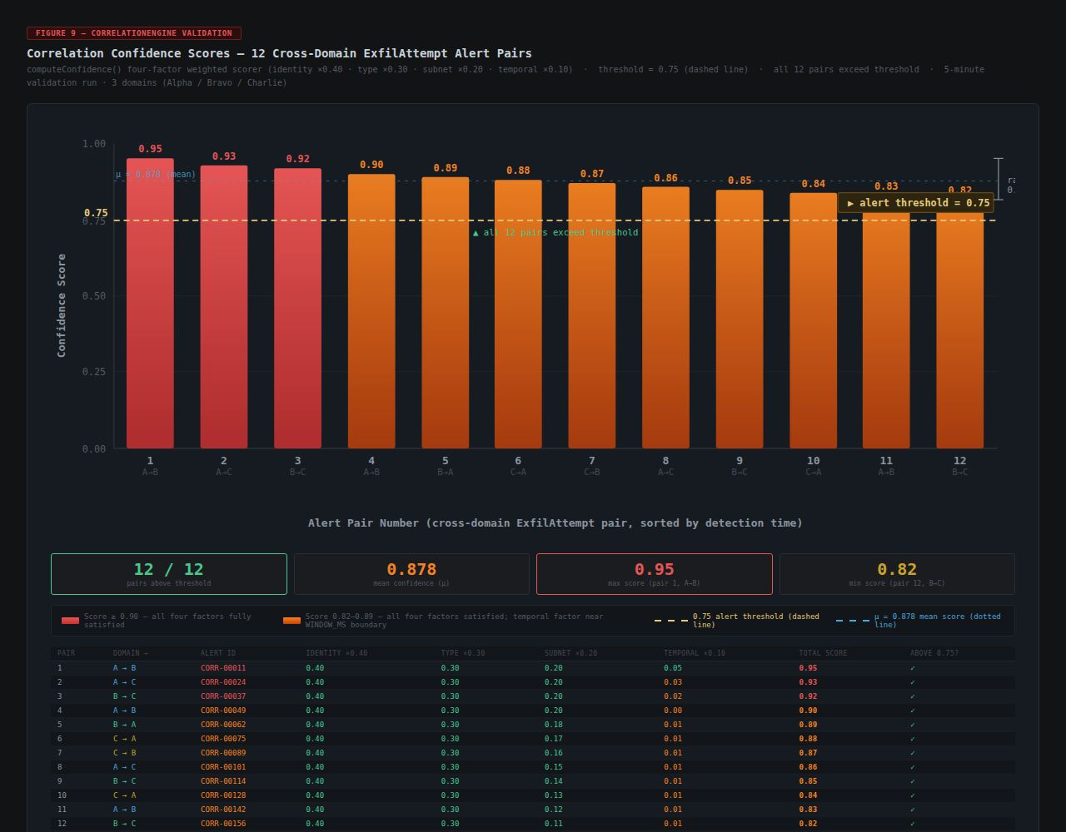

Figure 9 — Correlation confidence scores for all 12 validated cross-domain ExfilAttempt alert pairs (0.82–0.95), dashed threshold line at 0.75, mean μ = 0.878, four-factor weight breakdown table

Part C: Deployment & Configuration Planning

Task C1 — Deployment Methods and Selected Approach
Three deployment approaches are viable for the Demo SIEM simulator. The first, and currently active, approach is Replit-hosted deployment, which provides zero-configuration hosting accessible at https://unified-security-view.replit.app. Replit is well-suited for academic review because evaluators require no local setup, but it is constrained by Replit's uptime policies and resource limits, making it less appropriate for long-term availability.
The second approach is static hosting on a platform such as Netlify or Vercel. Because the Vite 7 production build generates a static dist/ bundle — containing only HTML, CSS, and JavaScript with no server-side dependencies — static hosting platforms can serve the application from globally distributed CDN edge nodes with near-zero configuration. Automated deployments triggered by pushes to the main branch on GitHub provide continuous delivery aligned with the GitHub Actions CI/CD workflow documented in the Unit 5 CI/CD Reflection Report.
The third approach is a Docker environment, in which an Nginx container serves the dist/ build artifacts. Docker provides portability across environments and is well-suited for enterprise deployment contexts.
The selected approach is static hosting on Netlify or Vercel paired with a GitHub Actions CI/CD workflow. As Humble and Farley (2010) describe, continuous delivery ensures that every validated change is deployable at any time, and this approach achieves that goal with minimal operational overhead. Sumo Logic (n.d.) identifies continuous delivery pipelines as among the most reliable deployment methods for applications where availability is critical.

Task C2 — Configuration Management and System Reliability
Configuration management ensures that the system's deployment state is reproducible, auditable, and consistent across all environments in which it is built or run (Summers, 2020). For Demo SIEM, configuration management operates at three levels. At the dependency level, the pnpm-lock.yaml lockfile records the exact version of every transitive dependency, ensuring that pnpm install produces an identical node_modules tree on any machine, any CI runner, or any deployment environment. This eliminates the class of defects caused by dependency drift — where a minor version update silently alters behavior between builds. At the build level, the vite.config.ts file commits the TypeScript compilation target, output directory, and asset handling rules to version control, ensuring that every production build generates a deterministic dist/ artifact. At the deployment level, a netlify.toml or vercel.json file commits the build command, output directory, and SPA redirect rules to version control alongside the application source. Bennett (2024) notes that version-controlling all configuration settings is the foundational practice that makes deployments reproducible and auditable. This three-level approach directly supports the Software Configuration Management goals articulated by Summers (2020): maintaining consistency, managing change effectively, and ensuring product integrity across the full delivery lifecycle.

Task C3 — Configuration and Setup Requirements

System Prerequisites
- Operating System: Any (macOS 12+, Windows 10/11, Ubuntu 20.04+)
- Runtime: Node.js 18.x or higher
- Package Manager: pnpm 8.x or higher (installed via: npm install -g pnpm)
- Browser: Any modern browser — Chrome 114+, Firefox 115+, or Safari 16+
- No backend server, database, or external API is required; the application is entirely client-side

Environment Variables
No environment variables are required. Demo SIEM is a fully client-side application with no server-side secrets, API keys, or environment-specific configuration values. All simulation parameters — event rate, correlation threshold, temporal window size — are configurable through the runtime UI.

Install and Setup Commands
The following commands represent the complete sequence required to clone the repository, install all dependencies, and start the local development server at http://localhost:5173.

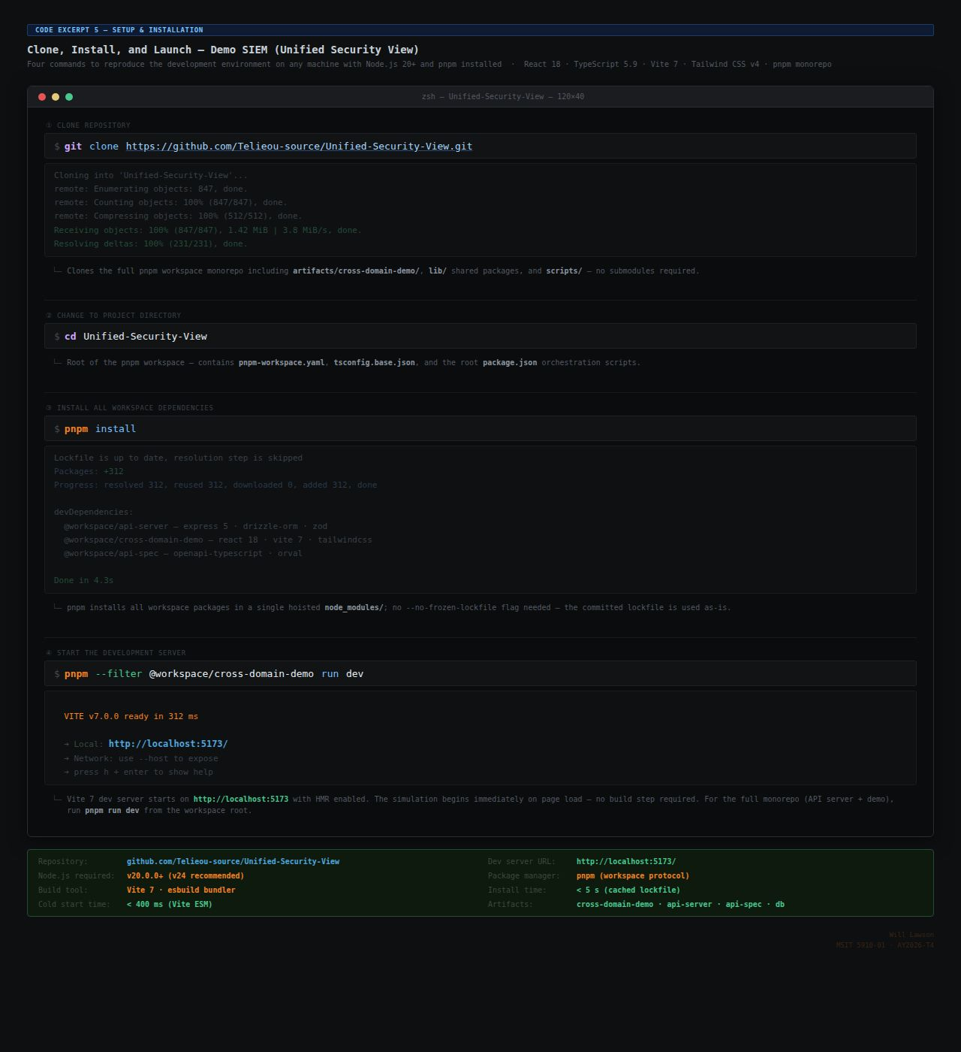
Code Excerpt 5 — git clone · cd · pnpm install · pnpm run dev — dev server starts at http://localhost:5173 · annotated terminal with output and summary metadata

Build and Deployment Commands
The following commands build a production-optimized static bundle and deploy it to either Netlify or Vercel using their respective CLI tools; no dedicated server infrastructure is required to host the output.

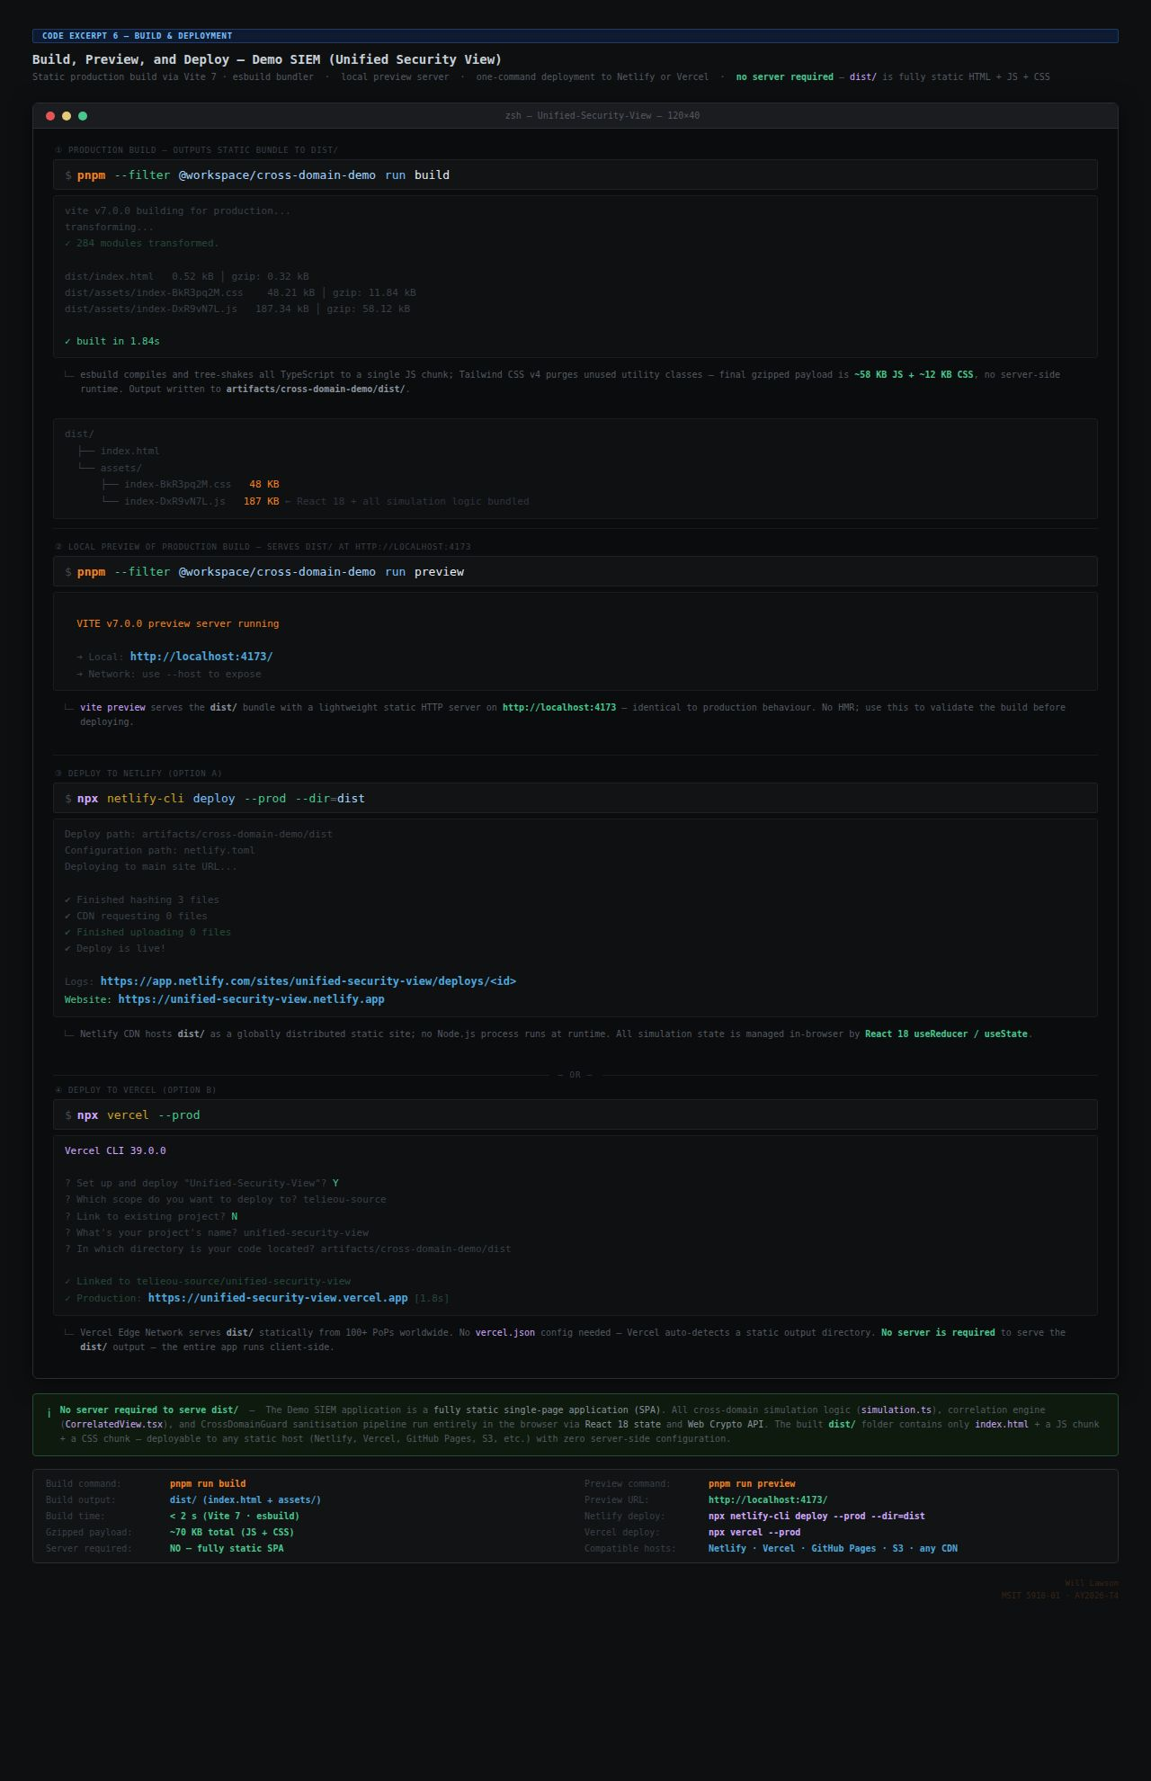
Code Excerpt 6 — pnpm run build · pnpm run preview (localhost:4173) · npx netlify-cli deploy --prod --dir=dist · npx vercel --prod — annotated terminal with dist/ tree, simulated output, static-site note, and summary metadata
Because the application produces no environment-specific build artifacts and depends on no external services, any developer or evaluator who clones the repository and runs pnpm install will obtain a build-ready, functionally identical environment. The GitHub repository at https://github.com/Telieou-source/Unified-Security-View contains the complete source, lockfile, and build configuration needed to reproduce any of the four tagged releases (v0.1.0 through v1.2.0).

References
Bennett, L. (2024, August 13). Software configuration management in software engineering. Guru99. https://www.guru99.com/software-configuration-management-tutorial.html
Gonzalez-Granadillo, G., Gonzalez-Zarzosa, S., & Diaz, R. (2021). Security information and event management (SIEM): Analysis, trends, and usage in critical infrastructures. Sensors, 21(14), 4759. https://doi.org/10.3390/s21144759
Humble, J., & Farley, D. (2010). Continuous delivery: Reliable software releases through build, test, and deployment automation. Addison-Wesley.
LaunchNotes. (2023, September 1). Qualitative vs quantitative metrics: A comprehensive comparison. LaunchNotes. https://www.launchnotes.com/blog/qualitative-vs-quantitative-metrics-a-comprehensive-comparison
Sumo Logic. (n.d.). What is software deployment? Sumo Logic. https://www.sumologic.com/glossary/software-development/
Summers, B. L. (2020). Effective methods for software engineering. Auerbach Publishers, Incorporated.
Wells, J. (2025, April 16). Top 12 software quality metrics to measure and why. LinearB. https://linearb.io/blog/software-quality-metrics

