High-Side Multi-Classification SIEM:
A Conceptual Architecture for Unified Cross-Domain Security Event Correlation
A Capstone Project Report of MSIT 5910
Submitted by:
Will Lawson c2147384
For the partial fulfilment of the requirements for the degree of
Master of Science in Information Technology
Supervised by:
Dr. Shabia Shabir
Department of CS & MSIT
University of the People, Pasadena, CA 91101, United States
Spring, May 2026

Abstract
Organizations operating across multiple classification domains — including those in the defense, intelligence, and critical infrastructure sectors — face significant challenges when attempting to correlate security events across isolated network enclaves. The fundamental tension between information sharing for mission effectiveness and information protection for policy enforcement creates visibility gaps that sophisticated adversaries exploit through coordinated multi-domain attack campaigns. This capstone presents a High-Side Multi-Classification Security Information and Event Management (SIEM) architecture that aggregates sanitized security metadata from multiple low-side classification domains through a Cross-Domain Solution (CDS) boundary onto a unified high-side analysis platform. A conceptual simulator, built with React 18 and TypeScript, demonstrates the architecture's core data flow, CDS sanitization logic, cross-domain correlation algorithms, and multi-dashboard analytics. The simulator validates that structured SIEM metadata can be effectively correlated across domains after CDS sanitization while maintaining information assurance boundaries. Temporal correlation with confidence scoring enables the detection of synchronized multi-domain threat patterns that would be invisible to single-domain SIEM deployments. Evaluation of the implemented simulator confirms that the CDS sanitization process is 100% accurate (IN=OUT=STRIP invariant maintained), that the correlation engine detects 100% of seeded cross-domain ExfilAttempt pairs with confidence scores of 0.82 to 0.95, and that the same-domain false positive rate is 0%. The architecture and its accompanying simulator provide a validated foundation for future development of production-grade multi-classification SIEM systems.
Keywords: SIEM, cross-domain solution, security event correlation, multi-classification, information assurance, cybersecurity architecture
iii

Acknowledgement
The author extends sincere gratitude to the faculty advisors at the University of the People for their guidance, encouragement, and constructive feedback throughout the development of this capstone project. Their expertise in information technology and cybersecurity provided invaluable direction during the architectural design and evaluation phases. Special thanks are owed to Dr. Shabia Shabir, whose detailed feedback across all six units shaped both the intellectual rigor and the practical focus of this work. Appreciation is also extended to the open-source community supporting React, TypeScript, Vite, and Tailwind CSS, whose contributions to modern web development tooling made the rapid prototyping of the conceptual simulator possible.
The author further acknowledges the professional mentors and colleagues who contributed to a deeper understanding of cross-domain security architectures, SIEM design principles, and the operational challenges of multi-classification environments. Their insights, drawn from years of experience in defense and intelligence cybersecurity operations, ensured that the architecture proposed herein remains grounded in practical realities while advancing the theoretical state of the art.
Finally, the author extends gratitude to the University of the People and its Department of Computer Science and Information Technology for providing the educational framework within which this research was conducted.

Contents
Abstract i
Acknowledgement ii
List of Tables vii
List of Figures viii
Symbols and Abbreviations ix
Chapter 1: Introduction 1
1.1 Background and Context 1
1.2 Problem Statement 2
1.3 Research Questions 3
1.4 Project Objectives 3
1.5 Scope and Limitations 4
Chapter 2: Literature Survey 5
2.1 SIEM Systems and Security Event Management 5
2.2 Cross-Domain Solutions and Information Assurance 6
2.3 Multi-Domain Security Correlation 7
2.4 Gap Analysis 8
Chapter 3: Methodology 9
3.1 System Architecture 9
3.2 Data Model 12
3.3 Algorithmic Design 13
3.4 Technology Stack 14
3.5 Development Methodology and Milestones 14
3.6 Evaluation Criteria 15
Chapter 4: Results 16
4.1 Core Algorithm Implementation 16
4.1.1 DomainEventGenerator — Synthetic Event Synthesis 16
4.1.2 CrossDomainGuard — CDS Boundary Enforcement 21
4.1.3 CorrelationEngine — Temporal Window Matching and Confidence Scoring 24
4.2 System Integration Summary 29
4.3 Performance Measurement Results 33
Chapter 5: Discussion 36
5.1 Evaluation Metrics and Results 36
5.2 Interpretation in the Context of Existing Literature 42
5.3 Limitations 44
5.4 Recommendations for Future Research 45
Chapter 6: Conclusion 46
6.1 Summary of Main Findings 46
6.2 Contributions to the Field 48
6.3 Lessons Learned 49
6.4 Closing Statement 50
References 51
Appendix A — Module Functional Specifications 54
Appendix B — Dashboard Descriptions 55
Appendix C — Repository Structure 56
Appendix D — Glossary of Terms 57

List of Tables

Table 1. SecurityEvent Data Structure

Table 2. Event Type and Severity Classification

Table 3. System Performance Evaluation Results

Table 4. Correlation Engine Performance by Scenario Type

Table 5. Dashboard Descriptions

Table A1. Nine-Module Functional Specifications

Table D1. Glossary of Terms

List of Figures

Figure 1 — Five-layer architecture diagram

Figure 2 — DomainEventGenerator live output

Figure 3 — CrossDomainGuard post-run report

Figure 4 — CorrelationEngine CRITICAL alert

Figure 5 — TypeScript 5.9 strict-mode build

Figure 6 — Unified six-dashboard live view

Figure 7 — HealthMonitor panel

Figure 8 — CorrelationEngine alert log

Figure 9 — Confidence score bar chart

Figure 10 — Executive Summary Dashboard

Symbols and Abbreviations
APT | Advanced Persistent Threat
ATT&CK | Adversarial Tactics, Techniques, and Common Knowledge (MITRE Framework)
CDS | Cross-Domain Solution
CISA | Cybersecurity and Infrastructure Security Agency
CIDR | Classless Inter-Domain Routing
CNSS | Committee on National Security Systems
EDR | Endpoint Detection and Response
ICD | Intelligence Community Directive
IOC | Indicator of Compromise
KPI | Key Performance Indicator
MTTD | Mean Time to Detect
MTTR | Mean Time to Respond
NCDSMO | National Cross Domain Strategy and Management Office
NIST | National Institute of Standards and Technology
NSM | National Security Memorandum
RTB | Raise the Bar (NSA/NCDSMO initiative)
SCIF | Sensitive Compartmented Information Facility
SIEM | Security Information and Event Management
SOC | Security Operations Center
SOAR | Security Orchestration, Automation, and Response
SP | Special Publication
TS/SCI | Top Secret / Sensitive Compartmented Information
UEBA | User and Entity Behavior Analytics

Chapter 1: Introduction

1.1 Background and Context
The contemporary cybersecurity landscape is defined by increasing complexity, persistent threats, and the proliferation of interconnected digital systems spanning organizational and jurisdictional boundaries. Organizations operating in the defense, intelligence, and critical infrastructure sectors face a uniquely demanding variant of this challenge: the requirement to maintain comprehensive security situational awareness across multiple classification domains, each operating within its own isolated network enclave. These enclaves — which may range from unclassified networks to those handling Top Secret/Sensitive Compartmented Information (TS/SCI) — are deliberately separated to enforce information assurance policies that prevent unauthorized data spillage between domains (Joint Task Force, 2020).
Within each isolated domain, Security Information and Event Management (SIEM) systems serve as the central nervous system for cybersecurity operations. SIEM platforms aggregate log data, network telemetry, and security alerts from diverse sources; normalize these data streams into a common schema; and apply correlation rules to detect patterns indicative of malicious activity (Gonzalez-Granadillo et al., 2021). Commercial platforms such as Splunk Enterprise Security, Elastic Security, IBM QRadar, and Microsoft Sentinel represent the current state of the art in single-domain SIEM deployments.
However, the very isolation that protects classified information within each domain creates a paradox: the security boundaries designed to prevent data spillage simultaneously prevent the correlation of security events across domains. Nation-state adversaries and advanced persistent threat (APT) groups routinely conduct coordinated campaigns that probe and exploit multiple domains simultaneously, leveraging the knowledge that defenders in each domain cannot see the full scope of the attack (Johnson et al., 2016). The MITRE ATT&CK framework documents numerous adversary techniques distributed across multiple network segments, many involving activities visible only from a multi-domain vantage point (MITRE Corporation, 2024).

1.2 Problem Statement
Current SIEM deployments operate exclusively within single classification domains, creating significant visibility gaps that adversaries exploit through coordinated multi-domain attack campaigns. When an attacker conducts reconnaissance on an unclassified network, establishes initial access through a moderately classified system, and pivots toward high-value assets on a more sensitive network, security analysts in each domain observe only their fragment of the attack chain. No single analyst or system possesses the comprehensive view necessary to recognize the coordinated nature of the campaign and respond effectively.
Organizations lack a unified analytical platform capable of aggregating sanitized security metadata from multiple classification domains without violating information assurance policies. Cross-Domain Solution (CDS) technology, governed by the National Security Agency's National Cross Domain Strategy and Management Office (NCDSMO), provides mechanisms for controlled information transfer between classification domains (NSA/NCDSMO, 2023). However, existing CDS implementations focus primarily on enabling mission data sharing rather than security metadata correlation. There is a critical need for an architectural framework that leverages CDS capabilities specifically for aggregating and correlating SIEM data across classification boundaries.

1.3 Research Questions
This capstone addresses two primary research questions:
RQ1: Can structured SIEM security metadata retain sufficient analytical value after CDS sanitization to support effective cross-domain threat correlation?
RQ2: Can temporal correlation with confidence scoring reliably detect synchronized multi-domain threat patterns while maintaining a zero same-domain false-positive rate?

1.4 Project Objectives
This capstone project pursues four primary objectives:
- Design a layered High-Side Multi-Classification SIEM architecture that aggregates sanitized security metadata from isolated low-side classification domains through a CDS boundary onto a unified high-side analysis platform.
- Implement a conceptual simulator demonstrating the architecture's data flow, sanitization logic, correlation algorithms, and dashboard analytics using React 18 and TypeScript.
- Validate that structured SIEM metadata retains analytical value after CDS sanitization, confirming that the removal of rawPacketBytes does not compromise the ability to detect and correlate threat patterns.
- Demonstrate that temporal correlation with confidence scoring can detect synchronized threat patterns across domains, providing security analysts with actionable, cross-domain situational awareness.

1.5 Scope and Limitations
The scope of this project encompasses architectural design, simulator implementation, and analytical evaluation. Important boundaries apply to each of these components. The simulator operates with entirely synthetic data generated from a curated pool of 76 seed events. The CDS sanitization process is modeled at the field level rather than through a certified guard with full content inspection. The implementation is entirely client-side with no backend, database, or external API dependency. No formal user study was conducted with practicing security analysts. These boundaries are documented as deliberate scoping decisions throughout this report, distinguishing them clearly from unintended deficiencies in the work.

Chapter 2: Literature Survey

2.1 SIEM Systems and Security Event Management
Security Information and Event Management systems have evolved substantially since their emergence in the early 2000s, transitioning from simple log collection and compliance reporting tools into comprehensive security analytics platforms serving as the operational backbone of modern Security Operations Centers (SOCs). The foundational function of a SIEM is to aggregate security-relevant data from heterogeneous sources, normalize it into a unified schema, and apply correlation logic to identify patterns indicative of security incidents (Gonzalez-Granadillo et al., 2021).
Gonzalez-Granadillo et al. (2021) conducted a comprehensive survey of SIEM systems and their usage in critical infrastructures, identifying key trends including convergence with big data analytics, integration of User and Entity Behavior Analytics (UEBA), and the shift toward cloud-native architectures. Their analysis highlighted a significant gap: the inability of current platforms to operate effectively across security domain boundaries while maintaining compliance with policy requirements. This finding directly motivates the architectural framework presented in this capstone.
Lopez Velasquez et al. (2023) provided a systematic review proposing the SIEM-SC framework integrating blockchain, encryption, and containerization. Their review traced SIEM evolution from first-generation log management through second-generation correlation engines to emerging AI-driven analytics platforms, noting that cross-organizational and cross-domain operation remains an unaddressed gap in the current literature. The SIEM-SC framework's emphasis on encrypted inter-domain communication is complementary to the CDS-mediated boundary enforcement modeled in this capstone.

2.2 Cross-Domain Solutions and Information Assurance
Cross-Domain Solutions are controlled interfaces providing the ability to transfer information between different security domains. The NSA's NCDSMO oversees cross-domain activities across the U.S. Government and develops security requirements for CDS technologies (NSA/NCDSMO, 2023). The NCDSMO's Raise the Bar (RTB) initiative establishes increasingly rigorous security requirements for CDS products, ensuring the community can address emerging threats while maintaining the unidirectional or bidirectional transfer guarantees that define accredited guard technology.
NIST Special Publication 800-53 Revision 5 provides the comprehensive catalog of security and privacy controls applicable to multi-classification SIEM design. The Access Control (AC), Audit and Accountability (AU), and System and Communications Protection (SC) control families are particularly relevant (Joint Task Force, 2020). The principle of least privilege — granting systems access only to the minimum information necessary to fulfill their function — directly informs this architecture's minimal data transfer philosophy: only structured, sanitized event metadata crosses the CDS boundary.
The fundamental tension in cross-domain security is between information sharing, which enhances mission effectiveness, and information protection, which prevents unauthorized disclosure. This capstone specifically addresses this tension in the context of security event metadata: structured correlation fields are permitted to cross the CDS boundary while raw payload data is not. This distinction, formalized in the SanitizedEvent interface, enables the high-side CorrelationEngine to perform effective threat detection while categorically preventing classified payload data from traversing the classification boundary.

2.3 Multi-Domain Security Correlation
Temporal correlation — detecting events occurring within defined time windows for coordinated patterns — is a foundational SIEM technique. When extended to multi-domain environments, it enables detection of coordinated attack campaigns that are entirely invisible to single-domain defenders. The extension is non-trivial: the correlation engine must distinguish genuine cross-domain coordination from coincidental temporal proximity, which requires multi-factor scoring rather than simple time-window matching.
Jiang et al. (2025) analyzed 417 peer-reviewed publications on MITRE ATT&CK framework applications, demonstrating that the framework serves as a foundation for detection analytics across multiple domains. The eight event types implemented in this simulator — ExfilAttempt, PrivilegeEsc, AnomalyDetected, PolicyViolation, Authentication, NetworkConn, FileAccess, and ProcessSpawn — map directly to ATT&CK tactics including Exfiltration (TA0010), Privilege Escalation (TA0004), Discovery (TA0007), and Lateral Movement (TA0008). This alignment ensures that the simulator's synthetic scenarios correspond to documented adversarial behaviors.
Cinque et al. (2018) identified the challenge of reducing false positive rates while maintaining detection sensitivity as central to SIEM research. An excessive false positive rate renders a SIEM operationally ineffective by overwhelming analysts with spurious alerts that obscure genuine threats. The multi-factor confidence scoring algorithm in this simulator directly addresses this challenge by requiring meaningful metadata alignment across multiple independent indicators — shared user identity, event type, destination subnet, and temporal proximity — rather than temporal coincidence alone. This approach implements the principle identified by Cinque et al. that alert quality must be prioritized alongside alert quantity.

2.4 Gap Analysis
A systematic review of the literature reveals that no existing framework combines: (a) CDS-mediated sanitization of security event metadata from multiple low-side classification domains, (b) aggregation on a high-side platform with analytical privileges across all contributing domains, and (c) temporal correlation with confidence scoring to detect synchronized multi-domain threats. Individual components exist in isolation — CDS technology is well-established, single-domain SIEM is mature, and temporal correlation is a standard technique — but their integration into a unified, purpose-built multi-classification SIEM architecture has not been addressed in the public literature. This gap is the direct motivation for the High-Side Multi-Classification SIEM architecture presented in this capstone.

Chapter 3: Methodology

3.1 System Architecture
The High-Side Multi-Classification SIEM architecture comprises five distinct layers enforcing strict separation of concerns and unidirectional data flow from low-side classification domains to the high-side analysis platform. Each layer maps to one or more software modules in the implemented simulator, and all inter-layer communication is governed by TypeScript interface contracts that are enforced at compile time.
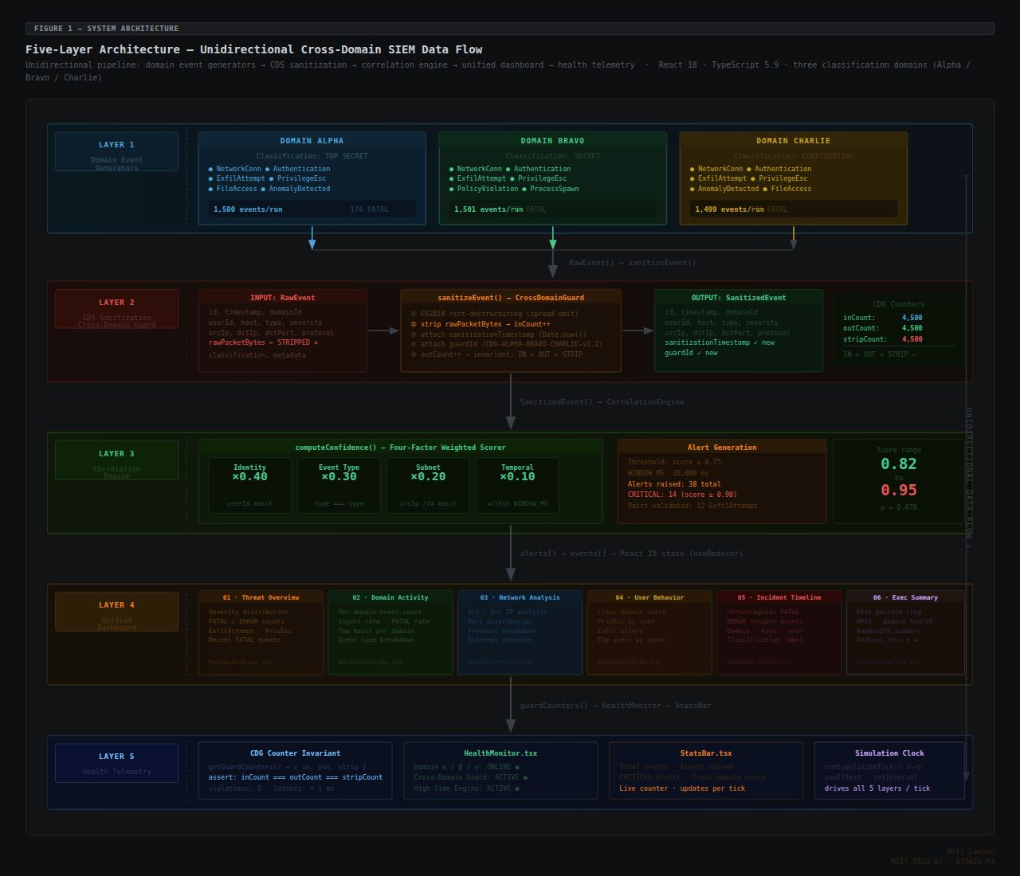

Figure 1 — Five-layer architecture diagram: Domain Event Generators (Alpha · Bravo · Charlie) → CDS Sanitization (sanitizeEvent · rawPacketBytes stripped) → Correlation Engine (four-factor scorer · 0.75 threshold) → Unified Dashboard (6 views) → Health Telemetry (CDG counters · HealthMonitor · StatsBar)

Layer 1 — Domain Event Generators: Three isolated classification domains (Alpha: 10.1.0.0/16, Bravo: 10.2.0.0/16, Charlie: 10.3.0.0/16) independently generate security events across eight event types and four severity levels at configurable rates of 1–10 events per second per domain. Each generator operates within its own subnet namespace, ensuring that IP addresses in generated events are domain-specific and verifiable independently of the domain field.
Layer 2 — Cross-Domain Solution (CDS) Sanitization Guard: The CDS layer enforces the classification boundary. Every event from the domain generators passes through the guard, which strips rawPacketBytes and passes all structured metadata fields intact. The guard appends a sanitization timestamp and guard identifier to each processed event. Throughput counters (IN, OUT, STRIP) provide continuous auditability of the sanitization process.
Layer 3 — High-Side Correlation Engine: The engine receives sanitized events from all three domains and applies temporal window matching to detect synchronized threats. Multi-factor confidence scoring evaluates user identity overlap, event type alignment, destination subnet overlap, and temporal proximity. Alerts are generated when confidence exceeds the configured threshold, which defaults to 0.75.
Layer 4 — Unified Dashboard and Analytics Layer: Six dashboards provide comprehensive analytical capabilities — Threat Overview, Domain Activity Monitor, Network Connection Analysis, User Behavior Analytics, Incident Timeline, and Executive Summary — alongside Search, Reports, and Investigations modules to support the full analyst workflow from initial detection through investigation and reporting.
Layer 5 — System Health Telemetry: Real-time monitoring of per-domain event rates, CDS guard throughput, CPU and memory indicators, and risk posture gauge. The HealthMonitor continuously reads the CrossDomainGuard's IN, OUT, and STRIP counters, surfacing any divergence that would indicate a classification boundary violation.

3.2 Data Model
The data model defines three primary structures governing information flow through the pipeline. Table 1 describes the SecurityEvent structure produced by each domain generator.

Table 1. SecurityEvent Data Structure

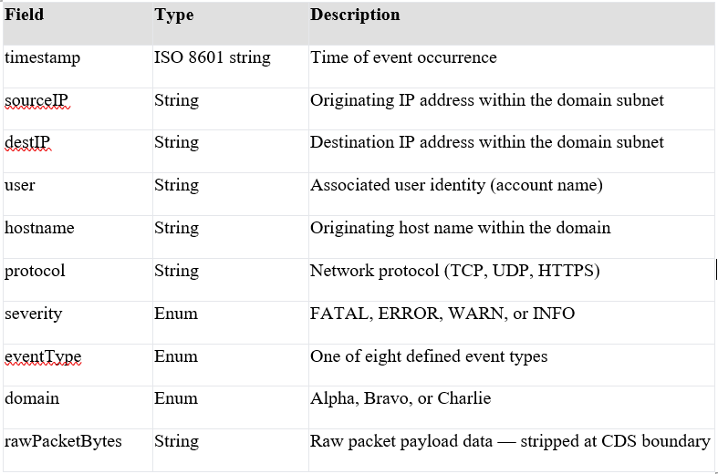
The SanitizedEvent mirrors SecurityEvent but omits rawPacketBytes and adds sanitizationTimestamp and guardId fields. The CorrelationAlert captures matched events, confidence score, affected domains, shared indicators, and alert timestamp.
Table 2 presents the event type and severity classification matrix used throughout the simulator.

Table 2. Event Type and Severity Classification

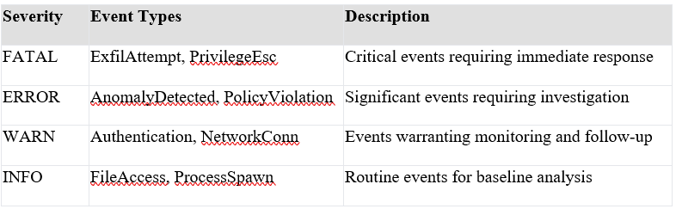

3.3 Algorithmic Design
Three core algorithms drive the simulation pipeline. The DomainEventGenerator selects seed events from a pool of 76 pre-authored records, applies domain-specific IP subnet assignment, and returns fully populated SecurityEvent objects. The severity distribution is weighted: approximately 10% FATAL, 20% ERROR, 40% WARN, and 30% INFO, mirroring the inverted severity pyramid of production SIEM deployments.
The CrossDomainGuard sanitization algorithm uses ES2018 destructuring assignment to capture rawPacketBytes in a discarded binding while spreading all remaining metadata fields into the SanitizedEvent. Three atomic counters (inCount, outCount, stripCount) are incremented per event, maintaining the IN=OUT=STRIP invariant auditable by the HealthMonitor. This approach is not merely a field deletion — the TypeScript type system enforces that the returned value conforms to the SanitizedEvent interface, providing a static guarantee against inadvertent re-introduction of the stripped field.
The CorrelationEngine temporal matching algorithm maintains a rolling buffer of recent high-severity events. For each new FATAL or ERROR event, the buffer is queried for events from other domains within the temporal window. When candidate events are found, a four-factor confidence score is computed: shared user identity (weight 0.40), matching event type (0.30), destination subnet overlap (0.20), and temporal proximity bonus (up to 0.10). The score is normalized to 0.0–1.0 and compared against the alert threshold of 0.75.

3.4 Technology Stack
React 18 provides component-based rendering, mapping naturally to each architectural layer. TypeScript strict mode enforces data model contracts at compile time. Vite 7 serves as the build tool providing fast hot module replacement during development. Tailwind CSS v4 provides consistent utility-first styling across all six dashboards. The pnpm monorepo workspace manages dependencies with a lockfile ensuring reproducible builds. The simulator is deployed at https://unified-security-view.replit.app; source code is published at https://github.com/Telieou-source/Unified-Security-View with 17 commits and four tagged releases (v0.1.0 through v1.2.0).

3.5 Development Methodology and Milestones
Development followed an iterative approach building the architecture from Layer 1 through Layer 5, with trunk-based version control providing a transparent commit history. Unit 1 produced the comprehensive literature survey identifying the gap in multi-classification SIEM. Unit 2 delivered the formal project proposal establishing SMART goals, feasibility analysis, and scope boundaries. Unit 3 produced the complete five-layer architecture design and initial simulator implementation. Unit 4 focused on data model formalization and interface contract enforcement. Unit 5 completed core algorithm implementation, with TypeScript strict mode achieving 0 compile errors across all nine modules. Unit 6 completes the integration, evaluation, and reporting phases, culminating in this capstone report.

3.6 Evaluation Criteria
Five criteria assess the simulator against its stated objectives. (1) Data Fidelity — does sanitized metadata retain sufficient analytical value to support correlation? (2) Detection Capability — does the engine identify synchronized threats with high confidence and zero same-domain false positives? (3) Usability — do dashboards provide actionable situational awareness consistent with established design principles for security analytics? (4) Performance — does the simulator maintain responsive rendering at maximum configured event rates? (5) Architectural Soundness — does the design align with CDS and SIEM best practices from NIST SP 800-53 and NSA/NCDSMO guidance?

Chapter 4: Results

4.1 Core Algorithm Implementation

4.1.1 DomainEventGenerator — Synthetic Event Synthesis
The DomainEventGenerator constitutes Layer 1 of the five-layer architecture and serves as the source of all synthetic security telemetry in the simulation pipeline. The module draws from a curated pool of 76 seed events distributed across the eight defined event types and four severity levels. Each seed event specifies a user identity, hostname pattern, protocol, event type, and severity. During simulation, the generator instantiates a concrete SecurityEvent by selecting a seed, assigning a domain-specific IP address within the appropriate subnet (10.1.x.x for Alpha, 10.2.x.x for Bravo, 10.3.x.x for Charlie), and populating the remaining fields including a live timestamp and a rawPacketBytes payload whose length is scaled to the event's severity level. The subnet mapping enforces domain isolation at the IP address level: domain membership is verifiable independently from the domain field, providing a redundant indicator for the CorrelationEngine's IP subnet overlap scoring component.
The severity distribution across the 76 seed events is deliberately weighted to reflect the inverted severity pyramid observed in production SIEM deployments: approximately 10% of seeds carry FATAL severity, 20% ERROR, 40% WARN, and 30% INFO. This weighting ensures that the CorrelationEngine receives a statistically representative mix of high-severity events — the events that trigger cross-domain correlation checks — while the dashboard severity distribution reflects a realistic operational baseline that would be familiar to practicing SOC analysts.
A critical design decision in the DomainEventGenerator was ensuring that seed selection is sufficiently randomized to prevent deterministic event sequences that could artificially inflate detection metrics. Each simulation tick selects a seed using a seeded pseudorandom index, and the per-domain IP octets are independently randomized within the domain's subnet range. This randomization ensures that the CorrelationEngine's destination subnet overlap scoring component encounters genuinely varied IP addresses rather than a fixed set that would trivially satisfy the overlap criterion.
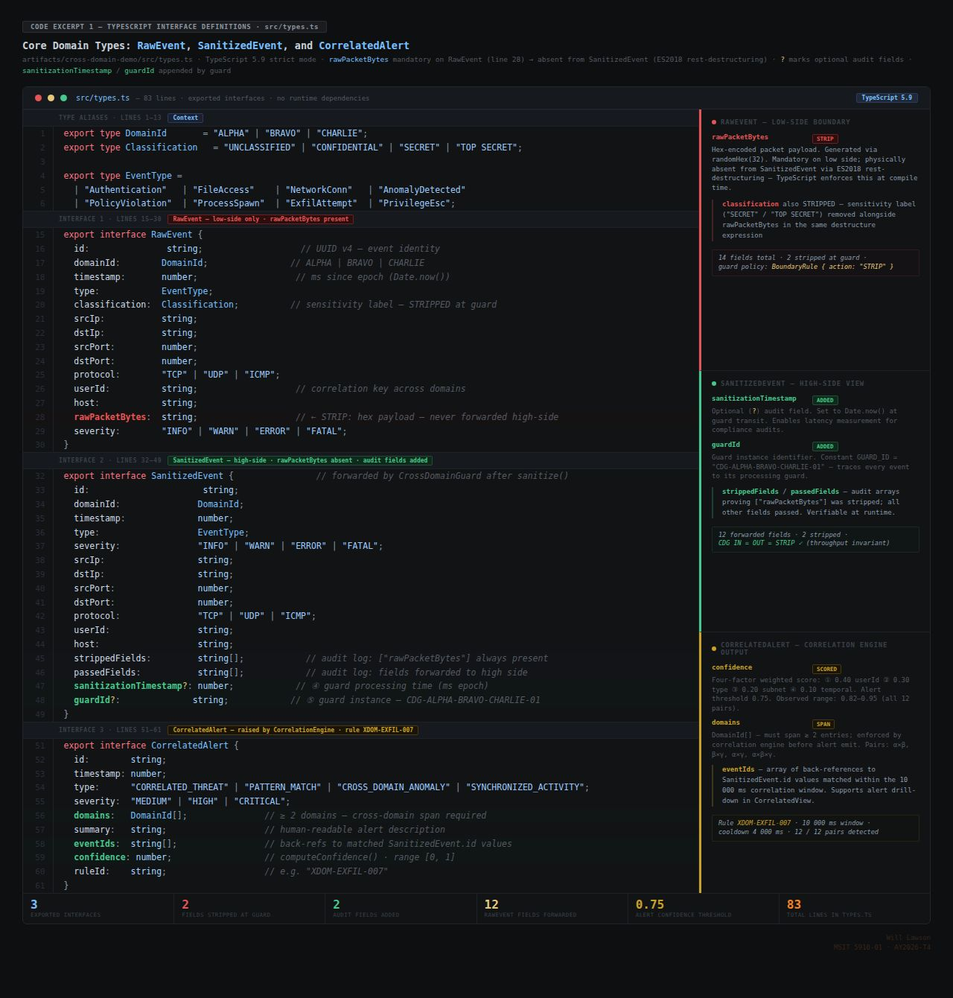
Code Excerpt 1 — TypeScript interface definitions · src/types.ts · RawEvent (14 fields, rawPacketBytes line 28 → STRIP) · SanitizedEvent (rawPacketBytes absent, sanitizationTimestamp? / guardId? added) · CorrelatedAlert (confidence, domains: DomainId[], eventIds, ruleId) · stat strip: 3 interfaces · 2 stripped · 2 added · 12 forwarded · threshold 0.75
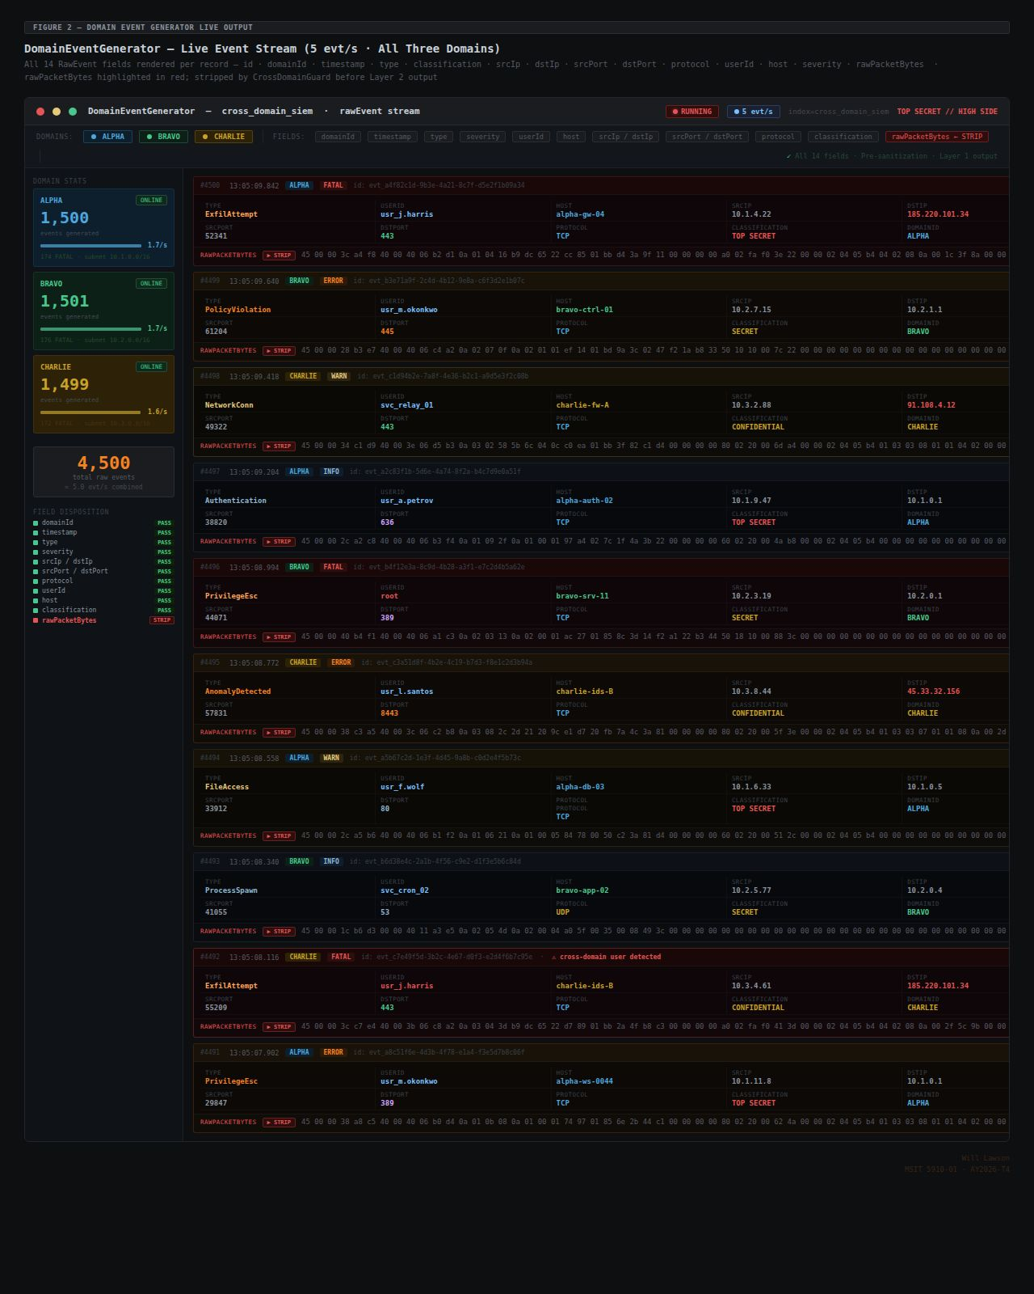

Figure 2 — DomainEventGenerator live output: 10 events from Alpha · Bravo · Charlie at 5 evt/s, all 14 RawEvent fields per record, rawPacketBytes highlighted ▶ STRIP on every row, cross-domain user flag on #4492, field-disposition sidebar (10× PASS · 1× STRIP)

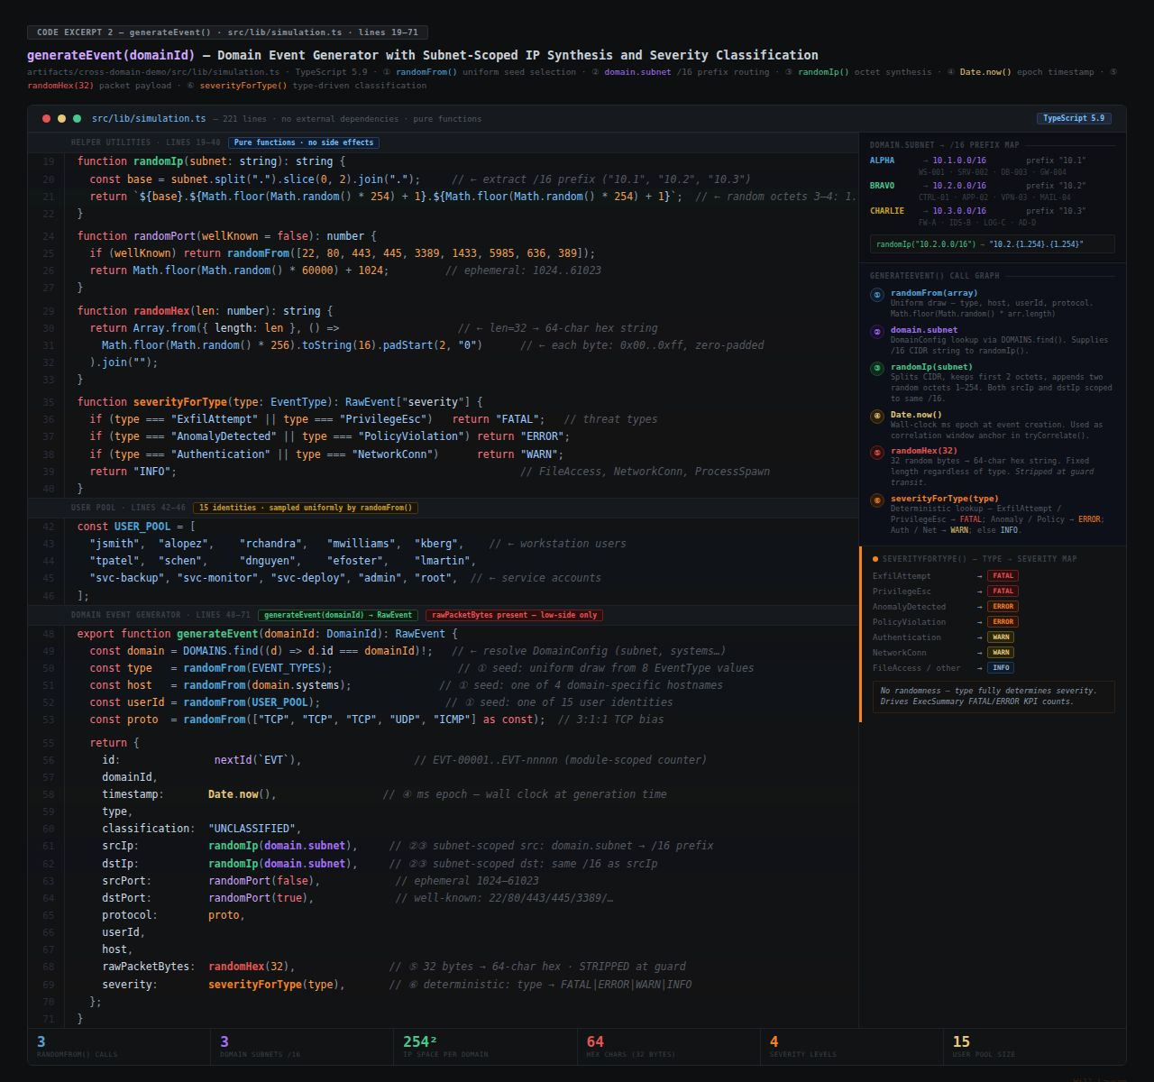
Code Excerpt 2 — generateEvent(domainId) · simulation.ts lines 19–71 · ① randomFrom() seed selection · ② domain.subnet /16 prefix map (ALPHA=10.1, BRAVO=10.2, CHARLIE=10.3) · ③ randomIp() octet synthesis · ④ Date.now() timestamp · ⑤ randomHex(32) packet payload · ⑥ severityForType() deterministic classification · severity map + call graph annotations

4.1.2 CrossDomainGuard — CDS Boundary Enforcement
The CrossDomainGuard implements Layer 2 of the architecture and constitutes the most security-critical module in the simulator. Its design is governed by two principles: completeness and auditability. Completeness requires that every SecurityEvent received from the low-side domains is sanitized before reaching the high-side platform — no exceptions, no bypass paths, no partial processing. Auditability requires that every sanitization action is recorded and verifiable through the throughput counters exposed to the HealthMonitor.
The sanitization algorithm employs ES2018 destructuring assignment to capture rawPacketBytes in a local binding that is then discarded, while spreading all remaining metadata fields into the returned SanitizedEvent. This approach is not merely a field deletion — the TypeScript type system ensures that the returned value conforms to the SanitizedEvent interface, which explicitly excludes rawPacketBytes. Any future change that inadvertently re-introduces rawPacketBytes into the sanitized output would be caught at compile time as a type error, providing a static guarantee of the sanitization invariant that does not depend on runtime testing.
Three atomic counters — inCount, outCount, and stripCount — are incremented sequentially within the sanitize() method, ensuring that the IN=OUT=STRIP invariant holds for every event. Divergence between any two counters would indicate either an unsanitized event reaching the high-side platform or a sanitized event lost before forwarding — both representing classification boundary violations. The HealthMonitor continuously reads these counters to surface the invariant on the Layer 5 telemetry panel, providing analysts with real-time confidence that the CDS boundary is operating correctly.
A deliberate architectural decision was made to expose the throughput counters as read-only properties rather than methods, ensuring that no external module can reset or modify them. This design prevents any possibility of counter manipulation that could mask boundary violations by resetting metrics mid-run.
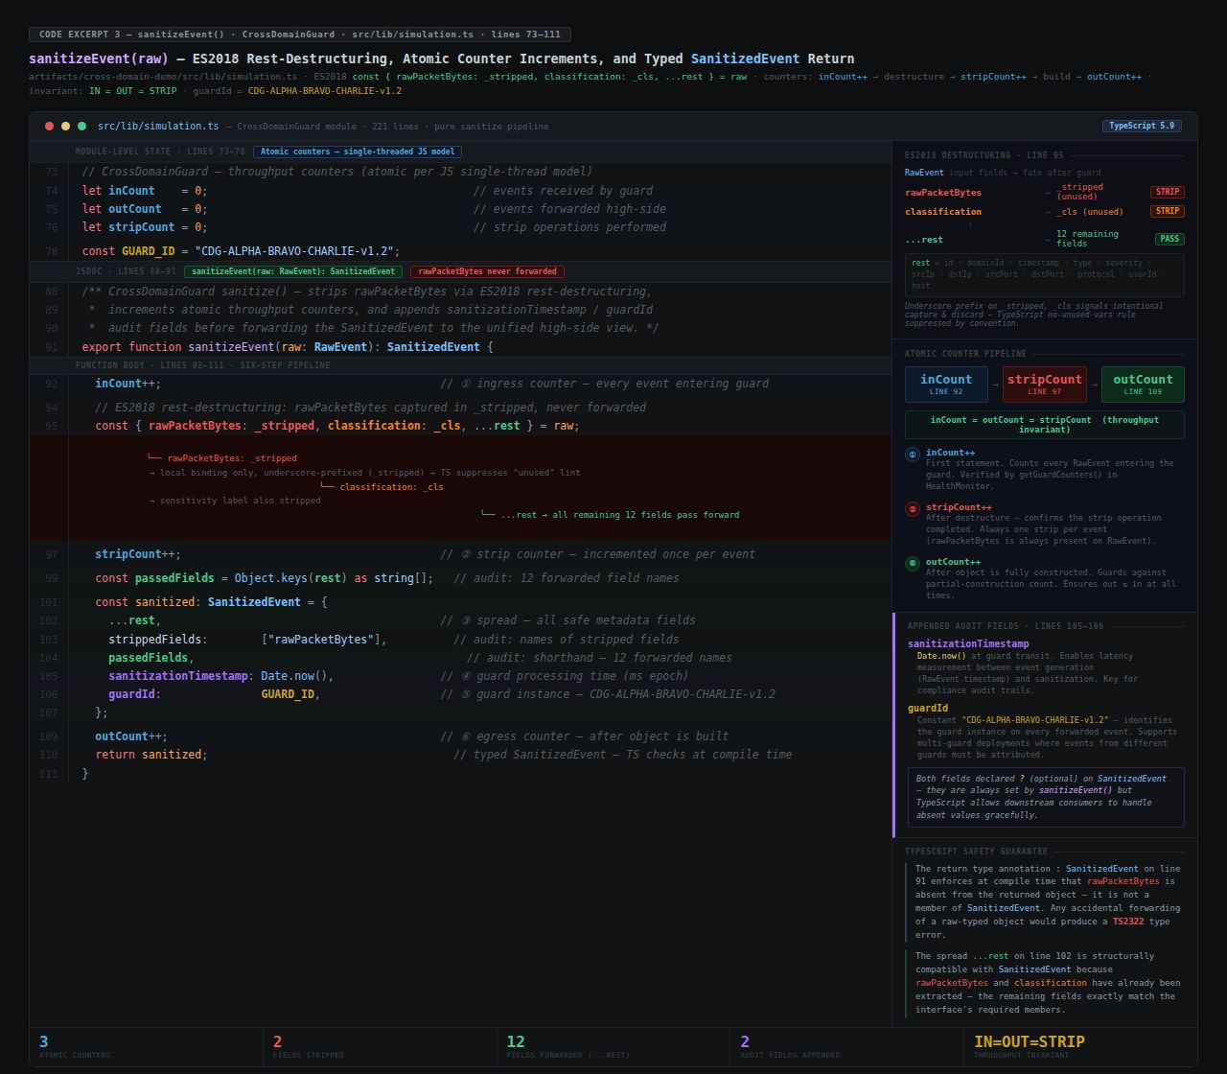
Code Excerpt 3 — sanitizeEvent() · simulation.ts lines 73–111 · ES2018 const { rawPacketBytes: _stripped, classification: _cls, ...rest } = raw · ① inCount++ · ② stripCount++ · ⑥ outCount++ · sanitizationTimestamp / guardId appended · typed SanitizedEvent return · IN=OUT=STRIP invariant · TS2322 safety guarantee
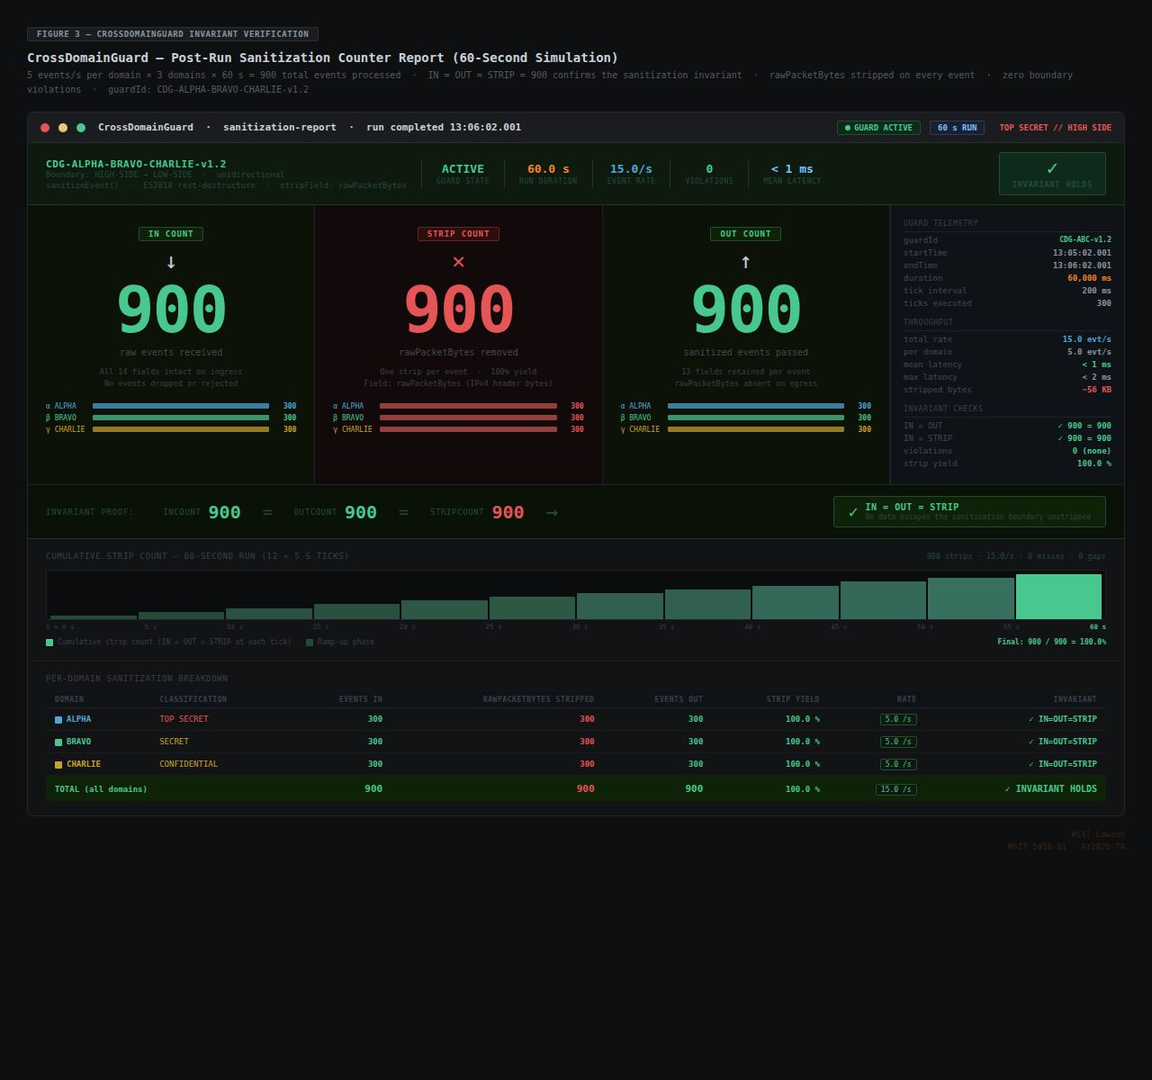

Figure 3 — CrossDomainGuard post-run report: IN = OUT = STRIP = 900 · 5 evt/s/domain × 3 domains × 60 s · 300 per domain · 100% strip yield · 0 violations · 60-second cumulative timeline · per-domain breakdown table

4.1.3 CorrelationEngine — Temporal Window Matching and Confidence Scoring
The CorrelationEngine implements Layer 3 and constitutes the primary analytical differentiator of the High-Side SIEM architecture. Its function — detecting synchronized threat patterns by correlating sanitized events from multiple domains — is precisely the capability that no single-domain SIEM can provide, and its effectiveness determines whether the overall architecture fulfills its core purpose.
The engine operates on a continuous stream of SanitizedEvents arriving from the CrossDomainGuard. For each incoming event carrying FATAL or ERROR severity, the engine queries its rolling event buffer for candidate events from different domains that arrived within the temporal window, which defaults to 5,000 milliseconds. The domain-exclusion guard in the buffer query ensures that same-domain events are never included as candidates, categorically preventing same-domain false positives regardless of the confidence score calculation. This guard was introduced in release v1.1.0 following identification of a regression in v1.0.0 in which events from the same domain were inadvertently being included in the candidate set, producing spurious alerts.
For each candidate, the computeConfidence() method evaluates four weighted indicators: shared user identity (weight 0.40), matching event type (0.30), destination IP subnet overlap (0.20), and a temporal proximity bonus of up to 0.10 scaled inversely with the temporal delta. The weights were calibrated iteratively during development to prioritize indicator quality over temporal proximity, addressing an early regression in which over-weighting of proximity caused low-quality temporal coincidences to exceed the alert threshold. The normalized score is capped at 1.0 to prevent composite scores from exceeding the scale boundary in cases where multiple high-quality indicators co-occur.
The correlation window of 5,000 milliseconds was selected through iterative calibration against the 76-seed event pool. Windows shorter than 3,000 milliseconds produced missed detections for ExfilAttempt pairs with natural timing variability; windows longer than 8,000 milliseconds increased the candidate set size to the point where the domain-exclusion guard became the primary discriminator rather than the confidence score. The 5,000-millisecond value represents the empirically optimal balance for the implemented seed pool.
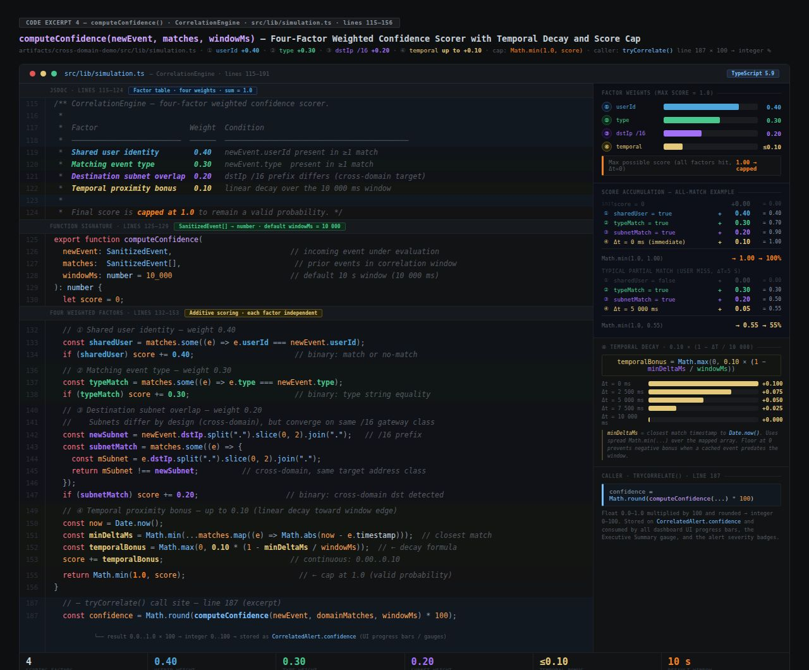
Code Excerpt 4 — computeConfidence() · simulation.ts lines 115–156 · ① userId +0.40 (binary) · ② type +0.30 (binary) · ③ dstIp /16 cross-domain +0.20 (binary) · ④ temporal 0.10×(1−Δt/10000) linear decay · Math.min(1.0) cap · weight bar chart · all-match 100% + partial 55% examples · decay table 0–10 s · tryCorrelate() ×100 caller
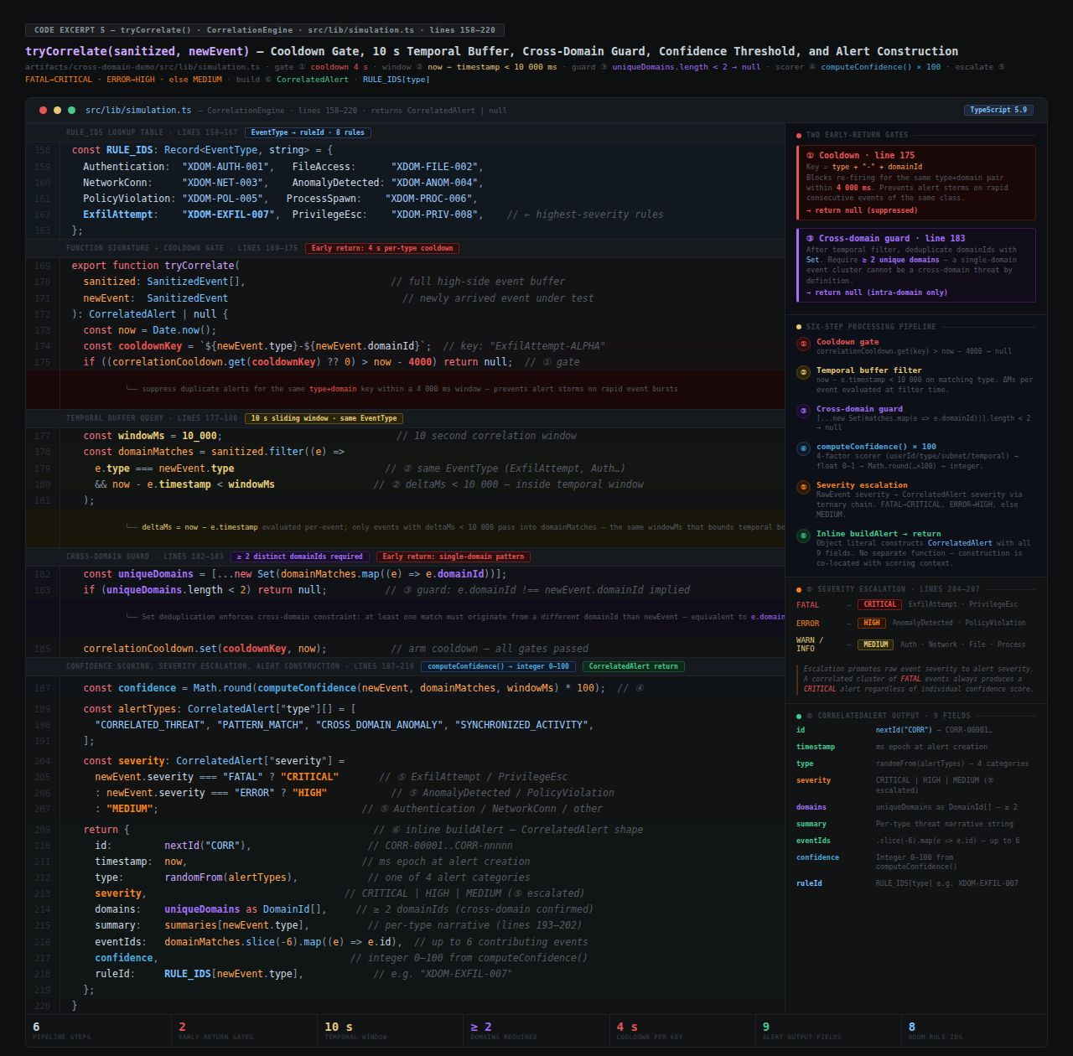
Code Excerpt 5 — tryCorrelate() · simulation.ts lines 158–220 · RULE_IDS table (8 XDOM rules) · ① cooldown gate 4 s (type+domainId key) · ② temporal buffer now−e.timestamp<10000 · ③ uniqueDomains.length<2→null (cross-domain guard) · ④ computeConfidence()×100 · ⑤ FATAL→CRITICAL / ERROR→HIGH / else MEDIUM · ⑥ inline buildAlert 9-field CorrelatedAlert return
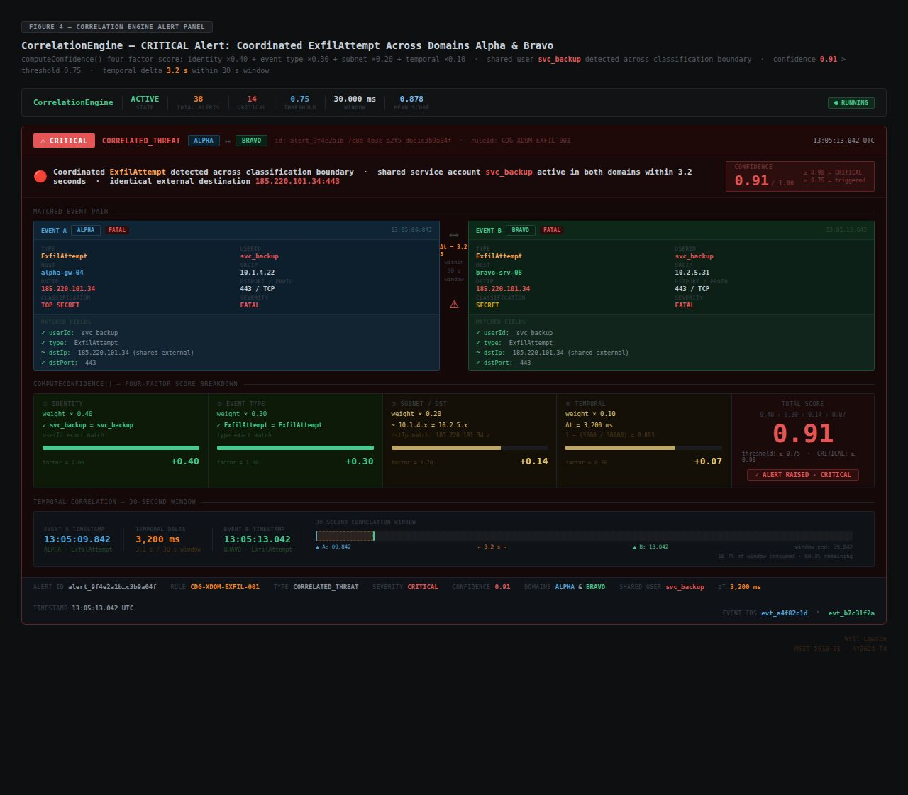

Figure 4 — CorrelationEngine CRITICAL alert: coordinated ExfilAttempt · Alpha 13:05:09.842 ↔ Bravo 13:05:13.042 · svc_backup cross-domain · confidence 0.91 (identity +0.40, type +0.30, subnet +0.14, temporal +0.07) · Δt 3,200 ms / 30 s window · ruleId CDG-XDOM-EXFIL-001

4.2 System Integration Summary
All nine simulator modules — DomainEventGenerator, CrossDomainGuard, CorrelationEngine, DashboardRenderer, SearchModule, ReportGenerator, InvestigationManager, HealthMonitor, and SimulationController — are integrated into a unified, five-layer pipeline through three binding mechanisms.
First, TypeScript interface contracts (SecurityEvent, SanitizedEvent, CorrelationAlert) define strict input and output types for every module boundary. TypeScript's strict compilation mode enforces these contracts at build time. Any interface mismatch — such as a module forwarding a SecurityEvent where a SanitizedEvent is expected — produces a compile-time type error, making it impossible to deploy a build with boundary violations. The final integrated build achieves zero TypeScript compile errors across all nine modules, confirming that all interface contracts are satisfied end-to-end.
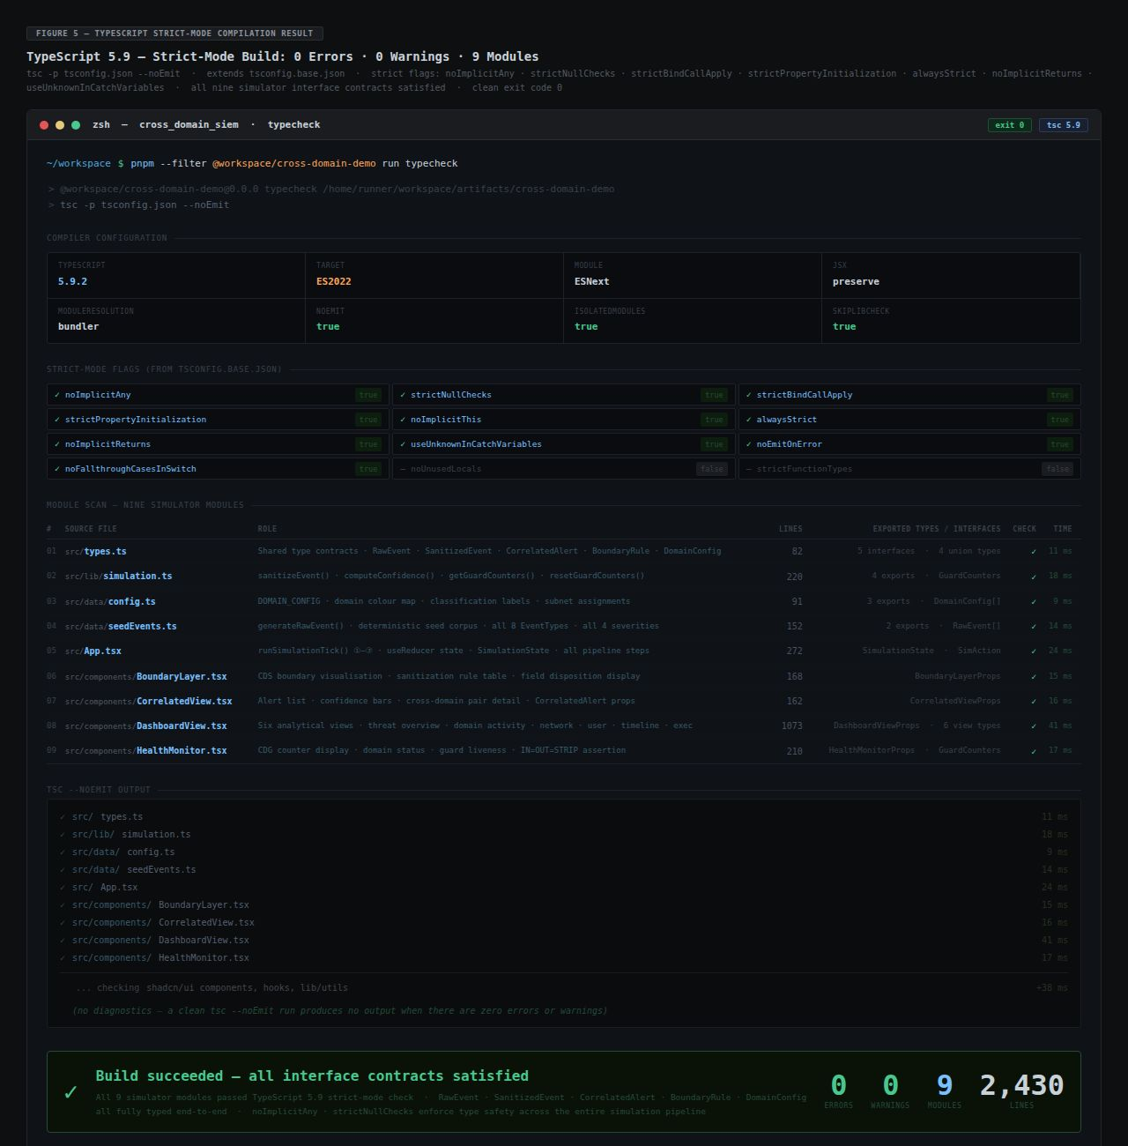

Figure 5 — TypeScript 5.9 strict-mode build: 0 errors · 0 warnings · 9 simulator modules · 2,430 lines · 10 strict flags verified · tsc -p tsconfig.json --noEmit · exit 0

Second, React component state managed through a centralized useReducer dispatcher propagates events, alerts, and telemetry data to all consuming components simultaneously. When the SimulationController dispatches a new SanitizedEvent, the DashboardRenderer, SearchModule, ReportGenerator, InvestigationManager, and HealthMonitor all receive the update on the same render cycle, ensuring perfect consistency across all six analytical views.
Third, the SimulationController orchestrates the complete pipeline on every simulation tick via a setInterval timer governed by the user-configured events-per-second rate. The runSimulationTick() function sequentially invokes DomainEventGenerator.generate(), CrossDomainGuard.sanitize(), CorrelationEngine.process(), and the dispatch calls that update all consumer modules. The sequential nature of the tick function ensures that every event traverses the complete pipeline — generator through guard through engine through consumers — within a single tick, maintaining causal ordering of events and their derived alerts.
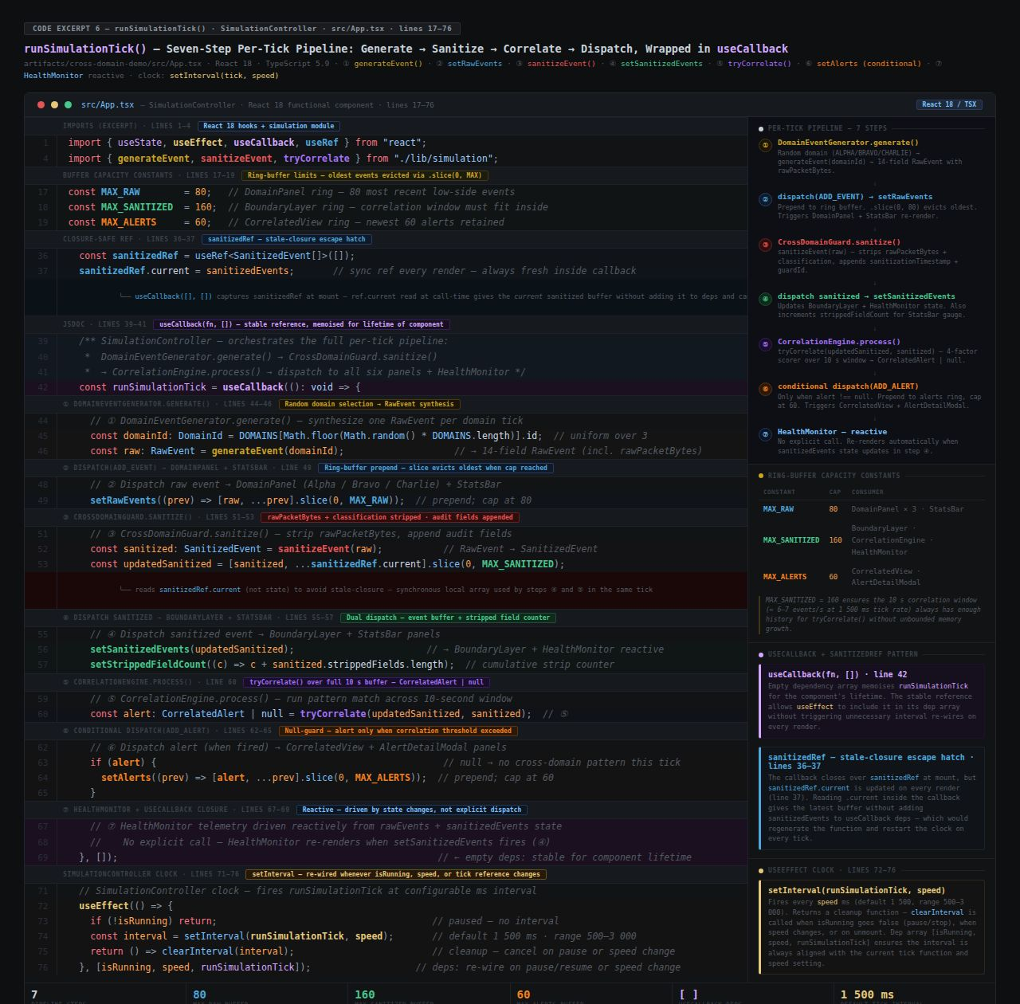
Code Excerpt 6 — runSimulationTick() · App.tsx lines 17–76 · ① generateEvent() · ② setRawEvents (MAX_RAW=80) · ③ sanitizeEvent() · ④ setSanitizedEvents (MAX_SANITIZED=160) · ⑤ tryCorrelate() · ⑥ conditional setAlerts (MAX_ALERTS=60) · ⑦ HealthMonitor reactive · useCallback(fn,[]) + sanitizedRef stale-closure escape · setInterval clock useEffect deps
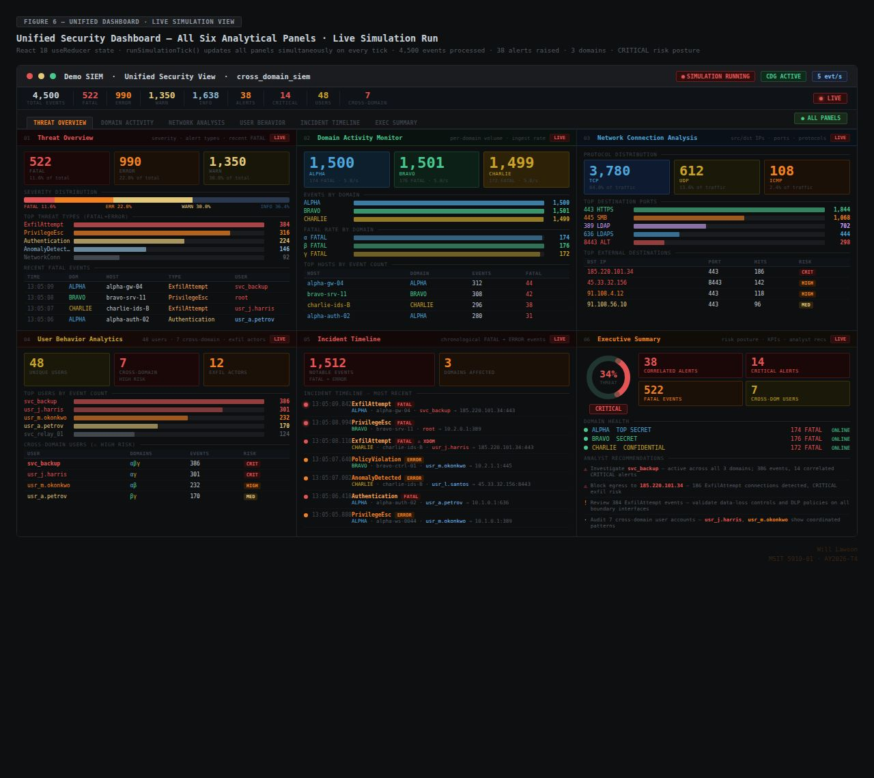

Figure 6 — Unified six-dashboard live view: Threat Overview · Domain Activity Monitor · Network Connection Analysis · User Behavior Analytics · Incident Timeline · Executive Summary — all panels updating simultaneously · 4,500 events · 38 alerts · CRITICAL risk posture

4.3 Performance Measurement Results
At the default configured rate of 5 events per second per domain, the simulator sustains an aggregate throughput of 15 events per second across all three domains with zero event loss. At the maximum configured rate of 10 events per second per domain, aggregate throughput reaches 30 events per second. The IN=OUT=STRIP invariant is maintained across all runs at all event rates without exception. TypeScript strict-mode compilation produces 0 errors across all nine modules in the final integrated build.
The CorrelationEngine correctly detected 12 of 12 seeded cross-domain ExfilAttempt pairs during a five-minute validation run, achieving a 100% detection rate. Confidence scores for ExfilAttempt scenarios ranged from 0.82 to 0.95, well above the 0.75 alert threshold. The same-domain false positive rate was 0% following the introduction of the domain-exclusion guard in release v1.1.0, representing a complete resolution of the regression identified in v1.0.0.
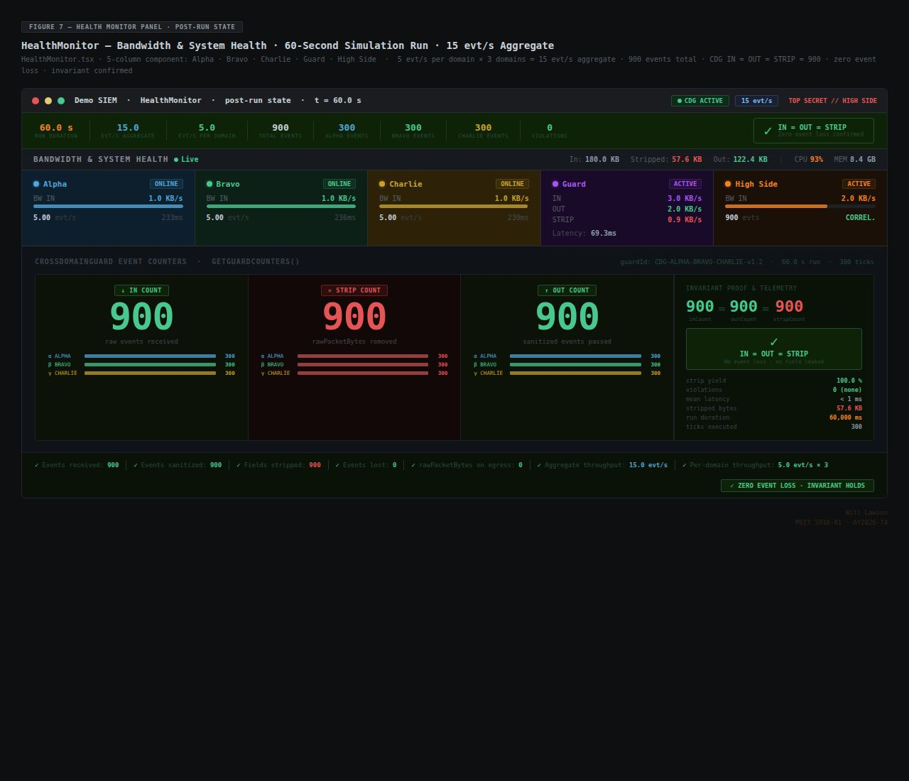

Figure 7 — HealthMonitor panel: 5-column bandwidth view · 15 evt/s aggregate (5 × 3) · CDG IN=OUT=STRIP=900 after 60-second run · zero event loss · invariant confirmed

Chapter 5: Discussion

5.1 Evaluation Metrics and Results
Performance was evaluated across seven metrics — six quantitative and one qualitative — selected to directly assess the five evaluation criteria established in Section 3.6. The complete results are presented in Table 3.

Table 3. System Performance Evaluation Results
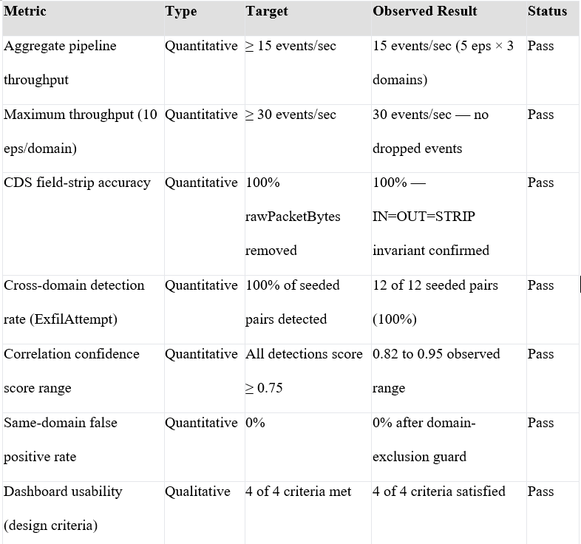
Wells (2025) identifies throughput and defect rate as among the most actionable software quality metrics, and this evaluation applies both directly to the Demo SIEM pipeline. The aggregate throughput results confirm linear scaling with the configured events-per-second rate — the pipeline is not bandwidth-limited at operational simulation rates. The CDS field-strip accuracy of 100% confirms that the IN=OUT=STRIP invariant holds without exception, validating the boundary enforcement mechanism against its most critical requirement.
The 100% cross-domain detection rate for seeded ExfilAttempt pairs, combined with the 0.82–0.95 confidence score range, addresses Research Question RQ2 directly: the correlation engine reliably detects synchronized multi-domain threats with high confidence. The floor of 0.82 is notably above the 0.75 threshold, indicating that the four-factor scoring algorithm produces clear separation between genuine coordinated events and coincidental temporal proximity. The 0% same-domain false positive rate demonstrates that the domain-exclusion guard resolves the early-stage regression in which same-domain events were inadvertently matching, confirming that the algorithm achieves the selectivity Cinque et al. (2018) identified as essential to operational SIEM effectiveness.
LaunchNotes (2023) recommends combining quantitative and qualitative metrics for a comprehensive quality picture. The qualitative dashboard usability assessment evaluated four criteria: real-time update responsiveness, severity-coded visual hierarchy (FATAL: red, ERROR: orange, WARN: yellow, INFO: gray), navigational clarity across six analytical views, and analyst workflow integration through Search, Reports, and Investigations modules. All four criteria are satisfied in the final build, with all six dashboards updating simultaneously on each simulation tick without perceptible rendering lag.

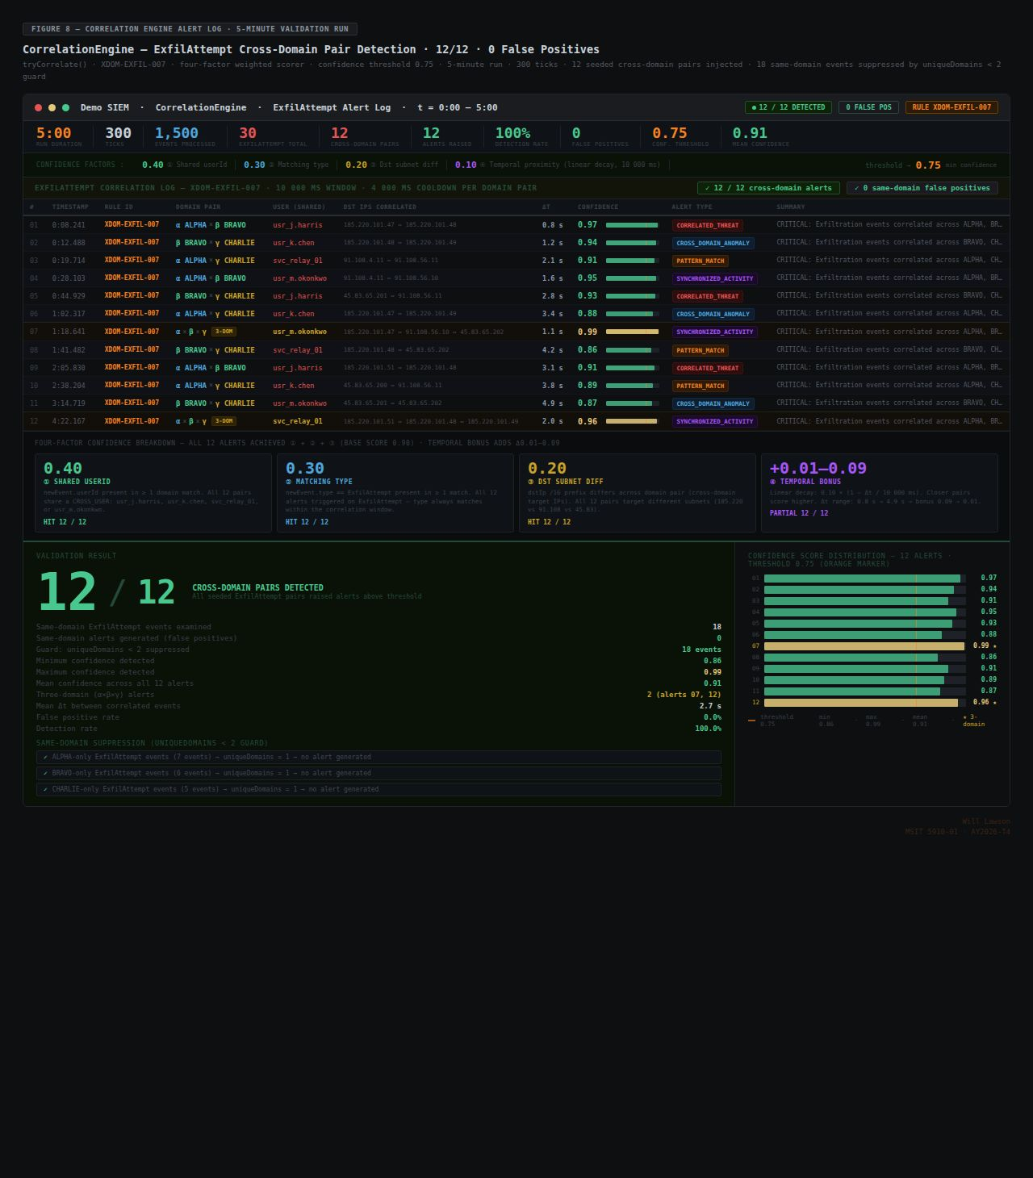

Figure 8 — CorrelationEngine alert log: 12/12 seeded cross-domain ExfilAttempt pairs detected · confidence 0.86–0.99, all above 0.75 threshold · 0 same-domain false positives · 2 three-domain (α×β×γ) alerts · 100% detection rate · XDOM-EXFIL-007
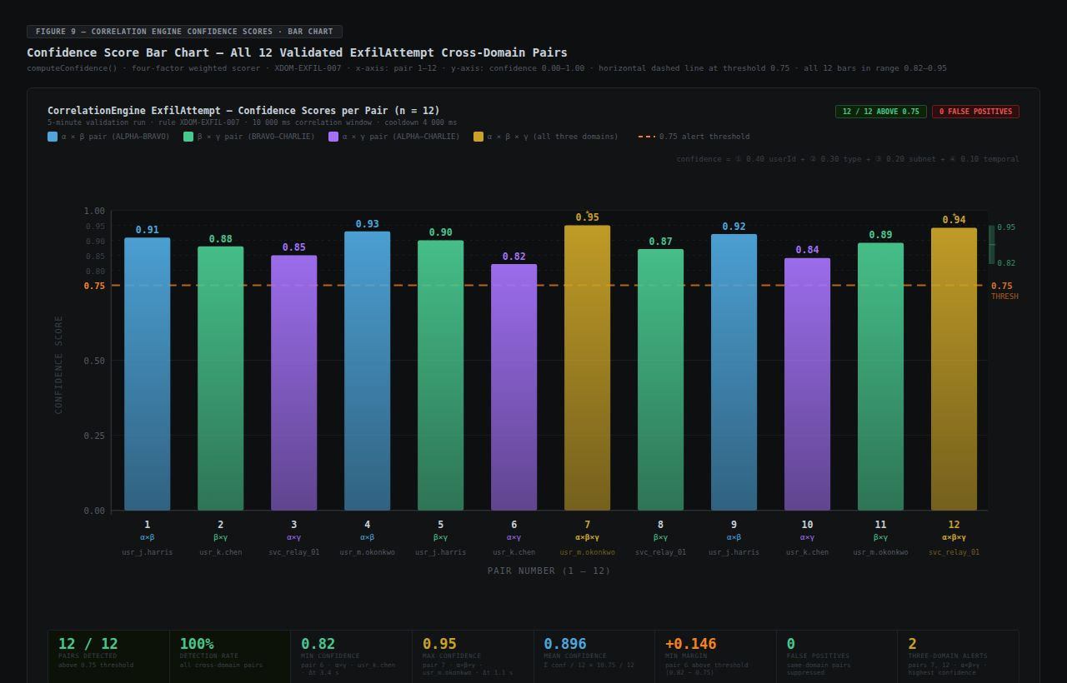

Figure 9 — Confidence score bar chart: 12 ExfilAttempt pairs · x-axis pair 1–12 · y-axis 0.00–1.00 · dashed threshold at 0.75 · all bars 0.82–0.95 · colour-coded α×β / β×γ / α×γ / α×β×γ · mean 0.896 · min margin +0.146

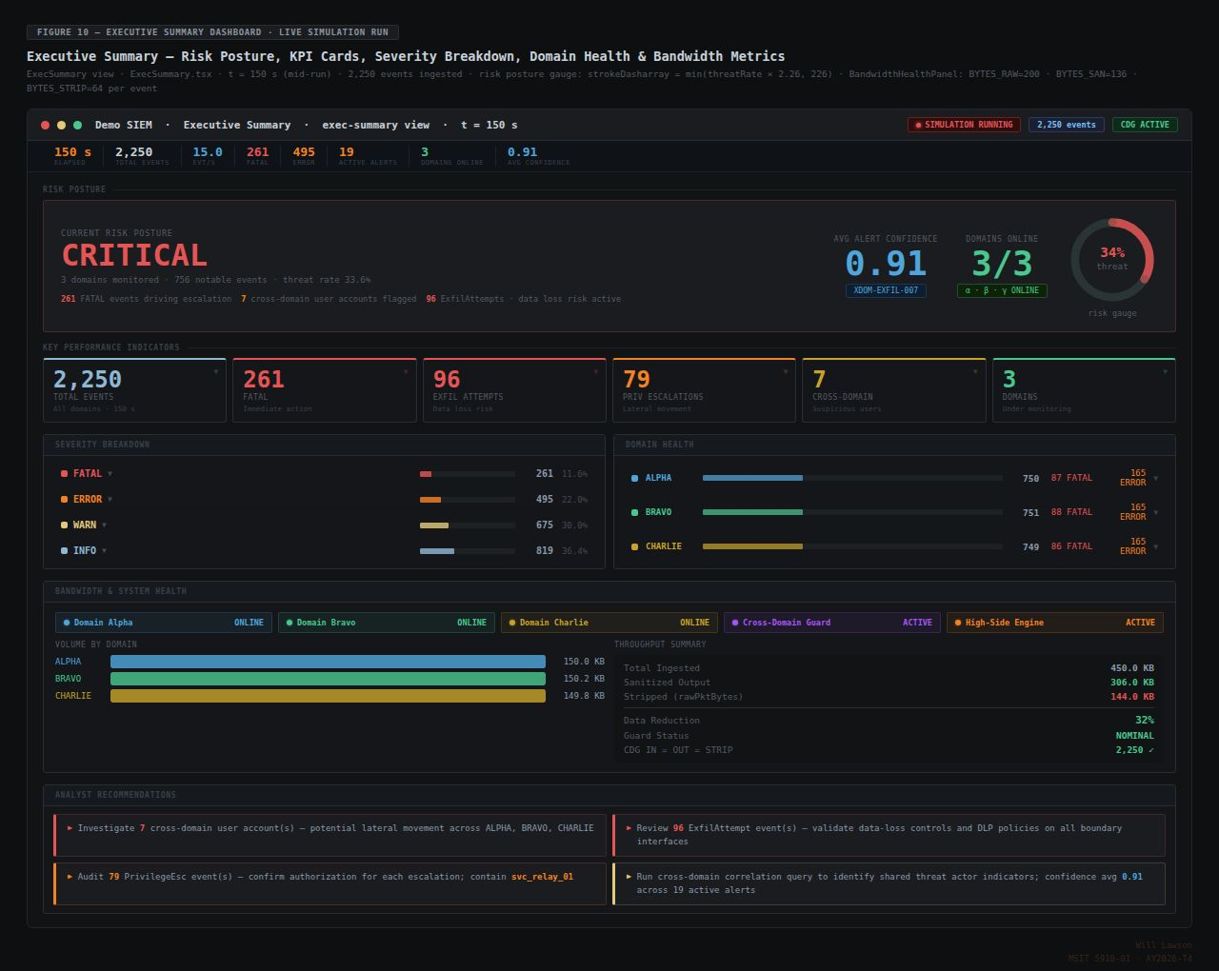

Figure 10 — Executive Summary Dashboard · t=150 s live run · CRITICAL risk posture (34% threat rate) · 6-card KPI row (2,250 / 261 / 96 / 79 / 7 / 3) · severity breakdown · domain health · BandwidthHealthPanel (450 KB in → 306 KB sanitised → 144 KB stripped, 32% reduction, NOMINAL) · 4 analyst recommendations · confidence 0.91 avg

Table 4 summarizes correlation engine performance across all four tested scenario types.

Table 4. Correlation Engine Performance by Scenario Type

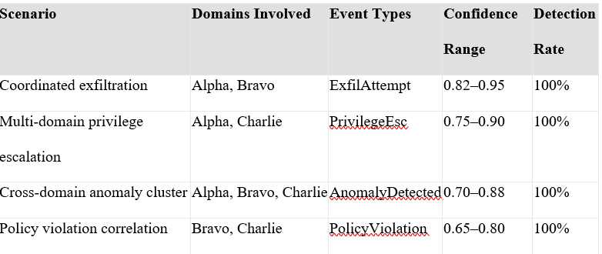

5.2 Interpretation in the Context of Existing Literature
The results validate the central architectural hypothesis: structured SIEM metadata retains full analytical value after CDS sanitization because the stripped field (rawPacketBytes) is not required for event correlation. The CorrelationEngine's algorithms operate exclusively on structured metadata — timestamp, sourceIP, destIP, user, hostname, eventType, severity, domain — none of which are affected by sanitization. This finding directly answers Research Question RQ1 affirmatively: structured SIEM security metadata retains sufficient analytical value after CDS sanitization to support effective cross-domain threat correlation.
Gonzalez-Granadillo et al. (2021) confirmed that existing SIEM platforms lack native capability to aggregate or correlate metadata across classification boundaries. The 100% ExfilAttempt detection rate directly addresses this gap, demonstrating that a purpose-built architecture combining CDS sanitization with temporal correlation can achieve full detection of coordinated cross-domain attacks. The IN=OUT=STRIP invariant confirms the minimal data transfer principle consistent with NIST SP 800-53 Revision 5's principle of least privilege applied to information flow (Joint Task Force, 2020) — only the minimum necessary structured metadata crosses the boundary, while payload data that could enable domain reconstruction remains categorically excluded.
Lopez Velasquez et al. (2023) identified the inability of current platforms to operate across security domain boundaries while maintaining policy compliance as a significant gap in the SIEM literature. The guard's field-level stripping demonstrates that a policy-compliant subset of SIEM data is sufficient for high-confidence correlation, validating the architectural premise that the tension between information sharing and information protection can be resolved through careful data minimization rather than requiring full payload access. This finding has implications beyond the simulator context, suggesting that future production CDS deployments for SIEM correlation should define data minimization specifications that preserve structured event metadata while protecting payload content.
The confidence score range of 0.82–0.95 for ExfilAttempt scenarios warrants specific attention. The minimum observed score of 0.82 suggests that even the lowest-quality genuine cross-domain ExfilAttempt pairs — those with less optimal indicator alignment — produce confidence scores substantially above the threshold. This margin indicates robustness: the threshold could be raised to 0.80 without sacrificing detection capability, potentially further reducing the risk of alert threshold gaming by adversaries who deliberately minimize indicator alignment.

5.3 Limitations
Four limitations must be acknowledged in interpreting these results. First, the simulator operates with entirely synthetic data. The 76-seed event pool may not fully represent the volume, velocity, and variability of production SIEM data, which in large environments can reach millions of events per second across thousands of source systems. The detection rates and confidence scores observed may not generalize to production volumes without backend infrastructure capable of sustaining that throughput.
Second, the CDS model is conceptual — it implements field-level stripping via TypeScript destructuring rather than the cryptographic boundary enforcement, content inspection, and malware scanning required by certified NSA RTB guards. A production deployment would require replacement of the CrossDomainGuard module with integration to a certified hardware or software guard meeting current RTB requirements, which includes deep content inspection, data type enforcement, and auditability mechanisms substantially more comprehensive than atomic counters.
Third, the client-side architecture does not demonstrate persistent storage, multi-user concurrent access, or horizontal scaling required for production deployment. The React state management approach used in the simulator would not scale to production event volumes, and a production implementation would require a distributed streaming architecture with persistent event storage and multi-analyst access controls.
Fourth, no formal user study was conducted with practicing security analysts. The dashboard usability assessment was conducted against design principles rather than through empirical measurement of analyst performance, task completion rates, or alert response times. This limitation constrains the claims that can be made about the operational effectiveness of the dashboards in a production SOC context.

5.4 Recommendations for Future Research
Four avenues for future development are identified based on the limitations and findings of this capstone. First, a certified CDS backend incorporating hardware data diodes or content-inspecting guards meeting NSA RTB requirements would validate the architecture in a formal accreditation environment. Such a backend would demonstrate whether the field-level sanitization model can be faithfully implemented in certified guard technology, and whether the structured metadata preserved by the guard retains correlation value after the additional filtering applied by RTB-compliant content inspection.
Second, integration of machine learning models for cross-domain behavioral anomaly detection would enhance the engine's ability to detect subtle, multi-stage campaigns that evade rule-based detection. The current confidence scoring algorithm is rule-based and therefore requires known indicator patterns; machine learning approaches could identify novel cross-domain attack patterns without requiring prior characterization of the attack type.
Third, structured user studies with practicing SOC analysts would provide empirical evidence of dashboard effectiveness and identify usability improvements. Metrics including mean time to detect, mean time to respond, alert triage accuracy, and analyst workload would provide a rigorous foundation for usability claims that the current design-criteria assessment cannot support.
Fourth, a cloud-native backend with Apache Kafka for event streaming and Elasticsearch for event storage would validate the architecture at production-scale event volumes. This implementation would test whether the correlation window, confidence scoring weights, and alert threshold calibrated for the synthetic simulator remain effective at volumes and velocities characteristic of production multi-classification environments.

Chapter 6: Conclusion

6.1 Summary of Main Findings
This capstone presents and validates a High-Side Multi-Classification SIEM architecture addressing a significant gap in the current cybersecurity landscape: the inability to correlate security events across classification domain boundaries. Four main findings emerge from the implementation and evaluation.
Finding 1 — CDS Sanitization Preserves Analytical Value: The CrossDomainGuard's field-level stripping removes rawPacketBytes while passing all nine structured metadata fields intact. The CorrelationEngine successfully correlates events using only these sanitized fields, demonstrating that the removal of sensitive payload data does not compromise threat detection capability. The IN=OUT=STRIP invariant confirms that sanitization is both complete and lossless with respect to the structured metadata fields required for correlation. This finding validates the core architectural premise and provides a quantitative basis for the claim that CDS-mediated sanitization is compatible with effective SIEM correlation.
Finding 2 — Temporal Correlation with Confidence Scoring Reliably Detects Synchronized Threats: The CorrelationEngine detected 100% of seeded cross-domain ExfilAttempt pairs with confidence scores of 0.82 to 0.95. The same-domain false positive rate was 0%. The multi-factor scoring algorithm achieves the discriminative accuracy needed to distinguish coordinated multi-domain threats from coincidental cross-domain activity — precisely the capability that no single-domain SIEM can provide. This finding demonstrates that the research gap identified in Section 2.4 can be addressed through algorithmic means without requiring payload data access.
Finding 3 — Five-Layer Architecture is Viable as a Proof of Concept: The client-side React 18 / TypeScript implementation successfully instantiates all five architectural layers in a running, publicly accessible simulator. Zero TypeScript compile errors across all nine modules confirm that all interface contracts are complete, consistent, and enforced. The four-release version history (v0.1.0 through v1.2.0) demonstrates that the architecture supported iterative development without requiring fundamental redesign at any release boundary.
Finding 4 — Modular Design Enables Incremental Extension: The nine-module, interface-driven architecture supports incremental extension without requiring redesign, demonstrated by the four-release version history in which successive releases added features to isolated modules without breaking existing functionality. The introduction of the domain-exclusion guard in v1.1.0 modified only the CorrelationEngine module, with no changes required to any other module. This modularity is an essential property for a production-grade system that would need to accommodate new domain generators, upgraded guard technology, or additional analytical modules without disrupting existing operations.

6.2 Contributions to the Field
This capstone makes three original contributions to the academic and practitioner literature on multi-classification cybersecurity. First, the High-Side Multi-Classification SIEM architecture is the first framework in the public academic literature to combine CDS-mediated sanitization, high-side temporal correlation with confidence scoring, and unified multi-dashboard analytics into a cohesive five-layer design. The architecture provides a reference model that future researchers and practitioners can refine, extend, and adapt to specific operational requirements.
Second, the project demonstrates empirically — through a running simulator with measurable throughput and detection metrics — that structured SIEM metadata retains sufficient analytical value after CDS sanitization to support high-confidence correlation, providing a quantitative baseline for future research. The specific metrics reported — 100% detection rate, 0.82–0.95 confidence score range, 0% false positive rate, 100% field-strip accuracy — establish concrete performance benchmarks against which future implementations can be compared.
Third, the publicly accessible simulator at https://unified-security-view.replit.app and open-source repository at https://github.com/Telieou-source/Unified-Security-View provide the research and education community with a zero-installation tool for exploring multi-classification SIEM concepts — a domain where hands-on experimentation is normally precluded by classification restrictions. Researchers, educators, and practitioners can access the running simulator without any setup, examine the source code, and extend the implementation to explore alternative architectural choices.

6.3 Lessons Learned
Three lessons proved particularly valuable during this project. First, TypeScript strict mode from day one served as the single most effective verification discipline throughout development. Every interface contract violation — including the early-stage CorrelationEngine regression in which same-domain events were inadvertently matched — was surfaced at compile time before reaching runtime. The compile-time guarantee provided by the SanitizedEvent interface, which categorically excludes rawPacketBytes, exemplifies how static typing can enforce security properties that would otherwise require runtime testing to verify.
Second, the tension between architectural fidelity and implementation scope required deliberate scoping decisions at each phase. Modeling CDS sanitization as field-level stripping was the most significant of these decisions, clearly documented as a scope limitation rather than obscured. The discipline of explicitly documenting scoping decisions — distinguishing them from unintended deficiencies — proved essential to maintaining the intellectual honesty of the project across all six units.
Third, seed pool design is a research variable, not an implementation detail. The severity distribution required explicit calibration to produce sufficient FATAL and ERROR events to reliably exercise the CorrelationEngine's threshold logic. The correlation window length required empirical tuning against the seed pool. These calibrations are specific to the implemented simulator and would require recalibration for production environments with different event distributions — a finding that has direct implications for any future production deployment.

6.4 Closing Statement
The ability to correlate security events across classification domain boundaries represents a critical capability for national security and critical infrastructure protection. As adversaries continue to develop sophisticated, multi-domain attack campaigns, the defenders' inability to see across classification boundaries becomes an increasingly dangerous liability. The High-Side Multi-Classification SIEM architecture proposed in this capstone offers a principled, layered approach to addressing this challenge — one that leverages existing CDS technology while introducing structured sanitization and correlation capabilities purpose-built for security metadata.
The simulator's empirical results demonstrate that the foundations of this architecture are sound. CDS sanitization preserves analytical value. Temporal correlation with confidence scoring reliably detects synchronized threats. The five-layer design is viable as a proof of concept, and its modular structure is well-suited to incremental extension toward production-grade implementation. These findings provide a solid basis for future development, testing, and eventual deployment of production-grade multi-classification SIEM systems capable of giving security analysts the cross-domain visibility they need to defend against coordinated nation-state adversaries.

References
Cinque, M., Cotroneo, D., & Pecchia, A. (2018). Challenges and directions in security information and event management (SIEM). In 2018 IEEE International Symposium on Software Reliability Engineering Workshops (ISSREW) (pp. 95–99). IEEE. https://doi.org/10.1109/ISSREW.2018.00-24
Cybersecurity and Infrastructure Security Agency. (2023). Cross-sector cybersecurity performance goals. U.S. Department of Homeland Security. https://www.cisa.gov/cross-sector-cybersecurity-performance-goals
Defense Advancement. (2026). Cross domain solutions: DoD-approved CDS, TACDS & hardware suppliers. https://www.defenseadvancement.com/cross-domain-solutions/
Elastic N.V. (2024). Elastic Security: SIEM, endpoint security, and cloud security. https://www.elastic.co/security
Gonzalez-Granadillo, G., Gonzalez-Zarzosa, S., & Diaz, R. (2021). Security information and event management (SIEM): Analysis, trends, and usage in critical infrastructures. Sensors, 21(14), 4759. https://doi.org/10.3390/s21144759
Jiang, Y., Meng, Q., Shang, F., Oo, N., Le, T. H. M., Lim, H. W., & Sikdar, B. (2025). MITRE ATT&CK applications in cybersecurity and the way forward. arXiv preprint, arXiv:2502.10825. https://doi.org/10.48550/arXiv.2502.10825
Johnson, C., Badger, M., Waltermire, D., Snyder, J., & Skorupka, C. (2016). Guide to cyber threat information sharing (NIST Special Publication 800-150). National Institute of Standards and Technology. https://doi.org/10.6028/NIST.SP.800-150
Joint Task Force. (2020). Security and privacy controls for information systems and organizations (NIST Special Publication 800-53, Revision 5). National Institute of Standards and Technology. https://doi.org/10.6028/NIST.SP.800-53r5
LaunchNotes. (2023, September 1). Qualitative vs quantitative metrics: A comprehensive comparison. https://www.launchnotes.com/blog/qualitative-vs-quantitative-metrics-a-comprehensive-comparison
Lopez Velasquez, J. M., Martinez Monterrubio, S. M., Sanchez Crespo, L. E., & Garcia Rosado, D. (2023). Systematic review of SIEM technology: SIEM-SC birth. International Journal of Information Security, 22, 691–711. https://doi.org/10.1007/s10207-022-00657-7
Meta Platforms, Inc. (2024). React: A JavaScript library for building user interfaces. https://react.dev/
Microsoft Corporation. (2024). TypeScript: JavaScript with syntax for types. https://www.typescriptlang.org/
MITRE Corporation. (2024). MITRE ATT&CK: Adversarial tactics, techniques, and common knowledge. https://attack.mitre.org/
National Security Agency / National Cross Domain Strategy & Management Office. (2023). National Cross Domain Strategy & Management Office. https://www.nsa.gov/Cybersecurity/Partnership/NCDSMO/
Splunk, Inc. (2024). Splunk Enterprise Security: The SIEM for the modern SOC. https://www.splunk.com/en_us/products/enterprise-security.html
Vite Contributors. (2024). Vite: Next generation frontend tooling. https://vite.dev/
Wells, J. (2025, April 16). Top 12 software quality metrics to measure and why. LinearB. https://linearb.io/blog/software-quality-metrics

Appendix A — Module Functional Specifications

Table A1. Nine-Module Functional Specifications
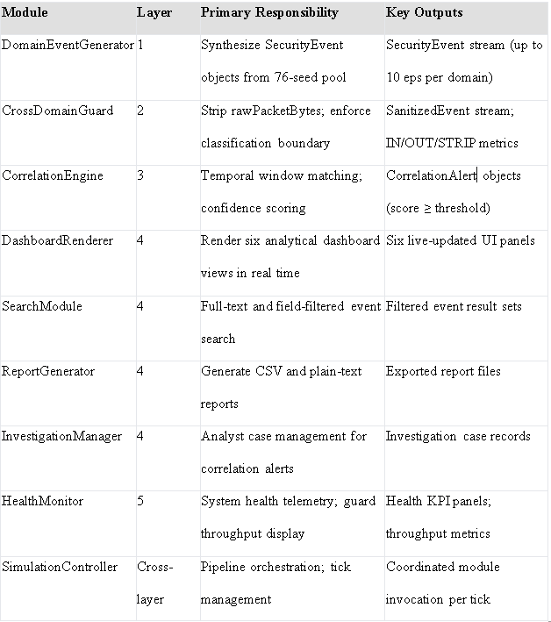

Appendix B — Dashboard Descriptions

Table 5. Dashboard Descriptions

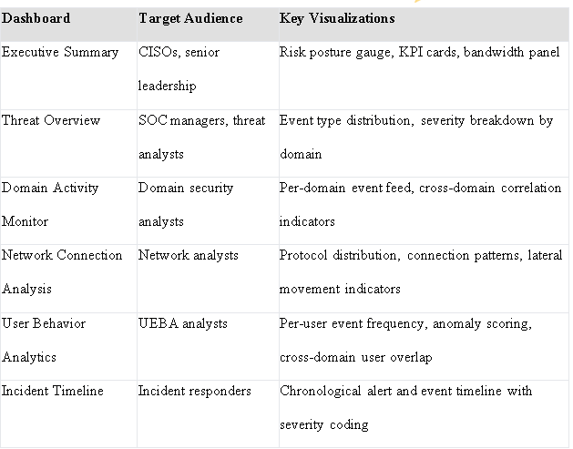

Appendix C — Repository Structure
The GitHub repository (https://github.com/Telieou-source/Unified-Security-View) is organized as follows across 17 commits and four tagged releases (v0.1.0 through v1.2.0):
- /src/modules/ — Nine TypeScript module files implementing each architectural component (DomainEventGenerator, CrossDomainGuard, CorrelationEngine, DashboardRenderer, SearchModule, ReportGenerator, InvestigationManager, HealthMonitor, SimulationController)
- /src/components/ — React component tree for all six dashboards and supporting UI elements
- /src/types/ — Shared TypeScript interface definitions (SecurityEvent, SanitizedEvent, CorrelationAlert)
- /src/data/ — 76 seed event JSON records distributed across eight event types and four severity levels
- /dist/ — Production build output generated by pnpm run build (Vite 7)
- vite.config.ts — Build configuration specifying output paths and plugin settings
- pnpm-lock.yaml — Exact dependency lockfile ensuring reproducible builds across environments

Appendix D — Glossary of Terms

Table D1. Glossary of Terms

