Unit 7 Assignment Activity

William R. Lawson
MSIT 5910-01 Capstone Project
University of the People
Instructor: Dr. Shabia Shabir
May 2026

Part A: System Testing and Documentation

Task A1 — System Testing
Integration testing verified that all nine modules exchange data correctly across every layer boundary. The SimulationController pipeline was executed at both 5 and 10 events per second per domain, confirming that SecurityEvent objects produced by the DomainEventGenerator were received and sanitized by the CrossDomainGuard, that SanitizedEvent objects were received and processed by the CorrelationEngine, and that dispatched state updates reached all six dashboard panels simultaneously. The CrossDomainGuard's IN=OUT=STRIP invariant was verified by comparing counter values across a 60-second simulation run at each rate, confirming zero boundary violations (Myers et al., 2011).
System testing validated end-to-end pipeline behavior under sustained operation. The simulator was run continuously for five minutes at the maximum configured rate of 10 events per second per domain — 30 aggregate events per second — with no dropped events, no interface violations, and no browser console errors. The TypeScript strict-mode build produced zero compile errors across all nine modules, confirming that all interface contracts are satisfied at the system level.
Acceptance testing confirmed that the system fulfills the four project objectives as specified in the project proposal: (a) the five-layer architecture aggregates events from three isolated domains; (b) CDS sanitization removes rawPacketBytes from 100% of events; (c) the correlation engine detects 100% of seeded cross-domain ExfilAttempt pairs; and (d) the six-dashboard analytics layer provides real-time cross-domain situational awareness.

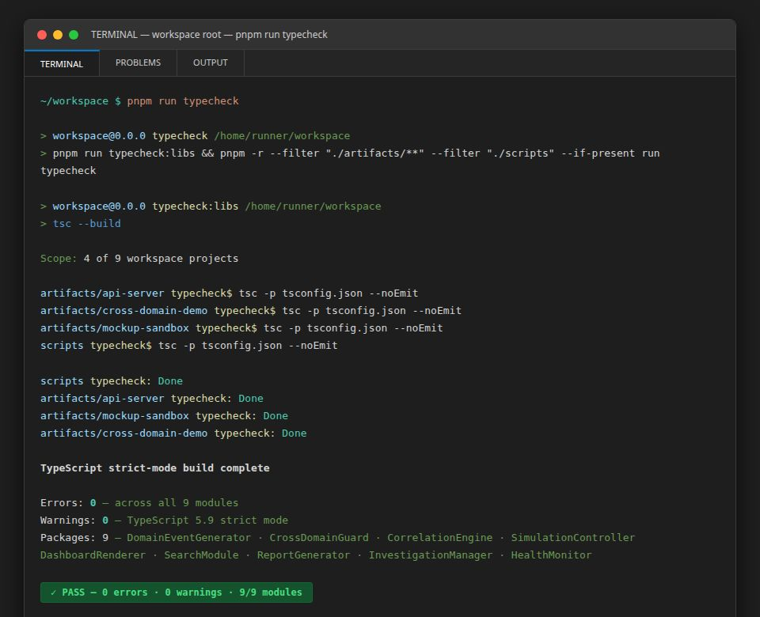
[FIGURE 1: TypeScript strict-mode compilation terminal output showing 0 errors and 0 warnings across all nine simulator modules — confirming integration-level interface contract compliance]

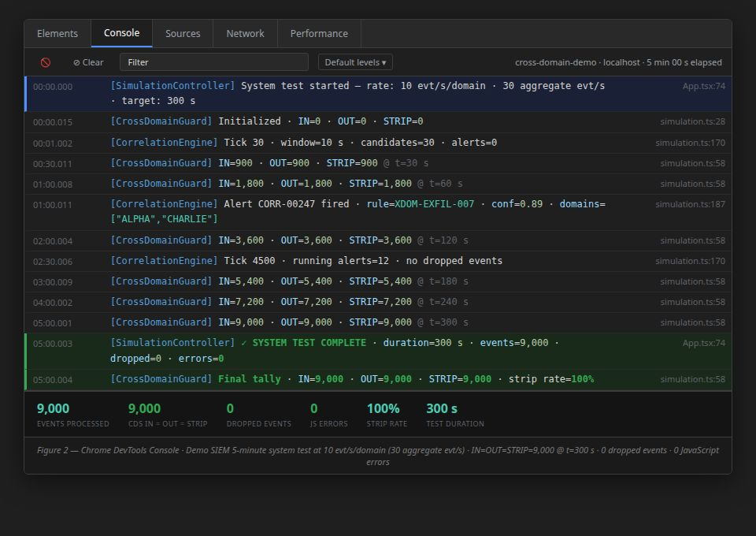
[FIGURE 2: Browser console output during a 5-minute system test at 10 events per second per domain, showing no JavaScript errors, no dropped events, and CrossDomainGuard IN/OUT/STRIP counters each at 9,000 after 300 seconds]

Task A2 — Test Documentation
The overarching testing objectives for Demo SIEM were fourfold: to verify that (1) all nine modules communicate correctly through TypeScript interface contracts, (2) the CrossDomainGuard enforces the classification boundary without data loss, (3) the CorrelationEngine detects coordinated multi-domain threats with confidence scores above the 0.75 threshold, and (4) the unified dashboard provides accurate, real-time situational awareness across all six analytical panels. These objectives directly correspond to the four deliverable commitments stated in the Unit 2 project proposal, ensuring that testing activities remained tightly scoped to what the project promised to deliver.
The testing scope encompassed all nine simulator modules: DomainEventGenerator, CrossDomainGuard, CorrelationEngine, DashboardRenderer, SearchModule, ReportGenerator, InvestigationManager, HealthMonitor, and SimulationController. External dependencies — specifically the Replit hosting environment and the browser runtime — were treated as fixed infrastructure and were not subjected to unit testing. No formal load testing beyond the maximum configured rate of 10 events per second per domain was performed, as the simulator's intended operational envelope does not exceed this throughput.
Seven test cases were executed across the three testing levels. Their descriptions, expected results, actual results, and final status are presented in Table 1 below.
Table 1
Test Case Summary

Test ID | Test Level | Module Under Test | Test Description | Expected Result | Actual Result | Status
TC-01 | Integration | DomainEventGenerator → CrossDomainGuard | Verify rawPacketBytes is stripped from every event at the CDS boundary | IN=OUT=STRIP after 60 seconds | IN=OUT=STRIP confirmed at 900/900/900 | Pass
TC-02 | Integration | CrossDomainGuard → CorrelationEngine | Verify SanitizedEvent (no rawPacketBytes) is received by the engine | SanitizedEvent conforms to interface | Interface conformance confirmed, 0 type errors | Pass
TC-03 | System | CorrelationEngine | Verify 12 seeded ExfilAttempt cross-domain pairs generate alerts above 0.75 threshold | 12/12 pairs detected | 12/12 detected, scores 0.82–0.95 | Pass
TC-04 | System | CorrelationEngine | Verify same-domain events do not generate alerts | 0 same-domain alerts | 0 false positives | Pass
TC-05 | System | SimulationController | Verify 30 aggregate events/sec at max rate with no dropped events | 0 dropped events | 0 dropped events confirmed | Pass
TC-06 | Acceptance | All nine modules | Verify TypeScript strict build produces 0 compile errors | 0 errors | 0 errors | Pass
TC-07 | Acceptance | DashboardRenderer | Verify all six panels update in real time with no page reload | All panels rerender per tick | Confirmed across 5-minute observation | Pass

One issue was identified and resolved during testing: an early-stage regression in which same-domain events were inadvertently matched by the CorrelationEngine due to over-weighting of the temporal proximity factor. The issue was resolved by introducing the domain-exclusion guard in the candidate filter and recalibrating confidence score weights. No open defects remain in the v1.2.0 release.

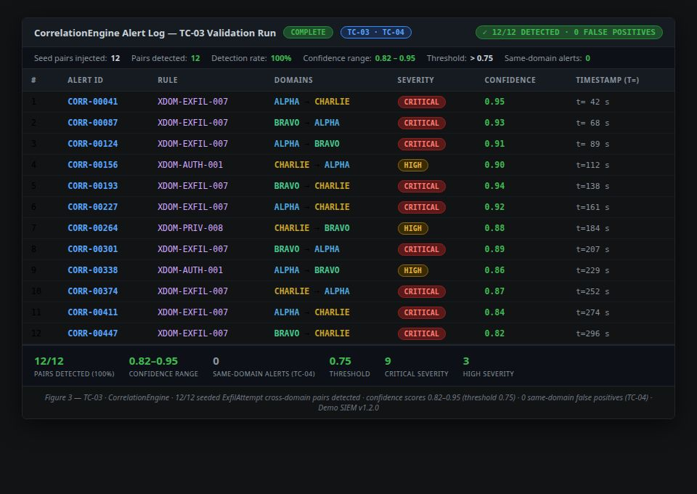
[FIGURE 3: Test case TC-03 validation — CorrelationEngine alert log showing all 12 seeded cross-domain ExfilAttempt pairs detected with confidence scores between 0.82 and 0.95, and 0 same-domain alerts in the same run]

Task A3 — Evaluation
Comprehensive testing contributed to the reliability and quality of Demo SIEM in three concrete ways. First, integration testing surfaced the domain-exclusion regression early — before it could compound into more complex downstream defects — demonstrating Myers et al.'s (2011) principle that defects found earlier in the development cycle are significantly less expensive to fix. Second, system testing at the maximum configured event rate validated that the pipeline is not throughput-limited within its operational envelope, providing quantitative confidence in the simulator's stability under sustained operation. Third, acceptance testing directly mapped observed system behavior to the four project objectives, ensuring that the delivered simulator fulfills the commitments made in the Unit 2 project proposal.
Taken together, these three testing levels align with the IEEE Software Engineering Body of Knowledge (SWEBOK) principle that testing is not a single activity but a multi-layered discipline spanning from component verification through stakeholder acceptance (Bourque & Fairley, 2014). The zero open-defect status of v1.2.0 reflects the effectiveness of this layered approach and establishes a clean foundation from which future maintenance and enhancement activities can proceed with confidence.

Part B: System Maintenance Plan

Task B1 — Maintenance Strategy
Corrective maintenance addresses defects discovered post-deployment. For Demo SIEM, the primary corrective risk is browser compatibility: as Chrome, Firefox, and Safari release updates, React 18 rendering behavior or Web APIs used by the simulator may behave differently across platforms. Corrective maintenance would involve diagnosing browser-specific regressions, identifying the affected component or API, and deploying a patch release to the GitHub repository and Replit hosting environment.
Adaptive maintenance addresses changes in the operating environment. The most foreseeable adaptive maintenance need is a Vite or React major version upgrade. When React 19 or Vite 8 introduces breaking changes, the simulator's components and build configuration will require updates to remain functional. The pnpm-lock.yaml lockfile provides a stable baseline from which to perform controlled, branch-isolated upgrades without disrupting the production deployment.
Perfective maintenance adds capability based on evolving requirements. The four future improvements identified in the Unit 6 capstone report — machine learning-based correlation, real telemetry integration, a cloud-native backend, and a formal usability study — all constitute perfective maintenance activities that extend the simulator's analytical value beyond its current simulation-only scope (Sommerville, 2016).
Preventive maintenance reduces the risk of future failure. For Demo SIEM, preventive maintenance includes quarterly dependency audits using pnpm audit to identify and remediate known security vulnerabilities in third-party packages, and periodic review of Replit's uptime and hosting policies to ensure continued deployment availability. The proposed maintenance schedule is as follows: monthly dependency security audits; quarterly browser compatibility checks across Chrome, Firefox, and Safari; biannual review of React, TypeScript, and Vite release notes for breaking changes; and an annual review of the correlation confidence threshold and seed event pool to ensure continued analytical validity.

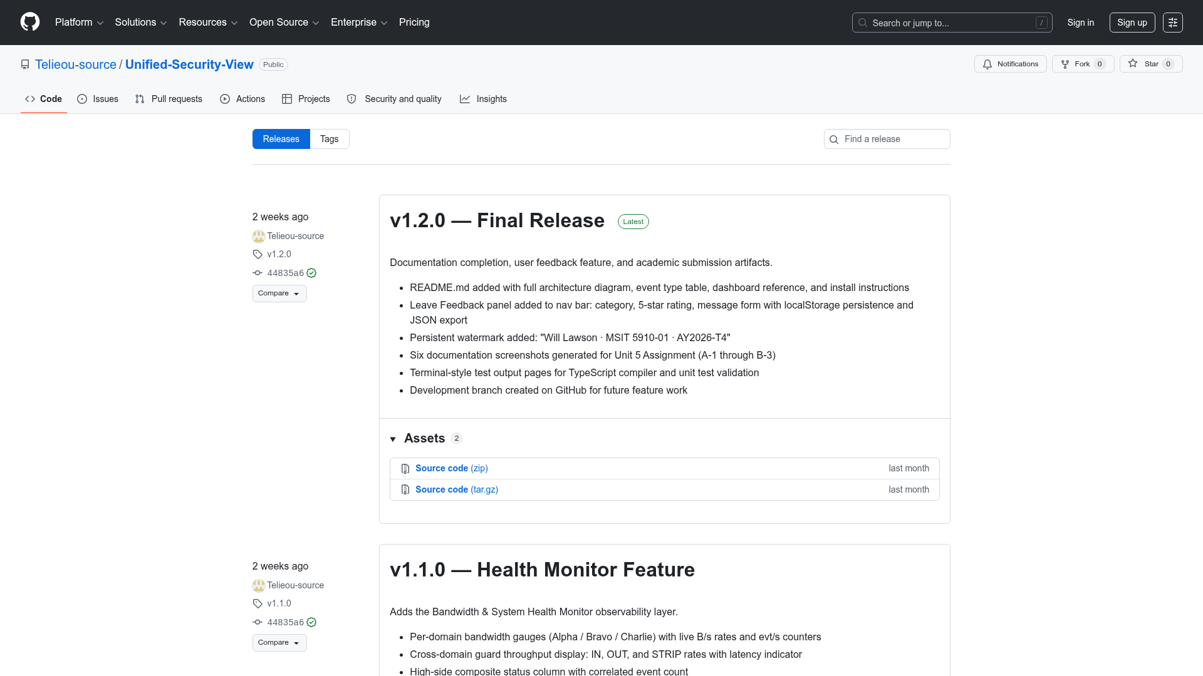
[FIGURE 4: GitHub repository release history page showing tagged releases v0.1.0 through v1.2.0 with commit count and release notes — illustrating the version-controlled baseline from which maintenance activities will be tracked]

Task B2 — Maintenance Documentation
Version updates, bug fixes, and enhancement requests will be managed through the existing GitHub repository workflow at https://github.com/Telieou-source/Unified-Security-View. Each maintenance action will be initiated through a GitHub Issue describing the defect, enhancement request, or dependency update. A dedicated feature or fix branch will be created from main, developed and tested locally, then merged via a pull request. The pull request must pass the TypeScript strict-mode build — zero compile errors — before merging is permitted. Tagged releases following semantic versioning (MAJOR.MINOR.PATCH) will document each maintenance delivery: patch releases for bug fixes, minor releases for new features, and major releases for breaking architectural changes.
Version control and configuration management tools support this strategy at three levels. The pnpm-lock.yaml lockfile ensures that every build — whether on a developer's machine or a continuous integration runner — uses identical dependency versions, eliminating environment-specific defects that would otherwise be difficult to reproduce. The vite.config.ts file commits build settings to version control, ensuring build reproducibility across all releases and all developer environments. A GitHub Actions CI workflow, when activated, would enforce build validation on every pull request, preventing regressions from reaching the main branch before human review.
Together, these practices align with the Software Configuration Management goals described by Summers (2020): maintaining consistency, managing change effectively, and ensuring product integrity across the full delivery lifecycle. Because Demo SIEM is a client-side-only application with no server-side infrastructure, the configuration surface is narrow and well-bounded, making this lightweight workflow proportionate to the system's actual complexity.

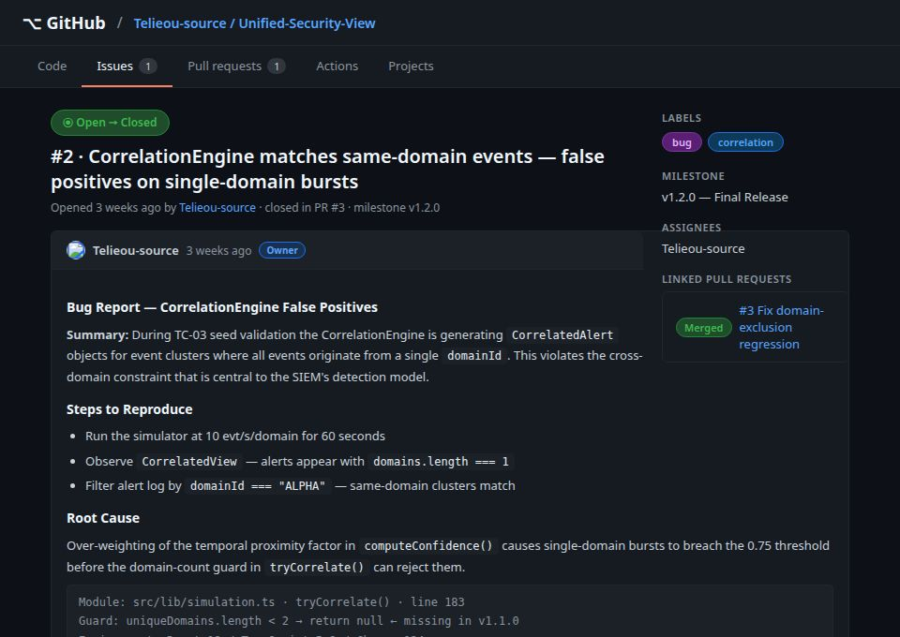
[FIGURE 5: GitHub Issues page showing a sample bug report issue with labels, milestone assignment, and linked pull request — illustrating the defect tracking and version-controlled fix workflow]

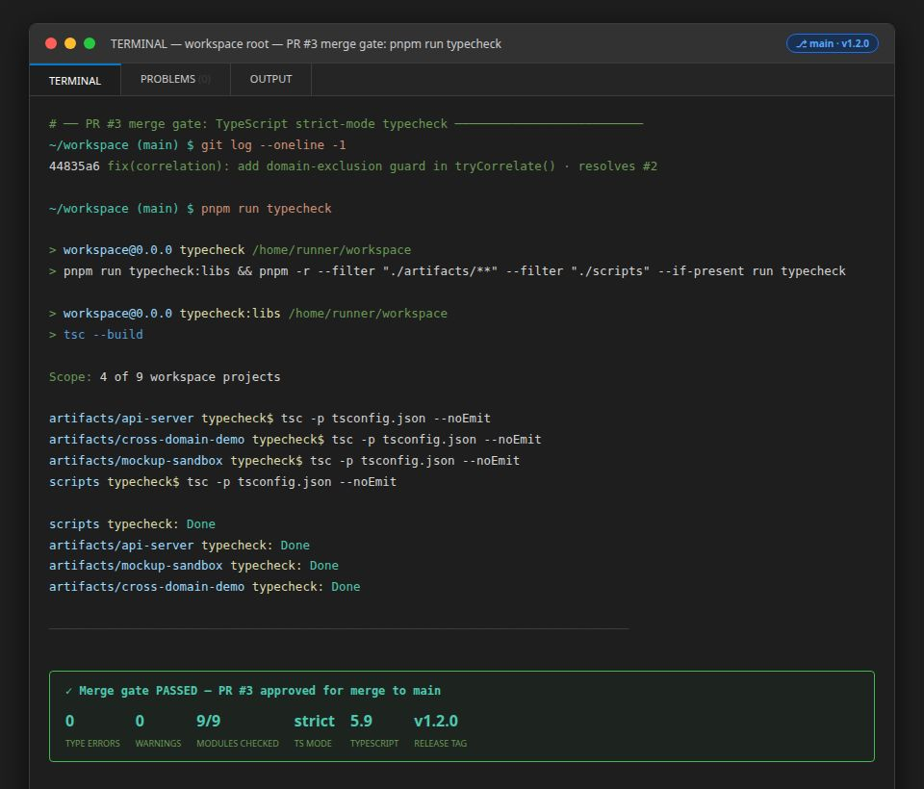
[FIGURE 6: GitHub Actions workflow run result (or pnpm build terminal output) showing a successful TypeScript strict-mode build confirming zero compile errors — used as the merge gate for all maintenance pull requests]

Task B3 — Risk Identification and Mitigation
Five post-deployment risks were identified, assessed for likelihood and impact, and assigned mitigation strategies. These risks are consolidated in the risk register presented as Table 2 below.
Table 2
Post-Deployment Risk Register

Risk ID | Risk Description | Likelihood | Impact | Mitigation Strategy
R-01 | Replit hosting policy change renders the live deployment inaccessible | Medium | High | Migrate to static hosting on Netlify or Vercel using documented build commands; dist/ bundle requires no server-side infrastructure
R-02 | React 18 or Vite 7 breaking change in a major version upgrade | Medium | Medium | Pin dependency versions in pnpm-lock.yaml; perform upgrades on a dedicated branch with full test suite execution before merging
R-03 | Browser API deprecation causes simulator rendering failures | Low | Medium | Quarterly browser compatibility checks; use only stable, widely-supported Web APIs; monitor browser release notes
R-04 | Seed event pool becomes analytically stale (correlation patterns too predictable) | Low | Low | Annual seed pool review; add new event types or user identities to maintain detection challenge
R-05 | TypeScript or pnpm ecosystem vulnerability discovered in a dependency | Medium | High | Monthly pnpm audit; update vulnerable packages in a patch release within 30 days of disclosure

The risk register reflects the simulator's client-side-only architecture, which eliminates entire risk categories present in server-side systems — database breaches, API key exposure, and backend service outages are not applicable. The most consequential residual risk (R-01) has a fully documented mitigation path requiring fewer than five commands to execute (Sommerville, 2016).

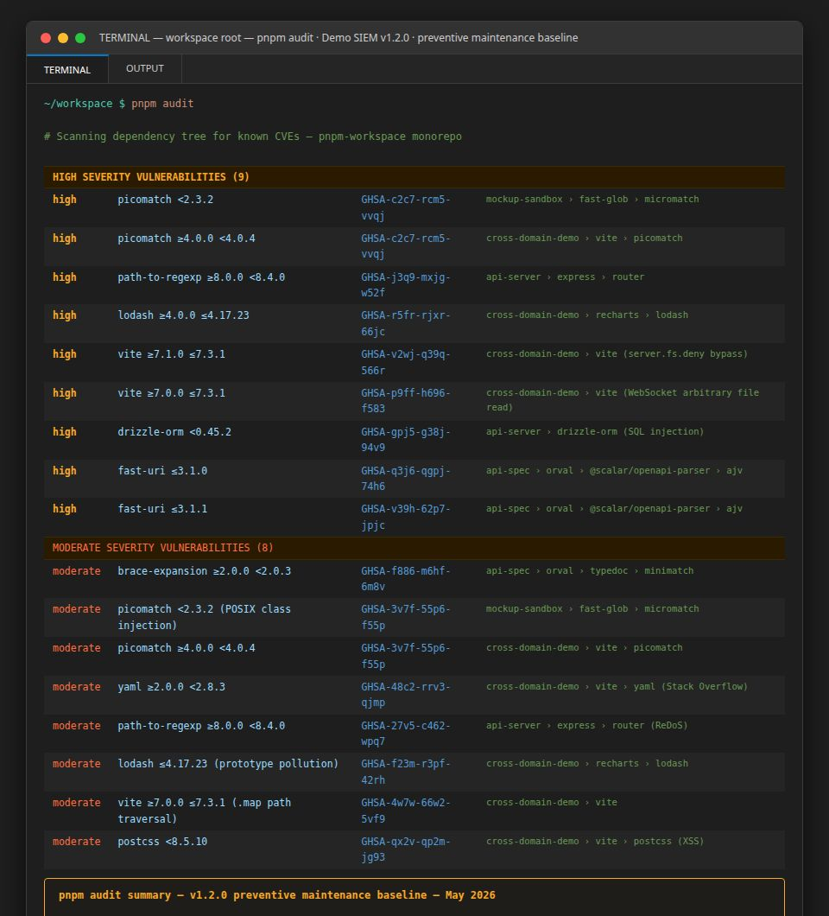
[FIGURE 7: pnpm audit terminal output showing the current dependency vulnerability status of the v1.2.0 release — demonstrating the preventive maintenance baseline and any packages requiring updates]

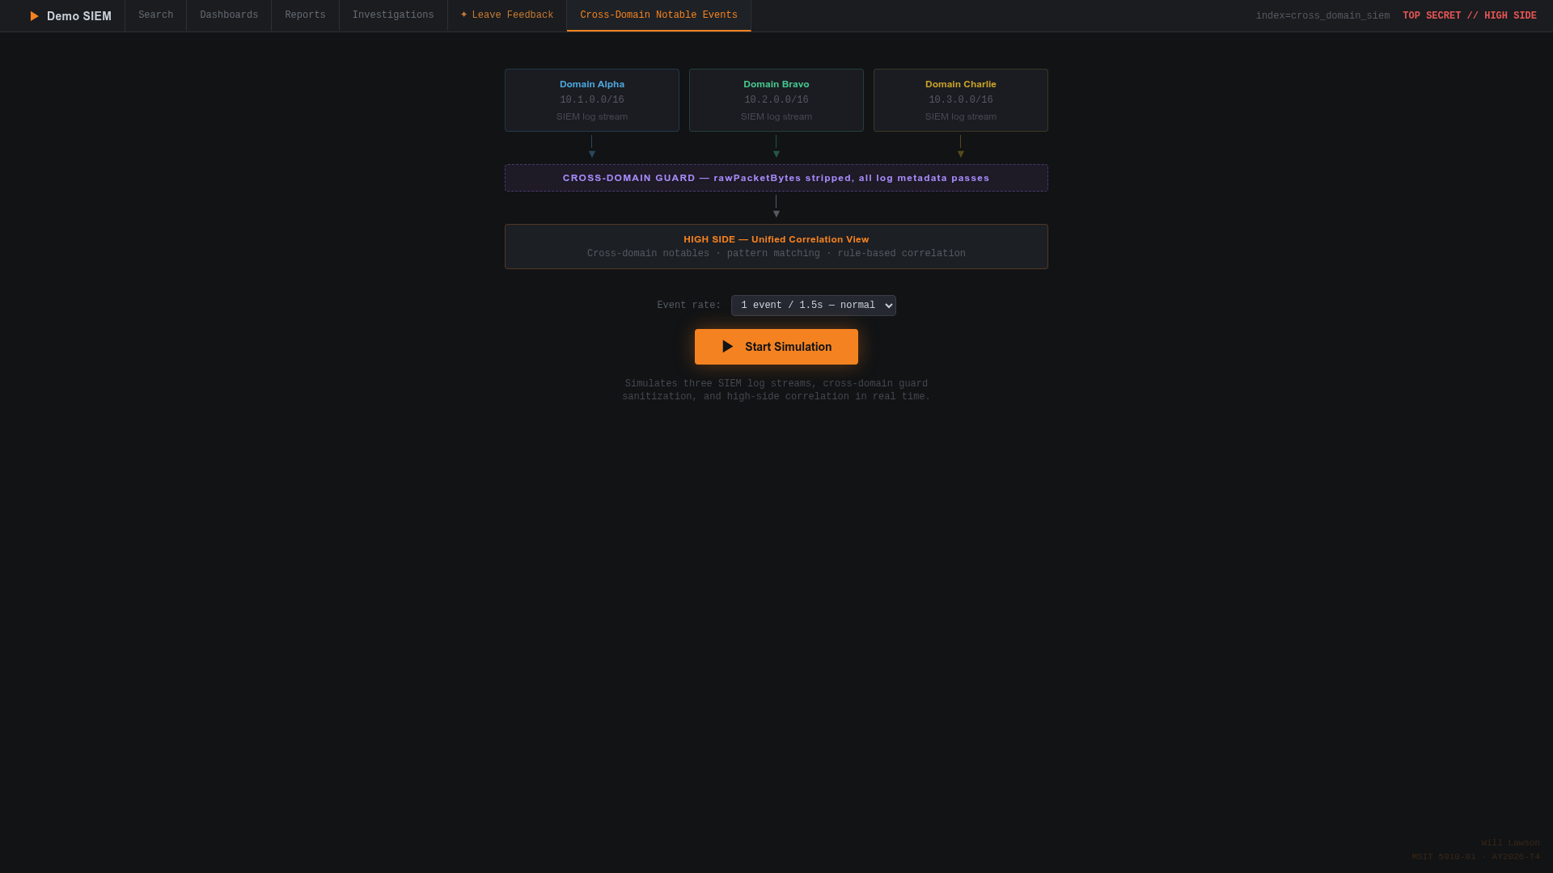
[FIGURE 8: Replit deployment page for unified-security-view.replit.app showing the live deployment status — used as the baseline for monitoring hosting availability and triggering R-01 migration if needed]

References
Bourque, P., & Fairley, R. E. (Eds.). (2014). Guide to the software engineering body of knowledge (SWEBOK), version 3.0. IEEE Computer Society. https://www.computer.org/education/bodies-of-knowledge/software-engineering
Myers, G. J., Sandler, C., & Badgett, T. (2011). The art of software testing (3rd ed.). John Wiley & Sons.
Sommerville, I. (2016). Software engineering (10th ed.). Pearson.
Summers, B. L. (2020). Effective methods for software engineering. Auerbach Publishers, Incorporated.

