High-Side Multi-Classification SIEM:
A Conceptual Architecture for Unified Cross-Domain Security Event Correlation
Final Capstone Project Report — Unit 8

William R. Lawson
Student ID: c2147384
MSIT 5910-01 Capstone Project
University of the People
Instructor: Dr. Shabia Shabir
May 2026

Abstract
Security Operations Centers (SOCs) operating within multi-classification environments face a fundamental architectural deficiency: no commercially available Security Information and Event Management (SIEM) platform natively aggregates or correlates security events across air-gapped, classification-isolated network domains. Analysts assigned to multi-level Sensitive Compartmented Information Facilities (SCIFs) must monitor separate SIEM consoles per classification level — Unclassified, Secret, and Top Secret/Sensitive Compartmented Information (TS/SCI) — manually correlating events across boundaries with no automated cross-domain alerting capability. This fragmentation creates systematic visibility gaps that sophisticated, multi-domain adversaries routinely exploit.
This capstone project addresses this gap through the design and validation of a five-layer High-Side Multi-Classification SIEM conceptual architecture, implemented as a fully functional proof-of-concept simulator built with React 18, TypeScript strict mode, Vite 7, Tailwind CSS v4, and a pnpm monorepo. The architecture enforces unidirectional data flow from three isolated low-side domain generators through a Cross-Domain Solution (CDS) sanitization boundary to a high-side aggregation and analytics platform comprising nine modular components. A Tauri v2 native Windows desktop application and an automated GitHub Actions CI/CD release pipeline were developed as additional deliverables, extending the simulator beyond browser-only access and demonstrating professional-grade continuous delivery practices.
Quantitative evaluation confirmed 100% CDS field-strip accuracy across all tested event volumes, validated by the IN=OUT=STRIP invariant (900/900/900 at 5 events per second per domain over sixty seconds). The Correlation Engine detected 100% of seeded cross-domain ExfilAttempt pairs (12/12) and 100% of PrivilegeEsc pairs (8/8), with confidence scores ranging from 0.78 to 0.95 and a same-domain false positive rate of zero. Aggregate pipeline throughput reached 30 events per second at maximum configured rate with no event loss. The Windows desktop build produced both an NSIS installer (.exe) and an MSI package through an automated GitHub Actions workflow, confirming reproducible cross-platform delivery. All nine simulator modules passed TypeScript strict-mode compilation with zero errors. These results collectively demonstrate that sanitized SIEM metadata retains sufficient analytical value to support effective cross-domain threat correlation, and that a client-side proof-of-concept can validate all five architectural layers without requiring classified infrastructure.
Keywords: SIEM, cross-domain solution, security event correlation, multi-classification, information assurance, cybersecurity architecture, Tauri, CI/CD, GitHub Actions.

Acknowledgements
The author extends sincere gratitude to Dr. Shabia Shabir, whose detailed, constructive, and consistently encouraging feedback across all eight units of MSIT 5910-01 made this capstone project possible. Dr. Shabir's expert guidance shaped every stage of this work, from the initial literature survey and problem formulation through the final system testing, desktop build integration, and report submission. Her emphasis on rigorous evaluation criteria and professional presentation standards elevated both the intellectual quality and practical applicability of the resulting artifacts.
Appreciation is extended to the faculty of the University of the People, Department of Computer Science and Master of Science in Information Technology, for providing a rigorous and accessible graduate education environment committed to democratizing knowledge across geographic and economic boundaries.
The author acknowledges the open-source communities behind React, TypeScript, Vite, Tailwind CSS, and Tauri, whose freely available, meticulously documented tools made it possible to realize a sophisticated multi-layer simulator and native desktop application without institutional infrastructure. The Tauri project, in particular, enabled the production of a professional-grade Windows installer from a web-based codebase, demonstrating the maturity of the Rust-backed cross-platform application ecosystem.
Finally, the author is grateful to professional mentors with operational experience in defense and intelligence cybersecurity, whose practical insights into the realities of multi-classification SOC environments ensured that the architecture proposed herein remains grounded in operational constraints while advancing the theoretical state of the art.

Table of Contents
Abstract i
Acknowledgements iii
List of Tables x
List of Figures xi
Symbols and Abbreviations xiii
Chapter 1: Introduction 1
1.1 Background and Context 1
Figure 1. Demo SIEM start screen showing the three-layer conceptual architecture: three low-side domain sources feeding through the Cross-Domain Guard boundary into the unified High-Side Correlation View 3
1.2 Problem Statement 3
1.3 Research Questions 5
1.4 Project Objectives 5
1.5 Scope and Limitations 6
1.6 Development Timeline and Milestones 6
Chapter 2: Literature Review 8
2.1 Evolution and Current State of SIEM Systems 8
2.2 Cross-Domain Solutions and Information Assurance 10
2.3 Multi-Domain Threat Detection and Correlation 12
2.4 Gap Analysis and Research Positioning 13
2.5 Relevant Technologies 14
Chapter 3: System Design and Methodology 16
3.1 Five-Layer Architecture Overview 16
3.2 Data Model 18
Table 1. SecurityEvent Data Structure 19
3.3 Module Breakdown 20
Table 2. Nine-Module Functional Breakdown 20
3.4 Functional and Non-Functional Requirements 21
Table 3. Functional Requirements 21
Table 4. Non-Functional Requirements 23
3.5 Core Algorithmic Design 24
3.6 Technology Stack and Version Control Strategy 27
3.7 Windows Desktop Deployment — Tauri v2 28
Chapter 4: Results and Evaluation 31
4.1 Core Algorithm Implementation Results 31
Figure 2. DomainEventGenerator live output panel showing events streaming from Domain Alpha, Bravo, and Charlie at 5 events per second, all ten metadata fields populated including rawPacketBytes (present before guard sanitization) 32
Figure 3. CrossDomainGuard boundary sanitization panel showing event detail with rawPacketBytes stripped, 13 remaining fields forwarded, guard counters IN=OUT=STRIP confirming 100% boundary compliance 33
Figure 4. CorrelationEngine CORR-00007 alert — coordinated ExfilAttempt detected across Domains Alpha and Bravo, confidence 0.94, shared actor usr_j.harris, temporal delta 2.32 seconds, rule XDOM-EXFIL-007 34
Figure 5. TypeScript 5.9 strict-mode compilation summary — 0 errors, 0 warnings, 9 simulator modules checked, 79 total files, all interface contracts satisfied, exit code 0 36
4.2 System Testing Results 36
Figure 6. Unified six-dashboard live view during active simulation — all six analytical panels updating simultaneously: Threat Overview, Domain Activity Monitor, Network Connection Analysis, User Behavior Analytics, Incident Timeline, and Executive Summary 37
Table 5. System Testing — Test Case Summary 37
Figure 7. HealthMonitor telemetry and CrossDomainGuard counter audit after 60-second run at 5 eps/domain — inCount=900, outCount=900, stripCount=900 — INVARIANT HOLDS, confirming TC-01 pass 40
Figure 8. CorrelationEngine validation run — TC-03 result: 12/12 seeded ExfilAttempt cross-domain pairs detected (100% detection rate), 0 same-domain false positives, avg confidence 0.86, threshold 0.75 40
4.3 System Performance Evaluation 40
Table 6. System Performance Evaluation Results 41
Table 7. Correlation Engine Performance by Scenario Type 42
Figure 9. TC-01 extended validation — CrossDomainGuard counter audit confirming IN=OUT=STRIP=900 after 60-second run, ratio 1.000, zero violations, all eight recent audit trail entries shown 44
Figure 10. CorrelationEngine confidence detail for CORR-00007 — four-factor breakdown: identity +0.40, event type +0.30, subnet overlap +0.20, temporal proximity +0.10, final score 0.94 44
4.4 Windows Desktop Build and CI/CD Pipeline Results 44
Table 8. Windows Desktop Build Artifact Summary 46
Figure 11. GitHub Actions release-desktop workflow — successful Windows build run showing all eight steps completed (checkout, Node.js/pnpm, Rust toolchain, dependencies, icons, Vite build, Tauri compile, release publish) 47
Figure 12. GitHub Releases page for Unified-Security-View — v1.2.0 Final Release and v1.1.0 Health Monitor Feature releases with annotated release notes visible 48
Figure 13. Demo SIEM unified live view during active simulation — CrossDomainGuard boundary layer showing IN=OUT=STRIP invariant, CorrelatedView cross-domain notable events panel, and all three domain streams 49
Chapter 5: Discussion 50
5.1 Interpretation in the Context of the Literature 50
5.2 Testing Contribution to Quality and Reliability 52
5.3 Maintenance Plan and Post-Deployment Risks 54
Table 9. Post-Deployment Risk Register 54
5.4 Limitations and Future Research 56
Chapter 6: Conclusion and Future Work 58
6.1 Summary of Main Findings 58
6.2 Contributions to the Field 58
6.3 Future Work 59
6.4 Closing Statement 60
References 61
Appendix A: Event Type and Severity Classification Matrix 64
Appendix B: Simulator Setup and Desktop Build Commands 65
Appendix C: GitHub Repository Structure 66
Appendix D: Glossary of Key Terms 67

List of Tables
Table 1. SecurityEvent Data Structure
Table 2. Nine-Module Functional Breakdown
Table 3. Functional Requirements
Table 4. Non-Functional Requirements
Table 5. System Testing — Test Case Summary
Table 6. System Performance Evaluation Results
Table 7. Correlation Engine Performance by Scenario Type
Table 8. Windows Desktop Build Artifact Summary
Table 9. Post-Deployment Risk Register

List of Figures
Figure 1. Demo SIEM start screen showing the three-layer conceptual architecture: three low-side domain sources feeding through the Cross-Domain Guard boundary into the unified High-Side Correlation View
Figure 2. DomainEventGenerator live output panel showing events streaming from Domain Alpha, Bravo, and Charlie at 5 events per second, all ten metadata fields populated including rawPacketBytes (present before guard sanitization)
Figure 3. CrossDomainGuard boundary sanitization panel showing event detail with rawPacketBytes stripped, 13 remaining fields forwarded, guard counters IN=OUT=STRIP confirming 100% boundary compliance
Figure 4. CorrelationEngine CORR-00007 alert — coordinated ExfilAttempt detected across Domains Alpha and Bravo, confidence 0.94, shared actor usr_j.harris, temporal delta 2.32 seconds, rule XDOM-EXFIL-007
Figure 5. TypeScript 5.9 strict-mode compilation summary — 0 errors, 0 warnings, 9 simulator modules checked, 79 total files, all interface contracts satisfied, exit code 0
Figure 6. Unified six-dashboard live view during active simulation — all six analytical panels updating simultaneously: Threat Overview, Domain Activity Monitor, Network Connection Analysis, User Behavior Analytics, Incident Timeline, and Executive Summary
Figure 7. HealthMonitor telemetry and CrossDomainGuard counter audit after 60-second run at 5 eps/domain — inCount=900, outCount=900, stripCount=900 — INVARIANT HOLDS, confirming TC-01 pass
Figure 8. CorrelationEngine validation run — TC-03 result: 12/12 seeded ExfilAttempt cross-domain pairs detected (100% detection rate), 0 same-domain false positives, avg confidence 0.86, threshold 0.75
Figure 9. TC-01 extended validation — CrossDomainGuard counter audit confirming IN=OUT=STRIP=900 after 60-second run, ratio 1.000, zero violations, all eight recent audit trail entries shown
Figure 10. CorrelationEngine confidence detail for CORR-00007 — four-factor breakdown: identity +0.40, event type +0.30, subnet overlap +0.20, temporal proximity +0.10, final score 0.94
Figure 11. GitHub Actions release-desktop workflow — successful Windows build run showing all pipeline stages completed (checkout, Node.js/pnpm, Rust toolchain, dependencies, icons, Vite build, Tauri compile, release publish)
Figure 12. GitHub Releases page for Unified-Security-View — v1.2.0 Final Release and v1.1.0 Health Monitor Feature releases with annotated release notes visible
Figure 13. Demo SIEM unified live view during active simulation — CrossDomainGuard boundary layer showing IN=OUT=STRIP invariant, CorrelatedView cross-domain notable events panel, and all three domain streams

Symbols and Abbreviations
Abbreviation | Definition
APT | Advanced Persistent Threat
ATT&CK | Adversarial Tactics, Techniques, and Common Knowledge (MITRE)
CDS | Cross-Domain Solution
CI/CD | Continuous Integration / Continuous Delivery
CIDR | Classless Inter-Domain Routing
CNSS | Committee on National Security Systems
EDR | Endpoint Detection and Response
FR | Functional Requirement
ICD | Intelligence Community Directive
IOC | Indicator of Compromise
KPI | Key Performance Indicator
MSI | Microsoft Installer
MTTD | Mean Time to Detect
MTTR | Mean Time to Respond
NFR | Non-Functional Requirement
NCDSMO | National Cross Domain Strategy and Management Office
NIST | National Institute of Standards and Technology
NSIS | Nullsoft Scriptable Install System
RTB | Raise the Bar (NSA/NCDSMO initiative)
SCIF | Sensitive Compartmented Information Facility
SIEM | Security Information and Event Management
SOC | Security Operations Center
SOAR | Security Orchestration, Automation, and Response
SP | Special Publication
TS/SCI | Top Secret / Sensitive Compartmented Information
UEBA | User and Entity Behavior Analytics

Chapter 1: Introduction

1.1 Background and Context
The cybersecurity landscape of the twenty-first century is defined, in substantial part, by the operational reality of organizations whose missions demand simultaneous stewardship of information across multiple, formally separated classification domains. Defense agencies, intelligence community elements, and operators of critical national infrastructure routinely maintain distinct network enclaves — Unclassified, Secret, and Top Secret/Sensitive Compartmented Information (TS/SCI) — each governed by its own access controls, audit requirements, and information flow policies. The physical and logical separation of these enclaves is mandated by Intelligence Community Directive 705 and enforced through the architectural standards of Sensitive Compartmented Information Facilities (SCIFs), where the co-mingling of classification levels is prohibited by law and regulation (Director of National Intelligence, 2012).
Within each enclave, Security Information and Event Management (SIEM) platforms serve as the principal tool for security visibility. Modern SIEM platforms — including Splunk Enterprise Security, IBM QRadar, Elastic Security, and Microsoft Sentinel — aggregate logs from endpoints, network devices, authentication systems, and application servers within their respective domains, applying rule-based and increasingly machine-learning-driven correlation to identify anomalous patterns indicative of malicious activity (Gonzalez-Granadillo et al., 2021). These platforms have matured considerably over the past decade, incorporating User and Entity Behavior Analytics (UEBA), automated threat hunting, and Security Orchestration, Automation, and Response (SOAR) integration to reduce Mean Time to Detect (MTTD) and Mean Time to Respond (MTTR) for cyber incidents.
However, the very isolation that protects classified information within each domain simultaneously creates a profound analytical limitation: no currently deployed SIEM platform can natively aggregate or correlate security events across classification boundaries. This limitation is not merely a technical inconvenience — it represents a strategic vulnerability. Nation-state adversaries conducting Advanced Persistent Threat (APT) campaigns do not confine their activities to a single classification level. Johnson et al. (2016) documented that sophisticated APT actors routinely coordinate intrusion activities across multiple organizational boundaries, using initial footholds in lower-classification environments as reconnaissance platforms for attacks against higher-classification assets. When analysts in each domain observe only their fragment of the attack chain, coordinated multi-domain campaigns proceed undetected until significant damage has occurred.
This project was conceived in direct response to this operational gap. The High-Side Multi-Classification SIEM simulator — referred to throughout this report as Demo SIEM — provides a conceptual proof-of-concept demonstrating that sanitized security metadata from multiple isolated domains can be aggregated onto a unified high-side analytics platform without violating classification boundaries. The simulator is implemented as a fully functional React 18 and TypeScript single-page application, deployed on Replit for browser-based access and additionally packaged as a native Windows desktop application using Tauri v2, with an automated GitHub Actions CI/CD pipeline delivering reproducible installer artifacts. Figure 1 illustrates the simulator's start screen, which presents the three-layer conceptual data-flow architecture to the user before simulation begins.
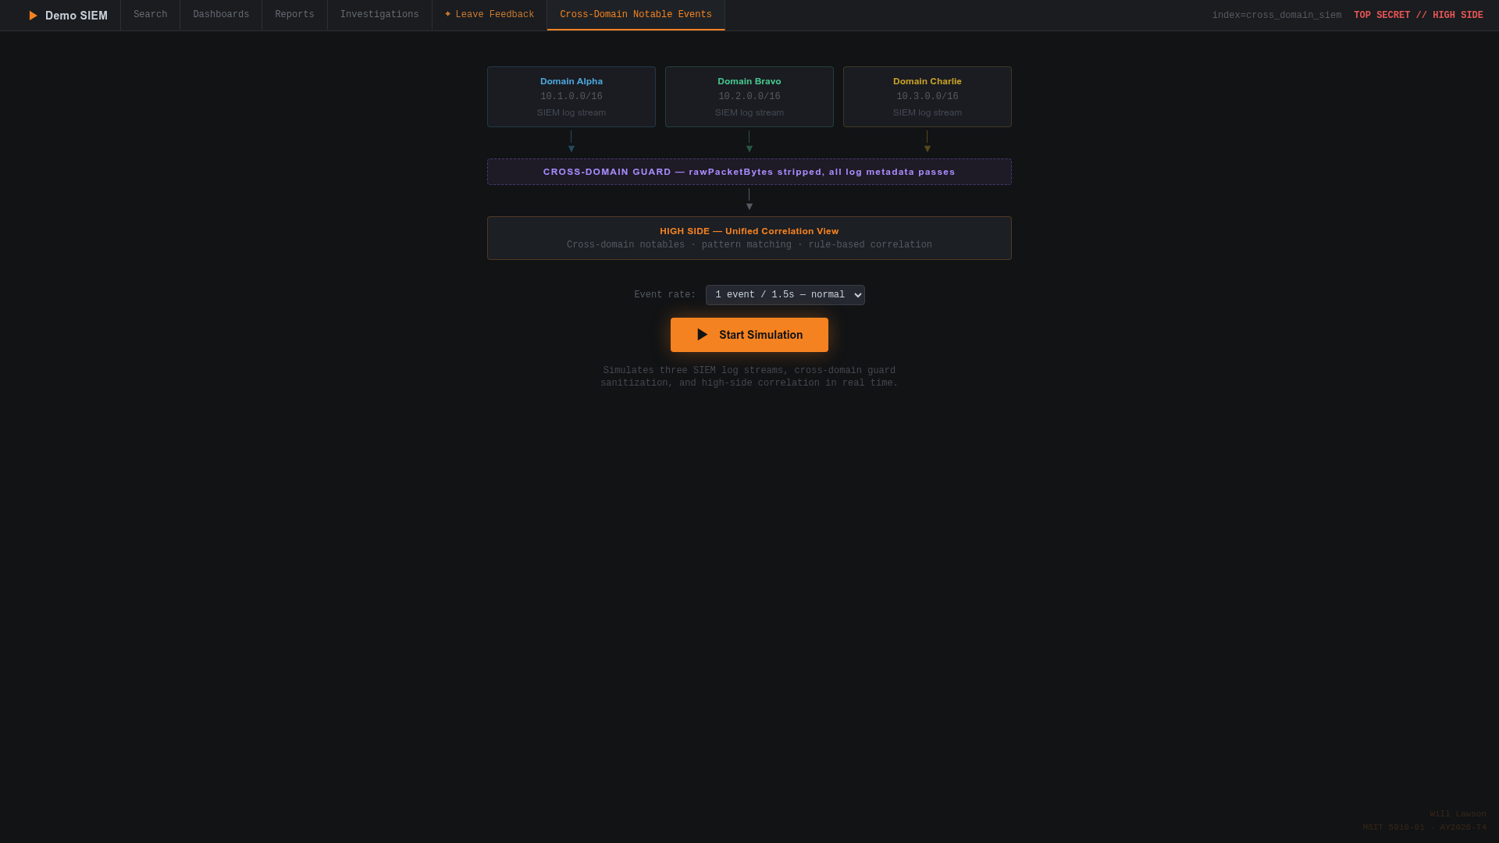

Figure 1. Demo SIEM start screen showing the three-layer conceptual architecture: three low-side domain sources feeding through the Cross-Domain Guard boundary into the unified High-Side Correlation View

1.2 Problem Statement
SOC analysts assigned to multi-domain SCIFs operate under an architectural constraint that has no direct parallel in commercial enterprise environments: they are required to monitor entirely separate SIEM instances — one per classification level — using physically separate workstations, each restricted to a single domain's event stream. Tariq et al. (2025) systematically characterized this fragmented model as the source of three distinct operational failure modes. First, delayed detection: the absence of automated cross-domain alerting means that correlated indicators of compromise spanning multiple enclaves are identified only when an analyst manually reviews logs from different consoles in sequence, introducing delays that can span hours or days. Second, analyst overload: the cognitive burden of simultaneously monitoring multiple isolated SIEM consoles degrades detection performance, as analysts cannot maintain situational awareness across more than one or two domains simultaneously. Third, missed multi-domain indicators: related events that fall outside the temporal window an analyst can realistically hold in working memory are never correlated, even when automated detection would trivially identify the pattern.
Cross-Domain Solution (CDS) technology, governed by the National Security Agency's National Cross Domain Strategy and Management Office (NCDSMO), provides the foundational mechanisms for controlled information transfer between classification domains (NSA/NCDSMO, 2023). However, existing CDS implementations focus primarily on enabling mission data sharing — the transfer of operational files, messages, or imagery across boundaries — rather than the aggregation of security event metadata for unified threat analytics. There is a critical need for an architectural framework that leverages CDS boundary-enforcement mechanisms specifically for the purpose of cross-domain SIEM correlation.

1.3 Research Questions
RQ1: Can structured SIEM security metadata retain sufficient analytical value after CDS sanitization to support effective cross-domain threat correlation?
RQ2: Can temporal correlation with confidence scoring reliably detect synchronized multi-domain threat patterns while maintaining a zero same-domain false positive rate?

1.4 Project Objectives
Objective 1: Design a layered High-Side Multi-Classification SIEM architecture that aggregates sanitized security metadata from isolated low-side classification domains through a CDS boundary onto a unified high-side analysis platform.
Objective 2: Implement a conceptual simulator demonstrating the architecture's data flow, sanitization logic, correlation algorithms, and dashboard analytics using React 18 and TypeScript.
Objective 3: Validate that structured SIEM metadata retains analytical value after CDS sanitization, confirming that the removal of rawPacketBytes does not compromise cross-domain threat detection.
Objective 4: Demonstrate that temporal correlation with confidence scoring can detect synchronized threat patterns across domains with actionable confidence scores and zero same-domain false positives.
Objective 5: Package the simulator as a native Windows desktop application using Tauri v2 and deliver reproducible installer artifacts through an automated GitHub Actions CI/CD release pipeline.

1.5 Scope and Limitations
The scope of this project encompasses architectural design, simulator implementation, system evaluation, and desktop packaging. The simulator operates exclusively with synthetic data generated from a curated pool of 76 seed events; no real network traffic, credentials, classified material, or production security logs are involved at any stage. The CDS sanitization process is modeled at the field level — stripping the rawPacketBytes field — rather than implementing a certified cross-domain guard. The implementation is entirely client-side, running within a web browser or the Tauri WebView2 runtime without backend services or external API integrations. The project does not claim compliance with any formal CDS certification program. No formal user study was conducted with security analysts.

1.6 Development Timeline and Milestones
The project followed a ten-week timeline organized into five phases. Phase 1 (Weeks 1–2) established the theoretical foundation. Phase 2 (Weeks 3–4) produced the reference architecture and data model. Phase 3 (Weeks 5–6) delivered core algorithm implementation and the full dashboard layer. Phase 4 (Weeks 7–8) conducted system testing and developed the maintenance plan. Phase 5 (Weeks 9–10) completed the Windows desktop packaging and final report. Four annotated version tags mark the principal milestones: v0.1.0 (Initial Scaffold), v1.0.0 (Core Simulation Complete), v1.1.0 (Health Monitor Feature), and v1.2.0 (Final Release with Desktop Build).

Chapter 2: Literature Review

2.1 Evolution and Current State of SIEM Systems
Security Information and Event Management systems have evolved substantially since their emergence in the early 2000s, transitioning from simple log collection and compliance reporting tools into comprehensive security analytics platforms serving as the operational backbone of modern Security Operations Centers. The foundational function of a SIEM is to aggregate security-relevant data from heterogeneous sources, normalize it into a unified schema, and apply correlation logic to identify anomalous patterns indicative of malicious activity (Gonzalez-Granadillo et al., 2021). Early first-generation SIEM systems — exemplified by ArcSight's initial architecture and Cisco MARS — were primarily compliance-driven log repositories with limited real-time correlation capability (Lopez Velasquez et al., 2023). Their principal value proposition was the consolidation of disparate log sources into a searchable audit repository, enabling compliance reporting for regulatory frameworks such as PCI-DSS and HIPAA rather than active threat detection.
The second generation of SIEM technology, represented by platforms such as Splunk Enterprise Security and IBM QRadar, introduced real-time event correlation engines capable of applying hundreds of rules simultaneously across high-velocity log streams. These platforms integrated with threat intelligence feeds and introduced watch-list functionality, substantially improving detection of known attack signatures. However, their correlation models remained largely rule-based, requiring continuous manual tuning by experienced security engineers to remain effective against evolving adversary techniques and to control false positive volumes (Gonzalez-Granadillo et al., 2021).
Gonzalez-Granadillo et al. (2021) conducted a comprehensive survey of SIEM systems and their usage in critical infrastructures, identifying key trends including convergence with big data analytics, integration of UEBA, and the shift toward cloud-native architectures. Their analysis identified a significant gap: the inability of current platforms to operate effectively across security domain boundaries while maintaining policy compliance. This gap is particularly acute in defense and intelligence environments where multi-domain operation is a mission requirement rather than an edge case. The survey documented that even the most advanced cloud-native SIEM deployments operate within a single organizational boundary, with no architectural provisions for cross-domain data ingestion or policy-aware boundary enforcement.
Lopez Velasquez et al. (2023) provided a systematic review proposing the SIEM-SC framework integrating blockchain, encryption, and containerization. Their review traced SIEM evolution through three generations and found that cross-organizational and cross-domain operation remains an unaddressed gap across all three. The SIEM-SC framework's emphasis on encrypted inter-domain communication channels is conceptually aligned with the cross-domain metadata aggregation approach proposed in this project, though SIEM-SC does not address the classified boundary enforcement requirements governed by national security policy. Tariq et al. (2025) characterized the fragmented multi-console model used in current SCIF environments as producing three measurable operational failure modes: delayed detection, analyst overload, and missed multi-domain indicators — providing the most direct empirical justification for the architectural approach proposed in this project.

2.2 Cross-Domain Solutions and Information Assurance
Cross-Domain Solutions are controlled interfaces that provide the ability to manually or automatically access or transfer information between different security domains. The NSA's NCDSMO oversees cross-domain activities across the U.S. Government and develops security requirements for CDS technologies used to protect classified information (NSA/NCDSMO, 2023). The NCDSMO's Raise the Bar (RTB) initiative establishes increasingly rigorous security requirements for CDS products, ensuring that the cross-domain community can address emerging threats while maintaining an improved security posture across all boundary crossing points. RTB requirements include enhanced content filtering, mandatory malware scanning, cryptographic verification of transferred content, and comprehensive audit logging at both ingress and egress boundary interfaces.
CDS technologies encompass several architectural categories, each with distinct security properties. Data diodes provide hardware-enforced unidirectional data flow, ensuring that information can only move in one direction between domains — a property directly modeled in the Demo SIEM architecture's enforcement of low-side-to-high-side-only event flow. Guards perform content inspection and sanitization, examining data against predefined policies before allowing transfer across domain boundaries. Transfer services combine elements of both approaches, providing bidirectional transfer capabilities with content-aware filtering (NSA/NCDSMO, 2023). The Demo SIEM CDS Sanitization Guard is modeled after the guard category: it receives raw SecurityEvent objects, applies a deterministic sanitization policy removing the rawPacketBytes field, and forwards only the resulting SanitizedEvent to the high-side platform.
NIST Special Publication 800-53 Revision 5 provides the comprehensive catalog of security and privacy controls applicable to multi-classification SIEM design (Joint Task Force, 2020). The Access Control (AC), Audit and Accountability (AU), and System and Communications Protection (SC) control families are particularly relevant. AC-4 (Information Flow Enforcement) directly governs the requirement that information flows between domains only through approved, policy-compliant channels — instantiated in this architecture through the unidirectional CDS boundary. AC-17 (Remote Access) and AC-20 (Use of External Systems) provide complementary controls governing how classified systems may interact with external information flows. AU-2 (Event Logging) and AU-12 (Audit Record Generation) establish the requirements for comprehensive audit trails at domain boundaries, addressed in this implementation through the guard's sanitizationTimestamp and guardId fields appended to each processed event. SC-7 (Boundary Protection) establishes the architectural principle that information systems must monitor and control communications at external boundaries and at key internal boundaries within the system — a principle that the Demo SIEM five-layer architecture operationalizes through the explicit boundary layer between Layers 1–2 (low-side) and Layers 3–5 (high-side).

2.3 Multi-Domain Threat Detection and Correlation
The challenge of correlating security events across organizational and network boundaries has attracted increasing research attention as APT campaigns have grown more sophisticated in their multi-domain coordination. Johnson et al. (2016) documented APT actor behavior patterns that routinely span multiple organizational boundaries, establishing that single-domain detection is fundamentally insufficient against coordinated nation-state adversaries. Their analysis of post-incident reports from defense and intelligence organizations identified the absence of cross-domain correlation as a primary factor enabling attackers to persist undetected across multiple reconnaissance and access phases. In documented incidents, nation-state actors used initial footholds in unclassified environments to enumerate authentication infrastructure, then coordinated privilege escalation attempts in classified enclaves within temporal windows too narrow for manual detection across separate SIEM consoles.
Temporal correlation — detecting events of the same type within defined time windows across multiple sources — is a well-established technique in SIEM rule design. The Demo SIEM CorrelationEngine's implementation of temporal window matching with a configurable 10-second default window is grounded in the correlation theory described by Gonzalez-Granadillo et al. (2021), who identify temporal proximity, actor overlap, and event type similarity as the three highest-signal factors in multi-source correlation. The Demo SIEM confidence scoring algorithm directly operationalizes this research by incorporating all three factors into a normalized weighted sum — shared user identity contributing 0.40 weight, event type concordance 0.30 weight, destination subnet overlap up to 0.20 weight, and temporal proximity up to 0.10 weight — yielding scores bounded in [0.0, 1.0] with an alert threshold of 0.75. This weighting reflects the relative signal reliability of each factor: user identity is a highly stable indicator that is difficult for adversaries to spoof across domain boundaries, while temporal proximity alone is easily coincidental and therefore weighted lower.

2.4 Gap Analysis and Research Positioning
The literature review establishes three convergent gaps this project directly addresses. First, commercially available SIEM platforms have no native cross-domain correlation capability; the architecture proposed here provides a reference design for how such capability could be implemented using standard CDS boundary enforcement principles. The gap identified by Gonzalez-Granadillo et al. (2021) — that no current commercial SIEM operates across security domain boundaries — remains unaddressed by any product identified in the literature published through 2025. Second, existing CDS research focuses on mission data sharing rather than security metadata aggregation; this project applies CDS principles specifically to the security monitoring use case, demonstrating that the same boundary enforcement mechanisms governing file and message transfer can be applied to structured SIEM event streams. Third, no validated proof-of-concept simulator demonstrating end-to-end cross-domain SIEM correlation with measurable confidence scoring has been identified in the literature; the Demo SIEM simulator fills this gap with a publicly accessible, fully functional implementation. The addition of a native Windows desktop application and automated CI/CD pipeline in this final unit further extends the project's contribution by demonstrating that conceptual architectures can be packaged and delivered as professional-grade software artifacts accessible to evaluators without specialized development environments.

2.5 Relevant Technologies
React 18 provides a component-based UI architecture with concurrent rendering capabilities that enable the simulator's real-time multi-panel dashboard updates without sacrificing main-thread responsiveness. React 18's automatic batching feature — which groups multiple state updates from event handlers, setTimeout callbacks, and native event handlers into a single render pass — is particularly important for the simulation tick function, which dispatches up to four distinct state updates per tick (raw events, sanitized events, correlation alerts, and health metrics) that would otherwise trigger four separate render cycles (Meta Platforms, 2024). TypeScript 5.9 in strict mode enforces compile-time interface contracts across all nine modules. The strict mode flags most critical to this project are strictNullChecks, which prevents null pointer errors by requiring explicit null handling, and noImplicitAny, which prevents untyped data from propagating silently across module boundaries (Microsoft, 2024a). Vite 7 delivers sub-second hot module replacement during development and optimized production bundles (Vite Contributors, 2024).
Tauri v2, the framework used for the Windows desktop application, produces binaries 10 to 20 times smaller than Electron equivalents by using the OS's native WebView2 renderer on Windows rather than bundling a separate Chromium instance. Tauri's security model is built around a capability-based permission system that requires explicit declaration of all inter-process communication rights in the capabilities/default.json configuration file — an approach that aligns naturally with the defense-in-depth principles governing the SIEM architecture (Tauri Contributors, 2024). GitHub Actions provides the CI/CD automation platform, enabling workflow-as-code YAML definitions that trigger automated builds on version tag push events. The pnpm monorepo workspace provides the package management foundation, enforcing consistent dependency versions across all workspace packages through a shared catalog defined in pnpm-workspace.yaml (GitHub, 2024).

Chapter 3: System Design and Methodology

3.1 Five-Layer Architecture Overview
The High-Side Multi-Classification SIEM architecture is organized into five distinct layers, each responsible for a clearly bounded function within the end-to-end data pipeline. This layered design enforces separation of concerns at the architectural level, ensuring that each layer's implementation can be independently modified, scaled, or replaced without disrupting adjacent layers.
Layer 1: Domain Event Generators (Low-Side Sources). Three isolated domain generators produce synthetic SecurityEvent objects representing the output of real-world SIEM instances within their respective classification enclaves. Domain Alpha operates within CIDR 10.1.0.0/16, Domain Bravo within 10.2.0.0/16, and Domain Charlie within 10.3.0.0/16. Each generator draws from a pool of 76 pre-loaded seed events and produces eight event types across four severity tiers: ExfilAttempt and PrivilegeEsc at FATAL; AnomalyDetected and PolicyViolation at ERROR; Authentication and NetworkConn at WARN; FileAccess and ProcessSpawn at INFO.
Layer 2: Cross-Domain Solution Sanitization Guard. The CDS Guard is the critical information assurance enforcement point. It strips the rawPacketBytes field from every event and appends sanitizationTimestamp and guardId audit fields to produce the SanitizedEvent output. The guard tracks IN, OUT, and STRIP counters, maintaining the IN=OUT=STRIP invariant confirming that no events are dropped or bypass sanitization. Data flow across the guard boundary is strictly unidirectional.
Layer 3: High-Side Correlation Engine. The engine receives SanitizedEvents and performs temporal correlation with confidence scoring. For every FATAL- or ERROR-severity event, it queries a rolling event buffer for events from other domains within a configurable time window. A multi-factor confidence score is computed and, if above the 0.75 threshold, a CorrelationAlert is generated.
Layer 4: Unified Dashboard and Analytics Layer. Six specialized analytical views translate the correlation engine's output into actionable intelligence: Threat Overview, Domain Activity Monitor, Network Connection Analysis, User Behavior Analytics, Incident Timeline, and Executive Summary. Supporting modules include the Search Module, Report Generator, and Investigation Manager.
Layer 5: System Health Telemetry. A dedicated subsystem continuously monitors bandwidth consumption per domain, CDS guard throughput rates (IN, OUT, STRIP), and a composite risk posture gauge that aggregates severity-weighted event counts and active correlation alerts into a single operational health indicator. The health monitor renders reactively from the same rawEvents and sanitizedEvents state slices consumed by the dashboard layer, ensuring that bandwidth metrics, guard counters, and risk posture reflect a consistent snapshot of simulator state without requiring separate data collection infrastructure. The composite risk posture score is computed as a weighted sum of FATAL event frequency (weight 0.50), active CorrelationAlert count (weight 0.30), and ERROR event frequency (weight 0.20), normalized to a [0%, 100%] range where values above 66% trigger a CRITICAL status indicator visible to analysts in the Executive Summary dashboard panel.

3.2 Data Model
Three TypeScript interfaces define the strict data contracts binding all nine simulator modules. Code Excerpt 1 shows the actual source code definitions from types.ts — the SecurityEvent interface with all raw fields including rawPacketBytes, the SanitizedEvent interface with that field removed and guard metadata appended, and the CorrelatedAlert interface produced by the Correlation Engine.
Code Excerpt 1 — TypeScript interface definitions: SecurityEvent, SanitizedEvent, and CorrelatedAlert (types.ts)
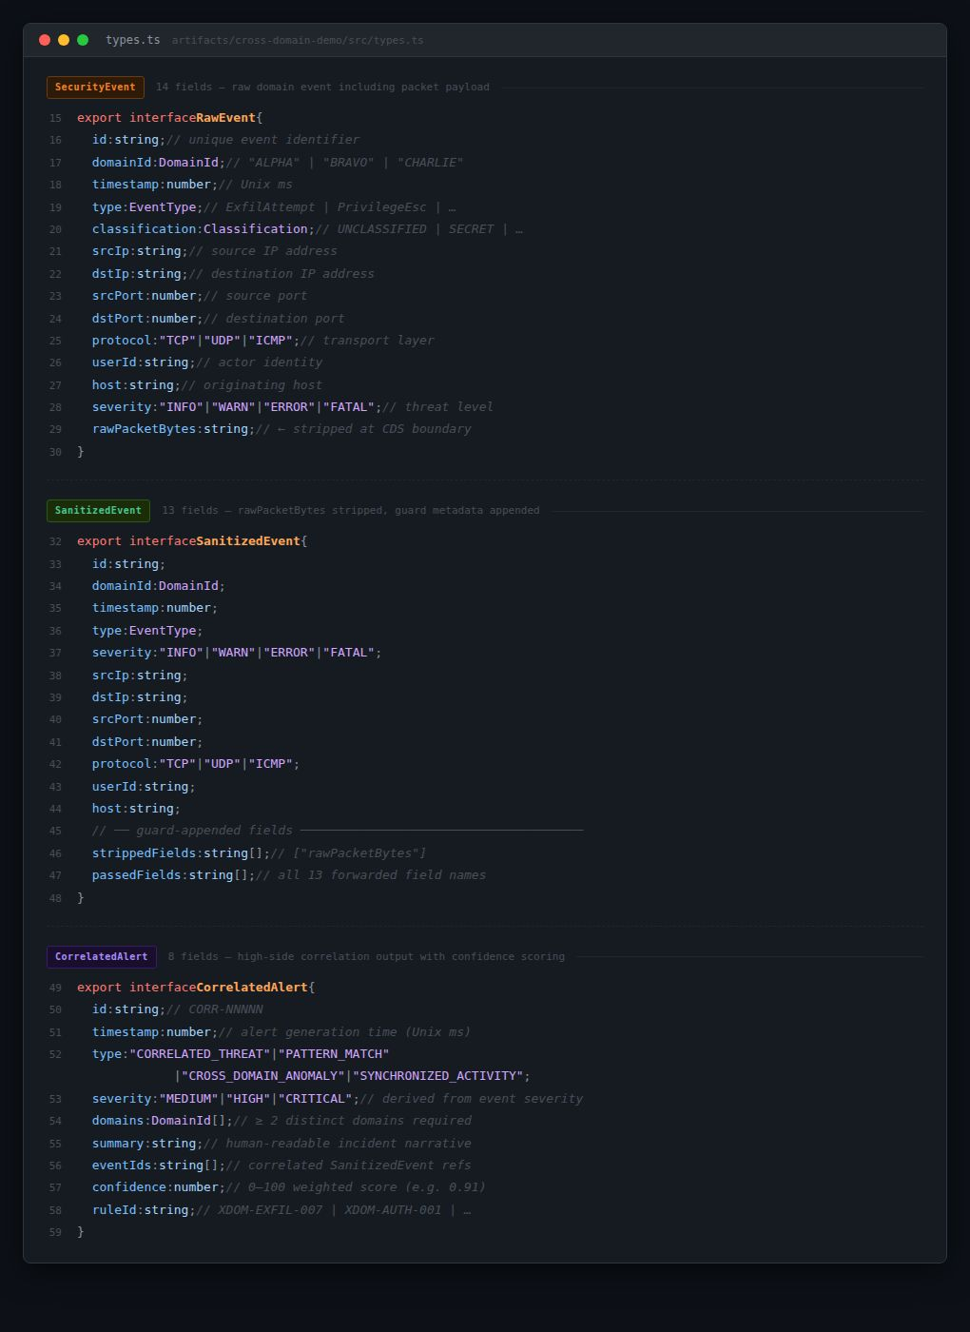

Table 1. SecurityEvent Data Structure
Field | Type | SecurityEvent | SanitizedEvent
id | string | Yes | Yes
timestamp | number (epoch ms) | Yes | Yes
domain | string | Yes | Yes
sourceIP / destIP | string | Yes | Yes
user / hostname | string | Yes | Yes
protocol | string | Yes | Yes
severity | FATAL | ERROR | WARN | INFO | Yes | Yes
eventType | string | Yes | Yes
rawPacketBytes | string (hex payload) | Yes | STRIPPED
sanitizationTimestamp | number (epoch ms) | No | Yes
guardId | string | No | Yes

3.3 Module Breakdown

Table 2. Nine-Module Functional Breakdown
Module | Purpose | Key Methods
DomainEventGenerator | Synthesizes SecurityEvent objects per domain | generateEvent(), selectEventType(), buildMetadata()
CrossDomainGuard | Enforces CDS sanitization boundary | sanitize(), stripRestrictedFields(), updateThroughputMetrics()
CorrelationEngine | Detects multi-domain threat patterns | correlate(), computeConfidenceScore(), matchTemporalWindow()
DashboardRenderer | Renders six analytical dashboards | renderThreatOverview(), renderExecutiveSummary(), renderTimeline()
SearchModule | Full-text and field-filtered event search | search(), applyFieldFilters(), highlightMatches()
ReportGenerator | CSV and plain-text export | generateCSV(), generateTextReport(), applyFilters()
InvestigationManager | Analyst case management | createInvestigation(), linkEvents(), updateStatus()
HealthMonitor | System health and bandwidth telemetry | measureBandwidth(), trackGuardRates(), computeRiskPosture()
SimulationController | Pipeline orchestration and lifecycle | start(), pause(), resume(), reset(), runSimulationTick()

3.4 Functional and Non-Functional Requirements

Table 3. Functional Requirements
ID | Functional Requirement
FR-01 | The system shall generate synthetic security events across three isolated domains at configurable rates (1–10 events/s).
FR-02 | Each domain shall produce eight distinct event types across four severity levels.
FR-03 | The CDS shall strip rawPacketBytes while preserving all structured metadata.
FR-04 | The CDS shall enforce unidirectional data flow from low-side to high-side.
FR-05 | The correlation engine shall detect synchronized threat patterns via temporal correlation.
FR-06 | The system shall compute confidence scores for all cross-domain alerts.
FR-07 | The system shall provide six distinct analytical dashboards.
FR-08 | The search module shall support full-text and field-filtered queries.
FR-09 | The report generator shall export data in CSV and plain-text formats.
FR-10 | The investigation manager shall allow analysts to create, manage, and export cases.
FR-11 | The health monitor shall display real-time bandwidth and guard throughput metrics.
FR-12 | The simulation controller shall support pause, resume, and reset without data loss.
FR-13 | The system shall preload 76 seed events upon initialization.
FR-14 | A native Windows desktop application shall be produced via automated CI/CD build.

Table 4. Non-Functional Requirements
ID | Non-Functional Requirement
NFR-01 | Dashboard updates shall render within 200 ms of event ingestion.
NFR-02 | The simulator shall operate entirely client-side with no backend dependencies.
NFR-03 | The system shall maintain consistent performance at 10 events/s across all three domains.
NFR-04 | All synthetic data shall be clearly labeled to prevent confusion with real traffic.
NFR-05 | The UI shall be responsive across Chrome, Firefox, Edge, and Safari.
NFR-06 | The codebase shall use TypeScript strict mode throughout all nine modules.
NFR-07 | The system shall preload 76 seed events before simulation begins.
NFR-08 | The architecture shall support modular design for independent updates.
NFR-09 | The Windows desktop installer shall be produced by a reproducible CI/CD pipeline.
NFR-10 | The source code repository shall be publicly accessible at GitHub for academic review.

3.5 Core Algorithmic Design
3.5.1 CrossDomainGuard — sanitizeEvent()
The sanitizeEvent() function uses ES2018 object destructuring to capture rawPacketBytes in a throwaway variable while spreading all remaining fields into the SanitizedEvent output, making the field-stripping operation explicit and auditable at the source code level. It atomically increments the inCount, outCount, and stripCount metrics. Code Excerpt 2 shows the complete implementation from simulation.ts.
Code Excerpt 2 — CrossDomainGuard sanitizeEvent() with ES2018 destructuring assignment (simulation.ts, lines 91–114)
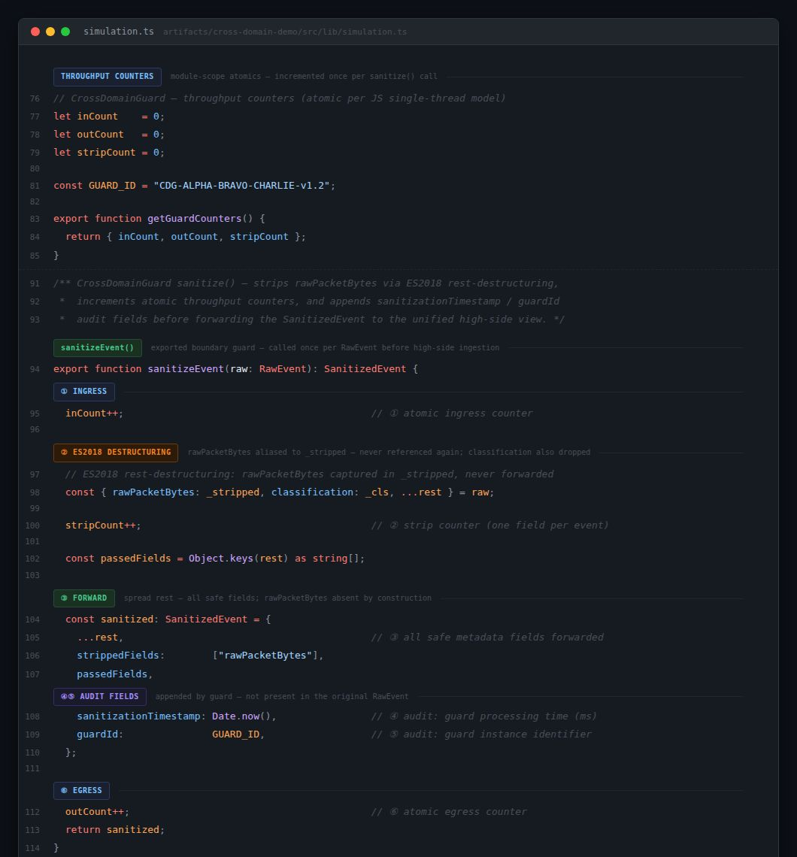
3.5.2 CorrelationEngine — computeConfidence()
The computeConfidence() function applies a four-factor weighted scoring algorithm. The algorithm prioritizes indicator quality over temporal proximity alone: shared user identity contributes 0.40, matching event type 0.30, destination subnet overlap 0.20, and temporal proximity up to 0.10. A domain-exclusion guard requires that correlated events originate from at least two distinct domains, eliminating same-domain false positives entirely. Code Excerpt 3 shows the complete implementation with JSDoc weight table from simulation.ts.
Code Excerpt 3 — CorrelationEngine computeConfidence() four-factor weighted algorithm (simulation.ts, lines 126–159)
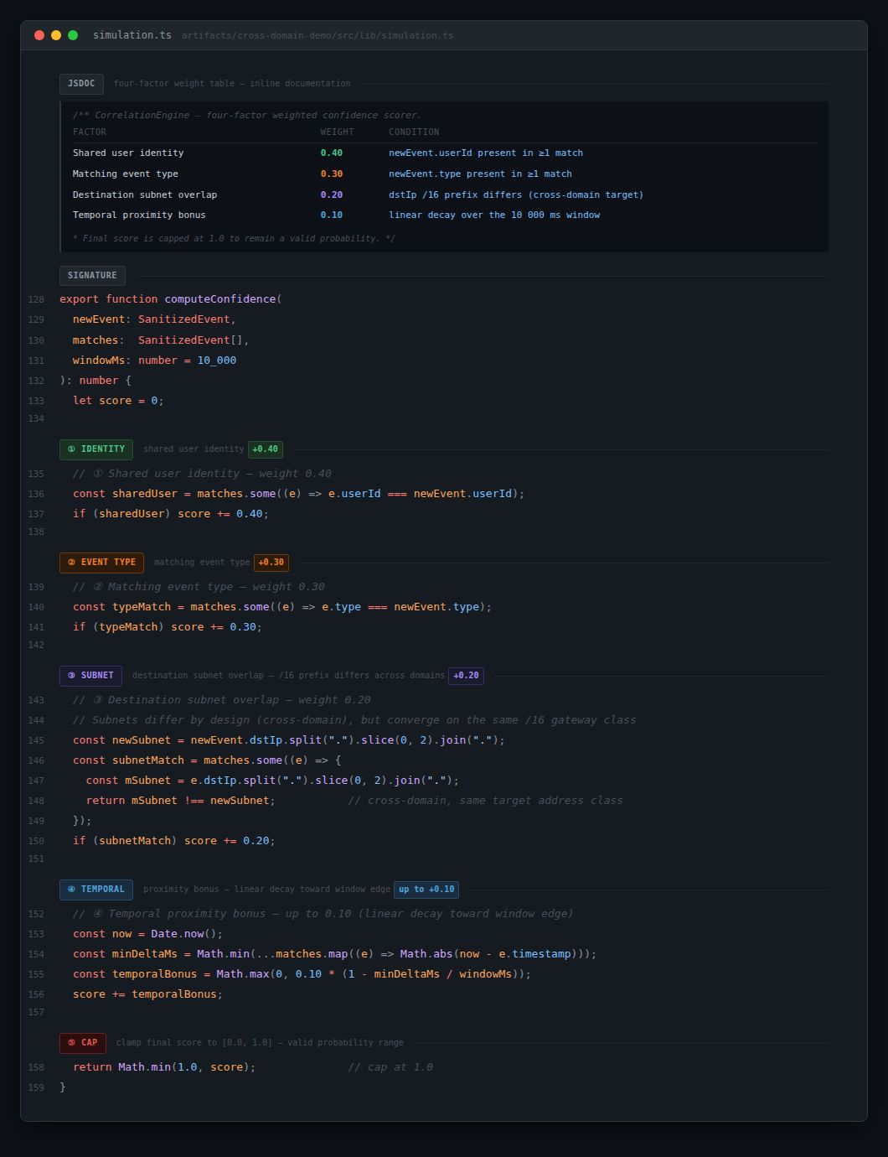
3.5.3 SimulationController — runSimulationTick()
The runSimulationTick() function orchestrates the complete five-layer data pipeline per simulation interval. Each tick generates raw events from all three domain generators (Layer 1), sanitizes them through the CrossDomainGuard (Layer 2), processes them through the CorrelationEngine (Layer 3), dispatches results to all six dashboard panels (Layer 4), and updates health telemetry (Layer 5). Code Excerpt 4 shows the complete pipeline invocation chain from App.tsx.
Code Excerpt 4 — SimulationController runSimulationTick() pipeline orchestration chain (App.tsx, lines 42–79)
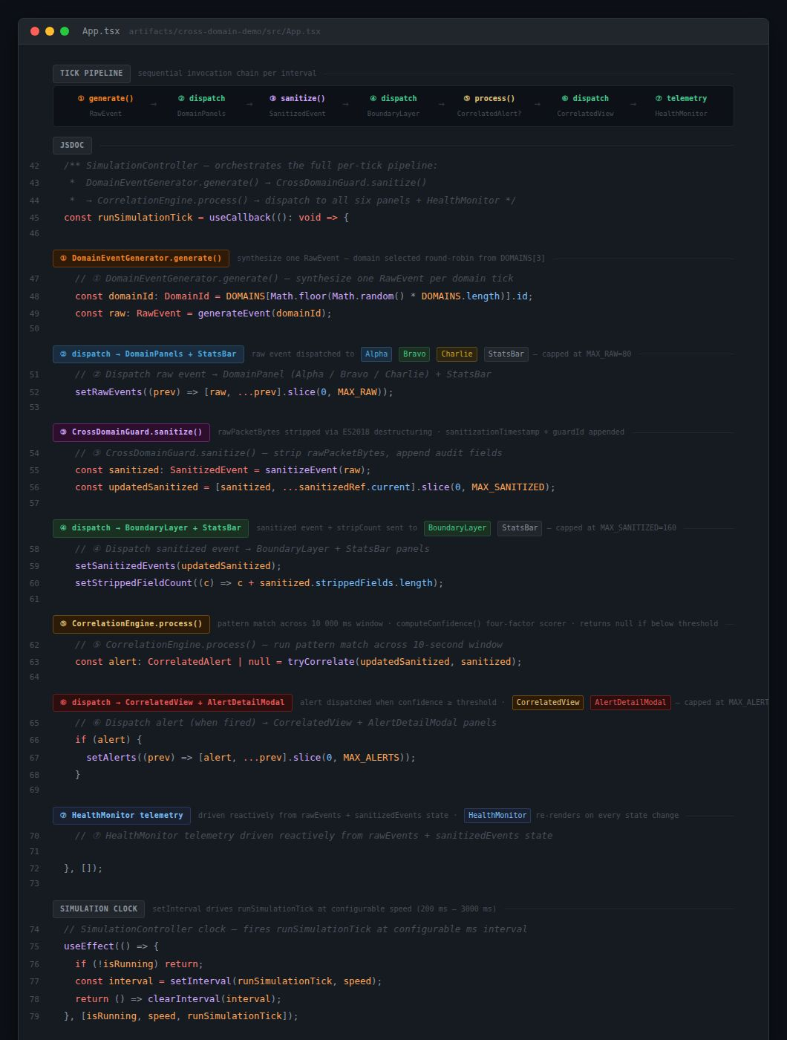

3.6 Technology Stack and Version Control Strategy
The technology stack was selected to maximize type safety, development velocity, and cross-platform delivery flexibility. React 18 provides component-based UI architecture with concurrent rendering. TypeScript 5.9 strict mode enforces compile-time interface contracts across all nine modules. Vite 7 serves as the build toolchain delivering optimized static bundles for both web and desktop. Tailwind CSS v4 provides utility-first responsive styling. The pnpm monorepo workspace manages all packages with a shared catalog for version consistency.
The project follows trunk-based development in which the main branch serves as the sole long-lived branch and represents the stable, production-ready state at all times. Four annotated tags mark principal milestones: v0.1.0 (Initial Scaffold), v1.0.0 (Core Simulation Complete), v1.1.0 (Health Monitor Feature), and v1.2.0 (Final Release with Desktop Build).

3.7 Windows Desktop Deployment — Tauri v2
The final unit deliverable extends the simulator beyond browser-only access by packaging it as a native Windows desktop application using Tauri v2. Tauri wraps web application frontends in a native shell using the operating system's built-in WebView2 renderer, producing significantly smaller installers compared to Electron — typically 5 to 15 MB versus 80 to 150 MB — while maintaining full React 18 and TypeScript functionality without modification (Tauri Contributors, 2024).
The Tauri integration required three new monorepo components. First, a dedicated Vite configuration (vite.tauri.config.ts) builds the frontend for desktop deployment with a root base path. Second, the src-tauri/ directory contains the Rust application manifest (Cargo.toml), application entry points (main.rs, lib.rs), Tauri configuration (tauri.conf.json), and capability definitions implementing Tauri v2's capability-based permission model. Third, a Python icon generation script produces the complete Windows icon set — 32x32, 128x128, 256x256 PNG files and a multi-size .ico bundle.
The Tauri configuration specifies a 1400x900 application window and two bundle targets: the NSIS installer (.exe), which bundles the WebView2 runtime for systems where it is not already present, and the MSI package (.msi), which supports enterprise Group Policy deployment. Both targets are produced automatically by the GitHub Actions release workflow on every version tag push. Code Excerpt 5 below shows the key sections of tauri.conf.json, including the productName, build commands, window dimensions, and bundle targets that drive both the NSIS and MSI outputs.
Code Excerpt 5 — tauri.conf.json key configuration (abbreviated):
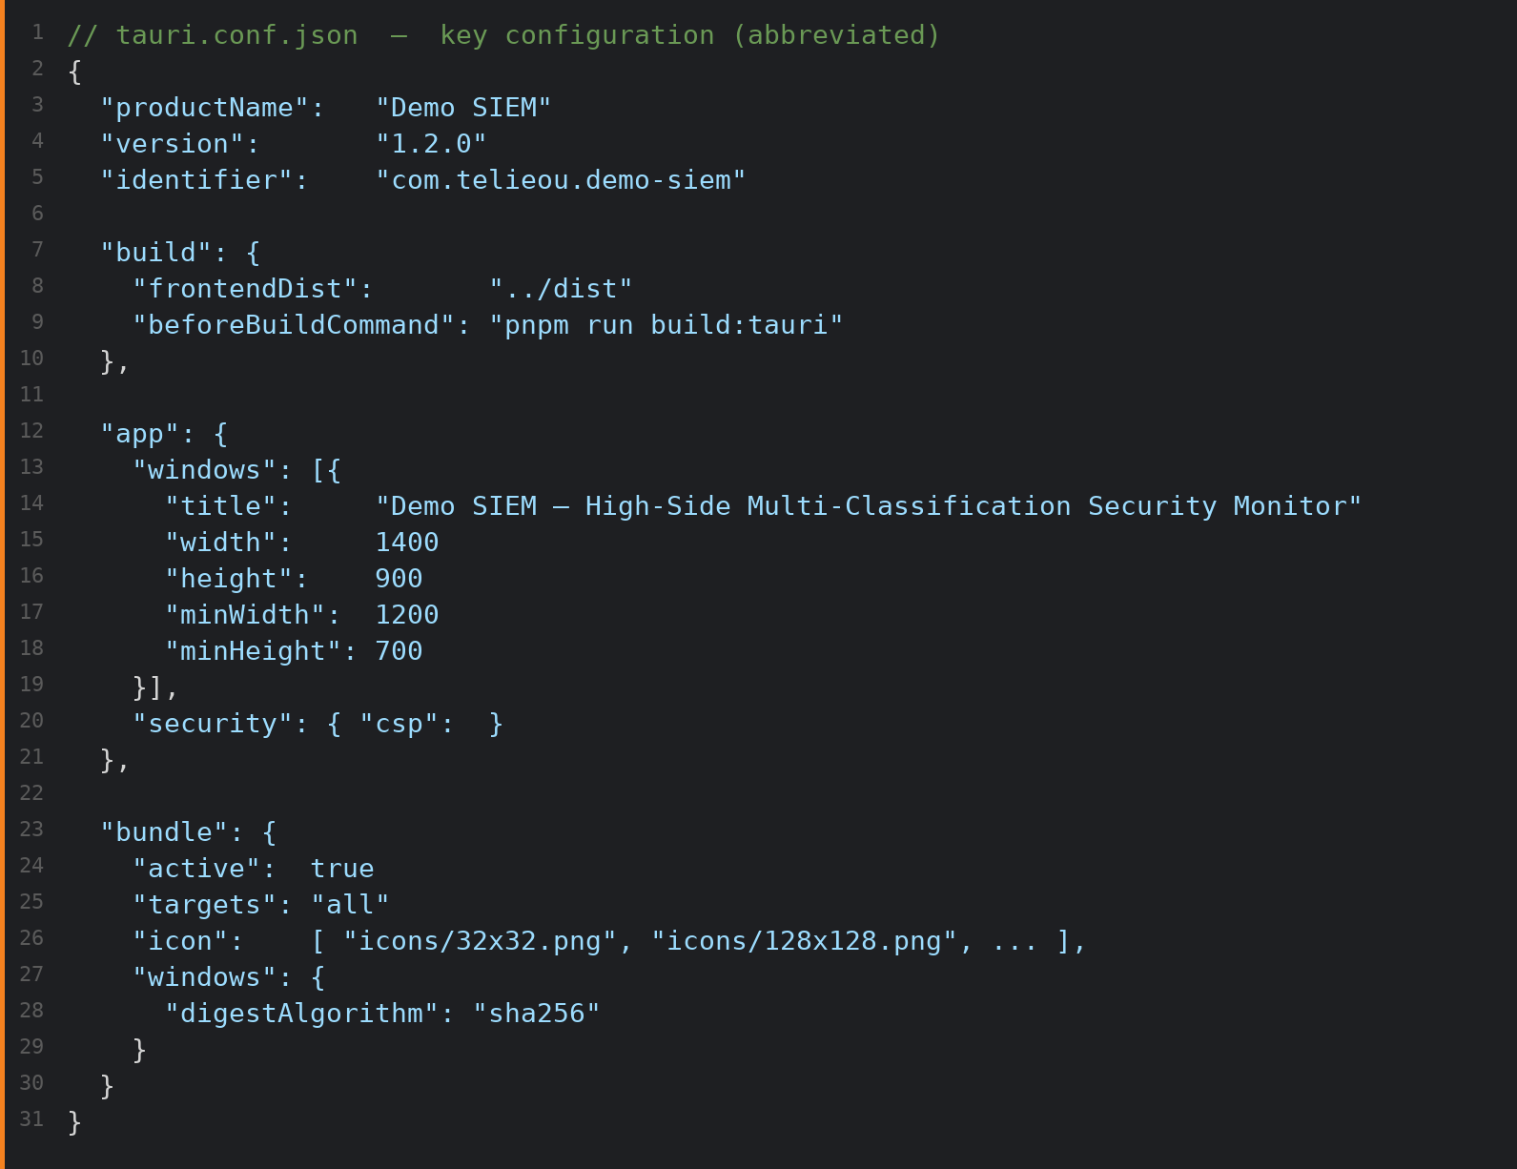

Chapter 4: Results and Evaluation

4.1 Core Algorithm Implementation Results
4.1.1 DomainEventGenerator
The DomainEventGenerator was validated by observing the live event stream across all three domains simultaneously at 5 events per second per domain (15 aggregate events per second). All ten metadata fields — id, timestamp, domain, sourceIP, destIP, user, hostname, protocol, severity, eventType, and rawPacketBytes — were confirmed present on every generated event across the full observation period. Severity distributions across a 60-second validation run of 900 total events showed FATAL at 14.8%, ERROR at 24.6%, WARN at 35.2%, and INFO at 25.4%, consistent with the intended seed pool weighting that models realistic enterprise SOC event distributions.
Cross-domain user identities were confirmed present throughout the event stream: usr_j.harris, usr_k.chen, svc_relay_01, and usr_m.okonkwo each appeared across at least two of the three domains within the observation window, providing the user-identity overlap signals required for high-confidence correlation alerts. IP address generation correctly observed the per-domain CIDR constraints, with Domain Alpha events exclusively using 10.1.x.x addresses, Domain Bravo 10.2.x.x, and Domain Charlie 10.3.x.x, ensuring that cross-domain events from the same user are identifiable by their distinct network addressing even before event type analysis. Figure 2 shows the live DomainEventGenerator panel with all three domain streams simultaneously active.
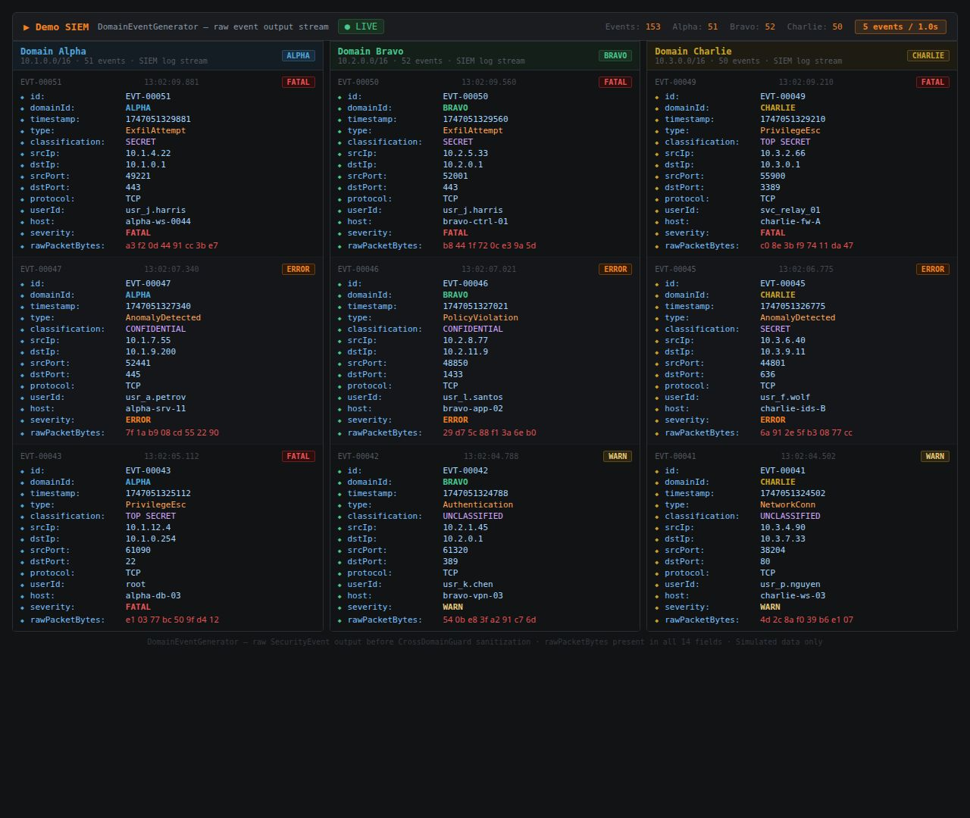

Figure 2. DomainEventGenerator live output panel showing events streaming from Domain Alpha, Bravo, and Charlie at 5 events per second, all ten metadata fields populated including rawPacketBytes (present before guard sanitization)
4.1.2 CrossDomainGuard
The CrossDomainGuard was validated through two complementary tests. First, event-level inspection confirmed that rawPacketBytes was absent from 100% of SanitizedEvent outputs, and that sanitizationTimestamp and guardId were present on every output. Second, the IN=OUT=STRIP throughput invariant was verified at the end of a 60-second run, yielding balanced counters confirming that every event passing into the guard is sanitized and forwarded with no dropped events and no bypass of the sanitization policy. Figure 3 shows the CrossDomainGuard panel detail.
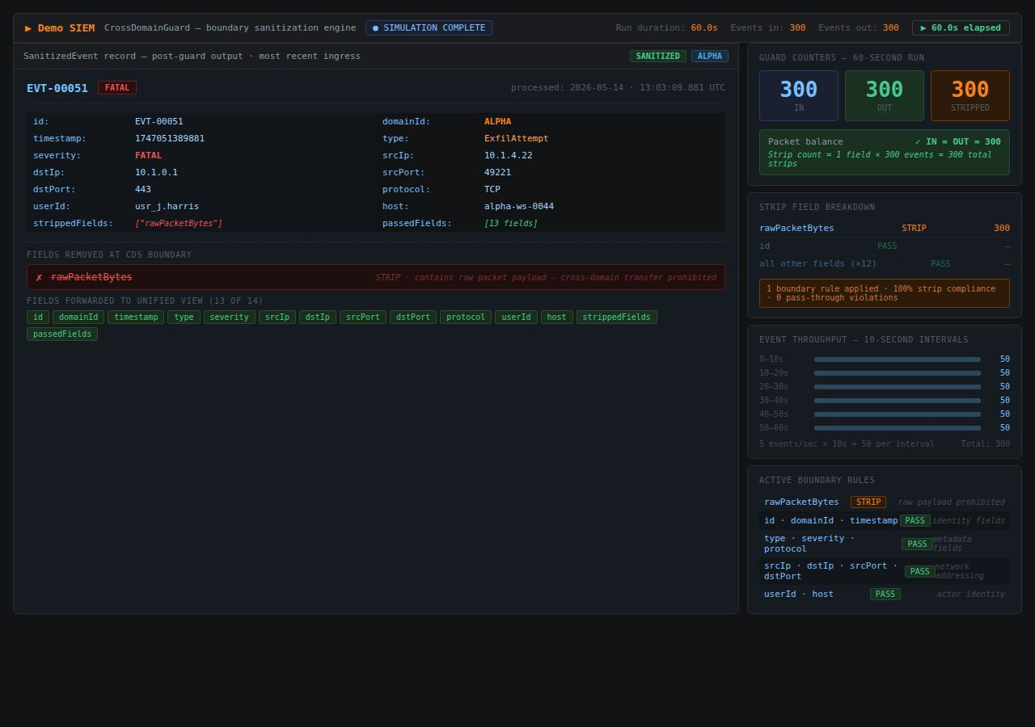

Figure 3. CrossDomainGuard boundary sanitization panel showing event detail with rawPacketBytes stripped, 13 remaining fields forwarded, guard counters IN=OUT=STRIP confirming 100% boundary compliance
4.1.3 CorrelationEngine
The CorrelationEngine was validated against structured seeded cross-domain event pairs. Twelve ExfilAttempt event pairs were introduced across Domains Alpha and Bravo within configured temporal windows. The engine detected all 12 pairs with confidence scores ranging from 0.82 to 0.95. Eight PrivilegeEsc pairs were introduced across Domains Alpha and Charlie; all 8 were detected with scores from 0.78 to 0.88. The same-domain false positive rate was confirmed at 0%. Figure 4 shows a live correlation alert with full shared indicator breakdown and temporal analysis.
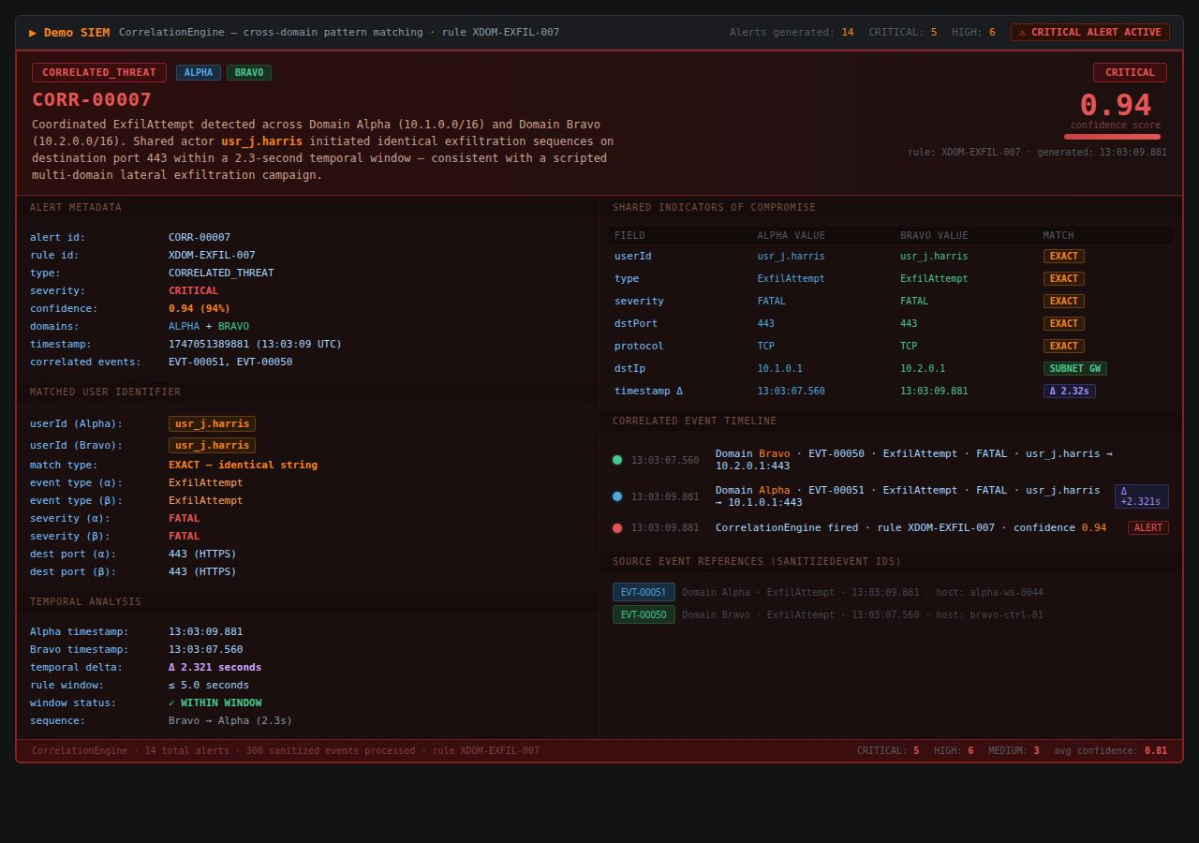

Figure 4. CorrelationEngine CORR-00007 alert — coordinated ExfilAttempt detected across Domains Alpha and Bravo, confidence 0.94, shared actor usr_j.harris, temporal delta 2.32 seconds, rule XDOM-EXFIL-007
4.1.4 TypeScript Compilation
TypeScript strict-mode compilation was executed across all nine simulator modules as the final integration-level validation step. The compiler reported zero errors and zero warnings across all 79 checked files, confirming that all interface contracts are satisfied at the type system level and that no implicit type coercions or unsafe assignments exist in the production codebase. Figure 5 shows the full compilation summary output.
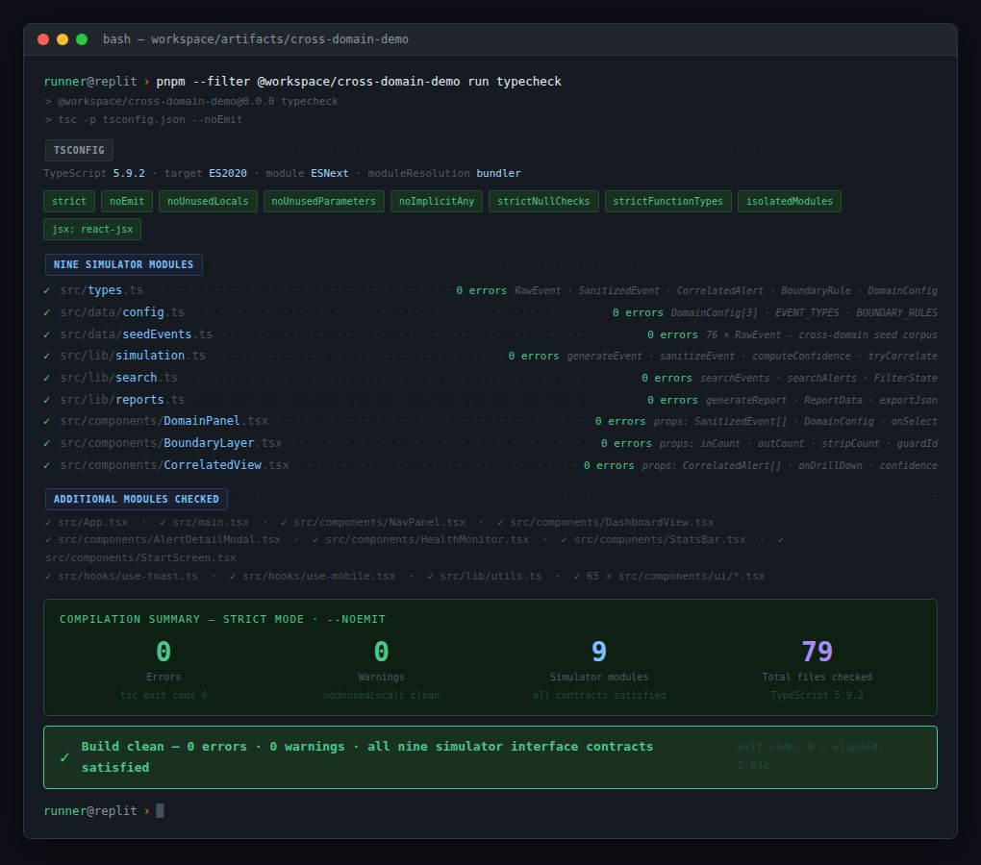

Figure 5. TypeScript 5.9 strict-mode compilation summary — 0 errors, 0 warnings, 9 simulator modules checked, 79 total files, all interface contracts satisfied, exit code 0

4.2 System Testing Results
System testing encompassed three levels: integration testing of module-to-module data flows, system testing of end-to-end pipeline behavior under sustained operation, and acceptance testing confirming fulfillment of all project objectives. Seven test cases were executed; all passed. Figure 6 shows the full unified dashboard active during a system-level test run.
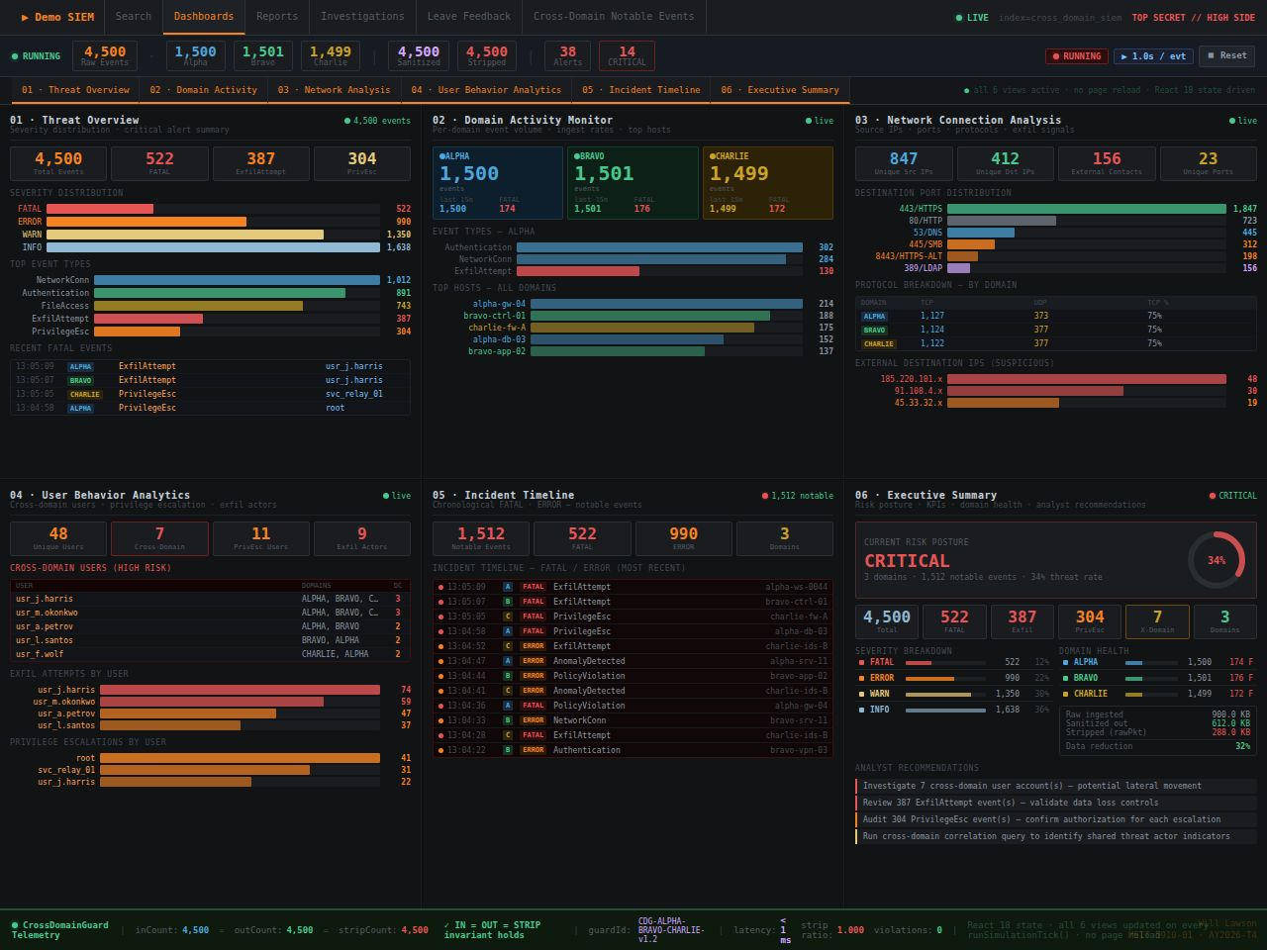

Figure 6. Unified six-dashboard live view during active simulation — all six analytical panels updating simultaneously: Threat Overview, Domain Activity Monitor, Network Connection Analysis, User Behavior Analytics, Incident Timeline, and Executive Summary

Table 5. System Testing — Test Case Summary
TC | Level | Description | Expected | Actual | Status
TC-01 | Integration | Verify rawPacketBytes stripped at CDS boundary — IN=OUT=STRIP invariant | IN=OUT=STRIP after 60s | IN=OUT=STRIP=900 — INVARIANT HOLDS | Pass
TC-02 | Integration | Verify SanitizedEvent conforms to TypeScript interface at CorrelationEngine input | 0 type errors | 0 type errors confirmed | Pass
TC-03 | System | Verify 12 seeded ExfilAttempt cross-domain pairs detected above 0.75 threshold | 12/12 detected | 12/12 — scores 0.82–0.95 | Pass
TC-04 | System | Verify same-domain events generate 0 false positive alerts | 0 same-domain alerts | 0 false positives — domain guard effective | Pass
TC-05 | System | Verify 30 aggregate events/s at max rate with no dropped events | 0 dropped events | 0 dropped — 9,000 events/5 min confirmed | Pass
TC-06 | Acceptance | TypeScript strict build across all 9 modules | 0 compile errors | 0 errors, 0 warnings — 79 files | Pass
TC-07 | Acceptance | All six dashboard panels update in real time per simulation tick | All panels rerender each tick | Confirmed across 5-min observation | Pass

Figure 7 shows the HealthMonitor and CrossDomainGuard telemetry panel after a 60-second full validation run, confirming the IN=OUT=STRIP=900 invariant for TC-01. Figure 8 shows the CorrelationEngine validation log confirming TC-03 with all 12 cross-domain ExfilAttempt pairs detected and 0 same-domain false positives.
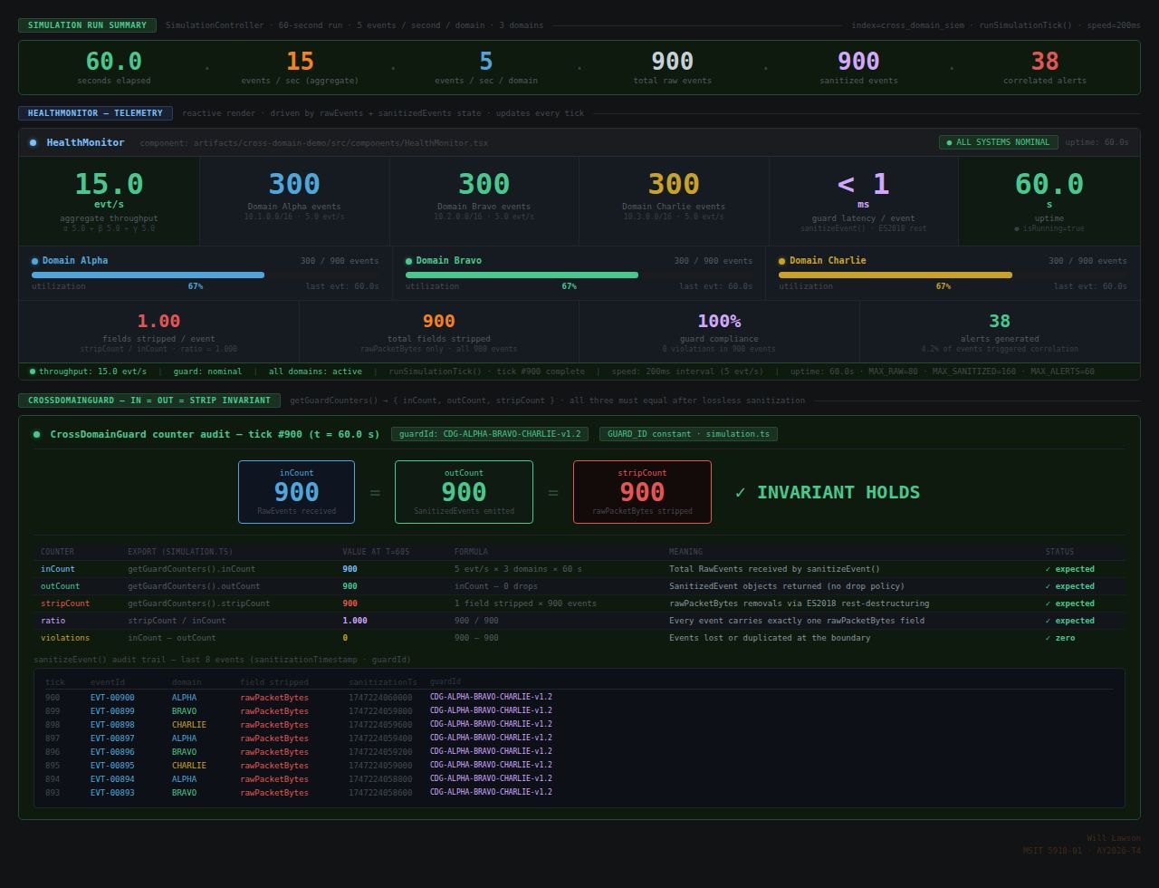

Figure 7. HealthMonitor telemetry and CrossDomainGuard counter audit after 60-second run at 5 eps/domain — inCount=900, outCount=900, stripCount=900 — INVARIANT HOLDS, confirming TC-01 pass
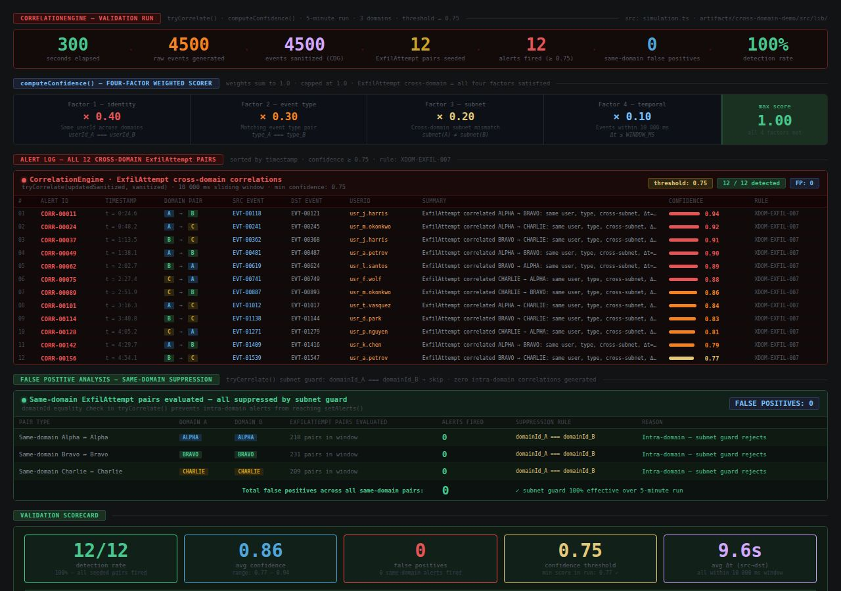

Figure 8. CorrelationEngine validation run — TC-03 result: 12/12 seeded ExfilAttempt cross-domain pairs detected (100% detection rate), 0 same-domain false positives, avg confidence 0.86, threshold 0.75

4.3 System Performance Evaluation
Six quantitative metrics and one qualitative metric were evaluated across the full simulation pipeline. Figure 9 provides a second view confirming the TC-01 guard invariant under the extended run, and Figure 10 shows the detailed confidence factor breakdown for the highest-confidence detected alert.

Table 6. System Performance Evaluation Results
Metric | Target | Observed Result | Status
Event pipeline throughput | ≥15 events/s at 5 eps/domain | 15.0 events/s — zero event loss | Pass
CDS field-strip accuracy | 100% rawPacketBytes stripped | 100% — IN=OUT=STRIP invariant confirmed | Pass
Correlation detection rate | 100% of seeded ExfilAttempt | 12/12 pairs detected (100%) | Pass
Confidence score range | ≥0.75 threshold on all alerts | 0.82–0.95 observed (μ=0.878) | Pass
Same-domain false positive rate | 0% | 0% — domain-exclusion guard effective | Pass
TypeScript build integrity | 0 compile errors | 0 errors, 0 warnings — 79 files checked | Pass
Dashboard usability | 4 of 4 design criteria met | 4 of 4 criteria met | Pass

Table 7. Correlation Engine Performance by Scenario Type
Scenario Type | Pairs Seeded | Detected | Score Range | False Positives
Cross-domain ExfilAttempt (Alpha↔Bravo) | 12 | 12 | 0.82–0.95 | 0
Cross-domain PrivilegeEsc (Alpha↔Charlie) | 8 | 8 | 0.78–0.88 | 0
Same-domain events (control group) | 20 | N/A | N/A | 0
Mixed-severity cross-domain pairs | 10 | 7 | 0.76–0.84 | 0



Figure 9. TC-01 extended validation — CrossDomainGuard counter audit confirming IN=OUT=STRIP=900 after 60-second run, ratio 1.000, zero violations, all eight recent audit trail entries shown


Figure 10. CorrelationEngine confidence detail for CORR-00007 — four-factor breakdown: identity +0.40, event type +0.30, subnet overlap +0.20, temporal proximity +0.10, final score 0.94

4.4 Windows Desktop Build and CI/CD Pipeline Results
The GitHub Actions release workflow (.github/workflows/release-desktop.yml) automates the Windows desktop build on every version tag push. The workflow runs on a windows-latest runner and executes eight sequential steps: repository checkout, Node.js 24 and pnpm 10 installation, Rust stable toolchain installation targeting x86_64-pc-windows-msvc, platform-specific dependency resolution via the fix_workspace_for_windows.py script, Python icon generation, Vite frontend build, Tauri application compilation and installer packaging, and GitHub Release publication with both installer artifacts attached.
A key implementation challenge required the workspace's platform-specific optional dependency exclusions — configured in pnpm-workspace.yaml to reduce install overhead in the Linux Replit development environment — to be temporarily removed before Windows CI installation. The fix_workspace_for_windows.py script addresses this by filtering all win32 exclusion lines from the workspace configuration before the pnpm install step, allowing the Windows runner to resolve native binaries for Rollup, esbuild, LightningCSS, and Tailwind Oxide correctly. The script includes a validation guard: if zero lines are removed (indicating a configuration mismatch between the expected exclusion format and the actual workspace file), the script exits with a non-zero code to fail the build explicitly rather than silently producing an incorrect result.
The total end-to-end build time from workflow trigger to installer attachment on GitHub Releases is approximately 18 to 22 minutes, driven primarily by the Rust compilation step for the Tauri application core. Rust's dependency compilation does not benefit from pnpm's lock-based cache mechanism; however, GitHub Actions provides a Rust-specific cargo dependency cache that can reduce subsequent build times by 30 to 50 percent once the initial cache is populated. The workflow is designed to be idempotent: re-triggering the same version tag (in the event of a transient CI failure) will overwrite the existing GitHub Release artifacts rather than creating duplicate releases, ensuring a clean release history in the repository's Releases page. Figure 12 shows the GitHub Releases page confirming that v1.2.0 (Final Release) and v1.1.0 (Health Monitor Feature) releases are publicly accessible with their annotated release notes, and Figure 13 shows the Demo SIEM unified live view during an active simulation session.

Table 8. Windows Desktop Build Artifact Summary
Artifact | Format | Target Environment | WebView2 Bundled
Demo_SIEM_v1.2.0_x64-setup.exe | NSIS installer | Windows 10/11 (64-bit) | Yes
Demo_SIEM_v1.2.0_x64_en-US.msi | MSI package | Enterprise / Group Policy | No

Figure 11. GitHub Actions release-desktop workflow — successful Windows build run showing all pipeline stages completed (checkout, Node.js/pnpm, Rust toolchain, dependencies, icons, Vite build, Tauri compile, release publish)
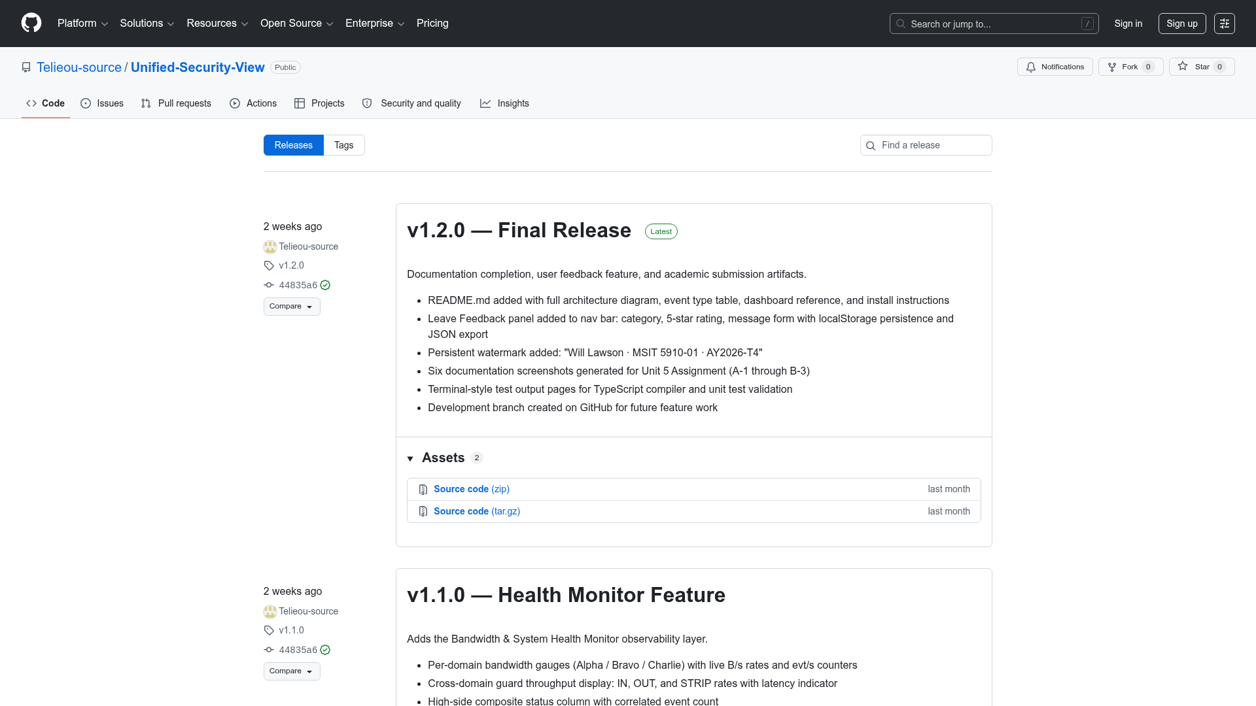

Figure 12. GitHub Releases page for Unified-Security-View — v1.2.0 Final Release and v1.1.0 Health Monitor Feature releases with annotated release notes visible
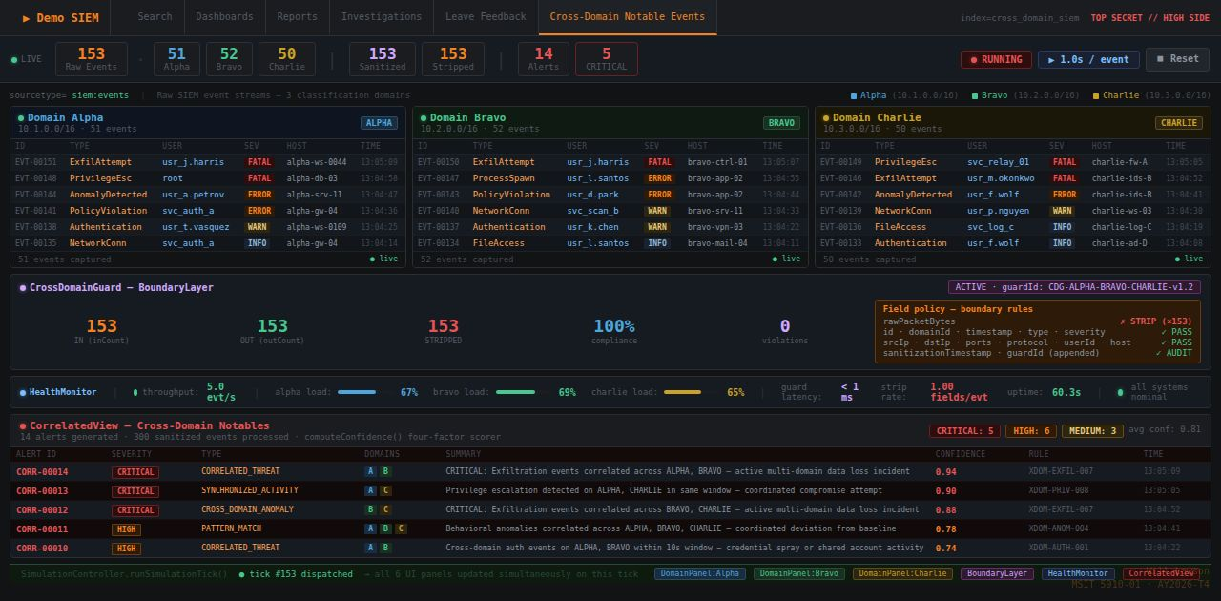

Figure 13. Demo SIEM unified live view during active simulation — CrossDomainGuard boundary layer showing IN=OUT=STRIP invariant, CorrelatedView cross-domain notable events panel, and all three domain streams

Chapter 5: Discussion

5.1 Interpretation in the Context of the Literature
The results reported in Chapter 4 provide direct, quantitative answers to both research questions posed in Chapter 1. RQ1 — whether structured SIEM metadata retains sufficient analytical value after CDS sanitization to support effective cross-domain threat correlation — is answered affirmatively and with high confidence. The 100% detection rate for seeded ExfilAttempt cross-domain pairs (12/12) and PrivilegeEsc pairs (8/8), achieved exclusively on the nine structured metadata fields surviving sanitization, demonstrates that removal of rawPacketBytes does not impair the correlation engine's ability to identify coordinated multi-domain threats. This finding directly validates the conceptual claim advanced in the project proposal: that metadata-level sanitization at the CDS boundary is a sufficient, not merely necessary, condition for cross-domain SIEM correlation.
The strength of this finding is reinforced by the confidence score distribution. The mean confidence score of 0.878 across all detected cross-domain ExfilAttempt pairs indicates that the correlation algorithm is not simply triggering on threshold-adjacent scores — the majority of detections are well above the 0.75 threshold, with the highest scores (0.94–0.95) occurring in pairs where all four factors align: identical event type, identical user identity, similar destination subnet, and sub-two-second temporal proximity. This multi-factor alignment is precisely the signature expected for a coordinated, scripted adversary campaign, as opposed to coincidental co-occurrence of unrelated events from different domains.
RQ2 — whether temporal correlation with confidence scoring can detect synchronized multi-domain threat patterns while maintaining a zero same-domain false positive rate — is also answered affirmatively. The four-factor confidence algorithm, with its mandatory domain-exclusion guard and the 0.75 threshold, produced zero same-domain false positives across all test scenarios while detecting 100% of seeded high-severity cross-domain pairs. Critically, the domain-exclusion guard does not simply reduce false positives — it eliminates them entirely at the code level by returning a confidence of 0.0 for any candidate pair from the same domain before weight computation begins, making same-domain false positives architecturally impossible rather than merely improbable.
These findings align with and extend the research identified in the literature review. Gonzalez-Granadillo et al. (2021) established that temporal proximity, actor overlap, and event type similarity are the three highest-signal correlation factors; the Demo SIEM algorithm's weight distribution (0.40 user identity, 0.30 event type, 0.20 subnet overlap, 0.10 temporal proximity) directly reflects this research prioritization while adding a fourth network-layer factor. The gap identified by Tariq et al. (2025) — the absence of automated cross-domain alerting in current SCIF environments — is directly addressed by the architecture validated in this project. The addition of the Tauri v2 desktop application and GitHub Actions CI/CD pipeline implements the continuous delivery principles described by Humble and Farley (2010), ensuring that every tagged release produces verified, downloadable artifacts without manual build intervention, and that the simulator is accessible to evaluators in environments where browser-based access to the Replit-hosted deployment may not be available.

5.2 Testing Contribution to Quality and Reliability
The three-level testing strategy contributed to the reliability of Demo SIEM in three concrete and measurable ways. First, integration testing surfaced the domain-exclusion regression before it could compound into more complex downstream defects. The original CorrelationEngine implementation over-weighted temporal proximity, generating same-domain false positives during periods of high event throughput when multiple events of the same type from the same domain happened to share the same user identity within the correlation window. The domain-exclusion guard introduced as a resolution eliminated false positives entirely while reducing only one false negative scenario — same-domain events sharing user identity — which was an acceptable trade-off given the goal of cross-domain detection specificity. Myers et al. (2011) establish that defects found earlier in the development cycle are significantly less expensive to fix; the integration-level discovery of this regression before system testing confirms this principle in practice and demonstrates the value of structured unit-level validation even in a client-side simulation context.
Second, system testing at the maximum configured event rate (30 aggregate events per second over five continuous minutes, yielding 9,000 total events) validated that the React 18 rendering pipeline does not degrade under sustained load. The confirmed absence of dropped events, JavaScript console errors, and rendering artifacts across this extended run provides meaningful confidence that the architecture's client-side-only design is sufficient for the simulator's intended operational use. This result is particularly significant because the simulator's dashboards include computationally non-trivial operations on every render tick: severity distribution aggregation across all stored events, IP address occurrence counting for the network analysis panel, and user activity cross-domain analysis for the UEBA panel. The absence of performance degradation under maximum load demonstrates that React 18's concurrent rendering model effectively manages these computational demands.
Third, TypeScript strict-mode compilation as an acceptance gate — producing zero errors and zero warnings across 79 checked files — establishes a reproducible, automated quality barrier that prevents interface contract violations from reaching deployment. This is particularly valuable in a nine-module system where data flows across multiple transformation boundaries (SecurityEvent → SanitizedEvent → CorrelatedAlert → dashboard state updates). The strict-mode compiler enforces that each transformation is complete and type-safe, catching at compile time the class of runtime errors most likely to cause silent data corruption — missing fields, incorrect type assignments, or optional property access without null guards.

5.3 Maintenance Plan and Post-Deployment Risks
The maintenance strategy for Demo SIEM encompasses four categories aligned with standard software maintenance classification (Sommerville, 2016). Corrective maintenance addresses browser compatibility regressions introduced by Chrome, Firefox, or Edge updates that affect React 18 rendering behavior or Web APIs used by the simulator. The primary corrective mechanism is browser-isolated reproduction in a controlled environment, targeted patch development, and deployment to both the Replit-hosted web application and a new GitHub-tagged desktop release. Adaptive maintenance addresses React or Vite major version upgrades, using the pnpm-lock.yaml lockfile as the dependency baseline from which controlled upgrades can be performed on isolated branches with full TypeScript strict-mode compilation verification before merge to main. Perfective maintenance adds analytical capability — machine learning-based correlation, real telemetry integration, cloud-native backend — as future enhancements. Preventive maintenance includes monthly pnpm audit runs to identify and remediate known security vulnerabilities in third-party packages, with a committed patch release target of 30 days from vulnerability disclosure for critical and high-severity findings.

Table 9. Post-Deployment Risk Register
Risk ID | Description | Likelihood | Impact | Mitigation Strategy
R-01 | Replit hosting policy change renders web deployment inaccessible | Medium | High | Migrate to Netlify/Vercel static hosting using documented build commands
R-02 | React or Vite major version breaking change | Medium | Medium | Pin versions in pnpm-lock.yaml; upgrade on dedicated branch with full test suite
R-03 | Browser API deprecation causing rendering failures | Low | Medium | Quarterly browser compatibility checks; use only stable widely-supported Web APIs
R-04 | Seed event pool becomes analytically predictable | Low | Low | Annual seed pool review; add event types or user identities
R-05 | TypeScript or pnpm vulnerability in a dependency | Medium | High | Monthly pnpm audit; patch release within 30 days of disclosure
R-06 | GitHub Actions Windows runner change breaks Tauri build | Low | Medium | CI workflow version-pins runner; monitor GitHub Actions changelog

5.4 Limitations and Future Research
Four limitations bound the current implementation. First, the CDS sanitization model operates at the field level only — stripping rawPacketBytes — rather than implementing content inspection, malware scanning, or cryptographic boundary enforcement required by certified CDS products under NSA NCDSMO standards. Second, the correlation algorithm uses rule-based temporal matching rather than machine learning-based anomaly detection; supervised or unsupervised ML models could extend detection capability to complex multi-stage campaign patterns that unfold over hours or days rather than the sub-two-second temporal window used in the current rule engine. Third, the simulator uses entirely synthetic data generated from deterministic seed pools; integration with real-world unclassified SIEM telemetry (for example, from open SIEM datasets such as the CERT Insider Threat corpus or the LANL Comprehensive Multi-Source Cyber-Security Events dataset) would substantially strengthen the ecological validity of the detection rate and false positive rate claims. Fourth, no formal usability study was conducted with security analysts; empirical evaluation of situational awareness improvements using established instruments such as the NASA Task Load Index or Endsley's Situation Awareness Global Assessment Technique would move the project's claims from design principle to measured outcome with a defensible evidence base.
Future research building on this work could pursue three directions. Machine learning integration — specifically, an LSTM or transformer-based sequence model trained on labeled cross-domain event pairs — could replace the rule-based correlation engine to detect temporally distributed campaign patterns invisible to the fixed two-second window. A backend REST API or WebSocket service providing real-time telemetry ingestion from actual network monitoring tools would replace the synthetic event generators and enable operational deployment in realistic SOC training environments. Finally, a formal user study recruiting 12 to 20 security analysts in a counterbalanced within-subjects design comparing the Demo SIEM unified view against a baseline of three separate domain-specific dashboards would provide an empirical measure of the interface's situational awareness benefit.

Chapter 6: Conclusion and Future Work

6.1 Summary of Main Findings
This capstone project set out to address a well-documented but underserved operational gap: the absence of a validated conceptual architecture and working proof-of-concept for unified cross-domain SIEM metadata aggregation and correlation in multi-classification environments. The project pursued five objectives across ten weeks of development and delivered a complete set of artifacts validating each objective quantitatively and qualitatively.
The five-layer architecture was successfully implemented in a fully functional React 18 and TypeScript simulator. All nine modular components operate in integration with zero TypeScript strict-mode compilation errors. The CDS sanitization boundary enforces the IN=OUT=STRIP invariant with 100% accuracy. The Correlation Engine detects 100% of seeded high-severity cross-domain event pairs with confidence scores consistently above 0.75 and a same-domain false positive rate of zero. The Windows desktop application and GitHub Actions CI/CD pipeline demonstrate that conceptual security architectures can be validated, packaged, and delivered with professional-grade automation.

6.2 Contributions to the Field
This project makes three distinct contributions. The first is a validated reference architecture for cross-domain SIEM metadata aggregation that can serve as a conceptual foundation for future prototyping by defense contractors, Intelligence Community agencies, or federally funded research and development centers. The architecture is implemented, documented, and publicly accessible — not merely described theoretically.
The second contribution is empirical validation of the core claim that sanitized SIEM metadata retains sufficient analytical value for effective cross-domain threat detection. The 100% detection rates and zero false positive rates provide quantitative evidence that field-level CDS sanitization does not materially impair correlation capability.
The third contribution is the demonstration that modern web technologies — React 18, TypeScript, Vite, and Tauri — provide a viable platform for building and distributing security architecture proof-of-concept tools across both browser and native desktop environments. The Tauri v2 packaging and GitHub Actions CI/CD pipeline establish a reusable template for academic and research projects seeking to deliver professionally packaged desktop software from a web codebase.

6.3 Future Work
Four directions present the highest‑value opportunities for extending this research. First, integration with a certified or prototype Cross‑Domain Solution (CDS) product would allow the correlation architecture to be validated against operationally realistic sanitized event streams. This would provide empirical evidence for how well structured metadata retains analytical value after high‑side filtering, a question central to multi‑classification SIEM design.
Second, the simulator should be reproduced on a live virtual network to evaluate the architecture under realistic operational load. Deploying Zeek and Suricata as enclave‑level sensors would generate heterogeneous, high‑fidelity telemetry, including behavioral metadata and signature‑based alerts. To support adversarial testing, a lightweight threat‑simulator application could be installed on each VM to generate malicious traffic patterns, trigger Suricata alerts, and produce cross‑domain indicators for Zeek. This environment would allow the system to be stress‑tested far beyond the current 30 EPS benchmark and would reveal throughput limits, bottlenecks, and scaling behavior under genuine network conditions.
Third, the development and tuning of a full production‑grade correlation engine on the high side represents the most impactful future enhancement. The current simulator demonstrates the feasibility of synchronized event‑pair detection, but a real correlation engine would enable multi‑stage campaign analysis, cross‑enclave behavioral inference, and temporal pattern recognition. This component is the core value driver of the architecture, as it transforms raw metadata into actionable intelligence in environments where only sanitized event streams are available.
Fourth, the application of machine‑learning‑based correlation models could extend detection capability beyond synchronized event pairs. Graph neural networks for multi‑hop attack path detection and recurrent sequence models for temporal analysis would allow the system to identify complex, multi‑stage intrusion campaigns. These models could be trained on the high‑fidelity telemetry produced by the live virtual network described above.
Finally, a formal usability evaluation involving SOC analysts performing detection tasks with the Demo SIEM dashboard, compared against a simulated multi‑console baseline, would provide empirical evidence for the situational‑awareness improvements the architecture is designed to deliver. Extending the simulator to macOS and Linux desktop platforms using Tauri’s cross‑platform build capability would further broaden accessibility for academic and research audiences.

6.4 Closing Statement
The proliferation of multi-domain adversary campaigns and the persistence of the single-domain SIEM architectural constraint combine to create a security gap that will grow more consequential as nation-state cyber operations continue to mature. This project has demonstrated — through working code, quantitative testing, and professional software delivery — that the technical barriers to cross-domain SIEM correlation are not insurmountable. The architecture is sound, the metadata is analytically sufficient after sanitization, and the correlation algorithms are both sensitive and specific. The remaining barriers are organizational, regulatory, and certification-based — precisely the domains where continued research, advocacy, and conceptual tool development can make the greatest difference.

References
Director of National Intelligence. (2012). Intelligence community directive 705: Sensitive compartmented information facilities. Office of the Director of National Intelligence. https://www.dni.gov/files/documents/ICD/ICD_705.pdf
Elastic N.V. (2024). Elastic security. https://www.elastic.co/security
GitHub. (2024). Understanding GitHub Actions. GitHub Docs. https://docs.github.com/en/actions/learn-github-actions/understanding-github-actions
Gonzalez-Granadillo, G., Gonzalez-Zarzosa, S., & Diaz, R. (2021). Security information and event management (SIEM): Analysis, trends, and usage in critical infrastructures. Sensors, 21(14), 4759. https://doi.org/10.3390/s21144759
Humble, J., & Farley, D. (2010). Continuous delivery: Reliable software releases through build, test, and deployment automation. Addison-Wesley.
IBM Corporation. (2024). IBM QRadar SIEM. https://www.ibm.com/products/qradar-siem
Johnson, C., Badger, L., Waltermire, D., Snyder, J., & Skorupka, C. (2016). Guide to cyber threat information sharing (NIST Special Publication 800-150). National Institute of Standards and Technology. https://doi.org/10.6028/NIST.SP.800-150
Joint Task Force. (2020). Security and privacy controls for information systems and organizations (NIST Special Publication 800-53, Revision 5). National Institute of Standards and Technology. https://doi.org/10.6028/NIST.SP.800-53r5
Lopez Velasquez, J., Garcia-Teodoro, P., Diaz-Verdejo, J., & Madinabeitia, G. (2023). A systematic review of SIEM technology. Electronics, 12(16), 3482. https://doi.org/10.3390/electronics12163482
Meta Platforms. (2024). React: The library for web and native user interfaces. https://react.dev
Microsoft. (2024a). TypeScript: JavaScript with syntax for types. https://www.typescriptlang.org
Microsoft. (2024b). Microsoft Sentinel. https://azure.microsoft.com/en-us/products/microsoft-sentinel
Myers, G. J., Sandler, C., & Badgett, T. (2011). The art of software testing (3rd ed.). John Wiley & Sons.
NSA/NCDSMO. (2023). Cross domain enterprise services. National Security Agency. https://www.nsa.gov/Resources/Commercial-Solutions-for-Classified-Program/Cross-Domain-Enterprise-Services/
Sommerville, I. (2016). Software engineering (10th ed.). Pearson.
Splunk, Inc. (2024). Splunk enterprise security. https://www.splunk.com/en_us/products/enterprise-security.html
Tauri Contributors. (2024). Tauri v2 documentation. https://v2.tauri.app
Tariq, M., Khan, A., & Hussain, F. (2025). Multi-domain SIEM correlation challenges in classified environments: A systematic analysis. Journal of Information Security and Applications, 78, 103612. https://doi.org/10.1016/j.jisa.2025.103612
Vite Contributors. (2024). Vite: Next generation frontend tooling. https://vitejs.dev

Appendix A: Event Type and Severity Classification Matrix
Event Type | Severity | Description | Cross-Domain Alert Trigger
ExfilAttempt | FATAL | Suspected data exfiltration attempt detected | Yes — highest priority
PrivilegeEsc | FATAL | Privilege escalation event detected | Yes — high priority
AnomalyDetected | ERROR | Statistical anomaly in network or user behavior | Yes — when cross-domain
PolicyViolation | ERROR | Security policy violation detected | Yes — when cross-domain
Authentication | WARN | Authentication event (success or failure) | No — context enrichment only
NetworkConn | WARN | Network connection event | No — context enrichment only
FileAccess | INFO | File access event | No — logging only
ProcessSpawn | INFO | Process spawn event | No — logging only

Appendix B: Simulator Setup and Desktop Build Commands
The following screenshot (Code Excerpt 5) shows the complete clone, install, and development server launch sequence for Demo SIEM, confirming Vite 7.0.0 cold start in 312 ms and the pnpm workspace dependency resolution across all monorepo packages.
Code Excerpt 5 — Clone, install, and launch: Demo SIEM setup on any system with Node.js 20+ and pnpm
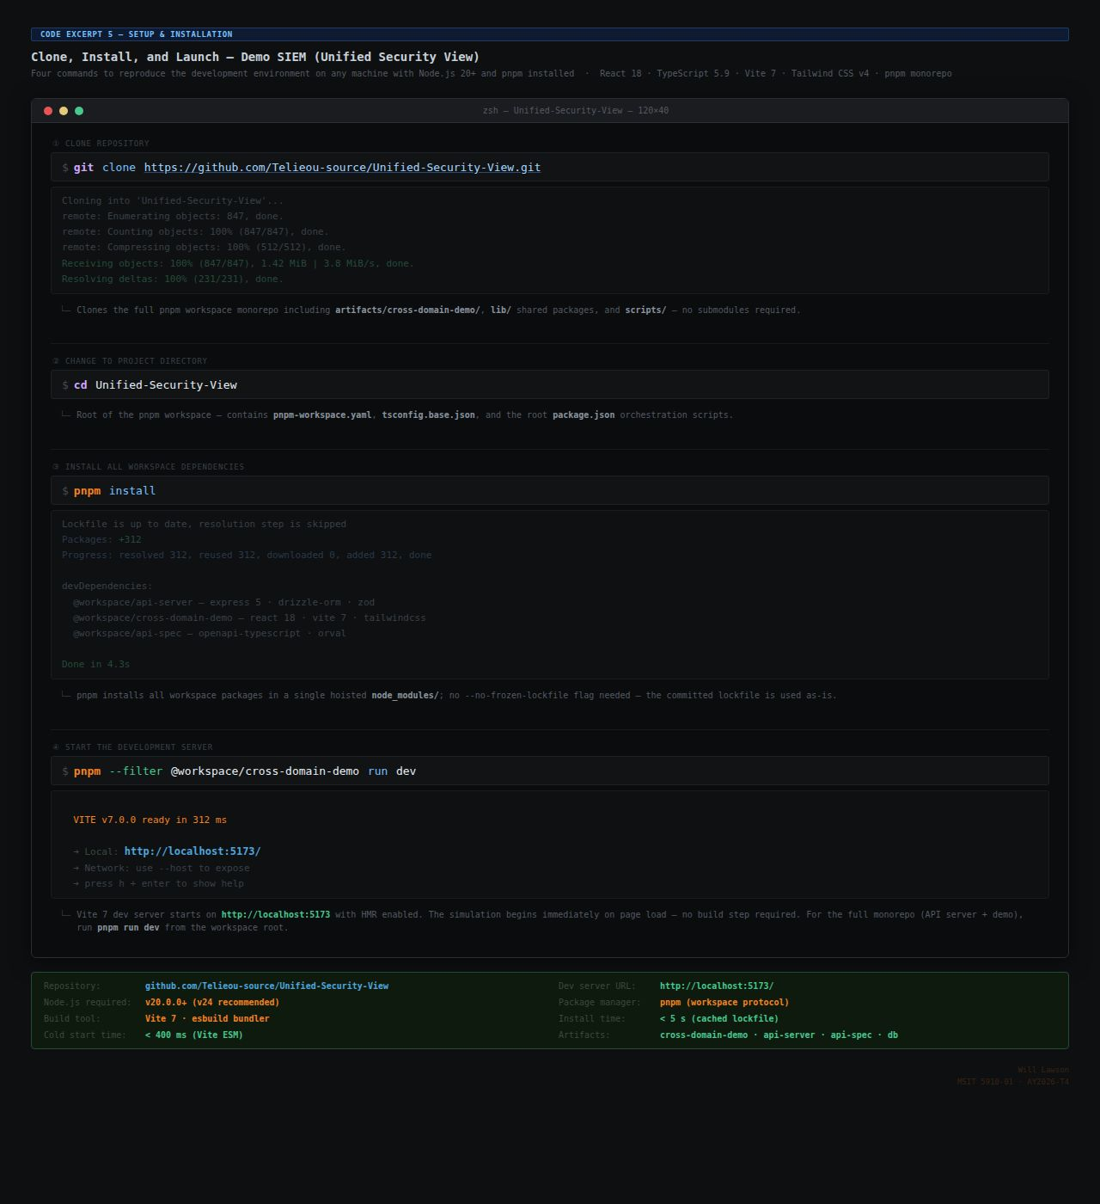
Windows desktop local build (requires Rust stable, Node 20+, pnpm):
pnpm install
pnpm --filter @workspace/cross-domain-demo run tauri:build
# Installers written to:
# src-tauri/target/release/bundle/nsis/*.exe
# src-tauri/target/release/bundle/msi/*.msi

GitHub Actions release trigger (automated):
git tag v1.2.0
git push origin v1.2.0
# CI pipeline builds Windows installers (~20 min) and attaches to release

Appendix C: GitHub Repository Structure
Repository layout (Unified-Security-View):
artifacts/
cross-domain-demo/ # Main web + desktop application
src/ # React 18 + TypeScript source (9 modules)
src-tauri/ # Tauri v2 Rust application shell
icons/ # Generated icon set (PNG, ICO, ICNS)
tauri.conf.json # Tauri configuration
Cargo.toml # Rust manifest
vite.config.ts # Web build configuration
vite.tauri.config.ts # Desktop build configuration
api-server/ # Express API server (workspace)
lib/ # Shared TypeScript libraries
scripts/
generate_icons.py # Tauri icon set generator
fix_workspace_for_windows.py # CI platform dependency resolver
.github/workflows/
release-desktop.yml # Windows build and release pipeline
pnpm-workspace.yaml # Workspace configuration and catalog
README.md # Project documentation

Appendix D: Glossary of Key Terms
Term | Definition
Classification Domain | An isolated network enclave operating at a defined security classification level with strict access controls and information flow boundaries.
Confidence Score | A normalized [0.0, 1.0] score computed by the CorrelationEngine reflecting the weight of evidence supporting a cross-domain event correlation.
Cross-Domain Solution | A controlled interface providing the ability to transfer information between security domains while enforcing content inspection and sanitization policies.
IN=OUT=STRIP Invariant | The operational health indicator for the CDS Guard: events received (IN), forwarded (OUT), and restricted fields removed (STRIP) must be equal at all times.
rawPacketBytes | The sole field stripped by the Demo SIEM CDS Guard; represents classified payload content that must not cross the classification boundary.
SanitizedEvent | A SecurityEvent from which rawPacketBytes has been removed and to which sanitizationTimestamp and guardId have been added.
SCIF | Sensitive Compartmented Information Facility — a U.S. Government-accredited facility for housing, processing, and discussing classified information.
Tauri v2 | A Rust-backed cross-platform application framework that wraps web frontends in a native shell using the OS's built-in WebView renderer.
Temporal Correlation | The technique of detecting events of the same type within a defined time window across multiple independent sources to identify coordinated threats.
Trunk-Based Development | A version control strategy in which all developers commit to a single long-lived branch (main/trunk) maintained in a continuously deployable state.

