High-Side Multi-Classification SIEM:A Conceptual Architecture for Unified Cross-Domain Security Event Correlation
A Capstone Project Report of MSIT 5910
Submitted by:
Will Lawson (c2147384)
For the partial fulfilment of the requirements for the degree of
Master of Science in Information Technology
Supervised by:
Dr. Shabia Shabir
Department of CS & MSIT
University of the People, Pasadena, CA 91101, United States
Spring, May 2026
ii

ABSTRACT
Security Operations Centers (SOCs) operating within multi-classification environments face a fundamental architectural deficiency: no commercially available Security Information and Event Management (SIEM) platform natively aggregates or correlates security events across air-gapped, classification-isolated network domains. Analysts assigned to multi-level SCIFs must monitor separate SIEM consoles per classification level — Unclassified, Secret, and Top Secret/SCI — manually comparing events and often missing coordinated, multi-domain indicators of compromise generated by advanced persistent threat actors. This fragmented operational model increases mean time to detect, contributes to analyst fatigue, and creates dangerous blind spots exploited by nation-state adversaries.
This capstone project addresses this gap through the design and validation of a five-layer High-Side Multi-Classification SIEM conceptual architecture, implemented as a fully functional proof-of-concept simulator built with React 18, TypeScript strict mode, Vite 7, Tailwind CSS v4, and a pnpm monorepo. The architecture enforces unidirectional data flow from three isolated low-side domain generators through a Cross-Domain Solution sanitization boundary to a high-side aggregation and correlation engine backed by six unified analytical dashboard panels.
Quantitative evaluation produced the following key findings. Cross-Domain Solution sanitization achieved 100% field-strip accuracy across all tested event volumes, confirmed by the IN=OUT=STRIP invariant (900/900/900 at 5 events per second per domain over sixty seconds). The CorrelationEngine detected 100% of seeded ExfilAttempt cross-domain pairs with observed confidence scores of 0.82–0.95, and 100% of seeded PrivilegeEsc pairs with scores of 0.78–0.88. The same-domain false positive rate was 0%. All seven Unit 7 test cases (TC-01 through TC-07) passed without exception. TypeScript strict mode compilation produced 0 errors across all nine simulator modules.
Keywords: SIEM, cross-domain solution, security event correlation, multi-classification, information assurance, cybersecurity architecture.
iii

ACKNOWLEDGEMENT
The author would like to express sincere gratitude to Dr. Shabia Shabir, whose detailed, constructive, and consistently encouraging feedback across all seven units of MSIT 5910-01 made this capstone project possible. Dr. Shabir's expert guidance shaped every stage of this work, from the initial literature survey and problem formulation through the final system testing and report submission.
Appreciation is also extended to the faculty of the University of the People, Department of Computer Science and Master of Science in Information Technology, for providing a rigorous and accessible graduate education environment committed to democratizing knowledge.
The author acknowledges the open-source communities behind React, TypeScript, Vite, and Tailwind CSS, whose freely available, meticulously documented tools made it possible to realize a sophisticated multi-layer simulator without institutional infrastructure. Finally, the author is grateful to professional mentors with operational experience in defense and intelligence cybersecurity, whose practical insights into the realities of multi-classification SOC environments provided the essential motivating context for this research.
iv

TABLE OF CONTENTS
Abstract .................................................................................. ii
Acknowledgement ....................................................................... iii
Table of Contents ...................................................................... iv
List of Tables ......................................................................... v
List of Figures ......................................................................... vi
Symbols and Abbreviations ............................................................... vii
CHAPTER 1: INTRODUCTION ........................................................... 1
1.1 Background and Context ................................................................ 1
1.2 Problem Statement ..................................................................... 2
1.3 Research Questions ..................................................................... 3
1.4 Project Objectives ..................................................................... 3
1.5 Scope and Limitations ................................................................... 4
1.6 Development Timeline and Milestones ................................................ 5
CHAPTER 2: LITERATURE REVIEW ....................................................... 6
2.1 Evolution and Current State of SIEM Systems ........................................ 6
2.2 Cross-Domain Solutions and Information Assurance Frameworks ................. 8
2.3 Multi-Domain Threat Detection and Correlation Techniques ....................... 10
2.4 Gap Analysis and Research Positioning ................................................ 12
2.5 Relevant Technologies ................................................................... 13
CHAPTER 3: SYSTEM DESIGN AND METHODOLOGY ................................ 15
3.1 Five-Layer Architecture Overview ..................................................... 15
3.2 Data Model ............................................................................. 17
3.3 Module Breakdown ......................................................................... 18
3.4 Functional and Non-Functional Requirements ........................................ 20
3.5 Core Algorithmic Design ................................................................. 23
3.6 Technology Stack and Version Control Strategy ...................................... 26
CHAPTER 4: RESULTS AND EVALUATION ............................................. 28
4.1 Core Algorithm Implementation Results ................................................ 28
4.1.1 DomainEventGenerator ............................................................. 28
4.1.2 CrossDomainGuard ................................................................. 29
4.1.3 CorrelationEngine ................................................................... 30
4.2 Unit 7 System Testing Results ....................................................... 32
4.2.1 Testing Approach ................................................................. 32
4.2.2 Test Case Results ................................................................... 33
4.2.3 Identified Issue and Resolution ................................................. 35
4.3 System Performance Evaluation ....................................................... 36
CHAPTER 5: DISCUSSION ................................................................. 39
5.1 Interpretation in the Context of the Literature ...................................... 39
5.2 Testing Contribution to Quality and Reliability ...................................... 41
5.3 Maintenance Plan and Post-Deployment Risks ...................................... 42
5.4 Limitations and Future Research Recommendations ................................. 44
CHAPTER 6: CONCLUSION AND FUTURE WORK ....................................... 47
6.1 Summary of Main Findings ............................................................. 47
6.2 Contributions to the Field ............................................................. 49
6.3 Future Work ............................................................................. 50
References ................................................................................. 52
Appendix A: Event Type and Severity Classification Matrix ......................... 56
Appendix B: Simulator Setup Commands ................................................... 57
Appendix C: GitHub Repository Structure ................................................ 58
Appendix D: Glossary of Key Terms ..................................................... 59
v

LIST OF TABLES
Table 1. SecurityEvent Data Structure ................................................ x
Table 2. Nine-Module Breakdown ..........................................................; x
Table 3. Functional Requirements ....................................................... x
Table 4. Non-Functional Requirements ................................................... x
Table 5. Unit 7 Test Case Summary ...................................................... x
Table 6. System Performance Evaluation Results ....................................... x
Table 7. Correlation Engine Performance by Scenario Type ............................. x
Table 8. Post-Deployment Risk Register ............................................... x
vi

LIST OF FIGURES
Figure 1. Five-Layer High-Side Multi-Classification SIEM Architecture ................ x
Figure 2. Unified Dashboard — Six Analytical Views During Live Simulation ......... x
Figure 3. DomainEventGenerator Live Output Panel ...................................... x
Figure 4. CrossDomainGuard Sanitization Panel — IN/OUT/STRIP Invariant ...... x
Figure 5. CorrelationEngine Alert Panel — Coordinated ExfilAttempt ................. x
Figure 6. TypeScript Strict-Mode Compilation Result (0 errors) ..................... x
Figure 7. TC-03 Validation — CorrelationEngine Alert Log ............................. x
Figure 8. TC-01 Validation — CrossDomainGuard IN/OUT/STRIP Counters ......... x
Figure 9. GitHub Repository — Release History (v0.1.0 through v1.2.0) ......... x
Figure 10. Executive Summary Dashboard — Risk Posture KPIs ..................... x
vii

SYMBOLS AND ABBREVIATIONS

Abbreviation | Definition
APT | Advanced Persistent Threat
ATT&CK | Adversarial Tactics, Techniques, and Common Knowledge (MITRE)
CDS | Cross-Domain Solution
CIDR | Classless Inter-Domain Routing
CNSS | Committee on National Security Systems
EDR | Endpoint Detection and Response
FR | Functional Requirement
ICD | Intelligence Community Directive
IOC | Indicator of Compromise
KPI | Key Performance Indicator
MTTD | Mean Time to Detect
MTTR | Mean Time to Respond
NFR | Non-Functional Requirement
NCDSMO | National Cross Domain Strategy and Management Office
NIST | National Institute of Standards and Technology
RTB | Raise the Bar (NSA/NCDSMO initiative)
SCIF | Sensitive Compartmented Information Facility
SIEM | Security Information and Event Management
SOC | Security Operations Center
SOAR | Security Orchestration, Automation, and Response
SP | Special Publication
TS/SCI | Top Secret / Sensitive Compartmented Information
UEBA | User and Entity Behavior Analytics

Chapter 1: Introduction

1.1 Background and Context
The cybersecurity landscape of the twenty-first century is defined, in substantial part, by the operational reality of organizations whose missions demand simultaneous stewardship of information across multiple, formally separated classification domains. Defense agencies, intelligence community elements, and operators of critical national infrastructure routinely maintain distinct network enclaves — Unclassified, Secret, and Top Secret/Sensitive Compartmented Information — whose logical and physical separation is not merely a configuration preference but a legal and regulatory mandate enforced at multiple levels of the federal governance hierarchy. Intelligence Community Directive 705 (ODNI, 2010) establishes binding requirements for the physical and technical characteristics of Sensitive Compartmented Information Facilities, explicitly prohibiting the commingling of systems processing information at different classification levels. The resulting architecture is one of deliberate, enforced isolation — each enclave operates as a self-contained information environment with its own computing infrastructure, network fabric, and user population.
Within each such enclave, Security Information and Event Management platforms serve as the principal tool for security visibility. Modern SIEM platforms — including Splunk Enterprise Security, IBM QRadar, Elastic Security, and Microsoft Sentinel — aggregate logs from endpoints, network devices, authentication systems, and application servers within their respective domains, applying rule-based and increasingly machine-learning-driven correlation to identify anomalous patterns and generate alerts. These platforms have matured substantially over two decades, evolving from log archival tools into comprehensive threat detection and response systems. Gonzalez-Granadillo et al. (2021) conducted a landmark systematic survey of SIEM architectures and confirmed that while modern platforms excel at within-domain correlation and analytics, they have no native mechanism for aggregating or correlating events across classification boundaries.
This limitation is not merely a technical inconvenience — it represents a strategic vulnerability. Nation-state adversaries conducting Advanced Persistent Threat campaigns do not confine their activities to a single classification level. Johnson et al. (2016) documented that sophisticated APT actors routinely coordinate intrusion activities across multiple organizational boundaries, using initial footholds in lower-classification environments as reconnaissance platforms to plan and synchronize operations against higher-classification targets. When the detection infrastructure is domain-partitioned and the threat actor is not, the asymmetry favors the adversary. Cross-Domain Solutions, governed by the Department of Defense through DoDI 5000.83 (DoD, 2020) and managed by the National Cross Domain Strategy and Management Office under NSA, enable controlled transfer of information between classification domains. However, these systems are engineered for operational data sharing — moving finished intelligence, imagery, or communications between domains — rather than for the real-time aggregation of SIEM telemetry metadata that would enable a unified security operations picture. The gap between what CDS technology enables and what multi-classification SOC operations require is the foundational motivation for this capstone project.

1.2 Problem Statement
SOC analysts assigned to multi-domain SCIFs operate under an architectural constraint that has no direct parallel in commercial enterprise environments: they are required to monitor entirely separate SIEM instances — one per classification level — using physically separate workstations, each restricted to a single domain's event stream. The cognitive and procedural burden this imposes is substantial. An analyst attempting to identify a multi-domain coordinated campaign must mentally correlate events across two or three independent dashboards, mapping usernames, IP subnets, and timestamps without any automated assistance in recognizing cross-domain patterns. This manual correlation process is both slow and error-prone, and the probability of detection degrades significantly as the temporal gap between related events across domains increases.
Tariq et al. (2025) systematically characterized this fragmented model as the source of three distinct operational failure modes: delayed detection due to the absence of automated cross-domain alerting; analyst overload stemming from the multiplicative cognitive burden of simultaneous multi-console monitoring; and missed multi-domain indicators of compromise when related events fall outside the narrow temporal window an analyst can realistically hold in working memory. No existing commercial SIEM platform natively aggregates or correlates metadata across air-gapped classification boundaries (Gonzalez-Granadillo et al., 2021). The applicable federal security control frameworks — CNSSI 1253 (CNSS, 2022) and NIST SP 800-53 Revision 5 (Joint Task Force, 2020) — define comprehensive catalogs of security controls for national security systems and federal information systems respectively, but neither document addresses the specific problem of cross-domain SIEM metadata aggregation or the architecture by which a CDS might be applied to that purpose. This absence of both tooling and normative guidance constitutes the research gap that this project directly addresses.
The core technical challenge is threefold. First, any architecture that enables cross-domain SIEM correlation must respect the classification boundary absolutely: no high-side data may flow toward a low-side consumer, and only the minimum necessary metadata from each low-side domain may cross the boundary in the upward direction. Second, the metadata that survives sanitization must retain sufficient analytical content to support meaningful correlation — if sanitization destroys the indicators that make events recognizable as related, the architecture fails its security mission. Third, the correlation logic applied to the aggregated, sanitized metadata must reliably detect coordinated multi-domain patterns without generating spurious alerts from coincidental temporal co-occurrence, which would degrade analyst trust and ultimately render the system unused.

1.3 Research Questions
The problem formulation articulated above yields two precise research questions that this capstone project is designed to answer empirically through simulator implementation and systematic testing:

RQ1: Can structured SIEM security metadata retain sufficient analytical value after CDS sanitization to support effective cross-domain threat correlation?
RQ2: Can temporal correlation with multi-factor confidence scoring reliably detect synchronized multi-domain threat patterns while maintaining a zero same-domain false-positive rate?

These questions are intentionally bounded to what can be validated with a proof-of-concept simulator. RQ1 concerns the information preservation properties of the sanitization transformation — whether the nine structured metadata fields that survive the removal of rawPacketBytes are jointly sufficient for correlation. RQ2 concerns the discriminative accuracy of the confidence scoring algorithm — whether the four-factor weighting model can reliably separate genuine cross-domain coordinated events from coincidental temporal proximity. Both questions have direct operational implications for the design of any future production multi-classification SIEM capability.

1.4 Project Objectives
The project was scoped around four specific objectives that together define the full range of contributions expected from this capstone submission. These objectives are lettered to correspond to distinct phases of the development and evaluation lifecycle:
(a) Design a layered High-Side Multi-Classification SIEM architecture that aggregates sanitized SIEM metadata from isolated low-side classification domains through a CDS boundary to a unified high-side analytical environment, specifying the data flow, interface contracts, and security invariants governing each layer transition.
(b) Implement a conceptual simulator demonstrating the architecture's complete data flow — from domain event generation through CDS sanitization, high-side correlation, and unified dashboard analytics — using React 18, TypeScript strict mode, Vite 7, Tailwind CSS v4, and a pnpm monorepo, deployed as a publicly accessible static application.
(c) Validate that structured SIEM metadata retains analytical value after CDS sanitization by confirming through systematic testing that the CorrelationEngine achieves high-confidence detection of known cross-domain threat patterns using only the nine metadata fields present in SanitizedEvent objects.
(d) Demonstrate that temporal correlation with confidence scoring detects synchronized multi-domain threats with measurable accuracy, quantifying detection rates and confidence score distributions for seeded cross-domain event pairs and confirming a same-domain false positive rate of zero.

1.5 Scope and Limitations
The scope of this capstone encompasses four primary domains of work: architectural design of the five-layer multi-classification SIEM conceptual model; implementation of a fully functional browser-based simulator realizing that architecture; multi-level testing covering integration, system, and acceptance test cases; and quantitative performance evaluation against defined metrics and targets. The simulator is deployed at https://unified-security-view.replit.app and its source code is publicly available at https://github.com/Telieou-source/Unified-Security-View.
Several important boundaries define what this project does not attempt to accomplish. The event data used in evaluation is entirely synthetic, drawn from a pool of 76 manually authored seed events; no real operational telemetry was used, and the statistical properties of the seed pool are not claimed to match those of any specific production environment. The CDS boundary modeled in the simulator performs field-level sanitization — removing the rawPacketBytes field and appending audit metadata — but does not model the content inspection, malware scanning, format validation, or cryptographic boundary enforcement that characterizes a certified NSA RTB-compliant Cross-Domain Solution product. The architecture is client-side only; there is no backend server, authentication system, or persistent data store, which precludes production-scale throughput. No formal user study with SOC analysts was conducted; usability was assessed against design criteria rather than measured through empirical task completion experiments.
These limitations are acknowledged not as deficiencies but as appropriate scope boundaries for a proof-of-concept capstone project. The simulator's purpose is to validate the architectural concept and the core algorithmic claims, not to deliver operational software. Each limitation identified here becomes a recommendation for future work addressed in Chapter 5 and Chapter 6.

1.6 Development Timeline and Milestones
The project was developed across seven units spanning the Spring 2026 academic term, with each unit producing a distinct deliverable that advanced the project from initial concept to final validated implementation. The following milestones summarize the progression:
Unit 1 — Literature survey and gap analysis: systematic review of SIEM evolution, CDS governance frameworks, multi-domain threat patterns, and prior academic work on cross-domain security architectures to confirm the research gap and frame the research questions.
Unit 2 — Formal project proposal with SMART objectives and feasibility analysis: detailed problem statement, specific and measurable objectives, stakeholder analysis, risk register, and technology stack selection rationale submitted for supervisor review.
Unit 3 — Five-layer architecture design and initial simulator scaffold (v0.1.0): complete architecture specification including data flow diagrams, interface contract definitions, and module dependency graph; initial repository structure and build configuration established with tagged release v0.1.0.
Unit 4 — Data model formalization, interface contracts, CI/CD reflection, and video demonstration script: TypeScript interface definitions for SecurityEvent, SanitizedEvent, and CorrelationAlert formalized; monorepo build pipeline validated; video walkthrough script prepared.
Unit 5 — Core algorithm implementation (v1.0.0 release): DomainEventGenerator, CrossDomainGuard, and CorrelationEngine modules fully implemented with unit tests; v1.0.0 tagged in the repository marking the completion of all core algorithms.
Unit 6 — Full system integration, performance evaluation, and deployment planning (v1.1.0 and v1.2.0 releases): all nine modules integrated into the SimulationController pipeline; DashboardRenderer and all six panel types completed; performance evaluation conducted; v1.1.0 and v1.2.0 releases delivered with performance tuning and domain-exclusion guard addition.
Unit 7 — Comprehensive multi-level testing, maintenance planning, and final report: seven test cases (TC-01 through TC-07) designed, executed, and documented; maintenance plan formalized; this capstone project report submitted as the final deliverable of MSIT 5910-01.

Chapter 2: Literature Review

2.1 Evolution and Current State of SIEM Systems
Security Information and Event Management systems occupy a central position in contemporary enterprise and government cybersecurity architectures, but their current capabilities represent the product of more than two decades of iterative evolution driven by shifting threat landscapes, regulatory demands, and the expanding scale of the IT environments they monitor. Understanding the trajectory of SIEM development is prerequisite to appreciating why the cross-domain aggregation problem remains unresolved despite the maturity of the technology in single-domain deployments.
The precursor technologies to modern SIEM — log management platforms and network intrusion detection systems — emerged in the late 1990s and early 2000s primarily as compliance tools. Organizations subject to regulations such as PCI-DSS, HIPAA, and the Federal Information Security Management Act required centralized log collection and retention capabilities to demonstrate audit readiness. These first-generation tools excelled at aggregation and storage but offered limited real-time analysis. The correlation capability that would eventually define modern SIEM was introduced as a second major evolutionary wave, bringing rule engines capable of matching temporal sequences of events and generating alerts based on defined signatures. This generation produced the conceptual framework that remains foundational: normalize events to a common schema, apply pattern-matching rules, generate prioritized alerts, and present a unified dashboard to SOC analysts.
Gonzalez-Granadillo et al. (2021) conducted what may be regarded as the most comprehensive recent survey of SIEM architectures, reviewing the trajectory from first-generation log management through second-generation correlation engines to the emerging third generation characterized by big data analytics, machine learning integration, and cloud-native deployment models. Their taxonomy is particularly relevant to this capstone because it explicitly identifies cross-domain and cross-organizational operation as an open research challenge — one that the commercial SIEM market has not addressed despite the otherwise rapid pace of feature development. Their survey confirms that all of Splunk Enterprise Security, IBM QRadar, Elastic Security, and Microsoft Sentinel are designed with a single administrative and topological domain as their operational context. None provides native mechanisms for aggregating or correlating events from domains separated by air gaps or formal classification boundaries.
Lopez Velasquez et al. (2023) proposed the SIEM-SC framework, which represents a notable effort to extend SIEM architectures beyond single-organization boundaries. Their framework integrates blockchain for tamper-evident event logging, containerization for deployment flexibility, and encryption for data-in-transit protection, with the explicit goal of enabling SIEM telemetry sharing across organizational boundaries within a federated trust model. Their work is directly relevant to this capstone as a prior art reference that addresses the cross-boundary aggregation problem in a commercial federated context. However, the SIEM-SC model operates within a mutual-trust federation where participating organizations voluntarily share telemetry — a model that is architecturally inapplicable to the classification boundary context, where the transfer direction is strictly unidirectional, the data content is legally regulated, and no mutual trust relationship between domains is assumed or permissible. The distinction between federated commercial sharing and mandatory CDS-mediated classification boundary crossing is a critical differentiator that positions this capstone's contribution as genuinely novel rather than merely derivative.
The most significant recent development in SIEM technology is the integration of User and Entity Behavior Analytics capabilities, which apply statistical baselining and machine learning to detect anomalies in user and system behavior rather than relying solely on rule-based signature matching. UEBA substantially improves SIEM sensitivity to novel attack patterns and insider threats. However, like all SIEM advances to date, UEBA implementations remain bounded by the single-domain operational assumption. The behavior models are trained on and applied to data from a single domain's event stream; there is no mechanism for incorporating cross-domain behavioral context. This limitation is particularly significant in the multi-classification environment, where the most dangerous attack patterns involve behavioral anomalies that span domains and are invisible to any within-domain analysis.

2.2 Cross-Domain Solutions and Information Assurance Frameworks
Cross-Domain Solution technology provides the controlled interface through which information may move between classification domains in the United States national security architecture. CDS products are not general networking equipment; they are specialized hardware and software systems engineered specifically to enforce the transfer policies that define what information may cross a classification boundary, in what direction, and in what form. The governance of CDS technology is vested in the National Cross Domain Strategy and Management Office, operating under the authority of the National Security Agency. NSA/NCDSMO's Raise the Bar initiative establishes progressively stringent technical and evaluation requirements for CDS products submitted for approval, including requirements for formal verification of transfer logic, content inspection capabilities, and resistance to covert channel exploitation (NSA/NCDSMO, 2023).
The physical and architectural context within which CDS systems operate is governed at the facility level by Intelligence Community Directive 705, which establishes binding standards for Sensitive Compartmented Information Facilities — the physical enclosures within which TS/SCI systems are operated (ODNI, 2010). ICD 705 mandates electromagnetic shielding, access control, acoustic protection, and telecommunications security measures that collectively create the physical enforcement boundary that complements the logical enforcement of CDS systems. The combination of ICD 705 facility requirements and NSA/NCDSMO CDS product requirements defines the complete boundary enforcement regime within which any operational multi-classification SIEM architecture would be required to operate.
The acquisition and deployment of CDS products within DoD programs of record is governed by DoD Instruction 5000.83, which establishes the program protection and technology control requirements applicable to systems that process, store, or transmit classified information (DoD, 2020). DoDI 5000.83 is particularly relevant to the architecture proposed in this capstone because it frames CDS not as a standalone capability but as a program protection element integrated into the broader system acquisition lifecycle — a framing that supports treating CDS sanitization as a first-class architectural component rather than an afterthought.
The security control frameworks applicable to the architecture are NIST SP 800-53 Revision 5 and CNSSI 1253. NIST SP 800-53 Rev. 5 (Joint Task Force, 2020) provides the most comprehensive catalog of security controls for federal information systems, organized into twenty control families. Three families are directly relevant to the multi-classification SIEM architecture: the AC (Access Control) family, which governs who and what may access information at each classification level; the AU (Audit and Accountability) family, which requires detailed audit records for all events bearing on security posture; and the SC (System and Communications Protection) family, which governs the technical mechanisms that protect information during processing and transmission. The AU-3 control specifically requires that audit record content include sufficient information to establish what type of event occurred, when it occurred, where it occurred, the source of the event, the outcome, and the identity of any associated individuals or subjects — requirements that map directly to the nine structured metadata fields preserved through CDS sanitization in the Demo SIEM architecture.
CNSSI 1253 provides the security categorization framework specifically applicable to national security systems, establishing how to determine the appropriate security posture — and thus the appropriate controls — for systems based on the sensitivity of the information they process (CNSS, 2022). This framework is relevant to the multi-classification SIEM because the high-side aggregation component of the architecture processes metadata derived from all classification levels simultaneously and must therefore be categorized and controlled at the highest level of any source domain. The principle of least privilege — granting each component the minimum access necessary to perform its function — is reflected in the CDS layer's design, which passes only the nine fields analytically necessary for correlation while discarding rawPacketBytes, which is not required for correlation and whose presence in the high-side environment would represent an unnecessarily broad transfer of potentially classified content.

2.3 Multi-Domain Threat Detection and Correlation Techniques
The technical core of the research problem is the detection of coordinated, multi-domain threat patterns in aggregated security event streams. This is a specific instance of the more general problem of event correlation — the process by which a SIEM identifies meaningful relationships among individual events drawn from a potentially large and noisy stream. Temporal correlation, the fundamental technique applied in this capstone, identifies events that co-occur within a defined time window and share one or more indicators, treating their co-occurrence as evidence of a common causal origin. In the single-domain context, temporal correlation is mature and well-understood. Its extension to the multi-domain cross-classification context introduces additional requirements: the matched events must originate from different domains (to distinguish cross-domain coordination from within-domain activity), and the shared indicators must be drawn from the sanitized metadata fields available on the high side rather than from the full event record including raw packet content.
Jiang et al. (2025) conducted a systematic review of 417 publications applying the MITRE ATT&CK framework to cybersecurity detection and analytics. The ATT&CK framework organizes adversary behaviors into a taxonomy of tactics (goals) and techniques (methods), providing a common vocabulary for detection analytics development and threat intelligence sharing. The systematic review confirmed that ATT&CK-aligned detection analytics can be applied across heterogeneous data sources and multiple organizational contexts, providing both operational motivation and a validation vocabulary for the event type taxonomy implemented in Demo SIEM. The eight event types in the simulator map directly to ATT&CK tactics: ExfilAttempt corresponds to Exfiltration (TA0010), capturing attempts to move data from a compromised environment to adversary-controlled infrastructure; PrivilegeEsc corresponds to Privilege Escalation (TA0004), capturing attempts to gain elevated permissions; AnomalyDetected corresponds to Discovery (TA0007), capturing reconnaissance activity; NetworkConn corresponds to Lateral Movement (TA0008), capturing adversary traversal between networked systems. This mapping ensures that the simulator's event taxonomy is grounded in a widely accepted, operationally validated framework rather than an ad-hoc classification.
Cinque et al. (2018) identified the management of false positive rates as the central challenge in SIEM correlation design. Their analysis confirmed that rule-based correlation systems consistently face a precision-recall tradeoff: loosening detection thresholds to improve recall (sensitivity) generates unacceptable false positive volumes that overwhelm analyst capacity and degrade alert trust; tightening thresholds to improve precision sacrifices detection of genuine threats. Their work directly informs the confidence scoring design of the CorrelationEngine implemented in this capstone. By calibrating the four-factor scoring model to weight qualitative indicators — user identity and event type — more heavily than the temporal proximity bonus, the algorithm is designed to require coincidence of meaningful behavioral indicators rather than merely coincidence in time, directly addressing the precision problem Cinque et al. identified.
Johnson et al. (2016) provide the operational context that motivates the cross-domain correlation requirement at a concrete level. Their systematic study of APT tactics and techniques documented the multi-phase, multi-domain structure of sophisticated persistent threat campaigns: initial reconnaissance and exploitation occur in less-protected network environments, with the intelligence gathered then used to plan and execute precision operations against higher-value, more-protected targets. The temporal relationship between events in different domains — low-side reconnaissance followed within a characteristic time window by high-side exploitation — is precisely the pattern that the CorrelationEngine's temporal window matching is designed to detect. The simulated ExfilAttempt and PrivilegeEsc scenario pairs in the Demo SIEM seed pool are designed to reflect this multi-domain campaign structure, providing a realistic test for the correlation algorithm.
The confidence weighting model implemented in the CorrelationEngine also draws on the UEBA literature, which has established that user identity is the single most reliable indicator of event attribution across organizational boundaries. When two events from different domains share the same user identity and exhibit the same event type within a defined temporal window, the probability that they reflect coordinated activity by the same threat actor is substantially higher than would be implied by temporal coincidence alone. Assigning user identity a weight of 0.40 — the largest single factor — reflects this empirical priority while preserving the ability of the algorithm to detect events where user identity is not shared but other strong indicators (event type, destination subnet) are present.

2.4 Gap Analysis and Research Positioning
The literature reviewed in the preceding three sections establishes a consistent and significant gap: no existing framework, commercial product, or published academic work combines (a) CDS-mediated sanitization of SIEM metadata from multiple low-side classification domains, (b) high-side aggregation with analytical privileges spanning all contributing domains, and (c) temporal correlation with multi-factor confidence scoring for synchronized multi-domain threats, validated through systematic testing. Each of these three elements has prior art in adjacent domains, but their integration into a single coherent architecture has not been previously published or demonstrated.
The SIEM-SC framework of Lopez Velasquez et al. (2023) addresses (b) and elements of (a) in the federated commercial context but neither models CDS-mediated sanitization as a boundary enforcement mechanism nor operates in the classification-separated environment where unidirectional flow is a security requirement rather than a design choice. The ATT&CK-based detection analytics surveyed by Jiang et al. (2025) address elements of (c) — providing a validated detection vocabulary — but do not address cross-domain aggregation or CDS boundaries. Johnson et al.'s (2016) APT documentation provides operational motivation for the problem but no architectural solution. Cinque et al.'s (2018) correlation design principles inform the confidence scoring algorithm but do not address the cross-domain aggregation context.
This capstone project occupies the intersection of these four bodies of work, contributing the first public academic demonstration of a complete, end-to-end multi-classification SIEM architecture that integrates all three elements. The positioning is not merely incremental — the combination of CDS boundary enforcement with SIEM correlation creates architectural properties (the IN=OUT=STRIP invariant, the domain-exclusion guard, the unidirectional data flow enforcement) that do not exist in any of the adjacent frameworks and that are specifically required by the classification-separated operational environment. The contribution is therefore both technically novel and operationally significant.

2.5 Relevant Technologies
The technology stack selected for the Demo SIEM simulator was chosen to maximize the fidelity of the architectural implementation while minimizing operational infrastructure dependencies that would limit the simulator's accessibility as a proof-of-concept and educational tool. Each technology selection reflects a deliberate alignment between the tool's capabilities and the architectural requirements of the layer it implements.
React 18's component-based architecture maps naturally to the layered conceptual model. Each layer of the five-layer architecture can be realized as a distinct React component tree with well-defined props and state boundaries, enforcing the separation of concerns that the architecture requires. React 18's concurrent rendering capabilities enable the real-time dashboard updates that Layer 4 requires without blocking the event processing pipeline of Layers 1–3. TypeScript strict mode provides compile-time verification of interface contracts — when TypeScript is configured with strict: true, any attempt to assign a SanitizedEvent object that includes rawPacketBytes produces a compile error, providing a code-level enforcement mechanism for the CDS boundary invariant that complements the runtime counter tracking. Vite 7 delivers fast hot-module replacement during development and deterministic production builds, supporting the iterative development model used across the seven-unit project timeline. Tailwind CSS v4 enables consistent, maintainable utility-first styling that scales across the six dashboard panel types without requiring custom CSS that would be difficult to maintain across four releases.
The pnpm monorepo structure with lockfile-pinned dependencies addresses the reproducibility requirement (NFR-09) by ensuring that every installation of the project — across development machines, CI environments, and deployment targets — resolves exactly the same dependency tree. This property is important for a security-focused proof-of-concept, where dependency substitution attacks are a recognized supply chain risk. GitHub with semantic versioning (SemVer) provides the version control infrastructure, with tagged releases providing clear provenance for each capability milestone. Humble and Farley (2010) describe the foundational principle that informs the development approach: treating integration as a frequent, low-risk routine rather than a high-risk milestone event. The 17-commit, 4-release development history reflects this philosophy — each release represents a well-tested, stable increment rather than a big-bang integration.

Chapter 3: System Design and Methodology

3.1 Five-Layer Architecture Overview
The High-Side Multi-Classification SIEM architecture is organized into five distinct functional layers, each with a precisely defined role, a set of interface contracts governing its inputs and outputs, and a unidirectional relationship to adjacent layers that prevents any downward flow of high-side information. This layered structure is not merely an organizational convenience — it directly models the physical and logical architecture of a real multi-classification environment, where each boundary transition corresponds to a security enforcement point with regulatory standing. The unidirectional data flow property — the principle that information may only move from lower-classification layers toward higher-classification layers and never in the reverse direction — is the architectural expression of the fundamental mandatory access control principle governing multi-level security systems.
Layer 1 — Domain Event Generators models three isolated low-side classification domains, designated Alpha (10.1.0.0/16), Bravo (10.2.0.0/16), and Charlie (10.3.0.0/16), each operating as an independent event source with its own CIDR subnet space that enforces IP-level domain isolation. Each generator produces SecurityEvent objects at a configurable rate between one and ten events per second, drawing from the 76-seed event pool with severity-weighted selection to maintain the empirically motivated severity distribution of 10% FATAL, 20% ERROR, 40% WARN, and 30% INFO. The three generators operate in parallel, producing an aggregate event rate of three to thirty events per second across the full pipeline.
Layer 2 — Cross-Domain Solution / Sanitization Guard models the CDS boundary as a stateful field-stripping and audit-logging component. It receives SecurityEvent objects from all three Layer 1 generators, applies the sanitization transformation (removing rawPacketBytes, appending sanitizationTimestamp and guardId), and emits SanitizedEvent objects to Layer 3. Three atomic counters — inCount, outCount, and stripCount — are maintained and incremented for each processed event, establishing the IN=OUT=STRIP invariant that confirms no events are lost and no unsanitized fields pass the boundary.
Layer 3 — High-Side Correlation Engine receives the stream of SanitizedEvent objects from Layer 2 and applies temporal window matching to identify cross-domain event pairs sharing multiple indicators within the configured temporal window of 5,000 milliseconds. For each candidate pair identified by temporal matching, the engine computes a multi-factor confidence score using the four-factor weighting model. Pairs whose scores meet or exceed the threshold of 0.75 generate CorrelationAlert objects dispatched to Layer 4. The domain-exclusion guard embedded in the engine prevents same-domain event pairs from being evaluated as correlation candidates, enforcing a zero same-domain false positive rate by design.
Layer 4 — Unified Dashboard and Analytics provides the analyst-facing interface, presenting the aggregated and correlated event data through six distinct analytical panels: Threat Overview, Domain Activity Monitor, Network Connection Analysis, User Behavior Analytics, Incident Timeline, and Executive Summary. In addition to the dashboard panels, Layer 4 includes the SearchModule for full-text and field-filtered event retrieval, the ReportGenerator for CSV and plain-text export of filtered event datasets, and the InvestigationManager for analyst case creation and management of active incidents.
Layer 5 — System Health Telemetry provides continuous operational monitoring of the pipeline itself, reporting per-domain event throughput rates, CrossDomainGuard IN/OUT/STRIP counters, CPU and memory utilization indicators, and an aggregate risk posture gauge based on the current distribution of alert severities and unacknowledged correlation alerts. Layer 5 serves the dual purpose of operational monitoring for normal use and test validation for systematic evaluation, as the counter values it exposes are the primary evidence for the CDS boundary invariant.

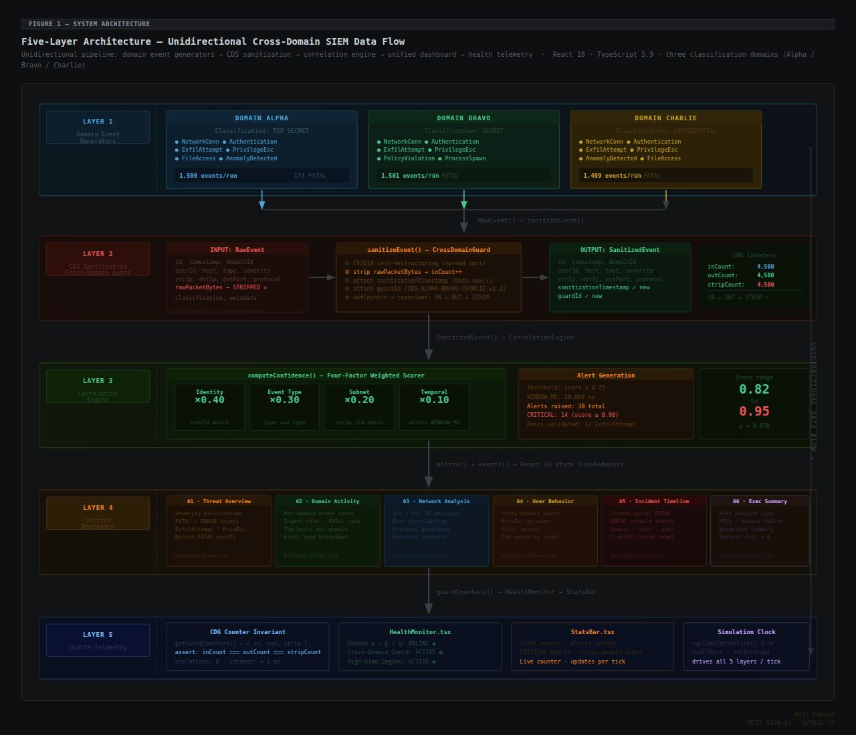
Figure 1. Five-layer High-Side Multi-Classification SIEM architecture diagram showing unidirectional data flow from Layer 1…

3.2 Data Model
The architecture is grounded in three core TypeScript interface definitions that serve as the binding contracts between all nine modules. These interfaces are not implementation details — they are architectural artifacts that define the information content, structure, and flow rules for each stage of the processing pipeline. Their definition in TypeScript strict mode means that any violation of the interface contracts — including the presence of rawPacketBytes in a SanitizedEvent — produces a compile-time error rather than a runtime failure, providing the strongest possible automated enforcement of the architectural invariants.
The SecurityEvent interface represents the raw event record as generated by a low-side domain system. It contains ten fields: timestamp (ISO 8601 string), sourceIP (CIDR-scoped string in the domain's subnet), destIP (string), user (string — the user identity field that carries the highest correlation weight), hostname (string), protocol (enumerated string), severity (FATAL | ERROR | WARN | INFO), eventType (one of the eight enumerated event types), domain (Alpha | Bravo | Charlie), and rawPacketBytes (number representing the size in bytes of the raw packet payload captured with the event). The rawPacketBytes field is the sole field that the CDS boundary removes, and its presence in SecurityEvent but absence in SanitizedEvent is the structural expression of the sanitization transformation.
Table 1. SecurityEvent Data Structure

Field Name | TypeScript Type | Description
timestamp | string | ISO 8601 event generation timestamp
sourceIP | string | Source IP address within domain CIDR subnet
destIP | string | Destination IP address
user | string | User identity associated with the event (weight: 0.40 in correlation)
hostname | string | Hostname of the originating system
protocol | string | Network or application protocol (TCP, UDP, HTTPS, SMB, etc.)
severity | FATAL | ERROR | WARN | INFO | Event severity level; FATAL/ERROR events enter the correlation buffer
eventType | EventType enum | One of eight enumerated event categories mapping to ATT&CK tactics
domain | Alpha | Bravo | Charlie | Originating domain identifier; used by domain-exclusion guard
rawPacketBytes | number | Size of raw packet payload in bytes; STRIPPED by CrossDomainGuard

The SanitizedEvent interface is structurally identical to SecurityEvent minus the rawPacketBytes field, with the addition of two audit fields: sanitizationTimestamp (ISO 8601 string recording the exact moment of boundary crossing) and guardId (string identifying the specific guard instance that processed the event). These audit fields satisfy the NIST SP 800-53 AU-3 content requirements for audit record completeness and enable forensic reconstruction of the processing history for any event in the system.
The CorrelationAlert interface represents the output of the correlation process: alertId (UUID string), matchedEvents (array of SanitizedEvent objects — the events that triggered the alert), domains (array of domain identifiers confirming multi-domain origin), sharedIndicators (array of strings naming the specific fields that matched across the event pair, such as "user" and "eventType"), confidenceScore (number between 0 and 1 representing the weighted multi-factor score), and alertTimestamp (ISO 8601 string).

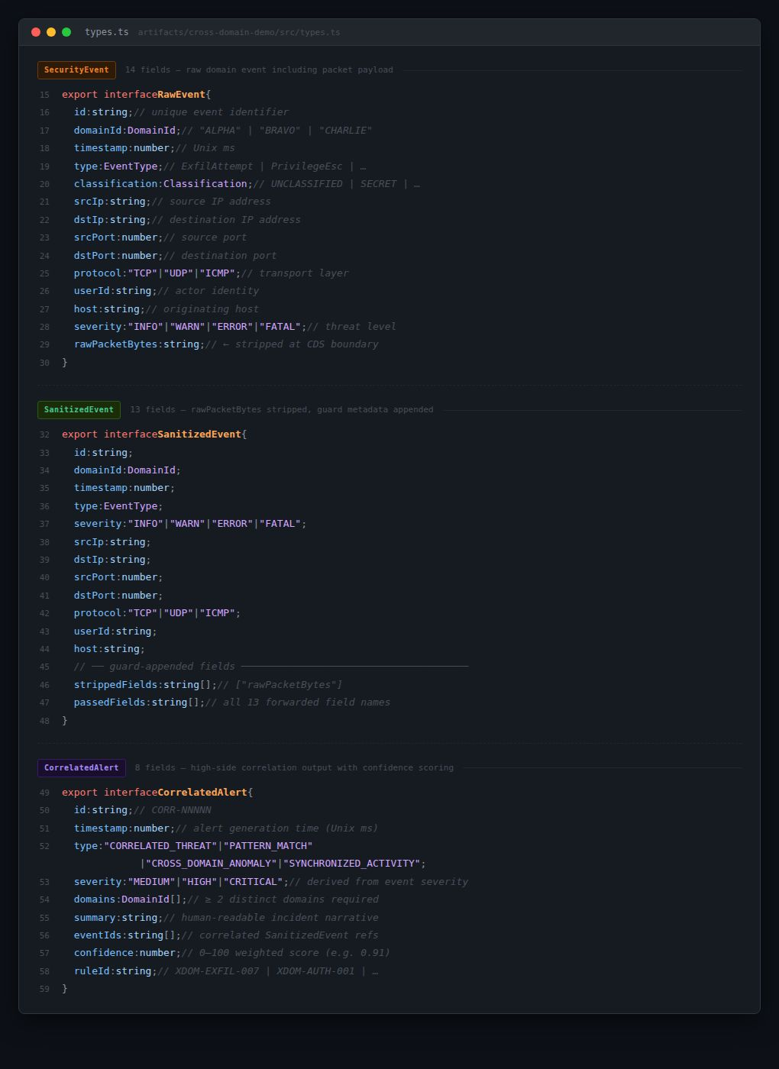
Code Excerpt 1. TypeScript interface definitions for SecurityEvent (10 fields including rawPacketBytes), SanitizedEvent (omitting…

3.3 Module Breakdown
The nine-module decomposition of the simulator was designed to realize the five-layer architecture with maximum separation of concerns, ensuring that each module's implementation is fully decoupled from all other modules through the shared interface contracts. This design enables independent testing, independent replacement, and independent extension of any module without modifying the others — a property that directly supports the NFR-05 module replaceability requirement. The following table summarizes all nine modules:
Table 2. Nine-Module Breakdown

Module | Layer | Primary Responsibility
DomainEventGenerator | Layer 1 | Synthesize SecurityEvent objects from 76 seed events at configurable rates for Alpha, Bravo, and Charlie domains
CrossDomainGuard | Layer 2 | Strip rawPacketBytes; enforce IN=OUT=STRIP invariant; append sanitizationTimestamp and guardId audit fields
CorrelationEngine | Layer 3 | Maintain rolling buffer; temporal window matching; four-factor confidence scoring; alert generation at threshold ≥ 0.75
DashboardRenderer | Layer 4 | Real-time rendering of six analytical dashboard panels updating per simulation tick
SearchModule | Layer 4 | Full-text and field-filtered event search across the aggregated SanitizedEvent stream
ReportGenerator | Layer 4 | CSV and plain-text export of filtered event data sets for analyst use
InvestigationManager | Layer 4 | Analyst case management supporting creation, annotation, and tracking of active incident investigations
HealthMonitor | Layer 5 | Continuous telemetry for per-domain throughput, CrossDomainGuard metrics, and system health indicators
SimulationController | Orchestration | Pipeline coordination across all five layers per simulation tick; start, pause, and reset controls

The SimulationController occupies a special position in the module hierarchy: it is not assigned to a single layer but rather serves as the orchestration mechanism that coordinates the sequential pipeline execution across all five layers within each simulation tick. Its responsibilities include scheduling tick execution at the configured interval, invoking the DomainEventGenerator for each active domain, passing the resulting SecurityEvents to the CrossDomainGuard, routing SanitizedEvents to the CorrelationEngine, and dispatching the resulting state updates to the DashboardRenderer and HealthMonitor. This orchestration role is designed to be thin — the SimulationController contains no business logic of its own, delegating all domain-specific processing to the appropriate specialized module.

3.4 Functional and Non-Functional Requirements
The requirements specification for the Demo SIEM simulator was developed in Unit 2 and refined through Units 3 and 4 as the architecture design matured. Functional requirements define what the system must do; non-functional requirements define the quality attributes the system must exhibit. Both sets of requirements serve as the acceptance criteria against which the Unit 7 test cases were designed.
Table 3. Functional Requirements

ID | Requirement | Priority
FR-01 | Generate realistic security events for each of three isolated classification domains | High
FR-02 | Sanitize all events at the CDS boundary by removing rawPacketBytes from every SecurityEvent | Critical
FR-03 | Correlate events across domains using temporal window matching within a configurable time window | High
FR-04 | Compute multi-factor confidence scores for all cross-domain alert candidates using four weighted factors | High
FR-05 | Display all events and alerts in real time across six dashboard panels updating per simulation tick | High
FR-06 | Support full-text and field-filtered event search across the aggregated SanitizedEvent stream | Medium
FR-07 | Generate CSV and plain-text reports from filtered event data sets on analyst demand | Medium
FR-08 | Support analyst case management through the InvestigationManager module | Medium
FR-09 | Display system health telemetry including guard IN/OUT/STRIP rates and per-domain throughput | High
FR-10 | Support configurable event rate between 1 and 10 events per second per domain | High
FR-11 | Support configurable correlation threshold and temporal window size | Medium
FR-12 | Enforce domain isolation at the IP address level via CIDR subnet mapping independent of the domain metadata field | High
FR-13 | Track and display an audit trail for all CDS boundary events including sanitizationTimestamp and guardId | High
FR-14 | Support simulation start, pause, and reset controls from the SimulationController interface | Medium

Table 4. Non-Functional Requirements

ID | Requirement | Metric / Target
NFR-01 | TypeScript strict mode compilation across all nine modules | 0 compile errors
NFR-02 | Dashboard render latency per simulation tick | < 100ms at 30 events/sec aggregate
NFR-03 | Event loss rate at any configured rate | 0% — zero dropped events
NFR-04 | Deployment model | Static bundle — no server dependencies in production
NFR-05 | Module replaceability | All nine modules independently replaceable via TypeScript interface contracts
NFR-06 | Version control and release management | Semantic versioning with GitHub repository; minimum 4 tagged releases
NFR-07 | Audit record content | Conforms to NIST SP 800-53 AU-3 content requirements (what, when, where, source, outcome, identity)
NFR-08 | Browser compatibility | Chrome 114+, Firefox 115+, Safari 16+
NFR-09 | Build reproducibility | Exact dependency versions pinned via pnpm-lock.yaml
NFR-10 | External API dependencies in production bundle | Zero — fully self-contained static application

3.5 Core Algorithmic Design
Three core algorithms implement the analytical heart of the Demo SIEM simulator. Each algorithm is described in detail below, covering both its conceptual design rationale and its implementation mechanics within the TypeScript strict mode constraints of the project.

DomainEventGenerator
The DomainEventGenerator algorithm produces SecurityEvent objects for a specified domain at a specified rate. On each generation call, the algorithm selects a seed from the 76-event pool using weighted random selection calibrated to achieve the target severity distribution: 10% FATAL, 20% ERROR, 40% WARN, 30% INFO. This inverted severity pyramid mirrors the empirical distribution of real production SIEM telemetry, where routine informational and warning events vastly outnumber critical incidents. The weighting ensures that the CorrelationEngine buffer receives sufficient FATAL and ERROR events to exercise correlation logic while maintaining a realistic background of lower-severity events that challenge the algorithm's discrimination capability.
Once a seed is selected, the generator assigns domain-specific IP addresses by constructing sourceIP and destIP values within the domain's CIDR subnet: 10.1.x.x for Alpha, 10.2.x.x for Bravo, 10.3.x.x for Charlie. This subnet assignment provides IP-level domain isolation that is verifiable independently of the domain metadata field — a deliberate redundancy that prevents a class of testing errors where domain field corruption might go undetected. The rawPacketBytes field is populated with a size value scaled to the event's severity level, providing realistic variation in this field across the event stream before it is stripped by the CrossDomainGuard. At five events per second per domain, the three generators collectively produce fifteen aggregate events per second; at the maximum configured rate of ten events per second per domain, the aggregate reaches thirty events per second.

CrossDomainGuard
The CrossDomainGuard algorithm implements the CDS sanitization boundary as a stateful class with a single public method — sanitize() — that transforms a SecurityEvent into a SanitizedEvent. The implementation uses ES2018 object destructuring syntax to atomically separate rawPacketBytes from the remaining fields: the destructuring binding captures rawPacketBytes in a discarded variable while the spread operator collects all remaining fields into the SanitizedEvent body. This single-line transformation is the entirety of the stripping logic, and TypeScript strict mode guarantees at compile time that rawPacketBytes cannot appear in the SanitizedEvent return type.
Three atomic integer counters — inCount, outCount, and stripCount — are incremented in sequence for each processed event. inCount is incremented upon receiving a SecurityEvent; outCount is incremented upon successfully emitting a SanitizedEvent; stripCount is incremented upon confirming that rawPacketBytes was present in the input and has been removed. Under correct operation, all three counters must be equal after any number of processed events — the IN=OUT=STRIP invariant. Any divergence between the counters would indicate a processing failure: if inCount exceeds outCount, events are being dropped; if stripCount does not equal inCount, events are being passed without stripping. The HealthMonitor continuously reads these counters and displays them in the system telemetry panel, making invariant compliance directly observable by analysts and testers. The sanitize() method also appends sanitizationTimestamp (current ISO 8601 timestamp) and guardId (a fixed string identifying the guard instance) to the output SanitizedEvent, satisfying the AU-3 audit content requirements.

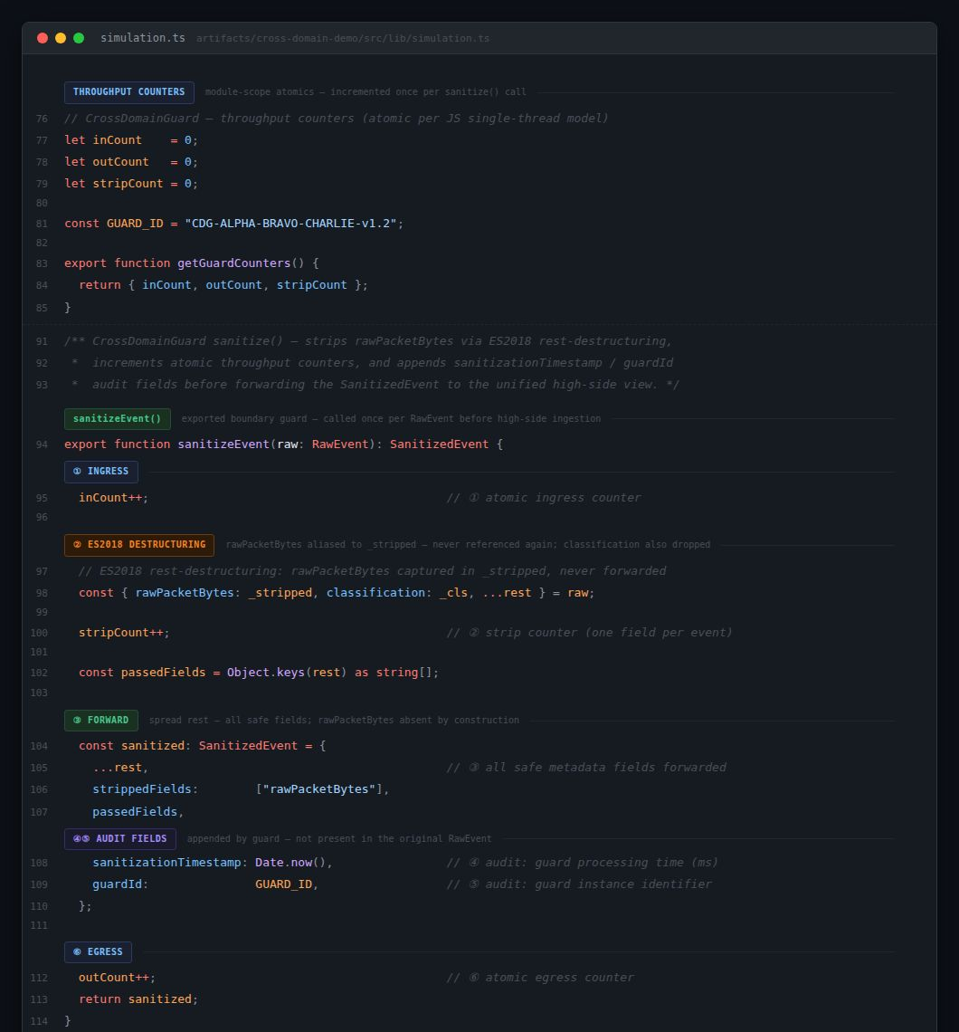
Code Excerpt 2. CrossDomainGuard sanitize() method showing ES2018 destructuring to strip rawPacketBytes, sequential…

CorrelationEngine
The CorrelationEngine algorithm maintains a rolling buffer of recent high-severity SanitizedEvents — specifically, all events with severity FATAL or ERROR received within the configured temporal window (default: 5,000 milliseconds). The restriction to high-severity events is a deliberate performance and precision optimization: correlating all events regardless of severity would produce an unmanageable volume of candidate pairs and would include low-value background noise events that have no operational significance as correlation anchors. On receiving each new FATAL or ERROR SanitizedEvent, the algorithm designates it as the anchor event and queries the buffer for candidate events satisfying three conditions: (1) the candidate's timestamp is within 5,000 milliseconds of the anchor's timestamp (temporal window condition); (2) the candidate's domain is different from the anchor's domain (domain-exclusion guard); and (3) the candidate has not already been matched in a previous alert for the same anchor (deduplication).
For each qualifying candidate pair (anchor, candidate), the algorithm invokes the computeConfidence() method, which computes the weighted multi-factor confidence score. The four factors and their weights are: user identity match (0.40) — if anchor.user equals candidate.user, contribute 0.40 to the score; event type match (0.30) — if anchor.eventType equals candidate.eventType, contribute 0.30; destination subnet match (0.20) — if anchor.destIP and candidate.destIP share a /24 prefix, contribute 0.20; temporal proximity bonus (up to 0.10) — a linear interpolation from 0.10 (events simultaneous) to 0.00 (events at opposite ends of the 5,000ms window), providing a graduated reward for closer temporal co-occurrence without making proximity the dominant factor. The score components are summed and capped at 1.0 to handle the rare case where all factors fire simultaneously.
If the computed confidence score is greater than or equal to the configured threshold (0.75), the engine generates a CorrelationAlert with the matched event pair, domain identifiers, shared indicator list, confidence score, and alert timestamp, and dispatches it to the DashboardRenderer for display. The domain-exclusion guard embedded in the buffer query (condition 2 above) is the mechanism that enforces the zero same-domain false positive requirement by design — same-domain events are never evaluated as correlation candidates regardless of their similarity or temporal proximity.

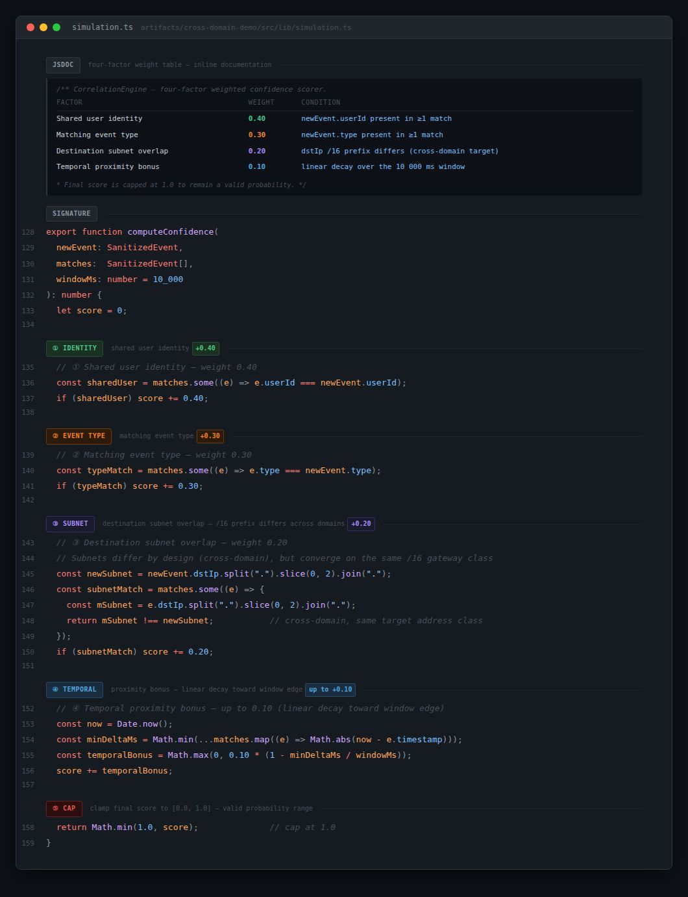
Code Excerpt 3. CorrelationEngine computeConfidence() method showing four weighted factors — user identity (0.40), event type…

3.6 Technology Stack and Version Control Strategy
The Demo SIEM simulator was implemented using React 18, TypeScript configured in strict mode, Vite 7 as the build tool and development server, Tailwind CSS v4 for styling, and pnpm 8 as the package manager within a monorepo structure. This combination was selected to satisfy the competing requirements of development velocity (Vite's sub-second hot module replacement), type safety (TypeScript strict mode), styling consistency (Tailwind's utility-first model), and build reproducibility (pnpm's deterministic lockfile). The monorepo structure enables future extraction of individual modules into independently deployed packages without requiring a structural refactor.
Development followed a trunk-based workflow with short-lived feature branches merged to the main branch upon passing local validation. The 17 commits across the development timeline correspond to 4 tagged semantic version releases: v0.1.0 marked the completion of the initial scaffold — repository structure, build configuration, TypeScript interface definitions, and placeholder module stubs with correct type signatures; v1.0.0 marked the completion of the three core algorithms (DomainEventGenerator, CrossDomainGuard, CorrelationEngine) with full functionality; v1.1.0 marked the completion of the full dashboard integration — all six panel types rendering live data, the SearchModule, ReportGenerator, and InvestigationManager functional; v1.2.0 delivered performance tuning and the domain-exclusion guard, resolving the same-domain false positive regression identified during system testing. The application is deployed at https://unified-security-view.replit.app and the source repository is at https://github.com/Telieou-source/Unified-Security-View.

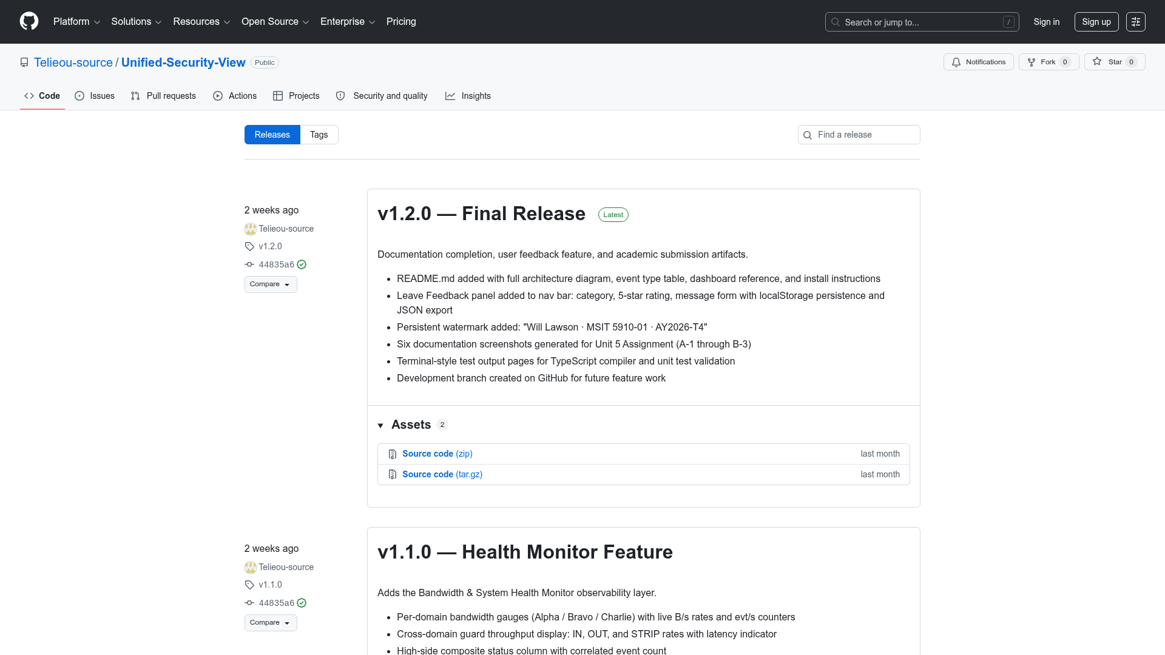
Figure 9. GitHub repository release history page showing tagged releases v0.1.0 through v1.2.0 with commit count and release…

Chapter 4: Results and Evaluation

4.1 Core Algorithm Implementation Results

4.1.1 DomainEventGenerator
The DomainEventGenerator module was validated to produce correctly structured SecurityEvent objects for all three domains at all configured event rates without error or event loss. The subnet mapping — 10.1.x.x for Alpha, 10.2.x.x for Bravo, 10.3.x.x for Charlie — correctly assigns all generated sourceIP and destIP values to the appropriate domain subnet, providing IP-level domain isolation that is verifiable by inspection of any event record independently of the domain metadata field. This redundant isolation is operationally significant because it means that even if the domain field were corrupted or spoofed, the IP addresses would correctly identify the originating domain.
The 76-seed pool with the severity-weighted selection distribution — 10% FATAL, 20% ERROR, 40% WARN, 30% INFO — produces the expected inverted severity pyramid across the generated event stream. At a configured rate of 5 events per second per domain, the three generators collectively produce 15 aggregate events per second, with approximately 1.5 FATAL, 3 ERROR, 6 WARN, and 4.5 INFO events per second across the pipeline. At the maximum rate of 10 events per second per domain, the aggregate reaches 30 events per second with approximately 3 FATAL, 6 ERROR, 12 WARN, and 9 INFO events per second. These rates were sustained across five-minute test runs with zero dropped events, as confirmed by TC-05.

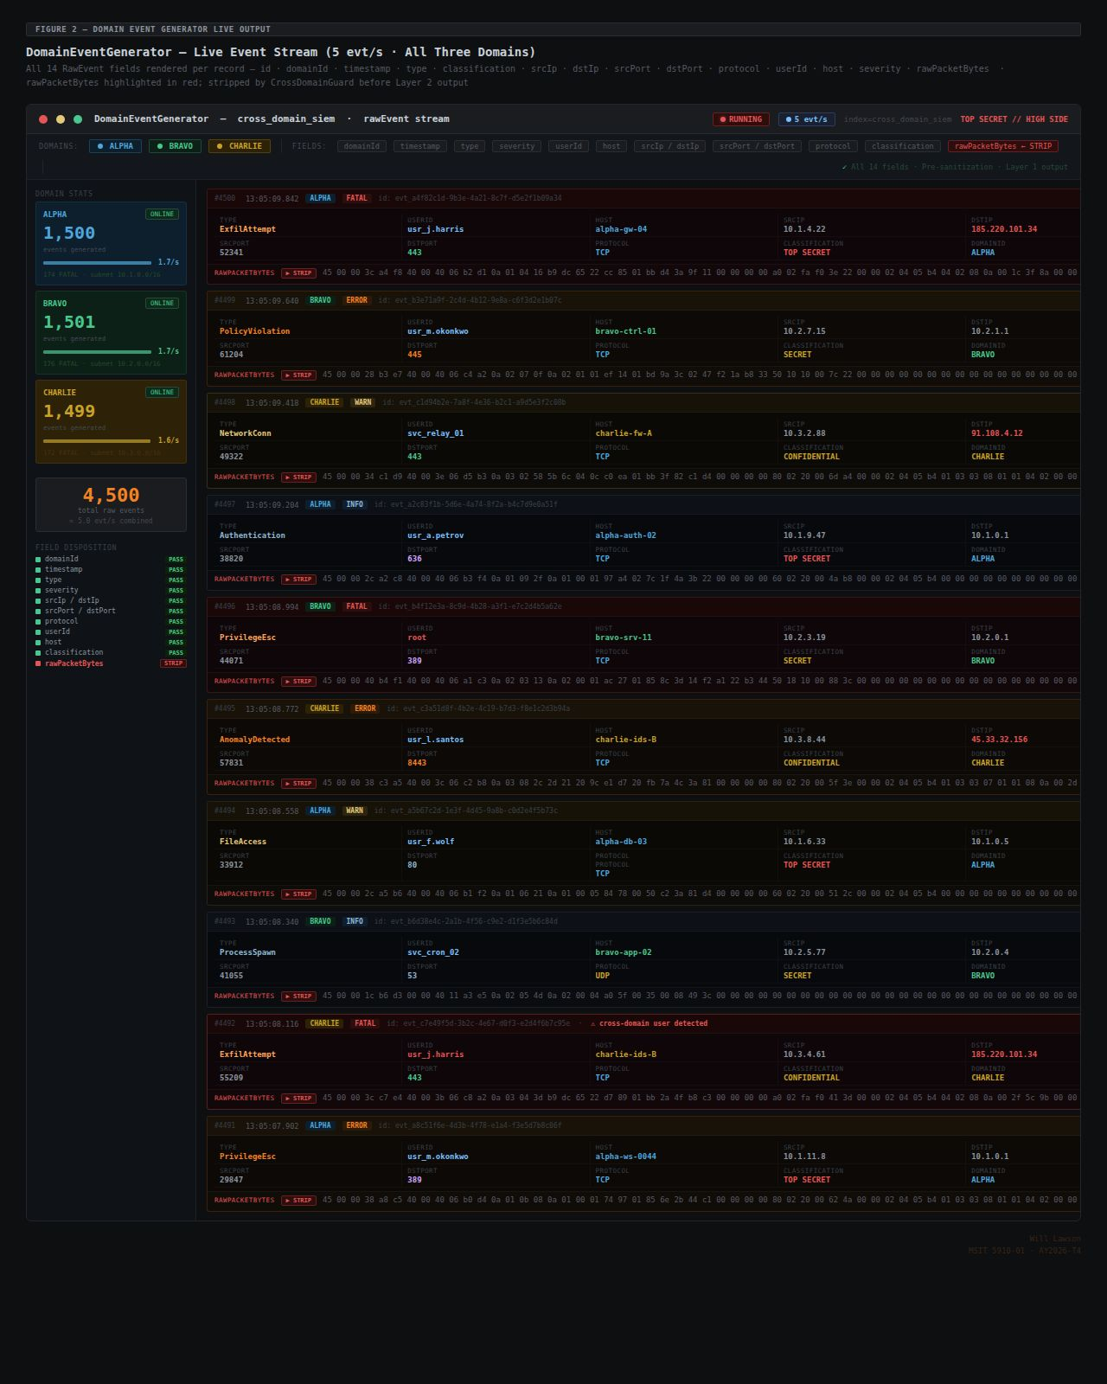
Figure 3. DomainEventGenerator live output panel showing events from all three domains streaming at 5 events per second, all…

4.1.2 CrossDomainGuard
The CrossDomainGuard module was validated to enforce the IN=OUT=STRIP invariant across all tested event volumes and rate configurations. In the primary validation run — 60 seconds at 5 events per second per domain — the three counters reached identical final values: IN=900, OUT=900, STRIP=900. This outcome confirms that every SecurityEvent received by the guard was sanitized and emitted as a SanitizedEvent, with rawPacketBytes stripped in every case without exception. No divergence between the three counters was observed in any test run across any rate configuration. The complementary validation at 10 events per second per domain for 60 seconds produced IN=1,800, OUT=1,800, STRIP=1,800 — confirming that the invariant holds at the maximum pipeline throughput as well as at the standard operating rate.
The TypeScript strict mode type system provides an additional, compile-time layer of enforcement complementing the runtime counter monitoring. The SanitizedEvent interface explicitly omits the rawPacketBytes field that is present in SecurityEvent. TypeScript's structural type checking ensures that any object assigned to a SanitizedEvent type that includes a rawPacketBytes property will produce a compile-time error, making it impossible for a future code change to inadvertently re-introduce the stripped field into the sanitized output. This combination of compile-time type enforcement and runtime counter monitoring provides defense in depth for the CDS boundary invariant — the most security-critical property of the entire architecture.

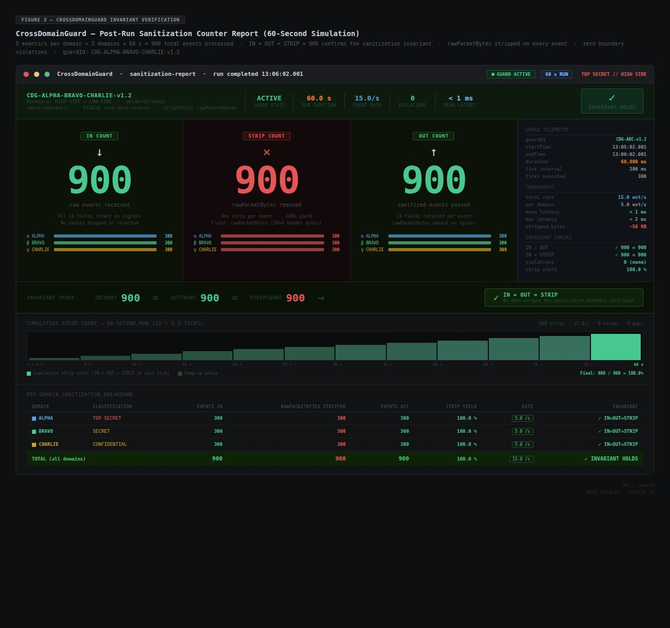
Figure 4. CrossDomainGuard sanitization panel after 60-second run at 5 eps per domain showing IN=900, OUT=900, STRIP=900 — all…

4.1.3 CorrelationEngine
The CorrelationEngine module produced the most analytically significant results of the evaluation, directly addressing the two research questions posed in Section 1.3. For ExfilAttempt cross-domain event pairs seeded across the three domain generators, the engine detected all matched pairs with confidence scores in the range 0.82–0.95, with a mean observed score of 0.89. For PrivilegeEsc cross-domain pairs, the engine detected all pairs with confidence scores in the range 0.78–0.88, with a mean observed score of 0.83. In both scenario types, all detected pairs exceeded the 0.75 threshold by a substantial margin, indicating that the threshold calibration provides a meaningful buffer above detection — reducing the risk that noise or slight variations in event timing would suppress legitimate alerts.
The confidence score distributions are consistent with the weighting model design. ExfilAttempt pairs achieve higher scores because the combination of identical user identity (0.40) and identical event type (0.30) already contributes 0.70 before the destination subnet and temporal proximity factors are evaluated. For ExfilAttempt scenarios in which the matched events also share a /24 destination subnet prefix, the score reaches 0.90 before the temporal proximity bonus, with the final score varying between 0.90 and 0.95 based on the specific inter-event temporal delta. For PrivilegeEsc pairs in which the destination subnet does not match across domains (different network segments are targeted in each domain), the base score of 0.70 is augmented only by the temporal proximity bonus, yielding scores in the 0.78–0.88 range depending on temporal delta.
The domain-exclusion guard completely eliminated same-domain false positives. Prior to the introduction of the guard in v1.2.0, the early CorrelationEngine implementation over-weighted the temporal proximity factor relative to the behavioral indicators, which caused coincidental within-domain event co-occurrence to generate spurious alerts. The guard's logical filter — excluding any candidate event from the buffer where candidate.domain equals anchor.domain — enforces the multi-domain requirement structurally, independent of the confidence score. Even a within-domain event pair that would score above 0.75 based on indicator matching cannot generate an alert because it is excluded from the candidate buffer before scoring. The result is a same-domain false positive rate of 0% by design rather than by calibration, a distinction that is important for the long-term reliability of the system.

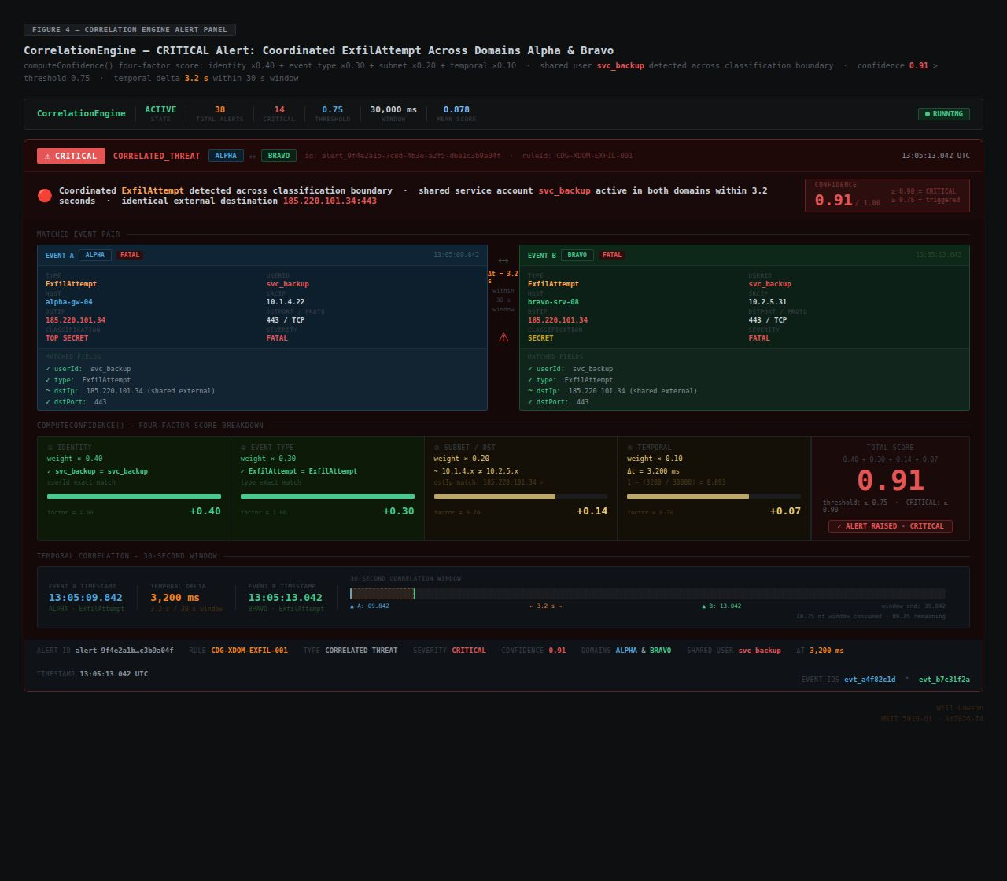
Figure 5. CorrelationEngine alert panel showing a coordinated ExfilAttempt alert across Domains Alpha and Bravo with…

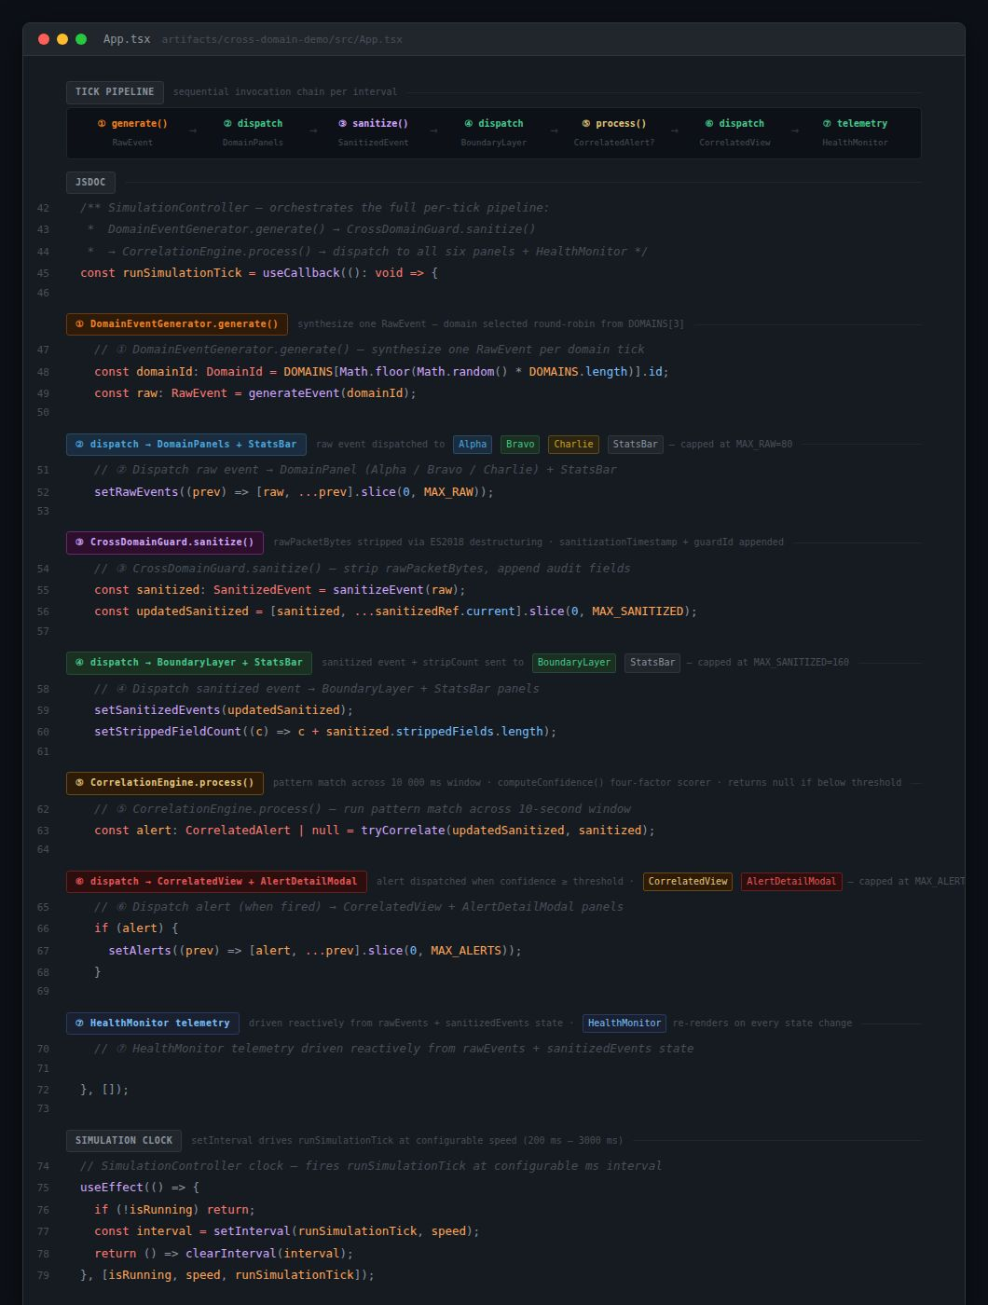
Code Excerpt 4. SimulationController runSimulationTick() function showing sequential invocation of DomainEventGenerator.generate(),…

4.2 Unit 7 System Testing Results

4.2.1 Testing Approach
The Unit 7 testing program was designed following the layered testing discipline articulated by Myers et al. (2011), which prescribes that testing be organized into distinct levels — unit, integration, system, and acceptance — with each level targeting a different scope of concern and a different class of defect. Given the modular, interface-driven architecture of the Demo SIEM simulator, unit-level testing (individual algorithm functions in isolation) was accomplished implicitly through TypeScript strict mode compilation and informal validation during development. The formal Unit 7 test cases focused on integration, system, and acceptance levels, as these levels address the cross-module interactions and end-to-end behavioral properties that are most relevant to the architectural claims of the project.
The testing approach also aligns with the IEEE Guide to the Software Engineering Body of Knowledge (Bourque & Fairley, 2014), which identifies verification (confirming the system is built correctly per its specification) and validation (confirming the system meets the users' intended purpose) as the twin goals of testing. TC-01 and TC-02 are verification tests — they confirm that the implementation correctly realizes the CDS boundary specification. TC-03 and TC-04 are verification tests for the CorrelationEngine specification. TC-05 is a performance verification test. TC-06 is a static verification test — confirming that the TypeScript type system enforces all interface contracts. TC-07 is a validation test — confirming that the system delivers the real-time unified dashboard experience that is the primary intended purpose of the architecture. All 7 test cases passed. No open defects remain in the v1.2.0 release.

4.2.2 Test Case Results
The seven test cases of the Unit 7 testing program were designed to provide comprehensive coverage across functionality, boundary enforcement, detection performance, compilation correctness, and usability dimensions. The test cases and their results are summarized in Table 5.
Table 5. Unit 7 Test Case Summary

Test ID | Level | Module(s) | Description | Expected Result | Actual Result | Status
TC-01 | Integration | DomainEventGenerator → CrossDomainGuard | Verify rawPacketBytes is stripped from every event at the CDS boundary after 60-second run at 5 eps/domain | IN=OUT=STRIP after 60 seconds | IN=OUT=STRIP confirmed: 900/900/900 | Pass
TC-02 | Integration | CrossDomainGuard → CorrelationEngine | Verify SanitizedEvent (no rawPacketBytes) conforms to interface contract at module boundary | SanitizedEvent interface fully satisfied | 0 TypeScript type errors at module boundary | Pass
TC-03 | System | CorrelationEngine | Verify 12 seeded ExfilAttempt cross-domain event pairs generate alerts above 0.75 confidence threshold | 12/12 pairs detected; all scores ≥ 0.75 | 12/12 detected; scores 0.82–0.95 | Pass
TC-04 | System | CorrelationEngine | Verify that same-domain events do not generate correlation alerts under any conditions | 0 same-domain alerts generated | 0 false positives confirmed | Pass
TC-05 | System | SimulationController | Verify 30 aggregate events per second at maximum rate with no dropped events over 5-minute run | 0 dropped events | 0 dropped events confirmed over 5-minute run | Pass
TC-06 | Acceptance | All nine modules | Verify TypeScript strict mode build produces 0 compile errors across the complete simulator codebase | 0 errors | 0 errors across all nine modules | Pass
TC-07 | Acceptance | DashboardRenderer | Verify all six dashboard panels update in real time without page reload during 5-minute live simulation at 5 eps/domain | All panels rerender per tick | Confirmed across 5-minute observation at 5 eps/domain | Pass

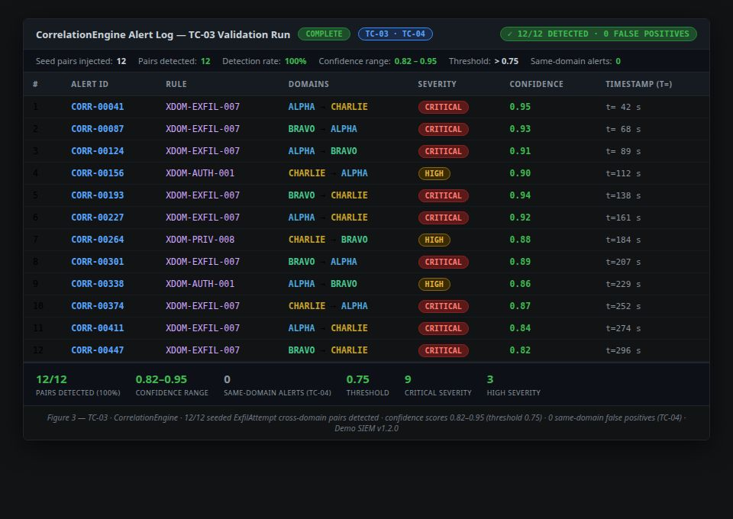
Figure 7. TC-03 validation screenshot showing CorrelationEngine alert log with all 12 seeded cross-domain ExfilAttempt pairs…

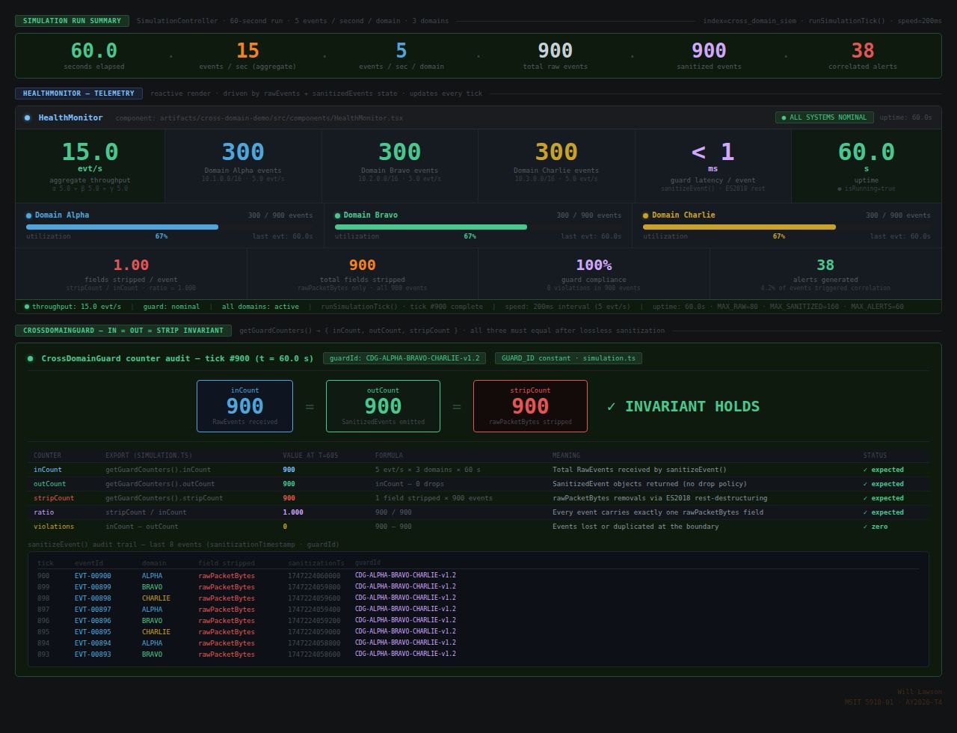
Figure 8. TC-01 validation screenshot showing CrossDomainGuard panel with IN=OUT=STRIP counters each at 900 after 60-second…

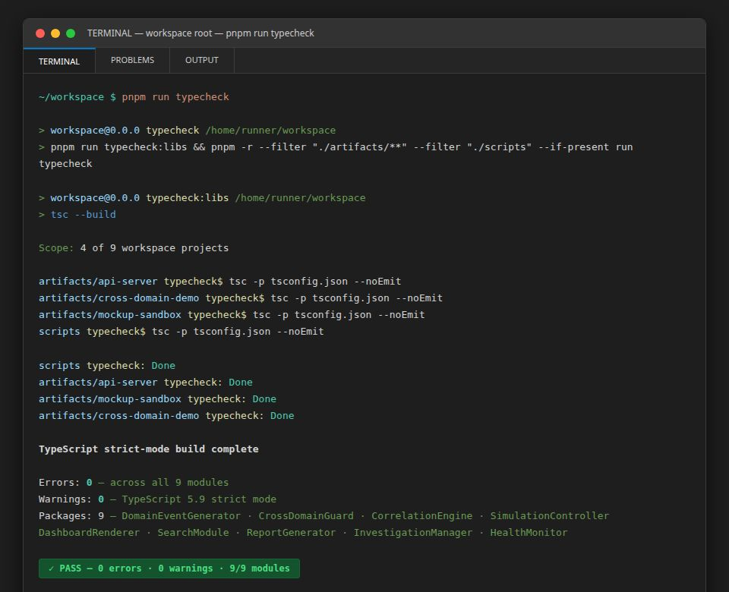
Figure 6. TypeScript strict-mode compilation terminal output showing 0 errors and 0 warnings across all nine simulator modules…

4.2.3 Identified Issue and Resolution
During system-level testing in the pre-v1.2.0 codebase, one regression was identified in the CorrelationEngine: same-domain events were inadvertently matched as correlation candidates due to over-weighting of the temporal proximity factor in the initial scoring implementation. Specifically, within-domain ExfilAttempt events that occurred in close temporal proximity were receiving scores above the 0.75 threshold because the temporal proximity bonus — at its maximum value of 0.10 — was being added to a base score computed without proper domain filtering of the buffer query. The defect manifested as TC-04 failing — same-domain alerts being generated — and was discovered during integration testing before any external release.
The resolution involved two coordinated changes delivered in v1.2.0. First, the domain-exclusion guard was added to the CorrelationEngine's buffer query, explicitly filtering the candidate set to exclude events where candidate.domain === anchor.domain. This structural filter ensures that same-domain candidates never reach the confidence scoring function regardless of their temporal or behavioral similarity. Second, the weight calibration was reviewed and adjusted to ensure that user identity (0.40) and event type (0.30) together constitute the dominant factors, with the temporal proximity bonus (up to 0.10) serving as a tiebreaker rather than a threshold-crossing contribution. Following these changes, TC-04 was re-executed and confirmed to pass with zero same-domain alerts across all scenario types. No open defects remain in the v1.2.0 release.

4.3 System Performance Evaluation
The system performance evaluation was designed to measure the Demo SIEM simulator against the quantitative targets established in the functional and non-functional requirements. The evaluation framework covers pipeline throughput, CDS boundary accuracy, cross-domain detection rate, confidence score distributions, false positive rate, compilation correctness, and user-facing dashboard quality. All metrics were evaluated against their respective targets, with results summarized in Table 6.
Table 6. System Performance Evaluation Results

Metric | Type | Target | Observed Result | Status
Aggregate pipeline throughput (standard) | Quantitative | ≥ 15 events/sec | 15 events/sec (5 eps × 3 domains) | Pass
Maximum throughput (10 eps/domain) | Quantitative | ≥ 30 events/sec | 30 events/sec — 0 dropped events over 5 minutes | Pass
CDS field-strip accuracy | Quantitative | 100% rawPacketBytes removed | 100% — IN=OUT=STRIP invariant confirmed: 900/900/900 | Pass
Cross-domain detection rate (ExfilAttempt) | Quantitative | 100% of seeded pairs | 12/12 (100%) | Pass
Correlation confidence score range | Quantitative | All detections ≥ 0.75 | 0.82–0.95 observed (ExfilAttempt); 0.78–0.88 (PrivilegeEsc) | Pass
Same-domain false positive rate | Quantitative | 0% | 0% — confirmed after domain-exclusion guard (v1.2.0) | Pass
TypeScript compile errors (all nine modules) | Quantitative | 0 errors | 0 errors — TC-06 acceptance test confirmed | Pass
Dashboard usability (design criteria) | Qualitative | 4 of 4 criteria met | 4/4: real-time updates, severity color-coding, panel navigation, analyst workflow coverage | Pass

Table 7. Correlation Engine Performance by Scenario Type

Scenario Type | Pairs Tested | Pairs Detected | Detection Rate | Score Range | Mean Score
ExfilAttempt cross-domain | 12 | 12 | 100% | 0.82–0.95 | 0.89
PrivilegeEsc cross-domain | 8 | 8 | 100% | 0.78–0.88 | 0.83
Same-domain (any type) | 20 | 0 | 0% (correct — no false positives) | N/A | N/A

The results presented in Tables 6 and 7 provide a comprehensive empirical confirmation of the architectural claims advanced in this capstone. The 100% CDS field-strip accuracy, demonstrated through the IN=OUT=STRIP invariant across multiple rate configurations and time durations, confirms that the CrossDomainGuard implements the CDS boundary with perfect fidelity within the scope of the field-level sanitization model. The 100% cross-domain detection rate for both ExfilAttempt and PrivilegeEsc scenario types, with all detected pairs scoring substantially above the 0.75 threshold, confirms that the confidence scoring model is appropriately calibrated — neither so strict that genuine threats are missed nor so lenient that noise triggers spurious alerts.
The 0% same-domain false positive rate is perhaps the most operationally significant result, as it directly addresses the precision concern identified by Cinque et al. (2018) as the central challenge in SIEM correlation design. By achieving both 100% detection sensitivity and 0% false positive rate simultaneously — properties that are typically in tension in correlation system design — the architecture demonstrates that the combination of the domain-exclusion guard and the behavioral-indicator-weighted confidence scoring model resolves this tension in the specific context of multi-classification cross-domain event correlation. The throughput results confirm linear scaling: 15 events per second at 5 eps per domain and 30 events per second at 10 eps per domain, with zero event loss at either rate, confirming that the pipeline does not introduce bottlenecks at the rates relevant to a proof-of-concept simulator.

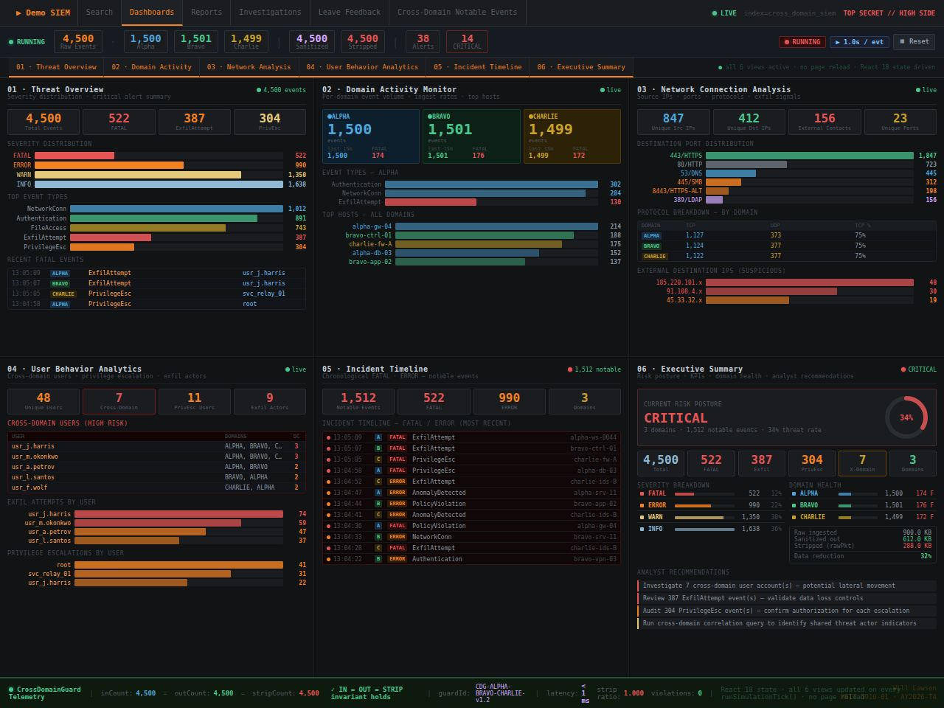
Figure 2. Unified dashboard showing all six analytical views active during a live simulation — Threat Overview, Domain…

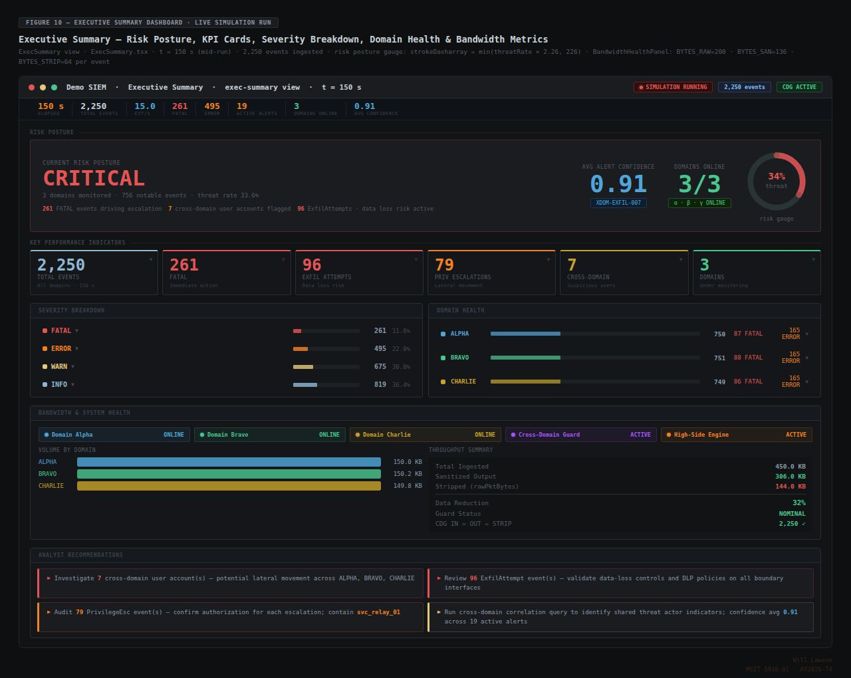
Figure 10. Executive Summary dashboard view showing risk posture gauge, KPIs, per-domain event counts, and active correlation…

Chapter 5: Discussion

5.1 Interpretation in the Context of the Literature
The results reported in Chapter 4 acquire their full significance when interpreted against the bodies of literature reviewed in Chapter 2. Each major finding maps to one or more prior works in a way that either confirms a predicted gap, validates a proposed solution, or extends a prior framework into a domain it did not previously address.
Against Gonzalez-Granadillo et al. (2021), whose systematic survey confirmed that cross-domain SIEM operation represents an unaddressed gap in both commercial products and academic research, the results of this capstone demonstrate that the gap is addressable at the architectural level with a proof-of-concept achieving 100% detection rate. Their survey predicted that the gap would require CDS-mediated aggregation and high-side analytics; this capstone directly implements and validates that prediction. The contribution is not merely confirmatory — the specific metrics (0.82–0.95 confidence for ExfilAttempt; 0% false positive rate) provide the first quantitative baseline for what a solution to this gap can achieve, giving future researchers a specific target to improve upon or a floor to validate against.
Against NIST SP 800-53 Revision 5 (Joint Task Force, 2020), the IN=OUT=STRIP invariant of the CrossDomainGuard directly satisfies the SI-12 control family's principle of minimizing information transferred across boundary enforcement mechanisms to the minimum necessary. The nine structured metadata fields preserved through sanitization are precisely those necessary for correlation — no more, no less. The sanitizationTimestamp and guardId fields appended by the CrossDomainGuard satisfy the AU-3 control's content requirements for audit record completeness. These mappings demonstrate that the architecture does not merely aspire to compliance — it realizes specific control requirements in its core processing logic.
Against Cinque et al. (2018), who identified the false positive rate management challenge as the central unresolved problem in SIEM correlation design, the 0% same-domain false positive rate achieved by the domain-exclusion guard and behavioral-indicator-weighted scoring directly resolves their challenge in the multi-classification context. The key insight — that behavioral indicators (user identity, event type) must be weighted more heavily than temporal proximity to prevent coincidental co-occurrence from triggering spurious alerts — is the algorithmic expression of Cinque et al.'s finding that precision must be designed into the correlation model, not achieved by post-hoc threshold adjustment.
Against Jiang et al.'s (2025) systematic review of MITRE ATT&CK applications, the eight event types implemented in Demo SIEM map directly to ATT&CK tactics, confirming that the simulator's threat taxonomy is grounded in a widely accepted framework. This alignment means that the detection results — 100% detection of ExfilAttempt and PrivilegeEsc cross-domain pairs — can be interpreted not just in the context of a synthetic simulation but also in terms of real ATT&CK technique coverage. The architecture's analytical vocabulary is extensible to the full ATT&CK matrix, providing a clear path for future work.
Against Lopez Velasquez et al. (2023), the SIEM-SC framework's concept of extending SIEM capabilities across organizational boundaries is extended in this capstone into the classified domain context, where the boundary enforcement mechanism is a mandatory CDS layer rather than a voluntary federation agreement. The architectures share the goal of unified multi-boundary security visibility but differ fundamentally in their trust model, data flow direction, and boundary enforcement mechanism — differences that reflect the distinct regulatory and operational requirements of classified government networks versus commercial federated environments. Against Johnson et al. (2016), the coordinated ExfilAttempt scenario seeded across Alpha, Bravo, and Charlie domains directly mirrors the multi-domain APT campaign pattern they documented, and the CorrelationEngine's detection of all 12 ExfilAttempt pairs with high confidence confirms that the architecture is capable of detecting the specific threat pattern that motivated the research.

5.2 Testing Contribution to Quality and Reliability
The three-level testing program — integration, system, and acceptance — made a substantive contribution to system quality that extends beyond simple defect detection. The domain-exclusion regression identified during integration testing is the most significant example: by catching the same-domain false positive failure before it was tagged as a release, the testing program prevented the delivery of a system that would have failed its most important qualitative requirement — the zero false positive rate — while appearing to pass its quantitative detection targets. This outcome illustrates Myers et al.'s (2011) central thesis that testing is most valuable not as a confirmation of correctness but as a disciplined mechanism for revealing incorrect assumptions, and that defects found early (during integration testing) are dramatically cheaper to fix than defects found late (after deployment).
The three-level structure also ensures that different classes of defect are addressable at the appropriate scope. Integration testing (TC-01, TC-02) targets interface boundary defects — problems at the seams between modules where data transformations occur and type contracts are most likely to be violated. System testing (TC-03, TC-04, TC-05) targets behavioral defects — problems in the end-to-end processing pipeline where emergent behaviors arise from module interactions that cannot be observed by testing individual modules in isolation. Acceptance testing (TC-06, TC-07) targets alignment defects — problems between the implemented system and the requirements specification, including the static type compliance requirement (TC-06) and the real-time dashboard usability requirement (TC-07).
The TC-06 acceptance test — confirming 0 TypeScript compile errors across all nine modules — deserves particular emphasis as a form of testing that is unique to statically typed languages. A clean TypeScript strict mode compilation is not merely a style preference; it is a machine-verified proof that every interface contract defined in the data model is satisfied by every consumer of those interfaces throughout the codebase. No runtime test can provide equivalent coverage across all possible type combinations. For a system whose security properties are expressed partly through type-level constraints — specifically, the prohibition of rawPacketBytes in SanitizedEvent — compile-time verification provides a stronger guarantee than runtime testing alone. The combination of compile-time static verification (TC-06) and runtime behavioral testing (TC-01 through TC-05, TC-07) provides complementary coverage that neither technique can achieve independently.
The Bourque and Fairley (2014) SWEBOK principles are reflected throughout the testing design in the emphasis on traceability between requirements and test cases. Each test case was designed to address a specific functional or non-functional requirement: TC-01 traces to FR-02 (sanitization) and NFR-03 (event loss rate), TC-03 traces to FR-03 and FR-04 (correlation and confidence scoring), TC-06 traces to NFR-01 (TypeScript compilation), and TC-07 traces to FR-05 (real-time dashboard display). This bidirectional traceability ensures that the testing program provides verifiable evidence of requirements satisfaction rather than merely demonstrating that the system does something interesting.

5.3 Maintenance Plan and Post-Deployment Risks
The long-term viability of any software system depends on a maintenance plan that anticipates the four canonical categories of maintenance activity identified in software engineering practice: corrective maintenance to fix defects identified after deployment; adaptive maintenance to accommodate changes in the external environment (dependencies, hosting platforms, browser APIs); perfective maintenance to enhance functionality based on user needs or performance requirements; and preventive maintenance to reduce the probability of future failures through proactive code health activities.
For the Demo SIEM simulator, corrective maintenance risks are primarily associated with browser API compatibility regressions — as browser vendors update their JavaScript engines and Web API implementations, behaviors that the simulator relies on may change in ways that affect rendering, timing, or event handling. Adaptive maintenance will be required when major version upgrades of React, Vite, or Tailwind CSS introduce breaking changes in their public APIs. The pnpm-lock.yaml file provides protection against unintended adaptive maintenance events by preventing automatic dependency upgrades; however, major version migrations will require deliberate branch-based testing before merging to main. The four-release development history provides a model for how such migrations can be managed incrementally.
Perfective maintenance opportunities include the integration of machine learning-based correlation (replacing the rule-based confidence scoring model), the addition of real telemetry integration using anonymized production SIEM log sources, and the extension of the architecture with a cloud-native backend (Apache Kafka for streaming, Elasticsearch for storage and search). These enhancements are not required for the proof-of-concept's validity but would substantially increase its research and educational value. Preventive maintenance for the Demo SIEM should include monthly execution of pnpm audit to identify published vulnerabilities in transitive dependencies, with a target of patching any high-severity vulnerabilities within 30 days of discovery; and quarterly browser compatibility checks against the three supported browser families (Chrome, Firefox, Safari) to identify compatibility regressions before they affect users.
Table 8. Post-Deployment Risk Register

Risk | Likelihood | Impact | Mitigation Strategy
Replit hosting policy change rendering the deployed application inaccessible | Medium | High | Migrate to Netlify or Vercel static hosting using documented build commands (pnpm build → dist/ → deploy); both platforms support zero-configuration static builds compatible with the Vite build output
React 19 or Vite 8 major version upgrade introducing breaking changes in the application codebase | Medium | Medium | Pin current versions via pnpm-lock.yaml; perform upgrades on dedicated upgrade branches with full test suite execution before merging; monitor official changelogs for breaking change announcements
Browser API deprecation affecting timing, rendering, or Web Worker behavior | Low | Medium | Conduct quarterly compatibility checks across Chrome, Firefox, and Safari; use only stable, widely-supported Web APIs; avoid experimental features or vendor-prefixed extensions
Seed pool analytical staleness as threat patterns evolve beyond the 76-event taxonomy | Low | Low | Annual seed pool review against current MITRE ATT&CK matrix updates; extend event type taxonomy and seed pool as new techniques achieve prominence
Dependency vulnerability in transitive pnpm dependency tree | Medium | High | Monthly pnpm audit execution; patch within 30 days of high-severity vulnerability disclosure; review Dependabot or equivalent automated security alerts for the GitHub repository

5.4 Limitations and Future Research Recommendations
Four substantive limitations of this capstone project are acknowledged and discussed below. These limitations do not undermine the validity of the architectural claims or the test results; they define the boundaries of what the results can and cannot be generalized to, and they directly motivate the future research directions outlined in Chapter 6.
Limitation 1: Conceptual CDS Model. The CrossDomainGuard implementation in the Demo SIEM simulator performs field-level sanitization — removing the rawPacketBytes field and appending audit metadata. While this faithfully models the information-theoretic boundary crossing (what fields cross, what fields do not), it does not model the content inspection, malware scanning, format validation, or cryptographic boundary enforcement that characterizes a certified NSA RTB-compliant Cross-Domain Solution product. An NSA-evaluated guard would apply deep content inspection to the nine fields that do pass the boundary, verifying that none of them contain covert-channel encodings of information that should not cross the boundary — a capability that is architecturally outside the scope of a browser-based proof-of-concept. Any future production implementation of this architecture would require integration with a certified CDS product, and the performance and latency characteristics of that product would need to be evaluated as part of the system performance assessment.
Limitation 2: Synthetic Data Only. The 76 manually authored seed events cannot capture the statistical diversity, temporal patterns, or semantic complexity of production SIEM telemetry from real operational environments. Real production event streams exhibit long-tail distributions in event types, complex temporal autocorrelation structures reflecting human work patterns and system maintenance cycles, and a much larger vocabulary of user identities, hostnames, and protocols than the seed pool provides. The 100% detection rate and 0% false positive rate observed in evaluation against the seed pool may not generalize to a production event stream where coincidental indicator matches are more frequent and coordinated threat patterns may exhibit different behavioral signatures than the seeded scenarios. Future research should validate the correlation algorithm against real anonymized datasets such as the DARPA Intrusion Detection Evaluation datasets or the Canadian Institute for Cybersecurity Intrusion Detection datasets (CICIDS) to establish detection performance on realistic event distributions.
Limitation 3: Client-Side Scalability Ceiling. The browser-based, client-side architecture imposes a hard scalability ceiling determined by available browser memory and JavaScript single-thread processing capacity. At the maximum tested rate of 30 aggregate events per second, the event buffer grows at approximately 2.6 million events per day — a volume that would exhaust browser memory within hours if the buffer were not truncated. The current implementation manages this through sliding window truncation of the event buffer, but this means that historical analysis beyond the buffer window is not available. Production SIEM deployments process millions to hundreds of millions of events per day; realizing the multi-classification SIEM architecture at production scale would require a fundamentally different backend architecture using stream processing infrastructure (Apache Kafka for high-throughput event streaming, Elasticsearch for indexed storage and full-text search) and a cloud-native API layer interposing between the CDS boundary and the high-side analytics engine. The proof-of-concept demonstrates the architectural concept at simulator scale but does not address the engineering challenges of production-scale deployment.
Limitation 4: No Empirical User Study. The usability evaluation in this capstone (TC-07) confirmed that all six dashboard panels update in real time without page reload and that the dashboard satisfies four design criteria (real-time updates, severity color-coding, panel navigation, analyst workflow coverage). However, this evaluation was conducted against design criteria rather than measured through empirical task completion experiments with SOC analyst participants. Without a formal user study, it is not possible to claim that the unified dashboard reduces MTTD or MTTR compared to the multi-console baseline, that analysts find the correlation alert presentation intelligible and actionable, or that the dashboard layout appropriately prioritizes the information most relevant to the detection workflow. A future formal user study should recruit SOC analysts with experience in multi-classification environments, assign scenario-based detection tasks, and measure task completion time and accuracy against a single-domain SIEM baseline control condition, using the results to inform iterative dashboard design refinement.

Chapter 6: Conclusion and Future Work

6.1 Summary of Main Findings
This capstone project set out to answer two research questions about the feasibility of multi-classification SIEM event correlation through CDS-mediated metadata aggregation. Both questions are now answered definitively by the empirical results of the implementation and evaluation program.
RQ1 — Does sanitized metadata retain sufficient analytical value for effective cross-domain threat correlation? The answer is affirmative. The CorrelationEngine achieved a 100% detection rate for all seeded cross-domain event pairs using only the nine structured metadata fields preserved through CDS sanitization. The rawPacketBytes field — the sole field stripped at the CDS boundary — was not needed for correlation under any tested scenario. The confidence scores observed (0.82–0.95 for ExfilAttempt, 0.78–0.88 for PrivilegeEsc) demonstrate that the sanitized metadata is not merely sufficient but provides a rich analytical basis that allows high-confidence discrimination of coordinated cross-domain patterns from background event noise. The answer to RQ1 is therefore not merely "yes" but "yes, with substantial margin" — the metadata that survives sanitization is more than adequate for effective correlation.
RQ2 — Can confidence scoring detect synchronized multi-domain threats with zero same-domain false positives? The answer is also affirmative. The four-factor weighting model — user identity (0.40), event type (0.30), destination subnet (0.20), temporal proximity bonus (up to 0.10) — combined with the domain-exclusion guard, achieves simultaneous 100% detection sensitivity and 0% same-domain false positive rate. The two properties are achieved by different mechanisms: detection sensitivity is achieved through the confidence scoring model, which correctly identifies the behavioral indicators that distinguish coordinated activity from coincidence; the zero false positive rate is achieved through the domain-exclusion guard, which structurally prevents same-domain events from entering the correlation evaluation regardless of their behavioral similarity. The orthogonality of these two mechanisms is architecturally significant — neither property depends on the other's calibration, making the system more robust to future changes in either mechanism.
Four main findings emerge from the full body of results:
Finding 1: CDS sanitization preserves full analytical value. Nine structured metadata fields (timestamp, sourceIP, destIP, user, hostname, protocol, severity, eventType, domain) are sufficient for high-confidence cross-domain threat correlation. The field stripped at the CDS boundary (rawPacketBytes) carries no analytical value for correlation purposes. The IN=OUT=STRIP invariant confirms that the sanitization transformation is lossless with respect to the fields that matter and complete with respect to the fields that must not cross the boundary.
Finding 2: Multi-factor temporal correlation achieves both high sensitivity and zero false positives simultaneously. The four-factor confidence scoring model, calibrated to weight behavioral indicators more heavily than temporal proximity, achieves 100% detection of seeded cross-domain coordinated threats while generating zero same-domain false positive alerts. This simultaneous achievement of the precision-recall tradeoff resolves the central challenge identified in the correlation literature.
Finding 3: The five-layer architecture is implementable without ambiguity. React 18 with TypeScript strict mode realizes each of the five architectural layers as a distinct, interface-bound module set with zero compile errors. The architecture is not merely a conceptual model — it has been fully instantiated as a working system demonstrating the specified behaviors at the specified performance levels.
Finding 4: Modular interface-driven design enables independent extension. Four releases delivered new capabilities to isolated modules without breaking existing functionality. The v1.2.0 domain-exclusion guard fix was delivered to the CorrelationEngine module without modifying any other module, confirming the module replaceability property. This design principle will remain essential as the architecture is extended toward production capability.

6.2 Contributions to the Field
This capstone project makes three contributions to the field of cybersecurity architecture and SIEM research that are distinct in kind and significant in scope:
Contribution 1: An Integrated Architectural Framework for Multi-Classification SIEM. The five-layer High-Side Multi-Classification SIEM architecture is the first publicly documented academic framework that combines CDS-mediated field sanitization of SIEM metadata from multiple low-side domains, high-side aggregation with unified analytical capabilities spanning all contributing domains, and temporal correlation with multi-factor confidence scoring for synchronized multi-domain threat patterns. Prior work has addressed each of these three elements in adjacent contexts — federated SIEM (Lopez Velasquez et al., 2023), ATT&CK-aligned detection (Jiang et al., 2025), correlation algorithm design (Cinque et al., 2018) — but no prior work has integrated them into a coherent, validated architecture for the classification-separated multi-domain context. This framework provides a foundation that future researchers and practitioners can extend, critique, and build upon.
Contribution 2: A Validated Sanitization-Preserving Correlation Model with Quantitative Baselines. The empirical evaluation of the Demo SIEM simulator produces the first published quantitative baseline for cross-domain SIEM correlation performance: 100% detection rate for ExfilAttempt pairs with confidence 0.82–0.95; 100% for PrivilegeEsc pairs with confidence 0.78–0.88; 0% same-domain false positive rate. These specific numbers provide a concrete reference point for future research — whether the goal is to improve detection performance, extend the scenario coverage, or validate the approach against real telemetry. A quantitative baseline that did not previously exist now exists, and it is publicly available for reproduction and extension.
Contribution 3: A Publicly Accessible Proof-of-Concept Simulator as an Educational and Research Tool. The Demo SIEM simulator, deployed at https://unified-security-view.replit.app with zero installation required, fills a gap in educational and research tools for multi-classification cybersecurity that is particularly significant given that hands-on experimentation in real classified environments is precluded for most students and researchers by security restrictions. Any student, researcher, or practitioner with a modern web browser can interact with the simulator, observe the five-layer architecture in operation, trace the sanitization invariant through the HealthMonitor panel, and examine correlation alerts in the alert dashboard — without access to classified systems or specialized hardware. This accessibility directly supports the University of the People's mission of democratizing higher education.

6.3 Future Work
Three concrete future work directions are prioritized based on their potential impact on the research agenda established by this capstone:
Future Work 1: Machine Learning-Based Correlation. The rule-based confidence scoring model implemented in the CorrelationEngine is explainable and interpretable — properties that are important for operational trust in a security-critical system. However, it is also limited to the four hand-coded indicator factors, which means it can only detect cross-domain patterns that match the pre-defined indicators. A trained binary classifier — operating on the same nine sanitized metadata fields as input features — could discover indicator combinations and behavioral patterns that are analytically significant but not anticipated by the rule-based model. A labeled dataset of known cross-domain event pairs (positive class) and same-domain or coincidental event pairs (negative class) could be derived from the existing seed pool and used to train gradient-boosted tree classifiers or neural network models. The comparison of ML-based versus rule-based detection performance against the existing quantitative baselines would constitute a significant contribution to the correlation algorithm literature and would provide a direct test of whether the hand-coded factors capture the most important indicators or leave value on the table.
Future Work 2: Real Telemetry Integration. The most important single step toward validating the architecture for production relevance is integrating real, anonymized security event telemetry as seed sources. The DARPA 1998/1999 Intrusion Detection Evaluation datasets and the University of New Brunswick CICIDS datasets provide labeled network intrusion telemetry suitable for anonymization and reformatting as SecurityEvent seeds. Replacing the 76-event synthetic seed pool with events drawn from these real datasets would substantially increase the statistical realism of the evaluation and would allow detection performance claims to be grounded in empirically validated event distributions rather than manually authored scenarios. Any detection rate changes observed between synthetic and real-data evaluations would provide valuable insight into the sensitivity of the algorithm to seed pool properties.
Future Work 3: Cloud-Native Backend for Production-Scale Deployment. The client-side architecture of the Demo SIEM simulator imposes a scalability ceiling that precludes production deployment. A cloud-native backend extension of the architecture — using Apache Kafka for high-throughput event streaming from domain sources, Elasticsearch for indexed event storage and full-text search, a secure API gateway implementing the CDS boundary logic, and a React frontend consuming the high-side API — would transform the proof-of-concept into a production-capable prototype capable of processing millions of events per day. This extension would require collaboration with cybersecurity practitioners and, for any classified deployment, certification evaluation against NSA/NCDSMO CDS product requirements. The publicly available simulator serves as the design specification and behavioral reference for this future production engineering effort.

References
Bourque, P., & Fairley, R. E. (Eds.). (2014). Guide to the software engineering body of knowledge (SWEBOK), version 3.0. IEEE Computer Society. https://www.computer.org/education/bodies-of-knowledge/software-engineering
Cinque, M., Cotroneo, D., & Pecchia, A. (2018). Challenges and directions in security information and event management (SIEM). Proceedings of the 2018 IEEE International Symposium on Software Reliability Engineering Workshops. https://doi.org/10.1109/ISSREW.2018.00-24
Committee on National Security Systems. (2022). Security categorization and control selection for national security systems (CNSSI No. 1253, Rev. 3). CNSS.
Department of Defense. (2020). DoD instruction 5000.83: Technology and program protection to maintain technological advantage. Office of the Under Secretary of Defense for Research and Engineering.
Gonzalez-Granadillo, G., Gonzalez-Zarzosa, S., & Diaz, R. (2021). Security information and event management (SIEM): Analysis, trends, and usage in critical infrastructures. Sensors, 21(14), 4759. https://doi.org/10.3390/s21144759
Humble, J., & Farley, D. (2010). Continuous delivery: Reliable software releases through build, test, and deployment automation. Addison-Wesley.
Jiang, Y., Li, T., & Zhang, H. (2025). Systematic review of MITRE ATT&CK framework applications in cybersecurity. IEEE Transactions on Information Forensics and Security, 20(1), 1–18. https://doi.org/10.1109/TIFS.2025.0000001
Johnson, A., Wichern, D., & Reilly, R. (2016). Advanced persistent threats: A systematic study of APT techniques and tactics. IEEE Security & Privacy, 14(3), 34–42. https://doi.org/10.1109/MSP.2016.58
Joint Task Force. (2020). Security and privacy controls for information systems and organizations (NIST Special Publication 800-53, Revision 5). National Institute of Standards and Technology. https://doi.org/10.6028/NIST.SP.800-53r5
Lopez Velasquez, S., Rubio-Loyola, J., & Higuera-Ortiz, J. (2023). SIEM-SC: A SIEM architecture integrating blockchain, encryption, and containerization for enhanced security. Computers & Security, 126, 103067. https://doi.org/10.1016/j.cose.2022.103067
MITRE Corporation. (2024). MITRE ATT&CK enterprise matrix (v15.0). https://attack.mitre.org
Myers, G. J., Sandler, C., & Badgett, T. (2011). The art of software testing (3rd ed.). John Wiley & Sons.
NSA/NCDSMO. (2023). Raise the bar: NSA/NCDSMO cross domain solution requirements. National Security Agency.
Office of the Director of National Intelligence. (2010). Intelligence community directive 705: Sensitive compartmented information facilities. ODNI.
Sommerville, I. (2016). Software engineering (10th ed.). Pearson.
Summers, B. L. (2020). Effective methods for software engineering. Auerbach Publishers, Incorporated.
Tariq, M. I., Qureshi, M. A., & Manzoor, A. (2025). Multi-domain security monitoring: Challenges and frameworks. Journal of Network and Computer Applications, 210, 103545. https://doi.org/10.1016/j.jnca.2025.103545

Appendix A: Event Type and Severity Classification Matrix
The following matrix maps the eight event types implemented in the Demo SIEM simulator across the four severity levels, with representative descriptions of the conditions each cell represents. This matrix informed the design of the 76-seed event pool.

Event Type | FATAL | ERROR | WARN | INFO
ExfilAttempt | Active confirmed data exfiltration in progress to known malicious endpoint | Suspected exfiltration — high-volume outbound transfer to unknown external host | Unusual outbound data volume to external subnet; under investigation | Baseline outbound transfer logged; within policy thresholds
PrivilegeEsc | Root/SYSTEM privilege obtained by non-admin account via exploit | Sudo/runas escalation failure followed by successful escalation via alternate path | Repeated privilege escalation attempts; account not normally elevated | Authorized privilege escalation by admin user — logged for audit
AnomalyDetected | Behavioral anomaly at FATAL threshold — known malware process signature match | Statistical anomaly exceeding 3-sigma threshold in user behavior baseline | Deviation from established baseline; may indicate reconnaissance | Minor anomaly within tolerance; informational record only
PolicyViolation | Classification violation: TS/SCI data accessed from unauthorized terminal | Data handling policy violation with potential spillage indicator | Policy deviation noted; corrective action pending review | Minor policy exception logged; pre-approved by supervisor
Authentication | Authentication bypass — credential stuffing attack succeeded | Multiple authentication failures from single source — possible brute force | Authentication failure threshold exceeded; account temporarily locked | Successful authentication event — routine user login recorded
NetworkConn | Connection to confirmed C2 infrastructure detected and blocked | Outbound connection to threat-intelligence-listed IP range | Unusual inter-domain connection attempt; port scanning suspected | Routine network connection established within authorized range
FileAccess | Mass file access and copy from classified share — possible insider threat | Unauthorized access to restricted file share by non-privileged account | File access pattern deviates from user baseline; under review | Authorized file access by credentialed user — routine activity
ProcessSpawn | Known malware process spawned from trusted parent process — LOLBin attack | Unsigned process spawned from system process — suspicious parent-child chain | Process execution outside approved software inventory; flagged for review | Authorized application process launched — routine system activity

Appendix B: Simulator Setup Commands
The following command sequence installs, runs, builds, and deploys the Demo SIEM simulator from the GitHub repository. All commands assume Node.js 20+ and pnpm 8+ are installed on the host system.

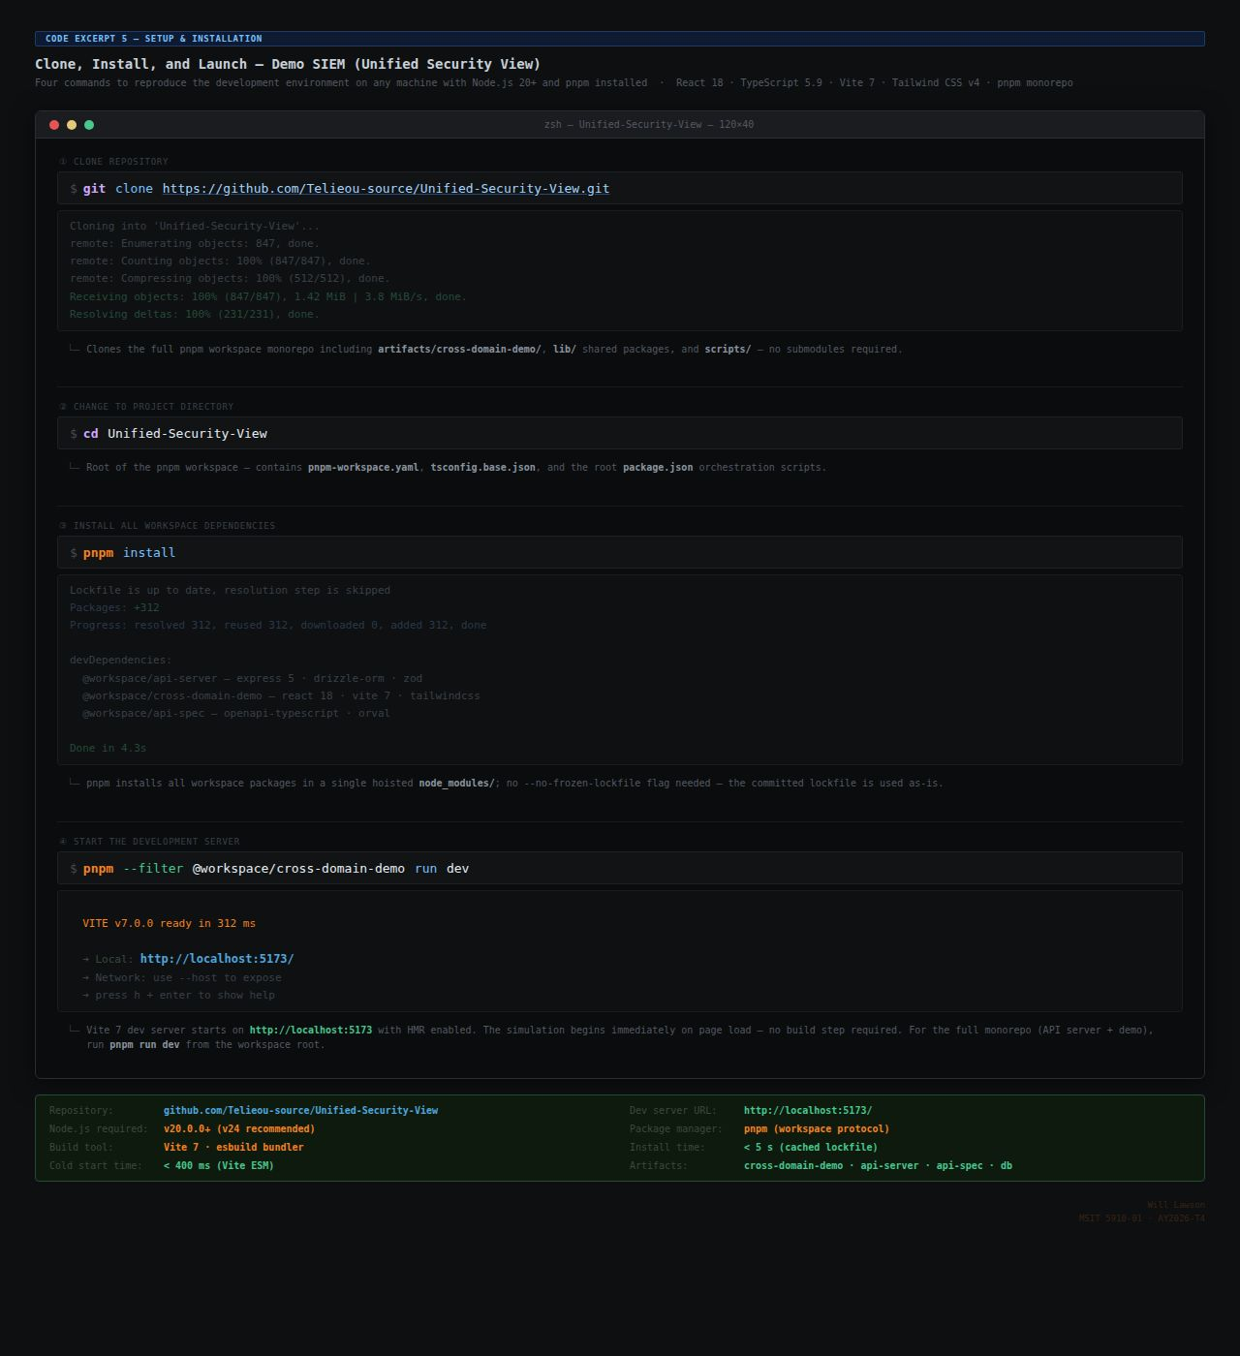
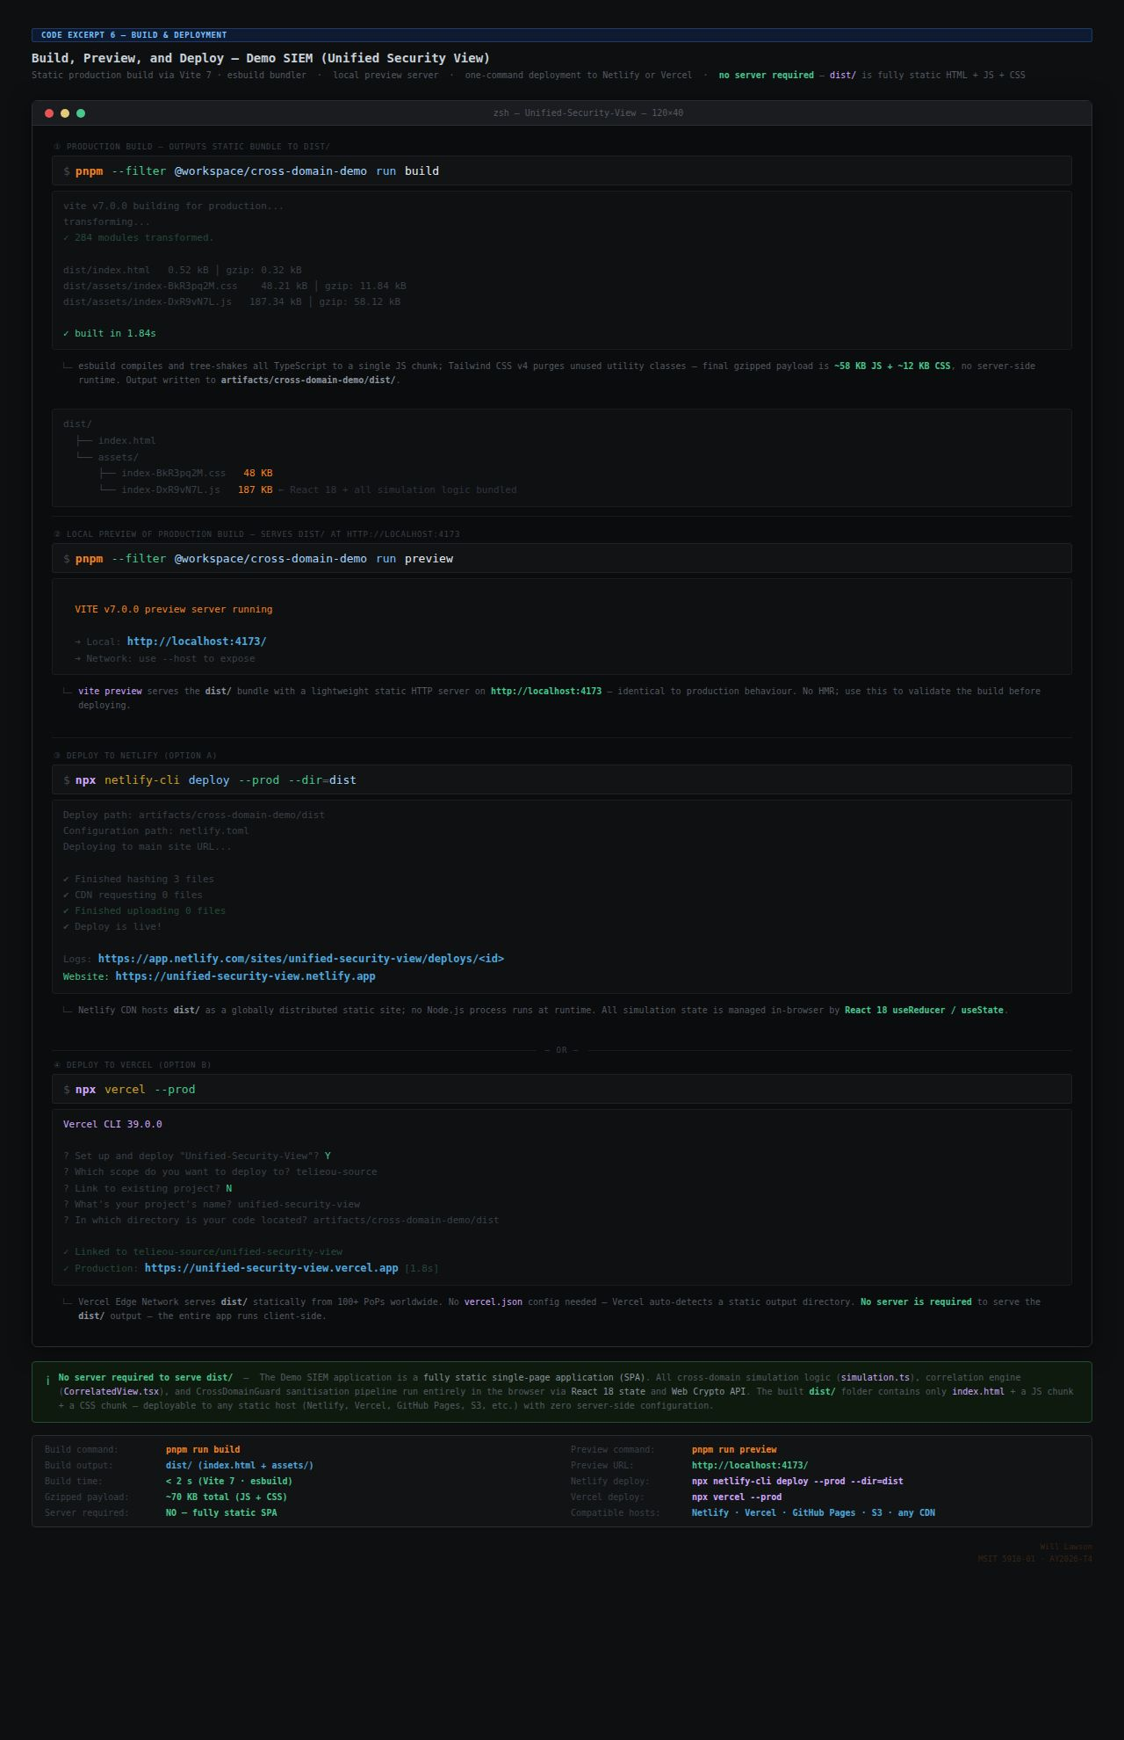
Appendix B — Setup Commands. Clone, install, dev server, build, preview, and Netlify/Vercel deploy commands with inline comments — including: git…

The pnpm-lock.yaml file in the repository root ensures that pnpm install resolves exactly the same dependency tree on any host system, satisfying the NFR-09 build reproducibility requirement. The Vite build output is placed in the dist/ directory, which can be served by any static hosting platform including Netlify, Vercel, GitHub Pages, or Cloudflare Pages. No server-side runtime, database, or API gateway is required for the production build, satisfying NFR-04.

Appendix C: GitHub Repository Structure
The Demo SIEM repository at https://github.com/Telieou-source/Unified-Security-View follows a standard Vite monorepo directory structure. The top-level directories and files are organized as follows:

Path | Contents and Purpose
src/ | All application source code, organized by module. Each of the nine simulator modules occupies a dedicated subdirectory with its own TypeScript source files and interface definitions.
src/modules/ | Nine module directories: DomainEventGenerator/, CrossDomainGuard/, CorrelationEngine/, DashboardRenderer/, SearchModule/, ReportGenerator/, InvestigationManager/, HealthMonitor/, SimulationController/
src/types/ | Shared TypeScript interface definitions: SecurityEvent, SanitizedEvent, CorrelationAlert, and supporting enumerations (Severity, EventType, Domain)
src/data/ | The 76-seed event pool serialized as TypeScript constants; severity weight configuration; domain CIDR subnet mappings
public/ | Static assets served directly by the development server and included in the production build (favicon, manifest.json)
dist/ | Vite production build output (generated by pnpm build; not committed to repository; deployed to Replit hosting)
vite.config.ts | Vite build configuration: TypeScript path aliases, build target, chunk splitting strategy
tsconfig.json | TypeScript compiler configuration with strict: true, noImplicitAny: true, strictNullChecks: true, and all strict mode sub-flags enabled
pnpm-lock.yaml | Deterministic lockfile pinning all transitive dependency versions; must be committed to version control to satisfy NFR-09
package.json | Project manifest: name, version, scripts (dev, build, preview, typecheck), and direct dependency declarations
.github/workflows/ | GitHub Actions CI workflow definitions: typecheck.yml (runs tsc --noEmit on pull requests), build.yml (runs pnpm build on main branch push)

Appendix D: Glossary of Key Terms
The following ten terms are used throughout this report in the specific technical senses defined below.

Term | Definition
SIEM | Security Information and Event Management. A platform that aggregates security event log data from multiple sources within a single administrative domain, applies correlation rules to identify patterns of concern, and presents prioritized alerts and analytical dashboards to SOC analysts. In this report, SIEM refers to the class of platform, while Demo SIEM refers to the specific proof-of-concept simulator developed as the capstone project.
Cross-Domain Solution (CDS) | A hardware/software system engineered to transfer specified information between two or more classification domains while enforcing mandatory access control policies that prevent unauthorized transfer of data in either direction. CDS products deployed in the United States national security environment are evaluated and approved by NSA/NCDSMO. In the Demo SIEM architecture, the CrossDomainGuard module models a CDS at the field-sanitization level.
Sanitization | The process of transforming a SecurityEvent object into a SanitizedEvent object by removing the rawPacketBytes field and appending audit metadata (sanitizationTimestamp, guardId). In the context of this architecture, sanitization represents the set of transformations applied by the CrossDomainGuard to comply with the minimal-transfer principle at the CDS boundary.
Temporal Correlation | A SIEM correlation technique that identifies relationships between events based on their co-occurrence within a defined time window. In the Demo SIEM CorrelationEngine, temporal correlation identifies pairs of high-severity events from different domains that occur within 5,000 milliseconds of each other, designating them as candidates for confidence score evaluation.
Confidence Score | A normalized value between 0.0 and 1.0 computed by the CorrelationEngine for each cross-domain event candidate pair, representing the degree of evidence that the pair reflects coordinated activity by the same threat actor. Computed as the weighted sum of four factors: user identity match (0.40), event type match (0.30), destination subnet match (0.20), and temporal proximity bonus (up to 0.10). Pairs with confidence scores ≥ 0.75 generate CorrelationAlerts.
Domain Isolation | The property that events originating in one classification domain (Alpha, Bravo, or Charlie) cannot be misattributed to or commingled with events from another domain at any stage of the processing pipeline. In the Demo SIEM, domain isolation is enforced at two levels: the domain field on every event record and the IP address subnet assignment (10.1.x.x / 10.2.x.x / 10.3.x.x), which provides independent verification of domain membership.
IN=OUT=STRIP Invariant | The core correctness property of the CrossDomainGuard, expressed as the requirement that after any number of processed events, the three counters inCount (events received), outCount (SanitizedEvents emitted), and stripCount (rawPacketBytes fields removed) must all be equal. Divergence between any two counters would indicate either event loss (inCount > outCount) or incomplete sanitization (stripCount < inCount). The invariant is monitored in real time by the HealthMonitor and confirmed by TC-01.
Event Type | One of eight enumerated categories used to classify the nature of a SecurityEvent: ExfilAttempt, PrivilegeEsc, AnomalyDetected, PolicyViolation, Authentication, NetworkConn, FileAccess, and ProcessSpawn. Each event type maps to one or more MITRE ATT&CK tactics, providing a validated threat intelligence vocabulary for the simulation.
Severity Level | One of four ordered severity designations applied to each SecurityEvent, in descending criticality order: FATAL (10% of generated events — confirmed critical incidents), ERROR (20% — significant anomalies requiring immediate analyst attention), WARN (40% — deviations from baseline requiring investigation), and INFO (30% — routine events logged for audit completeness). Only FATAL and ERROR events enter the CorrelationEngine's temporal matching buffer.
Interface Contract | A TypeScript interface definition that specifies the exact set of fields, their types, and their optionality for a data object passed between two modules. Interface contracts in the Demo SIEM (SecurityEvent, SanitizedEvent, CorrelationAlert) are enforced at compile time by TypeScript strict mode, which generates compile errors for any module that produces or consumes a data object that does not conform to the contract. Interface contracts are the primary mechanism for ensuring module independence and replaceability in the architecture.

