**Angular**

**Step 1: Install Angular CLI**

Open your terminal or command prompt and run the following command:

npm install -g @angular/cli

This will install Angular CLI globally on your machine.

**Step 2: Create a New Angular Project**

Navigate to the directory where you want to create your new Angular project and run:

ng new your-project-name

Replace **your-project-name** with the name you want to give to your project. The CLI will prompt you to choose some configuration options. For most cases, the default settings are sufficient.

**Step 3: Navigate to the Project Directory**

cd your-project-name

**Step 4: Run the Development Server**

Now, run the following command to start the development server:

ng serve

Or, you can use:

ng serve --open

The **--open** (or **-o**) option will automatically open the application in your default web browser.

Once the server is running, you can navigate to **http://localhost:4200/** to see your new Angular app in action.

That's it! You've successfully created a new Angular project. You can now start building your Angular application.

Components.  
(main component) App

* (Inside App) NavBar
* Courses
* Sidebar
* Course
* Rating
* Module
  + Courses (all module examples)
  + Messaging
  + Instructor
  + Admin

Assets:

Images and any other files like this go here.

Environment:

For storing configurations for different environments

Every application has at least one module and one component.

Examples of changes made

Added courses.components

Result – the courses component is called into the html and displays what is In the component.

**Interpolation** gives the same results.

**Directives** – in real world you will get your information from the server which you will need to use **service**.

Result

Service-create new file in app courses.service.ts

Took list from course components and put it in the service.

this causes an issue where if anything is changed it requires multiple changes in the code and added arguments.

Instead use do it like this so you don’t have to modify multiple locations in your code

Now you have to declare the **CoursesService** dependencies in the above constructor in the providers of the **app.module.ts- Note: make sure you import coursesService.**

How to generate a service using the CLI instead

Terminal command – **ng g s email**. (S for service.)

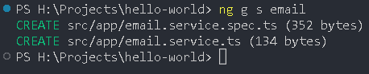

Image- and width of image

**Install bootstrap**



**Note:** When you need to install packages from a git repository use npm install it will look at the package.jason file for what packages are used and install them.

*Import bootstrap from nod modules into style.css or styles.scss*

*Bootstrap button example-* added padding in styles.scss to move button from edge.

**Class Binding**

If you inspect the button it will show an active class

If you change the isActive to equal false then it wont show the active class.

Style Binding

<https://www.w3schools.com/jsref/dom_obj_style.asp>

if backgroundColor is true it will be blue if false it will be white. Example of many different options.

**Event Binding**

This will console log the button being clicked as an event.

For more detailed events

Event Bubbling

Multiple events at once

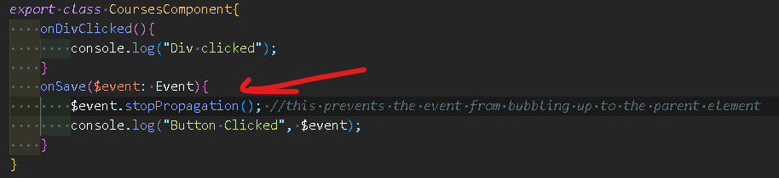

No more div event in console

**Event Filtering**

when you type something in the input and press enter it should be logged.

**Cleaner way of doing it.**

Template Variables

If you want to get the value that was typed in to the previous input field.

Cleaner Angular way – declare a template variable with the # symbol.

**Two-Way Binding**

Better way for Object oriented languages.

**Pipes**

Buile-in Pipes

* Uppercase
* Lowercase
* Decimal
* Currency
* Percent
* Custom pipes

Pipes underlined in red. After pipes are arguments to customize pipes. Notes in code snippet.

**Custom Pipes**

Need to create a new file in app

Transform(value: string can be replaced with value: any string is just used here for readability.

Add declaration to app.module.ts

**More complex way next:**

**Component.ts**

**Summary.pip.ts**

**+**