

Lab Report

|  |  |
| --- | --- |
| Name: Joshua Lollis | Date: 08/28/23 |
| Course: CPSC-483 | Lab #: 0 |

Grading Criteria:

|  |  |  |
| --- | --- | --- |
| **Section** | **Earned Points** | **Possible Points** |
| Screenshots: |  | 100 |
| Total: | 0 | 100 |

**PLEASE UPLOAD YOUR REPORT IN CANVAS. NO PAPER REPORTS.**

Professor Comments:

**Instruction: follow the lab 0 instruction and take screenshot of fig 1, 2, 3 and 4. Put them into the lab template. (please take whole page screenshot. I need to see your toolbar and time.)**

# Fig. 1 Screenshot

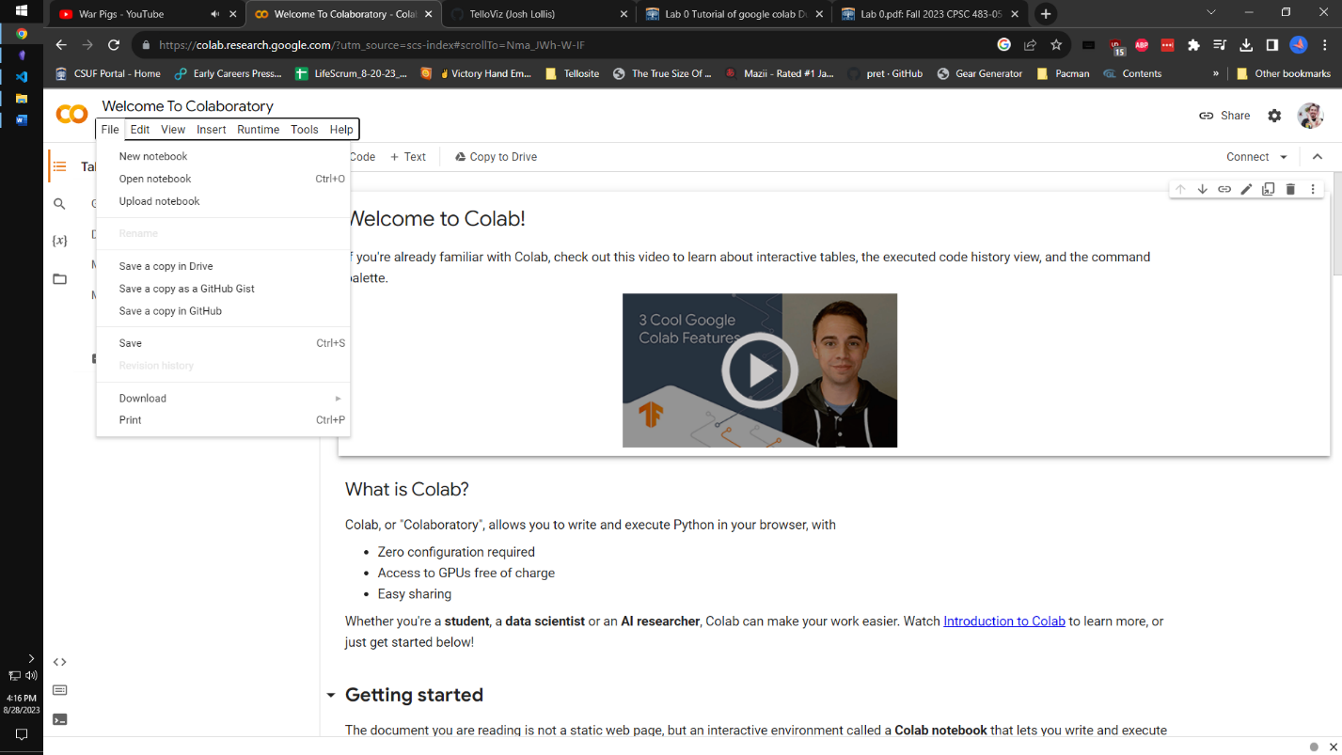

# Fig. 2 Screenshot

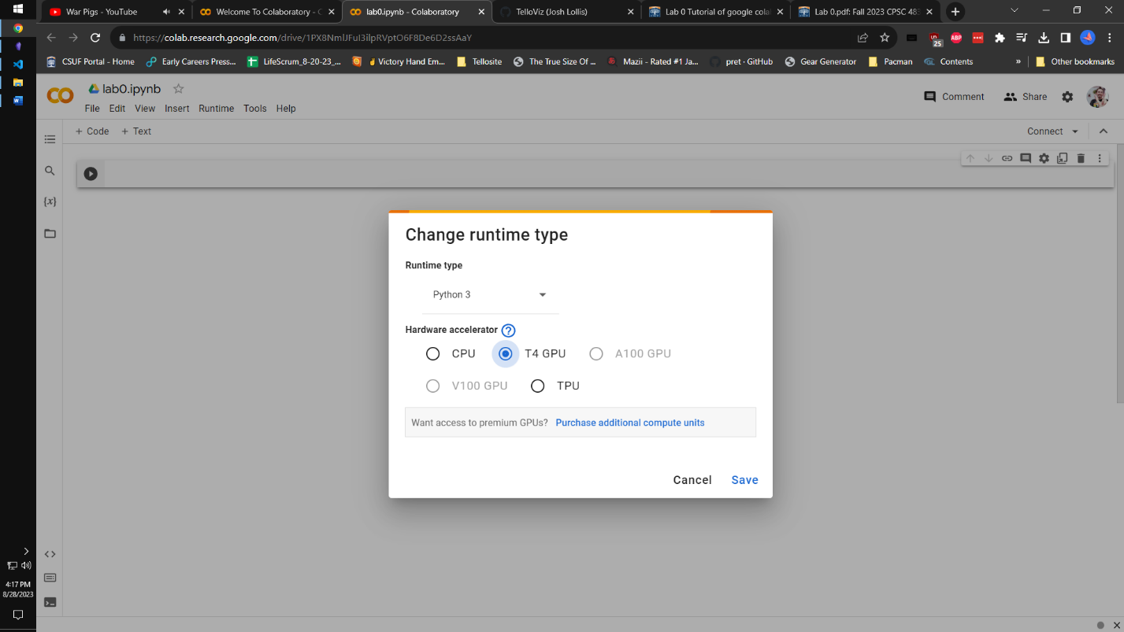

# Fig. 3 Screenshot

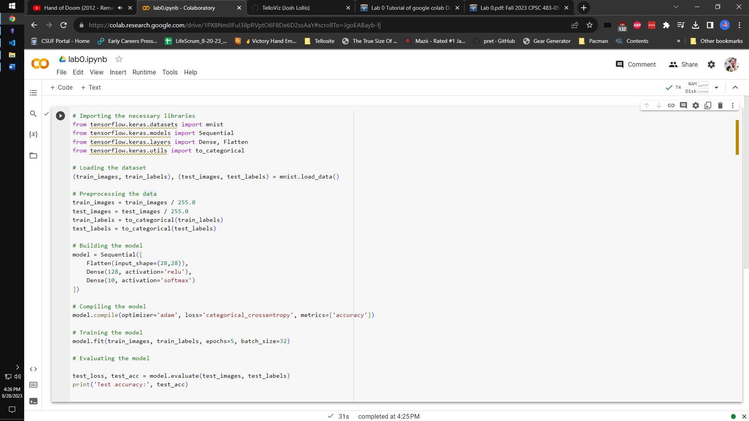

# Fig. 4 Screenshot

