Assignment(Graphite)

Equations in 2d

1.x^{3}+y^{3}=10

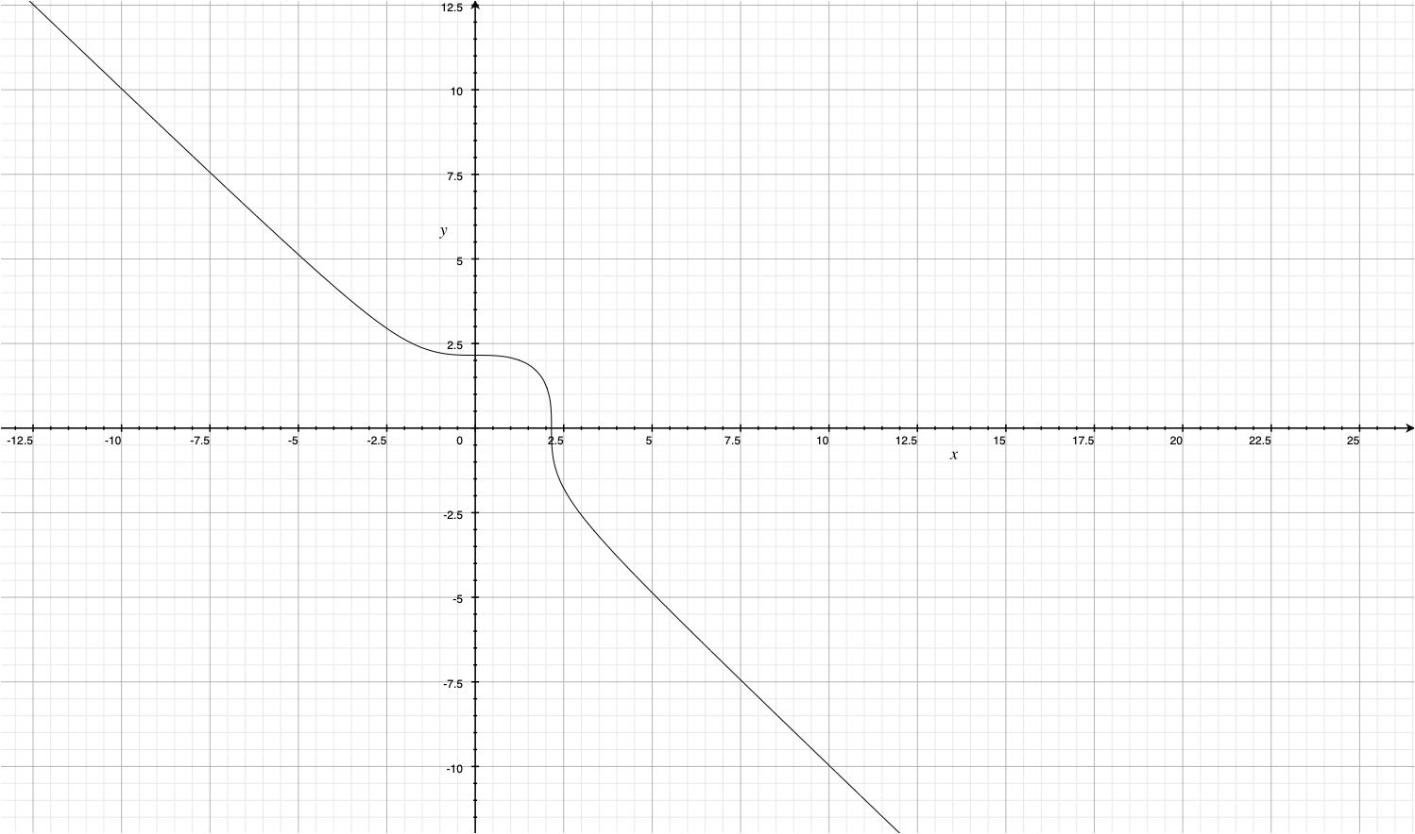

2.x^{3}-y^{3}=100

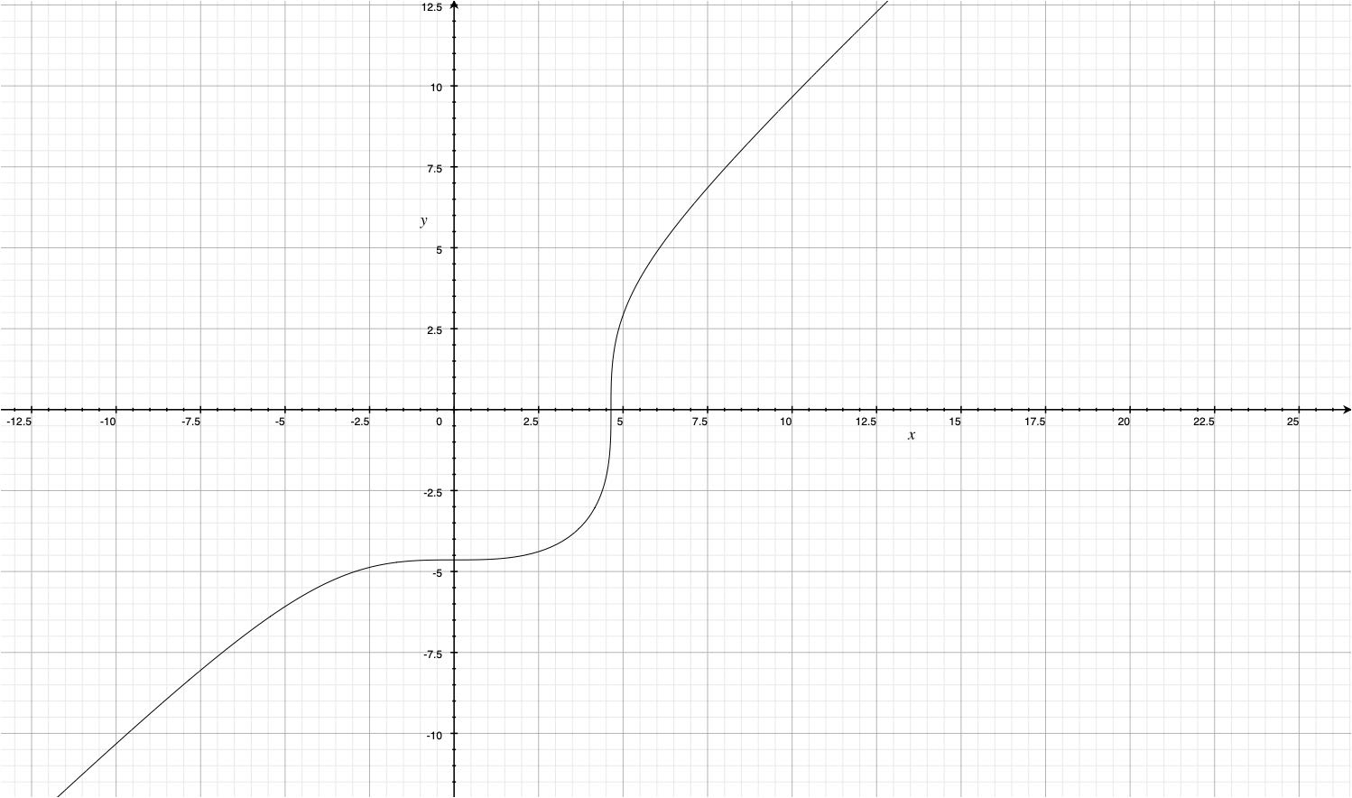

3.|_frac_{{x^{2}};{25}}+|_frac_{{y^{2}};{36}}=1

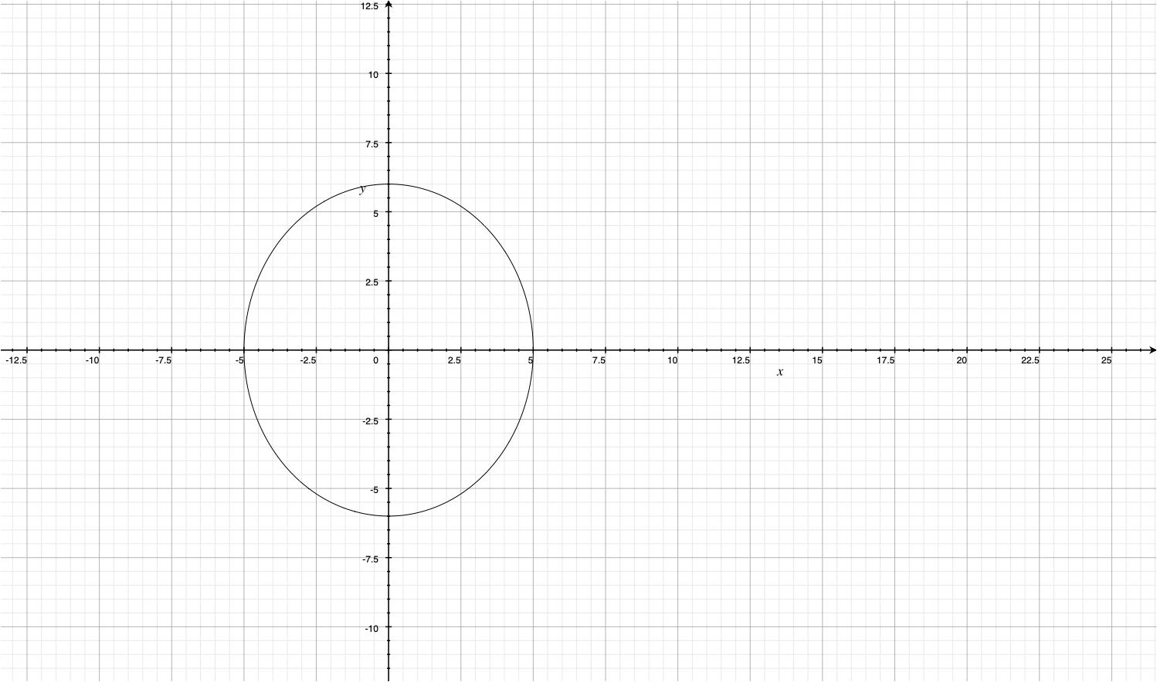

4.|_frac_{{y^{2}};{16}}-|_frac_{{x^{2}};{9}}=1

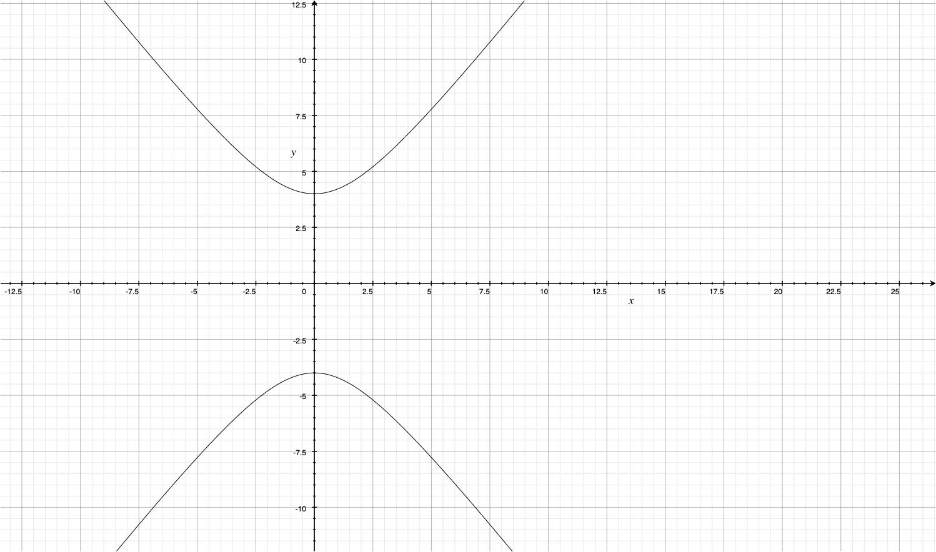

5. y=|sqrt{x}

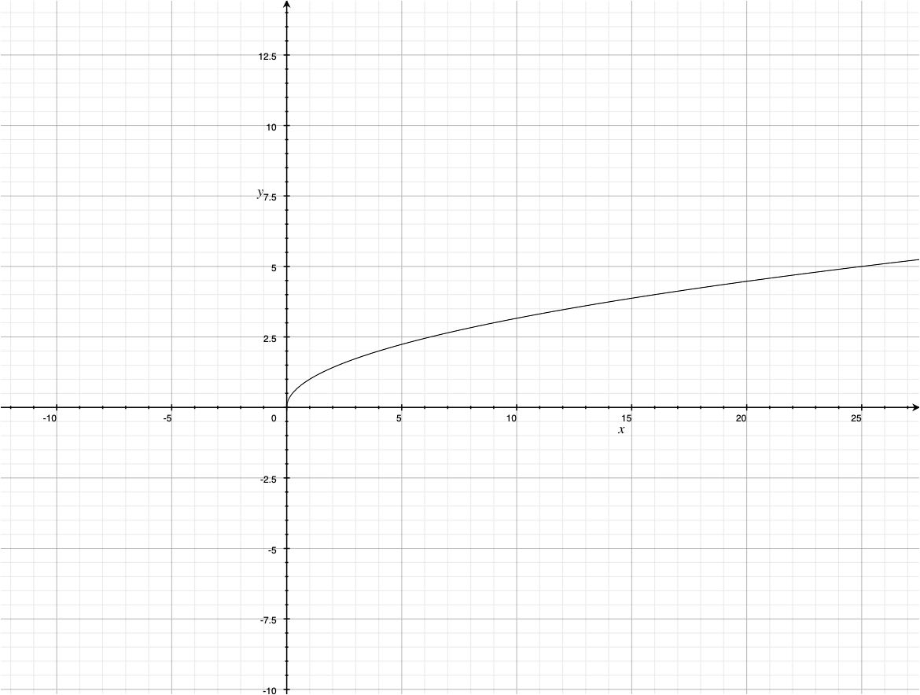

6. y=cosx+15

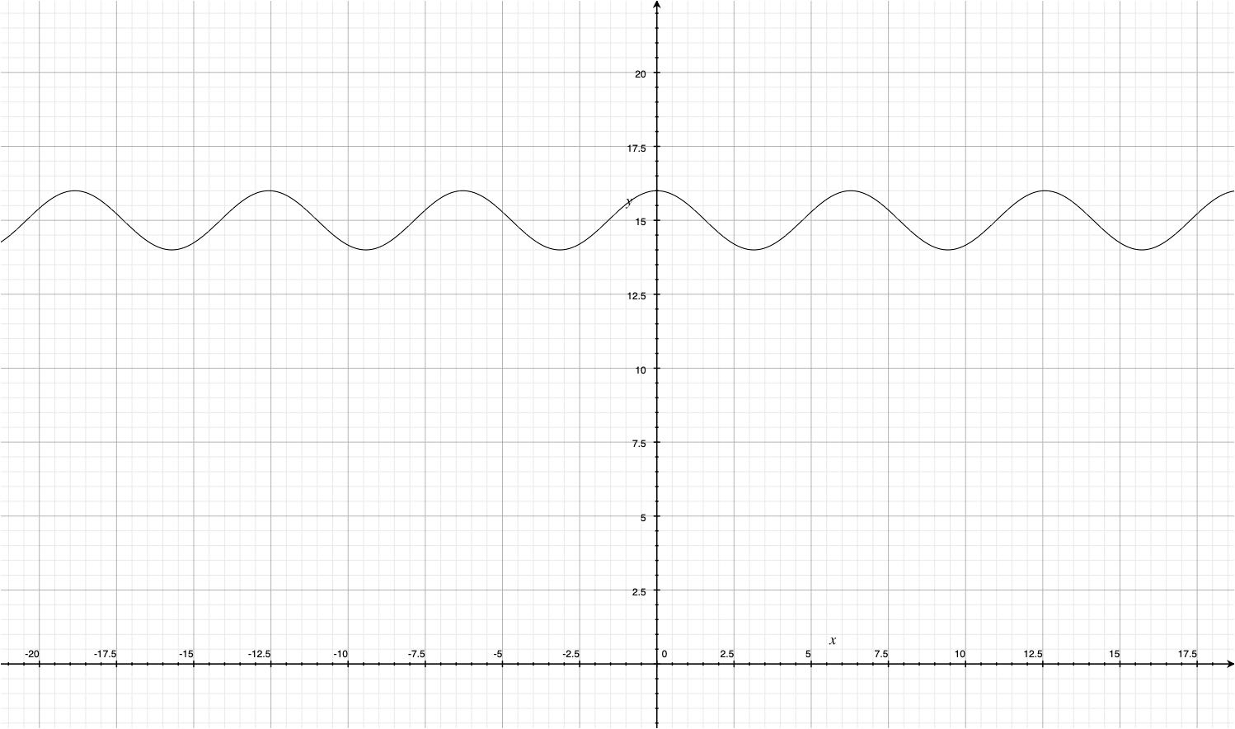

7. y=cos({x+15})

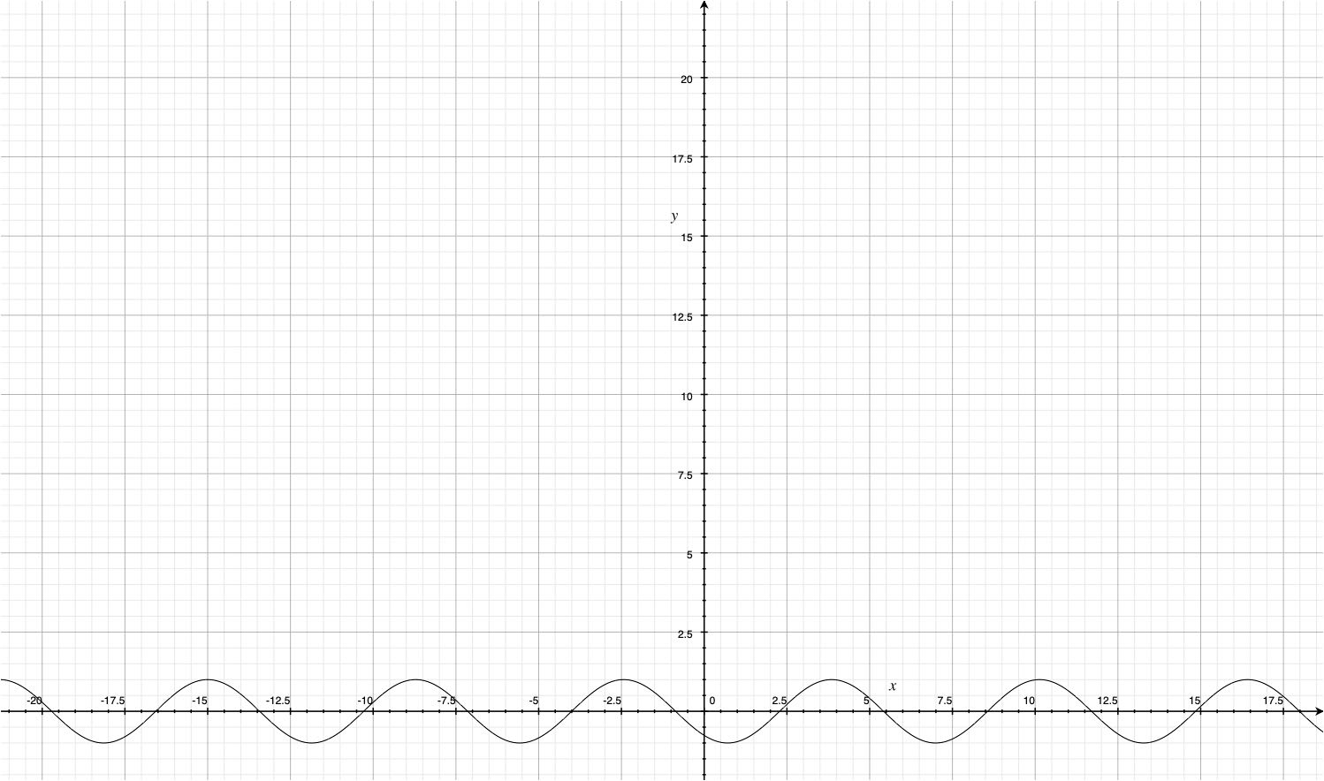

Equations in 3d:

1. z=x^{3}-y^{3}10

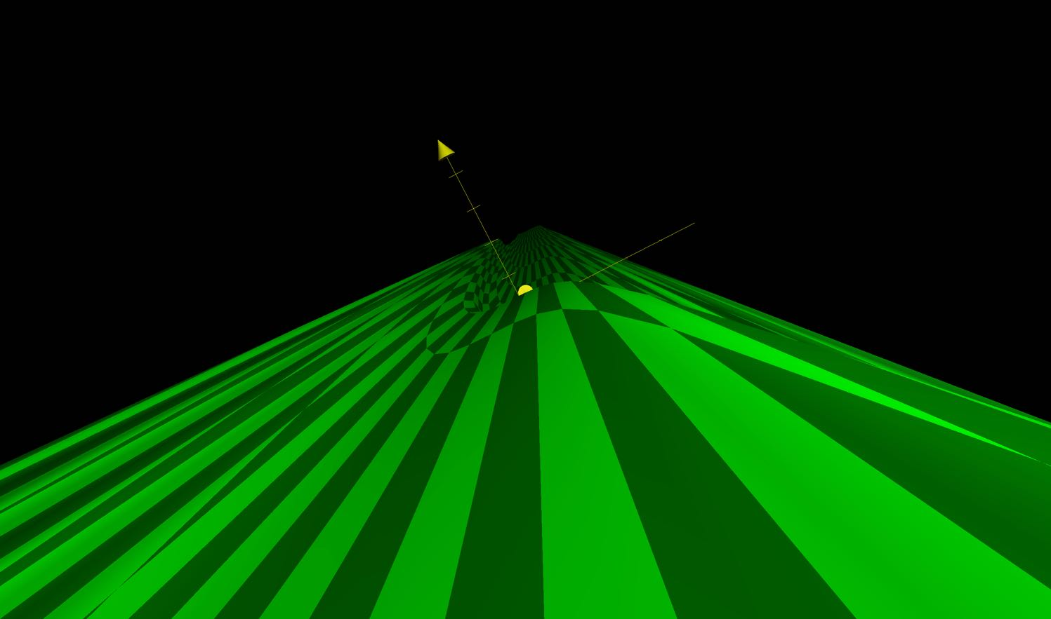

1. z=x^{3}-y^{3}-100

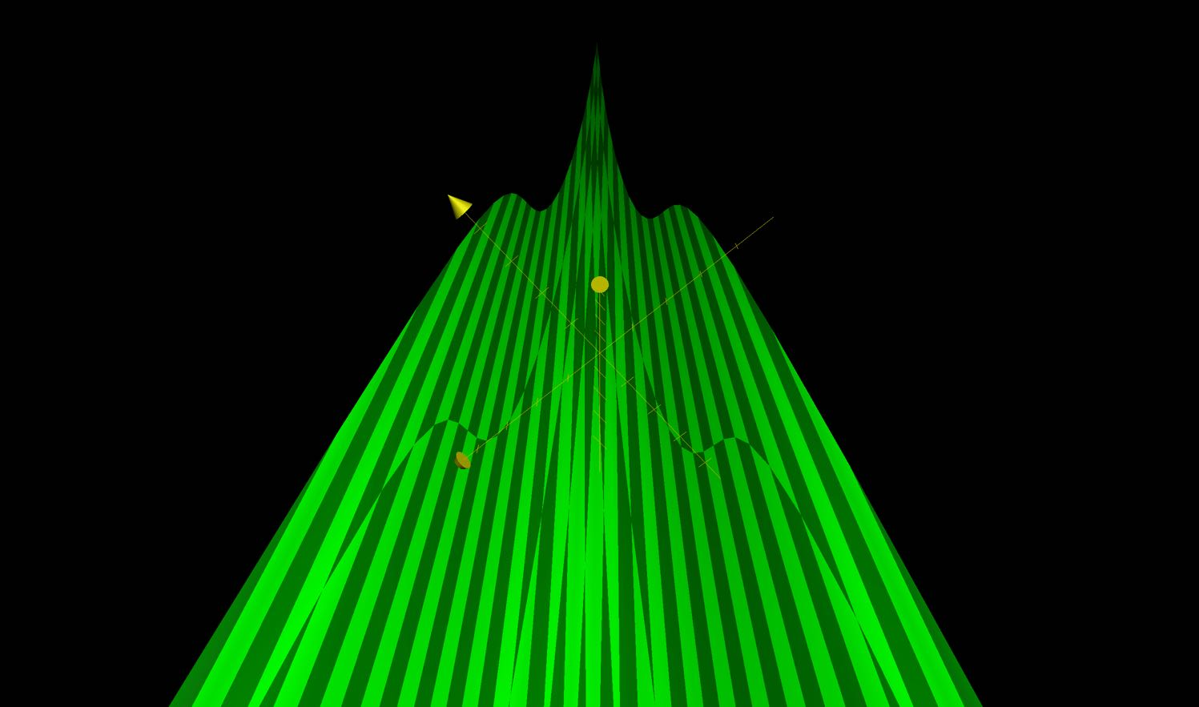

1. z=|_frac_{{x^{2}};{25}}+|_frac_{{y^{2}};{36}}-1

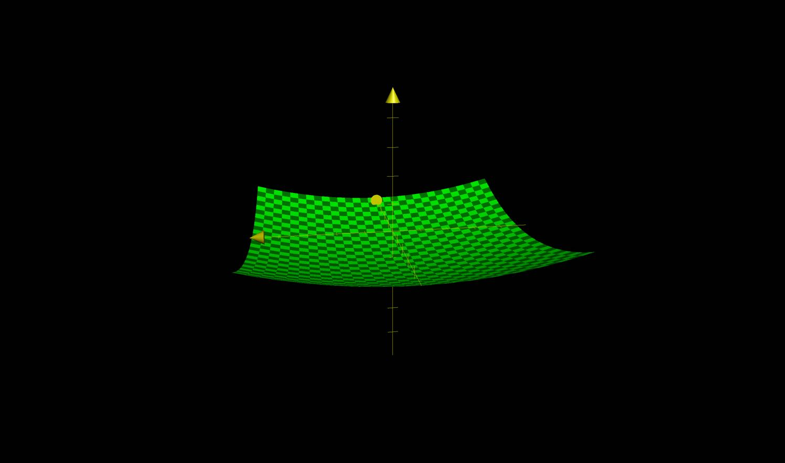

1. z=|_frac_{{y^{2}};{16}}-|_frac_{{x^{2}};{9}}-1

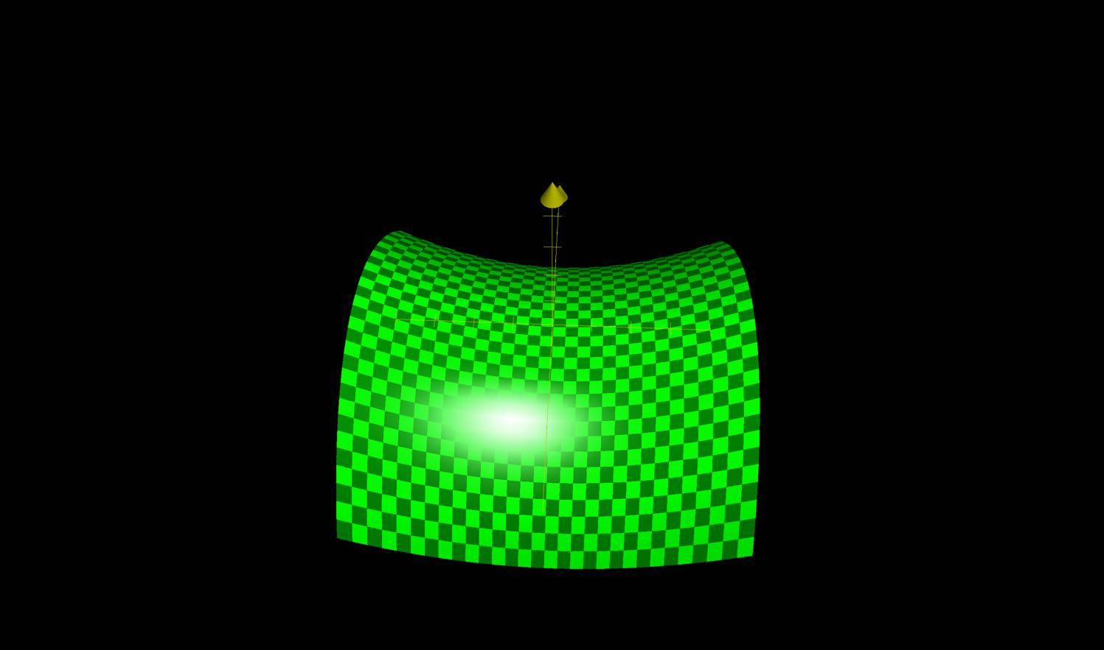

1. z=y-|sqrt{x}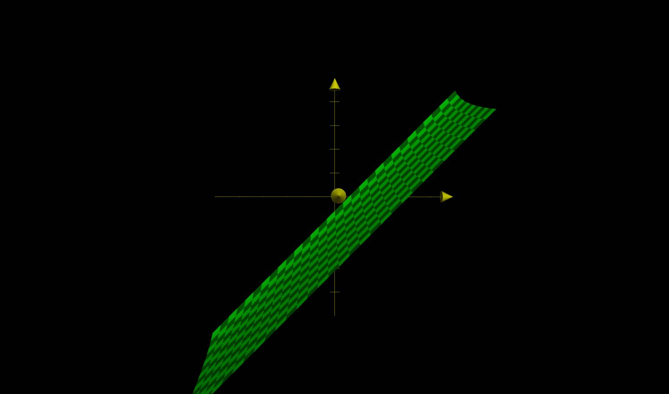
2. z=cosx+15-y

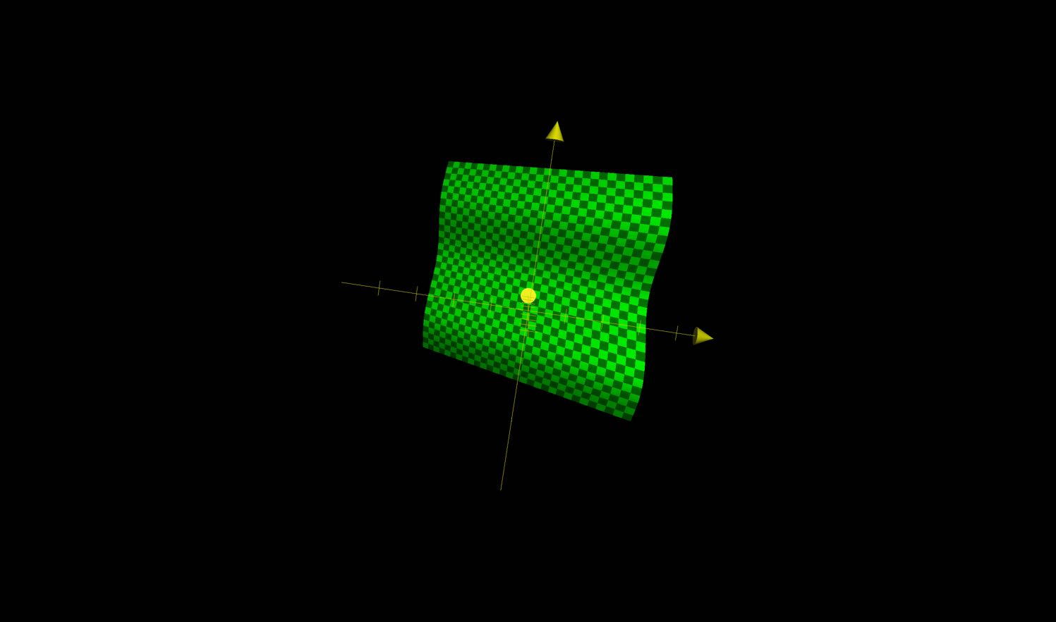

1. z=cos({x+15})-y

