
EX-POST AND EX-ANTE VALIDATION OF STATISTICAL MODELS
TELLUSANT QUICK READS
Validation Design
We evaluate model performance using a pseudo out-of-sample holdout framework. For each specification, the model is estimated using data available up to a fixed forecast origin (training window of 5–20 years). Let Y_{t} denote the dependent variable and X_{t} the vector of independent variables. The model is estimated using observations {Y_{t}, X_{t} } for t ≤ T, and forecasts are generated for t = T+1, …, T+H (H = e.g., 5 years horizon in our application).
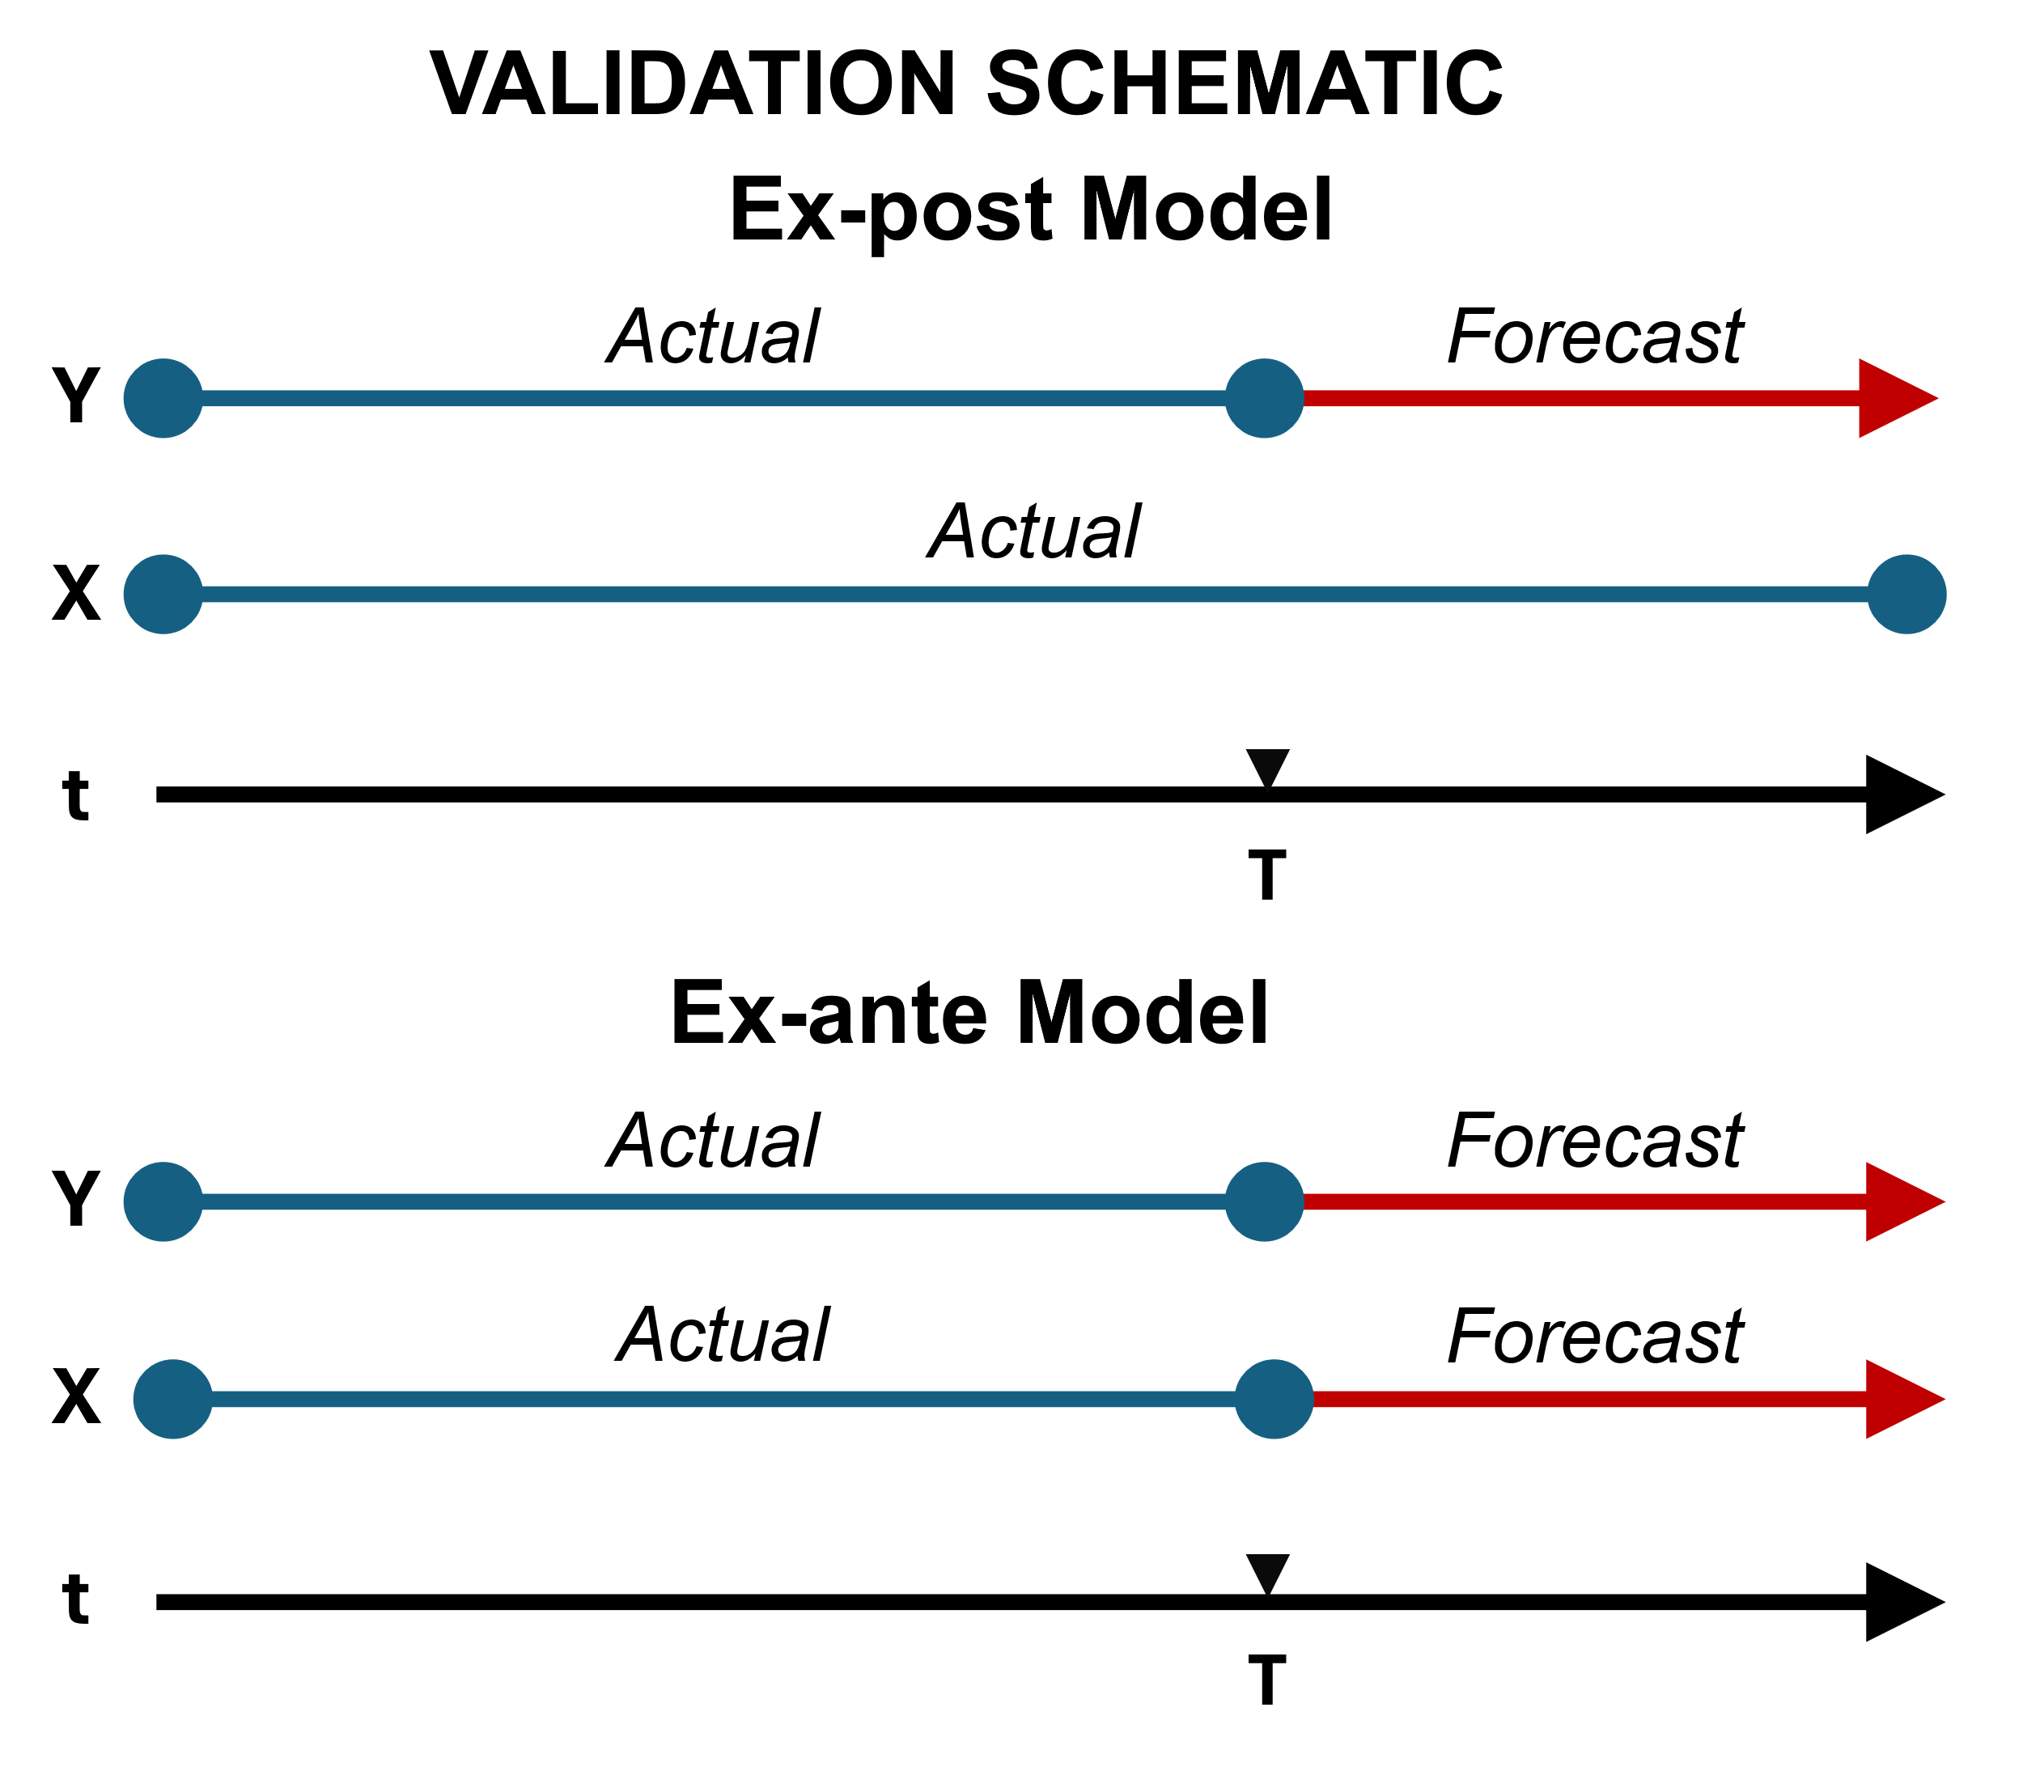
Importantly, forecasts over the holdout period are constructed conditional on the realized values of the independent variables. That is, forecasts take the form Ŷ where X_{t} are the actual observed values in the holdout period, rather than forecasts of X_{t} that would have been available at time T.

Forecast accuracy is assessed using symmetric Mean Absolute Percentage Error (MAPE) over the holdout period, using a Möbius[1,0,1,2] transformation.
Interpretation
This evaluation corresponds to a conditional ex-post forecast (conditional on X being known) rather than a fully operational ex-ante forecast. As such, it measures the model’s ability to map predictors X_{t} to outcomes Y_{t} assuming perfect knowledge of future X_{t}.
The resulting accuracy metrics therefore isolate the contribution of model specification and parameter estimation, and the structural relationship between X and Y, while avoiding errors arising from forecasting X_{t} themselves.
This distinction is standard in the forecasting literature, where conditional (ex-post) forecasts are used to assess the intrinsic predictive power of a model separately from upstream predictor forecasts (Hyndman & Athanasopoulos, 2021).
Limitations
Because the evaluation assumes knowledge of future X_{t}, reported accuracy should not be interpreted as directly representative of real-time forecasting performance. In practical applications where X_{t} must themselves be forecast, total forecast error will generally be larger.
To complement this, an operational ex-ante analysis should be conducted, if feasible, using only information available at time T, including forecasted independent variables X_{t}
Summary
The conditional holdout approach provides a diagnostic of whether the model Y_{t} = f(X_{t}) is well-specified. When paired with ex-ante validation, it enables decomposition of forecast error into model error (structure/fit) and input error (forecast error in X_{t}). This dual evaluation framework is widely used in empirical forecasting applications, including settings where forecasts are conditioned on realized predictors (Ferraro, Rogoff, and Rossi, 2015).

References
Tashman, L.J. (2000). Out-of-Sample Tests of Forecasting Accuracy: An Analysis and Review. International Journal of Forecasting.
Ferraro, D., K. Rogoff, and B. Rossi (2015). Can Oil Prices Forecast Exchange Rates? NBER Working Paper.
Hynman, R.J., & G. Athanasopoulos (2021). Forecasting: Principles and Practice (3rd ed.).

