**Programmer Manual**

**Tree ADT – Huffman Code Program**

1. **Problem Description**

This program reads through a file, creates a Huffman Table, re reads the input file and creates a Huffman Encoding Tree and Huffman Code. The program then outputs, if the user wishes, files to store the table and tree. This program may also decode an encoded message, provided a key table and encoded message are supplied. A user menu is presented, allowing for a choice of usage for the program.

1. **Data Types and Classes**

The data types used in this program are of two categories: pre-defined and programmer defined.

* 1. **int (predefined)**

Variables:

Choice – to hold the integer value of which the user entered for menu selection

* 1. **char (predefined)**

Variables:

Pick – to hold the character value of which the user entered for option selection

* 1. **Tree (user -defined)**

This class has:

Data members: message, *root, arr[26]

Member functions: insert, SearchAndDestroy, writeTree, fullTree, emptyTree, make_tree, getlist, print_Huff_table, encode, store_table, store_msg, decode

Variables:

Tree_obj – to access the member functions and data of the tree class. Used to create a

Huffman tree and table.

* 1. **list (predefined)**

Variables:

Mylist – a list to hold the value of items required. It is composed of <TreeNode<info>>.

* 1. **info (user -defined)**

This is a struct used to hold the desired data from a user input file. It consists of a CHAR letter, an INT weight, and a STRING code.

1. **High Level Program Solution**

**Main Program**

Prompt user for option selection for directive.

IF choice 1

Sets mylist equal to the return value from the getlist function. Calls getlist to create and return a list of codes. Asks user if they would like to display the Huffman Table for the given code. Then creates Huffman Tree. Asks the user where they would like to store the table and encoded message.

IF choice 2

Asks user for a Huffman Table input file, as well as an associated Encoded Message input file. Then decodes and displays the encoded message in the console.

IF choice 3

Ends the program.

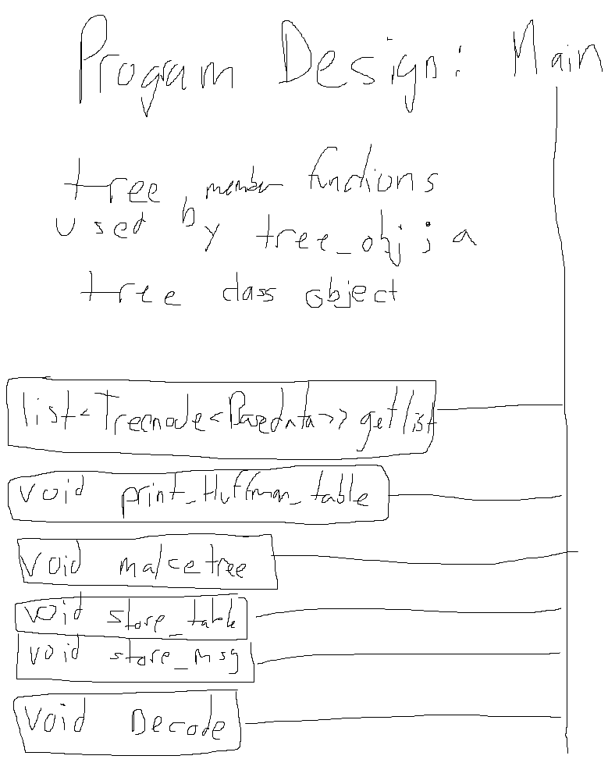

1. **Limitations and Suggestions**

This program is extremely reliant on a properly formatted input message file, and input Huffman table. Meaning if there are any discrepancies within the formatting an undesirable output will be displayed. The program only tracks lower case characters. This program only works for .txt files.