KOMATSU EXCAVATOR

PC750-6

LOADING SHOVEL

WITH: | MIKUNI HEATER,
 | 4.5 m³ BOTTOM DUMP BUCKET,
 | 4600 mm BOOM & 3400 mm ARM,
 | STEEL CAB
 | 610 mm DOUBLE GROUSE SHOE
FOR: | -40ºC to +40ºC OPERATION



(Specification are subject to change without notification)
KOMATSU PC750-6 HYDRAULIC EXCAVATOR
(LOADING SHOVEL)

SPECIFICATIONS

OPERATING WEIGHT

With 4.5 m3 (5.89 cu. Yd) bucket 74,680 kg
INCLUDING LUBRICANT, FULL FUEL TANK, HYDRAULIC OIL, OPERATOR, AND

Boom : 4600 mm One-piece
Arm : 3400 mm
Bucket : Heaped 4.5 m3 Bottom dump
Shoe : 610 mm Double

FLYWHEEL HORSEPOWER:
SAE (J1349) | 444 HP (331 kW) / 1800 RPM
DIN (6270) | 450 PS (331 kW) / 1800 RPM
BUCKET CAPACITY
Heaped | 4.5 m3
Struck | 3.60 m3
BUCKET WIDTH | 2320 mm
BOOM LENGTH | 4600 mm
ARM LENNGTH | 3400 mm
DIGGING FORCE
Bucket digging force
With 3.80 m3 bucket | 44,000 kgf (97,000 lb / 431 kN)
With 4.50 m3 bucket | 40,800 kgf (89,950 lb/ 400 kN)
ARM CROWD FORCE | 45,000 kgf (99,210 lb / 441 kN)
ENGINE:
MANUFACTURER | KOMATSU
MODEL | SAA6D140E-2
COOLING SYSTEM | WATER COOLED
ASPIRATION | TURBOCHARGED AND AFTERCOOLED
No. OF CYLINDERS | 6
BORE | 140 mm
STROKE | 165 mm
PISTON DISPLACEMENT | 15.24 ltr.
Performance:
Max. torque | 2099 N.m (214 kgf.m)
Engine RPM at max. torque | 1350 RPM
FUEL SYSTEM
FUEL | DIESEL GAS OIL, ASTM SPECIFICATION D975-60T No. 2D
COMBUSTION METHOD | DIRECT INJECTION
GOVERNOR TYPE | MECHANICAL, ALL-SPEED CONTROL
LUBRICATION SYSTEM:
LUBRICATION METHOD | FORCED LUBRICATION
LUBRICATION PUMP | GEAR PUMP
LUBRICATION FILTER | FULL-FLOW and bypass combination
COOLING METHOD | WATER COOLED
FAN TYPE | SUCTION TYPE
AIR CLEANER TYPE | DRY TYPE WITH AUTOMATIC DUST EVACUATOR
STARTING SYSTEM:
STARTING METHOD | BY ELECTRIC MOTOR
STARTING MOTOR VOLTAGE | 24 V
STARTING capacity | 11.0 kW
ALTERNATOR VOLTAGE | 24 V
ALTERNATOR AMPERAGE | 75 A
BATTERY | 2 x 12 V / 170 Ah
HYDRAULIC SYSTEM:
Type | OLSS (Open-center Load Sensing hydraulic system)
No. of selectable mode | 2
MAIN PUMP
TYPE | VARIABLE CAPACITY PISTON PUMP
No. OF PUMP | 2
MAXIMUM FLOW | 1015 ltr./min.
SUB pump
Type | Gear pump
Maximum flow | 140 ltr./min.
RELIEF VALVE SETTINGS

IMPLEMENT CIRCUITS | 320 kg/cm²
TRAVEL CIRCUITS | 320 kg/cm²
SWING CIRCUITS | 290 kg/cm²
PILOT CIRCUITS | 30 kg/cm²
CONTROL VALVE
TYPE | 1-spool type x 1  4- spool type x 1  5-spool type x 1
HYDRAULIC MOTOR
TRAVEL | AXIAL PISTON TYPE x 2
SWING | AXIAL PISTON TYPE x 1
No. of cylinders-bore x stroke x rod dia.
BOOM | 2-180 mm x 1490 mm x 120 mm
ARM | 1- 225 mm x 1530 mm x 160 mm
BUCKET | 2- 180 mm x 1300 mm x 130 mm
Bucket bottom | 2- 140 mm x 335 mm x 90 mm
OPERATOR’S CAB:
TYPE | ALL WEATHER, ENCLOSED TYPE
IMPLEMENT CONTROLS:
TYPE | TWO LEVERS ACTUATED BOOM, ARM, BUCKET AND SWING
STEERING CONTROL:
TYPE | Two-lever with pedal
DRIVE:
DRIVE METHOD | HYDROSTATIC
REDUCTION SYSTEM | 3-stage planetary gear
MAXIMUM DRAWBAR PULL | 57,000 kgf (559 kN)
MAXIMUM TRAVEL SPEED (High) | 4.2 km/h
Maximum travel speed (Low) | 2.7 km/h
Gradeability | 70% (35 deg)
BRAKE:
TRAVEL
SERVICE BRAKE | HYDRAULIC LOCK
PARKING BRAKE | Wet, multiple-disk brake
SWING
SERVICE BRAKE | HYDRAULIC LOCK
PARKING BRAKE | Wet, multiple-disk brake
UNDERCARRIAGE
TYPE | CRAWLER-TRACTOR-DESIGN UNDERCARRIAGE
CENTER FRAME | H – leg frame
SEAL OF TRACK | SEALED TRACK
TRACK ADJUSTER | HYDRAULIC TYPE
ROLLER TYPE | FLOATING SEAL
TRACK SHOES
TYPE | Double
No. OF SHOES | 47 each side
No. OF ROLLERS
CARRIER ROLLERS | 3, each side
TRACK ROLLERS | 8, each side
GROUND PRESSURE | 1.21 kg/sm² (119 kPa)
SWING SYSTEM
DRIVE METHOD | HYDROSTATIC
REDUCTION SYSTEM | Planetary gear, double-reduction
SWING CIRCLE BEARING | Single row shear type ball bearing
SWING SPEED | 5.7 RPM
SERVICE REFILL CAPACITIES:
FUEL TANK | 880.0 ltr.
RADIATOR | 85.0 ltr.
ENGINE | 32.0 ltr.
FINAL DRIVE, EACH SIDE | 20.0 ltr.
SWING DRIVE | 30.0 ltr
HYDRAULIC SYSTEM | 440.0 ltr.

(Specification are subject to change without notification)

KOMATSU PC750-6 HYDRAULIC EXCAVATOR
(LOADING SHOVEL)

DIMENSIONS
(BOOM 4600 mm, ARM 3400 mm)

A:OVERALL LENGTH | 9760 mm
B:OVERALL WIDTH | 4110 mm
C:OVERALL HEIGHT (TO TOP OF BOOM) | 5075 mm
D:OVERALL HEIGHT (TO TOP OF CAB) | 3515 mm
E:GROUND CLEARANCE, COUNTERWEIGHT | 1555 mm
F:MIN. GROUND CLEARANCE | 840 mm
G:TAIL SWING RADIUS | 4300 mm
H:LENGTH OF TRACK ON GROUND | 4500 mm
I:TRACK LENGTH | 5810 mm
J:TRACK GAUGE | 3500 mm
K:WIDTH OF CRAWLER | 4110 mm
K: Width of crawler (when retracted) | 3390 mm
L:SHOE WIDTH | 610 mm
M:GROUSER HEIGHT | 50 mm
N:MACHINE HOOD HEIGHT | 3495 mm
O:MACHINE COUNTER WEIGHT HEIGHT | 2965 mm
P:MACHINE CAB WIDTH | 3195 mm
Q: Distance, swing center to rear end | 4205 mm

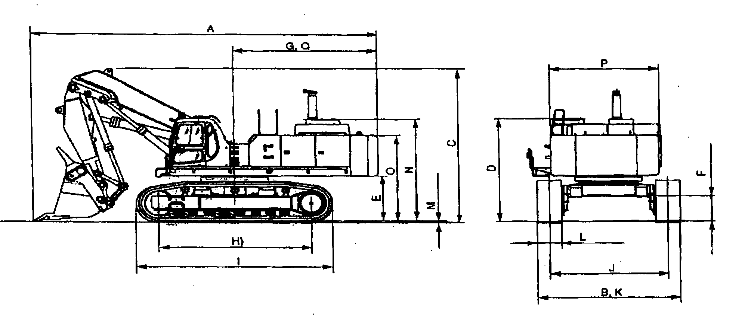
KOMATSU PC750-6 HYDRAULIC EXCAVATOR
(LOADING SHOVEL)

WORKING RANGE with 4.5 m3 bucket
4600 mm BOOM
3400 mm ARM
A: MAX. CUTTING HEIGHT | 10765 mm
B: MAX. DUMPING HEIGHT | 7630 mm
C: MAX. DIGGING DEPTH | 3515 mm
D: MAX.DIGGING REACH | 10095 mm
E: MAX.DIGGING REACH AT GROUND LEVEL | 9720 mm
F: LEVEL CROWDING DISTANCE | 3970 mm
G:REACH AT MAX.DUMPING HEIGHT | 5550 mm
H: MIN. SWING RADIUS | 5805 mm
I: MAX. HEIGHT OF MIN. SWING RADIUS | 7005 mm

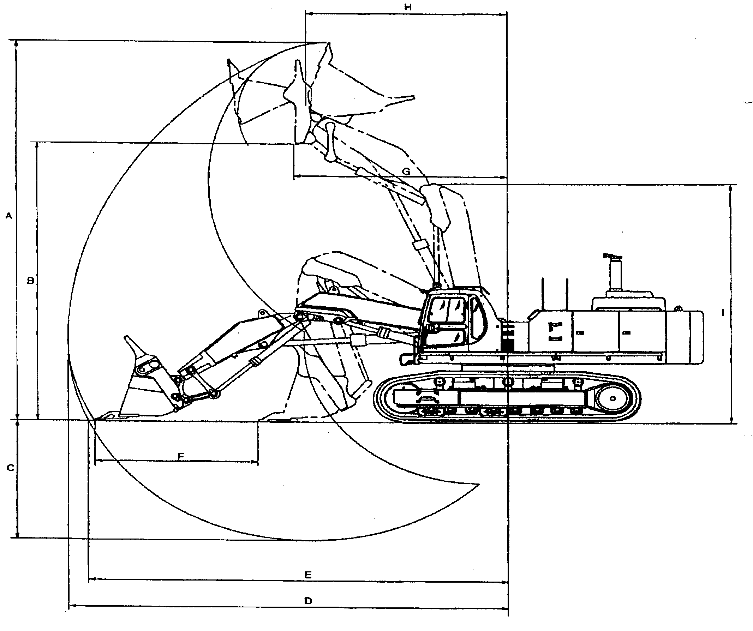



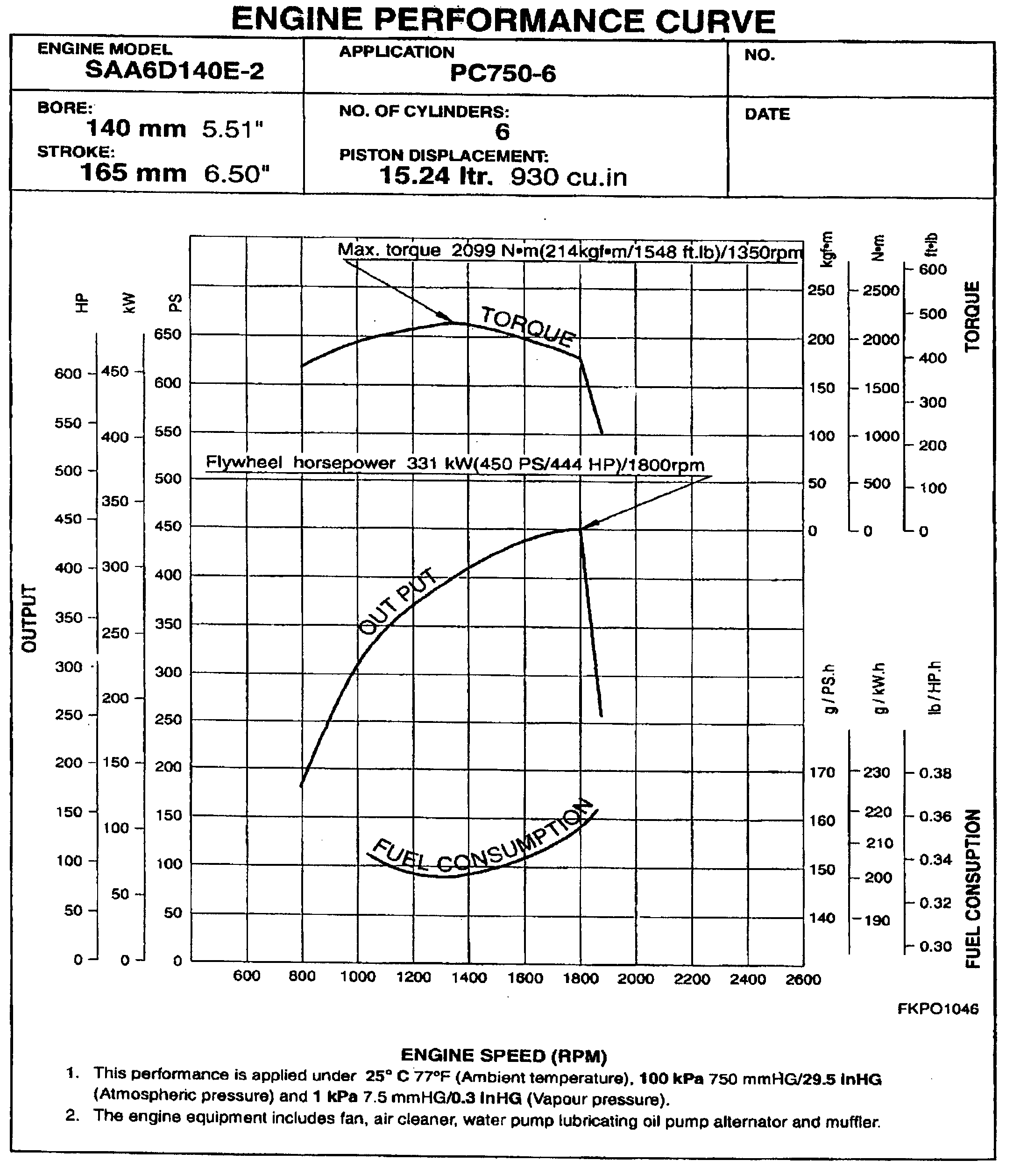

KOMATSU PC750-6 HYDRAULIC EXCAVATOR
(LOADING SHOVEL)

ACCESSORY PARTS TABLE

PART No. | PART NAME | Q-TY | REMARKS
 | STARTING SWITCH KEY | 2
 | PARTS BOOK | 1
 | OPERATION & MAINTANANCE MANUAL | 1
KOMATSU 750-6 HYDRAULIC EXCAVATOR
(LOADING SHOVEL)

OPTIONAL TOOL TABLE

PART No. | PART NAME | Q-TY | REMARKS
09000-30006 | WRENCH SET | 1
09020-10284 | SOCKET WRENCH SET | 1 s
09033-00190 | SCREWDRIVER | 1
09036-00150 | PLIERS | 1
09039-00150 | SCREWDRIVER | 1
09055-10390 | BAR | 1
09019-08035 | WRENCH | 1 | FOR FILTER
178-98-11120 | WRENCH | 1
195-98-11590 | SOCKET | 1
07950-80002 | GREAE PUMP | 1
07950-90403 | CARTRIDGE (GREASE) | 1
07951-11400 | NOZZLE | 1
09056-05513 | TOOL BAG | 1
KOMATSU PC750-6 HYDRAULIC EXCAVATOR
(LOADING SHOVEL)

SPARE PARTS TABLE

PART No. | PART NAME | Q-TY |  | REMARKS
600-211-1231 | CARTRIDGE | 2 | ENGINE OIL FULL-FLOW FILTER
600-212-1511 | CARTRIDGE | 1 | ENGINE OIL BYPASS FILTER
600-311-7132 | CERTRIDGE | 2 | FUEL FILTER
6128-81-7042 | ELEMENT ASS'Y | 1 | AIR CLEANER
6212-85-6840 | V-BELT | 1 | FOR ALTERNATOR DRIVE
600-736-9650 | V-BELT | 1 | FOR FAN DRIVE
07063-01210 | ELEMENT | 2 | FOR HYDRAULIC OIL RETURN FILTER
07000-05180 | 0-RING | 2 | FOR HYDRAULIC OIL RETURN FILTER
363-60-33310 | FILTER | 1 | FOR HYDRAULIC DRAIN FILTER
07002-03034 | O-RING | 4 | FOR FINAL DRIVE DRAIN PLUG
07002-32434 | 0-RING | 1 | FOR P.T.O. DRAIN PLUG

