КОМАTSU BULLDOZER
D375A-5

With SEMI-U TILT DOZER
GIANT RIPPER
STEEL CAB & ROPS CANOPY
710 mm SINGLE GROUSER SHOE
AIR CONDITIONER
SANDY AREA ARRANGEMENT

FOR –20C - +40C OPERATION



KOMATSU D375A-5 TRACTOR
Specifications
OPERATING WEIGHT 49800 kg (109,790 Ib.)

FLYWHEEL HORSEPOWER;

SAE (J1349) 391 kW (525 HP) /1800 rpm
DIN (6270) 391 kW (532 PS) /1800 rpm

PERFORMANCE:

Travel speed and drawbar pull:
Forward 1st 0 - 3.8 km/h (2.4 MPH)
2nd 0 - 6.8 km/h (4.2 MPH)
3rd 0 - 11.8 km/h (7.3 MPH)
Reverse 1st 0 - 5.1 km/h (3.2 MPH)
2nd 0 - 9.2 km/h (5.7 MPH)
3rd 0 - 15.8 km/h (9.8 МНР)
Max. drawbar pull: Refer to attached travel
performance curve
Turning radius 4.2 m (13 ' 9")

DIMENSIONS:

Overall length 5770 mm (1841")
Overall width 3220 mm (10'7")
Overa11 he ight:
To top of exhaust pipe 4035 mm (13'3")
Highest point,
exclusive of exhaust pipe .... 3429 mm (11'3")
To top of precleaner
Track gauge 2500 mm ( 8'2")
Length of track on ground 3840 mm (12'7")
Ground pressure 123 kPa
(1.25 kgf/cm²/17.8 PSI)
Ground clearance 610 mm ( 2' 0"}

ENGINE:

Model Komatsu SA6D170E-3
Type Water cooled, 4-cycle,
overhead valve, direct injection, turbocharged diesel engine with aftercooler
No. of cylinders - bore x stroke .... 6 - 170 mm x 170 mm
(6.69^{м} х 6.69")
Piston displacement 23.15 Itr. (1,413 in³}
Performance:
Max. torque 2648 N.m
(270 kgf.m/1,953 Ib.ft)
Engine rpm at max. torque 1300 rpm
Fuel system:
Fuel Diesel gas oil, ASTM
Specification D975-60T No.2D
Governor type Electronic, all-speed control
SPEC. NO. X21SP20010012
D375-lm
Lubrication system:
Lubrication method Gear pump, forced lubrication
Lubrication filter Full-flow
Cooling method Water cooled
Cooling system:
Cooling method Forced circulation by
centrifugal water pump
Fan type Pusher type fan
Air cleaner Dry type with dust indicator
and pre-cleaner with automatic dust ejector
Starting system:
Starting method By electric starting motor
Starting motor 24 V, 2 x 7.5 kW
Alternator 24 V, 60A
Battery 24 V (12 V x 2) - 170 Ah
POWER TRANSMITTING SYSTEM:

Torque converter:

Type 3-element, single-stage,
single-phase with lockup clutch
Cooling method Water cooled

TRANSMISSION:

Type Planetary gear and multiple-
disc clutch, hydraulically
actuated, forced lubrication
Gear shift 3 forward and 3 reverse speeds
Bevel gear Spiral bevel gear, splash
lubrication

Steering system:
Steering clutch Wet, multiple-disc clutch,
Spring loaded, hydraulically released, hand operated, interconnected with steering brake
Steering brake , Wet, multiple-disc,
spring actuated, hydraulically released, foot/lever operated
Service brake , , Steering brakes function as
service brake, foot operated
Final drive Spur gear single reduction
and planetary gear single reduction, splash lubrication
UNDERCARRIAGE:

Suspension Oscillation type, equalizer bar

SPEC. NO. X21SP20010012 D375-2m

No of rollers:
Carrier rollers ................ 2, each side
Track rollers 7, each side
Track shoe assembly:
Type Assembled, lubricated and
sealed track
Pitch 280mm (11.0")
Track shoe:
Type Single grouser (Extreme service)
Grouser height 93 mm. ( 3.7")
Shoe width 710 mm (28")
SERVICE REFILL CAPACITIES:
Specified Refilled
Coolant 165 ltr. 165 ltr.
{ 43.6 U.S. gal) ( 43.6 U.S. gal)
Fuel tank 1050 ltr. 1050 ltr.
( 277 U.S. gal) ( 277 U.S. gal)
Engine 68 ltr. 55.5 ltr.
( 18.0 U.S. gal) ( 14.7 U.S. gal)
Damper 2.1 ltr. 2.1 ltr.
( 0.6 U.S. gal) ( 0.6 U.S. gal)
Torque converter) 275 ltr. 150 ltr.
Transmission ) ( 72.7 U.S. gal) ( 39.6 U.S. gal)
Bevel gear case )
Steering case )
Final drive case, each side . . 65 ltr. 65 ltr.
( 17.1 U.S. gal) ( 17.1 U.S. gal)
SPEC. NO. X21SP20010012
D375-3m

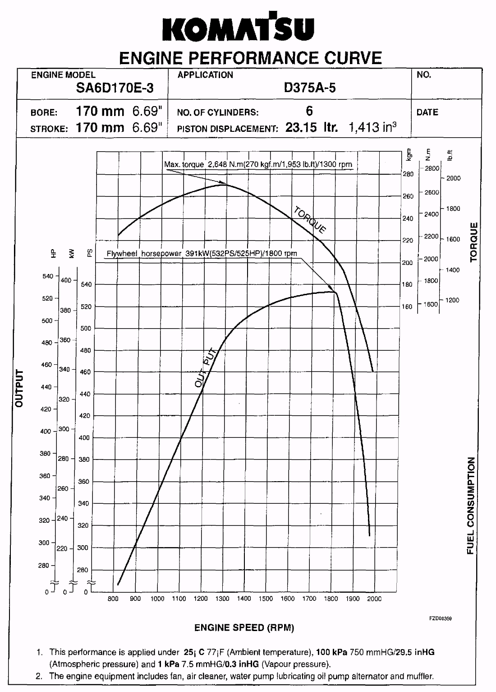

SPEC. NO. X21SP20010012
D375-4m

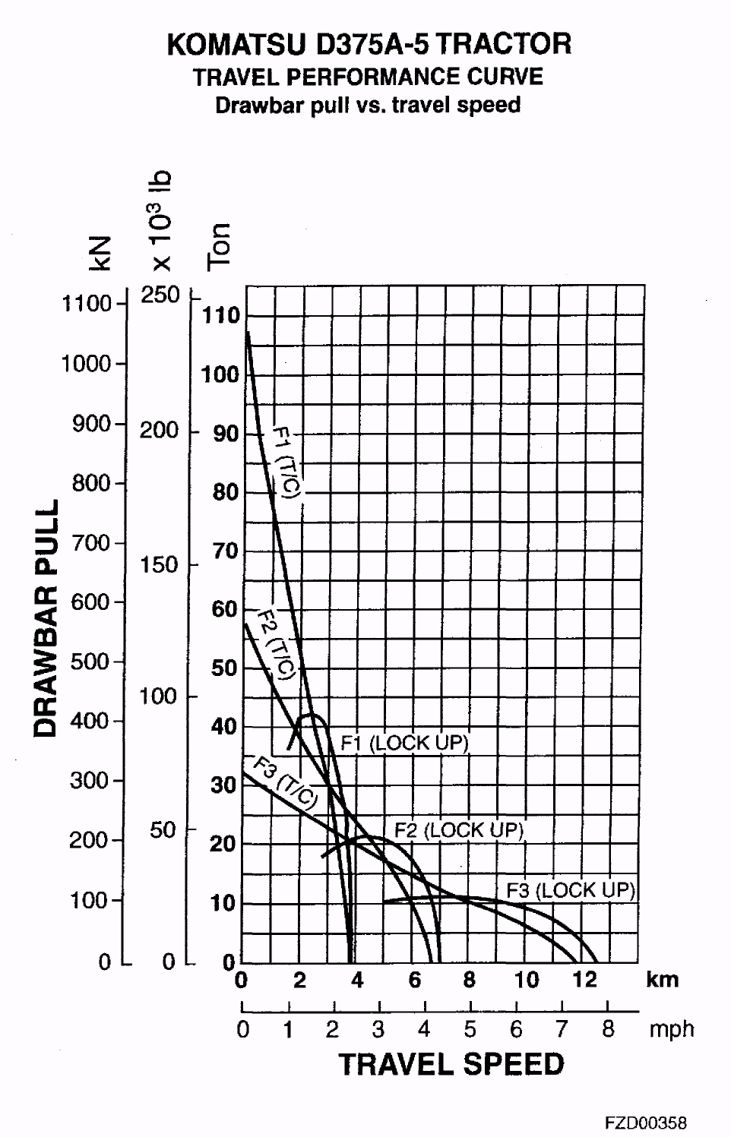

SPEC. NO. X21SP20010012
D375-5m

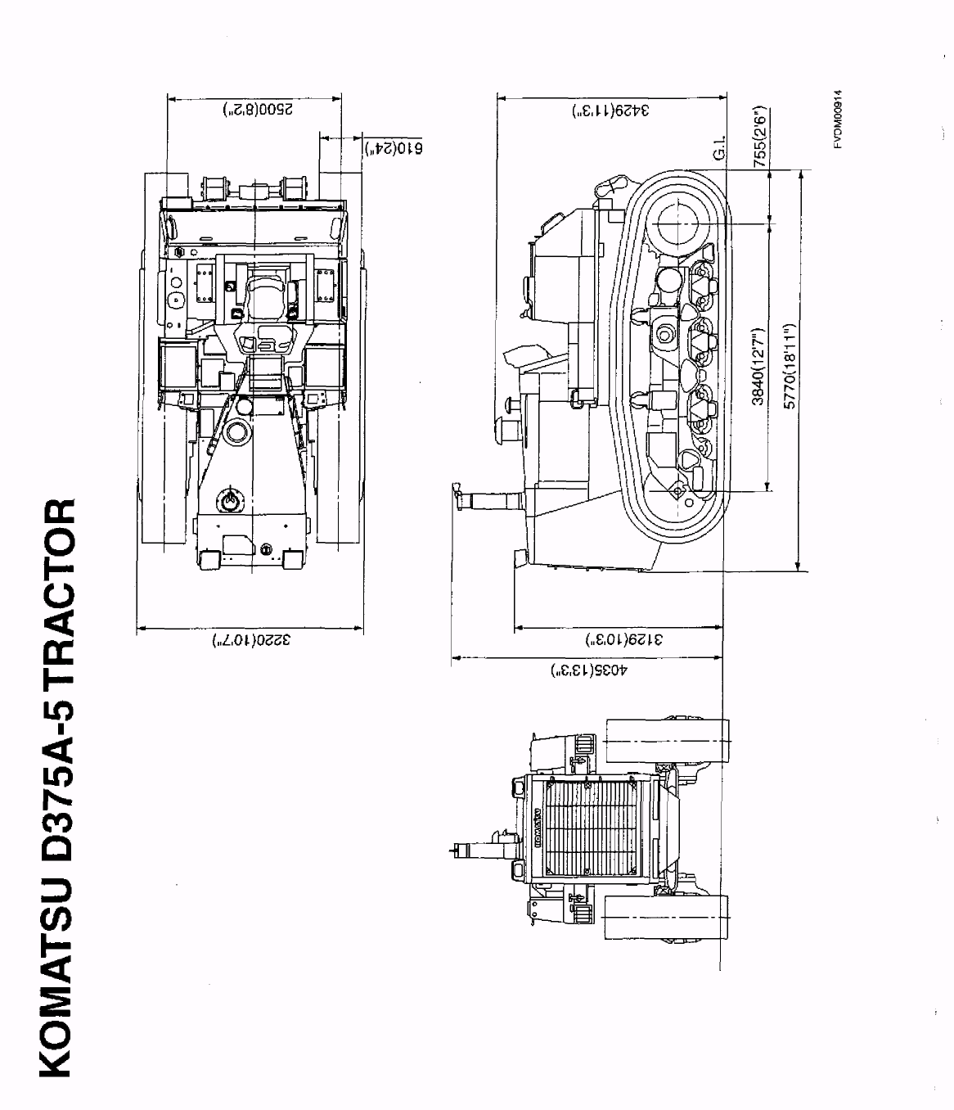

SPEC. NO. X21SP20010012
D375-6m

KOMATSU D375A-5 SEMI-U-DOZER

Specifications

EQUIPMENT WEIGHT (Additional weight to tractor):
Standard blade 10540 kg (23,240 Ib. )
With weld-on push plate 11140kg (24,5601b.)

DIMENSION:
Length
(Additional length to tractor) .. 1865 mm { 6' 1")
Overall width 4695 mm (15 '5")
Ground pressure (Additional pressure to tractor):
Standard blade 21.6 kPa 0.22 kgf/cm²/3.13 PSI)
With weld-on push plate 23.5 kPa 0.24 kgf/cm²/3.13 PSI}

DOZER EQUIPMENT:
Type Semi-U blade, hydraulically
tilting
Weight:
Standard blade 10490 kg (22,130 Ib)
With weld-on push plate 11090 kg (24,450 Ib)
Including blade support 930 kg (2,050 Ib) Blade:
Blade capacity 18.5 m³ (24.2 yd³)
Blade support method Brace support type
Width 4695mm (15’ 5")
Height 2265 mm ( 7’ 5")
Digging angle 55 deg.
Max. lift above ground 1660 mm ( 5’ 5")
Max. drop below ground 715 mm ( 2’ 4")
Max. tilt adjustment 1065 mm ( 3’ 6")
Hydraulic cylinders:
Type . Double-acting, piston type
No. of cylinders - bore:
Lifting cylinder 2 - 150 mm (5.9")
Tilting cylinder 1 - 225 mm (8.9")

HYDRAULIC EQUIPMENT:
Additional hydraulic oil weight ... 50 kg (110 Ib)
Max. oil pressure 20.6 MPa (210 kgf/cm², 990 PSI)
Hydraulic pump:
Type Gear pump
Capacity (discharge flow) 405 Itr. (107 U.S. gal)/min
at engine rated rpm
Location Rear of engine right side
Control valve Spool type
Position:
Lifting spool Raise, hold, lower and float
Tilting spool Right, hold and left
Hydraulic tank:
type Equipped with externally-
mounted control valve
Location , Right of operator's seat
filter Full-flow type
Hydraulic oil (Refilled) 120 Itr. (31.7 U.S. gal)

SPEC. NO. X21SP20010010
D375-llm

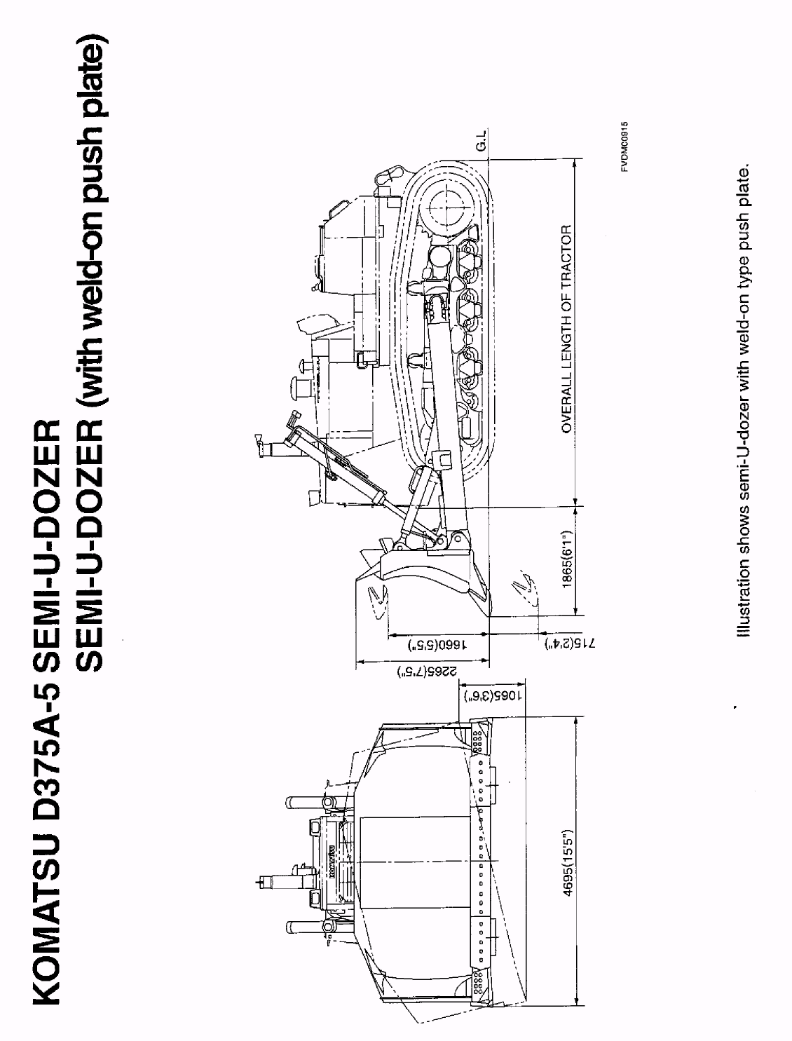

NO. X21SP20010010
D375-12m

KOMATSU D375A-5 GIANT R1PPKR
(Variable digging angle type)
Specifications
EQUIPMENT WEIGH:
(Additional weight to tractor) ..... 5470 kg (12,060 Ib)

DIMENSION:
Length
(Additional length to tractor). 2695 mm (8’10")
Ground pressure
(Additional pressure to tractor) 12 kPa (0.12 kgf/cm²/1.71 PSI)

RIPPER EQUIPMENT:
Type Parallelogram, variable
digging angle type
Weight .... 5250 kg (11,570 Ib)
Beam length 1367 mm ( 4'6")
Shanks:
No. of shanks 1
Tooth point Replaceable
Digging angle 45 deg., STD, (available
stepless angle adjustment)

Digging depth Adjustable to 3 stages
Max. digging depth 1435 mm ( 4’ 8")
Max. lift above ground 1060 mm { 3’ 6")
Hydraulic cylinders:
Type Double-acting, piston type
No. of cylinders - bore:
Lifting cylinder 2 - 225 mm (8.9")
Tilting cylinder 2 - 200 mm (7.9")

HYDRAULIC EQUIPMENT:
Additional weight 220 kg ( 490 Ib)
Max. oil pressure 20.6 MPa (210 kgf/cm²/2,990PSI}
Hydrauliс pump:
Type Gear pump
Capacity (discharge flow) 405 Itr. (107 U.S. gal)/min
at engine rated rpm
Location Rear of engine right side
Control valve Spool type
Position:
Lifting spool Raise, hold, lower and float
Tilting spool Digging angle increase, hold
and decrease
Note: Lifting spool and tilting spool are change-overed with
selector valve.
Hydraulic tank:
type Equipped with externally-
mounted control valve
Location Right of operator's seat
filter Full-flow type
Hydraulic oil (Refilled) 70 Itr. (18.5 U.S. gal)

SPEC. NO. X21SP20010006
D375-37m

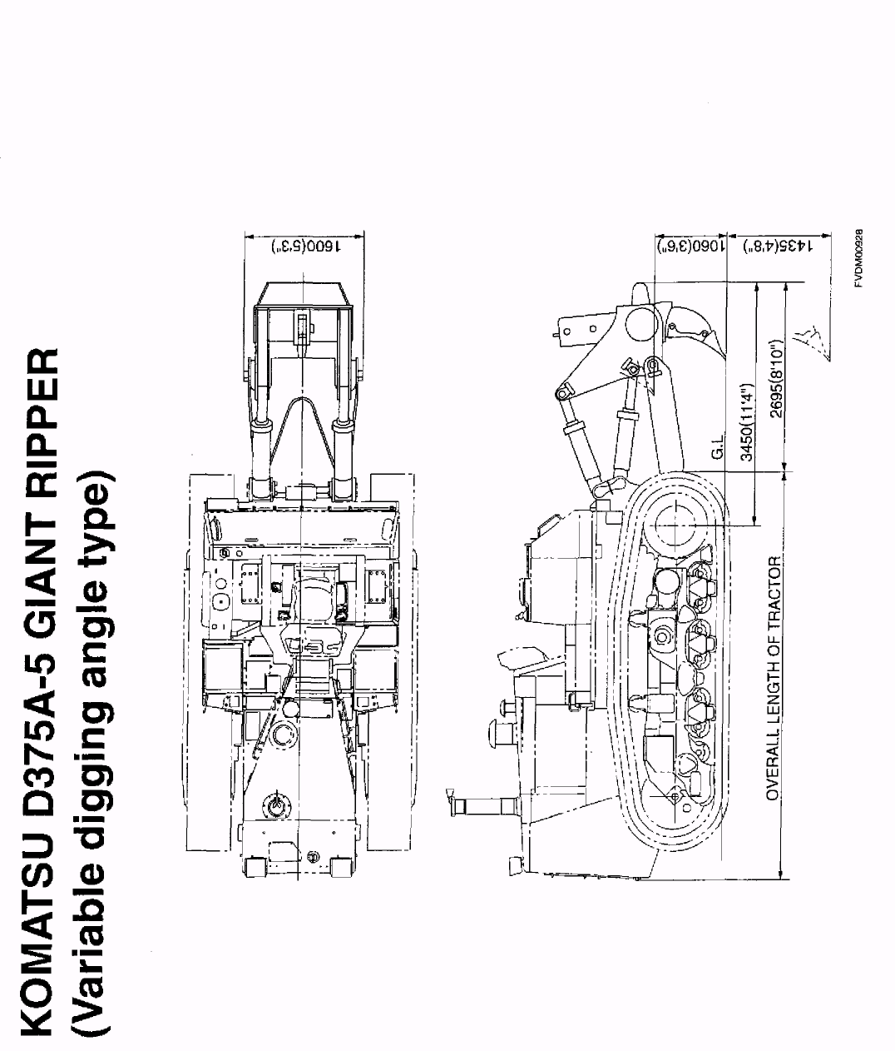

SPEC. NO. X21SP20010006
D375-38m

KOMATSU D375A-5 STEEL CAB

Specifications

EQUIPMENT WEIGH:
(Additional weight to tractor) ... 415 kg (910 Ib)

DIMENSION:
Overall height 4040 mm (13- 3")
Ground pressure
(Additional pressure to tractor). 1.0 kPa (0.01 kgf/cm²/0.14 PSI)

STEEL CAB:
Type All weather, enclosed type
Weight 415 kg ( 910 Ib)
Length 1790 mm ( 5'10")
Width 1455 mm ( 4' 9")
Height:
Cab height 1675 mm ( 5' 6")
Floor mat to ceiling 1530 mm ( 5' 0")

STANDARD EQUIPMENT:
Windshield wiper 4, front and rear windows,
left and right doors
Windshield washer 4, front and rear windows,
left and right doors
Room lamp 1
Cigarette light 1
Ashtray 1
Floor mat 1

OPTIONAL EQUIPMENT:
Air conditioner
Weight 60 kg (130 Ib)
Cooler 4500 kcal/hour
Heater 5000 kcal/hour
Additional heater 4000 kcal/hour
Room mirror 1
Sunvisor 3, left, center and right

SPEC. NO. X21SP20010007
D375-39ra

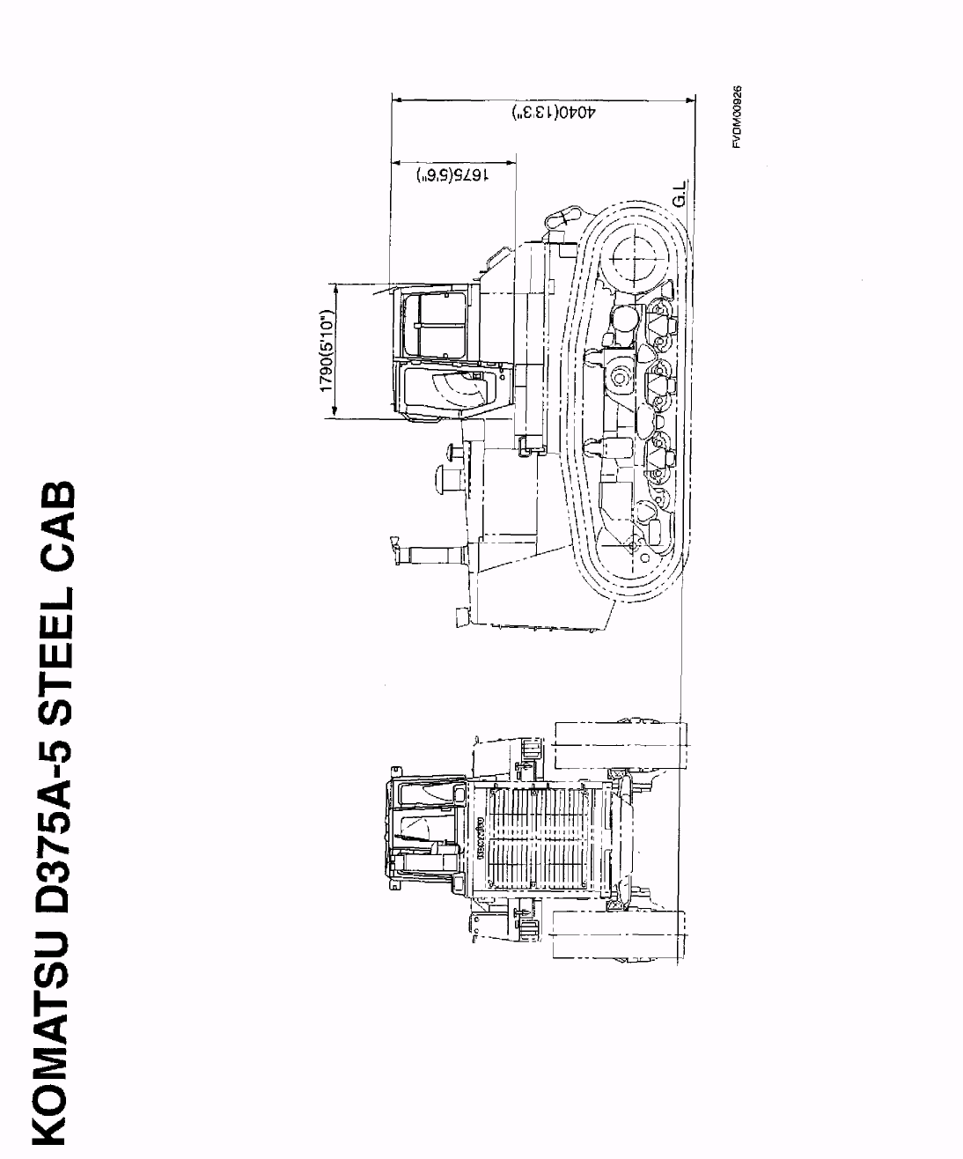

SPEC. NO. X21SP20010007

D375-40m

KOMATSU D375-5 ROPS CANOPY
Specifications
EQUIPMENT WEIGH:
(Additional weight to tractor) .....760 kg (1,680 lb)

DIMENSION:
Overall height 4230 mm (13'11")
Ground pressure
(Additional pressure to tractor) . 1.0 kPa (0.01 kgf/cra²/0.14 PSI)

ROPS CANOPY:
Type 2-column ROPS canopy
Weight 760 kg (1,680 lb)
Length 1405 mm ( 4’ 7")
Width 2035 mm ( 6’ 8")
Height (floor mat to roof) 1867 mm ( 6’ 2")
Roof area 2.30 m² (3,565 in²)
Plate thickness 4.5 mm (0.2")
Structure and strength comply with ISO 3417, SAE J1040 (April, 88), SAE J395 ROPS standards and ISO 3449 FOPS standards.

SPEC. NO. X21SP20010008
D375-41m

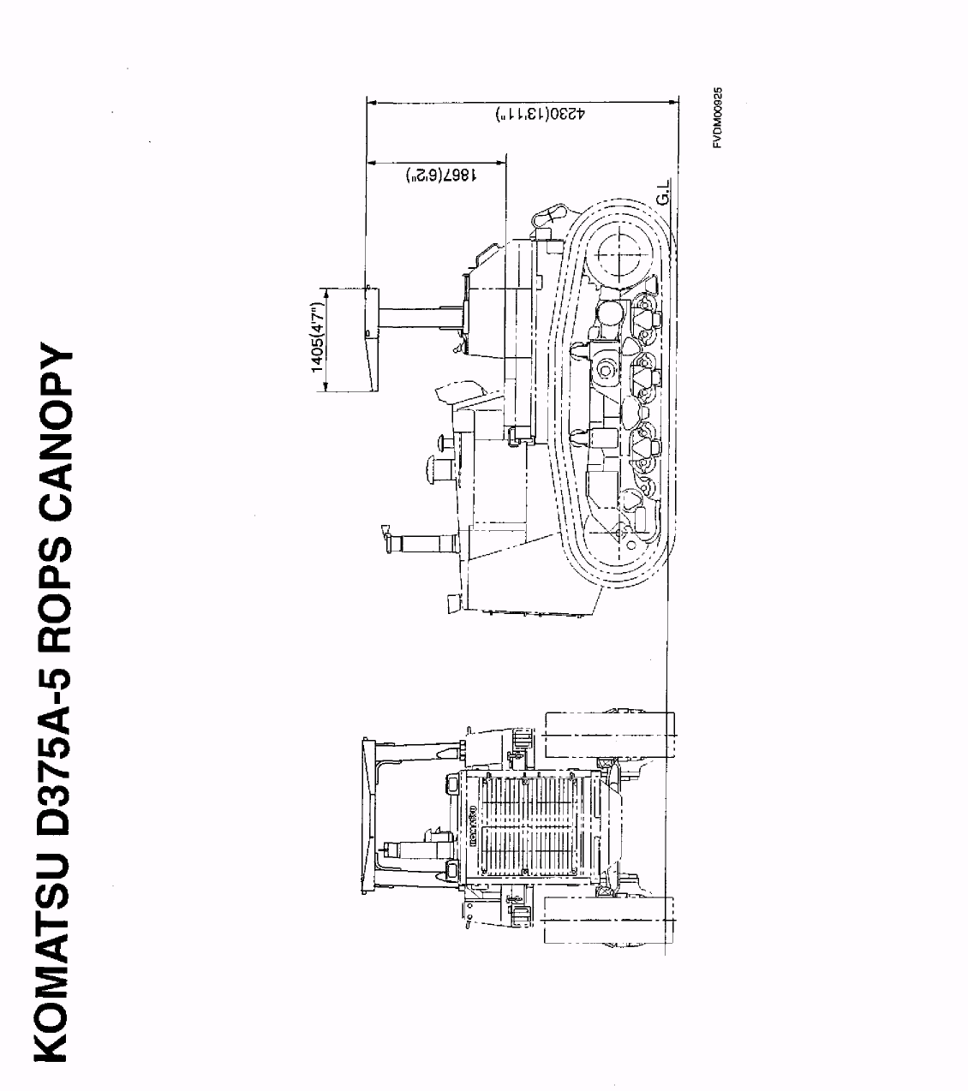

SPEC. NO. X21SP20010008
D375-42m

KOMATSU D375A-5 TRACTOR

ACCESSORY PARTS TABLE

Part No. Part Name Q'ty Remarks
STARTING SWITCH KEY 2
PARTS BOOK 1
OPERATION & MAINTENANCE 1

SPEC. NO. X21SP20010012
D375-7m

KOMATSU D375A-5 TRACTOR

OPTIONAL TOOL TABLE

Part No. Part Name Q’ty Remarks
09000-30006 WRENCH SET Is 8 x 10 12 x 14 13 x 17
19 x 22 24 X 27 30 X 32
09020-10284 SOCKET WRENCH SET Is 10, 13, 14, 17, 19, 22,
24, 27, 30, 32, 36,
09033-00190 SCREWDRIVER 1
09036-00150 PLIERS 1
09339-00150 HAMMER 1
07952-80002 GREASE PUMP 1
07951-11400 NOZZLE 1
07950-90403 CARTRIDGE (GREASE) 1
09055-10390 BAR 1
09002-03641 WRENCH 1 36 x 41
09001-04600 WRENCH 1 46
09019-08035 WRENCH 1
09054-00009 THICKNESS GAUGE 1
09056-05513 TOOL BAG 1
SPEC. NO.X21SP20010012 D375-8m

KOMATSU D375A-5 TRACTOR

OPTIONAL SPARE PARTS TABLE

Part No. Part Name Q'ty Remarks
07063-01142 ELEMENT 3 For transmission, steering
and hydraulic oil filter
07000-15175 0-RING 2 For transmission, and
steering oil filter
07000-15180 O-RING 1 For hydraulic oil filter
07000-13634 O-RING 6 For final drive drain plug
07020-00000 GREASE FITTING 4
6240-11-8810 GASKET 6 For cylinder head cover
6150-11-8820 RUBBER 36 For cylinder head cover
04122-22577 V-BELT 1 For cooling fan drive
6420-81-8720 V-BELT 1 For alternator drive
600-411-1171 CARTRIDGE 1 For corrosion resister
600-311-3110 CARTRIDGE 2 Fuel filter
600-211-1231 CARTRIDGE 2 For engine oil filter
0905Э-00800 SPARE PARTS BOX 1

SPEC. NO. X21SP20010012
D375-9m

