Pipelayers Comparison
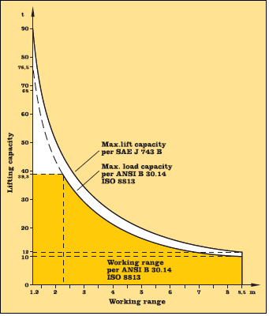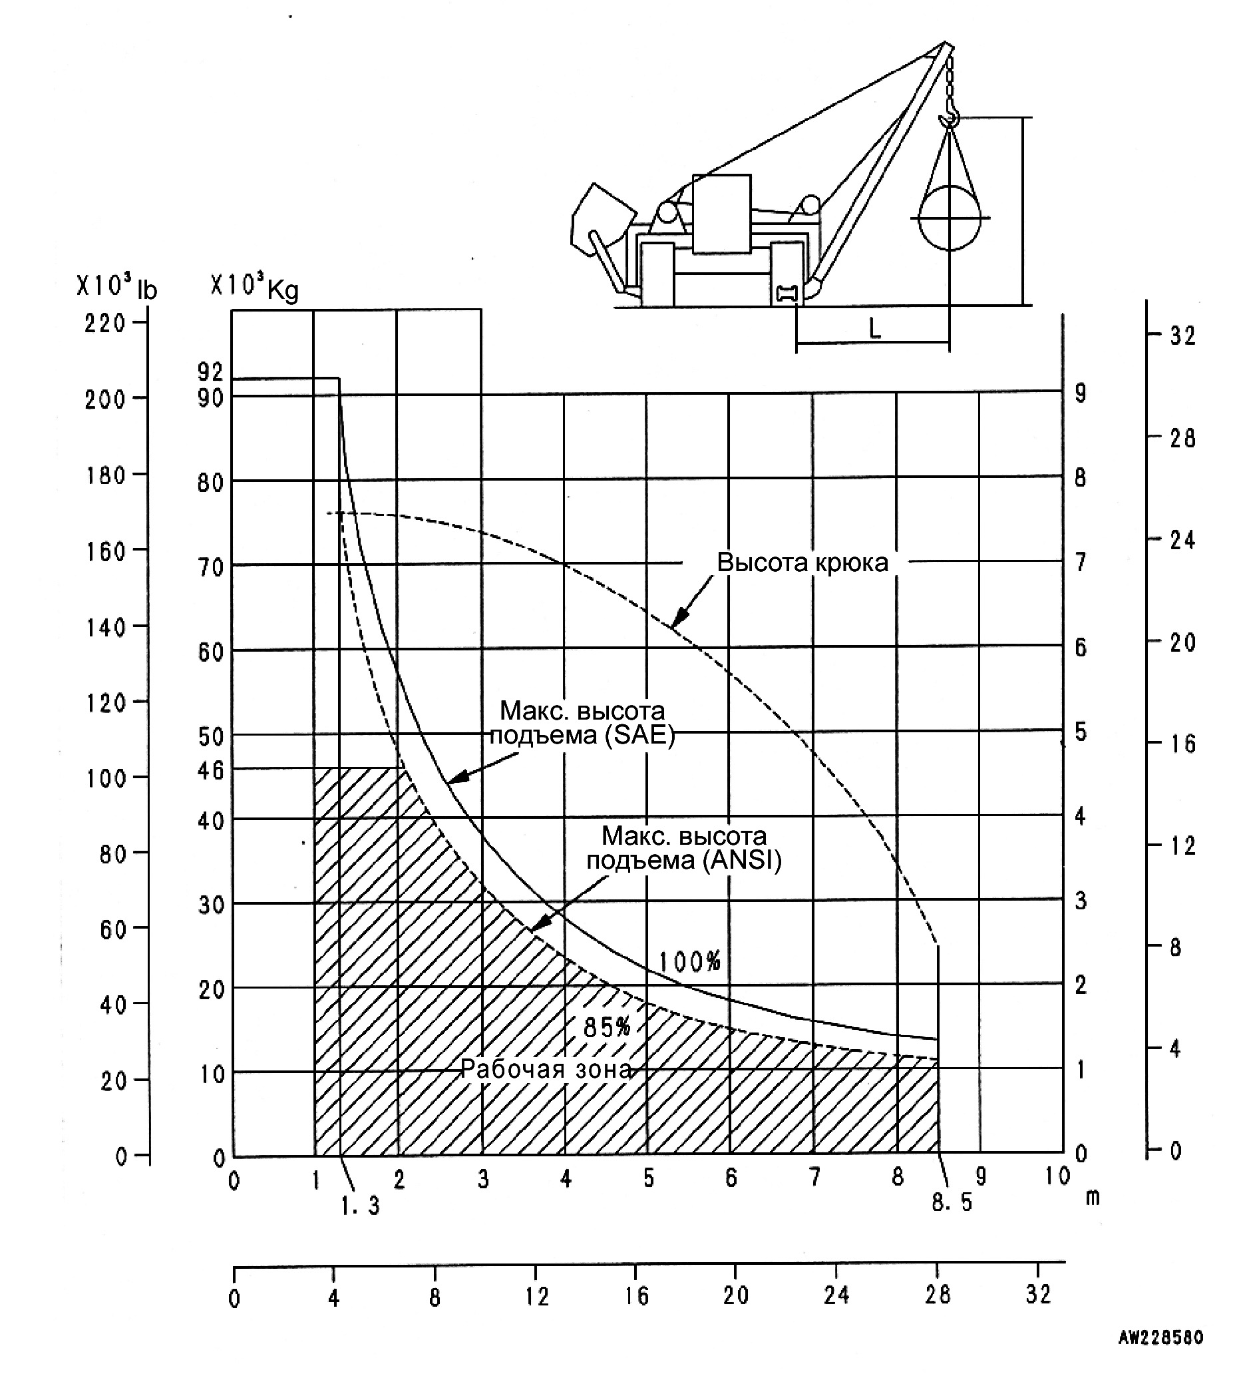

Liebherr RL52HD
Komatsu 355C-3

Dimensions
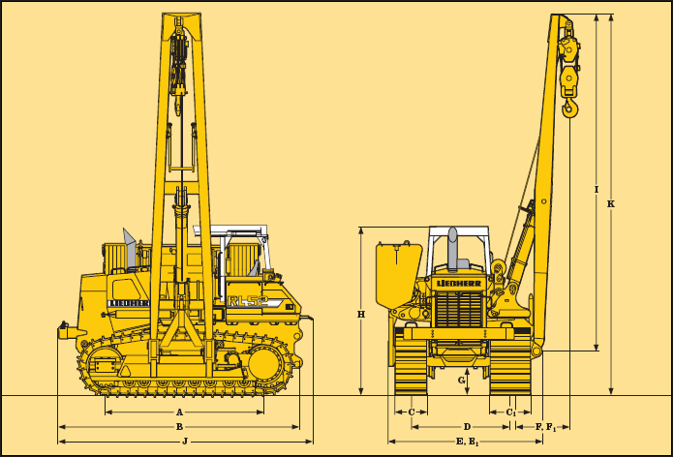
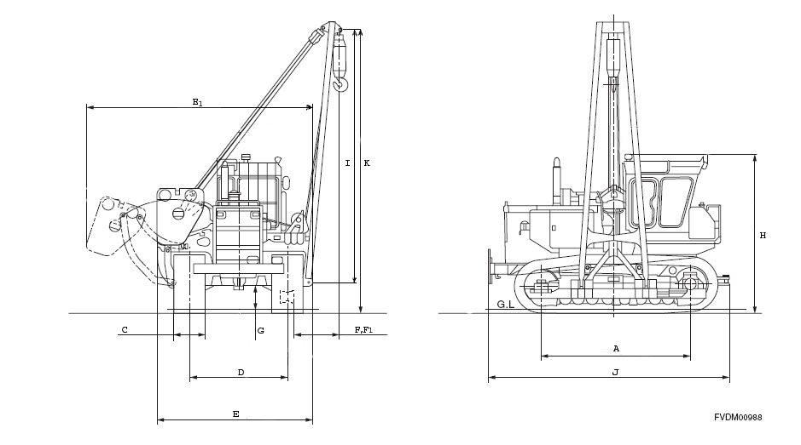

Liebherr Engines Komatsu
A Track on ground | 3605
В Length to rear end of machine | 5544
С/C1 Ground pad width – right/left hand side | 711/914
D Track gauge | 2260
E Transport width | 3755
E1 Width counterweight extended | 5509
F Hook radius, min. | 1200
F1 Hook radius, max. | 8500
G Ground clearance | 625
H Transport height | 3640
I Boom length | 8500
J Total length | 5776
К Total height | 9155
A Track on ground | 3750
В Length to rear end of machine | 5995
С Ground pad width | 860-1100
D Track gauge | 2550
E Transport width | 4250
E1 Width counterweight extended | 6315
F Hook radius, min. | 1300
F1 Hook radius, max. (for 8560 mm boom) | 8500
G Ground clearance | 635
H Transport height | 3955
I Boom length | 8500-9100
J Total length | 5995
К Total height | 9350

Liebherr-Diesel Engine  В 9406 TI-E | 330 HP (243 kW)/1800 RPM
Displacement 13 L /794 cu.in. | 13 L /794 cu.in.
Bore/stroke 135/150 mm | 135/150 mm
Design: 6 cylinder V engine | 6 cylinder V engine
Operation voltage 24 V | 24 V
Alternator | 55 A
Starter | 9 kW

Komatsu  SA6D140 | 360 HP (269 kW)/2000 RPM
Displacement | 15,25 L /930 cu.in.
Bore/stroke | 140/165 mm
Design | 6 cylinder Ln engine
Operation voltage | 24 V
Alternator | 50 A
Starter | 24 V, 22 kW (11 kW x 2)

Undercarriage

Track | Lubricated
Shoes | 48
Shoe type | Single grouser
Track rollers | 2
Carrier rollers | 8
Shoes width left/right, mm. | 711/914
Ground contact area std m2 | 5,86
Ground pressure std, kg/cm2 | 0,96

Track | Lubricated
Shoes | 42
Shoe type | Single grouser
Track rollers | 2
Carrier rollers | 8
Shoes width std/opt, mm. | 860 / 960; 1100
Ground contact area std/opt, m2 | 6,45 / 7,2; 8,25
Ground pressure std, kg/cm2 | 0,91 / 0,81; 0,71

Working equipments

Drum diameter, mm | 305
Drum length, mm | 254
Cable diameter, mm | 20
Cable length, m | 80
Max hook speed up/down, m/min | 16,6 / 16,6
Boom length std, m | 8,5
Counterweight, kg | 15 990

Drum diameter, mm | 290
Drum length, mm | 340
Cable diameter, mm | 20
Cable length, m | 105
Max hook speed up/down, m/min | 12,7 / 10,2
Boom length std, m | 8,56
Counterweight, kg | 12 900

