KOMATSU PC300-7
HYDRAULIC EXCAVATOR

FOR
ATMOSPHERIC TEMPERATURE
FROM - 30C UP TO + 40C
Specifications are subject to change without notice

KOMATSU PC300-7 HYDRAULIC EXCAVATOR
Specifications
OPERATING WEIGHT 30800 kg (57,900 lb)

Including Lubricant, Full fuel tank, Hydraulic oil, Operator and Boom: 6470 mm (21' 3") One-piece, Arm: 3185 mm (10' 5"), Bucket: SAE heaped 1.40 m3 (1.83 cu.yd) Backhoe, Shoe: 600 mm (23’6") Triple

FLYWHEEL HORSEPOWER:
SAE (J1349) 180 kW / 242 HP / 1900 RPM
DIN (6270) 180 kW / 245 PS / 1900 RPM

BUCKET CAPACITY
SAE heaped 1.40m3 (1.83 cu. yd)
CECE heaped 1.20m3 (1.57 cu. yd)

BUCKET WIDTH
Without side cutters 1340 mm (52.8’’)
With side cutters 1445 mm (56.9’’)
BOOM LENGTH 6470 mm (21’3’’)
ARM LENGTH 3185 mm (10’5’’)

DIGGING FORCE (at power max.)
Bucket digging force (SAE) 200 kN (20400 kg/44,970 lb)
Bucket digging force (ISO) 227 kN (23100 kg/50,930 lb)
Arm crowd force (SAE) 165 kN (16800 kg/37,040 lb)
Arm crowd force (ISO) 171 kN (17400 kg/38,360 lb)

ENGINE:
MANUFACTURER KOMATSU
MODEL SAA6D114E
COOLANT SYSTEM WATER COOLED
ASPIRATION TURBOCHARGED AND AFTERCOOLED
No. OF CYLINDERS 6
BORE 114 mm (4.49’’)
STROKE 135 mm (5.31’’)
PISTON DISPLACEMENT 8.27 ltr. (505 cu. in)
PERFORMANCE:
Max. torque 1079 N.m (110 kg.m/796 lb.ft )
Engine RPM at max. torque 1400 rpm
FUEL SYSTEM
FUEL DIESEL GAS OIL, ASTM
SPECIFICATION D975-60T No. 1D
COMBUSTION METHOD DIRECT INJECTION
GOVERNOR TYPE MECHANICAL, ALL-SPEED CONTROL
LUBRICATION SYSTEM:
LUBRICATION METHOD FORCED LUBRICATION
LUBRICATION PUMP Gear PUMP
LUBRICATION FILTER FULL-FLOW
COOLING METHOD WATER COOLED

COOLING METHOD FORCED CIRCULATION BY
CENTRIFUGAL Water PUMP
FAN TYPE SUCTION TYPE
AIR CLEANER TYPE DRY TYPE WITH AUTOMATIC
DUST EVACUATOR
STARTING SYSTEM:
STARTING METHOD BY ELECTRIC MOTOR
STARTING MOTOR 24 V
STARTING MOTOR POWER 11 kW
ALTERNATOR VOLTAGE 24 V
ALTERNATOR AMPERAGE 60 A
BATTERY 2 x 12 V/140 Ah
COOLANT HEATER ATTACHED COMBUSTION(10000 kcal/h)
OIL PAN HEATER COMMON AS ABOVE ONE(15000 kcal/h)
HYDRAULIC SYSTEM:
TYPE HydrauMind SYSTEM
No.OF SELECTABLE MODE 3
MAIN PUMP
TYPE VARIABLE DISPLACEMENT PISTON PUMP
No.OF PUMP 2
MAXIMUMS FLOW(TOTAL) 535 ltr. /min. (141 U.S. gal)/min
RELIEF VALVE SETTINGS
IMPLEMENT CIRCUITS 37.3 MPa (380 kgf/cm2/5,400 PSI)
TRAVEL CIRCUITS 37.3 MPa (380 kgf/cm2/5,400 PSI)
SWING CIRCUITS 27.9 MPa (285 kgf/cm2/4,050 PSI)
PILOT CIRCUITS 3.2 MPa (33 kgf/cm2/ 470 PSI)
CONTROL VALVE:
TYPE 6 SPOOL TYPE x 1
HYDRAULIC MOTOR
TRAVEL AXIAL-PISTON TYPE x 2
SWING AXIAL-PISTON TYPE x 1
No. Of Cylinders Bore x Stroke x Rod dia.
BOOM 2-140 mm x 1480 mm x 100 mm (5.5" x 58.3" x 3.9")
ARM 1-160 mm x 1825 mm x 110 mm (6.3" x 71.9" x 4.3")
BUCKET 1-140 mm x 1285 mm x 100 mm (5.5" x 50.6" x 3.8")
OPERATOR'S CAB:
TYPE ALL WEATHER, ENCLOSED TYPE
WINDOW FOR CABIN SINGLE GLASS
HATER HOT WATER TYPE 5000 kcal/h x 1
IMPLEMENT CONTROLS:
TYPE TWO LEVERS ACTUATED BOOM,
ARM, BUCKET AND SWING

STEERING CONTROL:
TYPE TWO-LEVER WITH PEDAL
DRIVE:
DRIVE METHOD HYDROSTATIC
REDUCTION SYSTEM Planetary gear, double reduction
MAXIMUM DRAWBAR PULL 264 kN (26900 kg / 59,300 Ib)

MAXIMUM TRAVEL SPEED (High) 5.5 km/h (3.4 MPH)
MAXIMUM TRAVEL SPEED (Low) 3.2 km/h (2.0 MPH)
Gradeability 70 % (35 degrees)
BRAKE:
TRAVE
SERVICE BRAKE HYDRAULIC LOCK
PARKING BRAKE MECHANICAL, DISC BRAKE
SWING
SERVICE BRAKE HYDRAULIC LOCK
HOLDING BRAKE MECHANICAL, DISC BRAKE
UNDERCARRIAGE
TYPE CRAWLER-TRACTOR-DESIGN UNDERCARRIAGE
CENTER FRAME X-LEG FRAME
TRAC FRAME BOX-SELECTION
SEAL OF TRACK SEALED TRACK
TRACK ADJUSTER HYDRAULIC TYPE
ROLLER TYPE FLOATING SEAL
TRACK SHOES
TYPE TRIPLE
No. OF SHOES 45 EACH SIDE
No. OF ROLLERS:
CARRIER ROLLERS 2 EACH SIDE
TRACK ROLLERS 7 EACH SIDE
Ground Pressure 62,8 KPa
(0,54 kgf/cm2 / 9,10 PSI)
SWING SYSTEM
DRIVE METHOD HYDROSTATIC
REDUCTION SYSTEM Planetary gear, DOUBLE-REDUCTION
SWING CIRCLE BEARING SINGLE ROW SHEAR TYPE BALL
SWING SPEED 9.5 RPM
SERVICE REFILL CAPACITIES:
FUEL TANK 605 ltr.(160 U.S. gal)
RADIATOR 32,0 ltr. (12.4 U.S. gal)
ENGINE 35,0 ltr. (9.2 U.S. gal)
FINAL DRIVE, EACH SIDE 8,5 ltr. (2.2 U.S. gal)
SWING DRIVE 13,4 ltr. (3.5 U.S. gal)
HYDRAULIC SYSTEM 188 ltr.(49.7 U.S. gal)

KOMATSU PC300-7 HYDRAULIC EXCAVATOR

DIMENSIONS
BOOM 6470 mm (21’3’’)
ARM 3185 mm (10’5’’)

А: OVERALL LENGTH | 11140 mm (36’7’’)
В: LENGTH ON GRUOND | 5755 mm (18’11’’)
С: OVERALL HEIGHT (TO TOP OF BOOM) | 3280 mm (10’9’’)
D: OVERALL WIDTH | 3190 mm (10’6’’)
Е: OVERAL HEIGHT (TO TOP OF CAB) | 3130 mm (10’3’’)
F: GROUND CLEARANCE, COUNTERWEIGHT  G: GROUND CLEARANCE (MINIMUM) | 1185 mm (3’11’’)  500 mm (1’8’’)
H: TAIL SWING RADIUS | 3450 mm (11’4’’)
I: TRAC LENGTH ON GROUND | 3700 mm (12’2’’)
J: TRACK LENGTH | 4625 mm (15’2’’)
K: TRACK GAUGE | 2590 mm (8’6’’)
L: WIDTH OF CRAWLER | 3190 mm (10’6’’)
M: SHOE WIDTH | 600 mm (23’6’’)
N: GROUSER HEIGHT | 36 mm (1’4’’)
O: MACHINE CAB HEIGHT | 2580 mm (8’6’’)
P: MACHINE CAB WIDTH  Q: DISTANCE, SWING CENTER TO REAR END | 2995 mm (9’10’’)  3405 mm (11’2’’)
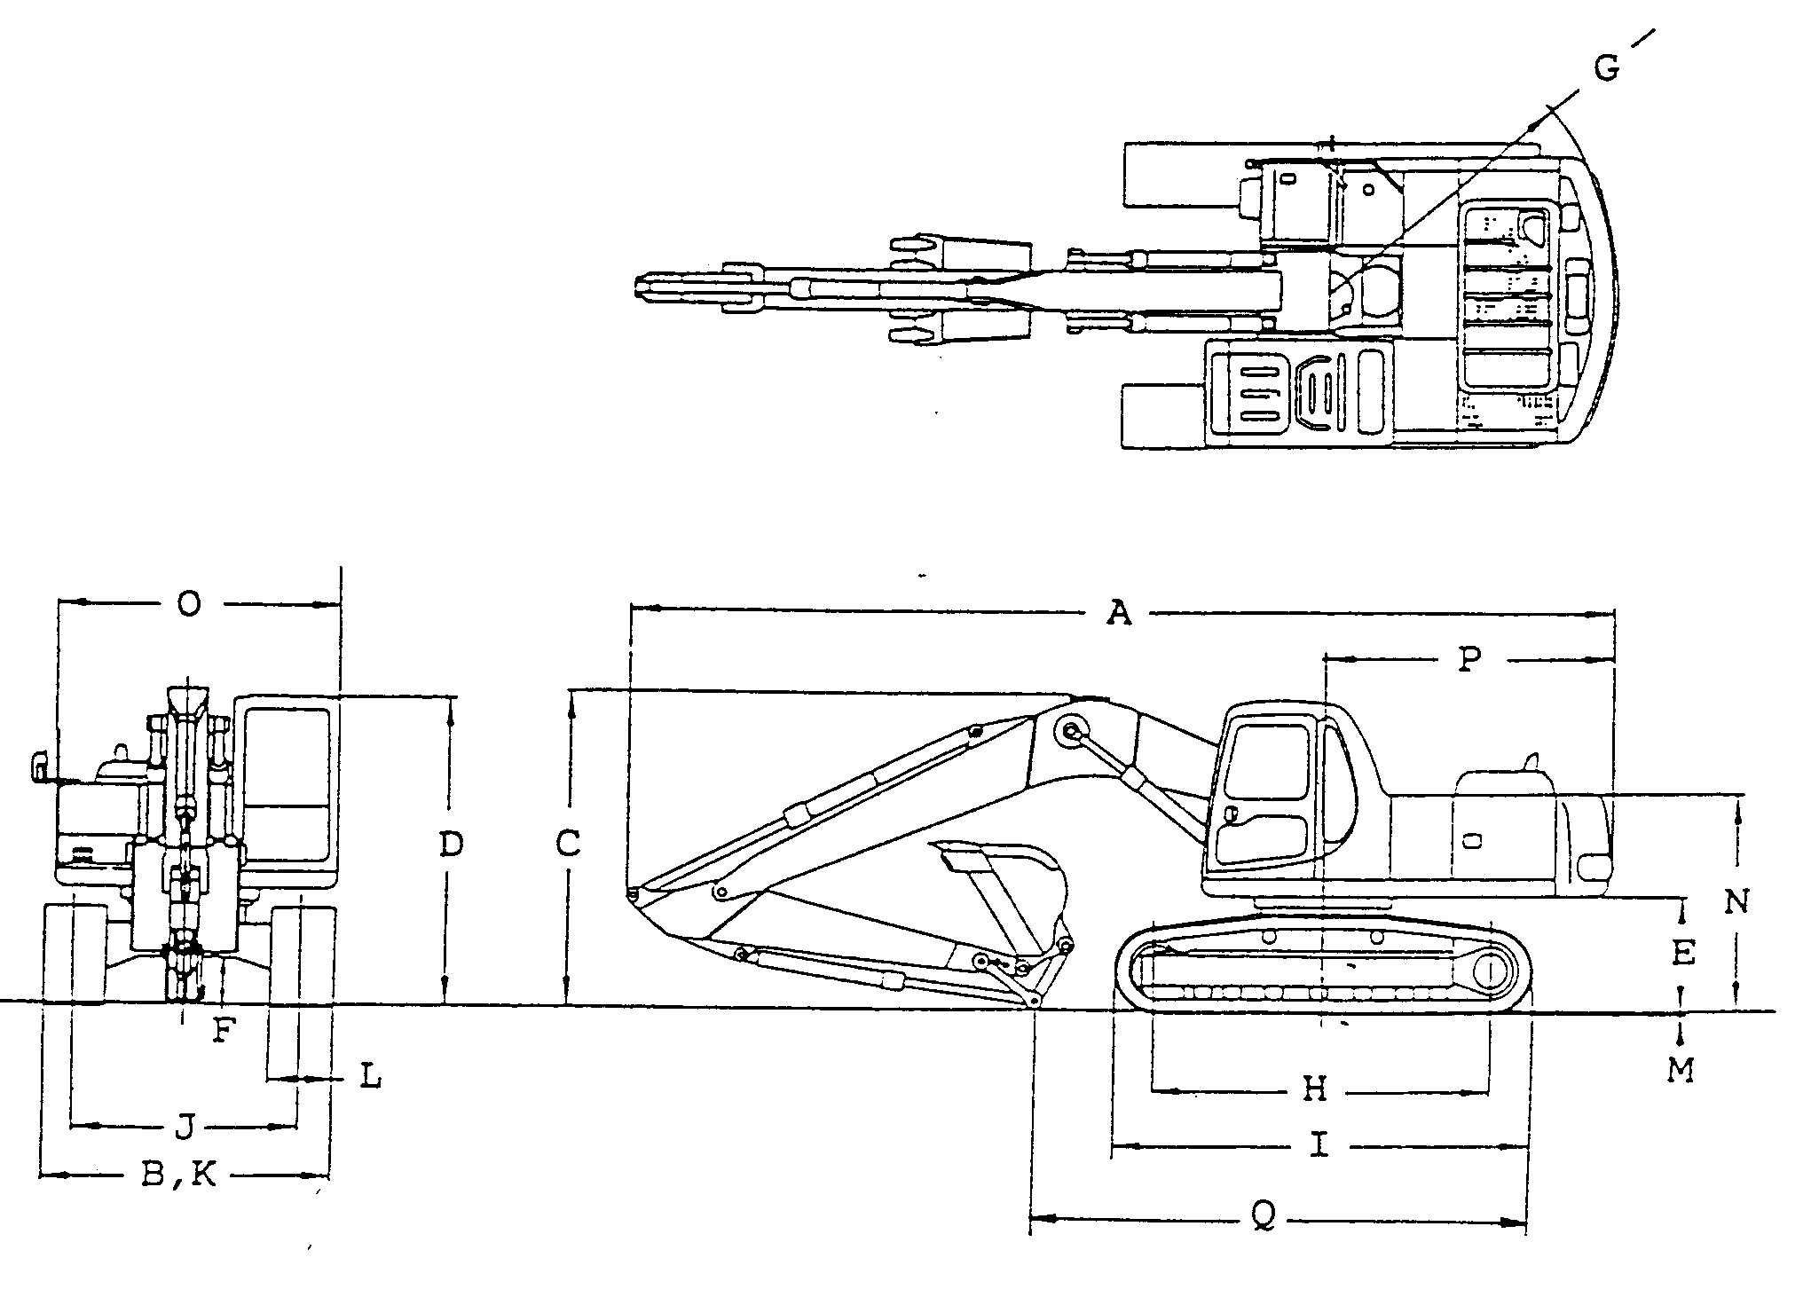
KOMATSU PC300-7 HYDRAULIC EXCAVATOR

WORKING RANGE
BOOM 6470 mm (21’3’’)
ARM 3185 mm (10’5’’)
А: MAX. DIGGING HEIGHT | 10210 mm (33’6’’)
В: MAX. DUMPING HEIGHT | 7110 mm (23'4'')
С: MAX. DIGGING DEPTH | 7380 mm (24'3'')
D: MAX. VERTICAL WALL DIGGING DEPTH | 6480 mm (21’3’’)
Е: MAX. DIGGING DEPTH OF CUT FOR 8' LEVEL | 7180 mm (23’7’’)
F: MAX. DIGGING REACH | 11100 mm (36’5’’)
G: MAX. DIGGING REACH ON GROUND LEVEL | 10920 mm (35’10’’)
Н: MIN. SWING RADIUS | 4310 mm (14’2’’)

KOMATSU PC300-7 HYDRAULIC EXCAVATOR

ACCESSORY PARTS TABLE
2
1

1

PART No.
PART NAME
STARTING SWITCH KEY
PERATION & MAINTANANCE MANUAL
PARTS BOOK
Q-TY
REMARKS

KOMATSU PC300-7 HYDRAULIC EXCAVATOR

OPTIONAL TOOL TABLE
TOOL BAG
WRENCH
WRENCH
WRENCH
DRIVER
HAMMER
BAR PINCH
PUMP
CARTRIGE
WRENCH
WRENCH
TOOL KIT
WRENCH
0'tv
1
1
1
1
1
1
1
1
1
1
1
1
1

Part No.
09056-04613
09019-08035
09002-01317
09002-01922
09033-00190
09039-00150
09055-10390
07952-70004 07950-90403 09002-00836 09002-03641
207-98-61130
09007-00425
Remarks
Name

KOMATSU PC300-7 HYDRAULIC EXCAVATOR

OPTIONAL SPARE PARTS TABLE

Part No.
For hydraulic tank breather
1307687H1
6741-11-8120
6732-11-8210
6742-01-4540
600-311-8321
6732-81-3330
07002-22434
07005-02216
207-60-71180
07000-15195
07002-01223
07002-12434
07020-00000
07020-00675
20Y-60-21470
207-98-71210
Part Name Q-ty
GASKET 1
O-RING 1
PACKING 4
CARTRIDGE (OIL) 1
CARTRIDGE (FUEL) 1
BELT 1
BELT 1
O-RING 1
ELEMENT 1
0-RING 1
0-RING 1
0-RING 6
GREESE-FITTING 4
GREESE-FITTING 4
ELEMENT 1
TABLE, SPARE PARTS 1
Remarks
For engine rocker cover
For engine heal cover
For engine head cover
For engine oil filter
For engine fuel filter
For cooling fan
For cooling fan
For engine oil drain plug
For hydraulic filter
For hydraulic filter
For P.T.O. level plug
For drain plug

