KOMATSU PC400-6 EXCEL HYDRAULIC EXCAVATOR

Arm 3380 mm
Boom 7060 mm
Bucket: SAE heaped 1.80 m3 (2.35 cu.yd) Backhoe
Shoe: 600 mm(24”) Triple

Air conditioner
Sandy area arrangement

For –20C - + 40C operation

KOMATSU PC400-6 EXCEL HYDRAULIC EXCAVATOR
(BACKHOE)
Specifications
OPERATING WEIGHT 41400 kg ( 91,270 Ib)
Including lubricant, full fuel tank, hydraulic oil, operator and Boom : 7060 mm (23' 2") One-piece
Arm : 3380 mm (11' 1")
Bucket : SAE heaped 1.80 m³ ( 2.35 cu.yd) Backhoe
Shoe : 600 mm (24") Triple
FLYWHEEL HORSEPOWER
SAE J1349 228 kW (306 HP) /1950 RPM
DIN 6270 228 kW (310 PS) /1950 RPM
BUCKET CAPACITY
SAE heaped 1.80 m³ ( 2.35 cu. yd)
CECE heaped 1.60 m³ ( 2.09 cu.yd)
BUCKET WIDTH
Without side cutters 1425 mm (56.1")
With side cutters 1575 mm (62.0")
BOOM LENGTH 7060 mm (23'2")
ARM LENGTH 3380 mm (11'1")
DIGGING FORCE
Bucket digging force 225 kN (22900 kg/50,490 Ib)
Arm crowd force 192 kN (19600 kg/43,210 Ib)
ENGINE
Manufacturer Komatsu
Model SA6D125E-2
Cooling system Water cooled
Aspiration Turbocharged and aftercooled
No. of cylinders 6
Bore 125 mm ( 4.92")
Stroke 150 mm ( 5.91")
Piston displacement 11.04 Itr. ( 674 cu.in)
Performance:
Max. torque 1213 N.m (123.7 kg.m/895 Ib.ft)
Engine RPM at max. torque 1400 rpm
Fuel system:
Fuel Diesel gas oil, ASTM
Specification D975-60T No. 2D
Combustion method Direct injection
Governor type Mechanical, all-speed control
Lubrication system:
Lubrication method Forced lubrication
Lubrication pump Gear pump
Lubrication filter Full-flow

SPEC. NO. X21SP970008
PC400 EXCEL-Ih

Cooling method Water cooled
Cooling method Forced circulation by
centrifugal water pump
Fan type Suction type
Air cleaner type Dry type with automatic
dust evacuator Starting system:
Starting method By electric motor
Starting motor voltage 24 V
Starting capacity 7.5 kW
Alternator voltage 24 V
Alternator amperage 33 A
Battery 2 x 12 V/ 150 Ah
HYDRAULIC SYSTEM:
Type HydrauMind system
Main pump
Type Variable capacity piston pump
No. оf pump 2
Maximum flow 616 Itr. /min.
(162.7 U.S.gal/ min.) Relief valve settings
Implement circuits 34.8 MPa (355 kg/cm²/5, 050 PSI)
Travel circuits 34.8 MPa (355 kg/cm²/5, 050 PSI)
Swing circuits 27.9 MPa (285 kg/cm²/4, 050 PSI)
Pilot circuits 2.9 MPa ( 30 kg/cm²/ 430 PSI)
Control valve
Type 6 + 1 spool type x 1
Hydraulic motor
Travel Axial piston type x 2
Swing Axial piston type x 1
No. of cylinders-bore x stroke x rod dia.
Boom 2-160 mm x 1570 mm x 110 mm
( 6.3" x 61.8" x 4.3")
Arm 1-185 mm x 1820 mm x 120 mm
( 7.3" x 71.7" x 4.7")
Bucket 1-160 mm x 1270 mm x 110 mm
( 6.3" x 50.0" x 4.3")
OPERATOR'S CAB:
Type All weather, enclosed type
IMPLEMENT CONTROLS:
Type Two levers actuated boom, arm
bucket and swing
STEERING CONTROLS:
Type Two-lever
DRIVE:
Drive method Hydrostatic
Reduction system Planetary gear,
double-reduction
Max. drawbar pull 330 kN (33700 kg/74, 300 Ib)

SPEC. NO. X21SP970008
PC400 EXCEL-2h

Max. travel speed (High) 5.5 km/h ( 3.4 MPH)
Max. travel speed (Low) 3.2 km/h (2.0 MPH)
Gradeability 70 % ( 35 deg )
BRAKE: Travel
Service brake Hydraulic lock
Parking brake Wet, multiple-disc brake
Swing
Service brake Hydraulic lock
Holding brake Wet, multiple-disc brake
UNDERCARRIAGE:
Type Crawler-tractor-design
undercarriage
Center frame X-leg frame
Track frame Box-section
Seal of track Sealed track
Track adjuster Hydraulic type
Rollers type Floating seal
Track shoes
Type Triple
No. of shoes 46 each side
No. of rollers
Carrier rollers 2 each side
Track rollers 7 each side
Ground pressure 77.5 kPa (0.79 kg/cm² /11.23 PSi;
SWING SYSTEM:
Drive method Hydrostatic
Reduction system Planetary gear,
double-reduction
Swing circle bearing Single row shear type
ball bearing
Swing speed 9.3 RPM
SERVICE REFILL CAPACITIES:
Fuel tank 605.0 Itr. ( 159.8 U.S.gal)
Radiator 47.0 Itr. ( 12 .4 U.S. gal)
Engine 32.0 Itr. ( 8.5 U.S. gal)
Final drive, each side 11.5 Itr. ( 3.0 U.S. gal)
Swing drive 21.5 Itr. ( 5.7 U.S. gal)
Hydraulic system 270.0 Itr. ( 71.3 U.S.gal)

SPEC. NO. X21SP970008
PC400 EXCEL-3h

KOMATSU PC400-6 EXCEL HYDRAULIC EXCAVATOR
(BACKHOE)
DIMENSIONS
7060 mm (23' 2") BOOM
3380 mm (11' 1") ARM
A: Overall length 11835 mm (38'10")
B: Overall width 3430 mm (11'3")
C: Overall height (to top of boom) 3635 mm (11'11")
D: Overall height (to top of cab) 3265 mm (10'9")
E: Ground clearance, counterweight 1320 mm ( 4'4")
F: Min. ground clearance 555 mm ( 1'10")
G: Tail swing radius 3500 mm (II¹6")
H: Length of track on ground 4020 mm (13'2")
I: Track length 5025 mm (16'6")
J: Track gauge 2740 mm ( 9'0")
K: Width of crawler 3340 mm (10'11")
L: Shoe width 600 mm ( 24")
M: Grouser height 37 mm ( 1.5")
N: Machine cab height 2365 mm (7'9")
O: Machine cab width 2995 mm (9'10")
P: Distance, swing center to rear end 3500 mm (11'6")
Q: Length on ground (transport) 6520 mm (21'5")
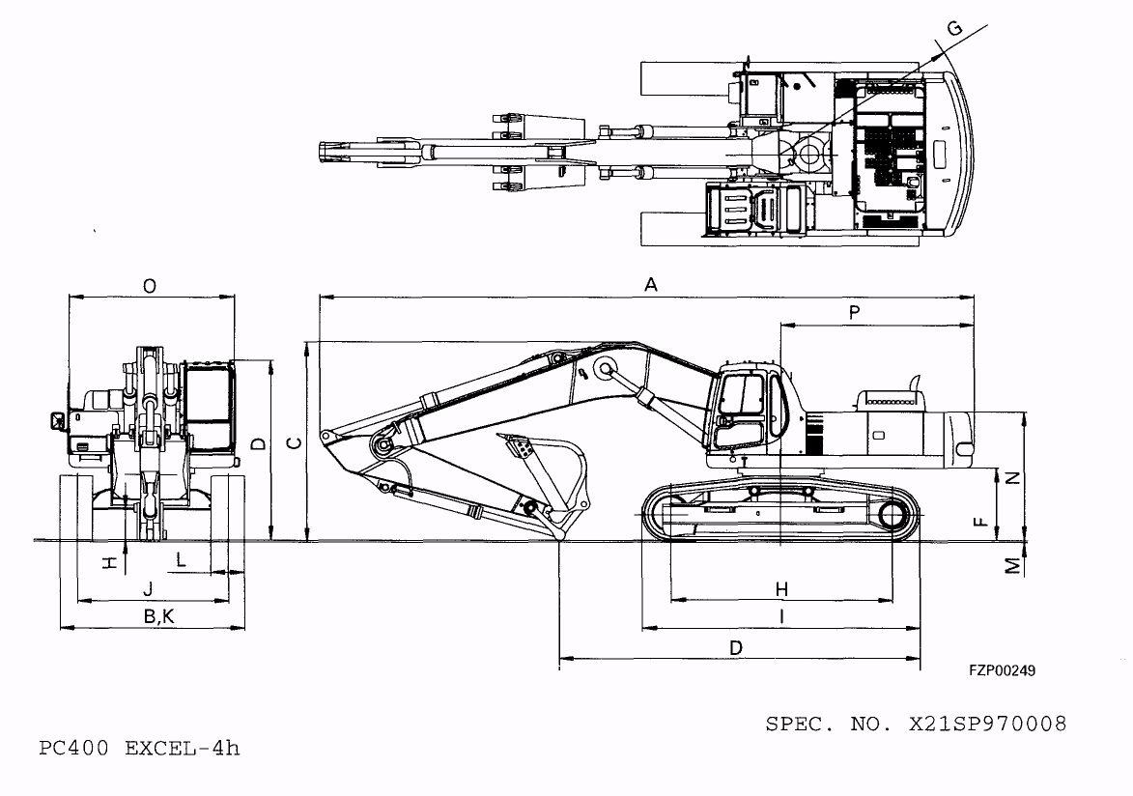

KOMATSU PC400-6 EXCEL HYDRAULIC EXCAVATOR
(BACKHOE)
WORKING RANGE
7060 mm (23' 2 " ) BOOM
3380 mm (11' 1") ARM
A: Max. digging height 10920 mm (35' 4")
A* : Max. digging height 11445 mm (37 ' 7 ")
B: Max. dumping height 7570 mm (24'10")
B* : Max. dumping height 7395 mm.(22' 3")
C: Max. digging depth 7760 mm (25' 6")
C*: Max. digging depth 7945 mm (26 ' 1")
D: Max. vertical wall digging depth 6850 mm (22' 6")
E: Max. digging depth of cut for 8' level 7620 mm (25' 0")
F: Max. digging reach 12020 mm (39' 5")
F*: Max. digging reach 12195 mm (40' 0")
G: Max. digging reach at ground level 11810 mm (38' 9")
G* : Max. digging reach at ground level 11995 mm (39' 4")
H: Min. swing radius 4770 mm (15' 8")
I: Max. height of min. swing radius 9200 mm (30 ' 2" )
Note: * indicates working range when front shovel.
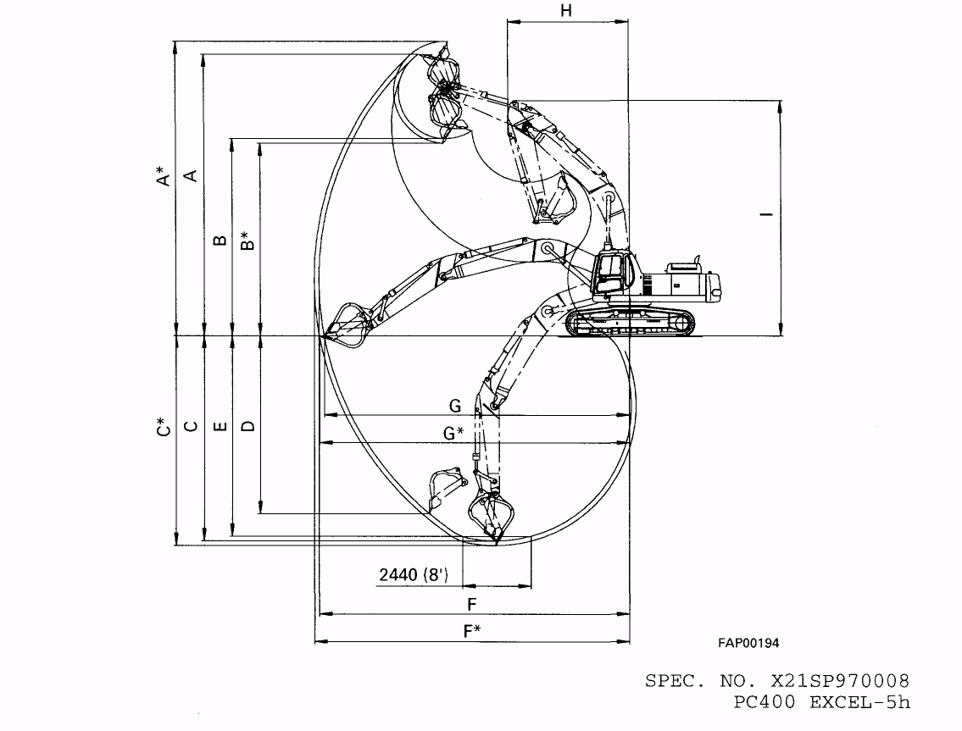

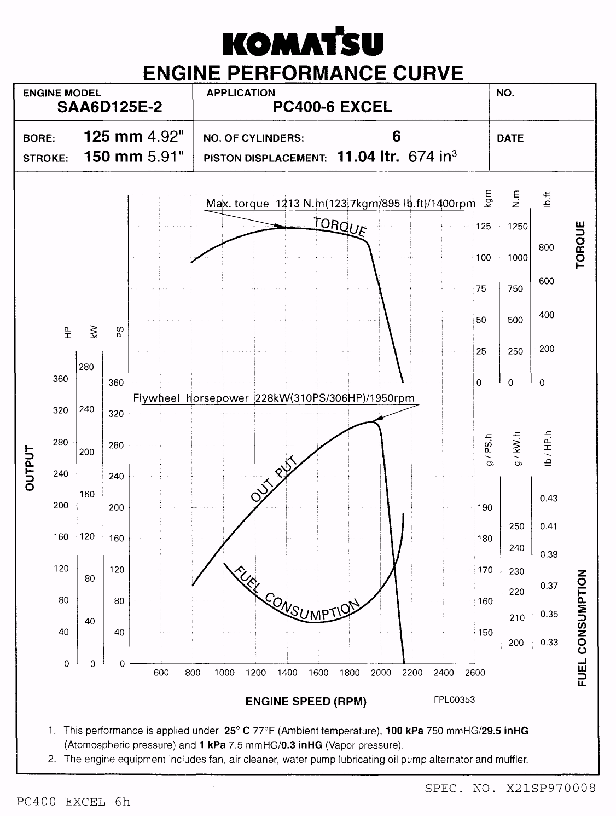

KOMATSU PC400-6 EXCEL HYDRAULIC EXCAVATOR
(BACKHOE)

ACCESSORY PARTS TABLE

Part No. Part Name Q'tv Remarks
STARTING SWITCH KEY 2
PARTS BOOK 1
OPERATION & MAINTENANCE MANUAL 1
SPEC.NO. X21SP970008 PC400 EXCEL-7h

KOMATSU PC400-6 EXCEL HYDRAULIC EXCAVATOR
(BACKHOE)
OPTIONAL TOOL TABLE
Part No. Part Name Q'tv Remarks
09056-05513 TOOL BAG 1
09019-08035 WRENCH 1 For filter
207-98-61130 SOCKET WRENCH 1
09033-00190 SCREWDRIVER 1
09039-00150 HAMMER 1
09055-10390 BAR 1
07950-10450 GREASE PUMP 1
07951-31400 NOZZLE 1
07950-90403 CARTRIDGE(GREASE) 1
09002-03641 WRENCH 1
09002-01317 WRENCH 1
09002-01922 WRENCH 1
09007-00836 WRENCH 1
SPEC. NO. X21SP970008 PC400 EXCEL-8h

KOMATSU PC400-6 EXCEL HYDRAULIC EXCAVATOR
(BACKHOE)
OPTIONAL SPARE PARTS TABLE
Part No. Part Name Q'tv Remarks
6150-11-7812 GASKET 6 For engine rocker cover
6150-11-8810 GASKET 6 For engine heal cover
6150-11-8820 RUBBER 24 For engine head cover
600-211-1230 CARTRIDGE 1 For engine oil filter
600-311-8292 CARTRIDGE 1 For fuel filter
04121-22262 BELT 1 For cooling fan
07002-22434 0-RING 1 For engine oil drain plug
208-60-61180 ELEMENT 1 For hydraulic filter
07000-05210 0-RING 1 For hydraulic filter
07002-01223 0-RING 1 For P.Т.О. drain plug
07002-02434 0-RING 4
07020-00000 FITTING 4
07020-00675 FITTING 4
07020-00900 FITTING 1
20Y-60-21470 ELEMENT 1 For hydraulic tank
20Y-60-21470 208-98-61110 SPARE PARTS TABLE 1
SPEC. NO. X21SP970008 PC400 EXCEL-9h

KOMATSU PC400-6 EXCEL HYDRAULIC EXCAVATOR
(BACKHOE)

LIFTING CAPACITY
.7060 mm (23'2") Boom
.1.80m³ (2.35 cu.yd) SAE heaped bucket
.600 mm (24") width triple grouser shoe
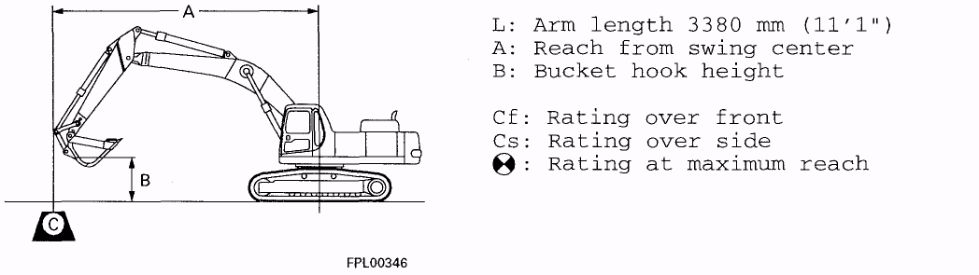
unit: kg Ib

*: Load is limited by hydraulic capacity rather than tipping. Ratings are based on SAE Standard No. J1097. Rated loads do notexceed 87 % of hydraulic capacity or 75 % of tipping load.
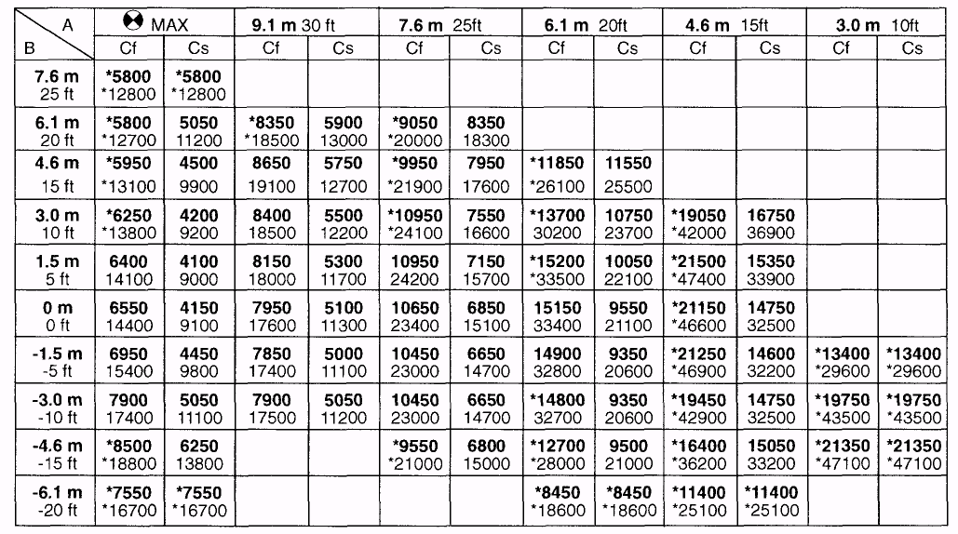
Specifications are subject to change without notice.

SPEC. NO. X21SP970008 PC400 EXCEL-lOh

