“Gayskiy GOK”

KOMATSU PC750SE-7
HYDRAULIC EXCAVATOR

4,0 m³ (SAE) BUCKET,
BOOM LENGTH 7100 mm.
ARM LENGTH 2945 mm,
STEEL CAB,
AIR CONDITIONER,
610mm SHOES.

FOR
ATMOSPHEROC TEMPERATURE FROM -30 C UP TO +40 C


KOMATSU PC700SE-7 HYDRAULIC EXCAVATOR
Specifications
OPERATING WEIGHT | 73 170 kg
Including lubricant, full fuel tank, hydraulic oil, operator and
Boom: 7 100 mm
Arm: 2 945 mm
Bucket: 4.0 m³ (SAE), Backhoe
Shoe: 610 mm, Double grouser.
FLYWHEEL HORSEPOWER:
SAE (J1349) | 338 kW(454 H.P.) / 1800 RPM
DIN (6270) | 338 kW (460 PS) / 1800 RPM
BUCKET CAPACITY
SAE | 4.0 m³
СЕСЕ | 3.5 m³
BUCKET WDTH:
Without side cutters | 2 000 mm
With side cutters | 2 100 mm
BOOM LENGTH | 7 100 mm
ARM LENGTH | 2 945 mm
DIGGING FORCE (at power max.)
Bucket diggiing force (SAE) | 391 кН (39 900 kg)
Bucket digging force (ISO) | 431 кН (43 900 kg)
Arm crowd force (SAE) | 331 кН (33 800 kg)
Arm crowd force (ISO) | 341 кН (34 800 kg)
ENGINE:
MANUFACTURED | KOMATSU
MODEL | SAА6D140Е-3
COOLANT SYSTEM | WATER COOLED
ASPIRATION | TURBOCHARGED AND AFTERCOOLED
No. OF CYLINDERS | 6
BORE | 140 mm
STROKE | 165 mm
PISTON DISPLACEMENT | 15.24 ltr
PERFORMANCE:
Max. torque | 2 108 N.m (215kg.m)
Engine RPM at max. torque | 1 350 rpm
FUEL SYSTEM:
FUEL | DIESEL GAS OIL, ASTM SPECIFICATION D975-60T No. 2D
COMBUSTION METHOD | DIRECT INJECTION
GOVERNOR | ELECTRONIC, ALL SPEED CONTROL
LUBRICATION SYSTEM:
LUBRICATION METHOD | FORCED LUBRICATION
LUBRICATION PUMP | GEAR PUMP
LUBRICATION FILTER | FULL-FLOW
COOLING METHOD | WATER COOLED
COOLING METHOD | FORCED CIRCULATION BY CENTRIFUGAL WATER PUMP
FUN TYPE | SUCTION TYPE
AIR CLEANER TYPE: | DRY TYPE WITH AUTOMATIC DUST EVACUATOR
STARTING SYSTEM:
STARTING METHOD | BY ELECTRIC MOTOR
STARTING MOTOR | 24 V
STARTING MOTOR POWER | 11 Kw
ALTERNATOR VOLTAGE 24V
ALTERNATOR AMPERAGE 75A
BATTERY | 12 V Х 2 – 200 А/h
HYDRAULIC SYSTEM:
TYPE | OLSS (OPEN-CENTER LOAD SENSING SYSTEM)
No. OF SELECTABLE MODE | 2
MAIN PUMP:
TYPE | VARIABLE DISPLACEMENT PISTON
No. OF PUMP | 2
MAXIMUMS FLOW ( TOTAL) | 988 ltr/min (261 U.S. gal/min)
SUB PUMP
TYPE | GEAR PUMP
RELIEF VALVA SETTINGS:
SWING | 290 kg/сm²
IMPLEMENT CIRCUITS | 320 kg/сm²
TRAVEL CIRCUITS | 350 kg/сm²
WHEN HEAVY LIFT | 350 kg/сm²
PILOT CIRCUITS | 30 kg/сm²
CONTROL VALVE:
TYPE | 4- SPOOL TYPE X 1  5-SPOOL TYPE X 1
HYDRAULIC MOTOR:
TRAVEL | PISTON TYPE X 2
SWING | PISTON TYPE X 2
No. OF CYLINDERS, BORE X STROKE X ROD DIA:
BOOM | 2-200 mm Х 1950 mm Х 140 mm
ARM | 2-185 mm Х 1610 mm Х 120 mm
BUCKET | 1-225 mm Х 1420 mm Х 160 mm
OPERATORS'S CAB:
TYPE | ALL WEATHER, ENCLOSED TYPE
IMPLEMENT CONTROLS:
TYPE | TWO LEVERS ACTUATED BOOM, ARM, BUCKET AND SWING
STEERING CONTROL:
TYPE | TWO-LEVER WITH PEDAL
DRIVE:
DRIVE METHOD | HYDROSTATIC
REDUCTION SYSTEM | 3-STAGE PLANETARY GEAR
MAXIMIM DRAWBAR PULL | 559 kN (57 000 kgf)
MAXIMIN TRAVEL SPWWD ( HIGH) | 4.2 km/h
MAXIMIN TRAVEL SPEED (LOW) | 2.8 km/h
GREADEBILITY | 70% (35º)
BRAKE:
TRAVEL:
SERVICE BRAKE | HYDRAULIC LOCK
PARKING BRAKE | WET, MULTIPLE-DISC BRAKE
SWING:
SERVICE BRAKE | HYDRAULIC LOCK
HOLDING BRAKE | WET, MULTIPLE-DISC BRAKE
UNDERCARRIAGE:
TYPE | CRAWLER-TRACTOR-DESIGN UNDERCARRIAGE
CENTRAL FRAME | H-LEG FRAME
TRACK FRAME | BOX-SECTION
SEAL OF TRACK | SEALED TRACK
TRACK ADJUSTER | HYDRAULIC TYPE
ROLLER TYPE | FLOATING SEAL
TRACK SHOES:
TYPE | DOUBLE GROUSER
No. OF SHOES | 47 EACH SIDE
No. OF ROLLERS:
CARRIER ROLLERS | 3 EACH SIDE
TRACK ROLLERS | 8 EACH SIDE
GROUND PRESSURE | 1.22 kg/сm²
SWING SYSTEM
DRIVE METHOD | HYDROSTATIC
REDUCTION SYSTEM | PLANETARY GEAR
SWING CIRCLE BEARING | SINGLE ROW SHEAR TYPE BALL BEARING
SWING SPEED | 6.8 RPM
SERVICE REFILL CAPACITIES:
FUEL TANK | 880 ltr
REDIATOR | 85 ltr
ENGINE | 55 ltr
FINAL DRIVE, EACH SIDE | 20 ltr
SWING DRIVE | 24.5 ltr
HYDRAULIC SYSTEM | 440 ltr

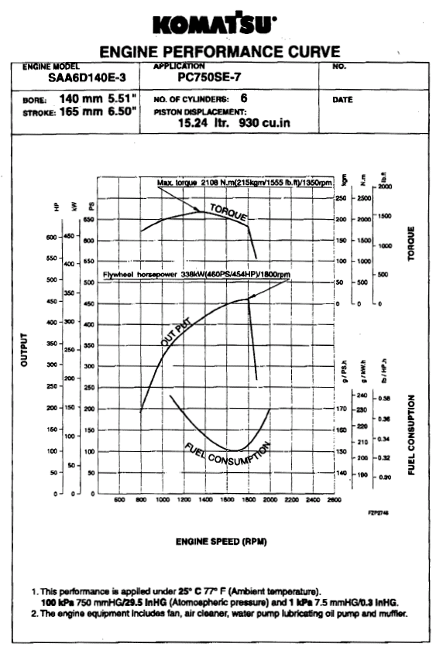

KOMATSU PС750SE-7 HYDRAIULIC EXCAVATOR

WORKING RANGE

BOOM 7 100 mm
ARM 2 945 mm

А: MAX. DIGGING HEIGHT | 11 330 mm
В: MAX DUMPING HEIGHT | 7 525 mm
С: MAX. DIGGING DEPTH | 7 130 mm
D: МАX. VERTICAL WALL DIGGING DEPTH | 4 080 mm
Е: MAX. DIGGING DEPTH OF CUT FOR 8' LEVEL | 6 980 mm
F: MAX. DIGGING REACH | 12 265 mm
G: MAX. DIGGING REACH ON GROUND LEVEL | 11 945 mm
Н: MIN. SWING RADIUS | 5 645 mm
I: MAX.HEIGHT OF MIN. SWING | 9 570 mm
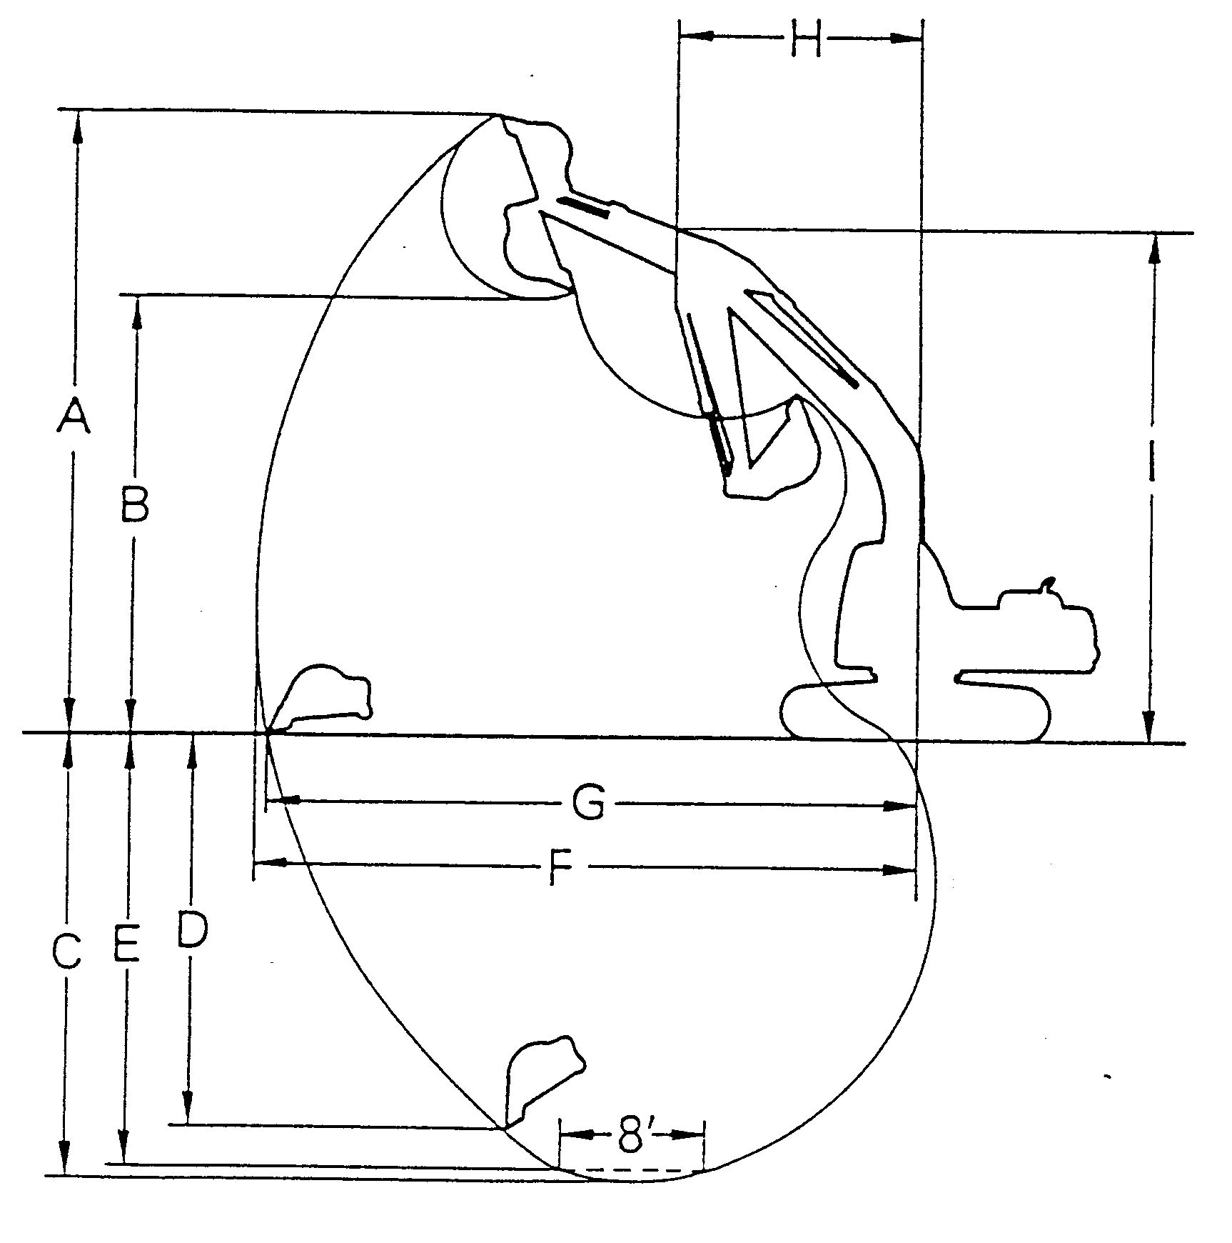
KOMATSU PС750SE-7 HYDRAILIC EXCAVATOR

DIMANSIONS

BOOM 7 100 mm
ARM 2 945 mm
А: OVERALL LENGTH | 13 030 mm
B: OVERALL WIDTH | 4 110 mm
С: OVERALL HEIGHT (TO TOP OF BOOM) | 4 615 mm
D: OVERALL HEIGHT (TO TOP OF CAB) | 3 560 mm
E: GRAUND CLEARANCE COUNTERWEIGHT | 1 560 mm
F: GROUND CLEARANCE (MINIMUM) | 840 mm
G:TALL SWING RADIUS | 4 245 mm
Н: TRACK LENGTH ON GROUND | 4 500 mm
I: TRACK LENGTH | 5 810 mm
J: TRACK GAUGE | 3 500 mm
К: WIDTH OF CRAWLER | 4 110 mm
WITH OF CRAWLER (WHEN RETRACTED) | 3 390 mm
L: SHOE WIDTH | 610 mm
М: GROUSER HEIGHT | 50 mm
N: MACHINE CAB HEIGHT | 3 445 mm
0: MACHINE CAB WIDTH | 4 000 mm
P: DISTANCE, SWING CENTER TO REAR END | 4 245 mm
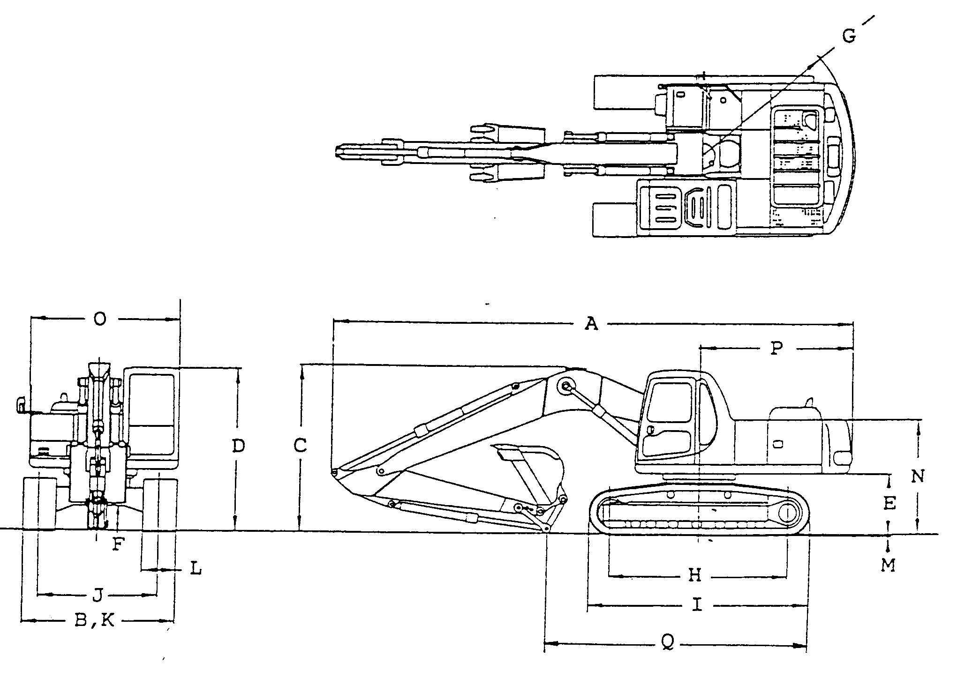
KOMATSU PС750SE-7 HYDRAIULIC EXCAVATOR
РАБОЧИЕ ХАРАКТЕРИСТИКИ ДВИГАТЕЛЯ
КОЛ-ВО ЦИЛИНДРОВ
РАБОЧИЙ ОБЪЕМ
ДИАМ.
ХОД

ACCESSORY PARTS TABLE

PART No. | PART NAME | Q-TY | REMARKS
 | STARTING SWITCH KEY | 2
 | OPERATION & MAINTANANCE MANUAL | 1
 | PARTS BOOK | 1
KOMATSU PС750SE-7 HYDRAIULIC EXCAVATOR

OPTIONAL TOOL TABLE

PART No. | PART NAME | Q-TY | REMARKS
07950-90403 | CARTRIDGE | 1
07952-70004 | GREASE PUMP | 1
09002-01922 | WRENCH | 1
09002-00836 | WRENCH | 1
09007-01040 | WRENCH | 1
21T-98-64120 | WRENCH | 1
209-98-77310 | TOOL KIT | 1
09033-00190 | DRIVER | 1
09039-00150 | HAMMER | 1
09055-10390 | BAR PINCH | 1
09056-04613 | TOOL BAG | 1
07286-01690 | HOSE | 2
KOMATSU PС750SE-7 HYDRAIULIC EXCAVATOR

OPTIONAL SPARE PARTS TABLE

PART No. | PART NAME | Q-TY | REMARKS
600-211-1340 | CARTRIDGE | 1
600-319-3310 | CARTRIDGE | 1
600-411-1171 | CARTRIDGE | 1
600-185-6100 | ELEMENT ASS | 1
600-736-9730 | V-BELT | 1
6210-81-6960 | V-BELT | 1
209-60-77530 | ELEMENT | 2
07000-15180 | O-RING | 2 | FOR HYDRAULIC OIL RETURN FILTER
209-60-76210 | FILTER CARTRIDGE | 1
07002-13034 | O-RING | 4
07002-22343 | O-RING | 1
424-16-11140 | OIL FILTER ELEM ASS | 1
424-16-11130 | O-RING | 1
419-15-14870 | GASKET | 1
419-15-14860 | O-RING | 1
07002-11223 | O-RING | 1
209-98-77250 | TABLE SPARE PARTS | 1
209-98-77260 | ACCESORY TABLE | 1

KOMATSU PС750SE-7 HYDRAIULIC EXCAVATOR

OPTIONAL LIST

DESCRIPTION

BATTERIES – LARGE
ALTERNATOR – 75 A
BOOM -7 100 mm
ARM- 2 945 mm
BUCKET 4 cub.m. WITH TEETH ROCK PENETRATOR (RP3)
COLD ARRANGE (-30C)
COOLANT HEATER ELECTRIC TYPE (230V, 1 500W)
ENGINE OIL PAN HEATER ELECTRIC TYPE (230V, 600W)
COMBUSTION TYPE COOLANT HEATER
(INSTALL TYPE, HOT WATER 3 500 KCAL/H, HOT AIR 4 000 KCAL/H)
SANDY AREA ARRANGE
POOR FUEL, WATER+DUST
FLUSH LIGHT
TRAVEL ALARM
INTERCONNECTED HORN
REAR VIEW MIRROR, LH
LIGHT, AMBER BEACON
FOPS
CAB FRONT FULL GUARD
SEAT BELT 78 mm
AUTO AIR CONDITIONER LARGE CAPACITY :
COOLING 4 300 KCAL/H & HETER 5 000 KCAL/H.
RADIO AM/FM
12V E/SUPPLY
SUN VISOR
WINDOW WIPER, FRONT
CATWALK
COUNTERWEIGHT
TRACK FRAME UNDERCOVER
DOUBLE FLANGE T. ROLLER
FIRE EXTINGIUSER
CAP & OVERAL
GENERAL TOOL KIT
SPARE PARTS -GENERAL
RUSSIAN PLATE

