KOMATSU
BULLDOZER
D275A-5

WITH

SEMI-U TILT DOZER
GIANT RIPPER
ROPS CANOPY & STEEL CAB
HEATER & DEFROSTER

FOR -50^{О}С ~ +40^{О}С OPERATION


KOMATSU D275A-5 TRACTOR

Specification

Operating weight | 37,680 кг
Flywheel horsepower SAE J1349  DIN (6270) | 306 kW (410 HP)/ 2000 rpm  306 kW (416 PS)/ 2000 rpm
PERFOMANCE:

Travel speed and drawbar pull:  Forward 1st  2nd  3rd  Revers 1st  2nd  3rd | 3.8 km/h  6.7 km/h  11.2 km/h  4.9 km/h  8.7 km/h  14.9 km/h
Turning radius | 3.9 m
DIMENSIONS:

Overall length | 5,255 mm
Overall width | 2,925 mm
Overall height
To top of exhaust pipe | 3,965 mm
Highest point,  exclusive of exhaust pipe | 3,070 mm  To top of aircleaner
Track gauge | 2,260 mm
Length of track on ground | 3,480 mm
Ground contact area | 42,456 см²
Ground pressure | 0.89 kgf/см²
Ground clearance | 507 mm
ENGINE:

Model | KOMATSU SDA6D140
Type | Water cooled, 4-cycle, direct injection, turbocharged and aftercooled diesel engine
No. Of cylinders – bore x stroke | 6 - 140 mm х 165 mm
Piston displacement | 15.24 ltr.
Performance:
Max. torque | 2000 rpm
Engine rpm at max. torque | 207 kgf.m/1400 prm
Flywheel horsepower SAE J1349  DIN (6270) | 410 HP/ 2000 rpm  416 PS/ 2000 rpm

Fuel system:  Fuel  Governor type |  | Diesel gas oil, ASTM Specification D975060T No.2D  Electronic, all-speed control
Lubrication system:  Lubrication method  Lubrication filter  Cooling method |  | Gear pump, forced lubrication  Full-flow  Water cooled
Cooling system:  Cooling method  Fan type |  | Forced circulation by centrifugal water pump  Pusher type fan
Air cleaner |  | Dry type with automatic dust evacuator and dust indicator
Starting system:  Starting method  Starting motor  Alternator  Battery |  | By electric starting motor  24 V, 22 kW (11 kW x 2)  24 V, 75 A  24 V (12 V x 2) – 200 Ah
Starting Aid
Combustion type coolant pre-heater |  | 26,000 kcal/h
Combustion type hot-air pre-heater |  | 30,000 kcal/h
Engine side cover |  | Closed type
Battery warmer |  | Hot water type  Battery box with felt lining
POWER TRANSMITTING SYSTEM:

Torque converter:
Type |  | 3-element, single-stage, single-phase
Cooling method |  | Water cooling
TRANSMISSION:

Type |  | Planetary gear and multiple-disc clutch, hydraulically actuated, forced lubrication
Gear shift |  | 3 forward and 3 reverse speed
Bevel gear |  | Spiral bevel gear, splash lubrication
Steering system:
Steering clutch |  | Wet, multiple-disc clutch, hydraulically released, hand operated, interconnected with steering brake
Steering brake |  | Wet, multiple-disc, spring actuated, hydraulically released, pedal/lever operated
Service brace |  | Steering brakes function as service brake, foot operated
Final drive |  | Spur gear and planetary
UNDERCARRIGE:
Suspension |  | Oscillation type, equalizer bar
No of rollers:
Carrier rollers |  | 2, each side
Track rollers |  | 7, each side
Track shoe assembly:
Type |  | Assembled, lubricated and sealed track
Pitch |  | 260.35 mm
Track shoe:
Type |  | Single grouser
Standart shoe width |  | 610 mm
Grouser height |  | 88 mm
No. of shoes |  | 39, each side
SERVICE REFILL CAPACITIES:
 | Specified |  | Refilled
Coolant | 130 ltr |  | 130 ltr
Fuel tank | 840 ltr |  | 840 ltr
Engine | 55 ltr |  | 52 ltr
Damper | 1.5 ltr |  | 1.5 ltr
Torque converter, Transmission, Bevel gear case, Steering case | 150 ltr |  | 90 ltr
Final drive case, each side | 40 ltr |  | 40 ltr

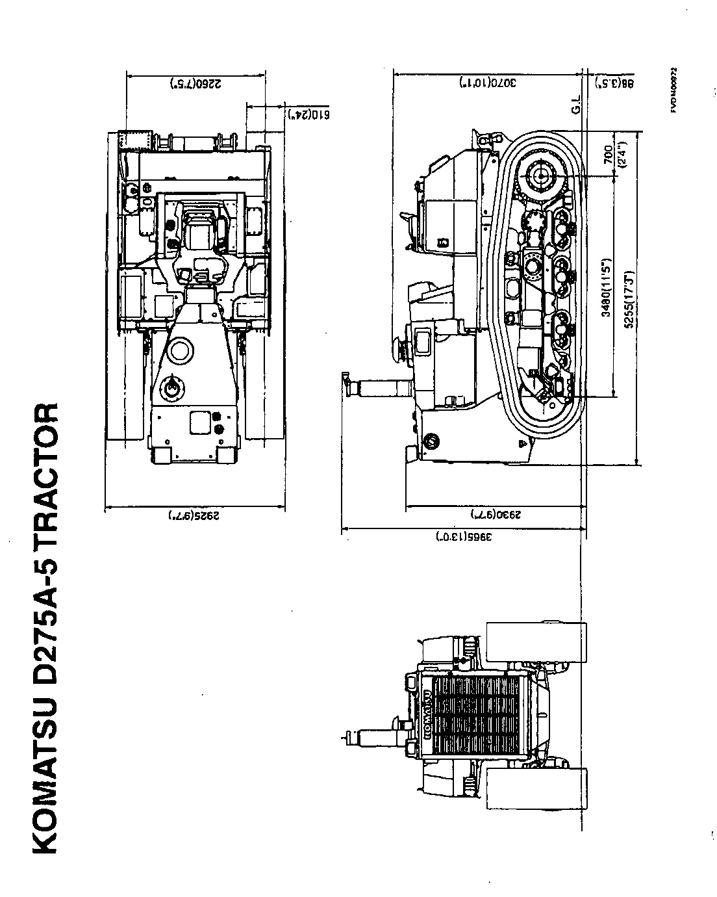

KOMATSU D275A-5 SEMI-U-DOZER
SPECIFICATIONS

EQUIPMENT WEIGHT (Additional weight to tractor)
Standard blade | 7 507 kg
DIMENSION:
Length (Additional length to tractor) | 1675 mm
Overall width | 4300 mm
Ground pressure (Additional pressure to tractor) | 0.18 kg/cm²
DOZER EQUIPMENT:
Type | Semi-U blade, hydraulically tilting
Blade:
Weight standard blade | 7507 kg Including blade support 728 kg
Blade capacity(SAE) | 13,7 m³
Blade support method | Brace support type
Length | 4300 mm
Height | 1960 mm
Digging angle | 52 deg.
Max. lift above ground | 1450 mm
Max. drop below ground | 640 mm
Max. tilt adjustment | 1000 mm
HYDRAULIC CYLINDERS:
Type | Double-acting, piston type
No. of cylinders – bore:  Lifting cylinder  Tilting cylinder | 2 – 120 mm  1 – 180 mm
HYDRAULIC EQUIPMENT:
Additional hydraulic oil weight | 29 kg
Max. oil pressure | 280 kg/cm²
Hydraulic pump:
Type | Plunger pump
Capacity (discharge flow) | 230 ltr./min at engine rated rpm
Location | Rear of engine right side
Control valve | Spool type
Position
Lifting spool  Tilting spool | Raise, hold, lower and float  Right, hold and left
Hydraulic tank:
Type | Equipment with externally-mounted control valve
Location | Right of operator`s seat
Filter | Full-flow type
Hydraulic oil (Refilled) | 130 ltr
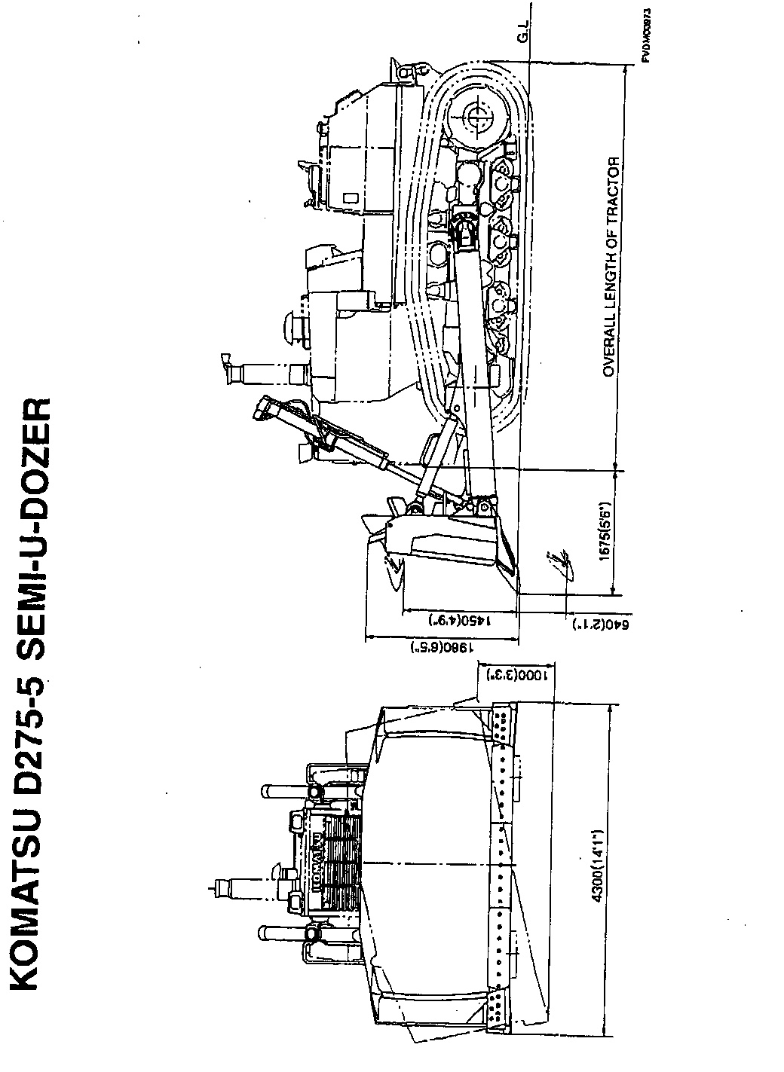
KOMATSU D275A-5 GIANT RIPPER
(Variable digging angle type)
Specifications
EQUIPMENT WEIGH:
(additional weight to tractor) | 4600 kg
DIMENSION:
Length (additional Length to tractor) | 2360 mm
Ground pressure to tractor (Additional pressure to tractor) | 0.11 kg/сm²
RIPPER EQUIPMENT:
Type | Parallelogram, variable digging angle type
Weight | 3849 kg
Beam lenght | 1252 mm
Shanks:
No. of shanks | 1
Tooth point | Replaceable
Digging angle | 52.7 deg., STD. (available stepless angle adjustment)
Max. digging depth | 1420 mm
Max. lift above ground | 1195 mm
Hydraulic cylinders:
Type | Double-acting, piston type
No. of cylinders – bore:
Lifting cylinder | 2 - 180 mm
Tilting cylinder | 2 - 160 mm
HYDRAULIC EQUIPMENT:
Max. oil pressure | 280 kgf/cm²
Hydraulic pump:
Type | Plunger pump
Capacity (discharge flow) | 230 ltr./ min at engine rated rpm
Location | Rear of engine right side
Control valve:
Тype | Spool type
Position:
Lifting cylinder | Raise, hold, lower and float
Tilting cylinder | Digging angle increase, hold and decrease

Note: Lifting spool and tilting spool are change-overed with selector valve.
Hydraulic tank:
Тype | Equipped with externally-mounted control valve
Location | Right of operator`s seat
Filter | Full-flow type
Hydraulic oil | 130 ltr.

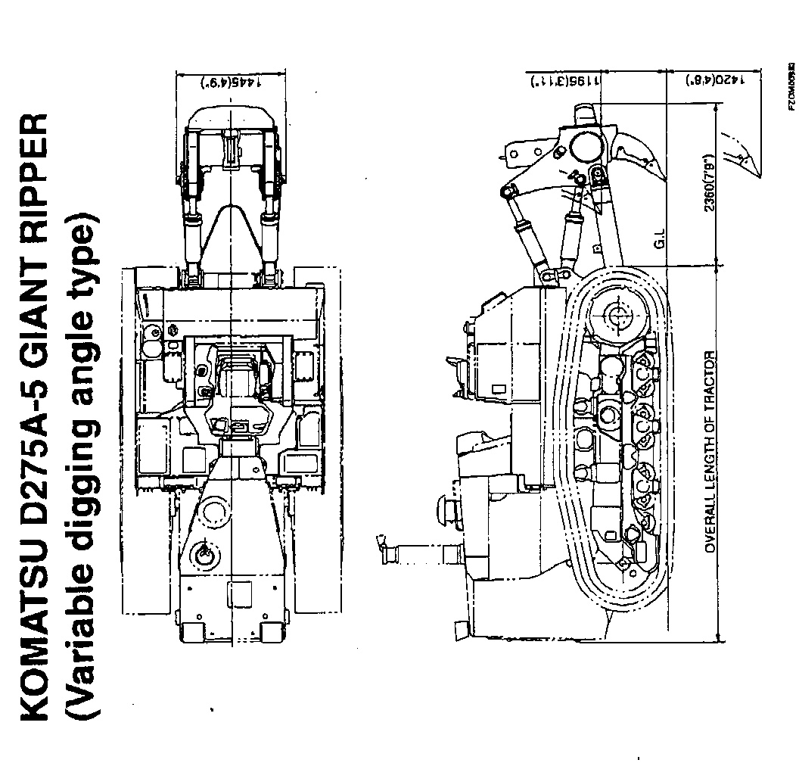

KOMATSU D275A-5 ROPS CANOPY

Specifications

EQUIPMENT WEIGH:
(Additional weight to tractor) | 650 kg
DIMENSION:
Ground pressure (Additional pressure to tractor) | 0.02 kgf/cm²

ROPS CANOPY
Type | 2-column ROPS canopy
Weight | 650 kg
Length | 1405 mm
Width | 2035 mm
Roof area | 2.30 m²
Plate thickness | 4.5 mm
Structure and strength comply with ROPS ISO 3471, SAE J1040 (April, 88), SAE J395 and ISO 3449 FOPS standards.

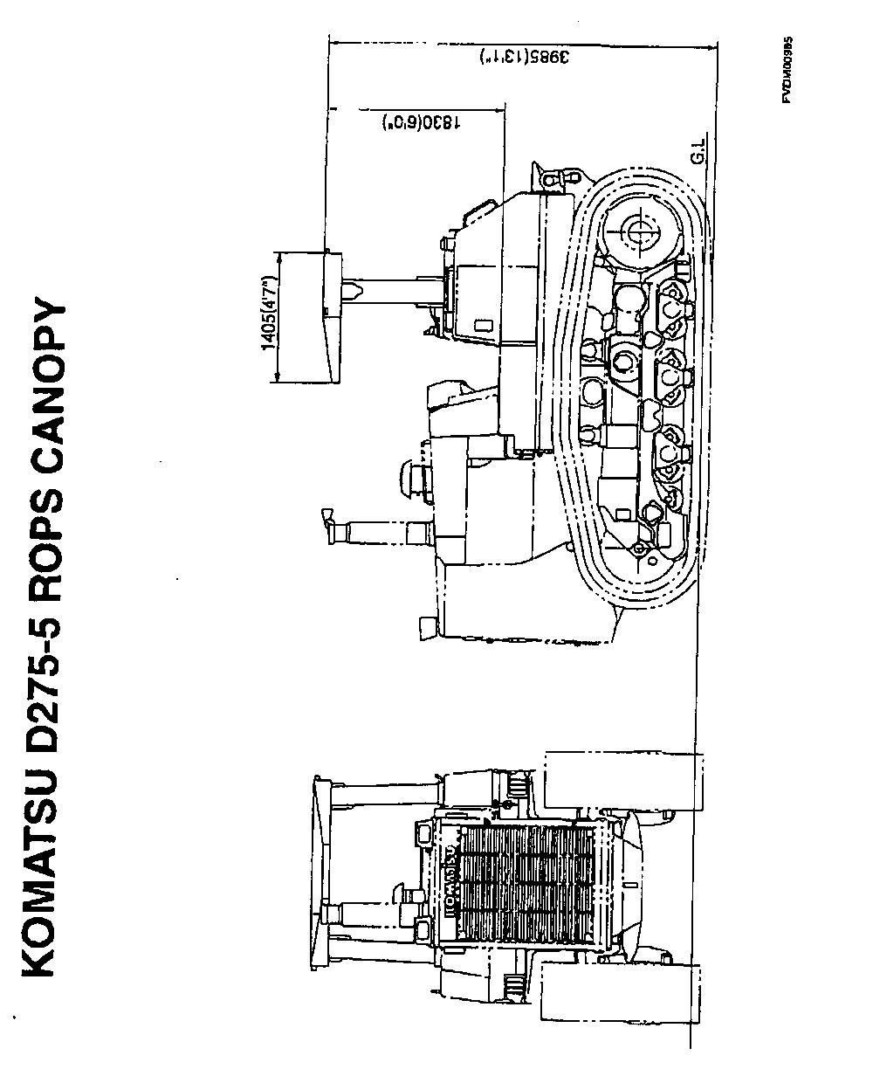

KOMATSU D275A-5 STEEL CAB
Specifications

EQUIPMENT WEIGH:
(Additional weight to tractor) | 490 kg
DIMENSION:
Ground pressure (Additional pressure to tractor) | 0.01 kg/см²
STEEL CAB
Type | All weather, enclosed type
Weight | 490 kg
Length | 1790 mm
Width | 1455 mm
Height:
Floor mat to ceiling | 1530 mm
HEATER | 5000 kcal/h x 1  4000 kcal/h x 1

STANDARD EQUIPMENT:
Wiper | 4 (2 front & 2 rear)
Lamp | 1
Rear view window | 1
Ash tray, cigarette lighter | 1
Floor mat | 1

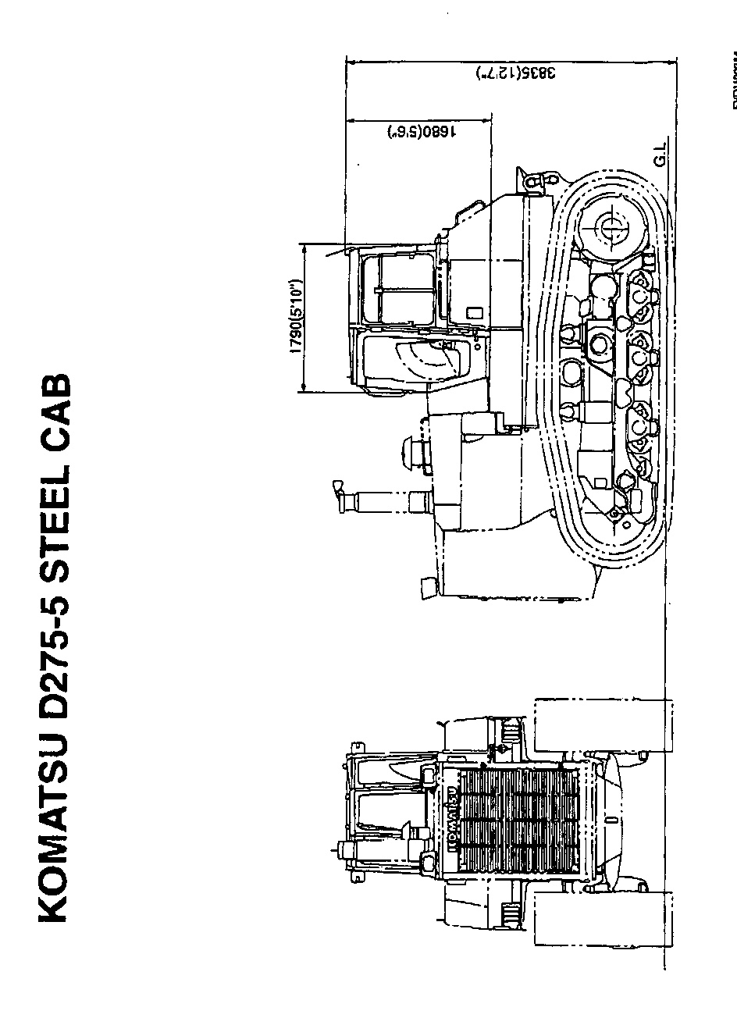

KOMATSU D275A-5 TRACTOR

ACCESSORY PARTS TABLE

Part No. | Part Name | Q`ty | Remarks
 | STARTING SWITCH KEY | 2
 | PARTS BOOK | 1
 | OPERATION & MAINTENANCE | 1

TOOL TABLE
Part No. | Part Name | Q`ty | Remarks
09000-30006 | Wrench set | 1
09020-10284 | Socket Wrench | 1
09022-00150 | Extension | 1
09022-00250 | Extension | 1
09023-00300 | Handle | 1
09024-00300 | Handle | 1
09026-00250 | Handle | 1
09025-00075 | Joint | 1
09027-00300 | Bar | 1
09033-00190 | Driver | 1
09036-00150 | Pliers | 1
09039-00150 | Hammer | 1
09040-00800 | Lubricator | 1
07952-70004 | Pump | 1
07951-11400 | Nozzle | 1
09055-10390 | Bar Pinch | 1
09002-03641 | Wrench | 1
09001-04600 | Wrench | 1
09019-08035 | Wrench | 1
07950-90403 | Cartridge | 1
09056-05513 | Bag | 1
09054-00009 | Gauge | 1

KOMATSU D275A-5 TRACTOR
SPARE PARTS TABLE
Part No. | Part Name | Q`ty | Remarks
09980-10550 | Overall | 1
09982-10057 | Cap | 1
09059-00800 | Spare parts box | 1
07063-01100 | Element | 2
20Y-60-31121 | Element | 1
07000-12130 | O-ring | 2
07000-15195 | O-ring | 1
07000-12110 | O-ring | 1
07002-03634 | O-ring | 6
07002-02034 | O-ring | 1
07020-00000 | Fitting | 4
07020-00675 | Fitting | 4
07020-00900 | Socket | 4
6212-85-6840 | V-belt | 1
6217-11-8820 | Gasket | 6
600-21-11340 | Cartridge | 1
600-31-13110 | Cartridge | 1

