KOMATSU D355C-3

PIPELAYER

WITH STEEL CAB

SHOE WIDTH: 860 mm
BOOM LENGTH: 8,560 mm

FOR
ATMOSPHERIC TEMPERATURE:
FROM -50 C UP TO +40 C

(SPECIFICATIONS ARE SUBJECT TO CHANGE WITHOUT NOTICE)

GENERAL SPECIFICATIONS

OPERATING WEIGHT:-----------------------------------------------------------59,550kg
DIMENSIONS:
Overall length-------------------------------------------------------------6,030 mm
Overall width--------------------------------------------------------------4,405 mm
(exclusive of boom, counterweight retracted )
Overall height:------------------------------------------------------------4,020 mm
Ground Pressure-----------------------------------------------------------0.92 kg/sq.sm
CONTAINS:
1 D355C PIPELAYER SPECIFICATIONS
2 D355C STEEL CAB SPECIFICATIONS
3 STANDARD TOOL, SPARE PARTS and ACCESSORY TABLE

KOMATSU D355C-3 PIPELAYER
SPECIFICATIONS:

OPERATING WEIGHT | 58,800 kg
SHIPPING WEIGHT (chassis only) | 41,100 kg
MAX. LIFTING CAPACITY | 117 ton.m (at 2.5m)
FLYWHEEL HORSEPOWER | 360 HP
DIMENSIONS:
Overall length | 6,030mm
Overall width:
Width counterweight retracted | 4,405 mm
Shipping width | 3,410 mm
(boom, frames, counterweight, steps, removed)
Overall height:
To highest point (cab light) | 4020 mm
To top of rain cap | 3,925 mm
To highest point, exclusive of exhaust pipe, boom, cabin, frame of right and left side counterweight (To top of winch) | 3,020 mm
Truck gauge | 2,550 mm
Length of truck on ground | 3,750 mm
Ground contact area | 64,500 sq.cm
Ground pressure | 0.91 kg/sq.sm
Ground clearance | 635 mm
PERFORMANCE:
Travel speed:
Forward 1-st | 0 - 3.3 km/h
2-nd | 0 - 5.9 km/h
3-rd | 0 - 9.8 km/h
Reverse 1-st | 0 - 3.9 km/h
2-nd | 0 - 7.0 km/h
3-rd | 0 - 11.0 km/h
PIPELAYER EQUIPMENT:
Lifting performance | Refer to the attached sheet, according to ANSI and SAE
Boom overhang | 1.3 - 8.5 m
Hook speed: (bare Drum)
Raise:
Low | 5.5 m/min
High | 12.7 m/min
Lower:
Low | 4.5 m/min
High | 10.2 m/min
Boom:
Type | Box section and be operated by wire ropes
Boom equipment:
Boom length | 8560 mm
Weight | 2,520 kg
Winch equipment
Type | Hydraulically controlled, double drum reversible
Driving system | Hydroshift, wet multiple disc clutch type
Brake | Hydraulicaly released, spring applied wet multiple disc clutch type
Transmission | Wet multiple disc clutch type, in high-low range
Winch drum:
Hook (dia x width) | 290mm x 340mm
Boom (dia x width) | 290mm x 166mm
Wire rope:
Hook (dia x length) | 20mm x 105mm
Boom (dia x length) | 20mm x 65mm
Weight | 3,310 kg
Counterweight equipment:
Type | Segment plate type, hydraulically controlled
Weight per plate | 1530 kg
No of plate | 6
Oil pressure | 140 kg/sq.sm
Weight including frame, link Assy, cylinder and weight plate | 12,900 kg
Safety equipment:
Boom | Automatic maximum stopper device
Winch and sheave | Automatic overwind stopper device
Boom | Indicator for load and moment
Hook | With safety lock

Moment limiter | Automatic overload limiter device 87%
Engine:
Model | KOMATSU S6D140-2
Type | Water cooled, 4-cycle, in-line, vertical type, direct injection type, turbocharged, diesel engine
No of cylinders - bore x stroke | 6 - 140mm x 165mm
Piston displacement | 15,240 cc
Performance
Rated RPM | 2000RPM
Flywheel horsepower | 360HP
Max.torque | 160kg.m/1400RPM
Fuel System:
Fuel oil | According to Komatsu recommendation
Governor | Mechanical, all speed control
Lubrication System:
Lubricating method | Gear pump, forced lubrication
Filter | Full-flow
Oil cooler | Water cooled
Cooling system | Forced circulation, by centrifugal water pump, reversible fan
Air cleaner | Dry type with automatic dust ejector and dust indicator
Starting method | By electrical starting motor 24V, 22KW (11kwx2)
Staring aid:
Combustion type coolant, oil pan heater | 30,000 Kcal/h
Intake air heater (electric type) | 24V, 5,7 KW
Coolant heater (electric type) | 230V, 1.5KWx1 (option)
Oil pan heater (electric type) | 230V, 0.6KWx1 (option)
Battery warmer | Hot air type battery box with left lining
Engine side cover | Closed type
Automatic priming system:
Air intake system from bonnet inside port
Radiator shutter | Metal type, operated from cabin room
Engine room quilting | Cloth type (option)
Alternator | 24V, 50A
Battery | 24V (12Vx2)-200Ah
Portable combustion type heater | 30,000 Kcal/h x 1 (option)
POWER TRANSMITTING SYSTEM:
Torque converter:
Type | 3 element, single stage and single phase
Cooling method | Water cooled
Transmission:
Type | Planetary gear and multiple disc clutch, hydraulically actuated, forced lubrication
Gear shift | 3 forward nd 3 reverse speeds
Bevel gear | Spiral bevel gear
Steering system:
Steering clutch | Wet multiple disc, spring loaded, band operated, Hydraulically actuated
Steering brake | Wet, contracting band, foot operated, interconnected with steering clutch, with hydraulic booster
Final drive | Spur gear single reduction and planetary gear single reduction
UNDERCARRIAGE:
Suspension | Non-oscillating type
No of rollers:
Carrier roller | 2, each side
Track roller | 8, each side
Shoe:
Type | Assembled single grouser
Grouser height | 88mm
No of shoes | 42, each side
Pitch | 260.35mm
Width | 860mm
DRAWBAR
Type | Fixed type drawbar
Height of drawbar above ground  (Exclusive of grouser height) | 640mm
POWER TAKE OFF:
Location | Rear of engine
Shaft revolutions | 1725 RPM at engine 2000RPM
Rotational direction | Clockwise (as viewed from drive side)
COOLANT AND LUBRICANT CAPACITY:
Coolant water | 145ltr
Fuel tank | 640ltr
Engine | 42ltr
Torque converter  Transmission  Bevel gear case  Steering case | 230ltr
Final drive case | 68ltr
Winch case | 125ltr
Counterweight tank | 47ltr
Combustion preheater fuel tank | 12ltr
Others:
Material components for severe cold. Vandalism protection for fuel tank, hydraulic tank, radiator

KOMATSU D355C-3 STEEL CAB
Specifications

EQUIPMENT WEIGHT (Additional weight to bare-tractor) | 750kg
DIMENSIONS:
Overall height | 4020mm
Ground pressure (Additional pressure to bare tractor) | 0.01kg/sq.sm
STEEL CAB (Window glass: double type)
Type | All steel, enclosed type
Weight | 750kg
Length | 2070mm
Width | 1785mm
Height (Floor to ceiling) | 1460mm
ACCESSORY:
Wiper | 2 (Front and rear)
Room lamp | 1
Ventilator | 1
Rear lamp | 2
Floor mat | 1 set
Heater (hot water type including defroster) | 4400Kcal/hx3
Inspection lamp | 1
Sunvisor | 1
Fog lamp | 1
Fire extinguisher | 1
First aid box | 1
Water bottle | 1
Ash tray, cigarette lighter | 1
Rear view mirror | 1
Double glass window | 1 set
Working light (for boom) | 1
Winch lamp | 1
Aux. Cab heater | 1,600 kcal/h x1
Combustion preheater fuel tank | 8.4ltr

KOMATSU D355C-3 PIPELAYER

LIFTING PERFORMANCE CURVE
Lifting load performance curve
Boom length 8560 mm
Wirerope for hook
Diameter 20 mm
Wirre cutting load 27, 600 kg
Wirerope for boom
Diameter 20 mm
Wirre cutting load 27, 600 kg
- 8 part hook line
- 5 part book line
- Weight of counterweight plate 12,900 kg
- Lifting performance is shown with counterweight extended
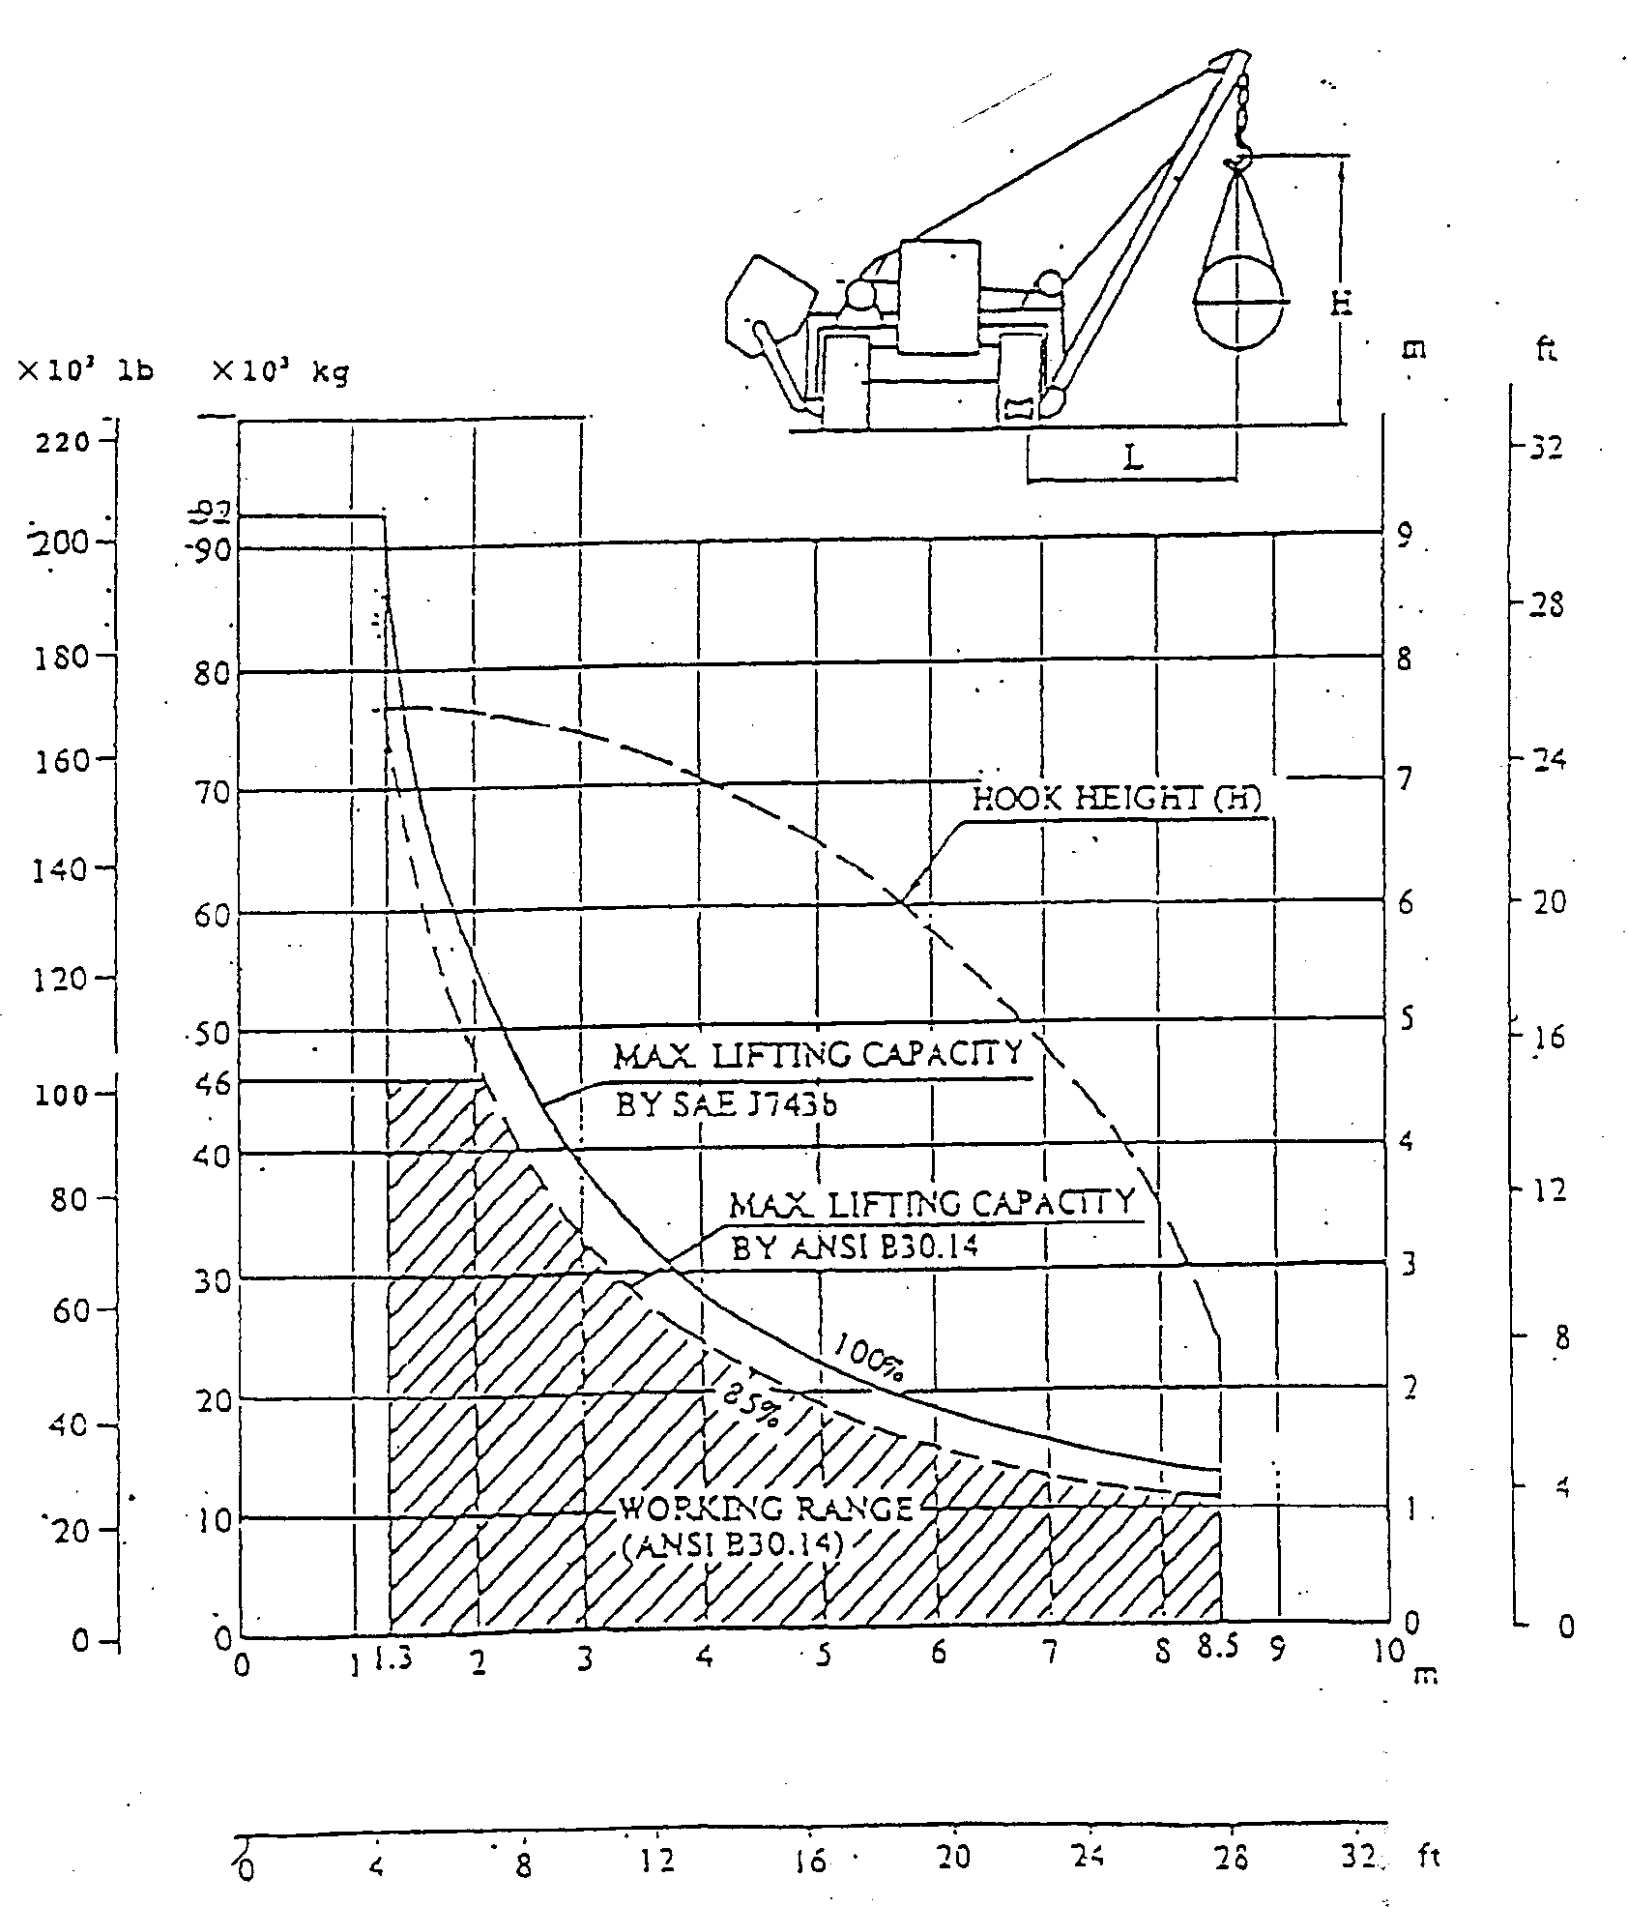
BOOM OVERHANG (L)

KOMATSU D355C-3 PIPELAYER
DRAWBAR PULL VS TRAVEL SPEED

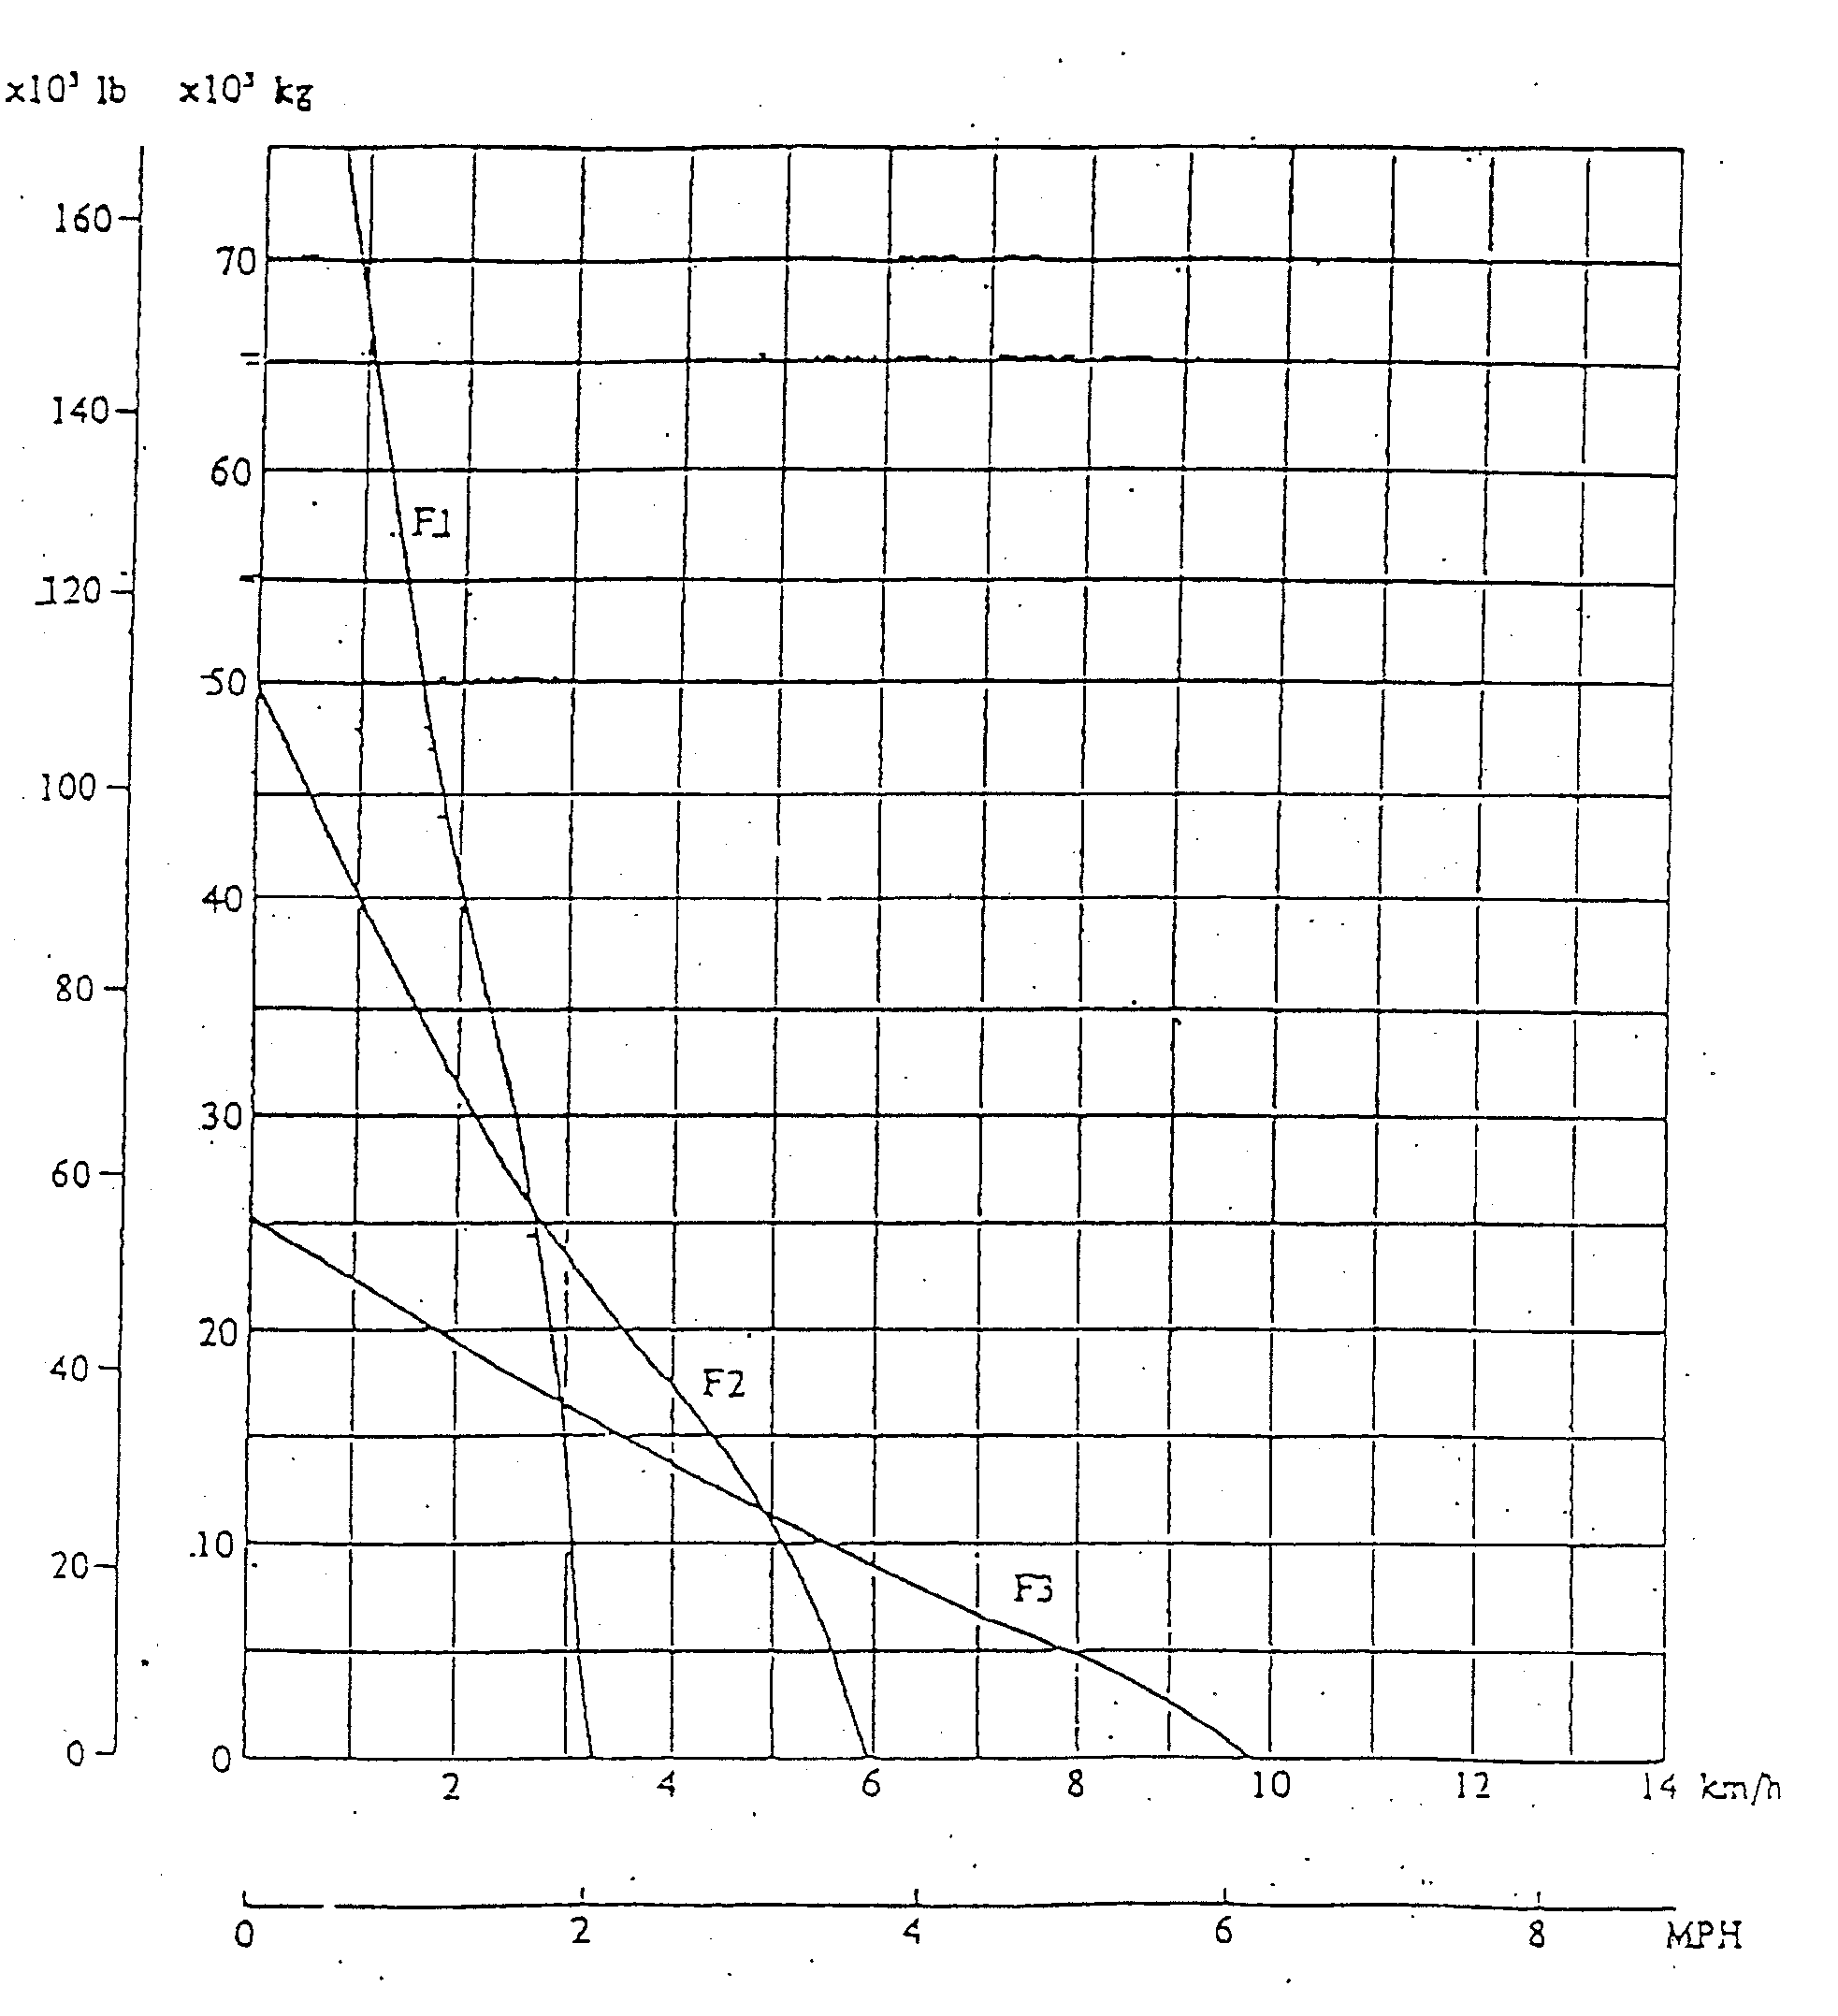
Note: The drawbar pull travel speed may be subject to change depending on the graund conditions and machine weight.
KOMATSU D355C-3 PIPELAYER
STANDARD TOOL TABLE

Parts No | Parts Name | Qty | Remarks
09000-30006 | WRENCH | 1 SET | 8X10, 12X14, 13X17, 19X22, 24X27, 30X32
09020-10284 | SOCKET WRENCH SET | 1 SET | 10. 12. 13. 14. 17. 19. 22. 24. 27. 30. 32
09033-00190 | SCREW DRIVER | 1
09030-00150 | SCREW DRIVER | 1
09036-00150 | PLIERS | 1
09039-00150 | HAMMER | 1
09040-00800 | OILER | 1
07952-80001 | GREASE PUMP | 1
07951-11400 | NOZZLE | 1
09055-10390 | PINCH BAR | 1
09054-00009 | THICKNESS GAUGE | 1
08690-00265 | HYDROMETER | 1
195-98-11590 | SOCKET | 1 | 41
09029-00450 | PINCH BAR | 1
07950-90401 | CARTRIDGE | 1
09002-03236 | WRENCH | 1 | 32, for power line rubber hose
09002-03641 | WRENCH | 1 | 36, for winch rubber hose
09001-04600 | WRENCH | 2 | for winch cooler rubber hose
09001-05500 | WRENCH | 2 | for power line rubber hose
09019-08035 | WRENCH | 1 | for engine filter
196-98-22100 | HOSE ASS’Y | 1 | For drainage of winch oil
175-900-3910 | LEVER ASS’Y | 1 | For over turning fan
196-98-41100 | PUMP ASS’Y | 1 | For inch-brake release
09031-00100 | SCREW DRIVER | 1
196-98-21190 | WRENCH | 1
196-98-41200 | HOSE ASS’Y | 1
196-98-41110 | SHIM | 1
196-98-41151 | GASKET | 1
196-98-41120 | SHIM | 1
196-98-41161 | GASKET | 1

KOMATSU D355C-3 PIPELAYER
STANDARD SPARE PARTS TABLE

PARTS No | PARTS NAME | QTY | REMARKS
175-49-11850 | ELEMENT | 3 | For steering oil filter
07000-43120 | O-RING | 3 | For steering oil filter
175-49-11580 | ELEMENT | 3 | For transmission oil filter
07000-42115 | O-RING | 3 | For transmission oil filter
130-60-48210 | ELEMENT | 3 | For counterweight oil filter
07000-43078 | O-RING | 3 | For counterweight oil filter
144-60-11160 | ELEMENT | 3 | For winch oil filter
07000-42115 | O-RING | 3 | For winch oil filter
07020-0000 | FITTING | 4
07020-00675 | FITTING | 4
07020-00900 | FITTING | 4
600-211-1291 | CARTRIDGE | 1 | For engine oil filter
600-311-7152 | CARTRIDGE | 1 | For engine fuel filter
6210-11-8820 | GASKET | 6 | For cylinder head cover
04122-32575 | V-BELT | 1 | For fan drive
600-736-9380 | V-BELT | 1 | For alternator
07002-43634 | O-RING | 1 | For torque converter oil drain
07002-43634 | O-RING | 1 | For steering case oil drain
07002-43634 | O-RING | 2 | For final drive case oil drain
07002-44234 | O-RING | 2 | For final drive case inlet port
07002-42434 | O-RING | 1 | For counterweight oil drain
07002-42434 | O-RING | 2 | For winch level gauge
07002-44234 | O-RING | 1 | For winch inlet port
195-98-13440 | PLUG SET | 1 | For combustion heater

KOMATSU D355C-3 PIPELAYER
ACCESSORY PARTS TABLE

PARTS No | PARTS NAME | QTY | REMARKS
09056-05513 | TOOL BAG | 1
 | SPARE PARTS TABLE | 1
 | PARTS BOOK | 1
 | OPERATION MANUAL | 1
09980-10550 | OVERALL | 1
09982-10057 | WORK CAP | 1
 | STARTING SWITCH KEY | 2

