“ALDANZOLOTO”

KOMATSU HD785-5 DUMP TRUCK

WITH TIRES 27.00R49**VMTP (E4) TL

PAYLOAD 91 TONS

- BODY ( HEAPED 2:1): 60M3
- ENGINE SA12V140
- SPECIFICATION: -40 С ДО +40С



HD785-5 DUMP TRUCK
SPECIFICATIONS

TYPE .................................................………………………….. | Dump truck
BODY CAPACITY:
Struck .......................................................……... | 40,0 m³
Head (2 : 1) ...................................................………… | 60,0 m³
Max. Gross vehicle weight …………………………... | 165000 kg
Max. gross vhicle weight not to exceed 165000 kg on 27.00 R49 ** VMTP E4 TL tires, including optional equipment, fuel ang payload.

WEIGHT:
Net weight.....................................................…………….. | 66930 kg
DISTRIBUTION:
Front axle ...................................................……….. | 31460 kg
Rear axle .......................................................……….. | 35470 kg
Operator………………………………………… | 120 kg
Rated payload………………… | 91000 kg
Gross weight....................................................…………….. | 158 010 kg
DISTRIBUTION:
Front axle ..................................................………... | 52140 kg
Rear axle ...................................................………….. | 105870 kg
PERFORMANCE:
Max. Travel speed ...................……….. | 65 km/h
Turning radius.....................................................………… | 9,9 m
Dumping angle...................…….. | 48⁰
Dumping speed ...............................……… | 13 second at rated engine speed
DIMENSION:
Overal length...............................................…………… | 10490 mm
Overal width....................................................………… | 5660 mm
Overal height………………………………………….. | 5050 mm
Wheel base........................................................................ | 4950 mm
TREAD:
Front.........................................................……... | 4230 mm
Rear .............................................................……... | 3500 mm
Ground clearance.....................................…....….. | 810 mm
Loading height…………………….. | 4285 mm
ENGINE:
Model..........................................................………………… | КOMATSU SA12V140
Type.......................................………………………………. | Water cooled, 4-stroke cycle, overhead valve,direct injection type, turbocharger and aftercooler
No. Of cylinders – bore X stroke...... | 12 - 140 mm x 165 mm
Piston displacement.......................................…………. | 30,48 ltr
PERFORMANCE:
Flywheel horsepower (Gross) ........…………. | 783 kW (1050 HP.) 2000 rpm
Flywheel horsepower (Net) | 753 kW (1010 HP.) 2000 rpm
Max. torque ..........................…….. | 4168 Nm (425 kgm)
Engine rpm at max. Torque……………………… | 1400 rpm
FUEL SYSTEM:
Fuel………………………………………………… | Diesel gass oil,, ASTM SPEC. D975-60T No. 2D
Governor……………………………………………... | Electronic type
LUBRICATION SYSTEM:
Lubrication method.................……………….. | Forced lubrication
Lubrication pump.................……………….. | Gear pump
Lubrication filter................……………….. | Full-Flow + By-Pass
Cooling method………...............................……… | Water cooled
COOLING METHOD ....................................………………... | Forced circulation by cebtrufugal water pump
FAN TYPE…………………………………………………... | Suction type
AIR CLEANER TYPE……………………………………... | Dry type with automatic dust evacuator and dust indicator
STARTING SYSTEM:
Starting method..............................……………… | By electric starting motor
Starting motor………………………………. | 24 V / 7.5 kW х 2
Alternator……………………………………………. | 24 V, 90 А
Battery ………………………………... | 12 V / 200 А.h х 4
DAMPER:
Type……………………………………………………… | Rubber type
TORQUE CONVERTER:
Model……………………………………………………….. | КOMATSU TCA49-1A
Type………………………………………………………… | 3-element, 2-phase,  1-stage
Lock up clutch………………………………………... | Wet, double disc, hydraulically controlled
Cooling method………………………………………... | Water cooled
TRANSMISSION:
Type………………………………………………………... | Planetary gear multiple-disc clutch, electricaly and hydraulically actuated,forced lubrication, full automatic
Gear shift …………………………………………….. | 7-forwartd and 1-reverse speeds
Gear ratio:
Forward 1-st ………………………………………….. | 4.692
2-nd ………………………………………………………... | 3.333
3-rd…………………………………………………………. | 2.475
4-th…………………………………………………………. | 1.838
5-th…………………………………………………………. | 1.365
6-th…………………………………………………………. | 1.000
7-th…………………………………………………………. | 0.742
Reverse 1-st………………………………. …………... | 3.934
DIFFERENTIAL AND REDUCTION:
Type………………………………………………………… | Spiral bevel gear, splash lubrucation
Reduction ratio …………………… | 3.467
Differential gear………………...……………….. | Straight bevel gear
FINAL DRIVE:
Type………………………………………………………… | Planetary gear, splash lubrication
Reduction ratio………………………………………… | 6.500
AXLES:
Front …………………………………………………….. | Independing suspension system
Rear………………………………………………………... | Full floating type
SUSPENSION:
Front ……………………………………………………... | Hydrapheumatic type
Rear………………………………………………………... | Hydrapheumatic type
WHEELS:
Tires:
Front ………………………………………………….. | 27.00R49**VMTP E4 TL х 2
Rear …………………………………………………….. | 27.00R49**VMTP E4 TL х 4
Tire inflation pressure:
Front………………………………………. | 686 kPa (7,0 kg/cm² / 100 PSI)
Rear…………………………………………….. | 686 kPa (7,0 kg/cm² / 100 PSI)
STEEERING SYSTEM:
Type………………………………………………………… | Full hydrostatic steering system with double acting cylinders
BRAKES:
Front.......................……………………………………… | Air-over-hydraulic, caliper disc
Rear ..................……………………………………………. | Air-over-hydraulic oil-cooled multiple-disc
Parking ………………………………………………….. | Spiral loaded,caliper disc
Retarder……………………………..………….. | Air-over-hydraulic,oil-cooled multiple-disc
CHASSIS FRAME……………………………………………... | Box section, welded construction, ladder type
BODY:
Type………………………………………………………… | V-shape, V-bottom
Inside length …………………………………………… | 7480 mm
Inside width……………………….…………… | 4880 mm
Max. body depth……………………….……………. | 1930 mm
HYDRAULIC CONTROL UNIT:
Relief valves setting……. | 20,6 mPa (210 kg/cm² / 2.990 PSI)
HYDRAULIC PUMP:
Location …………………………………………….. | Front of torque converter
For steering and body hoist:
Type…………………………………… | Gear pump
Capacity …………..……………………….. | 668 ltr/min at 2100 rpm
For torque converter charge:
Type…………………………………………………… | Gear pump
Capacity …………………………………………… | 353 ltr/min at 2100 rpm
For retarder cooling:
Type…………………………………… | Gear pump
Capacity …………..……………………….. | 1051 ltr/min at 2100 rpm
Control valve ………………………………………... | Spool type
Position …………………………………………… | Raise,hold, float and lower
Hoist cylinders:
Type……………………………………………………... | 2-stage telescoping cylinders, piston type, 2-nd stage is double acting
No. of cylinder- dia х stroke………. | 2 - (200 mm - 180 mm) х 2085 mm
STEERING CYLINDERS:
Type……………………………………………………... | Double acting,piston type
No of cylinders-dia х stroke………. | 2 - 110 mm х 455 mm
HYDRAULIC TANK:
Type……………………………………………………... | Equipped with built-in filters
Location………………………………………….. | Left side of frame
Filter………………………………………………. | Full flow type
SERVICE CAPACITY:
Fuel tank …………………………………..…………... | 1250 ltr
Radiator………………………………..……………. | 228 ltr
Engine……………………………………..……………… | 132 ltr
Torque converter, transmission.……………... | 102 ltr
Differentioal gear…………………………………. | 132 ltr
Final dive, each side……………..……… | 60 ltr
HYDRAULIC SYSTEM:
Hoist & steering ..…..…… | 153 ltr
Retarder cooling ………………………..… | 246 ltr
SUSPENSION CYLINDERS:
Front (each side)………………. | 20 ltr
Rear (each side)………………….. | 17,5 ltr
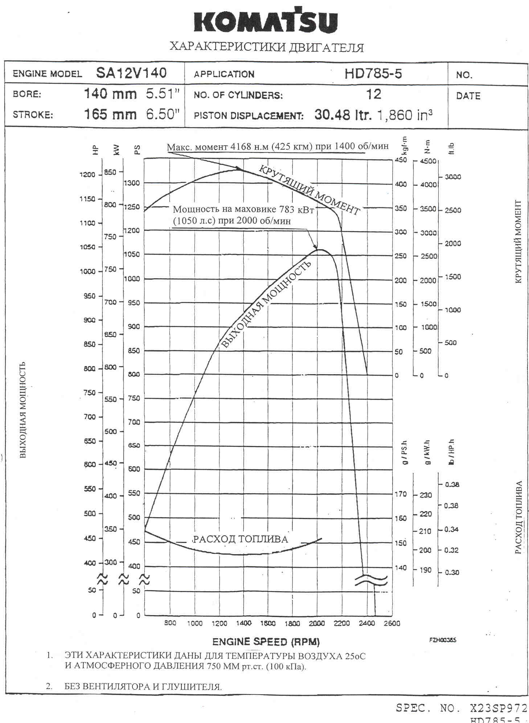

HD785-5 ТRAVEL PERFORMANCE CURVE
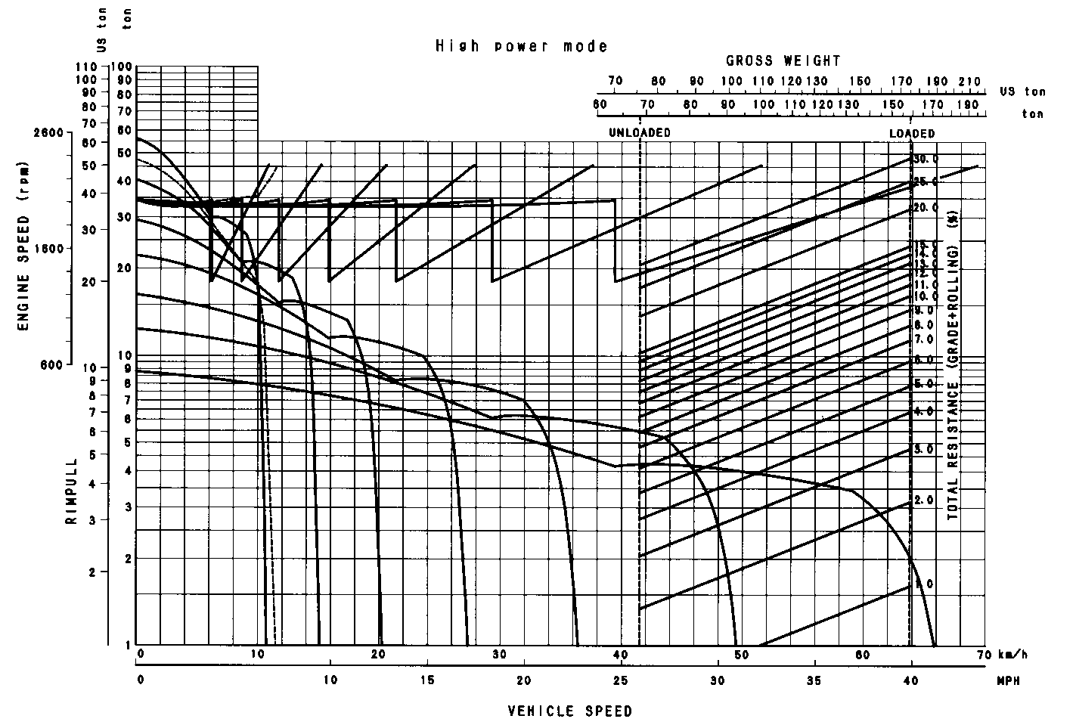
HD785-5 TRAVEL PERFORMANCE

HD785-5 RETARDER PERFORMANCE CURVE

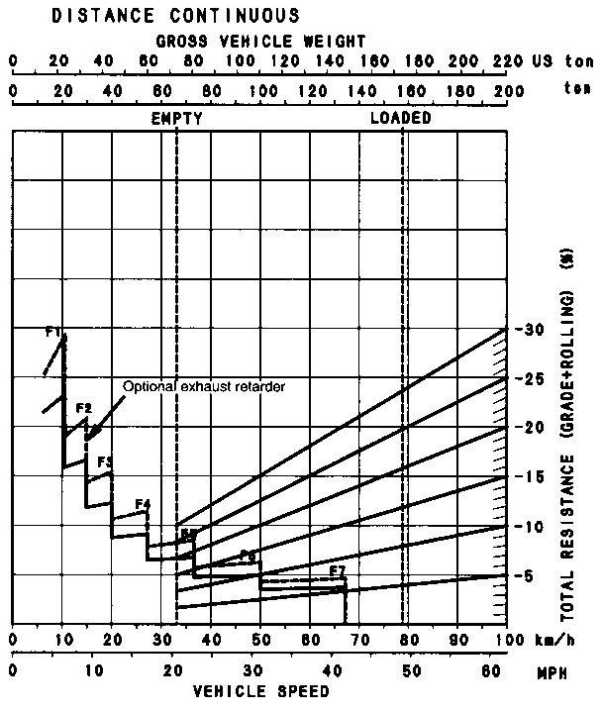 | 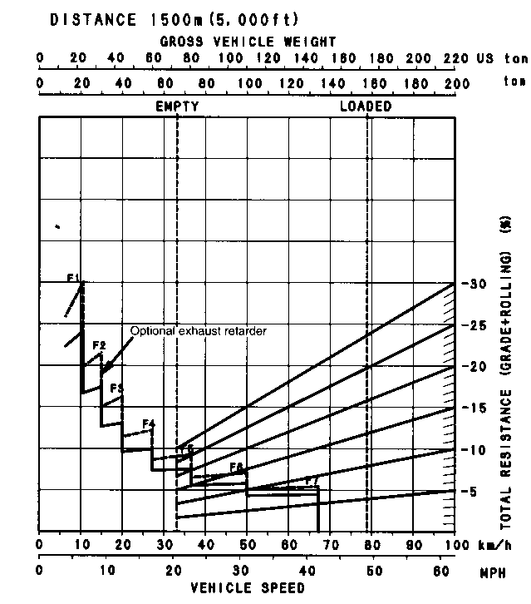
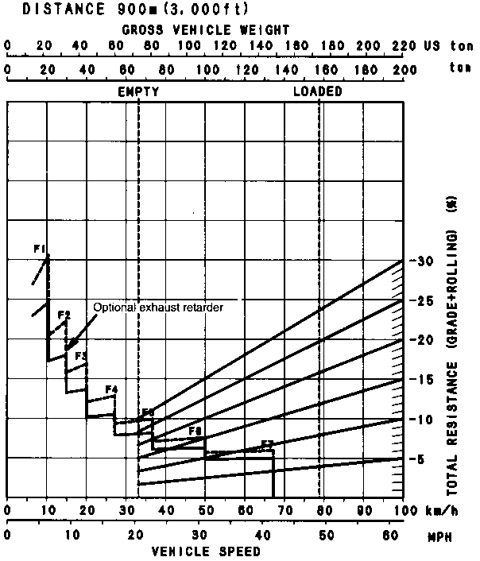 | 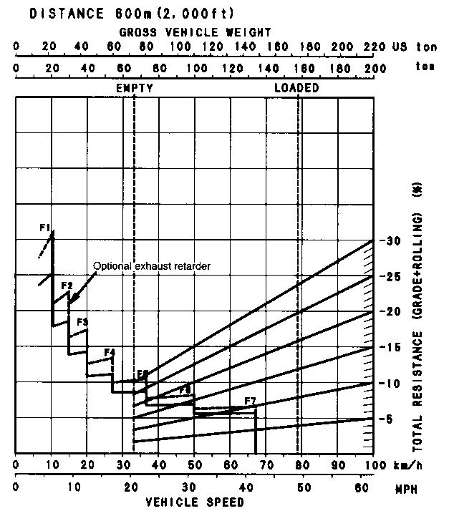
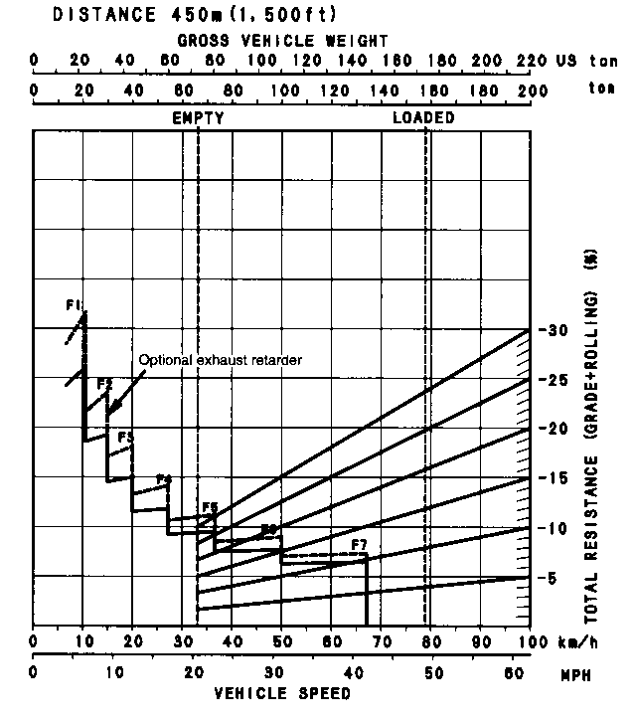
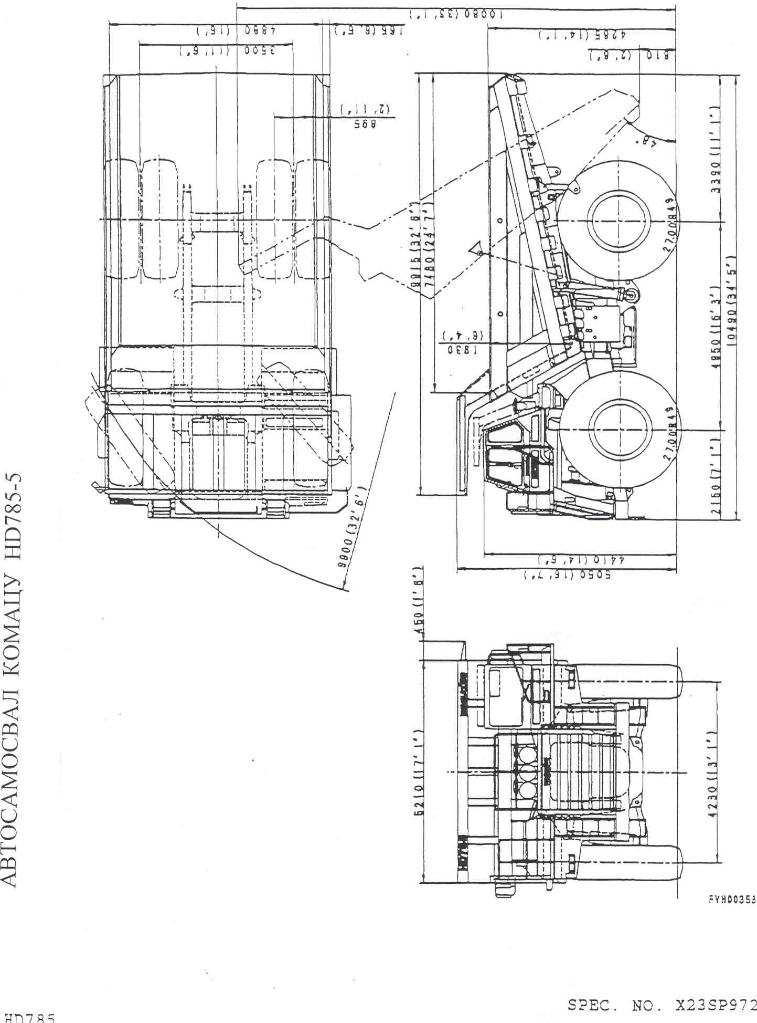
KOMATSU HD785-5 DUMP TRUCK
ACCESSORY PARTS TABLE

PART No | PART NAME | Q-TY | REMARKS
 | STARTING SWITCH KEY | 2
 | PARTS BOOK | 1
 | OPERATION & MAINTENANCE MANUAL | 1

KOMATSU HD785-5 DUMP TRUCK

TOOLS TABLE

НОМЕР ЧАСТИ | ОПИСАНИЕ | КОЛ-ВО | ПРИМЕЧАНИЕ
09000-30006 | WRENCH SET | 1
09014-10200 | WRENCH | 1
09019-08035 | WRENCH | 1 | FOR FILTER
09020-10284 | SOCKET WRENCH SET | 1
09023-00380 | HANDLE | 1
09033-00190 | SCREWDRIVER | 1
09036-00150 | PLIERS | 1
09039-00150 | HUMMER | 1
09054-00009 | THICKNESS GAUGE | 1
09055-10390 | BAR | 1
09289-10000 | GAUGE | 1 | FOR TIRES
07950-90403 | CARTRIDGE | 1
07951-11400 | NOZZLE | 1
07952-80002 | GREASE PUMP | 1
582-98-11410 | SOCKET | 1
568-35-11210 | HOSE | 1 | FOR AIR
281-09-11310 | AIR CONNECTOR | 1
281-98-12610 | PLUG | 1
568-35-11920 | HOSE | 1
04059-01080 | WIRE | 1
561-98-61120 | METER ASS. | 1 | FOR BRAKE DISC
09056-05513 | TOOLS BAG | 1

KOMATSU HD785-5 DUMP TRUCK

SPARE PARTS TABLE

PART No. | PART NAME | Q-TY | REMARKS
600-211-1231 | CARTRIDGE | 4 | FOR ENGINE OIL FILTER
600-212-1511 | CARTRIDGE | 2 | FOR BY-PASS FILTER
07063-01210 | ELEMENT | 3 | FOR HYDRAULIC FILTER
07000-25185 | O-RING | 3 | FOR HYDRAULIC FILTER
561-60-61160 | SEAL | 3 | FOR HYDRAULIC FILTER
600-311-7132 | CARTRIDGE | 2 | FOR FUEL FILTER
600-411-1171 | CARTRIDGE | 2 | FOR CORROSSION RESISTOR
04120-21951 | V- BELT | 1 | FOR ALTERNATOR
6215-61-3690 | V- BELT | 1 | FOR FAN
569-30-11600 | VALVE | 6 | FOR TIRES
09284-00045 | EXTANSSION | 2 | FOR TIRES
6210-11-8820 | GASKET | 12 | FOR COVER VALVES
424-16-11140 | ELEMENT | 4 | FOR FILTER TRANSMISSION
424-16-11130 | О-RING | 4 | FOR FILTER TRANSMISSION
424-16-11630 | O-RING | 8 | FOR FILTER TRANSMISSION
07002-01223 | O-RING | 4 | FOR FILTER TRANSMISSION

KOMATSU HD785-5 DUMP TRUCK

OPTIONAL EQUIPMENT LIST

BATTERIES - LARGE
ALTERNATOR - 90A
27.00 R49 ** VMTP (E4) TL TIRES (BRIDGESTONE)
EXHAUST BOX + MUFFLER
RADIATOR CURTAIN
COLD WEATHER ARRANGEMENT
ELECTRIC ENGINE OIL & COOLANT HEATER
HYDRAULIC OIL HEATER
POOR FUEL(WATER)SEPARATOR
BACK-UP LIGHT
SIDE WORKING LIGHTS
FOG LIGHTS
REAR VIEW MIRROR – RIGHT
ROPS COLUMN WITH FOPS
SEAT BELT, WIDE TYPE (78MM)
HEATER & DEFROSTOER, DOUBLE
ELECTRIC FAN
CIGA LIGHTER & ASHTRAY
DEFOGGER GLASS,FRONT
PAYLOAD METERFR (PLM-2)
BUDDY SYSTEM CUPPLER
ENGINE ROOM LIGHT
VANDALISM PROTECTION KIT
AIR DRYER
ALCOHOL INJECTOR
ENGINE SIDE COVERS
ENGINE UNDER GUARD
TRANSMISSION UNDER GUARD
PROPELLER SHAFT GUARD, FRONT
PROPELLER SHAFT GUARD, REAR
PLATFORM GUARD
TIRE GUARDS
FIRE EXTINGUISHER
FIRST AID KIT
CAP & OVERALL
GENERAL TOOL KIT
SPARE PARTS –GENERAL
AUTO GREASE (LINCOLN)
FRONT BRAKE CUT-OFF
ARSC (AUTO RETARD SPEED CONTROL)
ASR (AUTO SPIN REGULATOR)
VHMS (VEHICLE HEALTH MONITORING SYSTEM) WITHOUT ORBCOMM
FAST FILL COUPLER FOR FUEL TANK

