“SEVERSTALRESURS”

KOMATSU WА900-3
WHEEL LOADER

WITH
11,5 m³ SPADE NOSE BUCKET WITH TIP TYPE TEETH
45 / 65-45-58 PR (L-5) TIRES
ROPS CANOPY & STEEL CAB
HEATER & DEFROSTER

FOR -40 C - +40C



KOMATSU WA900-3 WHEEL LOADER

Specifications

OPERATING WEIGHT | 101 550 kg.(223 880 lb)
Operating weight includes 45 / 65-45-58PR (L-5) tubeless tires, 11,5 m³, spade-nose bucket with tip type teeth, optional steel cab, ROPS canopy and operator.
Weight distribution (empty)
Front axle | 55 750 kg. (122 910 lb)
Rear axle | 45 800 kg (100 970 lb)
FLYWHEEL HORSEPOWER:
SAE J1349 | 637 kW (853 HP) / 2000 rpm
DIN 6270 | 637 kW (865 PS) / 2000 rpm
PERFORMANCE:
Travel speed: Forward 1st  2nd  3rd  Reverse 1 st  2 nd  3 rd | 7,0 km/h ( 4,3 MPH  12,3 km/h ( 7,6MPH)  28,0 km/h (17,4 MPH)  7,1 km/h (4,4MPH)  12,4 km/h (7,7 MPH)  28,3 km/h (17,6MPH)
Max. rimpull | 588 kN (60000 kgf /132280lb)
Turning radius:  Outside corner of bucket teeth  Center of outside wheel | 11 000 mm ( 36' 1'' )  9 200 mm ( 30' 2'' )
DIMENSIONS:
Overall length | 14 270 mm ( 46' 1'' )
Overall width | 4 585 mm (15' 1'' )
Overall height:
To top of ROPS canopy | 5 275 mm ( 17' 4'' )
To top of exhaust pipe | 5 080 mm (16’ 8” )
To top of operator seat | 4 460 mm ( 14' 8'' )
Wheelbase | 5 450 mm. ( 17' 11” )
Tread, front and rear | 3 350 mm ( 11' 0'' )
Ground clearence | 550 mm ( 1' 10'' )
LOADER PERFORMANCE:
Bucket capacity:
Heaped | 11,5 m³ ( 15,0 yd³ )
Struck | 9,7 m³ ( 12,7 yd³ )
Bucket width:
Width over protector | 5 045 mm (16’ 6” )
Cutting edge width | 4 810 mm (15’ 9” )
Bucket edge | Spade-nose
Rated load | 20 700 kg ( 51 590 lb )
Breakout force | 703 kN ( 71 700 kgf / 158 070 lb )
Static tipping load:
Straight | 62 540 kg ( 137 880 lb )
Full turn | 55 030 kg ( 121 320 lb )
Lifting capacity:
SAE carry position | 635 kN (64 800 kgf / 142 860 lb )
Max. hinge pin height | 6 960 mm ( 22' 10'' )
Operating height, fully raised | 9 680 mm ( 31' 9'' )
Dumping clearance at max. height, 45º discharge angle | 5 020 mm ( 16' 6'' )
Dumping reach at max. height, 45º discharge angle | 2 215 mm ( 7' 3'' )
Max. tilt back angle, at carry position | 50^{о}
Max. dumping angle, fully raised | 47^{о}
Max. digging depth below ground:
When digging angle 0^{о} | 165 mm ( 6. 5'' )
When digging angle 10^{о} | 645 mm ( 2' 1'' )
ENGINE:
Model | KOMATSU SA12V140
Type | Water cooled, 4-stroke, over head valve, direct injection type, turbocharged and aftercooled diesel engine
No. of cylinders – bore x stroke | - - 140 mm x 165 mm ( 5.51” X 6.50”)
Piston displacement | 30,48 ltr. (1,860 in3)
Performance: Rated rpm  Max. torque | 2 000 rpm  4 090 N.m ( 417 kgf.m / 3 016 ft.lb )  at engine 1 300 rpm
Fuel system: Fuel oil  Governor | Diesel gas oil, ASTM  specifications D975-60T No.2D  Electronic all speed control
Lubrication system:
Lubricating method | Forced lubrication
Lubrication pump | Gear pump
Filter | Full-flow
Cooling method  Coolingn method | Water cooled.  Forced circulation by water pump
Air cleaner | Dry-type with automatic dust  Ejector and dust indicator
Starting method:
Type | By electric starting motor
Starting motor | 2 x 7.5KW, 24V
Alternator | 24 V, 90A
Battery | 4 X 12V / 200Аh
DAMPER:
Type | Rubber type
TORQUE CONVERTER:
Model | KOMATSU TCА51-1A
Type | 3-element, single-stage and  single-phase
Cooling method | Water cooled
TRANSMISSION:
Type | Planetary gear type,  multiple-disc clutch, hydraulically  actuated, forced lubrication
Gear shift | 3 forward and 3 reverse speeds
AXLE:
Drive system | Four-wheel drive
Front axle | Fixed type, full-floating
Rear axle | Center pin support, full-floating
Oscillation angle | Total 22°
Reduction gear | Spiral bevel gear
Differential gear | Straight bevel gear
Final drive | Planetary gear, single reduction
WHEELS:
Tire size | 45/65-45-58 PR (L-5) tubeless
Rims | 36.00 - 45
Tire inflation pressure | 667 kPa (6,8 kgf/cm²/ 97 PSI)
BRAKES:
Service brakes | Hydraulically actuated, wet, multiple- disc brakes actuate all four wheels
Parking brake | Spring applied, hydraulically released, dry caliper disc brake actuates front drive shaft
Emergency brake | Parking brake actuates as emergency brake
STEERING:
Type | Frame articulation
Description | Fully hydraulic power steering
Steering angle | 40°, each side
HITCH:
Type | Fixed type
Hitch height above ground | 1 390 mm ( 4' 7'' )
HYDRAULIC SYSTEM:
Steering system:
Hydraulic pump | Piston pump
Discharge flow at rated rpm: | 307 ltr./min.( 81.1 US gal/min)
Relief valve setting | 31.4 Mpa ( 320 kgf /cm² / 4,550 PSI )
Steering cylinder:
Type | Double-acting, piston type
No. of cylinders – bore x stroke | 2 - 160 mm х 503 mm (6.3” x 19.8”)
Control valve | Rotary valve + demand valve
Loader control:
Hydraulic pump | Piston pump
Discharge flow at rated rpm:
Loader pump | 405 ltr./min. (107.0 US gal/min)
Switch pump | 405 ltr./min. (107.0 US gal/min)
Relief valve setting | 34,3 Mpa ( 350 kgf /cm² / 4,980 PSI )
Control valve | 2-spool type x 2
Control positions:
Boom spool | Raise, hold, lower and float
Bucket spool | Tilt-back, hold and dump
Valve operating method | Pressure Proportional Control (PPC)
PPC pump | Gear pump
Discharge flow at rated rpm | 68.0 ltr./min. (18.0 US gal/min)
Relief valve setting | 3.7 MPa ( 38 kgf /cm² / 540 PSI )
Hydraulic cylinders:
Type | Double-acting, piston type
No. of cylinders – bore x stroke:
Boom cylinder | 2 - 260 mm х 1 368 mm (10.2” x 53.6”)
Bucket cylinder | 1 - 300 mm х 906 mm (11.8” x 35.7”)
Filter | Full-flow
Hydraulic cycle time:
Raise | 11,2 sec.
Dump | 2,0 sec.
Lower (empty) | 4,8 sec.
Total | 18,0 sec.
SERVICE RIFILLING CAPACITY:
Coolant | 301 ltr. ( 79.5 US gal )
Fuel tank | 1 425 ltr. ( 376.5 US gal )
Engine | 132 ltr. ( 34.9 US gal )
Torque converter, transmission | 140 ltr. ( 37.0 US gal )
Front axle  (differential & final drive) | 360 ltr. ( 95.1 US gal )
Rear axle  (differential & final drive) | 360 ltr. ( 95.1 US gal )
Hydraulic system | 725 ltr. ( 191.5 US gal )
Brake system | 31 ltr. ( 8.2 US gal )

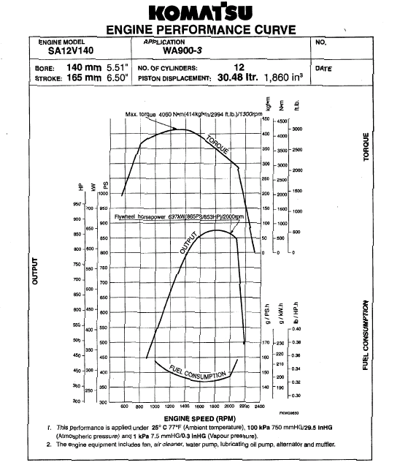

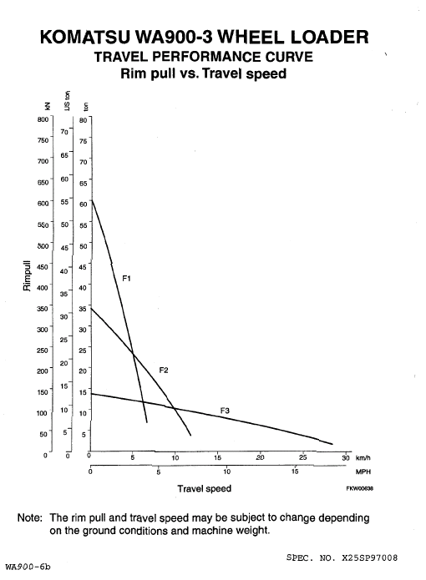

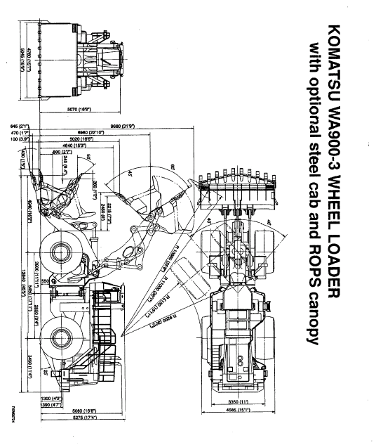

KOMATSU WA900-3 WHEEL LOADER

ACCESSORY PARTS TABLE

PART NO. | PART NAME | Q' TY | REMARKS
 | PARTS BOOK | 1
 | OPERATION & MAINTENANCE MANUAL | 1
 | STARTING SWITCH KEY | 2

KOMATSU WA900-3 WHEEL LOADER
OPTIONAL TOOL TABLE

PART NO. | PART NAME | Q’TY | REMARKS
424-98-11110 | NIPPLE | 1 | For axle oil drain
424-98-11120 | TUBE | 1 | For axle oil drain
09000-30006 | WRENCH SET | 1
09020-10284 | SOCKET WRENCH SET | 1
09033-00190 | SCREW DRIVER | 1
09036-00150 | PLIERS | 1
09014-10200 | ADJUSTABLE WRENCH | 1
09001-03600 | WRENCH | 1 | 36 mm
09289-00000 | GAUGE | 1 | For tire pressure
07952-80003 | GREASE PUMP | 1
07950-90403 | CARTRIDGE (GREASE) | 1
07951-31400 | NOZZLE | 1
09019-08035 | FILTER WRENCH | 1
424-98-11130 | BAR | 1
09963-03000 | PLATE | 1
09989-13301 | BAG | 1
09056-05620 | TOOL BAG | 1

KOMATSU WA900-3 WHEEL LOADER
OPTIONAL SPARE PARTS TABLE

PART NO. | PART NAME | Q' TY | REMARKS
6210-11-8811 | GASKET | 12 | For cylinder head cover
6210-11-8141 | RUBBER | 36 | For cylinder head cover
600-211-1231 | CARTRIDGE | 4 | For engine oil full-flow filter
600-311-7132 | CARTRIDGE | 2 | For fuel filter
424-16-11140 | ELEMENT | 6 | For transmission oil filter
07000-12125 | O-RING | 6 | For transmission oil filter
07000-12014 | O-RING | 6 | For transmission oil filter
600-212-1511 | CARTRIDGE | 1 | For engine oil bypass filter
07020-00900 | FITTING | 4
07020-00000 | FITTING | 4
07020-00675 | FITTING | 4
20Y-60-21510 | ELEMENT | 3 | For hydraulic filter
07000-12010 | O-RING | 3 | For hydraulic filter
07000-15175 | O-RING | 3 | For hydraulic filter
427-98-23110 | SPARE PART TABLE | 1
427-98-12210 | OIL | 1 | SAE 10W 10 liter
427-98-12230 | GREASE | 1 | KES LM-P
427-98-12240 | GREASE | 1 | KES LM-G
427-98-12410 | SPRAY | 10 | Paint (Natural yellow)
427-98-12420 | SPRAY | 3 | Paint (Cloud gray)
09059-00800 | SPARE PARTS BOX | 1

KOMATSU WA900-3 WHEEL LOADER
OPTIONAL EQUIPMENT LIST

DESCRIPTION
BASE MACHINE
BATTERIES – LARGE
ALTERNATOR - 90A
“GRAMMER” SET
SA12V140 WITH ELECTRONIC GOVERNOR
BKT, EX 11,5 VE TG TT
TEETH, SHARP, LIME
POOR FUEL (WATER) ARRANGEMENT
SIDE WORKING LIGHT
FOG LAMP
AIR HORN
REAR / VIEW MIRROR, LH & RH
LIGHT, AMBER BEACON
BАCK-UP ALARM
CANOPY, ROPS
CAB, STEEL
ROLL BELT – 78 MM SUS
EMERGENCY STEERING, AUTO, SAE
HEATER AND DEFROSTER
RADIO, AM-FM
WINDOW WIPER, REAR
FST FUEL FILL COUPLER “WIGGINS”
PM SERVICE CONNECTOR
AUTO GREASING SYSTEM “LINKOLN”
CAP LOCK & COVER LOCK

RADIATOR CORE PROTECTION GRID
IN-LINE FILTER
POWER TRAIN U/GUARD
MATERIALS CIS
FIRE EXTENGUISHER
CAP & OVERALL
GENERAL TOOL KIT
SPARE PARTS – GENERAL
RADIATOR SHUTTER
ADD HEATER
ARCTIC SEAL & HOSE

