Appendix No.
to Contract No.

KOMATSU HD1200-1

DUMP TRUCK

WITH COAL BODY

- Max. Payload: 130 ton
2. Coal Dump Body Capacity: 135 m³ with Tail Gate
3. +35ºC ~ -55ºC Specification
4. With Tires 33.00R51**
5. With Heavy Duty Rim 24.00-51



KOMATSU HD1200 Rear Dump Truck

Specifications

Type ............................................................................................... Diesel electric drive,
Rear Dump Truck
CAPACITY:
Struck ................................................................................... 107.0 m³
Heaped (SAE 3:1).................................................................. 135.0 m³
WEIGHTS:
Empty weight ........................................................................ 106,000 kg
Distribution:
Front Axle .......................................................................... 52,000kg
Rear Axle ........................................................................... 54,000kg
Max. payload ........................................................................ 130,000kg
Gross weight ........................................................................ 236,000kg
Distribution:
Front Axle .......................................................................... 76,000 kg
Rear Axle .......................................................................... 160,000 kg
PERFORMANCE:
Max. travel speed ................................................................. 57.5 km/h
Turning radius ....................................................................... 12.5 m
Dumping angle ...................................................................... 47º
Dumping speed ..................................................................... 15 seconds
DIMENSIONS:
Overall length ........................................................................ 12,030 mm
Overall width .......................................................................... 7,060 mm
Overall height
(when no load) .................................................................... 5,850 mm
Loading height
(when no load) .................................................................... 5,510 mm
Wheel base ........................................................................... 5,400 mm
Tread:
Front wheel ......................................................................... 5,016 mm
Rear wheel ......................................................................... 4,100 mm
Ground clearance
(when no load)..................................................................... 780 mm

ENGINE:
Model .......................................................................... KTTA38 C-1350
Type ............................................................................ Water-cooled 4 cycle,
V-type, direct injection,
Turbocharged and aftercooled
No. of cylinder
Bore x stroke ............................................................ 12-159mm x 159mm
Piston displacement .................................................... 37.8 litter
Performance:
Rated brake horse power .......................................... 1,007 kw/2,100 RPM
(1,350 HP/2,100 RPM)
Flywheel horse power ............................................... 977 kw/2,100 RPM
(1,310 HP/2,100 RPM)
Max. torque ............................................................... 5,264 Nm/1,500 RPM
(536.8 kgm/1,500 RPM)
Lubrication system:
Lubricating method .................................................... Gear pump, forced lubrication
Filter .......................................................................... Full flow type and by-pass type
Oil cooler ................................................................... Water-cooled
Cooling system ........................................................... Forced circulation by water
pump, suction type fan
Starting method ..................................................…...... Air starting motor
Attached equipment:
Air compressor .......................................................... two cylinders (850 l/min)
Electric equipment ..................................................... 24 volt alternator system
with 75 amperes
Engine mounting ............................................................... Front trunion support
Radiator mounting
Flywheel and flywheel housing
PT Pump
Oil Pan ............................................................................ Center sump,
129 litre capacity
Full flow filter and by-pass filter

ELECTRIC DRIVE SYSTEM:
Type .................................................................................. AC/DC current
Alternator............................................................................ TOYO ELECTRIC MFG.
Brushless type alternator
with built-in exciter,
model TDK-6620B
connected to the engine
through flexible coupling.
Rated 809 kW input for
traction.
Traction motor ..................................................................… TOYO ELECTRIC MFG.
Series wound DC motor,
model TDK-8911D. Rated
output is 343 kW/motor
Cooling ............................................................................... Forced, filtered air cools
both traction motors and
alternator
FINAL DRIVE:
Type ................................................................................... Planetary gear
Axle .................................................................................... Heavy duty, full floating
Reduction ratio .................................................................... 29.37 : 1
STEERING SYSTEM: ..................................................................... Full hydraulic power
steering with dual
steering cylinder
TIRES:
Front and rear ..................................................................... 33.00R51, two Star VRLS
tubeless,
front x 2, rear x 4.
Rim ..................................................................................... 24.00-51
BRAKES:
Emergency and parking ........................................................ Spring loaded,
calliper disk-type.

Service, front and rear ......................................................... Brake-drum shoe internal-
expanding type with
hydropneumatic drive,
980 x 250 mm

Dynamic brake ................................................................ 1492 kW (2000 HP) (See
performance curve) Dynamic
braking on rear wheel,
utilises wheel motors as
generators and dissipates
vehicle kinetic energy
into air cooled resistors.

SUSPENSIONS, front and rear .................................................... hydropneumatic type
DUMP SYSTEM:
Type .............................................................................… Twin, 3-stage hydraulic
cylinder double acting in
third stage.
Hydraulic pump:
Type ................................................................................….. Gear pump
Max. pressure ...................................................................… 210 kg/cm²
Capacity ...........................................................................….. 660 ltr/min

CAPACITY:
Fuel tank .............................................................................…. 1,900 ltr.
Cooling water ......................................................................….. 250 ltr.
Engine oil .............................................................................…. 134 ltr.

CAB .........................................................................................….. One side cab type.
Steering wheel is located
on the left side. One
operator seat and one
auxiliary seat.

DUMP BODY ............................................................................… SAE Geometric capacity of
rock type body is 107 m³
and with heap (3:1)- 135 m³.
The thickness of bottom
of the body is 19 mm and
tensile strength of bottom
plate is 130 kg/mm².

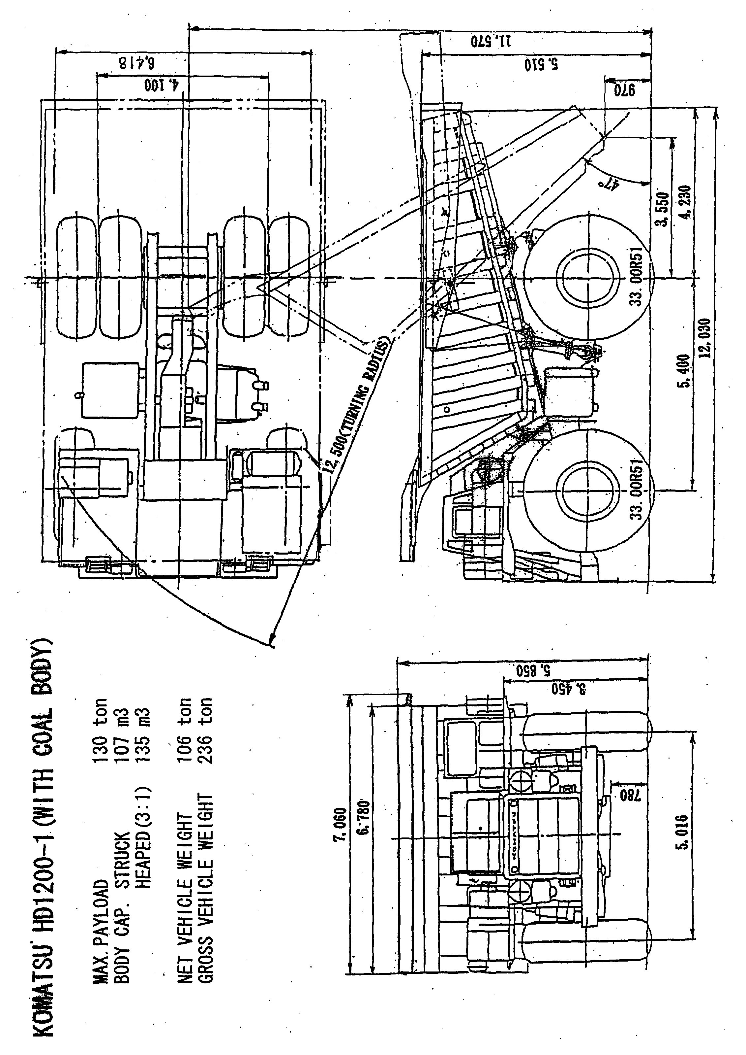

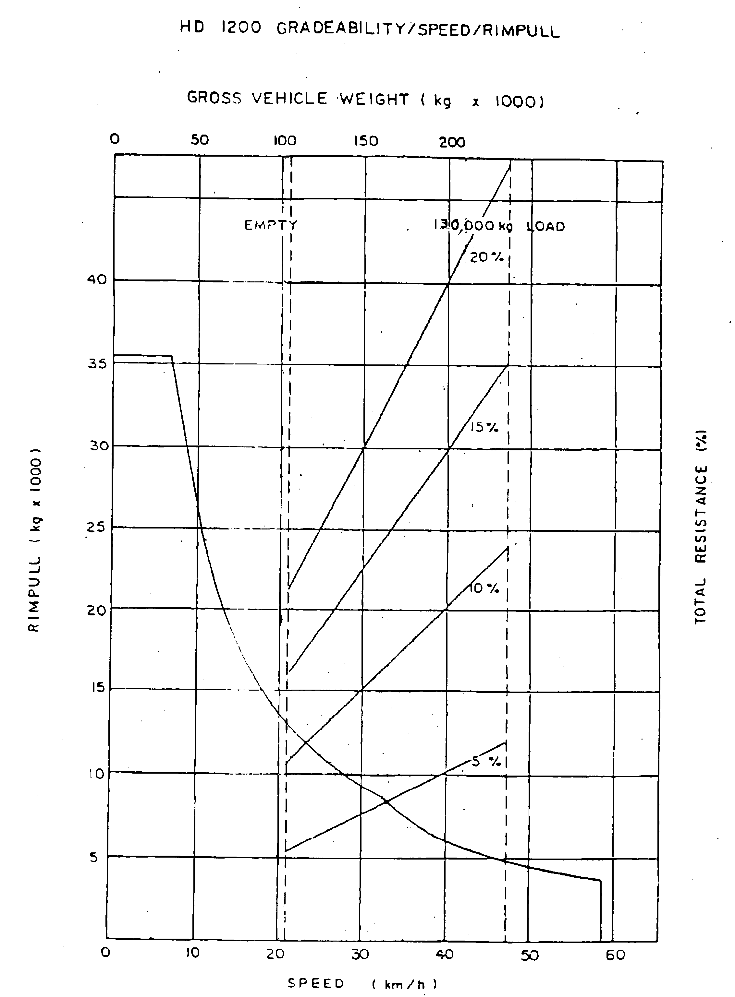

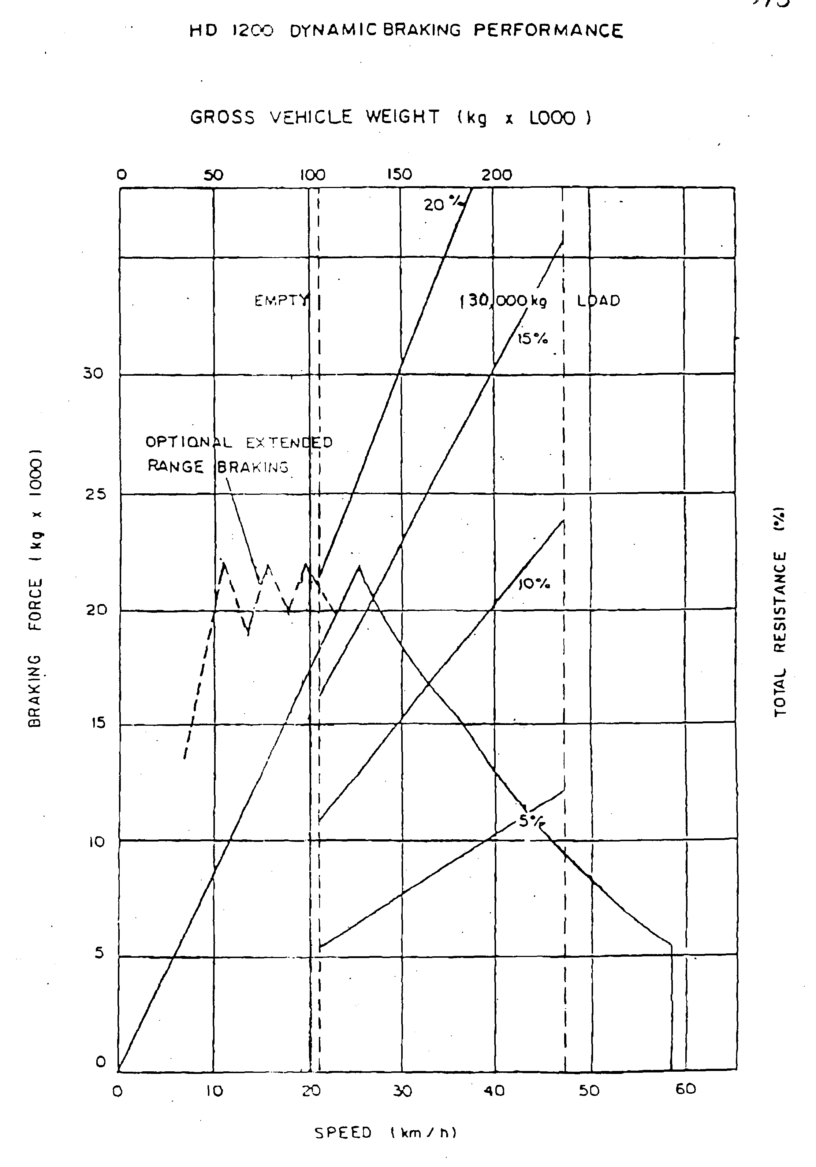

1) STANDARD EQUIPMENT
1-1) Cab:
Ash tray
Cigar lighter
Dome light
Adjustable sun visor
Low air pressure alarm
Central warning light
Windshield wiper
Windwasher tank
Glove box
Car radio
Heater & defroster (4400 kcal/h)

1-2) Instrument:
Engine oil temperature gauge
Engine water temperature gauge
Speed meter (km/h)
Tachometer
Air pressure gauge
Voltmeter (Battery out-put)
Hourmeter
Fuel gauge
Engine oil pressure indicator light
Engine water temperature indicator light
Over speed warning light
Dynamic brake indicator light
Service brake indicator light
Air pressure warning light
High beam indicator light
Brake lock indicator light
Parking brake indicator light
Turning signal indicator light
Electric equipment over heat warning light
Ground fault indicator light
Air cleaner restriction gauge
Lamp test switch
Hubodometer

Lamp switch (head light/instrument panel light/Tail light)
Working light switch
Wiper switch
Parking brake switch
Brake lock switch
Fuel gauge on tank
1-3) Vehicle
Dynamic retarding light
Backup light
Stop light
Tail light
Front clearance light (white) and turn signal light (yellow)
Rear turn signal light (yellow)
Working light
Dome light (for engine room)
Dome light (for axle housing)
1-4) Safety equipment:
Horn (warning)
Backup warning horn
Mirrors LH and RH
Air-over-hydraulic service brake with emergency relay
Parking brake
Full time power steering
Wheel brake lock
Radiator fan guard
Operator seat belt
Propulsion interlock (Parking brake/Control box door
open/Electric equipment heater
switch on/Brake lock)
Safety guard on bonnet
Safety guard for P.D.U.

2) SPECIALLY ATTACHED EQUIPMENTS

 | - Extended range Dynamic retarding
- Fire extinguishing system (covering engine/generator/
hydraulic pumps, including PDU: switch on of this system
effected in the cabin and on the ground) - 3 bottles
 | - Pull-hook (Rear)
 | - Pull-hook (Front)
 | - Low insulation lamp
 | - Rear clearance light (red)
 | - Reinforced operator seat
 | - Engine oil pressure gauge
 | - Dump lever indicator light and sound signalization
 | - Preliminary fuel pumping system
 | - Socket for portable inspection lamp (24V Russian Standard)
 | - Alcohol injection device
 | - Cold start aid (Ether type)
 | - Traction motor preheating device
 | - Traction motor preheating switch
 | - Engine side cover
 | - Engine room undercover (rod type)
 | - Engine winter-proof intake system
 | - Air dryer with heater
 | - Winter-proof hoses, wiring and shields
 | - Pre-lubrication device with heater
- Group lubrication system (2 groups: hoist cylinder pin upper
and lower, body hinge pin)
??? | - LINCOLN centro-matic system for (2 or 8 or all) points  lubrication
- Radiator coolant level warning device with caution lamp and
sound signal in cabin
- Fuel fired heater ("MIKUNI" model M-135 13500 kcal/h Air
flow 750m³/h) Heater for Cab/Electric control box/Battery
box/Air equipment box.)
 | - Emergency steering system
 | - Propulsion interlock (Body-up)
 | - Ladder to fuel tank
 | - Reinforced bumper
 | - Automatic emergency engine stopper
 | - Radiator curtain
 | - Hydraulic oil temperature gauge with warning lamp
 | - High pressure line-filter
 | - Passenger seat
 | - Radiator shutter (thermostatically controlled)
 | - Anti-slip plate on bonnet
 | - Strengthened type body rear rib
 | - Mud cover (for R.H. mirror)
 | - Clearance light
 | - Heavy duty additional car heater (4400 kcal/h)
 | - Air conditioner (hot: 3550 kcal/h, cooling: 3250 kcal/h)
 | - Spot fog lamp (H3) with switch
- Halogen lamp head light assembly with H1 bulb x 2 pcs
Halogen lamp head light assembly with H4 bulb x 2 pcs
- Hydraulic circuit suppliable hydraulic pressure from outside
(quick coupling type) without hose
- Hoses for hydraulic circuit suppliable hydraulic pressure from
outside (quick coupling type) - for 1 unit from 3 units
 | - Pay Load Meter PC type (type 2)
 | - Thermopane front glass
 | - Fuel tank strainer relocate
 | - Integral type ROPS Cab (optional)

3) STANDARD TOOLS:
09000-30006 Open end wrench set
09002-00810 wrench
09002-01214 wrench
09002-01317 wrench
09002-01922 wrench
09002-02427 wrench
09002-03032 wrench
09007-00528 wrench
09007-00632 wrench
09007-00836 wrench
09014-10200 wrench
09020-10284 Socket wrench set
09021-01016 socket
09021-01319 socket
09021-01422 socket
09021-01725 socket
09021-01928 socket
09021-02233 socket
09021-02436 socket
09021-02739 socket
09021-03044 socket
09021-03246 socket
09021-03653 socket
09022-00150 extension
09022-00250 extension
09023-00300 handle
09024-00300 handle
09025-00075 joint
09026-00250 handle
09027-00300 bar
09031-00100 driver, screw
09031-00150 driver, screw
09036-00150 pliers
09039-00150 hammer
09054-00009 gauge, thickness
09055-10390 bar
09289-10000 gauge, tire

07950-10400 pump, grease
07951-21045 nozzle A
07951-11400 nozzle B
07950-90403 cartridge, grease
09023-00380 handle
178-98-11120 socket
581-98-12120 adapter, handle
09288-20011 hose
09285-00000 adapter
09019-08035 wrench
287-98-12110 wrench
09084-00915 socket
09084-01118 socket
09084-01220 socket
09084-01422 socket
09084-01524 socket
09084-02030 socket
09082-01719 wrench
09082-01214 wrench
09056-05513 bag
6721-01-7501 drain hose ass'y

OTHER ATTACHED ARTICLES
One each of key for driver's door key
and starting key
One set of manuals

