KOMATSU HD1200-1D

DUMP TRUCK

With Deep Pit Drive System

1. Max. Payload: 136 ton
2. Dump Body Capacity: 78 m³
3. Heavy Duty Rim 24.00-51 (7 pcs) with Tires
4. KTTA38C-1350 Engine
5. +40ºC ~ - 45ºC Specification



KOMATSU HD1200-1D Rear Dump Truck
(with deep pit drive system)
Specifications

Type .............................................................................. Diesel electric drive, Rear Dump Truck
CAPACITY:
Struck ................................................................................…... 55.6 m³
Heaped (SAE2:1)................................................................…… 78.0 m³
WEIGHTS:
Empty weight ......................................................................... 103,980 kg
Distribution:
Front Axle ............................................................................ 45,550 kg
Rear Axle ............................................................................ 58,430 kg
Rated payload......................................................................... 120,000 kg
Max. payload .......................................................................... 136,000 kg
Gross weight ........................................................................... 239,980 kg
Distribution:
Front Axle .............................................................................. 76,330 kg
Rear Axle .............................................................................. 163,650 kg
PERFORMANCE:
Max. travel speed ..................................................................... 57.5 km/h
Turning radius ......................................................................... 12.5 m
Dumping angle ........................................................................ 47.5º
Dumping speed ....................................................................... 17 second
DIMENSIONS:
Overall length .......................................................................... 10,980 mm
Overall width ........................................................................... 6,640 mm
Overall height
(when no load) ..................................................................... 5,560 mm
Loading height
(when no load) ..................................................................... 4,810 mm
Wheel base ..............................................................…........… 5,400 mm
Tread:
Front wheel ..........................................................…............. 5,016 mm
Rear wheel ........................................................….........…... 4,100 mm
Ground clearance
(when no load).................................................….................. 700 mm

ENGINE:
Model .................................................................................. KTTA38 C-1350
Type ................................................................................... Water cooled 4 cycle,
V-type, direct injection,
turbocharged and
aftercooled
No. of cylinder-
bore x stroke ................................................................…. 12-159mm x 159mm
Piston displacement ..........................................................… 37.8 litres
Performance:
Rated brake horse power ................................................ 1,007 kw/2,100 RPM
(1,350 HP/2,100 RPM)
Flywheel horse power ...................................................... 977 kw/2,100 RPM
(1,310 HP/2,100 RPM)
Max. torque ..................................................................… 5,264 Nm/1,500 RPM
(536.8 kgm/1,500 RPM)
Lubrication system:
Lubricating method .......................................................… Gear pump, forced lubrication
Filter ............................................................................…. Full flow type and by-pass
types
Oil cooler .....................................................................…. Water cooled
Cooling system ...............................................................…. Forced circulation by water
pump, suction type fan
Starting method .............................................................….. Air starting motor
Attached equipment:
Air compressor ...........................................................….. two cylinder (850 l/min)
Electric equipment ......................................................….. 24 volt alternator system
with 75 amperes
Engine mounting ..............................................................…… Front trunion support
Radiator mounting
Flywheel and flywheel housing
PT Pump
Oil Pan ...........................................................................……. Center sump, 129 litres
capacity
Full flow filter and by-pass filters

ELECTRIC DRIVE SYSTEM:
Type .................................................................................... AC/DC current
Alternator............................................................................. TOYO ELECTRIC MFG.
Brushless type alternator
with built-in exciter,
model TDK-6621A connected
to the engine through
flexible coupling. Rated
921 kW Input for traction
.
Traction motor ..................................................................... TOYO ELECTRIC MFG.
Series wound DC motor,
model TDK-8935A. Rated
output is 395 kW/motor

Cooling ................................................................................ Forced, filtered air cools
both traction motors and
alternator
FINAL DRIVE:
Type .................................................................................... Planetary gear
Axle ..................................................................................... Heavy duty, full floating
Reduction ratio .................................................................... 26.0 : 1
STEERING SYSTEM: ..................................................................... Full hydraulic power
steering with dual
steering cylinder
TIRES:
Front and rear ...................................................................... 33.00-R51, two star VRLS
tubeless,
front x 2, rear x 4.

Rim ...................................................................................... 24.00-51
BRAKES:
Emergency and parking ....................................................... Spring loaded, calliper
disc type.

Service, front and rear .......................................................... Brake-drum shoe internal -
expanding type with
hydropneumatic drive,
980 x 250 mm

Dynamic brake .................................................................... 1492 kW (2000 HP) (See
performance curve) Dynamic
braking on rear wheel,
utilise wheel motors as
generators and dissipates
vehicle kinetic energy
into air cooled resistors.
SUSPENSIONS, front and rear ..................................................... hydropneumatic type
DUMP SYSTEM:
Type .................................................................................. Twin, 3-stage hydraulic
cylinder double acting in
third stage.
Hydraulic pump:
Type .................................................................................. Gear pump
Max. pressure .................................................................... 210 kg/cm²
Capacity ............................................................................. 660 ltr/min
CAPACITY:
Fuel tank ..............................................................................…. 1,900 ltr.
Cooling water .........................................................................… 250 ltr.
Engine oil ................................................................................… 134 ltr.
CAB .........................................................................................…… One side cab type.
Steering wheel is located
on the left side. One
operator seat and one
auxiliary seat.
DUMP BODY ............................................................................….. SAE Geometric capacity of
rock type body is 55.6 m³
and with heap - 78 m³.
The thickness of bottom
of the body is 19 mm and
tensile strength of bottom
plate is 130 kg/mm².

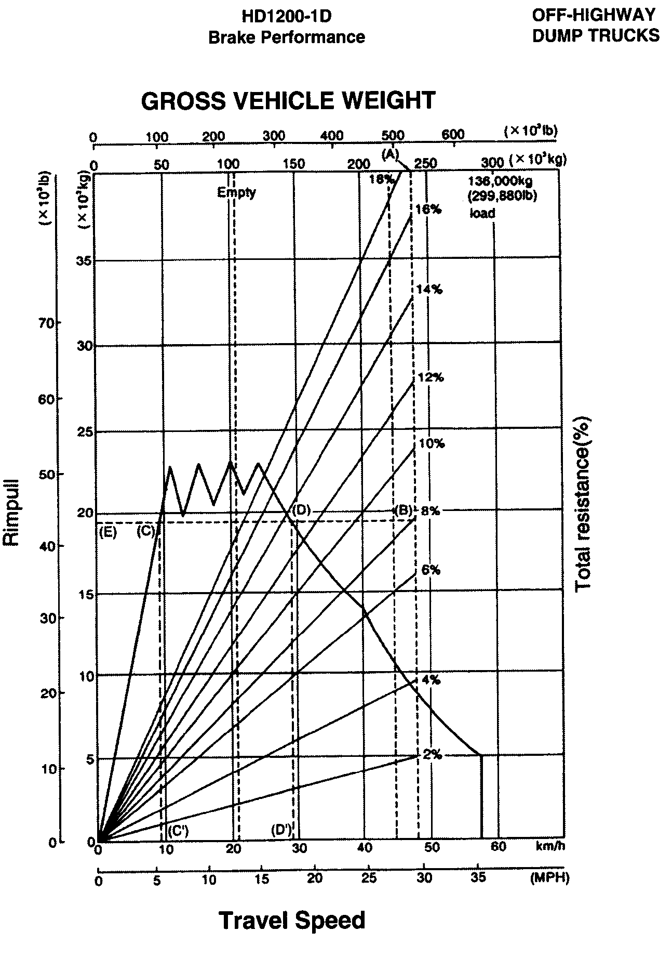
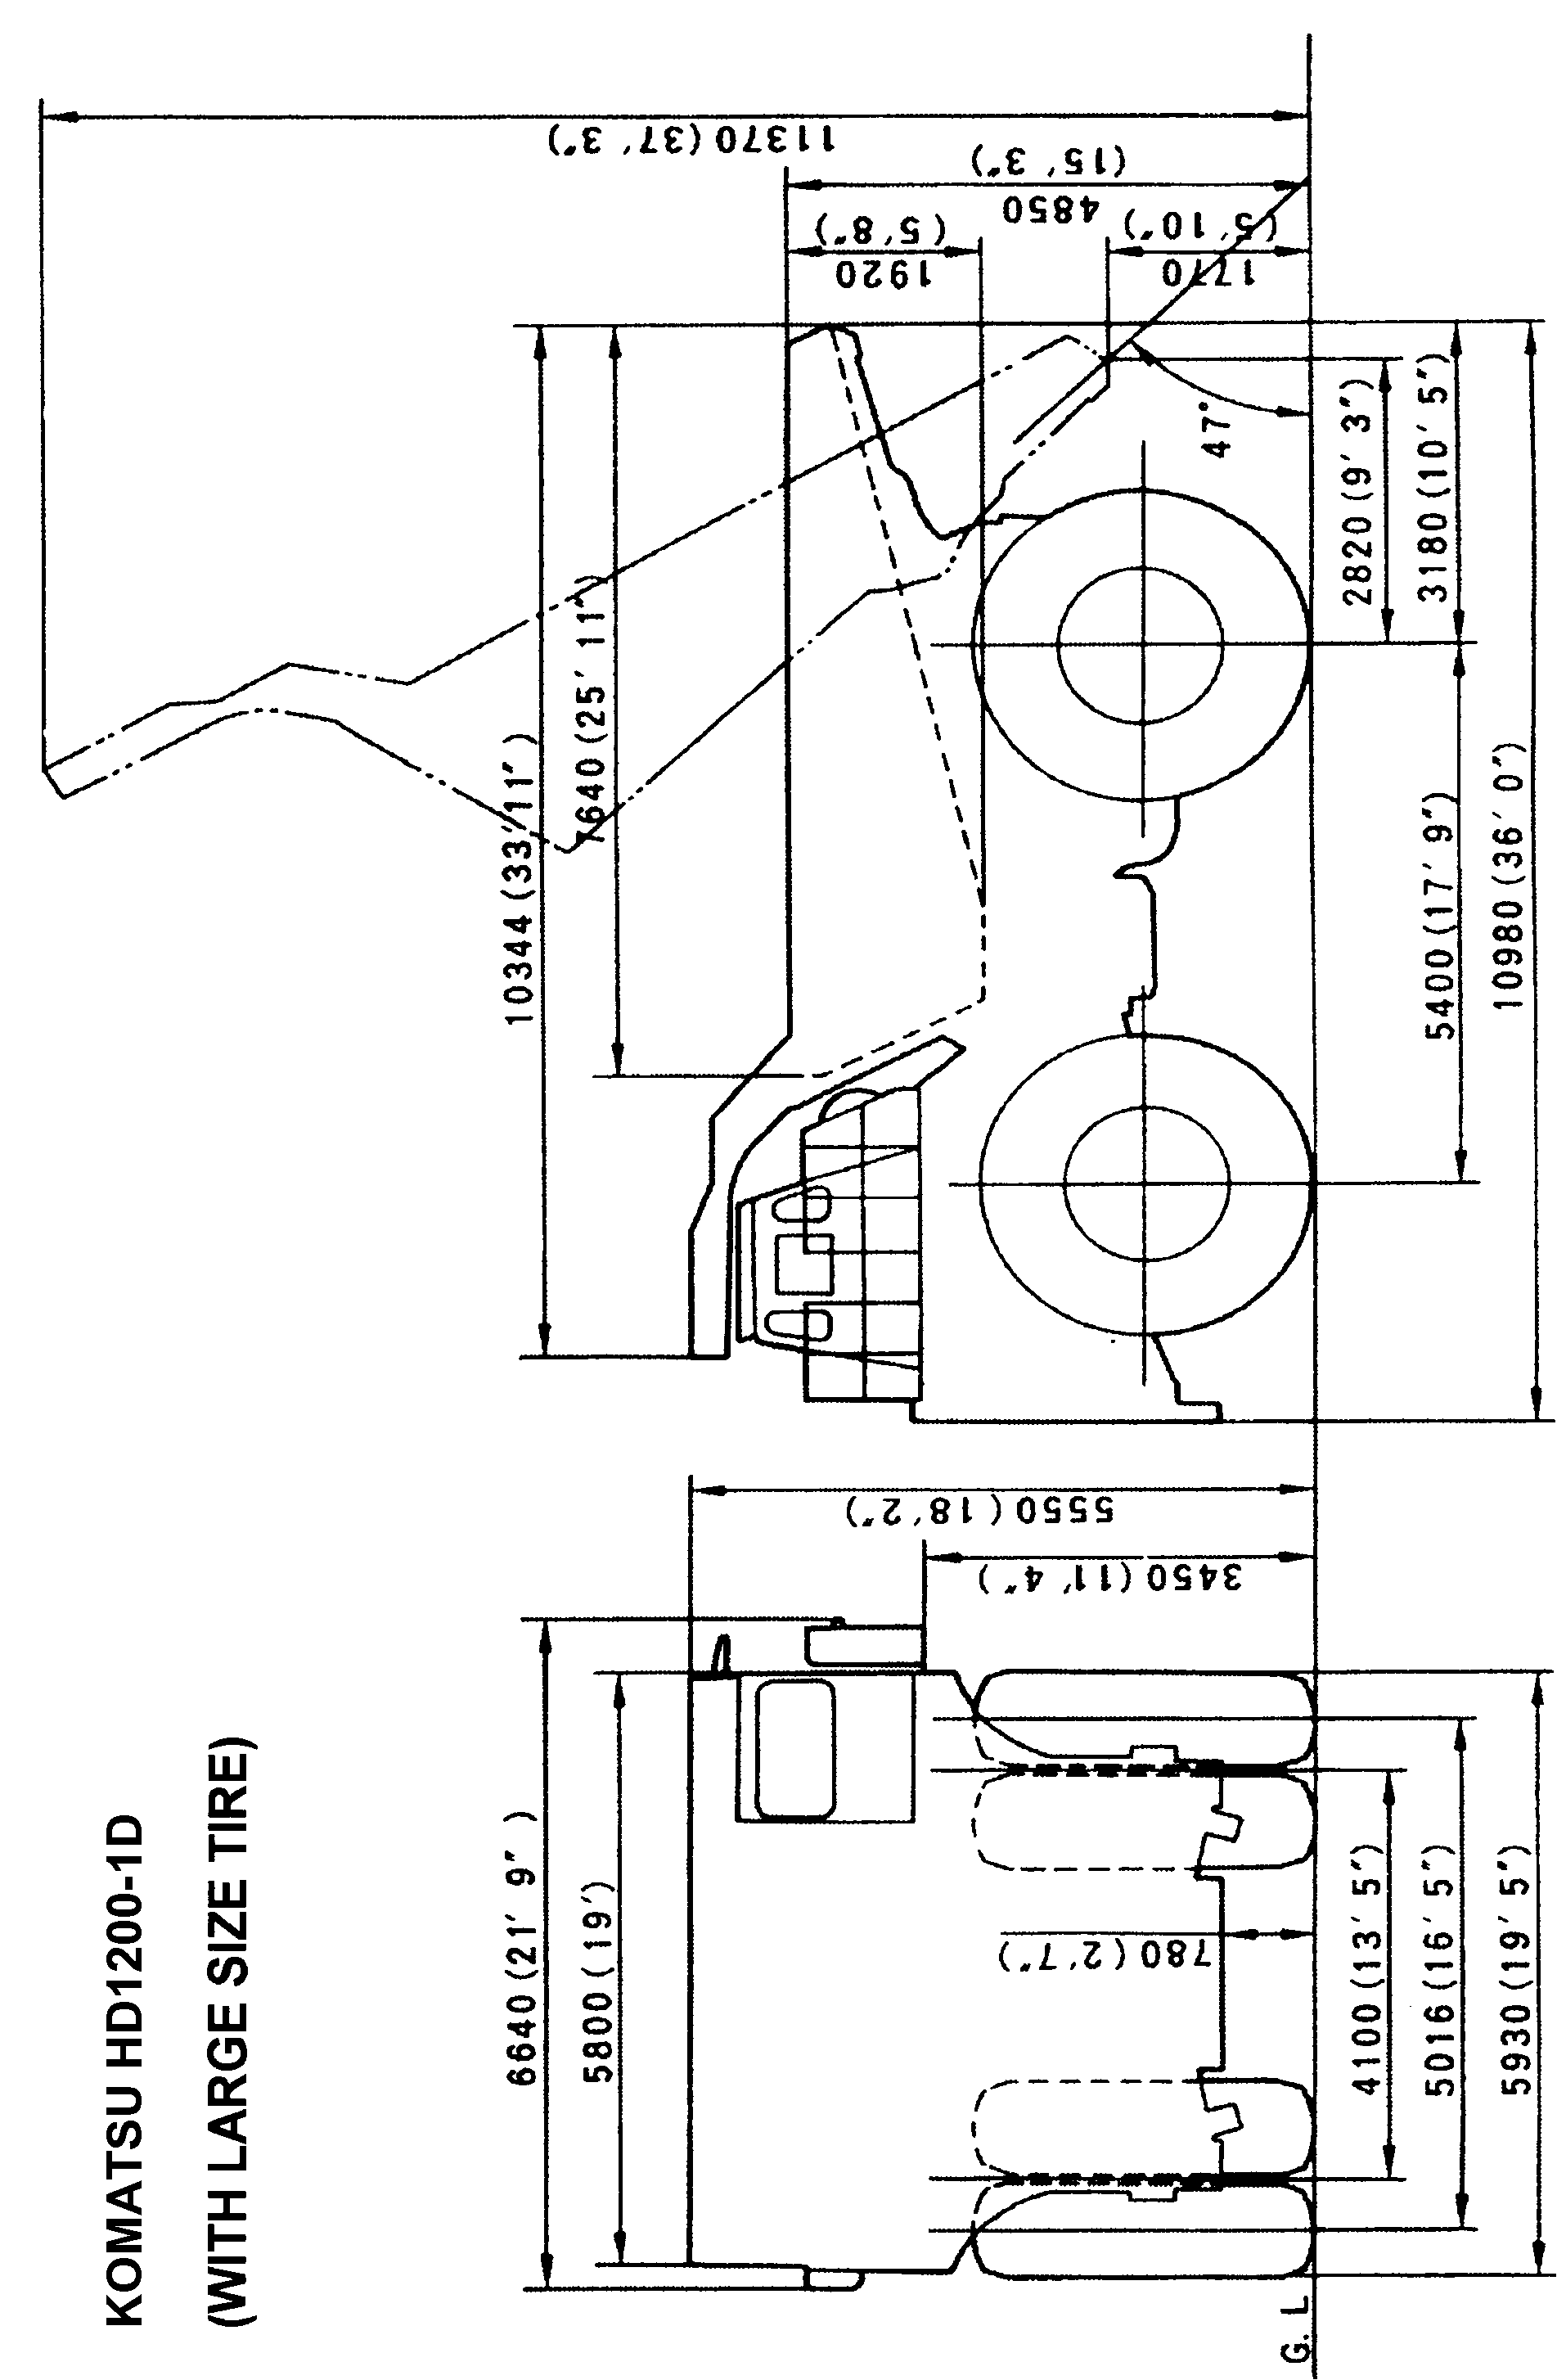
1) STANDARD EQUIPMENT
1-1) Cab:
Ash tray
Cigar lighter
Dome light
Adjustable sun visor
Low air pressure alarm
Central warning light
Windshield wiper
Windwasher tank
Glove box
Heater & defroster

1-2) Instrument:
Engine oil temperature gauge
Engine water temperature gauge
Speed meter (km/h)
Tachometer
Air pressure gauge
Voltmeter (Battery out-put)
Hourmeter
Fuel gauge
Engine oil pressure indicator light
Engine water temperature indicator light
Over speed warning light
Dynamic brake indicator light
Service brake indicator light
Air pressure warning light
High beam indicator light
Brake lock indicator light
Parking brake indicator light
Turning signal indicator light
Electric equipment over heat warning light
Ground fault indicator light
Air cleaner restriction gauge
Lamp test switch
Hubodometer

Lamp switch (head light/instrument panel
light/Tail light)
Working light switch
Wiper switch
Parking brake switch
Brake lock switch
Fuel gauge on tank
1-3) Vehicle
Dynamic retarding light
Backup light
Stop light
Tail light
Front clearance light (white) and turn signal
light (yellow)
Rear turn signal light (yellow)
Working light
Dome light (for engine room)
Dome light (for axle housing)
1-4) Safety equipment:
Horn (warning)
Backup warning horn
Mirrors LH and RH
Air-over-hydraulic service brake with
emergency relay
Parking brake
Full time power steering
Wheel brake lock
Radiator fan guard
Operator seat belt
Propulsion interlock (Parking brake/Control
box door open/Electric equipment heater
switch on/Brake lock)
Safety guard on bonnet
Safety guard for P.D.U.

2) SPECIALLY ATTACHED EQUIPMENT
- Extended range Dynamic retarding
- Fire extinguishing system (covering engine/
generator/ hydraulic pumps, including PDU:
switch on of this system effected in the cabin
and on the ground) - 3 bottles

- Pull-hook (Rear)
- Pull-hook (Front)
- Low insulation lamp
- Rear clearance light (red)
- Reinforced operator seat
- Engine oil temperature gauge
- Engine oil pressure gauge
- Dump lever indicator light and sound
signalization
- Preliminary fuel pumping system
- Socket for portable inspection lamp
(24V RF Standard)
- Alcohol injection device
- Cold start aid (Ether type)
- Traction motor preheating device
- Traction motor preheating switch
- Engine side cover
- Engine room undercover
- Air dryer with heater
- Winter-proof hoses, wiring and shields
- Pre-lubrication device
- Group lubrication system (2 groups: hoist
cylinder pin upper and lower, body hinge
pin)
- LINCOLN centro-matic system for 2 points
lubrication
- Radiator coolant level warning device with
caution lamp and sound signal in cabin
- Fuel fired heater ("MIKUNI" model M-135
13500 kcal/h Air flow 750m3/h) Heater for
Cab/Electric control box/Battery box/
Air equipment box.)
- Emergency steering system
- Propulsion interlock (Body-up)
- Ladder to fuel tank
- Reinforced bumper
- Automatic emergency engine stopper
- Radiator curtain
- Hydraulic oil temperature gauge
with warning lamp
- High pressure line-filters
- Passenger seat
- Radiator shutter (thermostatically controlled)
- Platform guard (R.H.)
- Anti-slip plate on bonnet
- Strengthened type body rear rib
- Clearance light
- 2 Heavy duty additional car heaters
(for defroster 4400 kcal)
- Heater switch
- Fog lamp
- PLM System (PC-type)

3) STANDARD TOOLS:
09000-30006 wrench set
09007-00528 wrench
09007-00632 wrench
09007-00836 wrench
09014-10200 wrench
09020-10284 socket wrench
09031-00100 screw, driver
09031-00150 screw, driver
09036-00150 pliers
09039-00150 hammer
09054-00009 gauge
09055-10390 bar. pinch
09289-10000 gauge
07952-80002 pump assy
07951-11400 nozzle
07950-90403 cartridge
09023-00380 handle
178-98-11120 socket
581-98-12120 adapter
09288-20011 hose
09285-00000 adapter
09019-08035 wrench
287-98-12110 wrench
09084-00915 socket
09084-01118 socket
09084-01220 socket
09084-01422 socket
09084-01524 socket
09084-02030 socket
09082-01719 wrench
09056-05513 bag
672-10-17501 hose assy
09082-01214 wrench

OTHER ATTACHED ARTICLES One each of key for driver's door key
and starting key
One set of manuals

