KOMATSU HD1200-1

DUMP TRUCK

LOADING CAPACITY 136 TON

1. Max. Payload: 136 ton
2. Dump Body Capacity: 78 m³
3. Heavy Duty Rim 24.00-51 (7 pcs) with Tires
4. With KTTA38C-1350 Engine
5. -30ºC ~ +40ºC Specification



KOMATSU HD1200-1 Rear Dump Truck

Specifications

Type .........................................................................……………. Diesel electric drive,
Rear Dump Truck
CAPACITY:
Struck ...........................................................……………. 53.5 m3
Heaped (SAE 2:1) …………………………………………... 78.0 m3
WEIGHTS:
Empty weight ................................................................... 100,880 kg
Distribution:
Front Axle ..................................................................... 46,730 kg
Rear Axle ...................................................................... 54,150 kg
Max. payload .................................................................... 136,000 kg
Gross weight ...................................................…………… 236,880 kg
Distribution:
Front Axle ........................................................................ 79,380 kg
Rear Axle ........................................................................ 157,500 kg
PERFORMANCE:
Max. travel speed ............................................................... 57.5 km/h
Turning radius .........................................................….....… 12.5 m
Dumping angle ............................................................…… 47.0º
Dumping speed ................................................................… 15 second
DIMENSIONS:
Overall length ..................................................................... 10,980 mm
Overall width ....................................................................... 6,640 mm
Overall height
(when no load) .................................................…….......... 5,560 mm
Loading height
(when no load) ...............................................................…. 4,650 mm
Wheel base ......................................................................... 5,400 mm
Tread:
Front wheel ...................................................................... 5,016 mm
Rear wheel ...................................................................... 4,100 mm
Ground clearance
(when no load).................................................................... 780 mm

ENGINE:
Model ................................................................................. KTTA38 C-1350
Type .................................................................................. Water cooled 4 cycle,
V-type, direct injection,
turbocharged and aftercooled
No. of cylinder-
bore x stroke .................................................................. 12-159mm x 159mm
Piston displacement .......................................................... 37.8 litres
Performance:
Rated brake horse power ................................................ 1,007 kw/2,100 RPM
(1,350 HP/2,100 RPM)
Flywheel horse power ..................................................... 977 kw/2,100 RPM
(1,310 HP/2,100 RPM)
Max. torque .................................................................... 5,264 Nm/1,500 RPM
(536.8 kgm/1,500 RPM)
Lubrication system:
Lubricating method ......................................................... Gear pump, forced lubrication
Filter .............................................................................. Full flow type and by-pass type
Oil cooler ....................................................................... Water-cooled
Cooling system ................................................................. Forced circulation by
water pump,
suction type fan

Starting method .............................................................… Air starting motor
Attached equipment:
Air compressor ...........................................................…. Two cylinder (850 l/min)
Electric equipment ......................................................…. 24 volt alternator system
with 75 amperes

Engine mounting ..............................................................….. Front trunion support
Radiator mounting
Flywheel and flywheel housing
PT Pump
Oil Pan ...........................................................................…… Center sump,
129 litres capacity

Full flow filter and by-pass filter

ELECTRIC DRIVE SYSTEM:
Type .................................................................................. AC/DC current
Alternator........................................................................... TOYO ELECTRIC MFG.
Brushless type alternator
with built-in exciter,
model TDK-6620B connected
to the engine through
flexible coupling. Rated
809 kW Input for traction.

Traction motor ................................................................... TOYO ELECTRIC MFG.
Series wound DC motor,
model TDK-8911D. Rated
output is 343 kW/motor

Cooling ............................................................................... Forced, filtered air cools
both traction motors and
alternator
FINAL DRIVE:
Type ................................................................................... Planetary gear
Axle .................................................................................... Heavy duty, full floating
Reduction ratio ................................................................... 29.37 : 1
STEERING SYSTEM: .................................................................... Full hydraulic power
steering with dual
steering cylinder
TIRES:
Front and rear .................................................................... 33.00R51 ∗∗, VRLS type E-4
tread, tubeless,
front x 2, rear x 4.

Rim ................................................................................... 24.00-51 (reinforced type)
BRAKES:
Emergency and parking .................................................... Spring loaded, caliper
Disc type.

Service, front and rear ....................................................... Brake-drum shoe internal -
expanding type with
hydropneumatic drive,
980 x 250 mm

Dynamic brake .................................................................. 1492 kW (2000 HP) (See
performance curve) Dynamic
braking on rear wheel,
utilizes wheel motors as
generators and dissipates
vehicle kinetic energy
into air cooled resistors.

SUSPENSIONS, front and rear .................................................... hydropneumatic type

DUMP SYSTEM:
Type .................................................................................. Twin, 3-stage hydraulic
cylinder double acting in
third stage.
Hydraulic pump:
Type ..................................................................................... Gear pump
Max. pressure ...................................................................... 210 kg/cm2
Capacity ............................................................................... 660 ltr/min
CAPACITY:
Fuel tank ................................................................................ 1,900 ltr.
Cooling water ......................................................................... 250 ltr.
Engine oil ............................................................................... 134 ltr.

CAB ........................................................................................... One side cab type.
Steering wheel is located
on the left side. One
operator seat and one
auxiliary seat.

DUMP BODY .............................................................................. SAE Geometric capacity of
rock type body is 53.5 m³
and with heap - 78 m³.
The thickness of bottom
of the body is 19 mm and
tensile strength of bottom plate
is 130 kg/mm².

KOMATSU HD1200 (WITH LARGE SIZE TIRE)
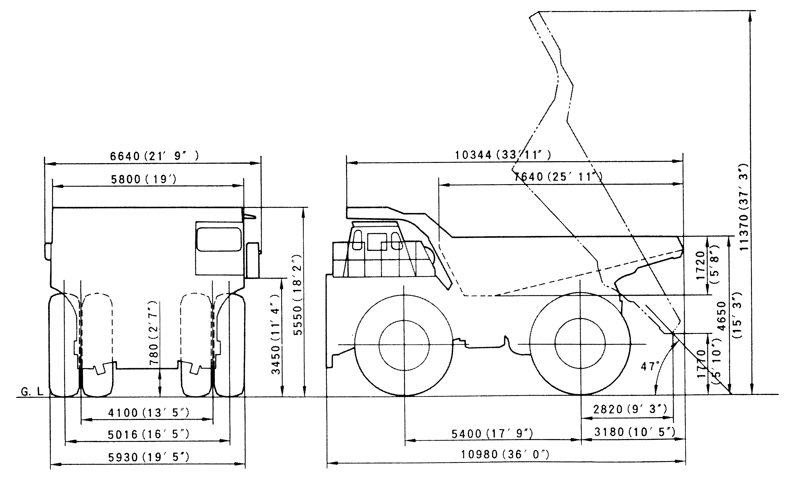
HD1200 GRADEABILITY / SPEED / RIMPULL

GROSS VEHICLE WEIGHT (kg x 1000)

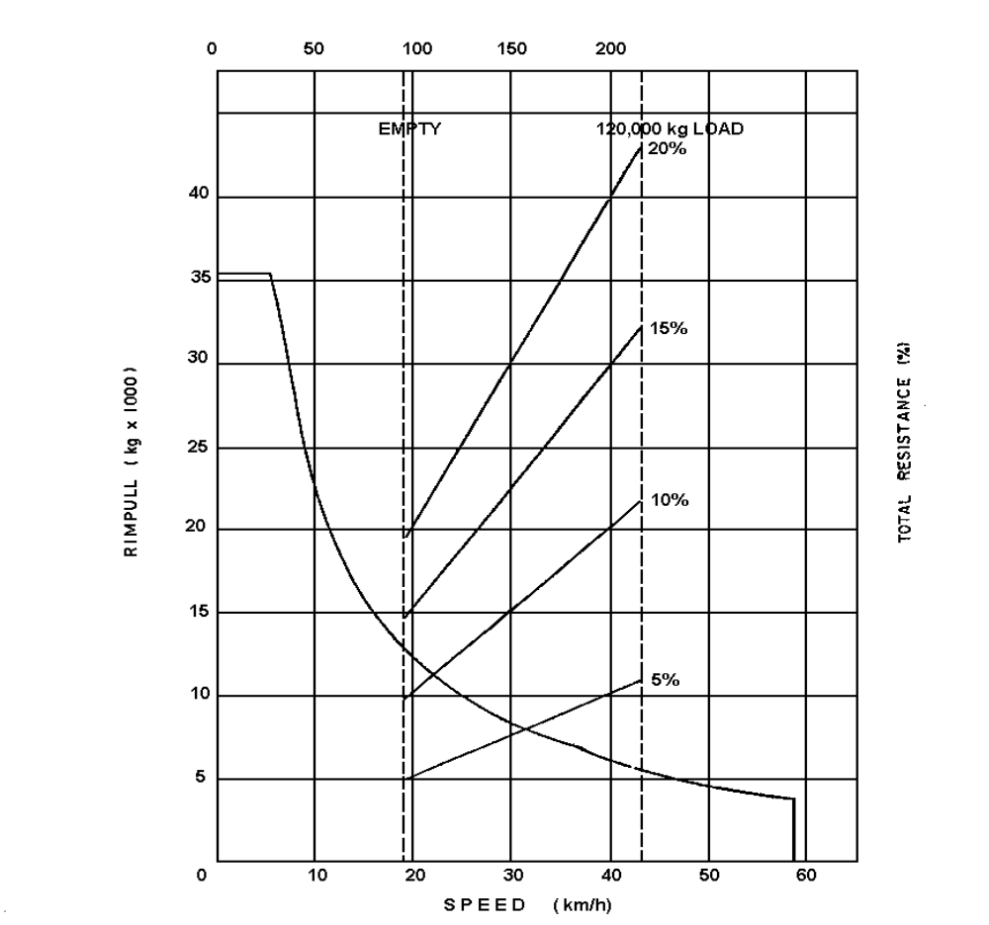

HD1200 DYNAMIC BRAKING PERFORMANCE

GROSS VEHICLE WEIGHT (kg x 1000)

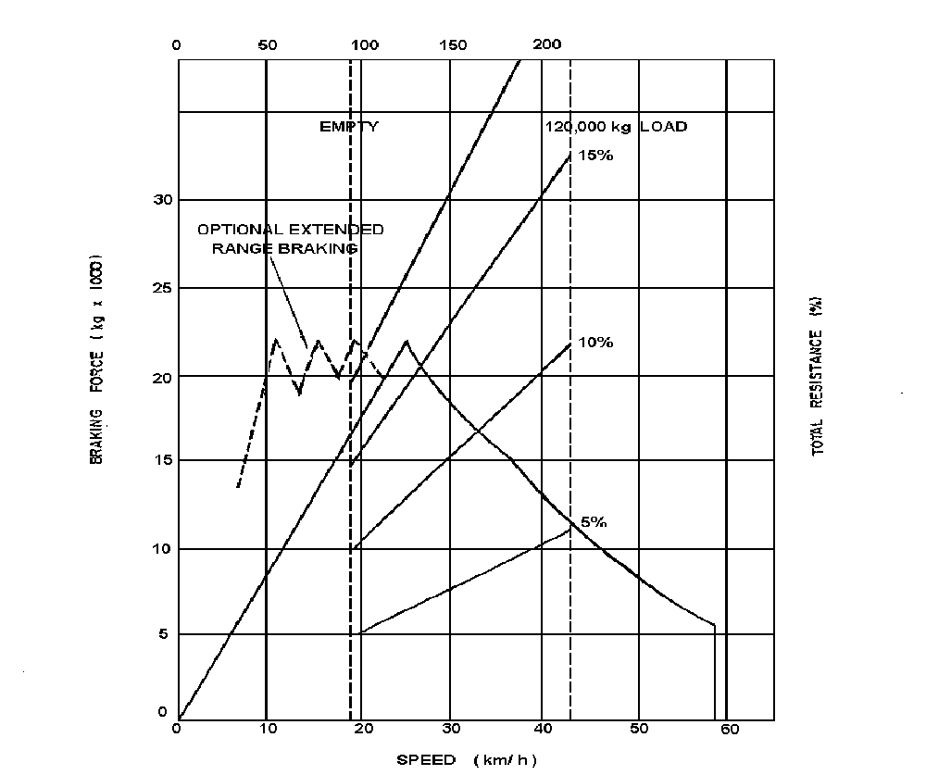

1) STANDARD EQUIPMENT
1-1) Cab:
Ash tray
Cigar lighter
Dome light
Adjustable sun visor
Low air pressure alarm
Central warning light
Windshield wiper
Windwasher tank
Glove box
Heater & defroster

1-2) Instrument:
Engine oil temperature gauge
Engine water temperature gauge
Speed meter (km/h)
Tachometer
Air pressure gauge
Voltmeter (Battery out-put)
Hourmeter
Fuel gauge
Engine oil pressure indicator light
Engine water temperature indicator light
Over speed warning light
Dynamic brake indicator light
Service brake indicator light
Air pressure warning light
High beam indicator light
Brake lock indicator light
Parking brake indicator light
Turning signal indicator light
Electric equipment over heat warning light
Ground fault indicator light
Air cleaner restriction gauge
Lamp test switch
Hubodometer
Lamp switch (head light/instrument panel light/
Tail light)
Working light switch
Wiper switch
Parking brake switch
Brake lock switch
Fuel gauge on tank
1-3) Vehicle
Dynamic retarding light
Backup light
Stop light
Tail light
Front clearance light (white) and
turn signal light (yellow)
Rear turn signal light (yellow)
Working light
Dome light (for engine room)
Dome light (for axle housing)
1-4) Safety equipment:
Horn (warning)
Backup warning horn
Mirrors LH and RH
Air-over-hydraulic service brake with emergency relay
Parking brake
Full time power steering
Wheel brake lock
Radiator fan guard
Operator seat belt
Propulsion interlock (Parking brake/Control box door
open/Electric equipment heater
switch on/Brake lock)
Safety guard on bonnet
Safety guard for P.D.U.

2) SPECIALLY ATTACHED EQUIPMENTS
- Extended range dynamic retarding
- Fire extinguishing system (covering engine/
generator/ hydraulic pumps, including PDU: switch
on of this system effected in the cabin and on the
ground) - 3 bottles
- Pull-hook (Rear)
- Pull-hook (Front)
- Low insulation lamp
- Rear clearance light (red)
- Reinforced operator seat
- Engine oil temperature gauge
- Engine oil pressure gauge
- Dump lever indicator light and sound signalization
- Preliminary fuel pumping system
- Socket for portable inspection lamp
(24V Russian Standard)
- Alcohol injection device
- Cold start aid (Ether type)
- Traction motor preheating device
- Traction motor preheating switch
- Engine side cover
- Engine room undercover
- Air dryer with heater
- Winter-proof hoses, wiring and shields
- Pre-lubrication device
- Group lubrication system (2 groups: hoist cylinder
pin upper and lower, body hinge pin)
- LINCOLN centro-matic system
for 2 points lubrication
- Radiator coolant level warning device
with caution lamp
and sound signal in cabin
- Fuel fired heater (“MIKUNI” model M-135 13,500
kcal/h Air flow 750 m3/h) Heater for Cab/Electric
control box/Battery box/ Air equipment box.)
- Emergency steering system
- Propulsion interlock (Body-up)
- Ladder to fuel tank
- Reinforced bumper
- Automatic emergency engine stopper
- Radiator curtain
- Hydraulic oil temperature gauge with warning lamp
- High pressure line-filter
- Passenger seat
- Radiator shutter (thermostatically controlled)
- Platform guard (R.H.)
- Anti-slip plate on bonnet
- Strengthened type body rear rib
- Mud cover (for R.H. mirror)
- Clearance light
- 2 Heavy duty additional car heaters
(for defroster 4400 kcal)
- Heater switch
- Fog lamp
- Backup light (white)
- PLM System ( PC-type)

3) STANDARD TOOLS:
09000-30006 | wrench set
09007-00528 | wrench
09007-00632 | wrench
09007-00836 | wrench
09014-10200 | wrench
09020-10284 | socket wrench
09031-00100 | screw, driver
09031-00150 | screw, driver
09036-00150 | pliers
09039-00150 | hammer
09054-00009 | gauge
09055-10390 | bar. pinch
09289-10000 | gauge
07952-80002 | pump assy
07951-11400 | nozzle
07950-90403 | cartridge
09023-00380 | handle
178-98-11120 | socket
581-98-12120 | adapter
09288-20011 | hose
09285-00000 | adapter
09019-08035 | wrench
287-98-12110 | wrench
09084-00915 | socket
09084-01118 | socket
09084-01220 | socket
09084-01422 | socket
09084-01524 | socket
09084-02030 | socket
09082-01719 | wrench
09056-05513 | bag
672-10-17501 | hose assy
09082-01214 | wrench

OTHER ATTACHED ARTICLES | One each of key for driver's door key and starting key One set of manuals

BUYERS | SELLERS
____________________ | ______________________
3) STANDARD TOOLS:

09000-30006 | Open end wrench set
09002-00810 | wrench
09002-01214 | wrench
09002-01317 | wrench
09002-01922 | wrench
09002-02427 | wrench
09002-03032 | wrench
09007-00528 | wrench
09007-00632 | wrench
09007-00836 | wrench
09014-10200 | wrench
09020-10284 | Socket wrench set
09021-01016 | socket
09021-01319 | socket
09021-01422 | socket
09021-01725 | socket
09021-01928 | socket
09021-02233 | socket
09021-02436 | socket
09021-02739 | socket
09021-03044 | socket
09021-03246 | socket
09021-03653 | socket
09022-00150 | extension
09022-00250 | extension
09023-00300 | handle
09024-00300 | handle
09025-00075 | joint
09026-00250 | handle
09027-00300 | bar
09031-00100 | driver, screw
09031-00150 | driver, screw
09036-00150 | pliers
09039-00150 | hammer
09054-00009 | gauge, thickness
09055-10390 | bar
09289-10000 | gauge, tire
07950-10400 | pump, grease
07951-21045 | nozzle A
07951-11450 | nozzle B
07950-90403 | cartridge, grease
09023-00380 | handle
178-98-11120 | socket
581-98-12120 | adapter, handle
09288-20011 | hose
09285-00000 | adapter
09019-08035 | wrench
287-98-12110 | wrench
09084-00915 | socket
09084-01118 | socket
09084-01220 | socket
09084-01422 | socket
09084-01524 | socket
09084-02030 | socket
09082-01719 | wrench
09082-01214 | wrench
09056-05513 | bag
6721-01-7501 | drain hose ass'y

OTHER ATTACHED ARTICLES
One each of key for driver's door key
and starting key
One set of manuals

BUYERS | SELLERS
____________________ | ______________________

