|  |  |  |
| --- | --- | --- |
| **Field name** | **Data type** | **Field size** |
| **Id** | **integer** | **8** |
| **Username** | **Text** | **80** |
| **Password** | **text** | **50** |

useraccount

**Student_details**

|  |  |  |
| --- | --- | --- |
| **Field name** | **Data type** | **Field size** |
| **Id** | **integer** | **8** |
| **Username** | **Text** | **80** |
| **Password** | **text** | **50** |
| **name** | **text** | **50** |
| **surname** | **text** | **50** |
| **usertype** | **text** | **50** |

|  |  |  |
| --- | --- | --- |
| **Field name** | **Data type** | **Field size** |
| **RegNumber** | **varchar** | **8** |
| **name** | **varchar** | **50** |
| **surname** | **varchar** | 50 |
| **address** | **varchar** | 50 |
| **fatherName** | **varchar** | 50 |
| **occupation** | **varchar** | 50 |
| **class** | **varchar** |  |

|  |  |  |
| --- | --- | --- |
| **Field name** | **Data type** | **Field size** |

**Book Details**

|  |  |  |
| --- | --- | --- |
| **Field name** | **Data type** | **Field size** |
| **Ssnb/acconnmber** | **varchar** | **50** |
| **RegNumber** | **varchar** | **50 (foreign key)** |
| **author** | **varchar** | 50 |
| **title** | **varchar** | 50 |
| **publication** | **varchar** | 50 |
| **edition** | **varchar** | 50 |
| **numberOfCopies** | **int** | 8 |
| **volume** | **varchar** | 50 |
| **Date_purchased** | **DateTime** | DateTime |
| **price** | **decimal** | (10,5) |
| **Date_entry** | **DateTime** | DateTime |
| **status** | **varchar** | 50 |

**borrowed**

|  |  |  |
| --- | --- | --- |
| **Field name** | **Data type** | **Field size** |
| **id** | **int** | **8** |
| **RegNumber** | **varchar** | **50 (foreign key)** |
| **FullName** | **varchar** | 50 |
| **class** | **varchar** | 50 |
| **address** | **varchar** | 50 |
| **gender** | **varchar** | 50 |
| **ssnb** | **varchar** | 50 |
| **title** | **varchar** | 50 |
| **author** | **varchar** | 50 |
| **Date_borrowed** | **datetime** | Current_date |
| **Date_return** | **datetime** |  |
| **numberofDays** | **integer** |  |
| **status** | **varchar** | **50** |
| **Processed_by** | **varchar** | **50** |

**User login form**



**Home Page**

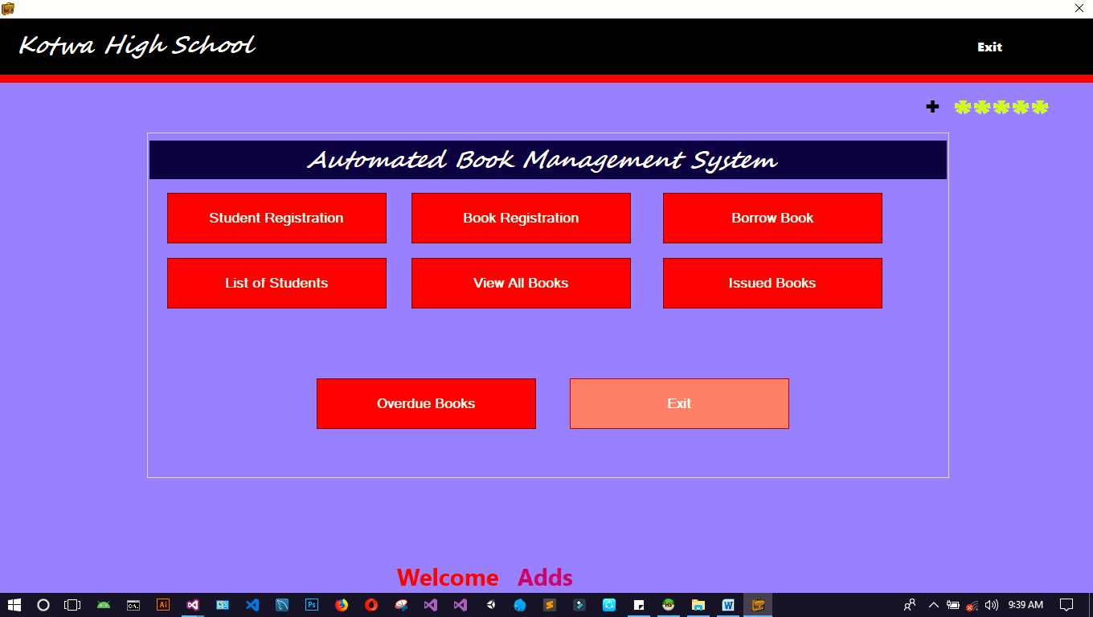

**Book entry**

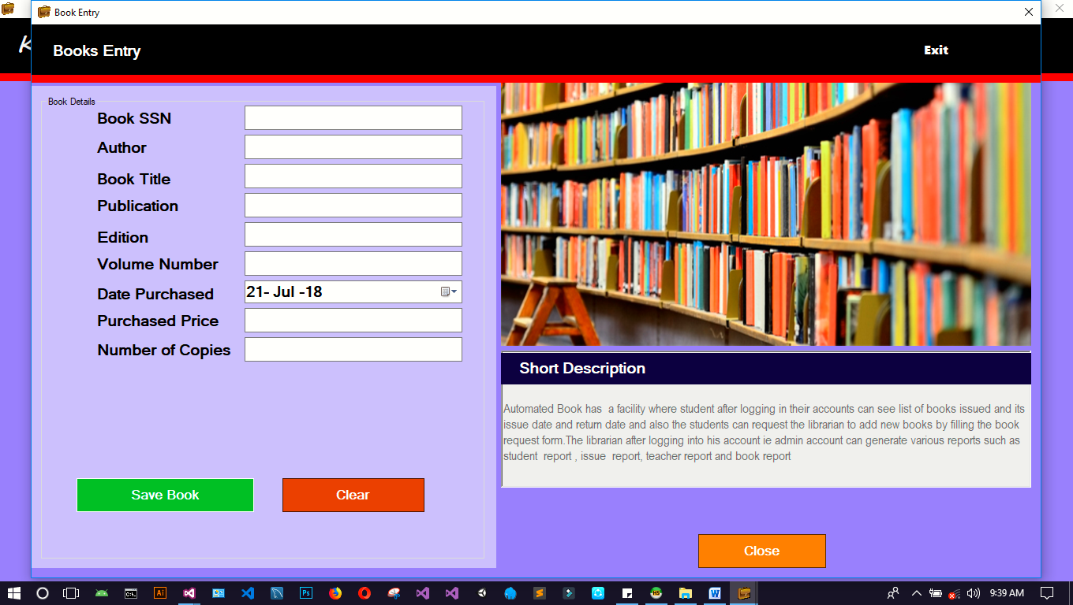

**Books list**

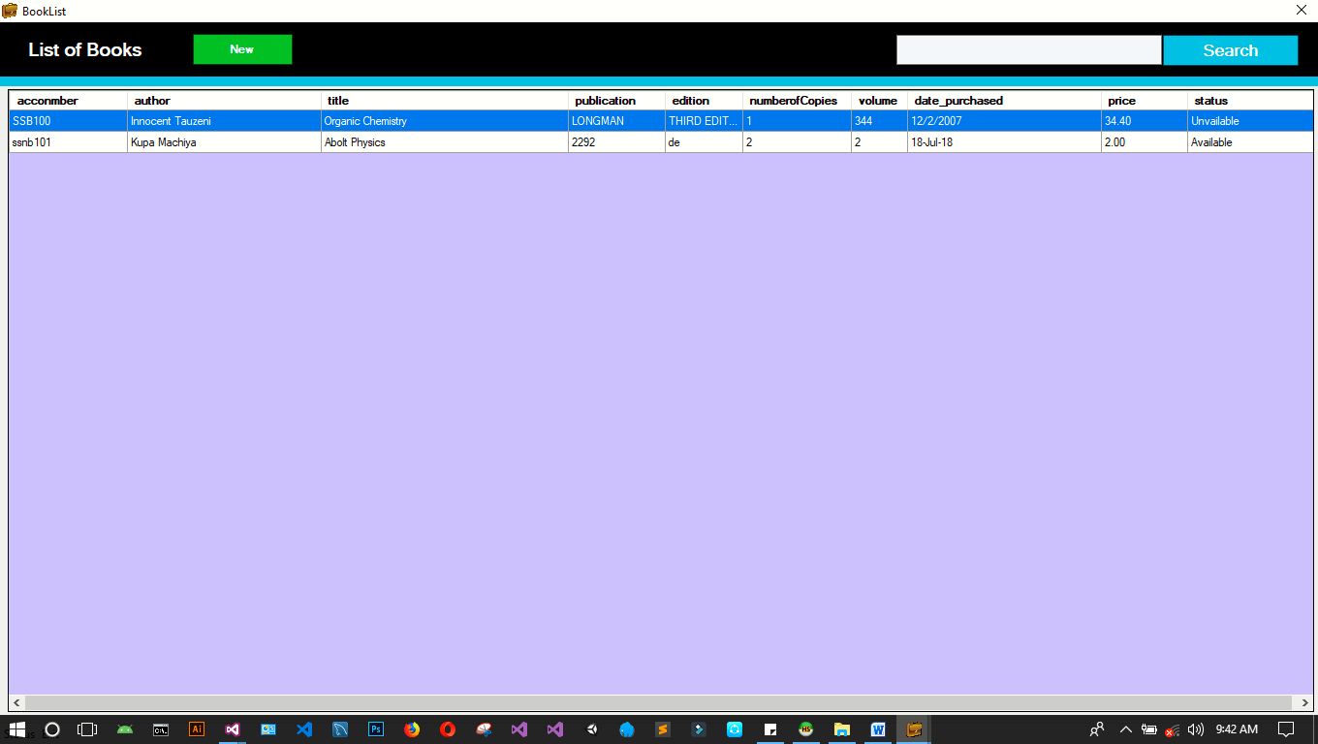

**Issue book to student form**

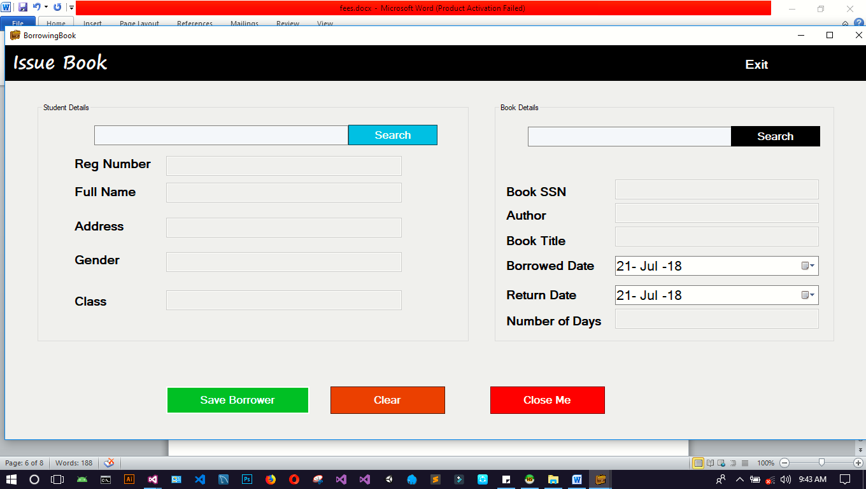

**After enter detail**

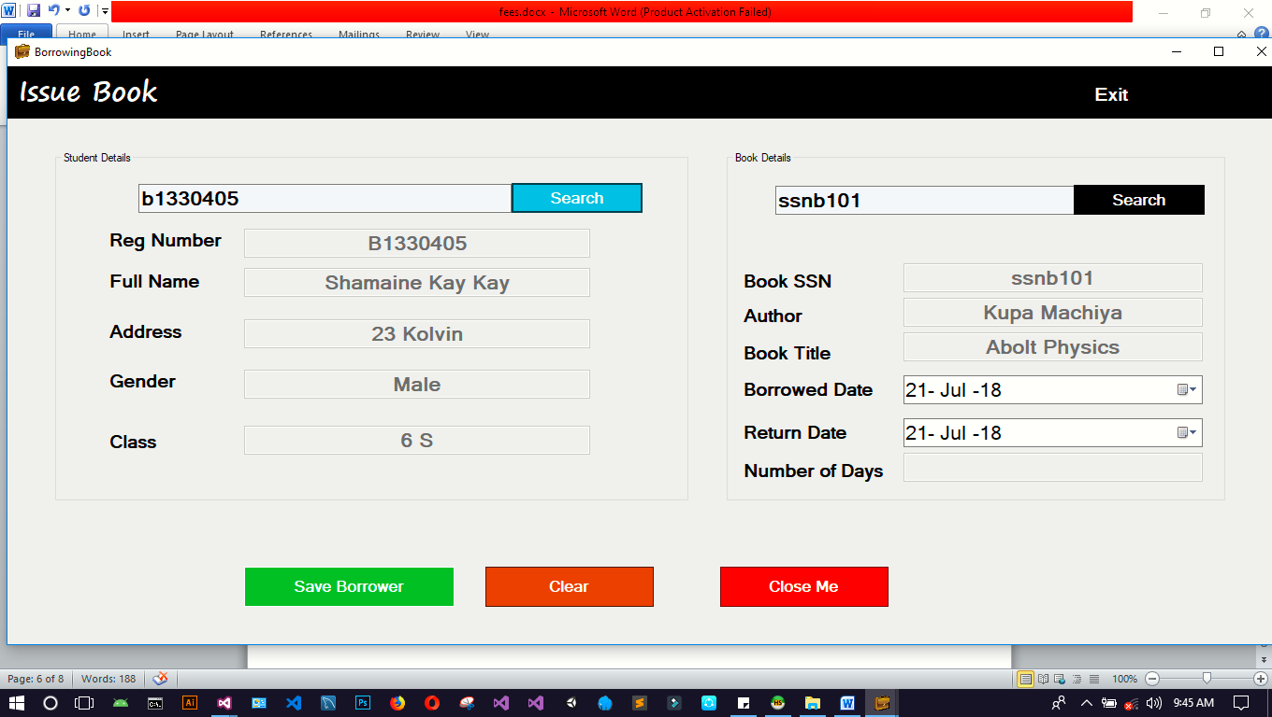

**Student entry**

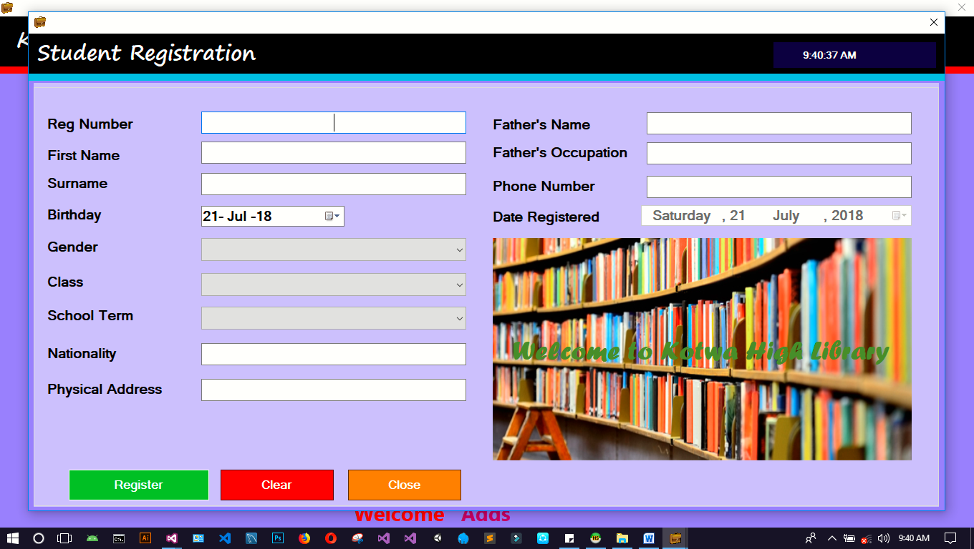

**Students list**

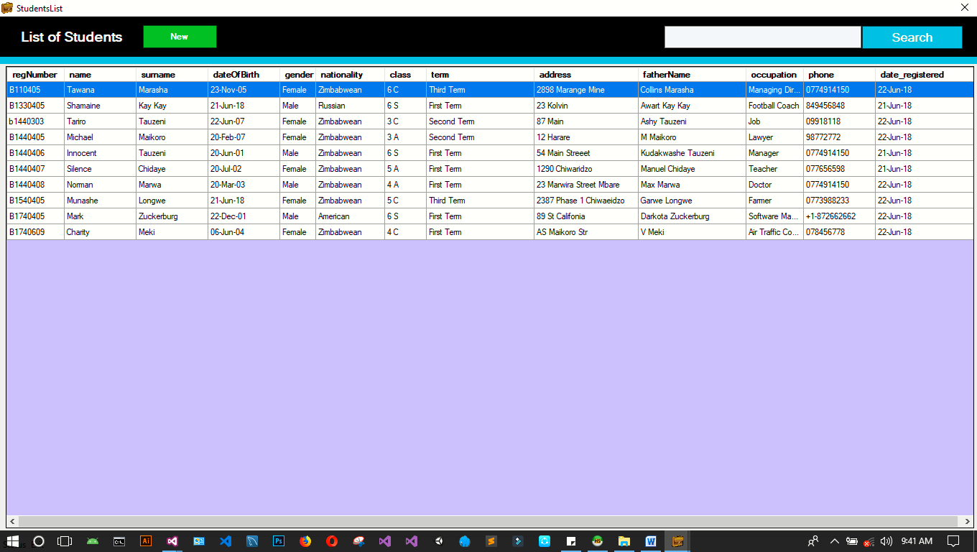

**Update student**

