Министерство образования Республики Беларусь  
Учреждение образования  
«Брестский государственный технический университет»  
Кафедра ИИТ

Лабораторная работа №5  
По дисциплине: «Создание приложения для работы с БД

и организация пользовательского интерфейса.»

Выполнил:  
студент 3 курса  
группы ИИ-24  
Крейдич А.А.

Проверил:  
Козик И. Д.

Брест 2025

**Цель работы**: получить навыки разработки приложений БД и организации пользовательского интерфейса.

**Задание**

Изучить материал, приведенный в “К лабораторной работе 5.doc”.

На основании логической модели (в соответствии с вариантом Лабораторной работы №1) создать приложение и организовать пользовательский интерфейс, используя соответствующие элементы и методы.

import tkinter as tk

from tkinter import ttk

import sqlite3

from tkinter import messagebox

class DatabaseApp:

def __init__(self, master, connection_params):

self.master = master

self.connection_params = connection_params

self.master.title("БД")

self.notebook = ttk.Notebook(master)

self.notebook.pack(expand=True, fill='both')

# Connect to the database

self.conn = sqlite3.connect(**connection_params)

self.cursor = self.conn.cursor()

# Fetch table names

self.table_names = self.get_table_names()

# Create a tab for each table

for table_name in self.table_names:

frame = tk.Frame(self.notebook)

self.notebook.add(frame, text=table_name)

self.create_table_view(frame, table_name)

def get_table_names(self):

# Fetch table names from the database

self.cursor.execute("SELECT name FROM sqlite_master WHERE type='table';")

table_names = [row[0] for row in self.cursor.fetchall()]

return table_names

def create_table_view(self, frame, table_name):

# Fetch column names

self.cursor.execute(f"PRAGMA table_info({table_name});")

columns = [row[1] for row in self.cursor.fetchall()]

# Create a treeview widget

tree = ttk.Treeview(frame, columns=columns, show='headings', selectmode='browse')

tree.pack(expand=True, fill='both')

# Add column headings

for col in columns:

tree.heading(col, text=col)

tree.column(col, width=100, anchor='center')

# Populate treeview with data from the table

self.populate_treeview(tree, table_name)

# Add buttons for CRUD operations

add_button = tk.Button(frame, text="Добавить", command=lambda: self.add_row(tree, table_name))

add_button.pack(side=tk.LEFT, padx=10)

delete_button = tk.Button(frame, text="Удалить", command=lambda: self.delete_row(tree, table_name))

delete_button.pack(side=tk.LEFT, padx=10)

edit_button = tk.Button(frame, text="Изменить", command=lambda: self.edit_row(tree, table_name))

edit_button.pack(side=tk.LEFT, padx=10)

refresh_button = tk.Button(frame, text="Обновить", command=lambda: self.populate_treeview(tree, table_name))

refresh_button.pack(side=tk.LEFT, padx=10)

def populate_treeview(self, tree, table_name):

# Fetch data from the table

self.cursor.execute(f"SELECT * FROM {table_name};")

data = self.cursor.fetchall()

# Clear existing data in treeview

tree.delete(*tree.get_children())

# Insert data into treeview

for row in data:

tree.insert('', 'end', values=row)

def add_row(self, tree, table_name):

# Get column names

self.cursor.execute(f"PRAGMA table_info({table_name});")

columns = [row[1] for row in self.cursor.fetchall()]

# Create a dialog for adding a new row

add_dialog = tk.Toplevel(self.master)

add_dialog.title("Добавить строку")

# Entry widgets for each column

entry_widgets = []

for col in columns:

label = tk.Label(add_dialog, text=col)

label.grid(row=columns.index(col), column=0, padx=10, pady=5, sticky='e')

entry = tk.Entry(add_dialog)

entry.grid(row=columns.index(col), column=1, padx=10, pady=5, sticky='w')

entry_widgets.append(entry)

# Function to insert the new row into the table

def insert_row():

values = [entry.get() for entry in entry_widgets]

placeholders = ', '.join(['?' for _ in values])

query = f"INSERT INTO {table_name} VALUES ({placeholders});"

self.cursor.execute(query, values)

self.conn.commit()

self.populate_treeview(tree, table_name)

add_dialog.destroy()

# Button to submit the new row

submit_button = tk.Button(add_dialog, text="Подтвердить", command=insert_row)

submit_button.grid(row=len(columns), columnspan=2, pady=10)

def delete_row(self, tree, table_name):

# Get the selected item in the treeview

selected_item = tree.selection()

if not selected_item:

messagebox.showwarning("Предупреждение", "Пожалуйста, выберите строку для удаления.")

return

# Confirm deletion

confirm = messagebox.askyesno("Подтверждение", "Вы уверены, что хотите удалить эту строку?")

if not confirm:

return

# Get the values of the selected row

values = tree.item(selected_item)['values']

# Create a WHERE clause for deletion

where_clause = ' AND '.join([f"{column} = ?" for column in tree['columns']])

# Execute the DELETE query

query = f"DELETE FROM {table_name} WHERE {where_clause};"

self.cursor.execute(query, values)

self.conn.commit()

# Update the treeview

self.populate_treeview(tree, table_name)

def edit_row(self, tree, table_name):

# Get the selected item in the treeview

selected_item = tree.selection()

if not selected_item:

messagebox.showwarning("Предупреждение", "Пожалуйста, выберите строку для изменения.")

return

# Get the values of the selected row

values = tree.item(selected_item)['values']

# Get column names

self.cursor.execute(f"PRAGMA table_info({table_name});")

columns = [row[1] for row in self.cursor.fetchall()]

# Create a dialog for editing the row

edit_dialog = tk.Toplevel(self.master)

edit_dialog.title("Изменить строку")

# Entry widgets for each column with current values

entry_widgets = []

for col, value in zip(columns, values):

label = tk.Label(edit_dialog, text=col)

label.grid(row=columns.index(col), column=0, padx=10, pady=5, sticky='e')

entry = tk.Entry(edit_dialog)

entry.insert(0, value)

entry.grid(row=columns.index(col), column=1, padx=10, pady=5, sticky='w')

entry_widgets.append(entry)

# Function to update the row in the table

def update_row():

new_values = [entry.get() for entry in entry_widgets]

set_clause = ', '.join([f"{column} = ?" for column in columns])

where_clause = ' AND '.join([f"{column} = ?" for column in columns])

query = f"UPDATE {table_name} SET {set_clause} WHERE {where_clause};"

self.cursor.execute(query, new_values + values)

self.conn.commit()

self.populate_treeview(tree, table_name)

edit_dialog.destroy()

# Button to submit the edited row

submit_button = tk.Button(edit_dialog, text="Подтвердить", command=update_row)

submit_button.grid(row=len(columns), columnspan=2, pady=10)

if __name__ == "__main__":

connection_params = {"database": "mydb.sqlite3"}

try:

root = tk.Tk()

app = DatabaseApp(root, connection_params)

root.mainloop()

except sqlite3.Error as err:

print(f"Error: {err}")

**Таблицы:**

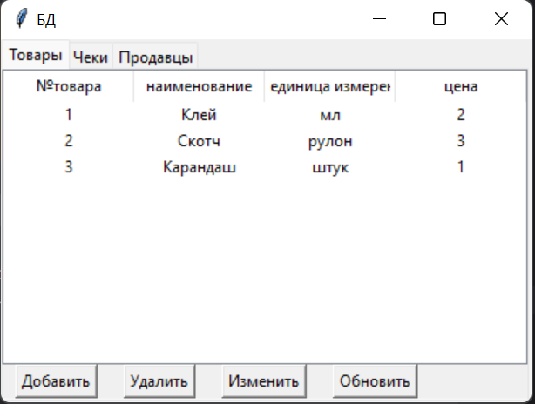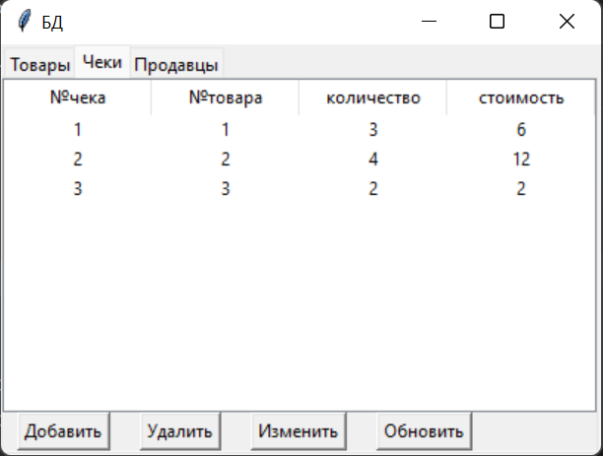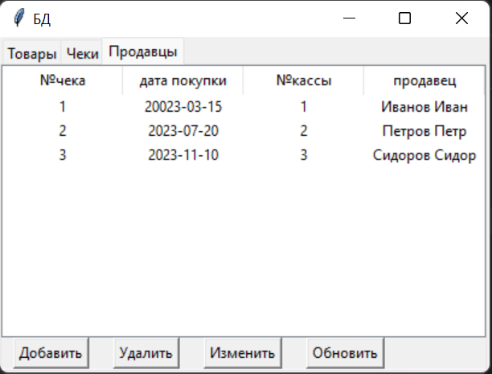

**Добавление:**

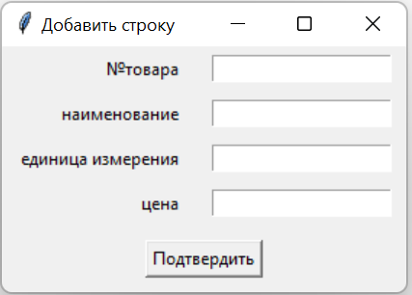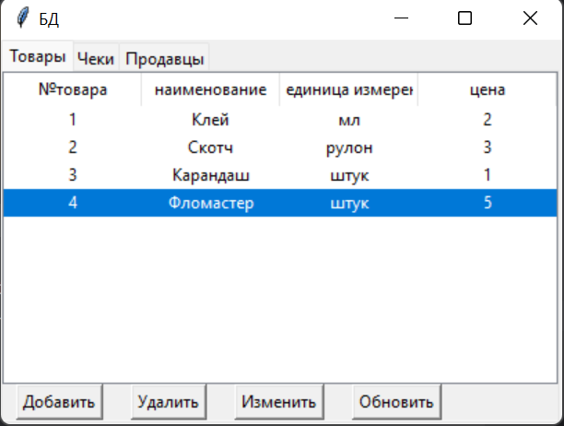

**Удаление:**

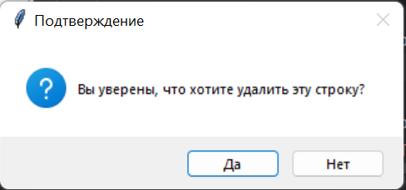

**Изменение:**

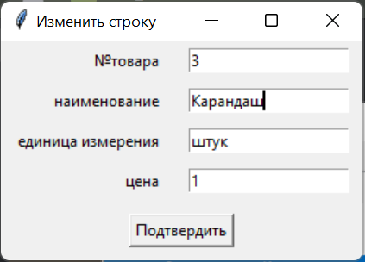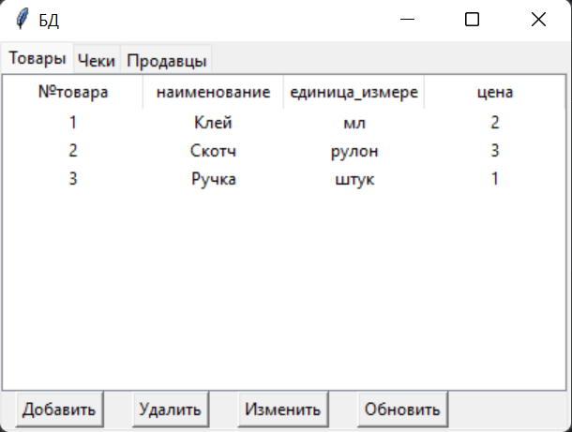

**Вывод**: в ходе лабораторной работы я создал приложение с графическим интерфейсом для управления базой данных.